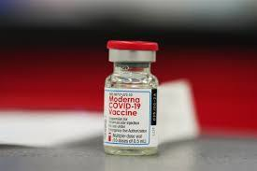

MODERNA COVID-19 VACCINE
TRAINING
Laurie A. Courtney, MSN, RN Immunization Nurse Manager and
Katie Reilly, MPH, MSN, RN, PHNA-BC, CIC
Healthcare Associated Infection Nurse Advisor

Bureau of Infectious Disease and Laboratory Sciences December 31, 2020
Image retrieved from https://www.nbcnews.com/news/us-news/doctor-uses-
allergy-autoinjector-stem-his-own-reaction-moderna-covid-n1252393:

Recommendations are Rapidly Evolving…

Always check the websites below
and other websites provided within this presentation for the latest guidance and information.

- ACIP’s COVID-19 vaccine specific recommendations: https://www.cdc.gov/vaccines/hcp/acip-recs/vacc-specific/covid-19.html
- Clinical Considerations for COVID-19 Vaccination: https://www.cdc.gov/vaccines/covid-19/clinical-considerations/index.html
- Interim Clinical Considerations for Use of COVID-19 Vaccine: https://www.cdc.gov/vaccines/covid-19/info-by-product/pfizer/clinical-considerations.html
- Interim Considerations: Preparing for the Potential Management of Anaphylaxis at COVID-19 Vaccination Sites: https://www.cdc.gov/vaccines/covid-19/info-by-product/pfizer/anaphylaxis-management.html
- COVID-19 Vaccine Product Information: https://www.cdc.gov/vaccines/covid-19/info-by-product/index.html

Learning Objectives

At the conclusion of this session, the participant will be able to:
  - Define ACIP COVID-19 Vaccine Recommendations
  - Explain Vaccine Storage and Handling
  - Describe COVID-19 Vaccine Screening
  - Explain Provider’s Role in Vaccine Administration
  - List Recommended Infection Control Measures
  - Summarize Principles of COVID-19 Vaccine Preparation
  - Identify Vaccine Adverse Reactions
  - Describe Vaccine Adverse Event Reporting
  - Summarize Recommendations for Vaccinating during the COVID-19 Pandemic

Outline

- Vaccine Information and Ancillary Kit Supplies
- Vaccine Storage and Handling
- Vaccine Preparation and Administration
  - Standing Orders
  - Screening
  - EUA fact sheets (Recipients and Healthcare Providers)
  - mRNA Dosing & Administration
  - Documenting the Vaccination
- Clinical Considerations
- ACIP COVID-19 Vaccine Recommendations

Outline

- Contraindications & Precautions
- Managing Adverse Reactions
- Observation Period Following Vaccination
- Vaccine Safety
- Vaccine Adverse Event Reporting (VAERS & V-Safe)
- Vaccinating During the COVID-19 Pandemic
  - Infection Control Measures
  - Personal Protective Equipment (PPE)
  - Clinics held at Satellite, Temporary, or Off-site Locations
- Resources
- MDPH Contact Information

VACCINE INFORMATION

Image retrieved from https://www.nbcnews.com/news/us-news/doctor- uses-allergy-autoinjector-stem-his-own-reaction-moderna-covid-n1252393:

Messenger RNA (mRNA) COVID-19 Vaccines

  - mRNA vaccines are being held to the same rigorous safety and effectiveness standards as all other types of vaccines in the United States. The only COVID-19 vaccines the Food and Drug Administration (FDA) will make available for use in the United States (by approval or emergency use authorization) are those that meet these standards. mRNA vaccines do not use the live virus that causes COVID-19. They cannot give someone COVID-19
  - mRNA doesn’t enter the nucleus of the cell, which is where our genetic material (DNA) is kept. The cell breaks down and gets rid of the mRNA soon after it is finished using the instructions
  - This means the mRNA vaccines do not affect or interact with our DNA

https://www.cdc.gov/vaccines/covid-19/hcp/mrna-vaccine-basics.html https://www.cdc.gov/coronavirus/2019-ncov/vaccines/vaccine-benefits/facts.html

Moderna COVID-19 Vaccine

- Shipped in 100-dose increments
  - Comes with Ancillary Supply Kit

- Does Not require reconstitution

- 10-dose multidose vial

- 0.5mL dosage

- Do Not combine residual vaccine from multiple vials to obtain an additional dose

- 2-dose series separated by 1 month (28 days)

Source: CDC Moderna COVID-19 Vaccine Preparation and Administration Summary 12/20/2020

Standard COVID-19 Vaccine Adult Ancillary Kit Contents
Massachusetts Department of Public Health mass.gov/dph
9

Standard COVID-19 Vaccine Adult Ancillary Kit
Supports administration of 100 doses
Product | Product Description | Quantity
Needles | 22 – 25G, 1” | 85
Needles | 22 – 25G, 1.5” | 20
Syringes | 1 ml or 3 ml | 105
Alcohol pads | Sterile, individual | 210
Vaccination record card |  | 100
Needle guide |  | 1
Face shield |  | 2
Face Mask |  | 4
Standard Ancillary Adult Kit Dimensions: 14” x 13” x 9” Weight: 3.5 lbs

https://www.cdc.gov/vaccines/imz-managers/downloads/COVID-19-Vaccination-Program-Interim_Playbook.pdf (pg. 30)

Not Included in Vaccine Ancillary Supply Kits

  - Ancillary supply kits will not include:
    - sharps containers
    - gloves
    - bandages

  - Additional personal protective equipment (PPE) may be needed depending on vaccination provider site needs

Preparing for COVID-19 Vaccine Second Doses

- Moderna and Pfizer vaccines require 2 doses:
  - The 2nd dose must be the same product as the first dose
  - Schedule the 2nd dose when administering the first dose
  - Develop a system for recalling vaccinees for 2nd dose
    - Moderna doses: 28 days apart
    - Pfizer doses: 21 days apart
    - Provide 2nd dose reminders:
    - Personal vaccination card, email, text or calls

  - Do not plan to hold COVID-19 vaccine from initial shipment for 2nd doses
    - 2nd doses are being withheld by the federal government and will be shipped as needed for the 2nd dose
    - Upon receipt of future shipments, identify which will be needed for 2nd doses

STORAGE & HANDLING

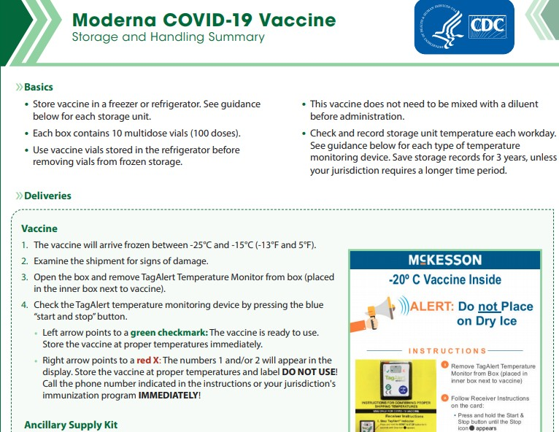

https://www.cdc.gov/vaccines/ covid-19/info-by- product/moderna/index.html

Massachusetts Department of Public Health mass.gov/dph

Moderna COVID-19 Vaccine
Massachusetts Department of Public Health mass.gov/dph
14

Thawing Frozen Vaccine
- Vaccine may be thawed in the refrigerator or at room temperature.
- Do Not refreeze thawed vaccine.
- Once a vial of vaccine has been thawed, it may be stored refrigerated at 2-8°C for up to 30 days.
- When thawed, the vaccine should be handled with care and protected from shocks, drops, vibration, etc.
- Vaccine being transported at temperatures others than frozen (-15 to -25°C) should begin with the vaccine in the frozen state if at all possible.

Source: CDC Moderna COVID-19 Vaccine Preparation and Administration Summary 12/20/2020

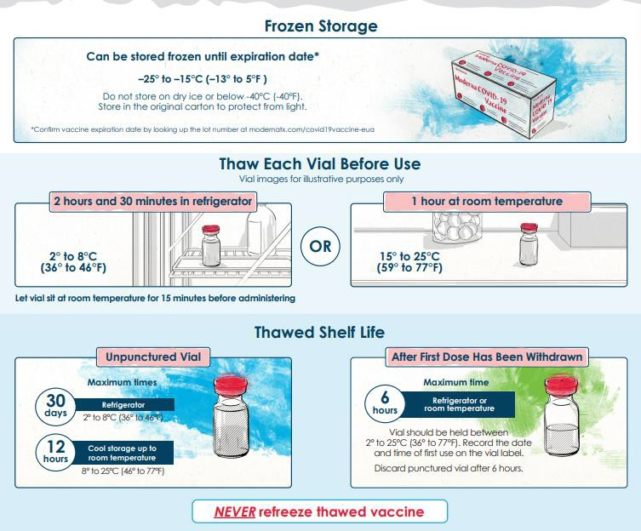
Moderna COVID-19 Vaccine Storage & Handling

https://www.modernatx. com/covid19vaccine- eua/providers/

Massachusetts Department of Public Health mass.gov/dph 15

Moderna COVID-19 Vaccine
Massachusetts Department of Public Health mass.gov/dph
16

If you must transport vaccine that has already been thawed, follow these general principles:
- Punctured vials should not be transported.
- Care must be taken to ensure vaccine does not re-freeze during transport.
- Vaccine must be protected as much as possible from drops, shocks, and vibration whether in the carton, vial, case or cooler.
- Vaccine should be transported in the carton whenever possible.
- If transport must be conducted at the vial level, the vial should be placed with dunnage (padding material
like bubble wrap or similar padding) to minimize movement during transport.
- The vaccine should always be transported in insulated containers qualified to maintain 2-8°C for the duration of transport.
- The transport containers must be secured when being transported to prevent unnecessary movement.
- After completion of transport, vaccine should immediately be placed into a vaccine storage unit at 2-8°C.
- Vaccine should only be transported one time and should not be transported back again to the point of origin or to a new location.

Source: CDC Moderna COVID-19 Vaccine Preparation and Administration Summary 12/20/2020

Moderna COVID-19 Vaccine Storage
Massachusetts Department of Public Health mass.gov/dph
17

- Store vials in a refrigerator 2°C to 8°C (36°F to 46°F) for up to 30 days.
- During storage, minimize exposure to room light, and avoid exposure to direct sunlight and ultraviolet light.
- Use vaccine within 6 hours after vial is first punctured.
  - Keep this in mind when you plan and run your clinics to avoid wastage
- Vials that have not been punctured may be kept between 8°C and 25°C (46°F and 77°F) for up to 12 hours
- Do Not refreeze.

https://www.modernatx.com/covid19vaccine-eua/

Expiration Dates for COVID-19 vaccines
Massachusetts Department of Public Health mass.gov/dph
18

Vaccine expiration dates should be checked prior to preparing or administering vaccine. NEVER use expired vaccine or diluent. As additional stability data become available, the expiration dates for some products may change.

CDC has set up an expiration date of 12/31/2069 to serve as a placeholder date in VTrckS for EUA COVID-19
vaccines that do not have a final expiration date.
- Such vaccines have a dynamic expiration date, which can change over time as additional stability data become available.
- The placeholder date should serve as a prompt for the provider to check the latest expiry information on
the manufacturer’s website.

Moderna COVID-19 vaccine: Determine expiration dates by scanning the QR code located on the vial or carton or access the manufacturer’s website. On the website, once you enter the lot number, the expiration date will be displayed.

Pfizer COVID-19 vaccine: Expiration date is located on the vaccine vial. CDC will be updating VTrckS effective immediately to replace the placeholder date in VTrckS with the actual expiration date.
https://www.cdc.gov/vaccines/covid-19/info-by-product/index.html

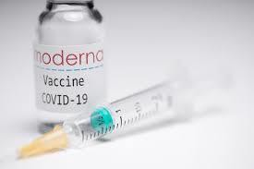

PREPARATION & ADMINISTRATION

Image source: forbes.com

COVID-19 Vaccine Eligibility Considerations

- Decisions about which eligible patients receive the COVID Vaccine should be based on the clinical judgement of hospitals and providers, consistent with the terms of the EUAs and with this guidance.
- Provider criteria for the COVID Vaccine use should be as clear, transparent, and objective as possible, and be based on biological factors related only to the likelihood and magnitude of benefit from the medical resources and should at all times minimize inequitable outcomes.
- Factors that have no bearing on the likelihood or magnitude of benefit, include but are not limited to, race, disability, gender, sexual orientation, gender identity, ethnicity, ability to pay or insurance status, socioeconomic status, English language proficiency, perceived social worth, perceived quality of life, immigration status, incarceration status, homelessness or past or future use of resources.

Vaccination/Immunization Standing Orders

  - Standing orders for vaccination facilitate the delivery of immunization services to patients
  - Standing orders for COVID-19 vaccines are available at:
    - Moderna: https://www.cdc.gov/vaccines/covid-19/info-by-product/moderna/downloads/standing-orders.pdf
    - Pfizer-BioNTech: https://www.cdc.gov/vaccines/covid-19/info-by-product/pfizer/downloads/standing-orders.pdf
  - Standing orders for many routine vaccines and Emergency Treatment are available from IAC: https://www.immunize.org/standing-orders/
    - Medical Management of Vaccine Reactions of Adults in a Community Setting: https://www.immunize.org/catg.d/p3082.pdf
    - Medical Management of Vaccine Reactions in Children and Teens in a Community Setting:
https://www.immunize.org/catg.d/p3082a.pdf
ACIP’s COVID-19 vaccine specific recommendations: https://www.cdc.gov/vaccines/hcp/acip-recs/vacc-specific/covid-19.html
CDC’s COVID Vaccination Training and Education: https://www.cdc.gov/vaccines/covid- 19/index.html?CDC_AA_refVal=https%3A%2F%2Fwww.cdc.gov%2Fvaccines%2Fcovid-19%2Fvaccination-resources.html
Useful CDC Guidance Links
Clinical Considerations for COVID-19 Vaccination: https://www.cdc.gov/vaccines/covid-19/clinical-considerations/index.html
•
•
•

Moderna COVID-19 Vaccine Standing Orders

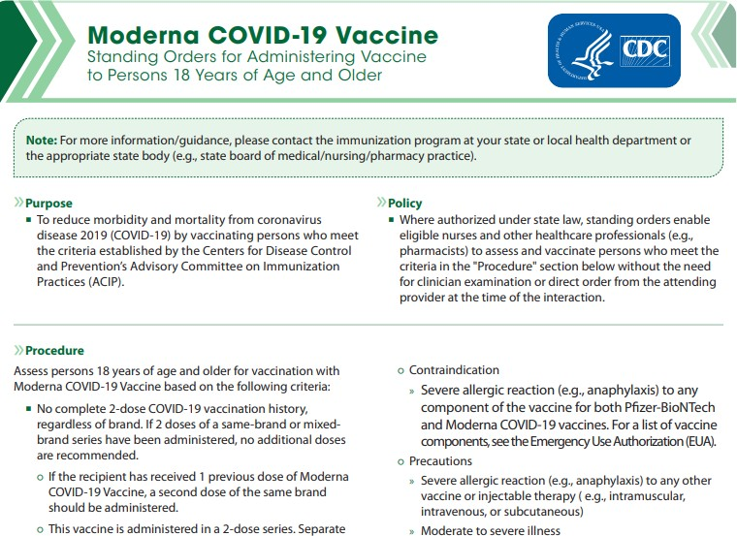

https://www.cdc.gov/vaccines/covid-19/info-by-product/moderna/downloads/standing-orders.pdf

Medical Management of Vaccine Reactions in Adults Standing Orders
Massachusetts Department of Public Health mass.gov/dph
23

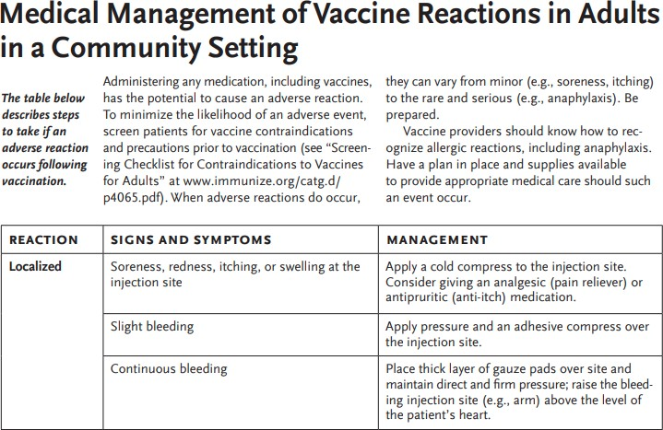
https://www.immunize.org/catg.d/p3082.pdf

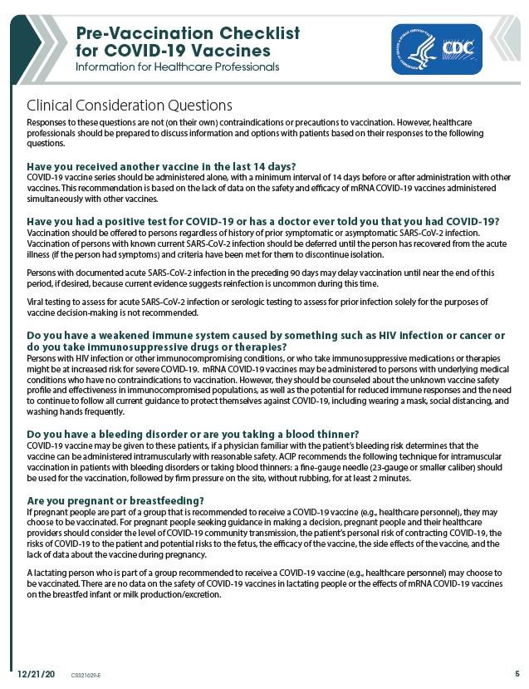
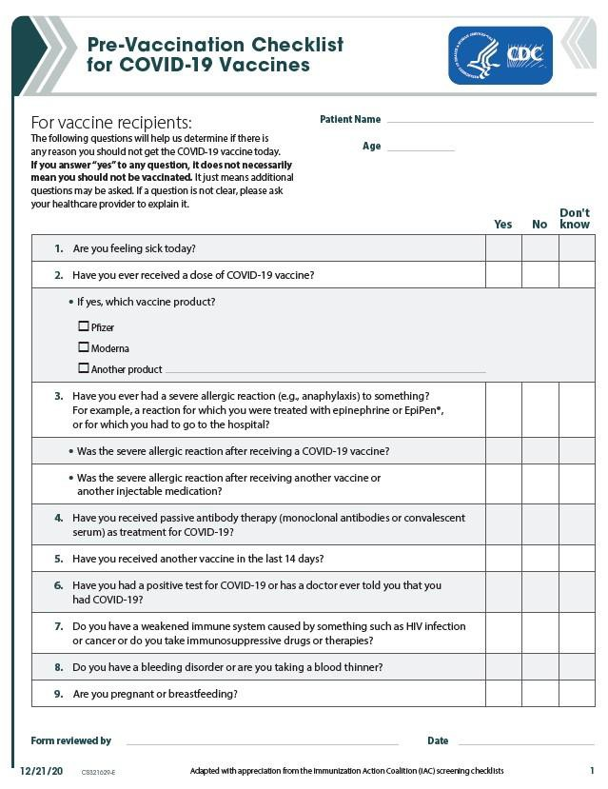
Screening
Massachusetts Department of Public Health
mass.gov/dph
24

- Is key to preventing serious adverse reactions
- Specific questions intended to identify contraindications or precautions to vaccination
- Screening must occur at every immunization encounter (not just before the first dose)

https://www.cdc.gov/vaccines/covid-19/downloads/pre-vaccination-screening-form.pdf

EUA Fact Sheet for Recipients

Each vaccine-specific EUA Fact Sheet for Recipients will provide the following information:
- Basic information on COVID-19, symptoms, and what to discuss with a healthcare provider before vaccination
- Who should and should not receive the vaccine
- That recipients have the choice to receive the vaccine
- Dosage and vaccine series information
- Risks and benefits of the vaccine, including common side effects
- Information on reporting side effects to VAERS
- An explanation of what an EUA is and why it is issued
- Any approved available alternatives for preventing COVID-19
Moderna EUA fact sheet: https://www.modernatx.com/covi d19vaccine-eua/providers/
- Additional resources

https://www2.cdc.gov/vaccines/ed/covid19/SHVA/10080.asp

EUA Fact Sheet for Healthcare Providers

Each vaccine-specific EUA Fact Sheet for Healthcare Providers will provide the following
information:
- COVID-19 disease description
- Dosage and administration information
- Storage and handling instructions
- Dose preparation and administration information
- Requirements for use of vaccine under EUA
- Risks and benefits, including common adverse events (AEs)
- Any approved available alternatives for preventing COVID-19
- Reporting requirements, including reporting AEs to VAERS
Moderna EUA fact sheet: https://www.modernatx.com/ covid19vaccine-eua/providers/
- Additional resources
https://www2.cdc.gov/vaccines/ed/covid19/SHVA/10070.asp

Dosing and Administration

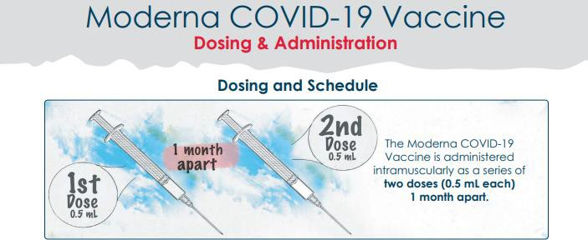

https://www.modernatx.com/covid19vaccine-eua/providers/

Moderna COVID-19 Vaccine Prep & Administration

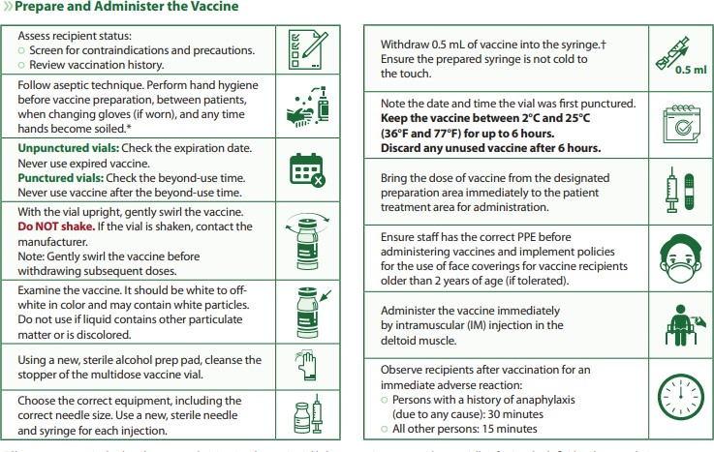
https://www.cdc.gov/vaccines/covid-19/info-by-product/moderna/downloads/prep-and-admin-summary.pdf

Dosing and Administration

  - Authorized age groups:
    - Pfizer-BioNTech: ≥ 16 years
    - Moderna: ≥ 18 years

  - Administration: two-dose series administered intramuscularly
    - Pfizer-BioNTech: 21 days apart
    - Moderna: 28 days apart

  - mRNA vaccines are not interchangeable with each other or other COVID-19 vaccines
    - Either vaccine series may be used; ACIP does not state a product preference

  - mRNA vaccines should be administered alone, with a minimum interval of 14 days before or after administration with any other vaccines
CDC Partner Update Call, 12/21/2020, COVID-19 Vaccine Implementation. Nancy Messonnier MD and Sarah Mbaeyi, MD

mRNA Vaccine Administration

- 2-dose series administered intramuscularly
  - Pfizer-BioNTech: 21 days apart
  - Moderna: 28 days apart
- Administration of 2nd dose within 4-day grace period considered valid
(However, doses administered earlier do not need to be repeated)

- If greater than the recommended interval since 1st dose, 2nd dose should be administered at earliest opportunity (However, no doses need to be repeated)

- Both doses are necessary for protection; efficacy of a single dose has not been systematically evaluated

https://www.cdc.gov/vaccines/covid-19/info-by-product/clinical-considerations.html 30

Document the Vaccination
Massachusetts Department of Public Health mass.gov/dph
31

COVID-19 vaccination providers must document vaccine administration in their medical record systems within 24 hours of administration and use their best efforts to report administration data to the relevant system for the jurisdiction (i.e., immunization information system - - MIIS) as soon as practicable and no later than 72 hours after administration.

https://www.cdc.gov/vaccines/covid-19/info-by-product/moderna/index.html

CLINICAL CONSIDERATIONS

Check for latest guidance on the CDC website

Vaccines & Immunizations

CDC > COVID-19 Vaccinations > Clinical Considerations

COVID-19 Vaccination

Product Info by US Vaccine

Clinical Considerations

mRNA COVID-19 Vaccines

Managing Anaphylaxis
Interim Clinical Considerations for Use of mRNA COVID-19 Vaccines Currently Authorized in the United States

Interim Considerations: Preparing for the Potential Management of Anaphylaxis at COVID-19 Vaccination Sites

Lab Tests After Severe Allergic Reaction

Provider Requirements and Support

Summary of recent changes
(last updated December 30, 2020):

On This P a g e

Background

Training and Education

Recipient Education +
Planning & Partnerships +
Vaccination Toolkits +

COVID -19 Vaccination Reporting Data Systems

https://www.cdc.gov/vaccines/covid-19/info-by- product/clinical-considerations.html
- Additional information on antibody therapies and COVID-19 vaccination
- Inf o r m at io n on CO VID -1 9 vaccination and outbreak management
- Additional information on vaccination of immunocompromised persons
- Updates to contraindications and precautions to vaccination
- Inf o r m a t io n on CO VID -1 9 vaccination and tuberculin skin testing

Background
The Advisory Committee on Immunization Practices (ACIP)has issues interim recommendations for the use of Pfizer-BioNTech and Moderna COVID-19 vaccines for the prevention of coronavirus disease 2019 (COVID-19) in the Unites States. Both vaccines are lipid nanoparticle-formulated, nucleoside-modified
Authorized age groups Administration
Interchangeability with other COVID-19 vaccine products

Coadministration with other vaccines

Booster doses

Vaccination of persons with SARS- CoV-2 infection or exposure

Vaccination of persons with

Massachusetts Department of Public Health mass.gov/dph 33

mRNA COVID-19 Vaccines

Two mRNA COVID-19 vaccines authorized under Emergency Use:
  - Pfizer-BioNTech
  - Moderna

- Both products demonstrate high vaccine efficacy
  - Across age groups, racial/ethnic groups, persons with underlying conditions

- Acceptable safety profile of both vaccines
  - Local and systemic reactogenicity, particularly after second dose

CDC Partner Update Call, 12/21/2020, COVID-19 Vaccine Implementation. Nancy Messonnier MD and Sarah Mbaeyi, MD

Interim Recommendations for Use Moderna COVID-19 Vaccine in the U.S.

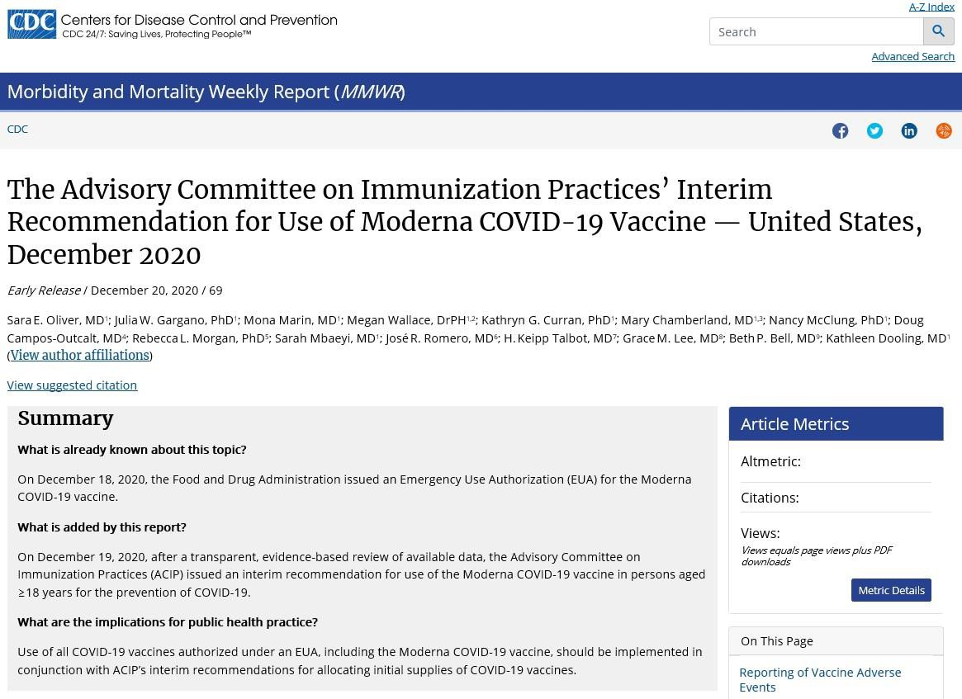
- On December 18, 2020, the Food and Drug Administration issued an Emergency Use Authorization for the Moderna COVID-19 vaccine.
- On December 19, 2020, after an explicit, evidence-based review of all available data, the Advisory Committee on Immunization Practices (ACIP) issued an interim recommendation for use
of the Moderna COVID-19 vaccine in persons aged
≥18 years for the prevention of COVID-19:
https://www.cdc.gov/mmwr/volumes/69/wr/mm695152e1.htm?s_cid=m m695152e1_w

COVID-19 Vaccine ACIP Recommendations
Massachusetts Department of Public Health mass.gov/dph
36

It is important that providers follow the Advisory Committee on Immunization Practices (ACIP) recommendations regarding COVID-19 vaccination.
- Their latest COVID-19 recommendations can be found at: https://www.cdc.gov/vaccines/hcp/acip-recs/vacc-specific/covid-19.html
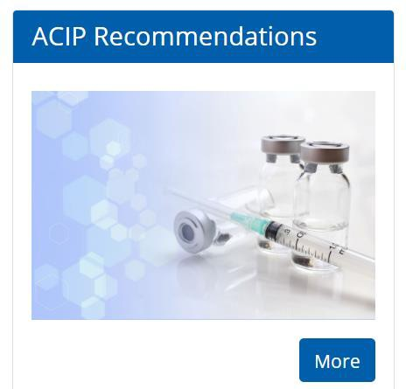
- Clinical considerations link: https://www.cdc.gov/vaccines/hcp/acip-
recs/vacc-specific/covid-19/clinical-considerations.html

Post-vaccination symptoms in Health Care Personnel (HCP)
Massachusetts Department of Public Health mass.gov/dph
37

- Based on available data, COVID-19 vaccination is expected to elicit systemic post-vaccination symptoms, such as fever,
headache, and myalgias.
- Strategies are needed to mitigate possible HCP absenteeism and resulting personnel shortages due to the occurrence of these symptoms.
- Considerations might include:
  - Staggering delivery of vaccine to HCP in the facility so that personnel from a single department or unit are not all vaccinated at the same time. Based on greater reactogenicity observed following the second vaccine dose in phase I/II clinical trials, staggering considerations may be more important following the second dose.
  - Planning for personnel to have time away from work if they develop systemic symptoms following COVID-19 vaccination.
- Health care personnel who develop any symptoms consistent with COVID-19 after vaccination should remain out of work and receive a test for SARS-CoV-2 as soon as possible.
  - Health care personnel with certain minimal symptoms (e.g., low grade fever, headache) and without respiratory symptoms may be
allowed to work.
  - See MDPH memo December 16, 2020 for specific details

https://www.mass.gov/info-details/covid-19-public-health-guidance-and-directives#health-care-organizations-

Pregnant women
- COVID-19 and pregnancy
  - Increased risk of severe illness (ICU admission, mechanical ventilation and death)
  - Might be an increased risk of adverse pregnancy outcomes, such as preterm birth
- There are few data on the safety of COVID-19 vaccines in pregnant Women
  - Limited animal developmental and reproductive toxicity (DART) data
  - Studies in humans are ongoing and more planned
- mRNA vaccines are not live vaccines
- If a woman is part of a group (e.g., healthcare personnel) who is recommended to receive a COVID-19 vaccine and is pregnant, she may choose to be vaccinated.

https://www.cdc.gov/vaccines/covid-19/info-by-product/clinical-considerations.html 38
https://www.cdc.gov/coronavirus/2019-ncov/need-extra-precautions/pregnancy-breastfeeding.html

Pregnant women

- Considerations for vaccination:
  - level of COVID-19 community transmission, (risk of acquisition)
  - her personal risk of contracting COVID-19, (by occupation or other activities)
  - the risks of COVID-19 to her and potential risks to the fetus
  - the efficacy of the vaccine
  - the known side effects of the vaccine
  - the lack of data about the vaccine during pregnancy

CDC Partner Update Call, 12/21/2020, COVID-19 Vaccine Implementation. Nancy Messonnier MD and Sarah Mbaeyi, MD
https://www.cdc.gov/vaccines/covid-19/info-by-product/clinical-considerations.html 39

Breastfeeding/Lactating

- There are no data on the safety of COVID-19 vaccines in lactating people or the effects of mRNA vaccines on the breastfed infant or milk production/excretion

- mRNA vaccines are not thought to be a risk to the breastfeeding infant

- A lactating person who is part of a group recommended to receive a COVID-19 vaccine (e.g., healthcare personnel) may choose to be vaccinated

https://www.cdc.gov/vaccines/covid-19/info-by-product/clinical-considerations.html 40

Persons with a history of SARS-CoV-2 infection

- Vaccination should be offered to persons regardless of history of prior symptomatic or asymptomatic SARS-CoV-2 infection
– Data from clinical trials suggest vaccination safe in these persons

- Viral or serologic testing for acute or prior infection, respectively, is not recommended for the purpose of vaccine decision-making

CDC Partner Update Call, 12/21/2020, COVID-19 Vaccine Implementation. Nancy Messonnier MD and Sarah Mbaeyi, MD
https://www.cdc.gov/vaccines/covid-19/info-by-product/clinical-considerations.html 41

Persons with known current SARS-CoV-2 infection

  - Vaccination should be deferred until recovery from the acute illness (if person had symptoms) and criteria have been met to discontinue isolation (usually 10 days after onset of symptoms or positive test)

  - No minimal interval between infection and vaccination

  - However, current evidence suggests reinfection uncommon in the 90 days after initial infection, and thus persons with documented acute infection in the preceding 90 days may defer vaccination until the end of this period, if desired

CDC Partner Update Call, 12/21/2020, COVID-19 Vaccine Implementation. Nancy Messonnier MD and Sarah Mbaeyi, MD

Persons who previously received passive antibody therapy
- Currently there is no data on safety or efficacy of mRNA COVID-19 vaccines in persons who received monoclonal antibodies or convalescent plasma as part of COVID-19 treatment
  - Vaccination should be deferred for at least 90 days, as a precautionary measure until additional information becomes available, to avoid interference of the treatment with vaccine-induced immune responses
– Based on estimated half-life of therapies and evidence suggesting reinfection is uncommon within 90 days of initial infection

- For persons receiving antibody therapies not specific to COVID-19 treatment (e.g., IVIG, RhoGAM) there is no recommended minimum interval between other antibody therapies (i.e., those that are not specific to COVID-19 treatment) and mRNA COVID-19 vaccination.

Persons with a known SARS-CoV-2 exposure

- Community or outpatient setting:
– Should not seek vaccination until their quarantine period has ended to avoid exposing healthcare personnel (HCP) or other persons to SARS-CoV-2 during the vaccination visit
- Person residing in congregate healthcare settings (e.g., long-term care facilities):
- May be vaccinated
- Healthcare personnel are already in close contact with residents and should employ
appropriate infection prevention and control procedures

- Residents of other congregate settings (e.g., correctional facilities, homeless shelters)
- May be vaccinated, in order to avoid delays and missed opportunities for vaccination
- Where feasible, precautions should be taken to limit mixing exposed individuals with other residents or staff (except those essential for the provision of vaccination services, who should employ appropriate infection and control procedures)

https://www.cdc.gov/vaccines/covid-19/info-by-product/clinical-considerations.htm 44

Persons with underlying medical conditions

  - mRNA COVID-19 vaccines may be administered to persons with underlying medical conditions who have no contraindications to vaccination.

  - Clinical trials demonstrate similar safety and efficacy profiles in persons with some underlying medical conditions, including those that place them at increase risk for severe COVID-19, compared to persons without comorbidities.

https://www.cdc.gov/coronavirus/2019-ncov/need-extra-precautions/people-with-medical-conditions.html

Immunocompromised persons

  - Persons with HIV infection, other immunocompromising conditions, or who take immunosuppressive medications or therapies might be at increased risk for severe COVID-19

  - Data not currently available to establish safety and efficacy of vaccine in these groups

  - These individuals may still receive COVID-19 vaccine if they have no contraindications to vaccination.

  - Individuals should be counseled about:
    - Unknown vaccine safety profile and effectiveness in immunocompromised populations
    - Potential for reduced immune responses
    - Need to continue to follow all current guidance to protect themselves against COVID-19

SARS-CoV-2 tests
  - Viral tests: Prior receipt of an mRNA COVID-19 vaccine will not affect the results of SARS-CoV-2 nucleic acid amplification or antigen tests

  - Antibody tests:
    - Currently available antibody tests for SARS-CoV-2 assess IgM and/or IgG to spike or
nucleocapsid proteins
    - Both Pfizer-BioNTech and Moderna COVID-19 vaccine contains mRNA that encodes the spike protein; thus, a positive test for spike protein IgM/IgG could indicate either prior infection or vaccination
    - To evaluate for evidence of prior infection in an individual with a history of mRNA COVID-19 vaccination, a test specifically evaluating IgM/IgG to the nucleocapsid protein should be used
    - Antibody testing is not currently recommended to assess for immunity to COVID-19 following mRNA COVID-19 vaccination or to assess the need for vaccination in an unvaccinated person

www.cdc.gov/vaccines/covid-19/info-by-product/clinical-considerations.html 47

Interchangeability with other COVID-19 vaccine products
  - mRNA COVID-19 vaccines are not interchangeable with each other or with other COVID-19 products
    - Safety and efficacy of a mixed series has not been evaluated

  - Persons initiating series with one mRNA COVID-19 vaccine should complete series with same product

  - If two doses of different mRNA COVID-19 vaccine products inadvertently administered, no additional doses of either vaccine recommended at this time
    - Recommendations may be updated as further information becomes available or additional vaccine types authorized

https://www.cdc.gov/vaccines/covid-19/info-by-product/clinical-considerations.html

Coadministration with other vaccines

- mRNA COVID-19 vaccine should be administered alone with a minimum interval of 14 days before or after administration with any other vaccines
– Due to lack of data on safety and efficacy of the vaccine administered simultaneously with other vaccines

- If mRNA COVID-19 vaccine is inadvertently administered within 14 days of
another vaccine, doses do not need to be repeated for either vaccine

https://www.cdc.gov/vaccines/covid-19/info-by-product/clinical-considerations.html

Reactogenicity
  - Before vaccination, providers should counsel vaccine recipients about expected local and systemic post-vaccination symptoms
- Depending on vaccine product, age group, and vaccine dose, approximately 80–89% of vaccinated persons
develop at least one local symptom and 55-83% develop at least one systemic symptom following vaccination.
  - Most are mild-moderate, occur within 3 days, and resolve within 1-2 days
  - More frequent and severe following dose 2 and among younger age groups

  - Unless a person develops a contraindication to vaccination, they should be encouraged to complete the series even if they develop post-vaccination symptoms in order to optimize protection against COVID-19
  - Antipyretic or analgesic medications may be taken for treatment of post- vaccination symptoms
- Routine prophylaxis for the purposes of preventing symptoms is not recommended at this time, due to lack of information on impact of use on vaccine-induced antibody responses

https://www.cdc.gov/vaccines/covid-19/info-by-product/clinical-considerations.html 50

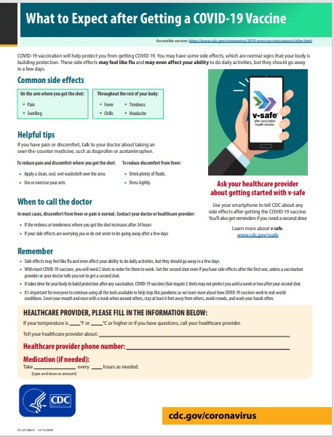
Massachusetts Department of Public Health mass.gov/dph
51

https://www.cdc.gov/coronavirus/2019-ncov/vaccines/pdfs/321466- A_FS_What_Expect_COVID-19_Vax_Final_12.13.20.pdf

Public health recommendations for vaccinated persons
  - Protection from vaccine is not immediate; vaccine is a 2-dose series and will take 1 to 2 weeks following the second dose to be considered fully vaccinated
  - No vaccine is 100% effective
  - Given the currently limited information on how well the vaccine works in the general population; how much it may reduce disease, severity, or transmission; and how long protection lasts, vaccinated persons should continue to follow all current guidance to protect themselves and others, including:
    - Wearing a mask
    - Staying at least 6 feet away from others
    - Avoiding crowds
    - Washing hands often
    - Following CDC travel guidance
    - Following quarantine guidance after an exposure to someone with COVID-19
    - Following any applicable workplace or school guidance
https://www.cdc.gov/coronavirus/2019-ncov/index.html

Amanda Cohn and Sarah Mbaeyi. What Clinicians Need to Know about Pfizer-BioNTech COVID19 Vaccine. CDC Partner Call 12-13-20 https://www.cdc.gov/vaccines/covid-19/downloads/pfizer-biontech-vaccine-what-Clinicians-need-to-know.pdf 52

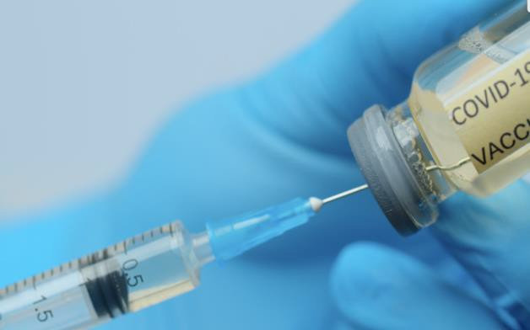
CONTRAINDICATIONS & PRECAUTIONS

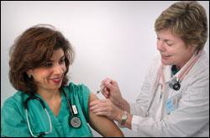

Image retrieved from: https://www.boldbusiness.com/wp- content/uploads/2020/06/Pandemic-Vaccine-Development-Story-Featured.jpg

Updated contraindications and precautions to vaccination

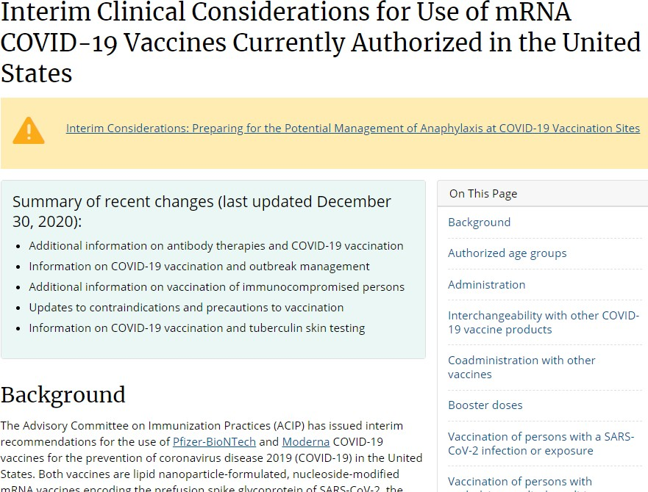
- Recommendations apply to both Pfizer-BioNTech and Moderna COVID-19 vaccines

- Guidance may change as further information becomes
available

- Definition of immediate allergic reaction to vaccine or medication:
– Any hypersensitivity-related signs or symptoms such as urticaria, angioedema, respiratory distress (e.g., wheezing, stridor), or anaphylaxis that occur within four hours following administration

54
https://www.cdc.gov/vaccines/covid-19/info-by-product/clinical-considerations.html

Contraindications to mRNA COVID-19 vaccination
Pfizer-BioNTech and Moderna COVID-19 vaccines

  - Contraindications to either of the mRNA COVID-19 vaccines:
    - Severe allergic reaction (e.g., anaphylaxis) after a previous dose of an mRNA COVID-19 vaccine
or to any of its components
    - Immediate allergic reaction of any severity to a previous dose of an mRNA COVID-19 vaccine or any of its components (including polyethylene glycol [PEG])*
    - Immediate allergic reaction of any severity to polysorbate (due to potential cross-reactive hypersensitivity with the vaccine ingredient PEG)*

  - Persons with an immediate allergic reaction to the first dose of an mRNA vaccine should not receive additional doses of either of the mRNA COVID-19 vaccines

* These persons should not receive mRNA COVID-19 vaccination at this time unless they have been evaluated by an allergist- immunologist and it is determined that the person can safely receive the vaccine (e.g., under observation, in a setting with advanced medical care available).

CDC COCA Call, 12/30/2020, COVID-19 Vaccines: Update on Allergic Reactions, Contraindications, and Precautions: Tom Shimabukuro, MD,
MPH, MBA and Sarah Mbaeyi, MD, MPH 55

Ingredients* included in mRNA COVID-19 vaccines
Description Pfizer-BioNTech Moderna

mRNA nucleoside-modified mRNA encoding the viral
spike (S) glycoprotein of SARS-CoV-2
Lipids
PEG2000-DMG: 1,2-dimyristoyl-rac-glycerol,
methoxypolyethylene glycol
2[(polyethylene glycol)-2000]-N,N-
ditetradecylacetamide
nucleoside-modified mRNA encoding the viral
spike (S) glycoprotein of SARS-CoV-2

1,2-distearoyl-sn-glycero-3-phosphocholine 1,2-distearoyl-sn-glycero-3-phosphocholine cholesterol cholesterol

(4-hydroxybutyl)azanediyl)bis(hexane-6,1- diyl)bis(2-hexyldecanoate)
SM-102: heptadecan-9-yl 8-((2-hydroxyethyl) (6-oxo-6-(undecyloxy) hexyl) amino) octanoate

Salts, sugars,
potassium chloride Tromethamine

monobasic potassium phosphate Tromethamine hydrochloride

buffers
sodium chloride Acetic acid
dibasic sodium phosphate dihydrate Sodium acetate

sucrose sucrose
*As reported in the prescribing information
CDC COCA Call, 12/30/2020, COVID-19 Vaccines: Update on Allergic Reactions, Contraindications, and Precautions: 56
Tom Shimabukuro, MD, MPH, MBA and Sarah Mbaeyi, MD, MPH

Polyethylene glycol (PEG)

  - Primary ingredient in osmotic laxatives and oral bowel preparations for colonoscopy procedures

  - Inactive ingredient or excipient in medications

  - Used in a process called pegylation to improve therapeutic activity of some medications

  - Cross-reactive hypersensitivity between PEG and polysorbates can occur
    - Polysorbates are included as an excipient in some vaccines and other therapeutic agents

Information on whether a medication contains PEG, a PEG derivative, or polysorbates can be found in the package insert. The NIH DailyMed database may also be used as a resource Medications that contain PEG and/or polysorbate are described in the supplemental materials of Stone CA, et al. "Immediate hypersensitivity to polyethylene glycols and polysorbates: more common than we have recognized." The Journal of Allergy and Clinical Immunology: In Practice 7.5 (2019): 1533-1540.
https://www.ncbi.nlm.nih.gov/pmc/articles/PMC6706272/pdf/nihms-1019221.pdf
57

Distinguishing allergic reactions from other types of reactions
CDC COCA Call, 12/30/2020, COVID-19 Vaccines: Update on Allergic Reactions, Contraindications,
and Precautions: Tom Shimabukuro, MD, MPH, MBA and Sarah Mbaeyi, MD, MPH

Characteristic

Timing after
vaccination

Signs and symptoms Constitutional Cutaneous

Neurologic

Respiratory Cardiovascular Gastrointestinal
Musculoskeletal
Immediate allergic reactions (including anaphylaxis)
Most occur within 15-30 minutes of
vaccination

Feeling of impending doom
Skin symptoms present in ~90% of people with anaphylaxis, including pruritus, urticaria, flushing, angioedema Confusion, disorientation, dizziness, lightheadedness, weakness, loss of consciousness

Shortness of breath, wheezing, bronchospasm, stridor, hypoxia Hypotension, tachycardia

Nausea, vomiting, abdominal cramps,
diarrhea
N/A

Vasovagal reaction
Most occur within 15 minutes

Feeling warm or cold
Pallor, diaphoresis, clammy skin, sensation of facial warmth

Dizziness, lightheadedness, syncope (often after prodromal symptoms for a few seconds or minutes), weakness, changes in vision (such as spots of flickering lights, tunnel vision), changes in hearing
Variable; if accompanied by anxiety, may have an elevated respiratory rate Variable; may have hypotension or bradycardia during syncopal event Nausea, vomiting

N/A

Vaccine side effects (local and systemic)
Median of 1 to 3 days after vaccination (with most occurring day after vaccination)

Fever, chills, fatigue
Pain, erythema or swelling at injection site; lymphadenopathy in same arm as vaccination
Headache

N/A N/A
Vomiting or diarrhea may occur

Myalgia, arthralgia

Vaccine recommendations

Receive 2nd dose of No
mRNA COVID-19
Yes
Yes
58

Precautions to mRNA COVID-19 vaccines
Pfizer-BioNTech and Moderna COVID-19 vaccines

- Any immediate allergic reaction to any other vaccine or injectable therapy (i.e., intramuscular, intravenous, or subcutaneous vaccines or therapies not related to a component of mRNA COVID-19 vaccines or polysorbate)

- Unknown risks of developing a severe allergic reaction should be balanced against
the benefits of vaccination

- Deferral of vaccination and/or consultation with an allergist-immunologist may be considered

CDC COCA Call, 12/30/2020, COVID-19 Vaccines: Update on Allergic Reactions, Contraindications,
and Precautions: Tom Shimabukuro, MD, MPH, MBA and Sarah Mbaeyi, MD, MPH 59

Considerations for risk assessment for mRNA COVID-19
vaccination in persons with a precaution to vaccination
  - Risk of exposure to SARS-CoV-2
    - e.g., residence in a congregate setting such as a long-term care facility, occupation

  - Risk of severe disease or death due to COVID-19
    - e.g., age, underlying medical conditions

  - Previous infection with SARS-CoV-2
    - Vaccination is recommended for persons with a history of COVID-19; persons with a precaution to vaccination and recent COVID-19 may choose to defer vaccination until further information is available

  - The unknown risk of anaphylaxis following mRNA COVID-19 vaccination persons with a history of an immediate allergic reaction to other vaccines or injectable therapies

  - Ability of the patient to be vaccinated in a setting where appropriate medical care is immediately available for anaphylaxis

CDC COCA Call, 12/30/2020, COVID-19 Vaccines: Update on Allergic Reactions, Contraindications, and Precautions: Tom Shimabukuro, MD, MPH, MBA and Sarah Mbaeyi, MD, MPH 60

Neither contraindications nor precautions to vaccination
Pfizer-BioNTech and Moderna COVID-19 vaccines
- History of allergic reactions not related to vaccines, injectable therapies,
components of mRNA COVID-19 vaccines, or polysorbates, including:

  - Food
  - Pet dander
  - Venom
  - Environment

  - Oral medications
  - Latex
  - Eggs
  - Gelatin

CDC COCA Call, 12/30/2020, COVID-19 Vaccines: Update on Allergic Reactions, Contraindications, and Precautions:
Tom Shimabukuro, MD, MPH, MBA and Sarah Mbaeyi, MD, MPH 61

Summary: Triage of persons presenting for mRNA COVID-19 vaccination

MAY PROCEED WITH VACCINATION
PRECAUTION TO VACCINATION
CONTRAINDICATION TO VACCINATION
ALLERGIES
History of allergies that are unrelated to components of an mRNA COVID-19 vaccine†, other vaccines, or injectable therapies, such as:
- Allergy to oral medications (including the oral equivalent of an injectable medication)
- History of food, pet, insect, venom,
environmental, latex, etc., allergies
- Family history of allergies

ACTIONS
- 30-minute observation period: Persons with a
history of anaphylaxis (due to any cause)
- 15-minute observation period: All other persons
ALLERGIES
- History of any immediate allergic reaction‡ to vaccines or injectable therapies (except those related to component of mRNA COVID-19 vaccines† or polysorbate, as these are contraindicated)

ACTIONS:
- Risk assessment
- Consider deferral of vaccination and/or referral to allergist-immunologist
- 30-minute observation period if vaccinated
ALLERGIES
History of the following are contraindications to
receiving either of the mRNA COVID-19 vaccines†:
- Severe allergic reaction (e.g., anaphylaxis) after a previous dose of an mRNA COVID-19 vaccine or any of its components
- Immediate allergic reaction‡ of any severity to a previous dose of an mRNA COVID-19 vaccine or any of its components^ (including polyethylene glycol)#
- Immediate allergic reaction of any severity to polysorbate^#

ACTIONS
- Do not vaccinate#
- Consider referral to allergist-immunologist

† Refers only to mRNA COVID-19 vaccines currently authorized in the United States (i.e., Pfizer-BioNTech, Moderna COVID-19 vaccines)
‡ Immediate allergic reaction to a vaccine or medication is defined as any hypersensitivity-related signs or symptoms consistent with urticaria, angioedema, respiratory distress (e.g., wheezing, stridor), or anaphylaxis that occur within four hours following administration.
^ See Appendix A for a list of ingredients. Note: Polyethylene glycol (PEG), an ingredient in both mRNA COVID-19 vaccines, is structurally related to polysorbate and cross-reactive hypersensitivity between these
compounds may occur. Information on ingredients of a vaccine or medication (including PEG, a PEG derivative, or polysorbates) can be found in the package insert.
# These persons should not receive mRNA COVID-19 vaccination at this time unless they have been evaluated by an allergist-immunologist and it is determined that the person can safely receive the vaccine (e.g., under observation, in a setting with advanced medical care available)
CDC COCA Call, 12/30/2020, COVID-19 Vaccines: Update on Allergic Reactions, Contraindications, and Precautions:
Tom Shimabukuro, MD, MPH, MBA and Sarah Mbaeyi, MD, MPH 62

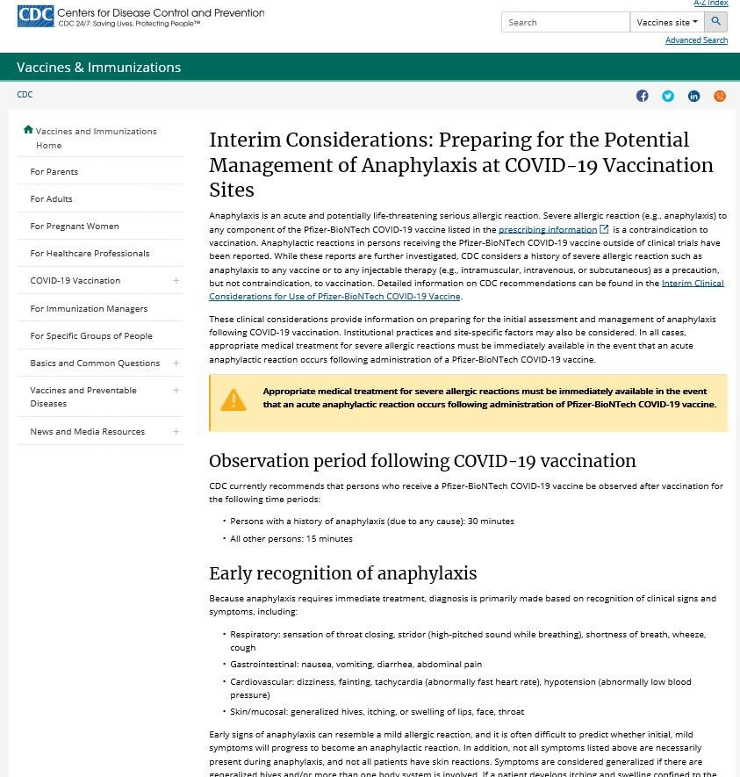
Interim considerations: preparing for the potential management of anaphylaxis at COVID-19 vaccination sites

- Information for sites on:
–Early recognition of anaphylaxis
–Medications and supplies
–Management of anaphylaxis at the vaccination site
–Recommendation for immediate activation of emergency medical services and transportation to higher level medical care
–Patient counseling
–Reporting of anaphylaxis

CDC COCA Call, 12/18/2020, COVID-19What Clinicians Need to Know About the Pfizer-BioNTech and Moderna COVID-19 Vaccines https://www.cdc.gov/vaccines/covid-19/info-by-product/pfizer/anaphylaxis-management.html

Recommended medications and supplies for the management of anaphylaxis at COVID-19 vaccination sties

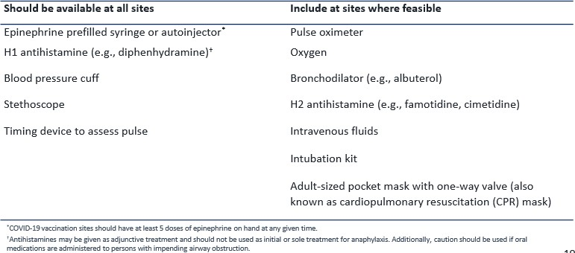
CDC COCA Call, 12/18/2020, COVID-19 What Clinicians Need to Know About the Pfizer-BioNTech and Moderna COVID-19 Vaccines

Managing Acute Vaccine Reactions
Massachusetts Department of Public Health mass.gov/dph
65

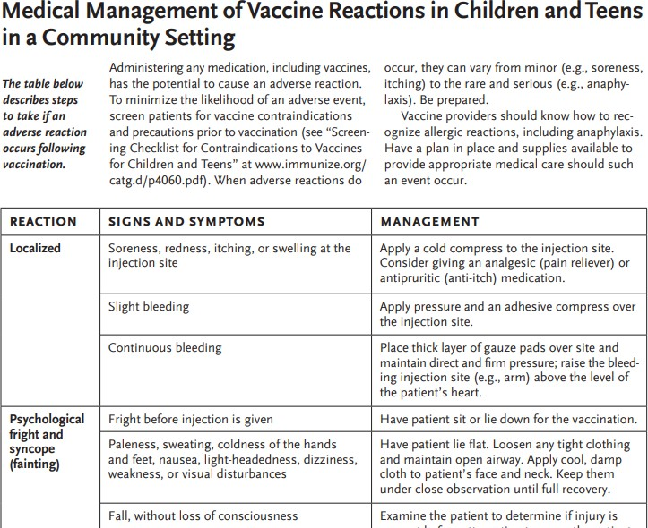
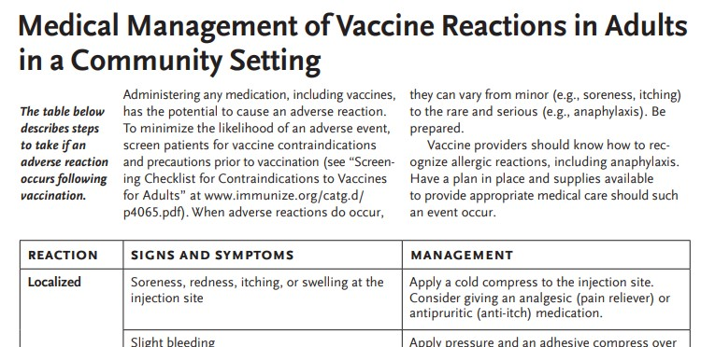
- Severe reactions are rare
- Screening can help prevent reactions
- Staff should be familiar with signs and symptoms of hypersensitivity/anaphylaxis
- There must be a clinic emergency plan for dealing with reactions and you need to ensure that all staff are familiar with that plan.

- Have Emergency Treatment Standing Orders signed before the clinic

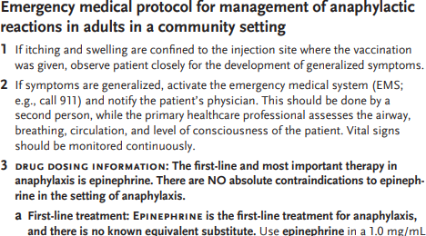
- Staff must have had appropriate training and equipment to manage
reactions

- All vaccination providers should be currently certified in CPR

https://www.immunize.org/catg.d/p3082a.pdf https://www.immunize.org/catg.d/p3082.pdf https://www.cdc.gov/vaccines/pubs/pinkbook/vac-admin.html https://www.cdc.gov/vaccines/hcp/acip-recs/general-recs/adverse-reactions.html

- Vaccine providers should observe patients after vaccination to monitor for the occurrence of immediate adverse reactions:
Persons with a precaution to

vaccination or a history of anaphylaxis
(due to any cause)
All other persons

Observation Period Following Vaccination

30 minutes
15 minutes
CDC COCA Call, 12/30/2020, COVID-19
Vaccines: Update on Allergic Reactions, Contraindications, and Precautions: Tom Shimabukuro, MD, MPH, MBA and Sarah Mbaeyi, MD, MPH

Early recognition of anaphylaxis symptoms
Prompt treatment with epinephrine
Activation of emergency medical services

Key messages
Preparing for the potential management of anaphylaxis at COVID-19 vaccination sites

https://www.cdc.gov/vaccines/covid-19/info-by-product/pfizer/anaphylaxis-management.html
CDC Partner Update Call, 12/21/2020, COVID-19 Vaccine Implementation. Nancy Messonnier MD and Sarah Mbaeyi, MD

VACCINE SAFETY

Vaccine Adverse Event Reporting System (VAERS)
Massachusetts Department of Public Health mass.gov/dph
69

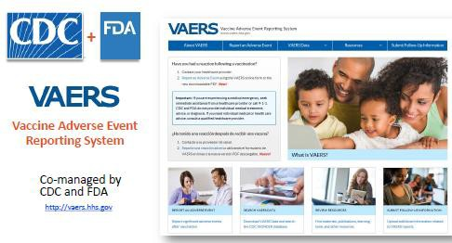
- Jointly administered by the CDC & FDA
- Receives ~40,000 reports per year
- National reporting system
- Passive; depends on health care providers and others to report
- Detects:
  - New or rare events
  - Increases in rates of known events after immunization
  - Patient risk factors associated with higher rates of adverse reactions
  - “Signals”, possible adverse reactions that may warrant further study
- VAERS cannot establish causality, additional studies would be needed

https://www.cdc.gov/vaccinesafety/ensuringsafety/monitoring/vaers/index.html https://vaers.hhs.gov/about.html

VAERS Reporting
Massachusetts Department of Public Health mass.gov/dph
70
  - Providers are required by law to report to VAERS:
    - Any adverse event listed on the VAERS Table of Reportable Events Following
Vaccination
    - Any adverse event listed by the vaccine manufacturer as a contraindication to further doses
  - Providers are encouraged to report:
    - Any adverse event following the administration of a vaccine, whether or not it is clear the vaccine caused the event
    - Vaccine administration errors
  - Manufacturers are required to report:
    - All adverse events that come to their attention

https://vaers.hhs.gov/resources/infoproviders.html https://vaers.hhs.gov/reportevent.html

COVID-19 Adverse Event (AE) Reporting

COVID-19 vaccination providers are required to report the
following to VAERS:

- vaccine administration errors whether or not associated with an adverse event
- serious adverse events* (irrespective of attribution to vaccination)
- cases of Multisystem Inflammatory Syndrome (MIS) in adults
- cases of COVID-19 that result in hospitalization or death.

https://www.fda.gov/media/144637/download

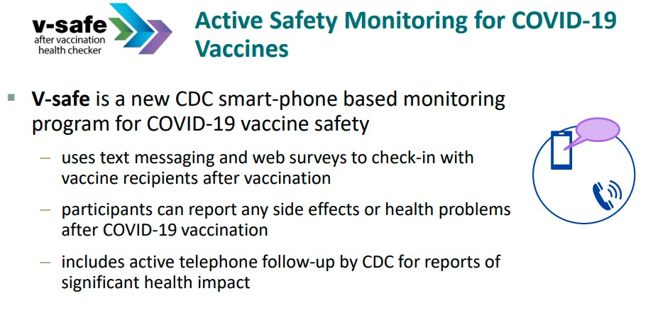

Slide courtesy of CDC’s Partner Call: COVID-19 Vaccine Distribution and Safety Overview (11/9/2020)

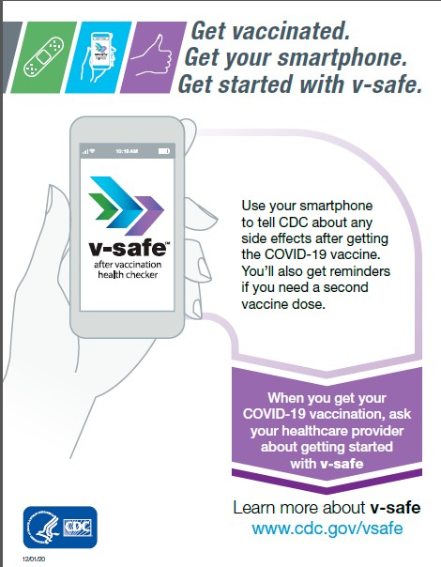
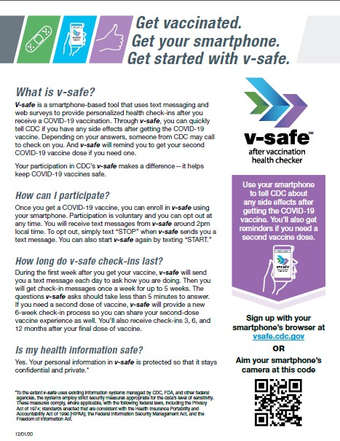

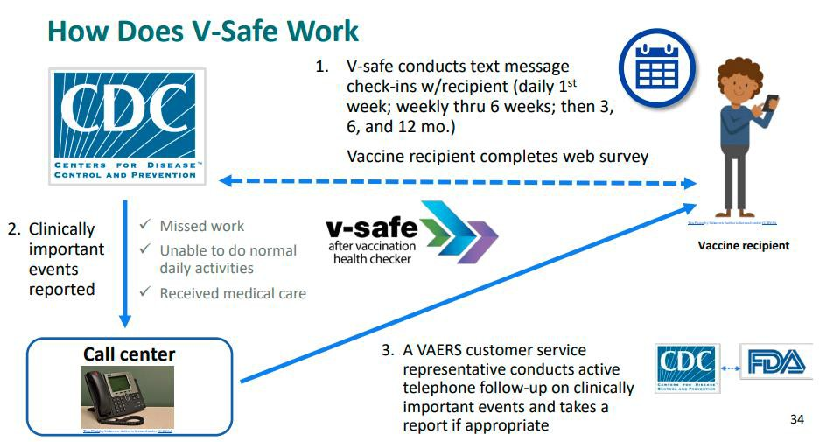

Slide courtesy of CDC’s Partner Call: COVID-19 Vaccine Distribution and Safety Overview (11/9/2020)

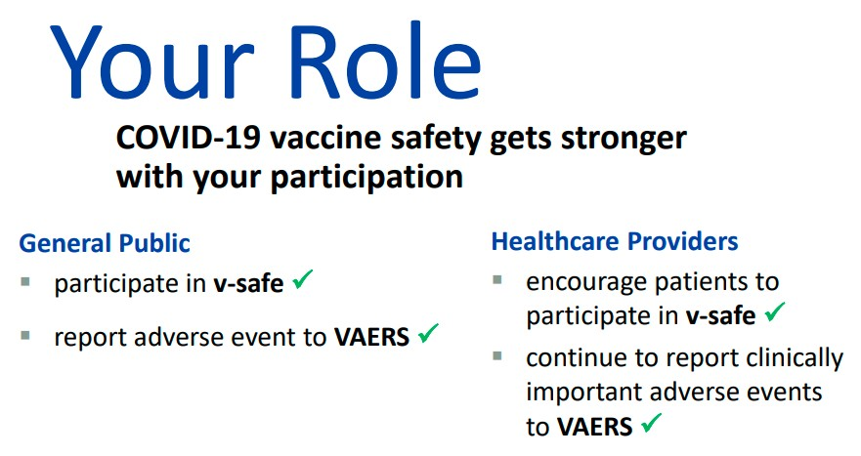

Slide courtesy of CDC’s Partner Call: COVID-19 Vaccine Distribution and Safety Overview (11/9/2020)

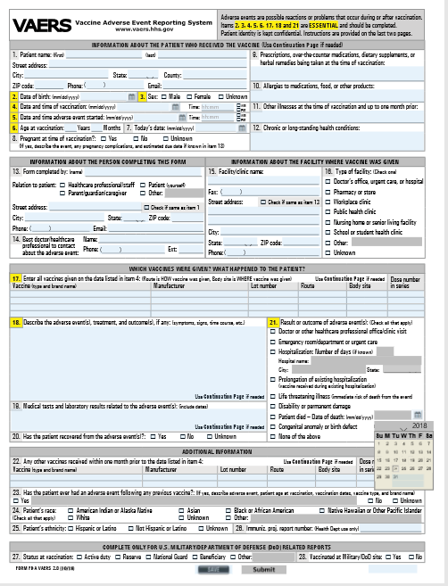
How to report an adverse event to VAERS
  - Go to vaers.hhs.gov and submit a report online
  - For help: call 1-800-822-7967, email info@VAERS.org
  - Video instructions https://www.youtube.com/watch?v=sbCWhcQADFE

How to contact CDC at CDC-INFO
  - Go to https://www.cdc.gov/cdc-info/index.html
  - Call 1-800-CDC-INFO (800-232-4636)

Safety information resources
    - https://www.cdc.gov/vaccinesafety/ensuringsafety/monitoring/vaers/index.html
    - https://www.cdc.gov/coronavirus/2019-ncov/vaccines/safety.html

76

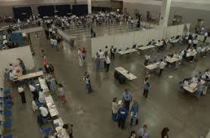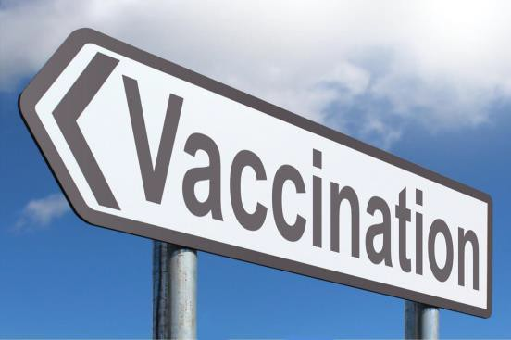

VACCINATING DURING THE COVID-19 PANDEMIC

Images retrieved from cdc.gov and https://3.files.edl.io/020d/18/12/13/172504- 0af4d430-18ed-4db8-96dd-63e408c9e9d2.jpg

Infection Control

- Wash hands or use alcohol-based hand sanitizer before vaccine preparation and between patients
- Gloves are not required unless the person administering the vaccine is likely to come in contact with potentially infectious body fluids or has open lesions on their hands.
- If gloves are worn, they should be changed between patients
- Perform hand hygiene between patients, even if wearing gloves
- Gloves cannot prevent needle stick injuries
- Have a needle stick policy

https://www.cdc.gov/handhygiene/index.html

Implement Enhanced Infection Control Measures

Refer to CDC guidance to prevent the spread of COVID-19 in health care settings , including outpatient and ambulatory care settings.

- Screen patients for COVID-19 symptoms before and during the visit.
- Physical distance (at least 6 feet apart, where possible)
- Limit and monitor facility points of entry and install barriers to limit physical contact with patients at triage.
- Respiratory hygiene (facemasks for staff and face coverings for patients over 2 years of age, if tolerated) and cough etiquette
- Hand hygiene (including at least 60% alcohol hand sanitizer for patients)
- Enhanced surface decontamination

https://www.cdc.gov/coronavirus/2019-ncov/hcp/infection-control-recommendations.html https://www.cdc.gov/coronavirus/2019-ncov/hcp/infection-control.html

Face mask Eye protection
Gloves

  - Recommended: All health care providers
(N95 masks not recommended)
- Recommended: Areas of moderate/substantial community transmission
- Optional: Areas of minimal/no community transmission
- Recommended: intranasal or oral vaccines
- Optional: intramuscular or subcutaneous vaccines

Use Personal Protection Equipment (PPE)
Gloves are not required unless the person administering the vaccine is likely to come in contact with potentially infectious body fluids or has open lesions on their hands.
- If gloves are worn, they should be changed between patients
- Perform hand hygiene between
patients, even if wearing gloves

Image credit: Pan American Health Organization

Guidance for Planning Vaccination Clinics Held at Satellite, Temporary, or Off-Site Locations

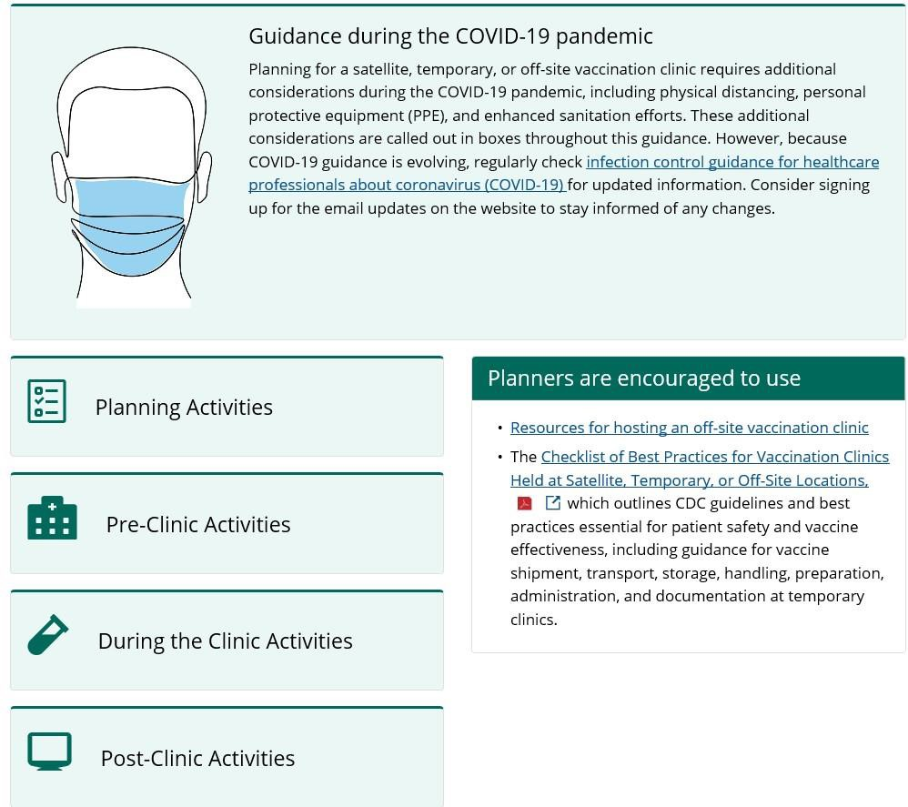
- To assist with planning and implementation of satellite, temporary, or off-site vaccination clinics. The guidance provides information on additional considerations that are required during the COVID-19 pandemic, including physical distancing, PPE, and enhanced sanitation efforts.

- The guidance is broken down into four categories:
  - Planning activities
  - Pre-clinic activities
  - During the clinic activities
  - Post-clinic activities

https://www.cdc.gov/vaccines/hcp/admin/mass-clinic-activities/index.html

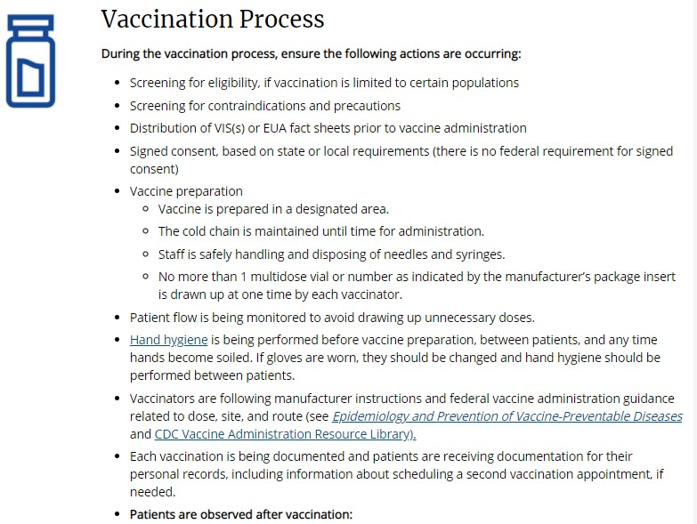

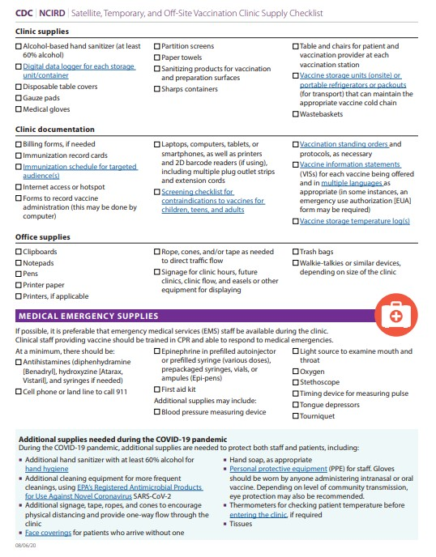
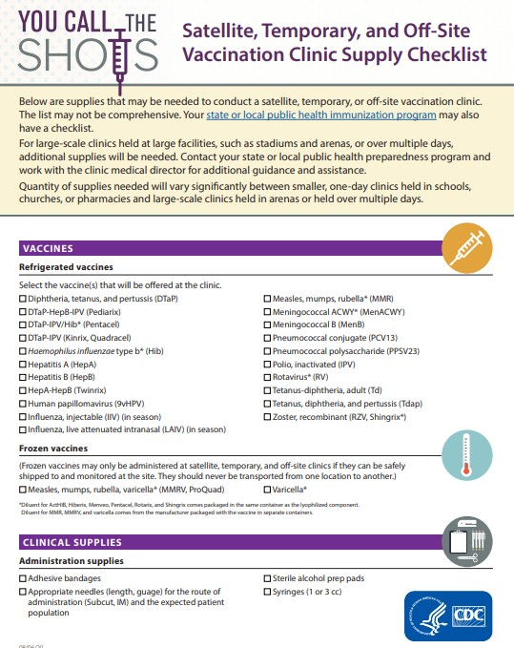

https://www.cdc.gov/vaccines/hcp/admin/mass-clinic-activities/vaccination-clinic-supply-checklist.html

RESOURCES

HEALTHCARE PROVIDERS/PUBLIC HEALTH:
CDC COVID-19 Vaccine Resources
COVID-19 Vaccination Clinical Resources https://www.cdc.gov/vaccines/covid-19/index.html
COVID-19 Product Info – by US Vaccine https://www.cdc.gov/vaccines/covid-19/info-by-product/index.html
Clinical Considerations
https://www.cdc.gov/vaccines/covid-19/clinical-considerations/index.html Training and Education
https://www.cdc.gov/vaccines/covid-19/training.html
Talking to Recipients about COVID-19 Vaccines https://www.cdc.gov/vaccines/covid-19/hcp/index.html
Understanding and Explaining mRNA COVID-19 Vaccines https://www.cdc.gov/vaccines/covid-19/hcp/mrna-vaccine-basics.html
Making a Strong Recommendation for COVID Vaccination https://www.cdc.gov/vaccines/covid-19/hcp/engaging-patients.html
Answering Patients’ Questions
https://www.cdc.gov/vaccines/covid-19/hcp/answering-questions.html
Frequently Asked Questions about COVID-19Vaccination
https://www.cdc.gov/coronavirus/2019-ncov/vaccines/faq.html COVID-19 Vaccination
https://www.cdc.gov/coronavirus/2019-ncov/hcp/vaccination.html
COVID-19 Vaccination Communication Toolkit For Medical Centers, Clinics, and Clinicians
https://www.cdc.gov/vaccines/covid-19/health-systems-communication- toolkit.html

ACIP
Main page https://www.cdc.gov/vaccines/acip/index.html
COVID-19 Recommendations
https://www.cdc.gov/vaccines/hcp/acip-recs/vacc-specific/covid-19.html
MMWR. The Advisory Committee on Immunization Practices’ Interim Recommendation
for Use of Moderna COVID-19 Vaccine— United States, December 2020
https://www.cdc.gov/mmwr/volumes/69/wr/pdfs/mm695152e1-H.pdf MMWR. The Advisory Committee on Immunization Practices’ Interim
Recommendation for Use of Pfizer-BioNTech COVID-19 Vaccine — United States,
December 2020 https://www.cdc.gov/mmwr/volumes/69/wr/pdfs/mm6950e2-H.pdf
MMWR. The Advisory Committee on Immunization Practices’ Updated Interim Recommendation for Allocation of COVID-19 Vaccine — United States, December 2020 https://www.cdc.gov/mmwr/volumes/69/wr/pdfs/mm695152e2-H.pdf

VACCINE SAFETY:
COVID-19 Vaccine Resources
Ensuring the Safety of COVID-19 Vaccines in the United States https://www.cdc.gov/coronavirus/2019-ncov/vaccines/safety.html

- Safe After Vaccination Health Checker:
https://www.cdc.gov/coronavirus/2019-ncov/vaccines/safety/vsafe.html

FAQ’s About V-Safe:
https://www.cdc.gov/coronavirus/2019-ncov/vaccines/safety/faq.html

VACCINE STORAGE & HANDLING TOOLKIT
with Covid-19 Vaccine Addendum
https://www.cdc.gov/vaccines/hcp/admin/storage/toolkit/index.html

GENERAL PUBLIC
COVID-19 Vaccine information https://www.cdc.gov/coronavirus/2019- ncov/vaccines/index.html
  - Frequently Asked Questions
  - Facts About COVID-19 Vaccines
  - Benefits of Getting a COVID-19 Vaccine
  - Ensuring Safety of COVID-19 Vaccines
  - Ensuring COVID-19 Vaccines Work
  - How CDC is Making COVID-19 Vaccine Recommendations
  - How COVID-19 Vaccines Work
  - Understanding and Explaining mRNA Vaccines
TRAINING & RESOURCES:
COVID-19 Training and Education for Healthcare Professionals
https://www.cdc.gov/vaccines/covid-19/training.html

COVID-19 Vaccine Training Module for Health Care Providers https://www2.cdc.gov/vaccines/ed/covid19/

COVID-19 Vaccination Training Programs and Reference Materials for Healthcare Professionals https://www.cdc.gov/vaccines/covid-19/downloads/COVID-19-Clinical-Training-and-Resources- for-HCPs.pdf
  - Vaccine Storage and Handling
  - Vaccine Administration
  - Communicating with Patients about Vaccines
  - COVID-19 Vaccine Training and Clinical Materials

COCA Calls/Webinars:
https://emergency.cdc.gov/coca/calls/index.asp
- 12/30/2020: COVID-19 Vaccines: Update on Allergic Reactions, Contraindications, & Precautions
- 12/18/2020: What Clinicians Need to Know About the Pfizer-BioNTech and Moderna COVID-19 Vaccines
- 12/14/2020: What Every Clinician Should Know about COVID-19 Vaccine Safety

CDC Partner Calls/Webinars:
https://www.cdc.gov/coronavirus/2019-ncov/communication/videos-webinars- calls.html?Sort=Date%3A%3Adesc
- 12/17/2020: Ten Truths about COVID-19

MODERNA
Moderna COVID-19 Vaccine Resources
Moderna Call Center: 1-866-MODERNA (1-866-663-3762)
Moderna COVID-19 Vaccine Website: https://www.modernatx.com/covid19vaccine-eua/
Moderna COVID-19 Vaccine EUA Website (EUA’s and exp date look-up): https://www.modernatx.com/covid19vaccine-eua/providers/ Moderna COVID-19 Vaccine EUA for Providers: https://www.modernatx.com/covid19vaccine-eua/eua-fact-sheet- providers.pdf
Moderna COVID-19 Vaccine EUA for Recipients: https://www.modernatx.com/covid19vaccine-eua/eua-fact-sheet- recipients.pdf
US FDA
EUA Guidance:
https://www.fda.gov/emergency-preparedness-and-response/mcm-legal- regulatory-and-policy-framework/emergency-use-authorization#covid19euas Moderna COVID-19 Vaccine: https://www.fda.gov/emergency-preparedness- and-response/coronavirus-disease-2019-covid-19/moderna-covid-19- vaccine#additional
EUA Letter, December 18, 2020 https://www.fda.gov/media/144636/download MODERNA EUA Factsheet for Providers: https://www.fda.gov/media/144637/download MODERNA EUA Factsheet for Caregivers: https://www.fda.gov/media/144638/download
CDC
COVID-19 Vaccination https://www.cdc.gov/vaccines/covid-19/index.html
Moderna COVID-19 Vaccine (general info, how to administer instructions, links to FAQs, EUAs, interim clinical considerations, storage and handling resources, screening form): https://www.cdc.gov/vaccines/covid-19/info-by-product/moderna/index.html
Interim Considerations: Preparing for the Potential Management of Anaphylaxis at COVID-19 Vaccination Sites https://www.cdc.gov/vaccines/covid-19/info-by- product/pfizer/anaphylaxis-management.html
COVID-19 Vaccine Prevaccination Screening Form
https://www.cdc.gov/vaccines/covid-19/downloads/pre-vaccination-screening-form.pdf
Moderna COVID-19 Vaccine Standing Order:
https://www.cdc.gov/vaccines/covid-19/info-by-product/moderna/downloads/standing- orders.pdf
Moderna COVID-19 Vaccine Preparation and Administration Summary Sheet: https://www.cdc.gov/vaccines/covid-19/info-by-product/moderna/downloads/prep-and- admin-summary.pdf
Moderna COVID-19 Vaccine Storage and Handling Summary: https://www.cdc.gov/vaccines/covid-19/info-by-product/moderna/downloads/storage- summary.pdf
COVID-19 Vaccine Expiration Date Tracking Tool
https://www.cdc.gov/vaccines/covid-19/info-by-product/pfizer/downloads/expiration- tracker.pdf

PFIZER BIONTECH
Pfizer-BioNTech COVID-19 Vaccine Resources
Pfizer Customer Service: 1-800-TRY-FIRST (1-800-879-3477) Pfizer-BioNTech COVID-19 Vaccine Website: https://www.cvdvaccine.com/
Pfizer BioNTech COVID-19 Vaccine EUA for Providers: http://labeling.pfizer.com/ShowLabeling.aspx?id=14471 Pfizer BioNTech COVID-19 Vaccine EUA for Recipients: http://labeling.pfizer.com/ShowLabeling.aspx?id=14472

US FDA
EUA Guidance:
https://www.fda.gov/emergency-preparedness-and-response/mcm- legal-regulatory-and-policy-framework/emergency-use- authorization#covid19euas
Pfizer-BioNTech COVID-19 Vaccine: https://www.fda.gov/emergency-preparedness-and- response/coronavirus-disease-2019-covid-19/pfizer-biontech-covid- 19-vaccine
EUA Letter, Dec 11, 2020: https://www.fda.gov/media/144412/download PFIZER-BIONTECH EUA Factsheet for Providers: https://www.fda.gov/media/144413/download PFIZER-BIONTECH EUA Factsheet for Recipients: https://www.fda.gov/media/144414/download
CDC
COVID-19 Vaccination https://www.cdc.gov/vaccines/covid-19/index.html
Pfizer-BioNTech COVID-19 Vaccine (general info, screening form, standing orders, vaccine prep and administration summary, mixing diluent, and more) https://www.cdc.gov/vaccines/covid-19/info-by-product/pfizer/index.html
Interim Considerations: Preparing for the Potential Management of Anaphylaxis at COVID-19 Vaccination Sites https://www.cdc.gov/vaccines/covid-19/info-by- product/pfizer/anaphylaxis-management.html
COVID-19 Vaccine Prevaccination Screening Form https://www.cdc.gov/vaccines/covid-19/downloads/pre-vaccination-screening- form.pdf
Pfizer-BioNtech COVID-19 Vaccine Standing Order https://www.cdc.gov/vaccines/covid-19/info-by- product/pfizer/downloads/standing-orders.pdf
Pfizer-BioNTech COVID-19 Vaccine Preparation and Administration Summary Sheet https://www.cdc.gov/vaccines/covid-19/info-by-product/pfizer/downloads/prep- and-admin-summary.pdf
Pfizer-BioNTech COVID-19 Vaccine Storage and Handling Summary: https://www.cdc.gov/vaccines/covid-19/info-by- product/pfizer/downloads/storage-summary.pdf
Diluent poster
https://www.cdc.gov/vaccines/covid-19/info-by-product/pfizer/downloads/diluent- poster.pdf

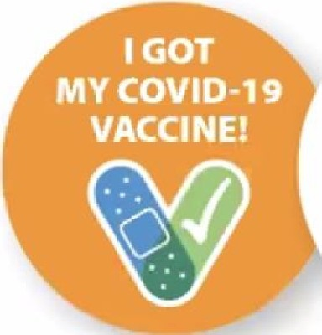
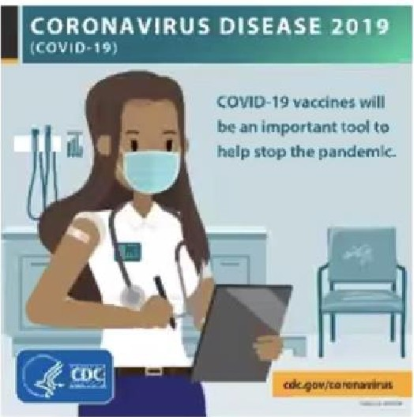
COVID-19 vaccine communication resources

  - Engaging in Effective COVID-19 Vaccine Conversations
- https://www.cdc.gov/vaccines/covid-
19/hcp/engaging-patients.htm
  - Toolkit for Medical Centers, Clinics, and Clinicians
- https://www.cdc.gov/vaccines/covid-19/health­
systems-communication-toolkit.html

  - More toolkits coming soon Long-term care facilities Health departments
Community-based organizations
Employers of essential workers

I GOT
MYCOVID-19 VACCINE!

:
Getting 'Back to Normal'
ls Going to Take All of Our Tools
If we use all the tools we have. we stand the best chance of getting our families, communities, school and workplaces “back to normal" sooner:
•
Get vaccinated.
Wear masks kmask.
.
S1ay 6 feet from others, Wash
and avoid crowds. hands often.

www.cdc.gOY/ c oronav,rus/vaccines
COVI D-19 vaccine Basics:
What Healthcare Personnel Need to Know
Prfttnt:M6on ff'l'tiopt,d"by: CDCCOVID-19itelponw
YM:dM THII Forni DK,:,nba.f2Ctt0
Vaccinatcwrth Confidence

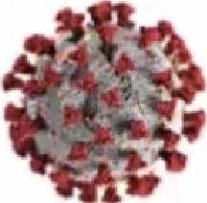
89

CDC Vaccine Administration Resources

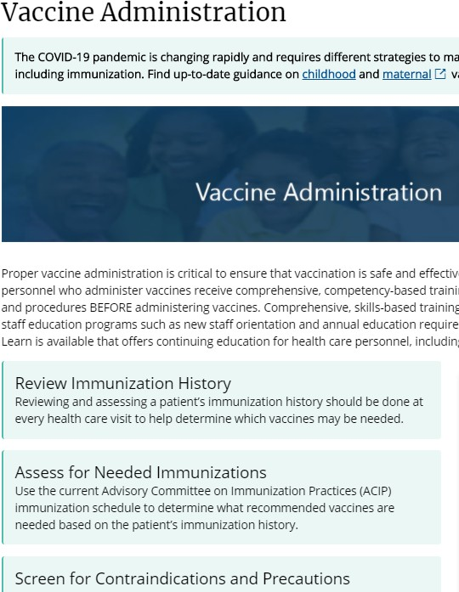
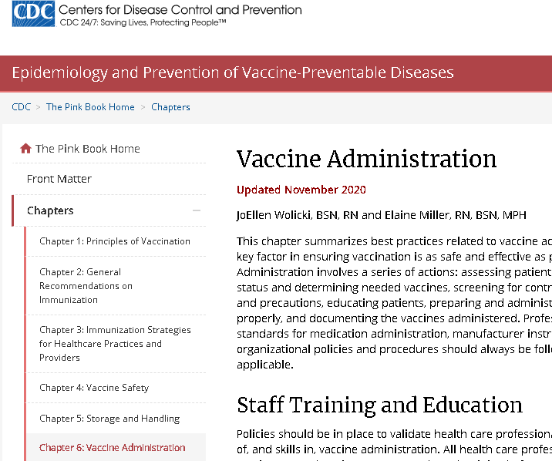
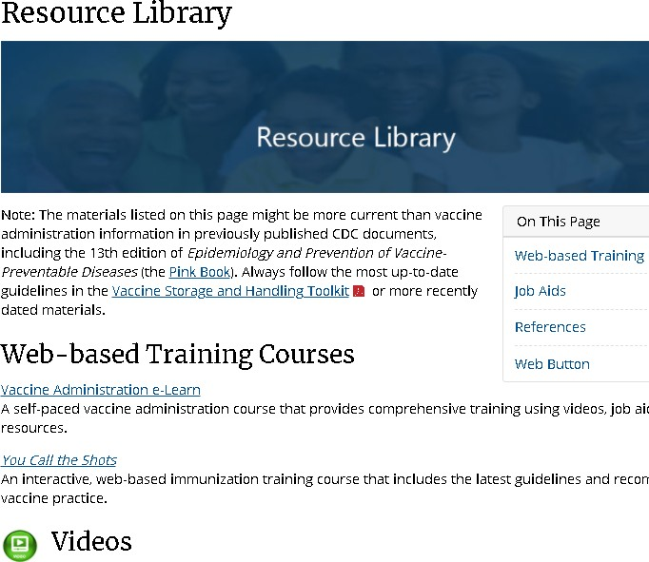

https://www.cdc.gov/vaccin es/hcp/admin/admin- protocols.html
https://www.cdc.gov/vaccines/
pubs/pinkbook/vac-admin.html
https://www.cdc.gov/vaccine s/hcp/admin/resource- library.html

Massachusetts Department of Public Health mass.gov/dph
90

Clinical Resources for Proper Vaccine Administration
Massachusetts Department of Public Health mass.gov/dph
91

- CDC Vaccine administration & Resource Library webpages-- information and materials for health care personnel including:
  - IM demonstration video
  - Job aids and infographics www.cdc.gov/vaccines/hcp/admin/admin-protocols.html

https://www.cdc.gov/vaccines/hcp/admin/resource-library.html

- CDC Vaccine Admin E-Learn module:
https://www2.cdc.gov/vaccines/ed/vaxadmin/va/ce.asp

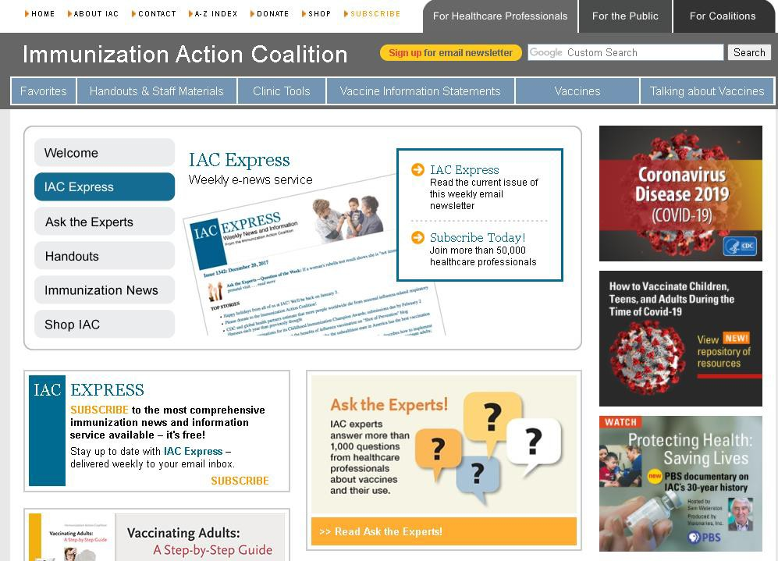
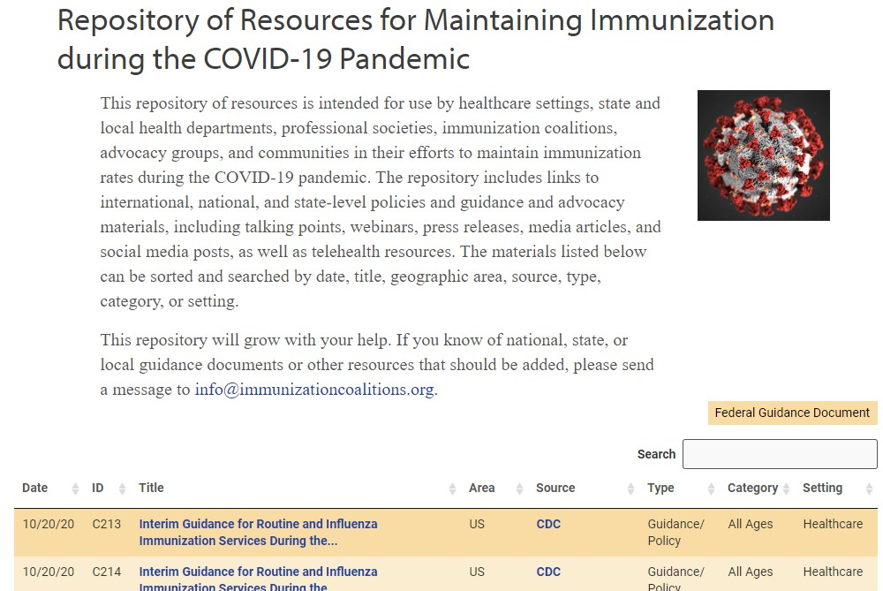

https://www.immunizationcoalitions.org/
resource-repository/

https://immunize.org/

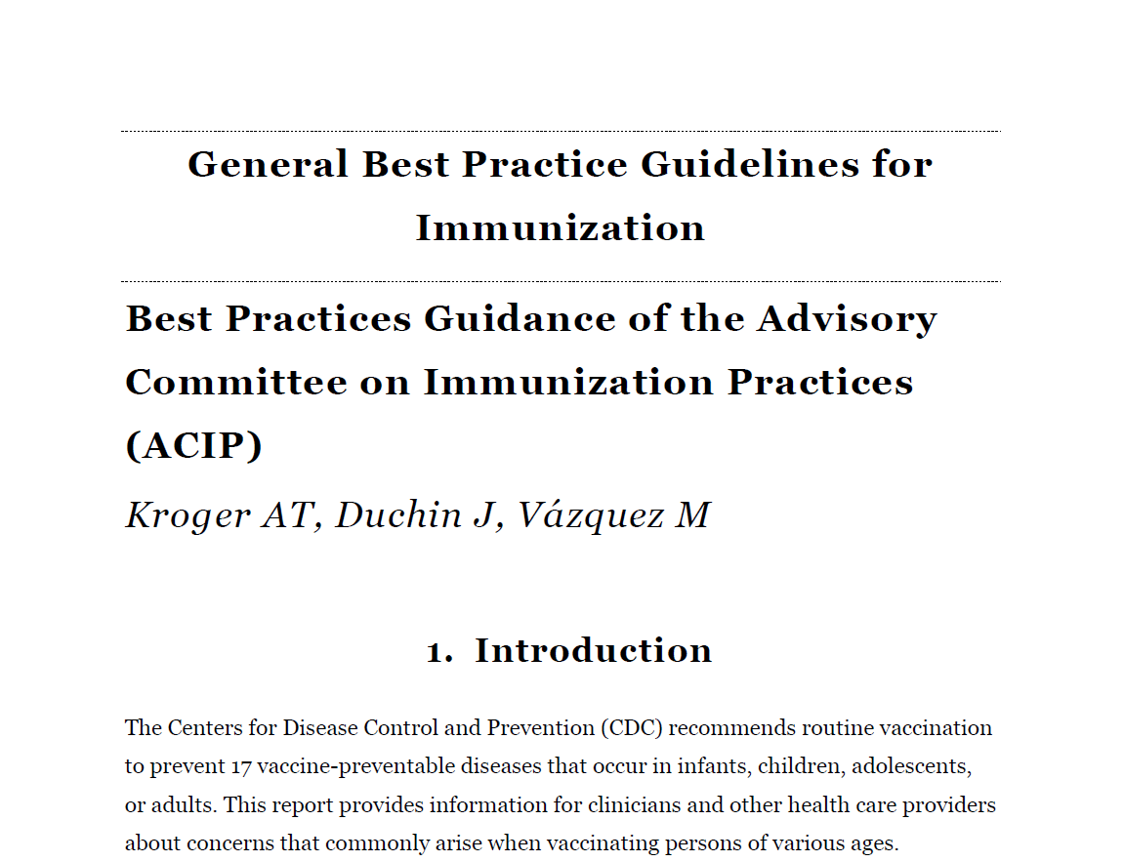
ACIP Best Practice Guidelines for Immunization

  - Describes the ACIPs recommendations and guidelines on vaccination practice

  - Updated as needed online

https://www.cdc.gov/vaccines/hcp/acip-recs/general-recs/index.html

Vaccination Clinic Planning Resources

- CDC Vaccination Guidance During a Pandemic: https://www.cdc.gov/vaccines/pandemic- guidance/index.html
- CDC Guidance for Planning for Vaccination Clinics Held at Satellite, Temporary or Off-Site Locations:
https://www.cdc.gov/vaccines/hcp/admin/mass-clinic-activities/index.html
- CDC Considerations for Planning Curbside/Drive-Through Vaccination Clinics: https://www.cdc.gov/vaccines/hcp/admin/mass-clinic-activities/curbside-vaccination-clinics.html
- CDC Resources for Hosting a Vaccination Clinic (including a Best Practices Checklist): https://www.cdc.gov/flu/business/hosting-vaccination-clinic.htm
- CDC Clinic Supplies Check List:
https://www.cdc.gov/vaccines/hcp/admin/mass-clinic-activities/vaccination-clinic-supply-checklist.html https://www.cdc.gov/vaccines/hcp/admin/downloads/2020-vaccine-clinic-supply-checklist-508.pdf
- CDC Infection Control Guidance: https://www.cdc.gov/coronavirus/2019-ncov/hcp/infection-control.html
https://www.cdc.gov/coronavirus/2019-ncov/hcp/infection-control-recommendations.html
- IAC Protective Measures for Vaccinating During a Pandemic: https://www.immunize.org/catg.d/p2009.pdf
- IAC COVID Repository of Resources for Maintaining Immunizations during the COVID-19 Pandemic: https://www.immunizationcoalitions.org/resource-repository/

MDPH Immunization Division Contact Information

Immunization Division Main Number
For questions about immunization recommendations, disease reporting, etc.
Phone: 617-983-6800 (24/7 MDPH Epidemiology line)
Fax: 617-983-6840
Website: https://www.mass.gov/topics/immunization

MIIS Help Desk
Phone: 617-983-4335
Fax: 617-983-4301
Email: miishelpdesk@state.ma.us
Website: https://www.mass.gov/service-details/massachusetts-immunization-
information-system-miis

MDPH Vaccine Unit
Phone: 617-983-6828
Fax: 617-983-6924
Website: https://www.mass.gov/service-details/vaccine-management

Connect with DPH
Massachusetts Department of Public Health mass.gov/dph
96

@MassDPH
Massachusetts Department of Public Health DPH blog
https://blog.mass.gov/publichealth

www.mass.gov/dph

Thank You For Being a COVID-19 Vaccinator !

