Cranberry Peachy Pops

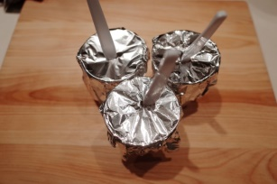
Ingredients
- 2 peaches (about 2 cups chopped)
- ½ cup plain yogurt
- 2 cups cranberry juice
- 8 5-oz. paper cups
- 8 plastic spoons or popsicle sticks
- Aluminum foil
Directions
- Wash and chop peaches. Divide among the 8 paper cups.
- Measure yogurt and place in a medium bowl.
- Slowly pour orange juice into the yogurt, stirring until blended.
- Evenly pour the juice/yogurt mixture over the peaches in the cups.
- Cut squares of aluminum foil to cover the tops of the cups, piercing each with the spoon handle. The foil should hold the handle in place.
- Freeze for at least four hours before serving.
- To eat, peel away paper cups from pops.

Serves: 8 ● Serving Size: 1 pop ● Prep Time: 10 minutes ● Freeze Time: 4 hours

Nutrition Facts Per Serving: 56 calories, 0 g Fat, 14 g Carbohydrate, 1 g Protein, 11 mg Sodium

Supplies
- Measuring cups
- Cutting board
- Knife
- Liquid measuring cup
- Medium bowl
- 8 (5-ounce) paper cups
- 8 spoons
- Aluminum foil
Chef Tips
- Substitute seasonal flavors:
  - Fall: apple cider, yogurt, chopped apples, and cinnamon
  - Winter: cranberry juice, yogurt, and clementine slices
  - Spring: white grape juice, yogurt, and strawberries
- Use your favorite WIC juice instead
- Use vanilla yogurt if you don’t have plain

- Use vanilla yogurt if you don’t have plain

