Massachusetts Department of Public Health

Division of Prevention and Wellness

Creating a Culture of Health: Organizational Approaches to Promoting and Protecting Employee Health

Results from the 2008 Massachusetts Worksite Health Improvement Survey

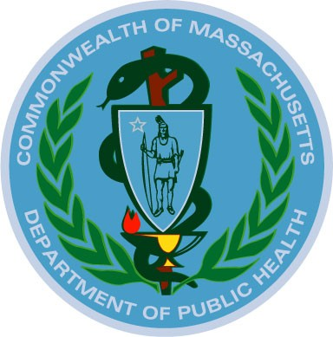

Deval L. Patrick, Governor
Timothy P. Murray, Lieutenant Governor
JudyAnn Bigby, MD, Secretary of Health and Human Services
John Auerbach, Commissioner, Department of Public Health

July 2009

Acknowledgements

The staff that prepared this report:

Lisa Erck, MS, Coordinator of Worksite Initiatives
Hilary K. Wall, MPH, Senior Epidemiologist
Letitia Davis, ScD, EdM, Director, Occupational Health Surveillance Program
Katrina D’Amore, MPH, Epidemiologist

Special thanks to Suzanne Nobrega and other colleagues at the Center for the Promotion of Health in the New England Workplace (CPH-NEW) at the University of Massachusetts Lowell who offered invaluable expertise and guidance to the 2008 Massachusetts Worksite Health Improvement Survey.

We wish to express our gratitude to the worksites of MA who participated in this survey, and to Ulrich Research, Inc. for survey implementation, data entry, and data analysis. We also wish to acknowledge the contributions of the staff of the many programs within the MA Department of Public Health who provided topical overviews and reviewed draft sections of this report relevant to their areas of expertise. Thanks also to Gregory Wagner, National Institute for Occupational Safety and Health (NIOSH), Glorian Sorenson, Harvard School of Public Health, and Beth Rosenberg, Tufts University School of Medicine, for their input in designing the survey.

Table of Contents

Introduction | 5
A Tool For You | 8
How You Can Help | 8
Worksite Health Improvement Survey Results and Suggestions for Taking Action | 8
Making Wellness an Organizational Priority | 8
Health Services and Education | 11
Nutrition and Healthy Eating | 13
Physical Activity Opportunities | 14
Stress Management | 15
Tobacco, Alcohol, and Drugs | 18
Occupational Safety and Health | 20
Emergency Response | 25
Glossary | 27
References | 29
Appendix A | 30
Appendix B | 32

Tables and Figures

Table | Title | Page
Table 1 | Distribution of responding worksites by industry sector and size with statewide comparison | 6
Table 2 | Percent of worksites that offer nutrition information by worksite size | 13
Figure 1 | Percent of worksites with an annual health promotion budget by worksite size | 9
Figure 2 | Common factors used to calculate a worksite health return on investment | 10
Figure 3 | Percent of worksites with preventive services covered by insurance by North American Industry Classification System code | 12
Figure 4 | Type of preventive services included in MA worksite insurance benefits | 12
Figure 5 | Type of stress reduction policies in MA worksites | 16
Figure 6 | Ways in which worksites support new parents | 17
Figure 7 | Places where smoking is permitted during work hours | 17
Figure 8 | Percent of worksites with policies governing employee smoking during the workday by North American Industry Classification System code | 20
Figure 9 | Type of assistance offered to help employees quit smoking | 20
Figure 10 | Percent of worksites with a worksite committee for health and safety hazards by worksite size | 22
Figure 11 | Percent of worksites with policies or procedures for reporting work-related injuries by North American Industry Classification System code | 22
Figure 12 | Percent of worksites reporting audit conduction to identify health and safety hazards by North American Industry Classification System code | 23
Figure 13 | Percent of worksites that maintain a log of illnesses and injuries by worksite size | 23
Figure 14 | Percent of worksites where managers analyze claims and injury data to plan workplace health and safety activities by worksite size | 24
Figure 15 | Percent of worksites with a written seatbelt policy by worksite size | 24
Figure 16 | Percent of worksites with at least one Automated External Defibrillator by worksite size | 26

Introduction

The majority of adults spend a significant amount of their waking hours at work. Thus the impact of worksite wellness programs on adults and their families can be significant considering that 66% of Massachusetts adults, or 3,122,010 people, are in the workforce. [1] Physical activity, healthy eating, managing stress, and avoiding tobacco are essential in lowering the risk of developing chronic diseases such as obesity, type 2 diabetes, heart disease, cancer, and stroke. Promoting a culture of health at the worksite provides opportunities for employees to change their behaviors. Once largely stand-alone enhancements, worksite wellness initiatives should be fully integrated within workplaces.

In 2006 Massachusetts became the first state in the country to accomplish near-universal access to affordable healthcare by passing Chapter 58 of the Acts of 2006, entitled An Act Providing Access to Affordable, Quality, Accountable Health Care. This legislation put much of the burden of insurance on employers. To help alleviate this burden, worksite wellness programs, in coordination with health and safety initiatives, work-life initiatives, supportive environments, and health benefit design programs, are providing more effective ways to deliver information about how to improve health and well-being. In building a comprehensive worksite wellness program, it is essential to address occupational health and safety hazards as well as risk factor prevention to create a worksite environment that is healthier for employees and enables them to more easily engage in healthy behaviors.

2008 Massachusetts Worksite Health Improvement Survey

In April 2008, the Massachusetts Department of Public Health (MDPH) surveyed a random sample of 3,000 worksites with 11 or more employees to assess their practices with regard to promoting and protecting employee health and well-being within their organizations. Eleven was chosen as the cut-off point to be in alignment with the Massachusetts Health Care Reform Act of 2006. The businesses were mailed a paper copy of the survey and respondents were given the option to complete the survey on-line. Follow-up phone calls were made as necessary to ensure adequate sample sizes. Just under 30% of the businesses (890) responded (Table 1), providing a comprehensive picture of how well the Commonwealth’s businesses support health-promoting behaviors. Appendix A contains detailed data on respondents.

The survey’s major findings indicate that employers are doing many things right: prohibiting the sale of tobacco products at the worksite, providing employees with on-site refrigerators and microwaves, implementing policies to support new parents, and implementing the legal requirement to report work-related injuries. The survey results also suggest many ways that worksites can become healthier such as providing on-site access to healthy foods with point-of-purchase information, offering preventive screenings and Health Risk Assessments, and coordinating between health and safety and worksite health promotion.

Table 1. Industry sector and business size with statewide comparison of responding worksites

 | 2008 Worksite  Survey Respondents | Massachusetts  Worksites With 10 or More Employees
Industry types  Education and Health Services  Manufacturing  Trade, Transportation, and Utilities  Professional & Business Services  Construction  Other Services  Financial Activities  Other | 17%  16%  15%  14%  10%  9%  7%  11% | ²  14%  8%  24%  15%  6%  5%  7%  20%
Business Size (no. employees)  Unknown  11-24  25-49  50-99  100-249  250-499  500-999  1,000+ | --  43%  25%  12%  9%  4%  3%  3% | ⁴  37%  29%⁵  21%⁶  7%  5%  1%  <1%  <1%
Notes: Industry groupings based on the North American Industry Classification System. The 2008 Massachusetts Worksite Health Improvement Survey was not administered to businesses with ≤ 10 employees
² Source: Quarterly Census of Employment and Wages (QCEW), March 2006 data, Inclusive of all establishments in MA subject to state and federal unemployment compensation laws, U.S Department of Labor, Bureau of Labor Statistics, accessed at http://stats.bls.gov/cew/ew06table4.pdf(private sector data) and http://data.bls.gov/PDQ/outside.jsp?survey=en(public sector data)
⁴ Source Massachusetts Employment & Wage Program, March 2007, Includes all establishments subject to state and federal unemployment compensation laws, Executive Office of Labor and Workforce Development (EOLWD), accessed at http://lmi2.detma.org/Lmi/sizeclass.asp

⁵ 29% of MA businesses with 10 or more employees have 10-19 employees per EOLWD business size categories

⁶ 21% of MA businesses with 10 or more employees have 20-49 employees per EOLWD business size categories

 | Worksite Survey Respondents*
Health Insurance Providers  Blue Cross/Blue Shield  Harvard Pilgrim Healthcare  Tufts Health Plan  Fallon Community Health Plan  Health New England  Neighborhood Health Plan  United Healthcare  Other  Do not offer health insurance  *total exceeds 100% due to multiple carriers | 49%  20%  16%  7%  4%  3%  2%  8%  4%
Number of work-shifts  1  2  3 | 73%  15%  10%
Have unionized employees | 13%

North American Industry Classification System (NAICS) Codes

NAICS Code | Industry Sector Title | Examples of MA Industries in Industry Sector
11 | Agriculture, Forestry, Fishing, and Hunting | Apple orchards, nursery and tree production, commercial fishing
21 | Mining | Construction sand and gravel mining
22 | Utilities | Electric power distribution
23 | Construction | Highway, street, and bridge construction; roofing and other specialty trade contractors, home builders
31-33 | Manufacturing | Fresh and frozen seafood processing, breweries, textile and fabric finishing mills
42 | Wholesale Trade | Fish and seafood merchant wholesalers
44-45 | Retail Trade | New car dealers, home centers, jewelry stores
48-49 | Transportation and Warehousing | Scheduled passenger air transportation, commuter rail systems, packing and crating
51 | Information | Newspaper publishers, radio networks
52 | Finance and Insurance | Credit unions, pension funds
53 | Real Estate and Rental and Leasing | Passenger car rental, video tape and disc rental
54 | Professional, Scientific, and Technical Services | Offices of lawyers, payroll services, testing laboratories
55 | Management of Companies and Enterprises | Offices of bank holding companies
56 | Administrative and Support and Waste Management and Remediation Services | Temporary help services, tour operators, solid waste collection
61 | Educational Services | Colleges, universities, and professional schools; fine arts schools
62 | Health Care and Social Assistance | Offices of physicians, HMO medical centers, community food services
71 | Arts, Entertainment, and Recreation | Museums, historical sites, sports teams and clubs, skiing facilities
72 | Accommodation and Food Services | Hotels, full-service restaurants
81 | Other Services (except Public Administration) | Car washes, automotive repair, nail salons, voluntary health organizations
92 | Public Administration | Legislative bodies, police protection

To the Employers of MA

A Tool for You
This report groups information from employers by business size and/or industry sector. Each section highlights certain areas where MA employers are doing well and others where there is room for improvement. Included within each section is an array of possible action steps and resources to making worksites healthier places to work. It is important to remember that while there are proven elements of a successful worksite wellness program, wellness is not one size fits all; resources available to employers vary greatly by business size and industry sector. While this report is meant to help you assess where your worksite is and where your worksite wants to go with regard to worksite wellness, it is most importantly a call to action for employers.

How You Can Help
As you read through the survey results and suggested action steps, consider your role in changing the work environment to protect and promote employee health within your organization. The policies and environmental supports suggested in this report are a guide for you to think about how to change your work environment to encourage employees to engage in behaviors to improve health and reduce the burden of chronic disease. Start small –address specific policies and environmental supports that impact the health risks of your employees and aim for establishing a comprehensive wellness program as outlined in this report. For additional information, you may contact Lisa Erck at the Massachusetts Department of Public Health at 617.624.5409 or Lisa.Erck@state.ma.us.

Worksite Health Improvement Survey Results & Suggestions for Taking Action

1. Making Wellness an Organizational Priority

There is growing evidence that worksite wellness programs improve individual health, reduce absenteeism and workers’ compensation claims, and increase recruitment and retention efforts. Employers are in the unique position to help their employees improve health status and maintain low-risk health status by implementing interventions that are specific to each worksite and the diverse needs of employees and their families. In addition to creating a work environment that supports optimal employee health, choosing appropriate interventions is a critical step in developing and delivering a results-oriented worksite wellness program. The activities implemented in the worksite wellness program should reflect the overall wellness goals, the specific interests of the employees (from an interest survey) and the major health risks that are prevalent within the specific population (from claims data, Health Risk Assessment (HRA) data, and/or health screening results). In addition, using data to make the business case helps to generate continued support for comprehensive worksite wellness programs.

Survey Results

Set an annual budget: 4% of responding businesses had an annual budget for health promotion activities, although this varied greatly by business size (Figure 1).

Establish a wellness committee: 7% of businesses reported having a worksite wellness committee, with a direct correlation to business size.

Offer a Health Risk Assessment: 5% of respondents reported offering a Health Risk Assessment (HRA) to employees in the past year. Of those offering an HRA, 12% used the information to negotiate health insurance plans.

Utilize incentives: 8% of responding businesses offered incentives to employees to engage in healthy behaviors. These incentives included days off, monetary incentives, and incentives tied to insurance premiums.

Use data: 2% of responding businesses calculated a Return on Investment (ROI) for worksite health. Common data sources used to calculate the ROI include workers’ compensation claims and healthcare costs (Figure 2).

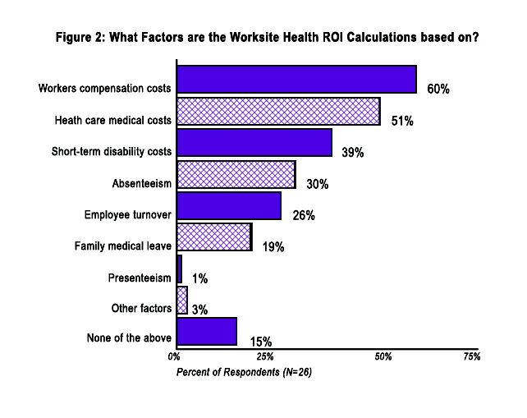
Suggestions for Taking Action for Making Wellness an Organizational Priority

Decide whether your goal is to reduce absenteeism, increase employee retention, or to increase worker productivity; be sure that your expectations are realistic; and evaluate progress on a regular basis (semi-annually or annually). In addition, align the worksite wellness program with company-wide goals and objectives.

Develop a budget for worksite health. The Wellness Council of America estimates the cost per employee to be between $100 and $150 per year for an effective wellness program that produces a return on investment of $300 to $450 although any investment is worthwhile.

Form a wellness team or committee that is representative of the employee population. A wellness team should include senior management, human resources, and representatives from all major areas or divisions within the worksite.
Annually assess employees’ risk of developing a chronic disease (e.g. biometric screenings, HRA).

Provide incentives to employees for completing an HRA, participating in a disease management program, or for adherence to healthy behaviors.
Calculate the ROI for the worksite wellness program by utilizing data sources such as healthcare medical costs, workers compensation costs, and employee turnover.

2. Health Services and Education

In MA, chronic diseases are a significant problem for the adult population. One in every fourteen adults has diabetes. Twenty-six percent of adults have high blood pressure while thirty percent have high cholesterol. One in twenty adults has had a heart attack while one in forty has had a stroke.

A hallmark of a successful worksite wellness program allows all employees and their families, regardless of health status, language, work shift, or level of physical or mental ability, to participate at some level. It focuses on those individuals who are at risk to develop a disease, by reducing their risks; on those with a chronic condition, to prevent them from getting worse; and on healthy people who can use assistance to stay healthy. A program should offer a variety of options tailored to address needs identified through a Health Risk Assessment and/or claims data, such as disease management programs, coaching sessions, risk reduction counseling, and other health maintenance programs. Guidance should be available to direct each employee into the most appropriate program according to his or her health status.

Survey Results

Focus on preventive services: Finance and Insurance (88%) and Public Administration (82%) were most likely to offer insurance benefits that cover preventive (non-regulated) services for employees (Figure 3) [Breast cancer, blood pressure, and cholesterol screenings were most likely to be covered by insurance benefits. Diabetes, diet/nutrition, depression, and tobacco cessation were among the least likely (Figure 4).

Offer on-site health screenings: 78% of respondents (data not shown) do not offer on-site screenings for common chronic conditions like high blood pressure, cholesterol, and glucose tolerance, although regular physical exams and health screening tests can prevent or detect diseases. Only 3% of businesses reported using a mobile health unit or on-site health center for preventive screenings.

Incorporate health education classes: Few businesses reported offering on-site health education classes or workshops; those offered most often were on nutrition/healthy eating or stress management, such as yoga.

Suggestions for Taking Action towards Health Services and Education

Use the Massachusetts Department of Public Health Adult Preventive Services Insurance Checklist as a guide for purchasing comprehensive insurance for your employees that complies with clinical guidelines (see Appendix B).

Increase disease prevention through on-site educational programs.

Partner with your insurance company, local hospital, community health center, or an outside vendor to offer on-site health screenings (e.g. blood pressure, body composition, cholesterol, glucose, and body mass index) and use the aggregate results, paired with Health Risk Assessment information, to assess the health risks of employees.

Publicize local screening services offered by hospitals, community groups, and/or chamber of commerce and support employee participation by allowing employees to attend those screenings on paid company time.

Offer an on-site worksite based health center for employees to engage in primary care and preventive services such as vaccines, health screenings, and weight-loss counseling. You can also partner with local hospitals to bring a mobile health outreach van to your worksite for on-site health screenings for blood pressure, cholesterol, and other health risk factors.

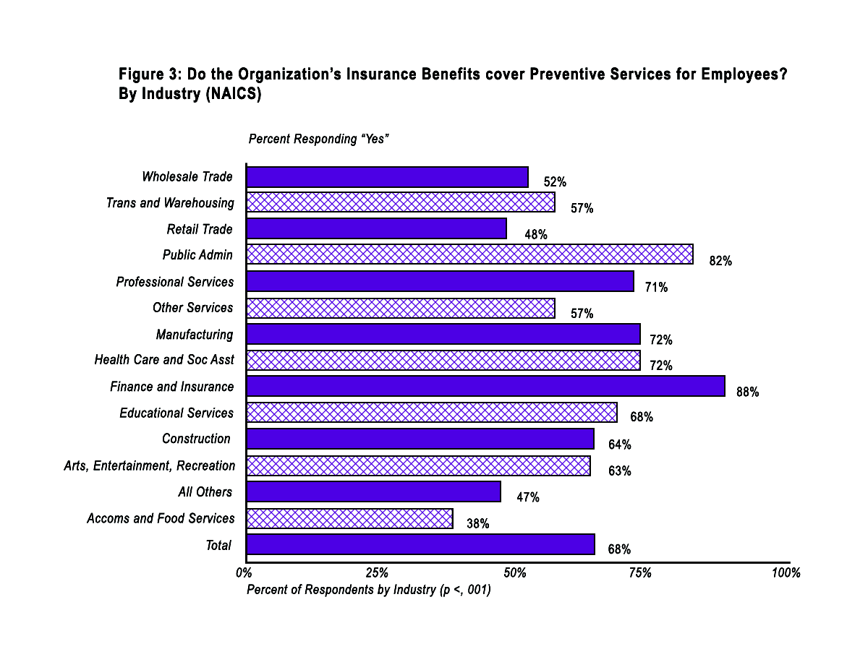
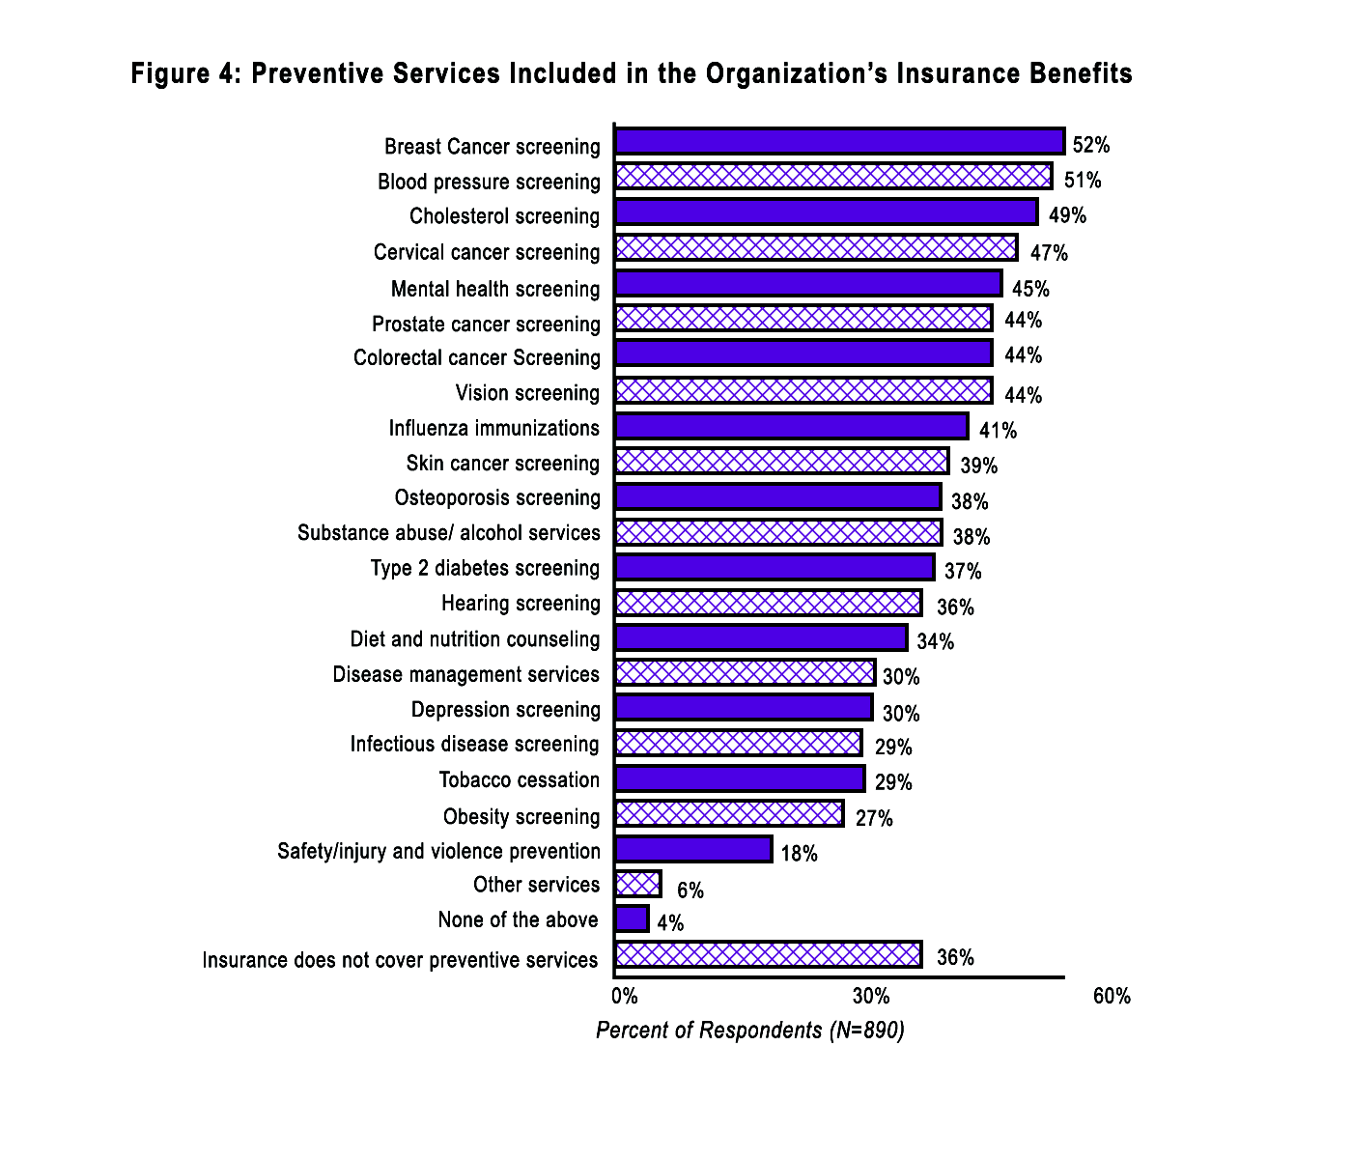

3. Nutrition & Healthy Eating

Only one in four adults in MA eat the daily recommended five or more servings of fruits and vegetables. [2] A healthy diet and good eating habits are essential components of wellness. Worksite wellness programs can support healthy eating by providing access to healthier foods at on-site cafeterias, in vending machines, and at company meetings or events. The worksite wellness program can also provide useful information about nutrition, how to buy and prepare healthy foods, and how employees and their families can incorporate healthier food choices into their diet.

Survey Results

Provide healthy food options: Almost 20% of businesses reported having written policies to ensure that healthy food items are offered in vending machines, in cafeterias, or at meetings and catered events.

Offer point of purchase nutrition information: Some businesses offer point of purchase nutrition information in the cafeteria or in vending machines although this varies by business size (Table 2).

Allow employees to prepare healthy food on-site: Almost all businesses offered employees access to a refrigerator, microwave, or both.

Table 2. Percent of responding worksites that offer point of purchase nutrition information in the cafeteria and vending machines

Business Size  (N=employees) | Percentage of respondents offering point of purchase nutrition information in
 | The cafeteria | Vending machines
11-24 | 42% | 5%
25-49 | 18% | 11%
50-99 | 22% | 17%
100-249 | 29% | 9%
250-499 | 33% | 4%
500+ | 49% | 14%

Total Number of worksites that have a cafeteria = 101
Total Number of worksites that have vending machines = 330

Suggestions for Taking Action to Increase Access to Healthy Foods

Establish a policy ensuring that healthy food and beverage offerings will be standard at all company-sponsored meetings and events. Visit the Massachusetts Health Promotion Clearinghouse at www.maclearinghouse.com for the Healthy Meeting and Event Guide.

Purchase microwaves, refrigerators, and toaster ovens to allow workers to prepare healthy foods on-site.
Provide a dedicated staff lunch/break room.

Establish a policy requiring that vending machines contain healthy options such as yogurt, water, baked chips, and un-salted almonds. For information about establishing food policies visit: http://www.preventioninstitute.org/sa/enact/members/index.php

Support the establishment of a farmers’ market and/or community sponsored agriculture drop off on-site or near the worksite to provide better access to seasonal fresh fruits and vegetables. For additional information visit: http://www.mass.gov/agr/massgrown/nutritioncouncil.htm.

Offer free or low-cost classes on healthy eating for employees.
Ensure that low-cost/healthier food choices are offered at the worksite and are identified with point-of-purchase nutrition information.

Work with cafeteria staff to offer healthy meal options, reduced portion sizes, and posted nutritional content of food provided in the cafeteria.

4. Physical Activity Opportunities

Over half of MA adults do not participate in regular physical activity. This, combined with poor eating habits, has resulted in almost 60% of adults in our state becoming overweight or obese. [3] Worksite wellness programs should create environments that make healthy behaviors easy. When employees are provided with an on-site exercise facility, subsidized memberships to a local gym, or a walking path with mile markers on or near the worksite, people are more likely to engage in physical activity. In the general population, overweight is more common among people of lower socioeconomic status, so it is important to offer these benefits to all employees, not only administrators and professionals.

Survey Results

Subsidize membership to an off-site physical activity facility: 46% of respondents subsidize membership to off-site physical activity facilities directly or through a health plan. Of those offering subsidized memberships, just over half offer this benefit to all employees.

Provide employees with an on-site worksite fitness center: 10% of responding businesses have on-site exercise facilities

Suggestions for Taking Action to Increase Opportunities for Physical Activity
Offer a secure bicycle storage unit at the worksite.
Ensure that the stairwells are centrally located, well advertised, and safe.
Make improvements to the stairs (e.g. lighting, painting, signage, music) to make the stairwells more inviting. For more information about how to implement a stairwell campaign visit: http://www.cdc.gov/nccdphp/dnpa/hwi/toolkits/stairwell/index.htm.

Offer subsidized or reimbursed membership to a local health club for all employees regardless of health insurance plan.

Provide employees with on-site fitness classes during the work day that are accessible for people with disabilities.

Create and distribute maps of accessible walking and bicycling routes with measured distances in/near the worksite and in the local community. For sample walking maps and routes visit: http://www.walkboston.org.

Have an on-site physical fitness facility that is accessible for people with disabilities, free or discounted, and open before, after, and during work hours.

5. Stress Management

Health conditions increase work-related absences and often reduce worksite productivity and performance. Studies show that approximately 15% of employees generate 85% of all healthcare costs. Each year approximately 60% of employees move from low-risk health status to high-risk health status. [3] With this in mind, the goal of worksite wellness programs is straightforward: keep the healthy people healthy and provide those at high-risk with the necessary resources to manage their conditions and reduce their risk of developing additional chronic diseases.

Impact of Poor Physical or Mental Health on MA Adults

 | Percent of MA Adults who Answered 1 or More Days (%) | All MA Adults | MA Adults who Answered 1 or More Days
 | Percent of MA Adults who Answered 1 or More Days (%) | Mean Days | Mean Days
How many days during the past 30 days was your physical health not good? | 35.3 | 4.2 | 11.3
How many days during the past 30 days was your mental health not good? | 34.8 | 3.5 | 10.7
How many days did poor physical or mental health keep you from doing your usual activities, such as self-care, work, or recreation? | 38.5 | 4.7 | 11.5

[Caption] Nearly 40% of MA adults reported that poor physical and mental health kept them from doing usual activities. Those adults reported an average of 11.5 days when they were kept from doing usual activities. Poor physical or mental health may result in losses to worksite productivity.
Source: 2007 Massachusetts Behavioral Risk Factor Surveillance System

The National Institute for Occupational Safety and Health (NIOSH) recommends a comprehensive approach to managing stress that combines changes in work organization and stress management for workers to effectively address stress in the worksite. Evidence from intervention research shows clear benefits for a “systems” approach that emphasizes primary prevention and combines approaches for improving working conditions with approaches for managing worker illness. [4]

Survey Results

Incorporate stress reduction policies: 292 businesses (32%) had some type of stress reduction policy. Of theses businesses with stress reduction policies, most had a sexual harassment policy, the majority had grievance procedures, and about half had extended disability or sick time allowances. Policies that were less common included telecommuting, strategies to address child care issues, and strategies to address elder care issues (Figure 5).

Offer maternity/paternity policies: Approximately 65% of businesses offer supports for new parents including maternity/paternity policies (Figure 6) while only 5% offer on-site child care facilities.

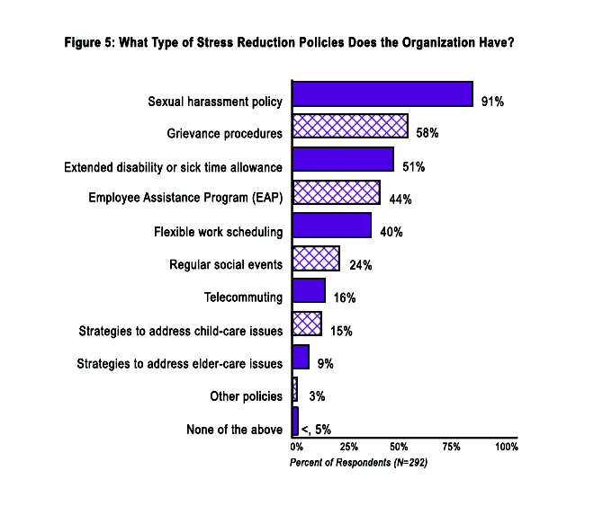

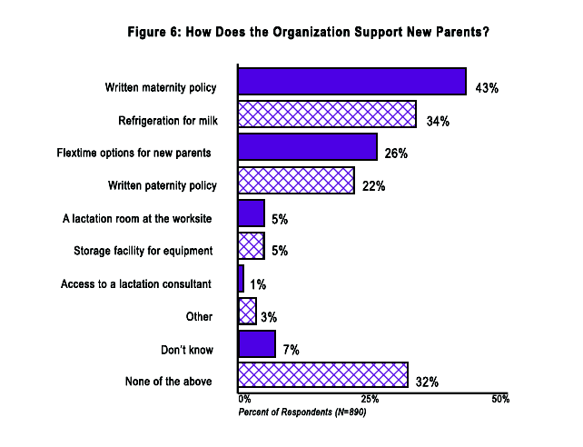

Suggestions for Taking Action to Encourage Stress Management

Create a flexible worksite with policies that allow and encourage flexible work arrangements (e.g. part-time work, tele-commuting, job sharing, or other modified work schedules). For additional information visit: http://www.we-inc.org/flex.cfm.

Provide an Employee Assistance Program (EAP) for all employees that can address employee needs.

Provide regular social events for employees.

Provide worksite supports for mothers wanting to breastfeed their infants. Supports should include an on-site lactation room for breastfeeding mothers as well as the use of flextime. An on-site lactation room should include a storage facility for equipment, refrigeration for milk, hospital grade electric pump, comfortable chair, sink for cleaning up, and privacy for pumping. For additional information visit: http://massbfc.org.

Ensure that employees are trained in programs for stress reduction or related issues (e.g. assertiveness, communication, time management, conflict resolution).
Provide employees with on-site child care facilities.

Have a back-up care program that provides temporary child and adult back-up care when regular care is not available.

6. Tobacco, Alcohol and Drugs

Helping employees to quit smoking is one of the most important health improvement options available to employers. In 2005, the productivity cost of smoking approached $1 billion and total healthcare expenditures approached $3.9 billion. [5] About 16% of MA adults currently smoke. [3] While smoking is a difficult habit to quit, many people have stopped smoking in the last decade and new approaches and therapies are helping people to quit every day. Other behavioral health issues, such as substance abuse, can negatively impact employee health and productivity. Awareness of these issues and in-house Employee Assistance Programs (EAP) or up-to-date referrals to treatment services should be part of a comprehensive program to encourage employee health.

The MA Smoke-free Workplace Law effective 07/05/2004, prohibits smoking in workplaces, including private offices, taxis, restaurants and bars in order to protect employees and the public from secondhand smoke. Under this law a workplace is defined as an indoor area, structure or facility or a portion thereof, at which one or more employees perform a service for compensation for the employer, or other enclosed spaces rented to or otherwise used by the public. Some narrow exceptions do apply. Please visit the Massachusetts Tobacco Control Program (www.mass.gov/dph/mtcp) for detailed information regarding the law.

Survey Results

Enforce Statewide Laws: Despite MA Smoke-Free Workplace Law which states that smoke cannot migrate back into the enclosed workspace, 45% of businesses reported allowing smoking anywhere outside during work hours (Figure 7).

Smoke-free workplace policy: 42% of businesses reported having written policies governing employee smoking during the workday, with educational services more likely to have such policies, while construction was least likely (Figure 8). Interestingly, 4% of respondents have written policies governing employees’ ability to smoke outside of work hours. Educational services (9%) and Accomodation & Food services (7%) reported the highest prevalence of having written policies governing employees’ ability to smoke outside of work hours.

Access to tobacco treatment: Almost 40% of businesses reported offering some type of smoking cessation to employees with access to prescription medications through health insurance coverage being the most common (29%) (Figure 9).
Written drug and alcohol free workplace policy: Three out of four businesses reported having written drug and alcohol-free worksite policies.

Suggestions for Taking Action to Decrease Alcohol and Tobacco Use

Post signs at the worksite to educate employees that the worksite is a no-smoking facility. Visit the MA Health Promotion Clearinghouse at www.maclearinghouse.com for free signage.
Prohibit the sale of tobacco products at the worksite.

Institute a smoke-free campus policy that prohibits smoking on all company property. For sample smoke-free campus policies visit: http://www.makesmokinghistory.org.

Establish a no smoking policy in any company vehicle or vehicle used during the course of the workday.

Provide access to free or low-cost smoking cessation counseling and all FDA- approved medication as requested.

Offer on-site smoking cessation programs for employees.

Promote 1-800-Try-to-Stop and www.trytostop.org resources.

Implement and enforce a written drug and alcohol-free worksite policy. To learn how to make your worksite drug-free visit the Department of Labor’s Working Partners Website at www.dol.gov/workingpartners.

Implement a policy requiring managers to be trained on the signs and symptoms of substance abuse. For additional information visit: http://www.talkaboutaddiction.org/treat/employers/index.html.

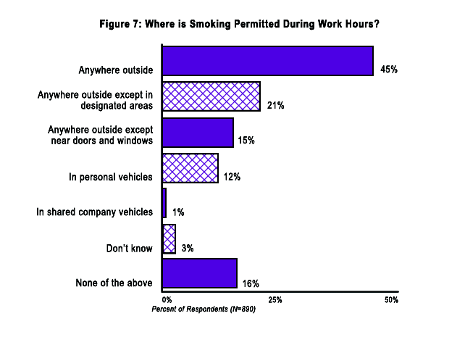

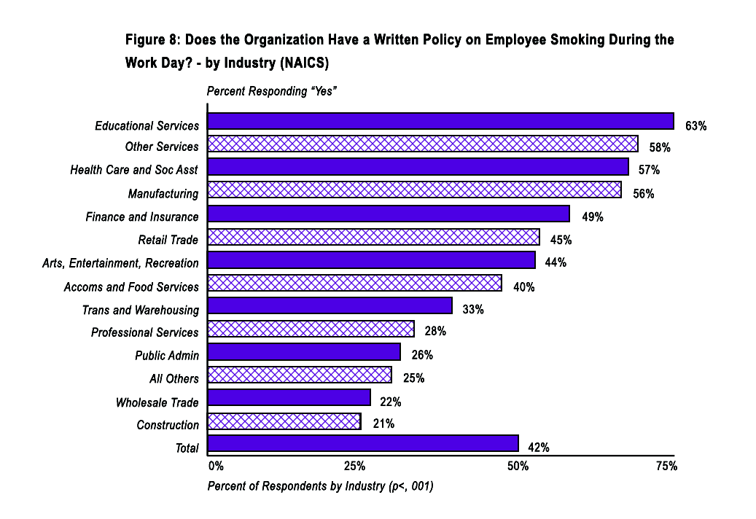
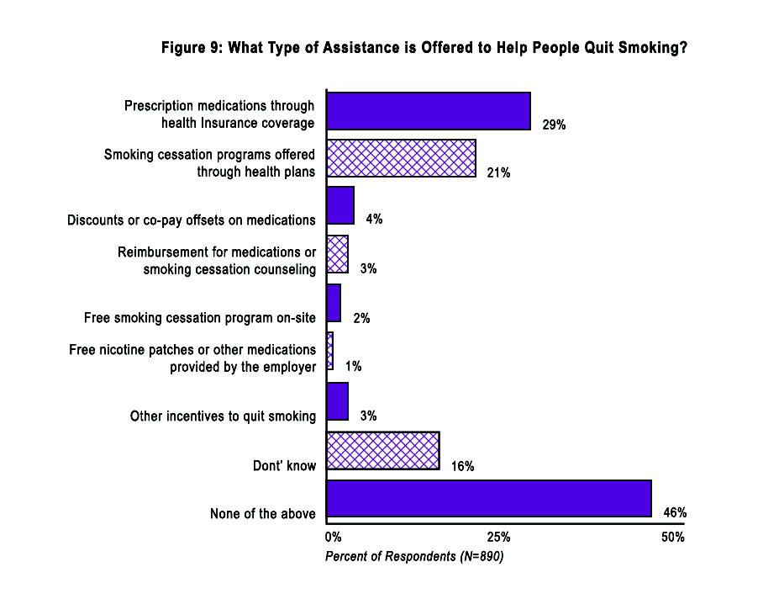

7. Occupational Safety & Health

Focusing on preserving the health and well-being of the workforce offers an important opportunity to provide protection from on-the-job hazards as well. Each year, close to 4 out of every 100 private sector workers in the Commonwealth – almost 88,000 people – are injured on the job or become ill as a result of exposures to hazards at work. Half of these injuries are severe enough to require job restrictions or transfers, or cause lost work time. Not only do these injuries result in pain and suffering for the affected workers and their families, they also impact productivity and morale as well as strain our healthcare system. Work-related injuries and illnesses are preventable; the steps taken to create a safer work environment result in confidence and increased participation in other health promotion efforts. [6]

Survey Results

Establish a worksite committee for health and safety hazards: 40% of survey respondents reported having a worksite committee for health and safety hazards. Larger businesses were more likely to have such a committee, as were manufacturing and construction businesses. Over 20% of respondents reported having neither a worksite health and safety committee (Figure 10) nor an individual designated as responsible for addressing health and safety hazards (Figure 11).

Report work-related injuries: 82% of respondents reported having a policy in place for reporting work-related injures; fewer (67%) reported having a policy in place for reporting unsafe worksite conditions. As shown in Figure 11, this varied by industry.

Conduct audits or inspections to identify worksite health and safety hazards: 61% of respondents reported conducting audits or inspections to identify worksite health and safety hazards. This also varied by industry (Figure 12).

Maintain and post logs of work-related injuries and illnesses: Occupational Safety and Health Administration (OSHA) regulations require most private sector employers with 11 or more employees in MA to maintain and annually post logs of work-related injuries and illness. Some types of service and trade establishments, such as doctors’ offices and restaurants, are excluded from this requirement. Public sector establishments (i.e. public administration) are not covered by OSHA in MA. Overall, 65% of businesses reported maintaining a work-related illness/injury log (Figure 13).

Use claims and injury data: 43% of overall businesses reported analyzing claims and injury data to plan health and safety activities. These findings were correlated with business size, and worksites in construction were more likely to use such data (Figure 14).

Coordinate health promotion initiatives with health and safety programs: 39% of businesses reported some level of coordination between health promotion and health and safety. For example, for employees who stand all day long, a walking program might be less appropriate than it would be for desk workers.

Implement a written seatbelt policy: One in four businesses reported having a written seatbelt policy (Figure 15). This varied by business size.

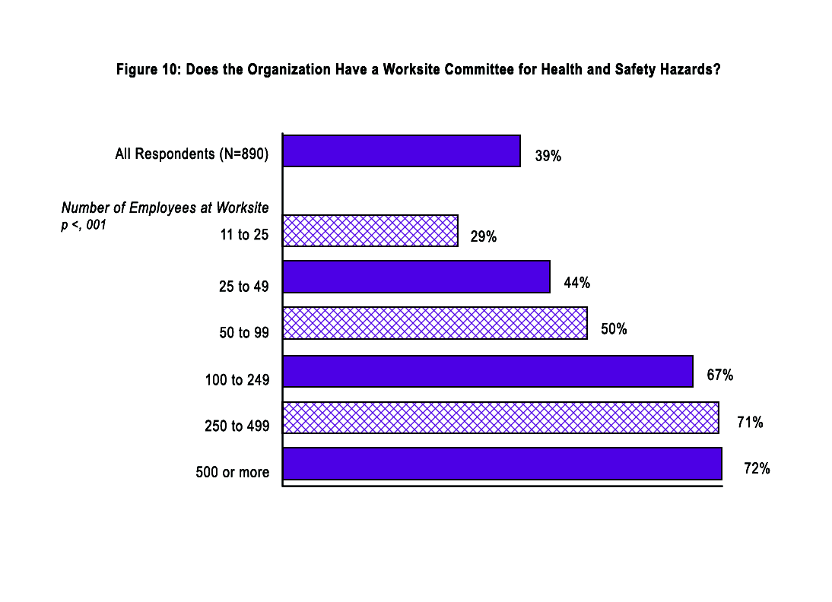

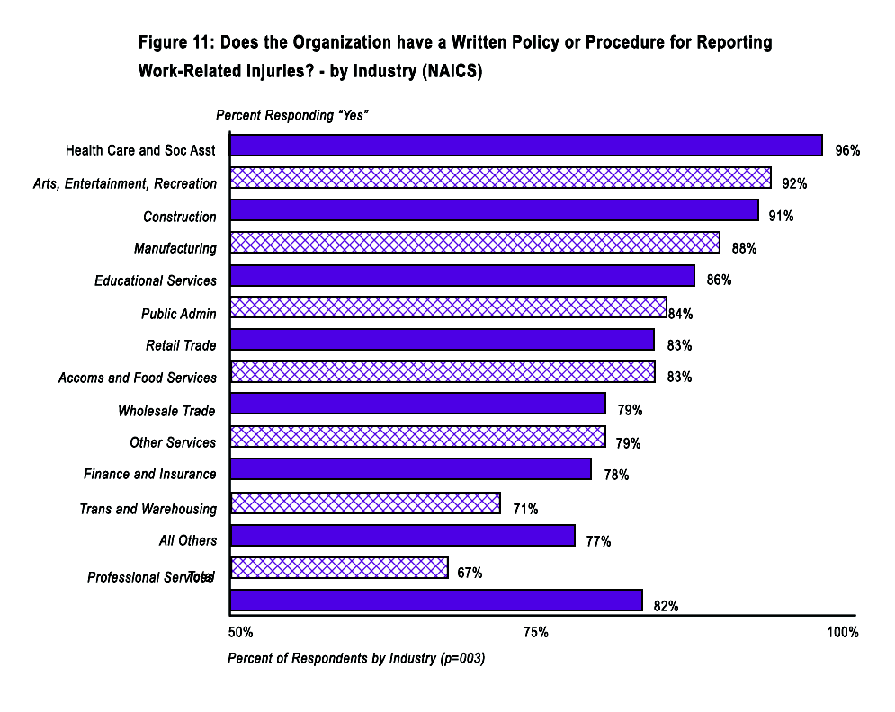

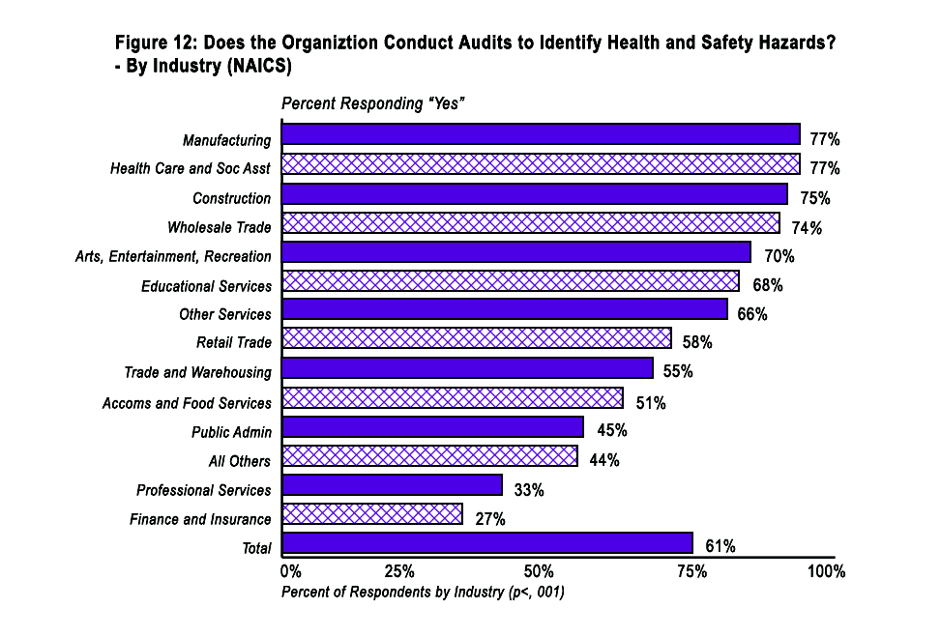

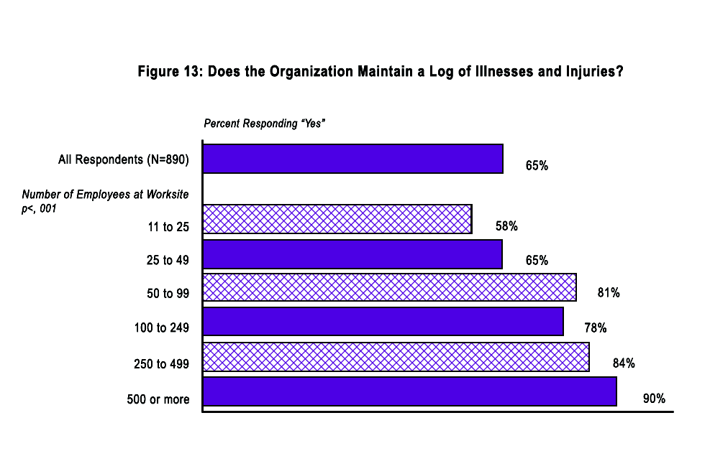

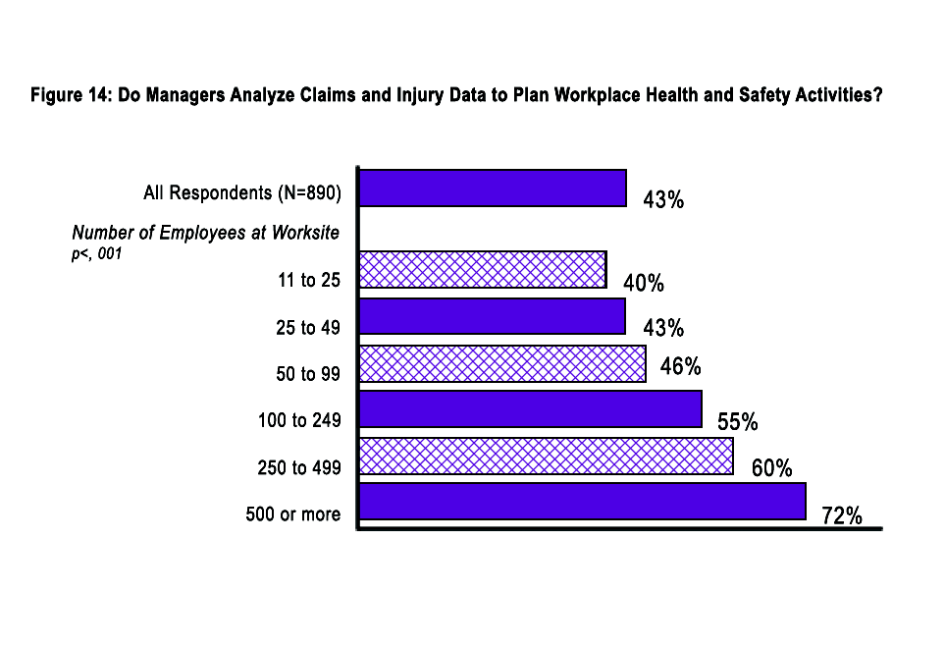

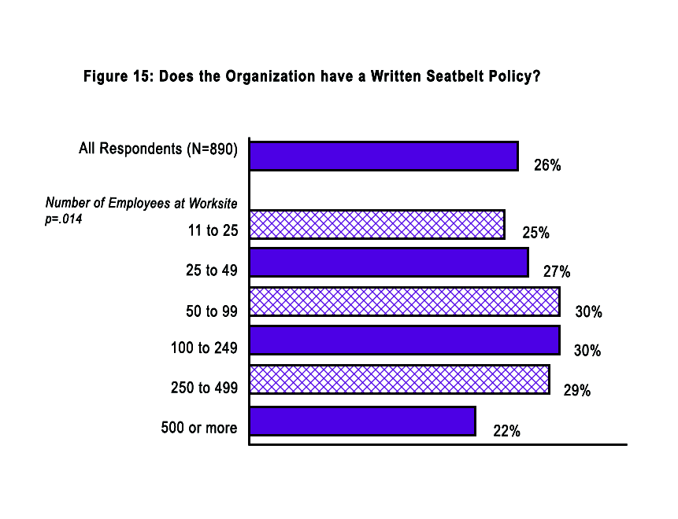

Suggestions for Taking Action to Promote Occupational Safety and Health

Routinely review work-related injury and illness data (OSHA log data, workers’ compensation records) to set priorities for interventions to reduce hazards.
Create a joint management-labor health and safety committee to ensure that the safety needs of management and all employees are being met.

Conduct periodic audits of health and safety hazards. The OSHA consultation program can assist employers in identifying potential hazards in their worksites and improve their occupational safety and health management systems. See OSHA’s business websites: http://www.osha.gov/dcsp/products/topics/businesscase/index.html http://www.osha.gov/dcsp/products/topics/businesscase/getting_started.html

Establish a system for reporting work-related injuries and illnesses and worksite hazards that does not penalize employees for reporting. Consider incentives to identify hazards in the worksite before they can cause harm and “near miss” reporting.

Develop ways for workers to use their experience to improve worksite safety and promote good health. Encourage workers to talk to each other and to supervisors about solutions.

To assist with these suggestions, OSHA has established voluntary guidelines for Safety and Health Program Management that are available on the OSHA website (http://www.osha.gov/pls/oshaweb/owadisp.show_document?p_table=FEDERAL_REGISTER&p_id=12909).

8. Emergency Response

Accidents and injuries can occur in all worksites. In 2006, 985 out-of-hospital heart attack deaths occurred across the state. Having a well-thought-out emergency response plan and properly organized and trained teams can help to minimize the extent of these events. In addition, having an Automatic External Defibrillator (AED) with employees trained in cardiopulmonary resuscitation (CPR) and the use of an AED is an important step towards ensuring that your employees receive the medical treatment they might need.

Survey Results

Emergency medical response training: Approximately one third of businesses reported offering emergency medical response training to employees including first aid (82%), CPR (79%), and AED (44%) trainings.

Installation of AEDs at the worksite: 16% of businesses reported having at least one AED at their worksite. This finding was correlated to business size (Figure 16) and varied by industry type.
Emergency response plan for medical emergencies: Almost half of businesses reported having a written response plan for medical emergencies (48%) and fire evacuation, bomb threats, natural disasters, or pandemic (49%). Of the 49% who offer written response plan for fire evacuation, bomb threats, natural disasters or a pandemic, only 61% specifically address assisting people with a disability during an emergency.

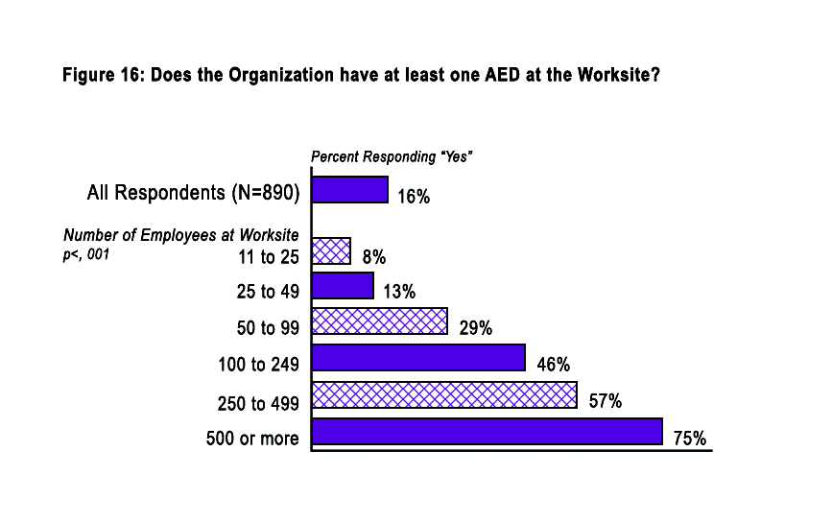

Suggestions for Taking Action

Install first aid kits at the worksite.

Prominently install AEDs at the worksite. The American Red Cross will perform an audit of your worksite to determine the best placement location for the AED. For additional information visit http://www.bostonredcross.org.

Post signs at the worksite to let employees know where the AED is located.
Implement a policy requiring that employees have first aid, CPR, and AED training with a refresher course every 2 years.

Have a written emergency response plan for medical emergencies (e.g. heart attack, asthma attack).

Conduct educational programs on the signs and symptoms of heart attack and stroke and on the appropriate reason to call 9-1-1. For more information, call 800-487-1119 or e-mail heart.stroke@state.ma.us.

GLOSSARY
Automatic external defibrillator (AED) – A device that detects irregular heart rhythms and delivers an electrical pulse to correct them.
Blood glucose – The main sugar found in the blood and the body’s main source of energy.
Blood pressure – The force blood exerts against the walls of the arteries as the heart
pumps. Blood pressure is typically recorded as two numbers: the systolic pressure (as the heart beats) over the diastolic pressure (as the heart relaxes between beats). For example: 120/70.
Body mass index (BMI) – A measure of weight in relation to height that is used to screen for overweight and obesity.
Cardiopulmonary Resuscitation (CPR) – A lifesaving technique useful in many emergencies in which someone’s breathing or heartbeat has stopped.
Cardiovascular disease (CVD) – Any disorder that affects the ability of the heart and blood vessels to function normally. Cardiovascular disease includes stroke and heart disease.
Cholesterol – A soft, waxy substance, manufactured by the body and found in certain
foods. Excess cholesterol can build up in blood vessels, contributing to cardiovascular disease.
Diabetes – A disease in which the body does not produce or properly use insulin. The major types of diabetes are:
Type 1 – A disease in which the body does not produce insulin, most often occurring in children and young adults, although can occur at any age.
Type 2 – A disease in which the body does not produce enough insulin or cannot properly use the insulin it does make. It is the most common form of the disease, accounting for 90-95% of all cases of diabetes.
Gestational – Glucose intolerance (the inability of the body to efficiently convert carbohydrates into energy) during pregnancy.
Prediabetes – A condition in which blood glucose levels are higher than normal but not high enough for a diagnosis of diabetes.
Employee Interest Survey – A survey to uncover the met and unmet health interests of the employees.
Health Risk Assessment (HRA) – An electronic or paper tool used to assess an individual’s risk of developing a disease. The HRA organizes and calculates individualized health risk information, compares it to standardized data for normal risk, and provides general quantitative measures of the individual’s risk of acquiring a disease.
Health Screenings – Physical measures such as blood pressure, body composition, cholesterol, glucose, and Body Mass Index that can help to detect diseases and provide employees with a baseline assessment of their health.
Heart disease – Any disease or condition of the heart. Abnormalities of the arteries, valves, and muscle of the heart are all forms of heart disease.
High blood pressure – Blood pressure that is consistently above 140/90 or above 130/80 for those with diabetes.
Insulin – A natural hormone made by the pancreas that is needed to convert sugar, starches, and other food into energy needed for daily life; it controls the level of sugar (glucose) in the blood.
Insurance claims – Claims including pharmaceutical costs, workers’ compensation costs, and medical costs that can be analyzed to determine the specific health conditions facing employees. Claims data may be available through insurance brokers and/or insurance companies.
Obesity – An excessively high amount of body fat in relation to lean body mass. Obesity is defined as a Body Mass Index of 30 or more for both men and women.
Overweight – Excess weight for height. A Body Mass Index between 25 - 29.9 is considered overweight for adults. Children are considered overweight when their BMI is at or above the 95th percentile for their sex and age.
Risk factor – A behavior, clinical condition, or characteristic that is associated with an
increased possibility of developing a chronic illness.
Stroke – Brain cell damage caused by either insufficient blood flow (ischemic stroke) or
bleeding (hemorrhagic stroke) in part of the brain. A stroke can impair movement, vision, and speech, among other functions.
Wellness – The optimal balance between body, mind, and spirit, regardless of health status or ability. Wellness involves conscious choices and responsible actions which are influenced by one’s social and physical environment.

References

- U.S. Census Bureau, D., Current Population Survey, December 2006.
- 2007 Behavior Risk Factor Surveillance System, Massachusetts Health Survey Program. Bureau of Health Statistics, Information, Research and Evaluation. Department of Public Health.
- Aldana, S.G., Financial impact of health promotion programs: a comprehensive review of the literature. American Journal of Health Promotion, 2001. 15(5): p. 296-320.
- LaMontagne, A., Protecting and promoting mental health in the workplace: developing a systems approach to job stress. Health Promotion Journal of Australia, 2007. 18(3): p. 221-227.
- Huang, X., Lunden, R, Land T, Keithly, L, Smoking-Attributable Mortality, Morbidity, and Economic Costs (SAMMEC) Massachusetts 2005. 2007.
- Sorensen, G.et.al., A comprehensive worksite cancer prevention intervention: behavior change results from a randomized controlled trial. J Public Health Policy, 2003. 24(1): p. 5-25.

Appendix A: Demographic Characteristics of Sample

 | Worksite Size (Number of Employees)
Region | 11-25 | 25-49 | 50-99 | 100-249 | 250-499 | 500-999 | 1,000 or more | No Response
Western  (n=182) | 47% | 22% | 11% | 10% | 5% | 2% | 4% | 0%
Central  (n=141) | 44% | 26% | 10% | 11% | 4% | 2% | 2% | 0%
North East  (n=142) | 40% | 30% | 15% | 5% | 4% | 2% | 2% | 1%
Metro West  (n=151) | 42% | 28% | 12% | 8% | 1% | 6% | 3% | 0%
South East  (n=143) | 46% | 24% | 12% | 7% | 4% | 3% | 3% | 1%
Boston  (n=112) | 44% | 18% | 13% | 13% | 6% | 2% | 3% | 0%

Worksite Size (Number of Employees)
North American Industry Classification System (NAICS) | 11-25 | 25-49 | 50-99 | 100-249 | 250-499 | 500-999 | 1,000 or more | No response
Construction  (n=73) | 63% | 19% | 14% | 4% | 0% | 0% | 0% | 0%
Manufacturing  (n=173) | 39% | 28% | 21% | 4% | 1% | 2% | 4% | 0%
Wholesale Trade  (n=33) | 60% | 24% | 10% | 5% | 1% | 0% | 0% | 0%
Retail Trade  (n=57) | 49% | 28% | 15% | 4% | 1% | 0% | 4% | 0%
Transportation & Warehousing  (n=26) | 32% | 38% | 0% | 12% | 11% | 2% | 6% | 0%
Finance & Insurance  (n=40) | 39% | 31% | 7% | 20% | 1% | 1% | 1% | 0%
Professional Service  (n=90) | 47% | 30% | 10% | 9% | 2% | 1% | 1% | 0%
Educational Services  (n=71) | 26% | 37% | 7% | 9% | 8% | 9% | 2% | 1%
Healthcare & Social Assistance  (n=118) | 26% | 26% | 6% | 11% | 11% | 10% | 7% | 2%
Arts, Entertainment, Recreation  (n=23) | 28% | 12% | 21% | 37% | 1% | 1% | 0% | 0%
Accommodations & Food Service  (n=36) | 48% | 19% | 6% | 11% | 3% | 12% | 0% | 3%
Other Services  (n=68) | 50% | 21% | 13% | 5% | 5% | 2% | 3% | 0%
Public Administration  (n=22) | 33% | 0% | 5% | 22% | 9% | 12% | 20% | 0%
All others  (n=60) | 48% | 19% | 19% | 9% | 2% | 0% | 2% | 0%

Appendix B: Massachusetts Department of Public Health Adult Preventive Services Insurance Checklist

The Insurance Checklist provides employers with recommendations about preventive care services, including counseling, screening, and immunizations, which should be covered by their health insurance plan. This tool provides guidance for the selection of clinical preventive services and is a resource to assess the quality of the preventive services that employers are currently offering employees. Preventive services highlighted in the checklist are recommendations from MA Health Quality Partners and the National Business Group on Health’s Purchasers Guide A Purchaser’s Guide to Clinical Preventive Services Moving Science into Coverage.

SCREENINGS#
Preventive Service | Definition | Yes | No
Health Maintenance Visit | Health Maintenance Visit should include assessments of family history of disease, height, weight, BMI, blood pressure, mental health status (depression), safety/injury and violence prevention, violence/abuse in the home, alcohol and drug use status (level of risk or problem use), smoking status, and mental status as well as age-appropriate physical exam, screenings, and immunizations  Individuals ages 18-21 – annual visit  Individuals ages 22-49 – visit every 1-3 years depending on risk factors  Individuals age 50+ – annual visit
Breast cancer screening | Women ages 18-39 – mammography for high-risk individuals  Women ages 40-49 – annual mammography at discretion of clinician/patient  Women 50-69 – annual mammography  Women age 70+ – mammography at discretion of clinician/individual
Cervical cancer screening | Women – pelvic exam and Pap test every 1-3 years at three years after first sexual intercourse or by age 21
Colorectal cancer screening | Individuals ages 18-49 – screening for high-risk individuals  Individuals ages 50+ – Colonoscopy at age 50 and then every 10 years, OR annual fecal occult blood test (FOBT) plus sigmoidoscopy every 5 years, OR double-contrast barium enema every 5 years, OR annual FOBT  Individuals age 80+ – Screening at clinician/patient discretion.
Skin cancer screening | Individuals ages 20-39 – skin exams every 3 years  Individuals age 40+ – annual skin exams
Testicular and prostate cancer screening | Men ages 40-49 – digital rectal exam for high-risk individuals; prostate specific antigen screening for high-risk individuals at clinician/patient discretion  Men age 50+ – digital rectal exam; prostate specific antigen screening at clinician/patient discretion
Cholesterol screening | Individuals age 18+ – screening at least every 5 years with a fasting lipoprotein profile
Type 2 diabetes screening | Individuals ages 18-44 – screening for high- risk individuals at least every three years  Individuals age 45+ - screening every three years
Chlamydia screening | Sexually active individuals under 25 – annual screening  Individuals age 25+ – annual screening if at risk
Gonorrhea screening | Sexually active individuals under 25 – annual screening  Individuals age 25+ – annual screening if at risk
Syphilis screening | Individuals age 18+ – annual screening if at risk
Hepatitis C screening | Individuals age 18+ – periodic screening for high-risk individuals
HIV screening | Individuals age 18+ – periodic screening for high-risk individuals
Tuberculosis screening | Individuals age 18+ – tuberculin skin testing for high-risk individuals
Eye exam for glaucoma and vision screening | Individuals ages 18-39 – glaucoma screening at least once in individuals with no risk factors; high risk individuals screen every 3-5 years; annual screening in individuals with diabetes  Individuals ages 40-64 – glaucoma screening every 2-4 years; annual screening in individuals with diabetes  Individuals age 65+ – glaucoma screening every 1-2 years; routine vision screening with Snellen acuity testing
Osteoporosis screening | Women ages 40-65 – bone mass density screening for postmenopausal high-risk individuals  Individuals age 65+ – bone mass density screening
#Adapted from the Massachusetts Health Quality Partners “2007/8 Adult Routine Preventive Care Recommendations” (http://www.mhqp.org/guidelines/preventivePDF/MHQP_AdultPrevCareGuidelines.pdf) and the National Business Group on Health “A Purchaser’s Guide to Clinical Preventive Services” (www.businessgrouphealth.org/benefitstopics/topics/purchasers/index.cfm)

IMMUNIZATIONS*
Vaccine | 19-49 years | 50-64 years | 65+ | Yes | No
Tetanus, diphtheria, pertussis | 1 dose booster every 10 years
Human papillomavirus | #
Measles, mumps, rubella | 1 or 2 doses | 1 dose
Varicella | 2 doses
Influenza | 1 dose annually | 1 dose annually
Pneumococcal | 1-2 doses |  | 1 dose
Hepatitis A | 2 doses
Hepatitis B | 3 doses
Meningococcal | 1 or more doses
Zoster |  | 1 dose (age 60+)
* Recommended Adult Immunization Schedule, United States, October 2007 – September 2008; for full immunization guidelines see http://www.cdc.gov/vaccines/recs/schedules/downloads/adult/07-08/adult-schedule.pdf
# 3 doses for females ≤ 26 years. A complete series consists of 3 doses. The second dose should be administered 2 months after the first dose; the third dose should be administered 6 months after the first dose.
For all persons in this category who meet the age requirements and who lack evidence of immunity (e.g., lack documentation of vaccination or have no evidence of prior infection)
Recommended if some other risk factor is present (e.g. on the basis of medical, occupational, lifestyle, or other indications)

COUNSELING
Preventive Service | Definition | Yes | No
Tobacco cessation | - Face-to-face and group counseling  - Tobacco cessation medications including the nicotine patch, gum, lozenge, and prescription medicines (including Chantix and Zyban)
Substance abuse services | - Substance abuse services need to be in parity with physical health services, and include diagnostic assessment, detoxification, residential treatment, outpatient, intermediate, and pharmacological services.
Mental health services | - Mental health services need to be in parity with physical health services, and include diagnostic assessment, inpatient, outpatient, intermediate, and pharmacological services.
Diet and nutrition counseling | - Counseling with a Registered Dietitian for individuals with a BMI of 25 or greater
Physical activity services | - Gym membership reimbursement or subsidy

