WATER DAMAGE ASSESSMENT

Crisafulli Elementary School
13 Robinson Road
Westford, Massachusetts

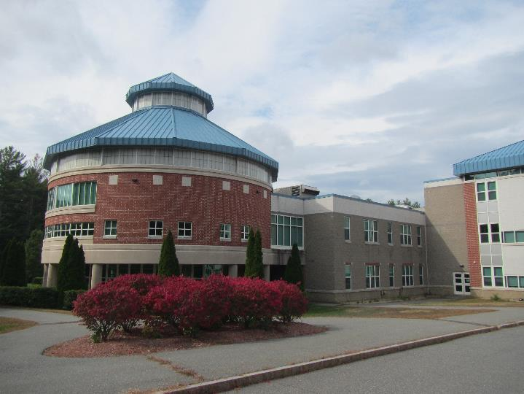

Prepared by:
Massachusetts Department of Public Health
Bureau of Environmental Health
Indoor Air Quality Program
October 2019

Background
Building: | Crisafulli Elementary School (CES)
Address: | 13 Robinson Road, Westford, Massachusetts
Assessment Requested by: | Paul Fox Jr., Director of Facilities, Westford Public Schools
Reason for Request: | Water damage following a sprinkler system leak
Date of Assessment: | October 7, 2019
Massachusetts Department of Public Health/Bureau of Environmental Health (MDPH/BEH) Staff Conducting Assessment: | Jason Dustin, Environmental Analyst, IAQ Program
Building Description: | The CES is a three-story, brick school opened in 2004 and serves ~ 425 students
Windows: | Not openable

Introduction
CES Facilities staff reported that a sprinkler system line in janitor closet #3 began leaking while the building was occupied (Picture 1). Due to the water being stagnant in the sprinkler lines, a foul odor was detected. Facilities staff immediately began to extract the water from the area and began drying activities within the first hour of the leak being discovered. In addition to drying activities, Facilities staff removed and discarded any porous material that was in contact with the leaking water.
BEH/IAQ staff noted that some vinyl tiles in the hall outside the janitor’s closet were slightly buckled (Picture 2). This condition likely resulted from the water re-activating the floor tile adhesive which then loosened the tiles. Facilities staff reported that the tiles will be removed and replaced due to the possible tripping hazard.
All building materials, in and outside the janitor closet where the leak originated, are nonporous materials (Picture 3) that are not susceptible to microbial colonization (e.g., concrete block, floor tiles). These walls and floors were cleaned and disinfected according to Facilities staff. However some occupants reported that the water flowed into an adjoining room (R3) and near the vinyl coving of a wall built with gypsum wallboard (GW). GW is considered a porous material having paper on both sides of the wall. No odors, moisture, or water damage was observed at the time of the assessment in the area of the GW wall. However, out of an abundance of caution, BEH/IAQ staff requested that Facilities staff inspect behind the vinyl coving to look for evidence of water damage or staining. This inspection was requested to take place while the building was unoccupied to minimize any dust/debris from impacting occupants. It is very unlikely that the water penetrated the vinyl coving and layers of floor wax at the base of the GW wall but this inspection was requested to completely rule out this possibility.

Methods
Please refer to the IAQ Manual for methods, sampling procedures, and interpretation of results (MDPH, 2015). In addition, visual observations were made of water-damaged materials, drying procedures being used, and other conditions that may impact IAQ.

Results and Discussion
The following is a summary of indoor air testing results in the area of the leak.
- Carbon dioxide levels were below the MDPH guideline of 800 parts per million (ppm) in all areas tested, indicating adequate air exchange in the areas assessed.
- Temperature was within the MDPH recommended range of 70°F to 78°F in areas assessed.
- Relative humidity was within the MDPH recommended range of 40% to 60% in areas assessed.
- Carbon Monoxide levels were non-detectable (ND) during the assessment.
- Fine particulate matter (PM2.5) concentrations measured were below the National Ambient Air Quality Standard (NAAQS) level of 35 micrograms per cubic meter (μg/m³) in areas assessed.
- Total Volatile Organic Compounds (TVOCs) were ND at the time of the assessment.

Ventilation
A heating, ventilating and air conditioning (HVAC) system has several functions. First it provides heating and, if equipped, cooling. Second, it is a source of fresh air. Finally, an HVAC system will dilute and remove normally-occurring indoor environmental pollutants by not only introducing fresh air, but by filtering the airstream and ejecting stale air to the outdoors via exhaust ventilation. Even if an HVAC system is operating as designed, point sources of respiratory irritation may exist and cause symptoms in sensitive individuals.
The CES has roof-mounted air handling units (AHUs) which draw in fresh air and filter, heat/cool and direct it to ceiling-mounted fresh air diffusers. Return/exhaust grates draw in stale air and return/exhaust it back to the AHUs.
To maximize air exchange, the MDPH recommends that both supply and exhaust ventilation operate continuously during periods of occupancy. In order to have proper ventilation with a mechanical supply and exhaust system, the systems must be balanced to provide an adequate amount of fresh air to the interior of a room while removing stale air from the room. It is recommended that HVAC systems be re-balanced every five years to ensure adequate air systems function (SMACNA, 1994). It is unknown when the last time this system was balanced.

Conclusions/Recommendations
- Inspect behind the vinyl coving in room R3 to determine if there is evidence of water damage in this GW wall. Since the sprinkler water was stagnant and had a foul odor, it would be considered “black water”. If evidence of water damage is found, this would require that the GW wall should be removed 1 foot above any high water level (staining) and replaced.
- Clean area thoroughly following any work in R3.
- Continue with plans to remove and replace buckled floor tile in the hallway.
- Activities that may be disruptive or lead to dust and odors should be conducted during off-hours (evenings and weekends) to the greatest extent practical.
- Ensure the ventilation system is operating continuously during occupied periods. This includes setting thermostats to “fan on” to ensure fresh air circulation occurs even when temperature settings are satisfied.
- Consider adopting a balancing schedule of every 5 years for all mechanical ventilation systems, as recommended by ventilation industrial standards (SMACNA, 1994).
- Refer to resource manual and other related IAQ documents located on the MDPH’s website for further building-wide evaluations and advice on maintaining public buildings. These documents are available at: http://mass.gov/dph/iaq.

References
MDPH. 2015. Massachusetts Department of Public Health. Indoor Air Quality Manual: Chapters I-III. Available at: http://www.mass.gov/eohhs/gov/departments/dph/programs/environmental-health/exposure-topics/iaq/iaq-manual/.
SMACNA. 1994. HVAC Systems Commissioning Manual. 1st ed. Sheet Metal and Air Conditioning Contractors’ National Association, Inc., Chantilly, VA.
Picture 1
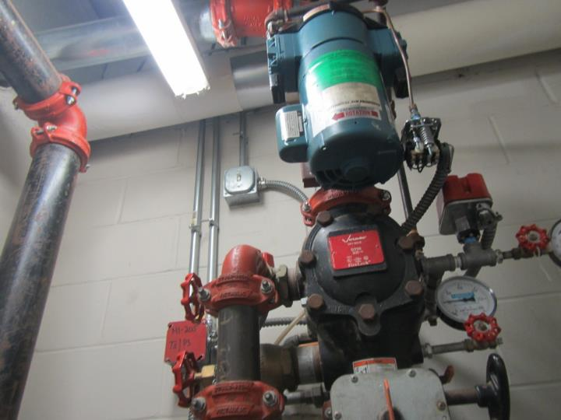
Sprinkler system/lines in Janitor closet #3 where leak occurred
Picture 2
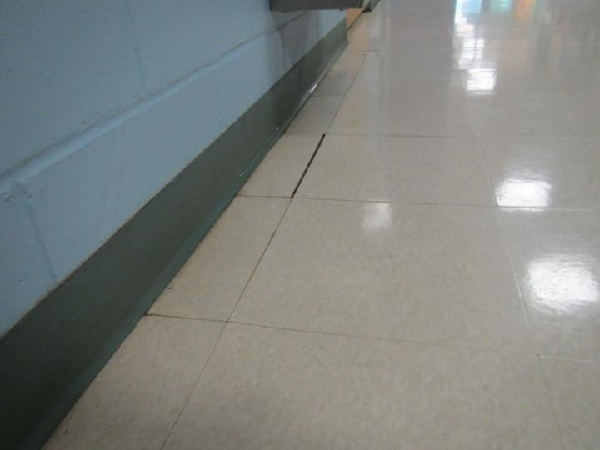
Buckled floor tiles in hallway outside janitor closet
Picture 3
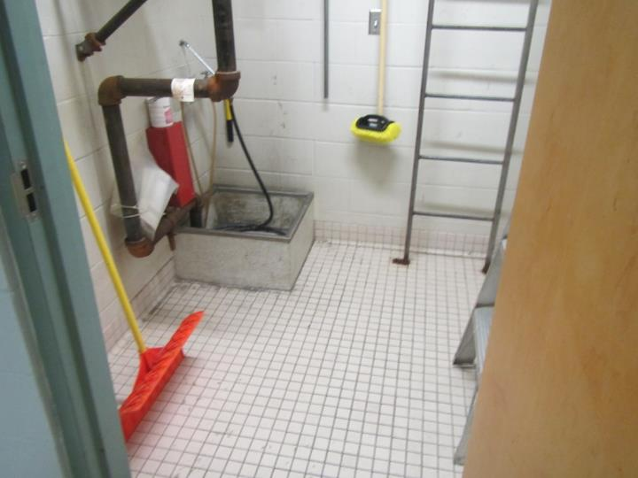
Nonporous tile and concrete in Janitor closet #3

