Developed by DEP Western Regional Office

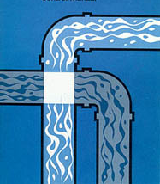
Clean Drinking Water

Polluted Source

What is a Cross Connection and What Can I do about it?

A cross connection is a connection between a drinking water pipe and a polluted source. The pollution can come from your own home. For instance, you’re going to spray fertilizer on your lawn. You hook up your hose to the sprayer that contains the fertilizer. If the water pressure drops at the same time you turn on the hose, the fertilizer may be sucked back into the drinking water pipes through the hose. This problem can be prevented by using an attachment on your hose called a backflow-prevention device.

The _______ Water Department recommends the installation of backflow prevention devices, such as a low cost hose bib vacuum breaker, for all inside and outside hose connections. You can purchase this at a hardware store or plumbing supply store. This is a great way for you to help protect the water in your home as well as the drinking water system in your town! For additional information on cross connections and on the status of your water systems cross connection program, please contact __________________________.

