Massachusetts Family Fees

Current fees and alternative options 2 and 5

One child, 2-person family

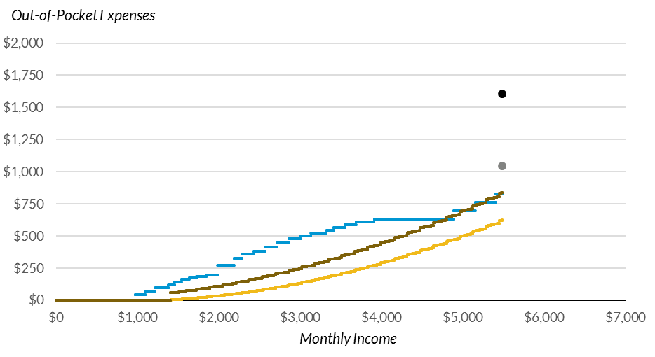

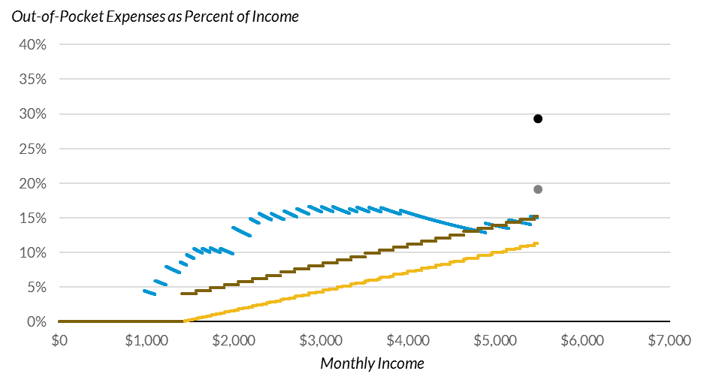

Source: Charts use 2018 data, including eligibility limits. Current fees based on October 1, 2018 policies from the CCDF Policies Database (https://ccdf.urban.org). Average price of care from Child Care Aware "The US and the High Price of Child Care: 2019."
Note: Copayments for single parent with a 24-month old child in full-time care. Prices reflect the average state price of full-time center and full-time family child care for a toddler.

Current fees and alternative options 2 and 5

Two children, 3-person family

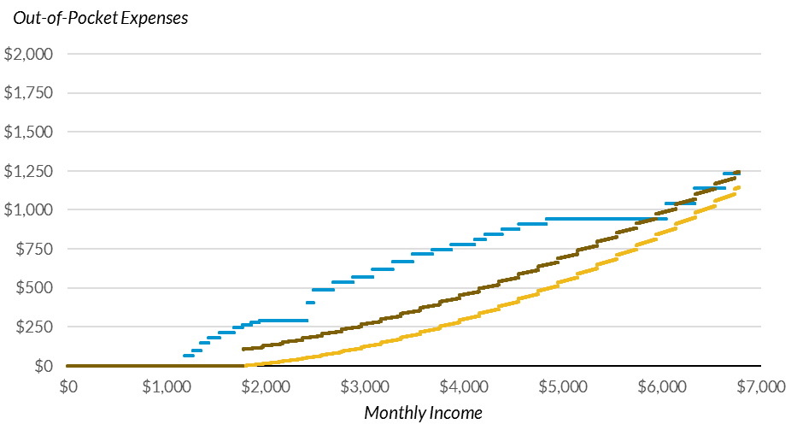

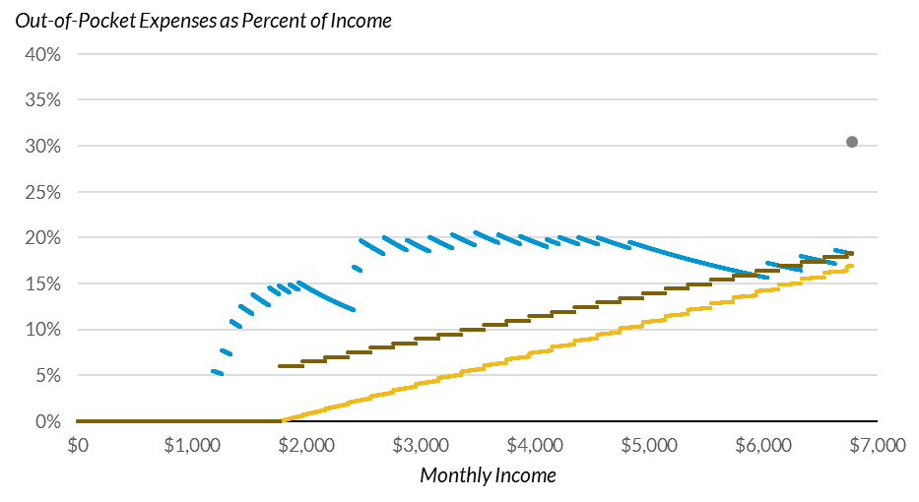

Source: Charts use 2018 data, including eligibility limits. Current fees based on October 1, 2018 policies from the CCDF Policies Database (https://ccdf.urban.org). Average price of care from Child Care Aware "The US and the High Price of Child Care: 2019."
Note: Copayments for single parent with a 24-month and a 48-month old child in full-time care. Prices are the combination of the average state price of full-time center and full-time family child care for an infant and a toddler

