

**FOR HELP: Statewide Advocacy for Veterans’ Empowerment (SAVE) | (617) 210-5743 | Toll-free: (888) 844-2838**

**This publication contains information on current or former military personnel who died by an unintentional/undetermined drug-related overdose in Massachusetts in 2019.**

**Massachusetts Military & Veteran Drug Overdose Deaths, 2019**

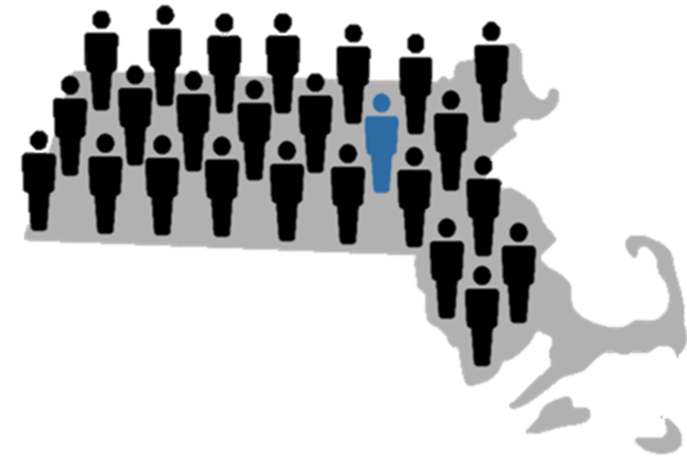

**90**

**current or former military personnel died from a drug-related overdose in Massachusetts in 2019.**

**1 in 25**

**of all Massachusetts drug-related overdose deaths in 2019 were current or former military personnel.**

**.**

A

**LIFE**

Save

**43%**

* **46%** had a bystander present at the time of overdose.
* By having the proper training and carrying Narcan, bystanders may be able to help prevent a fatal drug overdose.

**Current or Former Military Personnel**

**Non-military**

**Personnel**

**VS**

had a known current

mental health condition.

**16%**

had a diagnosis of PTSD

**5%**

had a diagnosis of PTSD

**#2**

**Depression**

**#1**

**PTSD**

**37%**

of the overdoses involved alcohol

**29%**

of the overdoses involved alcohol

**79%**

**42%**

died at home

**54%**

died at home

**34%**

**had evidence of a substance use disorder.**

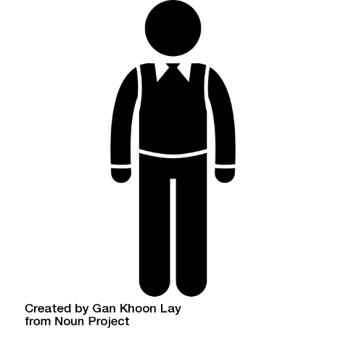

**had evidence of an alcohol use disorder.**

Average age

**50.5**

Male

**94%**

Average age

**41.4**

Male

**73%**

**Of those with evidence of drug use on scene,**

**Of decedents tested,**

**47%**

tested

positive for

**cocaine.**

**92%**

tested

positive for

**opioids.**

**Of decedents tested,**

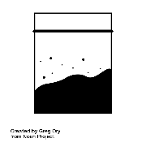

**Person icon:** Vaibhav Radhakrishnan from the Noun Project | **Massachusetts icon:** Linseed Studio from the Noun Project | **Mental health icon:** HeadsOfBirds from the Noun Project

**Cocaine icon:** Adrien Coquet from the Noun Project | **Drugs icon:** kareemovic2000 from the Noun Project | **Alcohol icon:** Adrien Coquet from the Noun Project | **Male Person icon:** Gan Khoon Lay | **Pill Icon:** tang5000 | **Alcohol Bottle:** Rainbow Designs | **Nasal Spray icon:** Prettycons from the Noun Project | **House icon**: Adrien Coquet from the Noun Project

**Data Source**: State Unintentional Drug Overdose Reporting System (SUDORS), Massachusetts Department of Public Health (DPH). Military status was ascertained from death certificates and medical examiner reports. All data were collected using guidelines recommended by the Centers for Disease Control and Prevention (CDC) and are based upon the International Classification of Disease codes (ICD-10) for mortality. CDC analytic file dated 10 Nov 2020 (total number of decedents reported on: 2,176).

