COMMONWEALTH OF MASSACHUSETTS

SUFFOLK COUNTY BOARD OF REGISTRATION IN PHARMACY

In the Matter of )
cvs #9 )
DS16477 )
Expires: December 31, 2015 )
PHA-2014-0160

CONSENT AGREEMENT FOR PROBATION

The Massachusetts Board of Registration in Pharmacy ("Board") and CVS Pharmacy #9 ("Licensee" or "Pharmacy"), DS16477, 300 Squire Road, Revere, Massachusetts, do hereby stipulate and agree that the following information shall be entered into and become a permanent part of the Pharmacy's record maintained by the Board:

- The Pharmacy acknowledges that the Board opened a complaint against its Massachusetts pharmacy license related to the conduct set forth in Paragraph 2, identified as Docket No. PHA-2014-0160 .1

- The Board and the Pharmacy acknowledge and agree to the following facts:

  - On or about May 28, 2014, Board Investigators conducted a compliance inspection of the Pharmacy and observed the following violations:

- Pharmacy failed to maintain proper supervisory ratios, in violation of 247 CMR 8.06(3);
ii. Expired medication was not included in the perpetual
inventory, in violation of 247 CMR 9.01(14);
iii. Pharmacy was not maintain d in a clean and sanitary
manner including, ceiling tiles which had water damage and a black substance on them and drawers used to store amber bottles were dirty and contained loose pills, in violation of 247 CMR 6.02(1);

1 The term "registration" applies to both a current registration and the right to renew an expired registration.

CVS #9 DS16477
PHA-2014-0160

Page 1 of 5

iv. An emergency schedule II prescription was received for a quantity of 60 oxycodone 5mg tablets with directions of one tablet twice a day as needed, in violation of 247 CMR 5.03(2)(a);
v. Expired medication in the refrigerator, in violation of 247 CMR 9.01(10);
vi. Freezer was not in proper temperature range, in violation of 247 CMR 9.01(1) & (5) and Board Policy No. 2011-01;
vii. Refrigerator temperatures were not recorded twice daily and the refrigerator did not have an out of range alarm, in violation of 247 CMR 9.01(1) and Board Policy No.
2011-01;
viii. Compounding area was not maintained in a clean and sanitary manner and contained beverages, in violation of 247 CMR 9.01(3) and USP 795;
- A graduated cylinder used for reconstitution was visibly dirty, in violation of247 CMR 9.01(3) and USP 795;
- The sink counter top and the cabinet door had exposed
particle board and laminate damage, in violation of 247 CMR 6.02(1), 247 CMR 9.01(3), and USP 795;
xi Pharmacy failed to provide copies of pharmacist vaccination certifications, in violation of 105 CMR. 700.004(6)(c} and Board Policy No. 2012-02;
xii. Inspector observed an unlabeled prescription vial that contained medication in the compounding area, m violation of247 CMR 9.01(3) and USP <795>;
xiii. API used for compounding was not labeled with an open date for determining BUD assignment, in violation of 247 CMR 9.01(3) and USP <795>.

  - On or about July 3, 2014, Board Investigators conducted a compliance inspection of the pharmacy and observed the following violations:

- Pharmacy failed to maintain accurate dates for the shipment of controlled substances in the perpetual inventory log, in violation of 247 CMR 9.01(1) and 21 CFR 1304.21(d);
ii. Pharmacy was not maintained in a clean and sanitary manner including, faded stains on ceiling tiles and dusty shelves, in violation of 247 CMR 6.02(1); and
iii. Expired medication on shelves, in violation of 247 CMR 9.01(10).

CVS #9 DS16477 PIIA·2014·0160

Page 2 of 5

c. On or about May 15, 2015, Board Investigators conducted a compliance inspection of the Pharmacy and observed the pharmacy failed to maintain proper supervisory ratios, in violation of 247 CMR 8.06(3).

- The Foregoing facts warrant disciplinary action by the Board under M.G.L. c. 112 §§ 42A & 61 and 247 CMR 10.03.

- The Pharmacy agrees that its registration shall be placed on PROBATION for one (1) year ("Probationary Period"), commencing with the date on which the Board signs this Agreement ("Effective Date").

- During the Probationary Period, the Pharmacy further agrees that it shall comply in all material respects with all Massachusetts laws and regulations governing the practice of pharmacy and pertinent provisions of the United States Pharmacopeia.

- During the Probationary Period, the Pharmacy further agrees that it shall submit documentation demonstrating that the current Manager of Record, the former Manager of Record (if still he/she is currently employed by CVS), the area supervisor, and the former area supervisor (if still he/she is currently employed by CVS) attest to reading all of 247 CMR 2.00 et seq.

- The Board agrees that in return for the Pharmacy's execution and successful compliance with the requirements of this Agreement it will not prosecute the Complaint.

- If the Pharmacy has complied to the Board's satisfaction with all the requirements contained in this Agreement, the Probationary Period will terminate one (1) year after the Effective Date upon written notice to the Pharmacy from the Board 2•

- If the Pharmacy does not materially comply with each requirement of this Agreement, or if the Board opens a Subsequent Complaint 3 during the Probationary Period, the Pharmacy agrees to the following:

2 In all instances where this Agreement specifies written notice to the Pharmacy from the Board, such notice shall be sent to the Pharmacy’s address of record.
3 The term "Subsequent Complaint" applies to a complaint opened after the Effective Date concerning acts, omissions, or events occurring after the Effective Date, which (1) alleges that the Pharmacy engaged in conduct that violates Board statutes or regulations, and (2) is

CVS #9
DS16477
PHA-2014-0160

Page 3 of 5

- The Board may upon written notice to the Pharmacy, as warranted to protect the public health, safety, or welfare:

- EXTEND the Probationary Period; and/or

ii. MODIFY the Probation Agreement requirements; and/or

iii. IMMEDIATELY SUSPEND the Pharmacy's license.

b. If the Board suspends the Pharmacy's license pursuant to Paragraph 9(a)(iii), the suspension shall remain in effect until:

- the Board provides the Pharmacy written notice that the Probationary Period is to be resumed and under what terms; or

ii. the Board and the Pharmacy s1gn a subsequent agreement; or

iii. the Board issues a written final decision and order following adjudication of the allegations (1) of noncompliance with this Agreement, and/ or (2) contained in the Subsequent Complaint.

10. The Pharmacy agrees that if the Board suspends its license in accordance with Paragraph 9, it will immediately return its current Massachusetts license to the Board, by hand or certified mail. The Pharmacy further agrees that upon said suspension, it will no longer be authorized to operate as a pharmacy in the Commonwealth of Massachusetts and shall not in any way represent itself as a pharmacy until such time as the Board reinstates its license or right to renew such license.

11. The Pharmacy understands that it has a right to formal adjudicatory hearing concerning the Complaint and that during said adjudication it would possess the right to confront and cross-examine witnesses, to call witnesses, to present evidence, to testify on its own behalf, to contest the allegations, to present oral argument, to appeal to the courts, and all other rights as set forth in the Massachusetts Administrative Procedures Act, M.G.L. c. 30A, and the Standard Adjudicatory Rules of Practice and Procedure, 801 CMR 1.01 et seq.

substantiated by evidence, as determined following the complaint investigation during which the Pharmacy shall have an opportunity to respond.

CVS #9
DS16477
PHA-2014·0160

Page 4 of 5

The Pharmacy further understands that by executing this Agreement it is knowingly and voluntarily waiving its right to a formal adjudication of the Complaints.

- The Pharmacy acknowledges that it has been at all times free to seek and use legal counsel in connection with the Complaint and this Agreement.

- The Pharmacy acknowledges that after the Effective Date, the Agreement constitutes a public record of disciplinary action by the Board. The Board may forward a copy of this Agreement to other licensing boards, law enforcement entities, and other individuals or entities as required or permitted by law.

- The Pharmacy certifies that it has read this Agreement. The Pharmacy understands and agrees that entering into this Agreement is a voluntary and final act and not subject to reconsideration, appeal or judicial review.

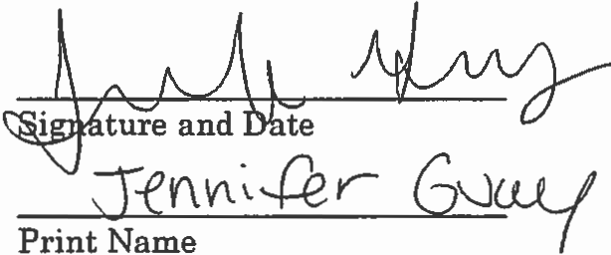
CVS Pharmacy
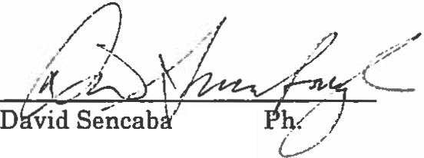

.

Executive Director
Board of Registration in Pharmacy

12-16-15

Effective Date of Probation Agreement

Fully Signed Agreement Sent to Registrant on 12/18/2015 by

Certified Mail No. 7015 3010 0001 7079 9796

cvs #9
DS16477
PHA-2014·0160

Page 5 of 5

