COMMONWEALTH OF MASSACHUSETTS

SUFFOLK COUNTY BOARD OF REGISTRATION IN PHARMACY

)
In the Matter of )
CVS Pharmacy #913 )
License No. DS3437 ) Expires December 31, 2015 )

Docket No. PHA-2015-004 7

CONSENT AGREEMENT FOR REPRIMAND

The Massachusetts Board of Registration in Pharmacy ("Board") and CVS Pharmacy #913 located at 19 Summer Street in Bridgewater, Massachusetts ("Licensee" or "Pharmacy"), a pharmacy licensed by the Board, license number DS3437 ("License" or "registration"), do hereby stipulate and agree that the following information shall be entered into and become a permanent part of the Pharmacy's record maintained by the Board:

1. The Pharmacy acknowledges that the Board opened a Complaint against its Massachusetts License related to the conduct set forth in Paragraph 2, identified as Docket Number PHA-2015-0047 ("Complaint").

- The Board and the Pharmacy acknowledge and agree to the following facts:

  - On or about August 8, 2014, Office of Public Protection investigators conducted a compliance inspection of the Pharmacy ("Inspection I'') and observed the following regulatory deficiencies:

    - Pharmacy failed to reconcile expired Schedule II controlled substance inventories every ten days in violation of 247 CMR 9.01(14);

ii. Pharmacy failed to maintain required supervisory ratios in that one pharmacist, one certified and registered technician, one registered and uncertified technician and two technicians in training were observed on duty in violation of 247 CMR 8.06(3);

iii. Pharmacy failed to have a balance tested and sealed by the state or local sealer of weights and measures annually in violation of 247 CMR 6.01(5)(a)(4);

- Pharmacy failed to comply with United States Pharmacopoeia (USP) Compounding Standards <795> in violation of 247 CMR 9.01(3) by failing to maintain complete compounding records that included complete stability data and beyond use dates (BUD);

- Pharmacy failed to post a sign complying with 247 CMR 9.07(3)(c), informing customers of their rights to counseling by a pharmacist;

vi. Pharmacy failed to maintain documentation of current CPR certification for all pharmacists administering immunizations in violation of Board Policy 2012-02.

  - On or about, December 3, 2014, Office of Public Protection investigators conducted a compliance inspection of the Pharmacy ("Inspection II'') and observed the following regulatory deficiencies:

    - Pharmacy failed to maintain required supervisory ratios in that one pharmacist, one certified and registered technician, one registered and uncertified technician and two technicians in training were observed on duty in violation of247 CMR 8.06(3);

ii. Pharmacy, through Manager of Record ("MOR"), failed to establish procedures and policies which maintain professional practice standards as related to dispensing of pharmaceuticals in violation of 247 CMR 6.07(1)(e), by maintaining seventy-six baskets containing prescriptions and medications vials waiting verification;

iii. Pharmacy failed to provide documentation that technician in training had no more than 1000 hours absent an extension granted by the Board in violation of 247 CMR 8.03(3); and

iv. Pharmacy failed to have a balance tested and sealed by the state or local sealer of weights and measures annually in violation of 247 CMR 6.01(5)(a)(4).

  - The foregoing facts warrant disciplinary action by the Board under M.G.L. c. 112 §§ 42A, 247 CMR 10.03(1)(v), and 247 CMR 10.03(l)(b).

CVS Pharmacy #913
DS3437
PHA-2015-0017

Page 2 of 4
- The Pharmacy agrees that the Board shall impose a REPRIMAND on its License based on the facts admitted in Paragraph 2, effective as of the date on which the Board signs this Agreement ("Effective Date").

- The Board requires a satisfactory and on-going Plan of Correction from the District Manager.

- The Board agrees that in return for the Pharmacy's execution and successful compliance with all the requirements of this Agreement, the Board will not prosecute the Complaint.

- The Pharmacy understands that it has a right to formal adjudicatory hearing concerning the Complaint and that during said adjudication the Pharmacy would possess the right to confront and cross-examine witnesses, to call witnesses, to present evidence, to testify on its own behalf, to contest the allegations, to present oral argument, to appeal to the courts, and all other rights as set forth in the Massachusetts Administrative Procedures Act,
M.G.L. c. 30A, and the Standard Adjudicatory Rules of Practice and Procedure, 801 CMR 1.01 et seq. The Pharmacy further understands that by executing this Agreement the Pharmacy is knowingly and voluntarily waiving its right to a formal adjudication of the Complaint.

- The Pharmacy acknowledges that it has been at all times free to seek and use legal counsel in connection with the Complaint and this Agreement.

- The Pharmacy acknowledges that after the Effective Date, the Agreement constitutes a public record of disciplinary action by the Board subject to the Commonwealth of Massachusetts' Public Records Law, M.G.L. c. 4, §7. The Board may forward a copy of this Agreement to other licensing boards, law enforcement entities, and other individuals or entities as required or permitted by law.

- The Pharmacy understands and agrees that entering into this Agreement is a voluntary and final act and not subject to reconsideration, appeal or judicial review.

- The individual signing this Agreement certifies that he/she is authorized to enter into this Agreement on behalf of the Pharmacy, and that he/she has read this Agreement.

CVS Pharmacy #913
DS3437
PHA-2015-0047

Page 3 of 4

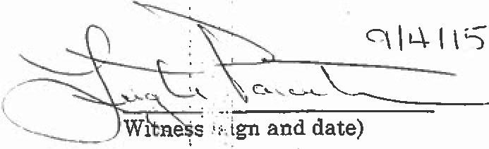
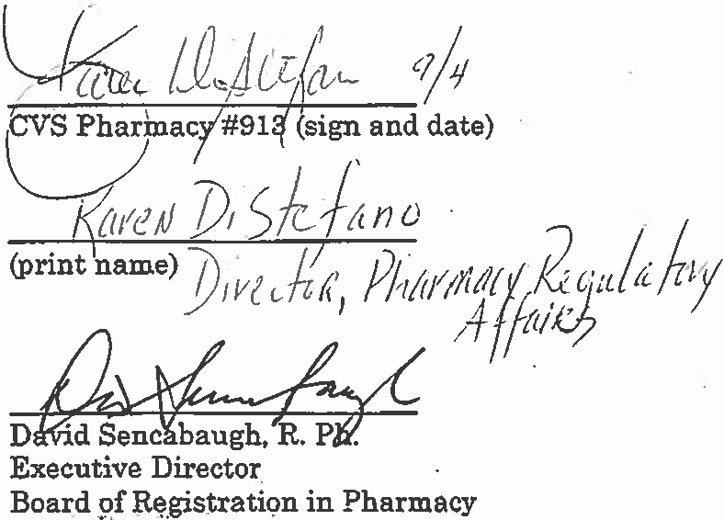

'

9/28/2015
Effective Date of Reprimand Agreement

Fully Signed Agreement Sent to Licensee on 10/2/2015 by

Certified Mail No. 7015 1520 0002 8254 7764

.
:

' .

Page 4 of 4

