Introduction
The Cybersecurity Improvements Grant Application (Application) includes 7 Appendixes, A-G, which include forms, statements, and certifications relevant to the grant. Review each appendix description and appendix, submitting all required information to the provided link listed under “WHAT DO I DO WITH THIS APPENDIX?”.

Projects cannot be officially approved until the required materials in Appendices A – D are submitted. If you have any questions while completing the application and required forms, contact MassDEP Drinking Water Program at program.director-dwp@mass.gov, subject, Cybersecurity Improvement Grant.
Appendix A: Authority to File Statement & Certifying Statement
WHAT IS INCLUDED IN THIS APPENDIX?
- Sample Authority to File Statement (Required)
- Sample Certifying Statement (Required if the Authority to File names an office)

WHAT IS THE PURPOSE OF THIS APPENDIX?
The application must contain a resolution or authorization designating by title the official (Mayor, City or Town Manager, Chairperson of the Board of Sewer Commissioners, Chairperson of the Select Board, etc.) to act as the representative of the applicant to sign for, accept, and take whatever action is necessary relative to the project. If the authority to file statement names an office, then a certified statement is required specifically identifying the individual currently holding that office. In the event the authorized official is replaced while the project is still active, a revised statement naming the new incumbent and the effective date of appointment must be submitted. On occasion an authorized representative may desire to delegate to another person the authority to also act on their behalf in processing paperwork during the implementation of the project. This is accomplished by having the authorized representative submit a letter advising of this delegation.

HOW DO I USE THIS APPENDIX?
Replace the content highlighted with your information and put these statement(s) on the PWS’ own letterhead.

WHAT DO I DO WITH THIS APPENDIX?
These statements are required to be submitted along with your Application and Scope of Work (SOW-CYBER) to MassDEP/DWP PWS Cybersecurity Improvement Grant Application Submission (smartsheet.com).
[https://app.smartsheet.com/b/form/ 900e35c760c24631ac208b462048fd4b].
Appendix B: Model Professional Services Agreements
WHAT IS INCLUDED IN THIS APPENDIX?
Required contract provisions.

WHAT IS THE PURPOSE OF THIS APPENDIX?
All contracts between SRF beneficiaries and professional services consultants must contain the listed provisions in this appendix.

HOW DO I USE THIS APPENDIX?
Copy/paste the listed provisions into all contracts between SRF beneficiaries and professional services consultants.

WHAT DO I DO WITH THIS APPENDIX?
At your earliest convenience following the submission of your Application, PWS must submit drafted professional service agreements which contain the listed provisions to MassDEP/DWP PWS Cybersecurity Improvement Grant Application Submission (smartsheet.com).

Appendix C: Disadvantaged Business Enterprise (DBE) Documents
WHAT IS INCLUDED IN THIS APPENDIX?
- DBE Guidance Document
- Documentation to prove PWS are meeting DBE requirements, including:
  - Schedule of Participation for Professional Services (Form EEO-DEP-190E)
  - Letter of Intent for Professional Services (Form (EEO-DEP-191E)
  - DBE Certification of United States Citizenship
- Documentation if PWS cannot meet the DBE requirements and have made every effort to meet the requirements.
  - Request for Waiver for Professional Services (Form EEO-DEP-490E)

WHAT IS THE PURPOSE OF THIS APPENDIX?
PWS when receiving a grant such as the Cybersecurity Improvements Grant are required to follow federal requirements regarding use of Disadvantaged Business Enterprise (DBE) for Professional Service Contracts. The Guidance Document provided will go over required forms and procedures to implement this condition. The forms/documents in this appendix serve to provide documentation that PWS are meeting the DBE requirements.

HOW DO I USE THIS APPENDIX?
- Schedule of Participation for Professional Services (Form EEO-DEP-190E)
This form must be completed by the PWS and lists the businesses/consultants that the PWS will be working with that are considered DBEs.

- Letter of Intent for Professional Services (Form EEO-DEP-191E)
This form must be completed by each DBE that the PWS will be working with. This form must be submitted to the PWS’s Prime Consultant.

- DBE Certification of United States Citizenship
This form must also be completed by each DBE that PWS will be working with. This form is used for MassDEP to verify the citizenship of DBE owner(s)/controller(s).

- Request for Waiver for Professional Services (Form EEO-DEP-490E).
If PWS cannot meet the DBE requirements and have made every effort to meet the minimum requirements, PWS may ask to be relieved of these requirements using a waiver. This form must be completed by the PWS Prime Consultant, and the PWS must submit evidence that minimum efforts have been taken, listed on the form.

WHAT DO I DO WITH THIS APPENDIX?
At your earliest convenience following the submission of your Application, PWS must submit the required forms in this appendix to MassDEP/DWP PWS Cybersecurity Improvement Grant Application Submission (smartsheet.com).
[https://app.smartsheet.com/b/form/ 900e35c760c24631ac208b462048fd4b].
Appendix D: Sample Compliance Tax Statement
WHAT IS INCLUDED IN THIS APPENDIX?
- Sample Statement of Tax Compliance

WHAT IS THE PURPOSE OF THIS APPENDIX?
The statement of tax compliance must be completed by all consulting engineers, to prove that the consulted engineers have complied with all laws of Commonwealth of Massachusetts regarding taxes.

HOW DO I USE THIS APPENDIX?
The statement in this appendix must be copied into a separate document using the Consultant Engineer’s official letterhead. Replace the content enclosed in brackets [] and highlighted with your own information.

WHAT DO I DO WITH THIS APPENDIX?
At your earliest convenience following the submission of your Application, PWS must submit the Statement of Tax Compliance, completed by consulting engineers, to MassDEP/DWP PWS Cybersecurity Improvement Grant Application Submission (smartsheet.com).
Appendix E: Example Project Approval Certificate
WHAT IS INCLUDED IN THIS APPENDIX?
An example of a Project Approval Certificate.

WHAT IS THE PURPOSE OF THIS APPENDIX?
This appendix is for reference purposes only. The Project Approval Certificate (PAC) will be issued to PWS whose projects were approved and may begin work. This appendix provides an example of the Project Approval Certificate.

HOW DO I USE THIS APPENDIX?
This appendix is for reference purposes only.

WHAT DO I DO WITH THIS APPENDIX?
You do not have to do anything with this appendix. It is provided for informational and reference purposes only.
Appendix F: Sample Reimbursement Form
WHAT IS INCLUDED IN THIS APPENDIX?
This appendix provides an example of the reimbursement form that PWS will be required to submit after they begin work.

WHAT IS THE PURPOSE OF THIS APPENDIX?
Once a financial assistance agreement has been executed with the Trust, the PWS may begin their project. Projects under this grant will be funded through the use of submitted invoices on a schedule chosen by MassDEP using the reimbursement form provided. PWS must submit this form to be provided the grant amount matching the recently submitted invoice. Do not include any sensitive information in this submittal.

HOW DO I USE THIS APPENDIX?
This appendix is for reference purposes only.

WHAT DO I DO WITH THIS APPENDIX?
You do not have to do anything with this appendix. It is provided for informational and reference purposes only. You will be provided with the reimbursement form and submission instructions after the project has been approved.
Appendix G: Sample Project Completion Certificate
WHAT IS INCLUDED IN THIS APPENDIX?
- Sample Project Completion Certificate

WHAT IS THE PURPOSE OF THIS APPENDIX?
The Project Completion Certificate (PCC) must be submitted by the PWS after the project has been completed. The final 10% of the Cybersecurity Improvement Grant will be distributed to the PWS after the PCC has been submitted and approved.

HOW DO I USE THIS APPENDIX?
Replace the content highlighted in this appendix with your information and put these statement(s) on the PWS’ own letterhead.

WHAT DO I DO WITH THIS APPENDIX?
The Project Completion Certificate (PCC) must be submitted by the PWS to program.director-dwp@mass.gov after the project has been completed.

APPENDIX A
Sample Authority to File Statement
The statement provided below is a sample statement, this statement must be copied onto a separate document with official PWS letterhead when submitted. Replace the content enclosed by brackets [ ] and highlighted with your own information.

-------------------------------------- SAMPLE BEGINS FOLLOWING THIS LINE -------------------------------------------

AUTHORITY TO FILE

Whereas, [Applicant], after thorough investigation,has determined that the work activity consisting of: [describe project] is both in the public interest and necessary to protect the public health, and that to undertake this activity, it is necessary to apply for assistance; and

Whereas, the Massachusetts Department of Environmental Protection (MassDEP) and the Massachusetts
Clean Water Trust (the Trust) of the Commonwealth of Massachusetts, pursuant to Chapter 21 and Chapter 29C of the General Laws of the Commonwealth (Chapter 21 and Chapter 29C) are authorized to make loans and grants to municipalities for the purpose of funding planning and construction activities relative to Water Pollution Abatement Projects and Drinking Water Projects; and

Whereas, the Applicant has examined the provisions of the Act, Chapter 21 and Chapter 29C, and believes it to be in the public interest to file a loan or grant application.

NOW, THEREFORE, BE IT RESOLVED by [Governing Body]

as follows:

- That [Title of Official] is hereby authorized on behalf of the Applicant to file applications and execute agreements for grant and/or loan assistance as well as furnishing such information, data and documents pertaining to the applicant for a grant(s) and/or loan(s) as may be required; and otherwise to act as the authorized representative of the Applicant in connection with this application;

- That the purpose of said loan(s)/grant(s), if awarded, shall be to fund approved activities.

- That if said award is made the Applicant agrees to pay those costs which constitute the required Applicant's share of the project cost.

-------------------------------------- SAMPLE ENDS PRIOR TO THIS LINE -------------------------------------------------

APPENDIX A
Sample Certifying Statement
The statement provided below is a sample statement, this statement must be copied onto a separate document with official PWS letterhead when submitted. Replace the content enclosed by brackets [ ] and highlighted with your own information.

-------------------------------------- SAMPLE BEGINS FOLLOWING THIS LINE -------------------------------------------

CERTIFYING STATEMENT

I hereby certify that the [Name of Governing Body] of the [Corporate Name of Local Government Unit] (hereinafter referred to as the "Applicant"), at a meeting noticed and conducted in accordance with all applicable legal requirements, duly voted to authorize [Title of Local Government Unit Official] to act on behalf of the Applicant, as its agent, in filing applications for, executing agreements regarding, and performing any and all other actions necessary to secure for the Applicant such as grant(s) and/or loan(s) for planning or construction of Water Pollution Abatement Projects or Drinking Water Projects as may be made available to the Applicant pursuant to the provisions of the Massachusetts Clean Waters Act (M.G.L. c.21, section 27-33E, inclusive, as amended) and the State Revolving Funds Drinking Water Program for the following project: [describe project]

I hereby certify that [Name of Person] is the present incumbent of the position referenced above, and do hereby certify:

- That the attached resolution is a true and correct copy of the resolution as finally adopted at a meeting of the governing body held on the [ day of month] day of [month, year] and duly recorded in my office.

- That said meeting was duly convened and held in all respects in accordance with law and to the extent required by law, due and proper notice of such meeting was given; and a legal quorum was present throughout the meeting, and a legally sufficient number of members of the governing body voted in the proper manner and for the adoption of said resolution; that all other requirements and proceedings under the law incident to the proper adoption or passage of said resolution, including publication, if required, have been duly fulfilled, carried out, and otherwise observed; and that I am authorized to execute this certificate.

- That if an impression of a seal has been affixed below, it constitutes the official seal of the Applicant and this certificate is hereby executed under such official seal; but if no seal has been affixed, the Applicant does not have an official seal:

IN WITNESS WHEREOF, I have hereunto set my hand this day of [day of month] day of [month, year].

Signature: Title:
Printed name:

[AFFIX SEAL]

-------------------------------------- SAMPLE ENDS PRIOR TO THIS LINE -------------------------------------------------

APPENDIX B
Model Professional Services Agreements
All contracts between SRF beneficiaries and professional services consultants shall contain the following provisions. PWS must submit a drafted service provision agreement with consulting engineers before projects may be approved.

-------------------------------------- PROVISIONS BEGINS FOLLOWING THIS LINE -------------------------------------

(1) The owner and the contractor agree that the following provisions apply to the eligible work to be performed under this agreement and that such provisions supersede any conflicting provisions of this agreement.
(2) The work under this agreement is funded in part by the American Rescue Plan Act. Neither the Commonwealth of Massachusetts nor the Massachusetts Department of Environmental Protection (MassDEP) nor the Clean Water Trust (the Trust) is a party to this agreement. As used in these clauses, the words "the date of execution of this agreement" means the date of execution of this agreement and any subsequent modification of the terms, compensation or scope of services pertinent to unperformed work.
(3) The owner's rights and remedies provided in these clauses are in addition to any other rights and remedies provided by law or this agreement.
(4) The contractor shall be responsible for the professional quality, technical accuracy, timely completion, and the coordination of all designs, drawings, specifications, reports, and other services furnished by the contractor under this agreement. The contractor shall without additional compensation, correct or revise any errors, omissions, or other deficiencies in his designs, drawings, specifications, reports, and other services.
(5) The contractor shall perform such professional services as may be necessary to accomplish the work required to be performed under this agreement, in accordance with this agreement and applicable MassDEP requirements in effect on the date of execution of this agreement.
(6) The owner's or MassDEP’s approval of drawings, designs, specifications, reports, and incidental work or materials furnished hereunder shall not in any way relieve the contractor of responsibility for the technical adequacy of his work. Neither the owner's nor MassDEP’s review, approval or acceptance of, nor payment for, any of the services shall be construed to operate as a waiver of any rights under this agreement or of any cause of action arising out of the performance of this agreement.
(7) The contractor shall be and shall remain liable, in accordance with applicable law, for all damages to the owner or MassDEP caused by the contractor's negligent performance of any of the services furnished under this agreement, except for errors, omissions or other deficiencies to the extent solely attributable to the owner, owner-furnished data or any third party not controlled by the contractor. The contractor shall not be responsible for any time delays in the project caused by circumstances beyond the contractor's control. Where innovative processes or techniques are recommended by the engineer and are used, the engineer shall be liable only for gross negligence to the extent of such use.
(8) The services to be performed by the contractor shall include all services required to complete the scope of work as defined and set out in the professional services agreement to which these provisions are attached in accordance with applicable regulations.
(9) The owner may, at any time, by written order, make changes within the general scope of this agreement in the services or work to be performed. If such changes cause an increase or decrease in the contractor's cost of, or time required for, performance of any services under this agreement, whether or not changed by any order, an equitable adjustment shall be made, and this agreement shall be modified in writing accordingly. The contractor must assert any claim for adjustment under this clause in writing within 30 days from the date of receipt by the contractor of the notification of change, unless the owner grants a further period of time before the date of final payment under this agreement.
(10) No services for which an additional compensation will be charged by the contractor shall be furnished without the written authorization of the owner.
(11) In the event that there is a modification of MassDEP’s requirements relating to the services to be performed under this agreement after the date of execution of this agreement, the increased or decreased cost of performance of the services provided for in this agreement shall be reflected in an appropriate modification of this agreement.
(12) Either party may terminate this agreement, in whole or in part, in writing, if the other party substantially fails to fulfill its obligations under this agreement through no fault of the terminating party. However, no such termination may be effected unless the other party is given (1) not less than ten calendar days written notice (delivered by certified mail, return receipt requested) of intent to terminate and (2) an opportunity for consultation with the terminating party before termination.
(13) The owner may terminate this agreement, in whole or in part, in writing, for its convenience, if the termination is for good cause (such as for legal or financial reasons, major changes in the work or program requirements, initiation of a new phase) and the contractor is given (1) not less than ten calendar days written notice (delivered by certified mail, return receipt requested) of intent to terminate, and (2) an opportunity for consultation with the terminating party before termination.
(14) If the owner terminates for default, an equitable adjustment in the price provided for in this agreement shall be made, but (1) no amount shall be allowed for anticipated profit on services not performed or other work, and (2) any payment due to the contractor at the time of termination may be adjusted to the extent of any additional costs the owner incurs because of the contractor's default.
If the contractor terminates for default or if the owner terminates for convenience, the equitable adjustment shall include a reasonable profit for services or other work performed. The equitable adjustment for any termination shall provide for payment to the contractor for services rendered and expenses incurred before the termination, in addition to termination settlement costs the contractor reasonably incurs relating to commitments which had become firm before the termination.
(15) Upon receipt of a termination action under paragraphs (13) or (14), the contractor shall (1) promptly discontinue all services affected (unless the notice directs otherwise), and (2) deliver or otherwise make available to the owner all data, drawings, specifications, reports, estimates, summaries, and such other information and materials as the contractor may have accumulated in performing this agreement, whether completed or in process.
(16) Upon termination under paragraph (13) or (14), the owner may take over the work and prosecute the same to completion by agreement with another party or otherwise. Any work the owner takes over for completion will be completed at the owner's risk, and the owner will hold harmless the contractor from all claims and damages arising out of improper use of the contractor's work.
(17) If, after termination for failure of the contractor to fulfill contractual obligations, it is determined that the contractor had not so failed, the termination shall be deemed to have been effected for the convenience of the owner. In such event, adjustment of the price provided for in this agreement shall be made as paragraph (14) provides.
(18) Except as this agreement otherwise provides, all claims, counter-claims, disputes, and other matters in question between the owner and the contractor arising out of or relating to this agreement or the breach of it will be decided by arbitration if the parties hereto mutually agree, or in a court of competent jurisdiction pursuant to the laws of Massachusetts.
(19) The Contractor shall maintain books, records, documents, and other evidence directly pertinent to performance on eligible work under this agreement in accordance with generally accepted accounting principles and practices consistently applied. The contractor shall also maintain the financial information and data used by the contractor in the preparation or support of the cost submission and a copy of the cost summary submitted to the owner. The Governor, the Secretary of Administration and Finance, MassDEP and State Auditor's Office or any of their duly authorized representatives, shall have access to such books, records, documents, and other evidence for inspection, audit, and copying. The contractor will provide proper facilities for such access and inspection.
(20) The contractor agrees to include paragraphs (19)-(23) in all his contracts and all subcontracts directly related to project performance that are in excess of $25,000.
(21) Audits conducted under this provision shall be in accordance with generally accepted auditing standards and established procedures and guidelines of the reviewing or audit agency(ies).
(22) The contractor agrees to the disclosure of all information and reports resulting from access to records under paragraphs (19) or (20), to any of the agencies referred to in paragraph (19), provided that the contractor is afforded the opportunity for an audit exit conference and an opportunity to comment and submit any supporting documentation on the pertinent portions of the draft audit report and that the final audit report will include written comments of reasonable length, if any, of the contractor.
(23) The contractor shall maintain and make available records under paragraph (19) and (20) during performance on eligible work under this agreement and until 7 years from the date of final payment for the project. In addition, those records which relate to any "Dispute", appeal under an assistance agreement, to litigation, to the settlement of claims arising out of such performance, or to costs or items to which an audit exception has been taken, shall be maintained and made available until 3 years after the date of resolution of such appeal, litigation, claim, or exception if such date is later than seven years from the date of final payment.
(24) (This clause is applicable if the amount of this agreement exceeds $100,000). If the owner or MassDEP determine that any price, including fee, negotiated in connection with this agreement or any cost reimbursable under this agreement was increased by any sums because the contractor or any subcontractor furnished incomplete or inaccurate cost or pricing data or data not current as certified in his certification of current cost or pricing data, then such price, cost, or fee shall be reduced accordingly and the agreement shall be modified in writing to reflect such reduction.

-------------------------------------- PROVISIONS END PRIOR TO THIS LINE ---------------------------------------------

APPENDIX C
Disadvantaged Business Enterprise (DBE) Documents

- Purpose
The purpose of this guidance document is to assist public water suppliers (PWS and their Prime Consultant in demonstrating compliance with the United States Environmental Protection Agency (EPA) requirements for disadvantaged business enterprise (DBE) participation in professional services contracts.

- Requirements
DISADVANTAGED BUSINESS ENTERPRISE PROGRAM BACKGROUND
In May 2008 an EPA rule became effective that changed the Minority Business Enterprise (MBE) and Women Business Enterprise (WBE) Program to a Disadvantaged Business Enterprise (DBE) Program.
For firms to qualify under the old MBE/WBE program they needed to be socially disadvantaged and had to be certified by the Supplier Diversity Office (SDO). Under the DBE rule, the firms must be both socially and economically disadvantaged, citizens of the United States, and certified as a DBE either by the state or the federal government. Women and certain minorities are presumed to be socially disadvantaged. The economic disadvantage is measured by the owner’s initial and continuing personal net worth of less than $1,320,000.
Because the Clean Water Act requires the use of MBEs and WBEs, these firms will still be utilized in the State Revolving Fund (SRF) Loan/Grant Program, but they must also be certified as DBEs.
SDO will continue to be the certifying agency for the SRF program. SDO certifies firms under the federal Department of Transportation program, which is acceptable for use in the SRF program. An additional form has been added to the DBE package to verify that DBEs are owned or controlled by United States citizens.
The following are the current DBE goals:
Disadvantaged MBEs 4.2% Disadvantaged WBEs 4.5% .

- Procedures

  - In cases where the professional services contracts achieve the goal of 4.2% D/MBE and 4.5% D/WBE participation, the PWS and/or its Prime Consultant is required to submit Form EEO-DEP- 190E (Schedule of Participation for Professional Services) and Form EEO-DEP-191E (Letter of Intent) to MassDEP. Form EEO-DEP-190E identifies the proposed DBE subcontractors, the type of services to be provided by each subcontractor (e.g., Architecture, preparation of O&M manuals, laboratory analysis, etc.), and the respective dollar value of their participation. Form EEO-DEP- 191E must be completed for each D/M/WBE subcontractor identified on Form EEO-DEP-190E. Each DBE must also sign the Certification of United States Citizenship form to verify that the firm is owned or controlled by a United States citizen.

  - In the event that a professional services contract does not achieve the goal of 4.2% D/MBE and 4.5% D/WBE participation, MassDEP may request that the PWS’s Prime Consultant provide additional documentation demonstrating what positive efforts were made to achieve the participation goal. In cases where the PWS’s Prime Consultant fails to demonstrate the 4.2% D/MBE and 4.5% D/WBE participation in the professional services contract, the Prime Consultant must submit Form EEO-DEP- 490E (Request for Waiver), together with the supporting documentation identified therein, to MassDEP.

  - MassDEP's project approval certificate shall contain a condition requiring the PWS's Prime Consultant to submit all executed consultant contracts, including contracts with D/M/WBE subcontractor(s) if in excess of $25,000, to MassDEP within sixty (60) days from the date of the award of financial assistance to the PWS by the Clean Water Trust (the Trust).

  - In order for MassDEP to monitor compliance with its above stated D/M/WBE provisions for professional services contracts, any PWS who does not file monthly or bi-monthly Payment Requisitions on Form 3000 (Consultant Engineer's Request and Certification) to document D/M/WBE activity, will be required at a minimum to submit Form EEO-DEP-390E (Quarterly D/M/WBE Activity Report) on a quarterly basis. The Form EEO-DEP-390E is not attached to this package but will be made available to those that need to use it when the Form 3000 reporting is not an option.

DISADVANTAGED BUSINESS ENTERPRISE PARTICIPATION MASSACHUSETTS DEPARTMENT OF ENVIRONMENTAL PROTECTION DIVISION OF MUNICIPAL SERVICES
SCHEDULE OF PARTICIPATION FOR PROFESSIONAL SERVICES

Project Title: Project Location:

Disadvantaged Minority Business Enterprise Participation in the SRF Loan/Grant Work
Name & Address of D/MBE | Nature of Participation | Dollar Value of Participation
Total D/MBE Commitment:  Percentage D/MBE Participation = (Total D/MBE Commitment) / Total Engineering Cost) = |  | $  %

Disadvantaged Women Business Enterprise Participation in the SRF Loan/Grant Work
Name & Address of D/WBE | Nature of Participation | Dollar Value of Participation
Total D/WBE Commitment:  Percentage D/WBE Participation = (Total D/WBE Commitment) / Total Engineering Cost) = |  | $  %

The Prime Consultant agrees to furnish implementation reports as required by the Awarding Authority to indicate the D/MBE(s) and D/WBE(s) which it has used or intends to use. Breach of this commitment constitutes a breach of the contract.

Name of Prime Consultant:

Date: By:
(Signature)
NOTE: Participation of a DBE may be counted in only their certified category; the same dollar participation cannot be used in computing the percentage of D/MBE participation and again of D/WBE participation.

EEO-DEP-190E
DISADVANTAGED BUSINESS ENTERPRISE PARTICIPATION MASSACHUSETTS DEPARTMENT OF ENVIRONMENTAL PROTECTION DIVISION OF MUNICIPAL SERVICES
LETTER OF INTENT FOR PROFESSIONAL SERVICES
This form is to be completed by the disadvantaged MBE and WBE and must be submitted by the Prime Consultant as part of the proposal. A separate form must be completed for each D/MBE and D/WBE involved in the project.
Project Title: Project Location:

TO:
(Prime Consultant)

FROM:
(Please Indicate Status D/MBE or D/WBE)
º I/we intend to perform work in connection with the above project as (check one):

º It is understood that if you are awarded the contract, you intend to enter into an agreement to perform the activity described below for the prices indicated.
DBE PARTICIPATION
Description of Activity | Date of Project  Commencement | $ Commitment | % Total  Engineering Cost
 |  | $ | %
o The undersigned certify that they will enter into a formal agreement upon execution of the contract for the above referenced project.
PRIME CONSULTANT |  | MBE/WBE
(Authorized Original Signature) Date  ADDRESS: |  | (Authorized Original Signature) Date  ADDRESS:
TELEPHONE #: |  | TELEPHONE #:
FEIN: |  | FEIN:
EMAIL: |  | EMAIL:
ORIGINALS:
- Compliance Mgr. City/Town Project Location
- MassDEP Program Manager for MassDEP's CRU Director

* Attach a copy of current (within 2 years) DBE Certification

EEO-DEP-191E
DISADVANTAGED BUSINESS ENTERPRISE PARTICIPATION MASSACHUSETTS DEPARTMENT OF ENVIRONMENTAL PROTECTION DIVISION OF MUNICIPAL SERVICES

DBE CERTIFICATION OF UNITED STATES CITIZENSHIP

For the SRF program, under the EPA Disadvantage Business Enterprise (DBE) Rule, a DBE must be owned or controlled by a socially and economically disadvantaged person that is also a citizen of the United States (See 40 CFR 33.202). “Ownership” is defined at 13 CFR 124.105 and “control” is defined at 13 CFR 124.106.
DBEs are certified for the SRF program through the Supplier Diversity Office using the federal Department of Transportation (DOT) DBE rules. EPA allows the use of DBEs certified under the DOT rules as long as they are also United States citizens. To ensure compliance with the EPA rule, MassDEP must verify United States citizenship through the completion of the following form for each DBE used on the project.

SRF Project Number

Contract Number

Contract Title

DBE Subcontractor

The undersigned, on behalf of the above named DBE subcontractor, hereby certifies that the DBE firm is either owned or controlled by a person or persons that are citizens of the United States.

Printed Name and Title of DBE Signatory

DBE Signature

Date
DISADVANTAGED BUSINESS ENTERPRISE PARTICIPATION MASSACHUSETTS DEPARTMENT OF ENVIRONMENTAL PROTECTION DIVISION OF MUNICIPAL SERVICES

REQUEST FOR WAIVER FOR PROFESSIONAL SERVICES

Upon exhausting all known sources and making every possible effort to meet the minimum requirements for DBE participation, the Prime Consultant seeks relief from these requirements by filing this form.
Failure to comply with this process shall be cause to reject the eligibility of engineering costs.

General Information
Project Title: |  | Project Location:
Prime Consultant:
Mailing Address:
Contact Person: | Telephone No.

Minimum Requirements
The Prime Consultant must show that good faith efforts were undertaken to comply with the percentage goals as specified. The firm seeking relief must show that such efforts were taken appropriately in advance of the time set for approval of the application by submitting the following:

    - A detailed record of the effort made to contact and negotiate with minority and/or woman owned businesses, including:
      - names, addresses, telephone numbers and contact dates of all such companies contacted;
      - copies of dated written notice(s) which were sent to DBE potential subcontractors prior to application deadlines;
      - copies of dated advertisements as appearing in general publications, trade-oriented publications, and applicable minority/women-focused media detailing the opportunities for participation;
      - a detailed statement as to why each subcontractor contacted (i) was not willing to do the job or (ii) was not qualified to perform the work as solicited; and
      - in the case(s) where a negotiated price could not be reached the Prime Consultant should detail what efforts were made to reach an agreement on a competitive price.

    - MassDEP may require the Prime Consultant to produce such additional information as it deems appropriate.

EEO-DEP-490E
(Page 1)
    - No later than fifteen (15) days after receipt of all required information and documentation, MassDEP shall make a determination, in writing, whether the waiver request is granted and shall provide that determination to the Prime Consultant and Awarding Authority. If the waiver request is denied, the facts upon which a denial is based will be set forth in writing.

Special Note
If at any time, MassDEP determines that one or more of the DBE contractors as submitted by the Prime Consultant on form EEO-DEP-190C is not certified, the bidder shall have 10 working days, following notification to MassDEP, to either find a certified DBE contractor to perform work equal to or greater than that of the uncertified contractor or submit a waiver request.

CERTIFICATION
The undersigned herewith certifies that the above information and appropriate attachments are true and accurate to the best of my knowledge and that I have been authorized to act on behalf of the Prime Consultant in this matter.

(authorized original signature) DATE

EEO-DEP-490E
(Page 2)
APPENDIX D
Sample Compliance Tax Statement
The Tax Compliance Statement provided below is a sample statement. This statement must be copied into a separate document using the Consultant Engineer’s official letterhead. Replace the content enclosed by brackets [ ] and highlighted with your own information.

-------------------------------------- SAMPLE BEGINS FOLLOWING THIS LINE -------------------------------------------

STATEMENT OF TAX COMPLIANCE
Under the laws of the Commonwealth of Massachusetts, Chapter 233; Section35, Acts of 1983, the LGU Consultant Engineer is required to complete the following:

I, [Title], as [Position] of whose principal place of business is located at [Business], do hereby certify that the above named has complied with all laws of the Commonwealth of Massachusetts relating to taxes, in accordance with the provisions of Massachusetts General Laws, Chapter 62C, 49A, as amended.

Signed under the penalties of perjury this [day of month] day of [month, year].

DATED: __________

__________________
(Authorized Signature)

-------------------------------------- SAMPLE ENDS PRIOR TO THIS LINE --------------------------------------------------

APPENDIX E
Example Project Approval Certificate
This appendix provides an example of a Project Approval Certificate (PAC), which is sent to a PWS with approved projects before funding is awarded.

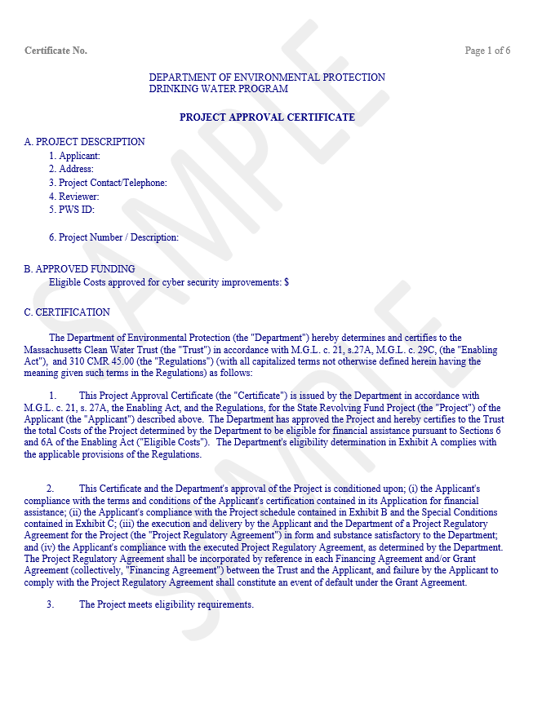

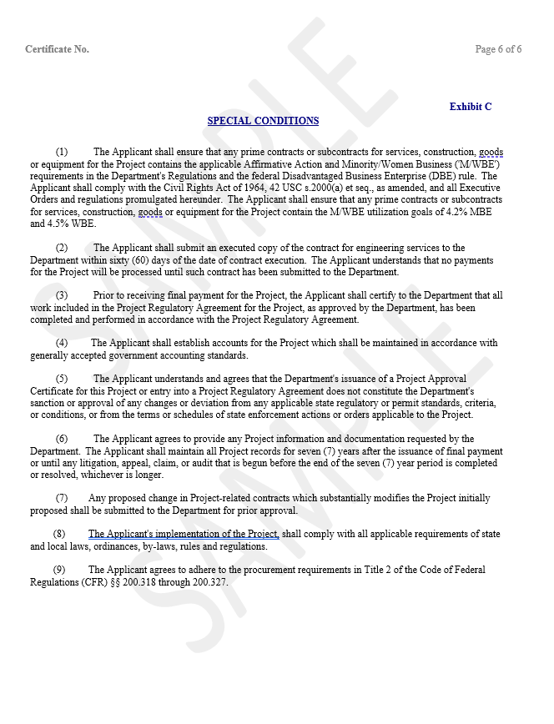

APPENDIX F
Sample Reimbursement Form

Once a financial assistance agreement/loan has been executed with the Trust, the community may seek reimbursement for costs incurred on the project. The community or its consultant engineer will complete the requisition forms, gather the appropriate backup documentation and submit the payment reimbursement request package in PDF form to MassDEP via email at DMSDEP.General@mass.gov. MassDEP will perform a complete review of the reimbursement packet, recommend payment upon approval, and then forward the signed Form 1000 to the Trust. The Trust will then electronically transfer (wire) the funds to the community.
The required form needed to seek reimbursement is Form 1000. Form 1000 form states the following: the approved amount of the loan/grant, the previous requests made by the community and the current requested amount. This form must be signed by the Authorized Representative of the community.
When the community signs a final loan/grant agreement with the Trust either the community or the consulting engineer should contact MassDEP to receive a copy of this forms. Please refer to State Revolving Fund Contact list for the accountant for your community. A Sample of this form is provided below
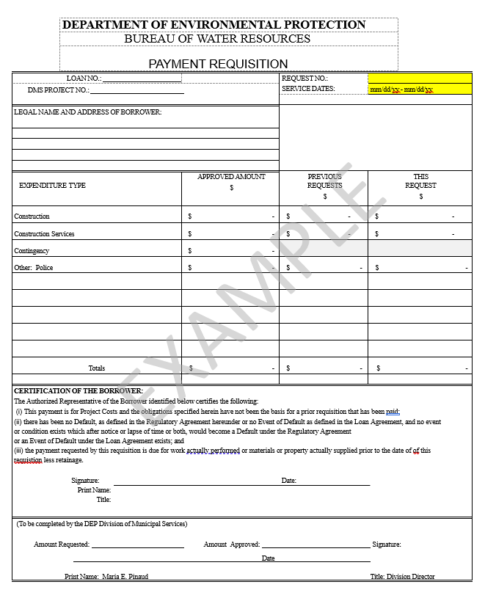
APPENDIX G
Sample Project Completion Certificate
The appendix includes an example of a Project Completion Certificate (PCC). The PWS must complete a PCC after they have completed their project. Replace the content enclosed by brackets [ ] and highlighted below with your own information and copy the contents into a separate document with the PWS’ official letterhead.

-------------------------------------- SAMPLE BEGINS FOLLOWING THIS LINE -------------------------------------------

Project Completion Certificate
Project Regulatory agreement No: ______________
Project Name: ___________________

I__________, duly authorized representative of the [Name of Public Water System (PWS)] herby certify as follows:
- The project has been implemented in accordance with the terms, conditions and assurances contained or referenced in the Project Regulatory Agreement.
- The project work has been completed in accordance with the Department- approved plan of the study or the scope of services, as applicable.
- [Name of Public Water System (PWS)] is responsible for maintaining a copy of the project scope and application in a secure location for MassDEP review. Due to sensitivity of the information contained therein, the MassDEP/DWP will not retain copies of PWS sensitive information.
- Furthermore, [Name of Public Water System (PWS)] understands that cybersecurity is a vital and routine part of Emergency Response Plan (ERP) requirements pursuant to 310 CMR 22.04(13) and all Massachusetts’ PWS are expected to assess and eliminate cybersecurity vulnerabilities as part of their emergency response planning responsibilities. This includes routinely monitoring and improving cyber hygiene to ensure the security of our systems.
- [Name of Public Water System (PWS)] understands that MassDEP will withhold 10 % of the funding approved for this project until such time that an executed Project Completion Certificate is submitted to and approved by MassDEP.

On behalf of the [Name of Public Water System (PWS)], I hereby certify under the pains and penalties of perjury, that I am duly authorized to provide this certificate and the information above is true, correct, and complete to the best of my knowledge.

_______________________________________________________________________________
Signature of Authorized Representative Date

-------------------------------------- SAMPLE ENDS PRIOR TO THIS LINE --------------------------------------------------

