2023 Annual Report

The Division of administrative law appeals

Table of Contents

Mission and General Overview 3

The General Jurisdiction Unit 3

A. 2023 in Review 4

B. Additional Accomplishments and Highlights 5

The Bureau of Special Education Appeals 7

A. 2023 in Review 7

B. Additional Accomplishments and Highlights 11

Appendix A: General Jurisdiction Unit: Cases Closed in 2023 13

Appendix B: General Jurisdiction Unit: Cases Opened in 2023 15

|  |  |  |
| --- | --- | --- |
|  | **The Commonwealth of Massachusetts**  **Division of Administrative Law Appeals**  **Bureau of Special Education Appeals**  **14 Summer Street, 4th Floor**  **Malden, MA 02148** | |
| NATALIE S. MONROE  Chief Administrative Magistrate | | | Tel: 781-397-4700  Fax: 781-397-4720  [www.mass.gov/dala](http://www.mass.gov/dala) |
|  | | |  |

August 8, 2024

Greetings:

I am pleased to submit the Division of Administrative Law Appeals’ (DALA) annual report for 2023 in accordance with M.G.L. ch. 7, § 4H. The report highlights the accomplishments of the dedicated and talented individuals at DALA who work every day to achieve the agency’s mission and to serve the people of Massachusetts.

A special thanks to Jennifer Ngo, Reece Ehrlichman, Myrto Flessas and James Rooney for their contributions to this report. I also would like to thank the team at A&F IT for their invaluable assistance with data analysis and visualization.

Sincerely,

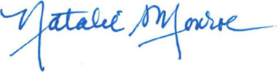

Natalie S. Monroe

Chief Administrative Magistrate

# MISSION AND GENERAL OVERVIEW

The Division of Administrative Law Appeals (DALA) is a quasi-judicial agency that hears and resolves challenges to decisions made by Massachusetts state agencies, as well as disputes among parents, school districts, private schools and state educational agencies. Fundamental to DALA’s work is upholding the due process rights of everyone who comes before the agency. In addition to protecting due process rights, DALA’s core objectives are to:

* Provide a neutral forum for the fair, equitable and independent resolution of disputes.
* Ensure full, equitable and easy access for every person and organization that appears before DALA.
* Ensure fair and respectful treatment throughout the mediation and hearing processes.
* Issue well-written, concise and understandable rulings and decisions.

DALA is comprised of two units: the General Jurisdiction Unit and the Bureau of Special Education Appeals. At the end of 2023, DALA had 32 employees. Throughout 2023, the agency was led by Acting Chief Magistrate James Rooney.

# THE GENERAL JURISDICTION UNIT

DALA’s General Jurisdiction Unit (GJU) hears challenges from decisions made by other state agencies. Although for historical reasons DALA’s name refers to “appeals,” most of the GJU’s work is not appellate in nature. Rather, the GJU functions more like a trial court. Those appearing before the GJU may file motions, obtain discovery and participate in evidentiary hearings at which, like a trial, they have an opportunity to present witnesses and any other evidence they consider relevant to their dispute.

Each case is assigned to an administrative magistrate who manages all aspects of that case, including holding prehearing conferences, overseeing discovery, ruling on motions, conducting the evidentiary hearing and issuing a decision. The rulings and decisions that the magistrate issues are binding on the parties. Like a trial court ruling, moreover, magistrates’ decisions can be appealed. Depending on the type of case, the appeal would go before another state agency or the trial court.

Cases come to the GJU in two ways: (1) by legislation requiring that certain types of cases be heard at DALA; and (2) upon request of an agency, subject to the approval of DALA’s Chief Administrative Magistrate and the Secretary of Administration and Finance. Currently, the GJU hears cases from approximately 20 state agencies, including the Contributory Retirement Appeal Board, the Board of Registration in Medicine, the Department of Public Health and the Fair Labor Division of the Office of the Attorney General. Thus, to the extent that Massachusetts has a “central administrative panel,” the GJU fills that role.

At the end of 2023, the GJU had a team of nine magistrates, one law clerk, three administrative staff and a fiscal manager.

## **A. 2023 in Review**

In 2023, the GJU received 606 new cases. As in past years, the majority (71.76%) related to public employees’ pensions, such as challenges to the calculation of an individual’s pension or the denial of an application for an accidental disability retirement. The second largest category of appeals (6.24%) came from challenges to Medicare reimbursement rates that the Executive Office of Health and Human Services (EOHHS) sets for nursing homes in Massachusetts.

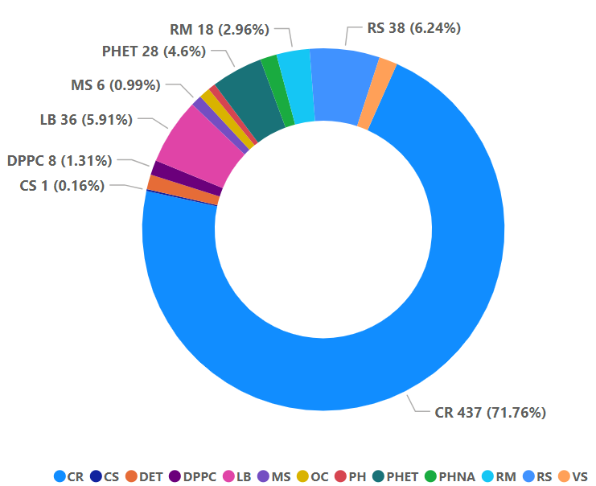

**Abbreviations**

**CR**: Cont. Retirement App. Bd.

**CS**: Civil Service Comm’n

**DET**: Dept. of Unemployment Assistance

**DPPC**: Disabled Persons Protection Comm’n

**LB**: AGO, Fair Labor Division

**MS**: Miscellaneous[1]

**OC**: Dept. of Early Education and Care

**PH**: Dept. of Public Health

**PHET**: Dept. of Public Health (EMTs)

**PHNA**: Dept. of Public Health (Nurse's Aides)

**RM**: Bd. of Registration in Medicine

**RS**: EOHHS (Rate Setting)

**VS**: Exec. Office of Veterans’ Services

Figure 1. GJU Cases Opened in 2023

The individual, agency or company that files a case with the GJU is typically called the petitioner (akin to the plaintiff in a civil lawsuit). The individual, agency or company against whom the legal action is taken is generally referred to as the respondent (similar to a defendant in a civil lawsuit).

Once a case is filed, the parties may conduct discovery, such as obtaining relevant documents from each other and third parties. The parties are entitled to file motions to resolve the case without the need for an evidentiary hearing. For example, a respondent could file a motion to dismiss on the grounds that the petitioner filed the case after the time allowed by law. Parties also are encouraged to talk and explore resolving their disputes amicably. And of course, parties also have the right to a full evidentiary hearing, after which a magistrate issues a decision based on the evidence presented and the applicable law. As a result, cases may resolve in many ways, including settlement, withdrawal, a ruling on a motion, or a written decision after an evidentiary hearing.

In 2023, the GJU continued its efforts to resolve cases more expeditiously, with a focus on its oldest cases, as well as on cases involving applications for an accidental disability retirement. Consequently, the GJU closed 1,897 cases last year. These cases were open an average of 1,727 days. Many considerations impacted the time to resolve these cases. Magistrates’ caseloads and agency staffing continued to be significant factors. Further, the complexity of a case, the need for discovery, and filing pre-hearing motions affect the time it takes for a case to proceed to hearing. In addition, parties may ask to stay a case, such as to explore settlement or to allow a related criminal investigation or prosecution to conclude. Appendix A contains a breakdown of the number of cases closed by type of appeal, as well as the average length of cases by the type of appeal.[2]

The GJU ended 2023 with 812 open cases.

## **B.** **Additional Accomplishments and Highlights**

1. Rate Setting Cases

The GJU has been engaged in a multi-year initiative to resolve a backlog of nursing home rate-setting cases; these cases concern the rate of reimbursement for services provided by nursing homes to Medicare patients. Many were filed years ago but not pursued. In 2022, the GJU closed over 1,000 nursing home rate-setting cases. In 2023, the GJU continued this progress by closing 590 more rate-setting cases. As it stood at the end of 2023, the GJU had reduced the number of open rate-setting cases to 213, a number that the agency expects to decrease as it wraps up the last of the older cases, and schedules hearings in the new cases.

2. Retirement Cases

The GJU also has continued its efforts to resolve its inventory of retirement cases and to process them in a timelier manner. At the end of 2022, the GJU had 1,075 open retirement cases. By the end of 2023, that number had been reduced to 439 open retirement cases.

The reduction is primarily attributable to adding resources and improving the agency’s intake system. Most importantly, the GJU received approval to hire a law clerk and a third administrative assistant to help process retirement appeals. This has allowed the GJU to improve its intake system and the resolution of cases in general. Now, for example, when retirement appeals are filed, they are screened and placed into three categories. First, if it appears from the filing that the appeal is legally flawed or procedurally barred, the agency issues an order to show cause directing the petitioner to provide facts that support the appeal. For example, the agency may issue an order to show cause if it appears that the petitioner filed the appeal long after the statutory deadline for doing so.

Second, if it appears that the parties’ disagreement can be resolved without live testimony, the GJU requires the parties to submit briefs and evidence setting forth their positions and the matter is then decided on the papers.[3] Third, if there are factual disputes, the GJU requires the parties to submit prehearing memoranda explaining the facts they intend to prove, along with proposed exhibits; after such memoranda and exhibits are filed, the matter is scheduled for an evidentiary hearing.

It formerly took many months to send out the appropriate orders to the parties, but with the addition of a third administrative assistant, the GJU has reduced processing times significantly. Since the end of 2023, the GJU has been able to screen cases in a week after they are filed and issue preliminary orders within two weeks.

3. Language Access

Consistent with Executive Order No. 615, the GJU implemented a Language Access Plan to ensure that all individuals who participate in matters before the GJU, including individuals who are limited in their English language proficiency, have meaningful access to DALA’s services. Language access serves not only the individual needs of parties and participants, but also the GJU’s goal of ensuring the fair and efficient resolution of the matters before it. To further improve language access, DALA also has contracted with a local vendor for interpreter and translation services.

# THE BUREAU OF SPECIAL EDUCATION APPEALS

The BSEA conducts mediations, hearings and facilitated meetings to resolve disputes among parents, school districts, private schools and state agencies. The BSEA derives its authority from both federal law (the Individuals with Disabilities Education Act, “IDEA”) and Massachusetts law (Chapter 71B of the Massachusetts General Laws, “Chapter 71B”).

A parent[4] or a school district may request a mediation or hearing on any matter concerning the eligibility, evaluation, placement, individualized education program, provision of special education or procedural protections for students with disabilities, in accordance with state and federal law. In addition, a parent may request a hearing on any issue involving the denial of a free appropriate public education guaranteed by Section 504 of the Rehabilitation Act of 1973.

Mediations, hearings and facilitated meetings are conducted by impartial and specially trained mediators and hearing officers. The BSEA is comprised of six hearing officers (all of whom are attorneys), six mediators, a coordinator of mediation, a scheduling coordinator, four administrative staff, a fiscal manager and a director.

The BSEA is federally funded through a grant managed by the Department of Elementary and Secondary Education (DESE). In 2010, the Legislature transferred the BSEA to DALA from DESE to ensure independence from any educational agency that could be a party to, or interested in, the matters that come before the BSEA. *See* Chapter 131 of the Acts of 2010.

## **A. 2023 in Review**

In Massachusetts, a public school district is responsible for developing an Individual Education Program (IEP) for a student with a disability who is found eligible pursuant to the IDEA or Chapter 71B. An IEP is a “road map” and “contract,” which is prepared by an interdisciplinary team, and which sets forth the goals, objectives, services, placement and accommodations necessary to provide an eligible student with a free appropriate public education (FAPE) in the least restrictive environment.

If the parent of a student rejects or does not respond to a proposed IEP, the school must notify the BSEA. The BSEA then sends a packet of information to the parents and school district notifying them of their dispute resolution options, including mediation and an evidentiary due process hearing. Parents and school districts are not required to request a BSEA mediation or hearing. After receiving this packet, therefore, the parents and school district may or may not contact the BSEA to request mediation or file a written request for a hearing.

In most instances involving a rejected IEP,[5] the families and school districts work collaboratively to resolve the rejections. As a result, only a small percentage of the rejected IEPs that the BSEA receives ultimately lead to a mediation, settlement conference or full evidentiary hearing. If the BSEA receives no request to schedule a mediation or hearing within three months of sending the packet of information, the matter is closed.

1. Rejected IEPS

The BSEA received approximately 12,560 rejected IEPs during fiscal year 2023,[6] representing an increase from the 11,830 received in the prior year. The BSEA mailed packets of information to the parents and school districts in each of these cases. In 1,627 instances, the BSEA received a request for mediation or hearing, as discussed further below. The BSEA was not contacted with respect to the remaining rejected IEPs.

2. Mediations

The BSEA received 1,236 requests for mediation in 2023, representing an increase from the 1,091 requests the previous year. The BSEA mediators conducted 715 mediations in 2023; this represented an increase from the 588 conducted during the prior year. The 715 mediations conducted include mediations that were requested in 2022 and 2023.  Of the 1,236 requests in 2023, moreover, 457 did not result in mediation because one party declined mediation or the parties resolved the matter instead of using mediation; 134 requests were pending at the end of 2023 and were closed in 2024.

The parents and school districts reached an agreement in 607 (85%) of the 715 mediations that the BSEA conducted last year.  As shown in Figure 2 below, the BSEA mediators have a settlement rate well above the national average.  Further, as indicated in Figure 3, the BSEA receives more requests for mediation, per student count, than any other state.

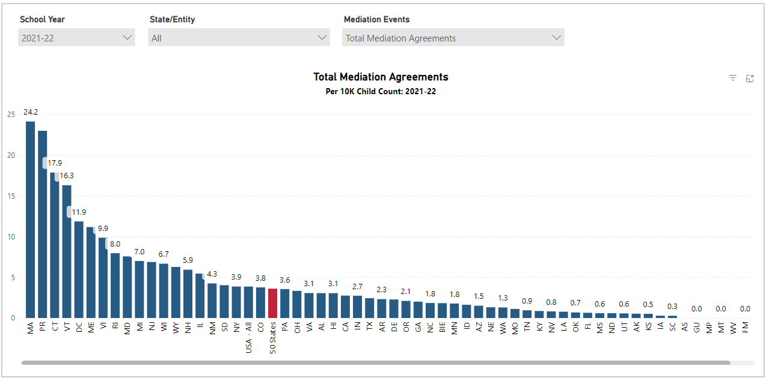

Figure 2. Mediated Agreement Rate. Reproduced from: <https://www.cadreworks.org/national-state-dr-data-dashboard>.

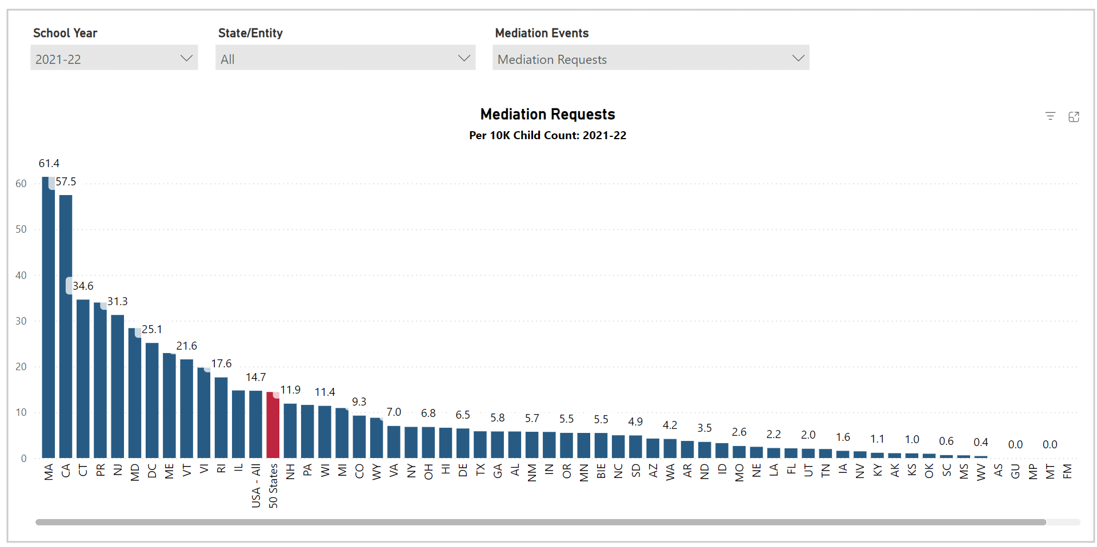

Figure 3. Requests for Mediation. Reproduced from: <https://www.cadreworks.org/national-state-dr-data-dashboard>.[7]

3. Evidentiary Hearings and Settlement Conferences

The BSEA also received 391 hearing requests in 2023, a slight increase from the 381 requests received in the prior year. BSEA hearing officers conducted full evidentiary hearings in 12 cases, resulting in the issuance of 12 decisions, a decrease from the 14 issued in the previous year. The BSEA also issued 78 substantive written rulings in 2023, compared to 57 the year before. Furthermore, the BSEA held settlement conferences in 43 of the cases that were filed for hearing in 2023, compared to 48 held in the prior year. Of these, 39 cases settled and one resulted in an interim agreement. The remaining cases were either withdrawn or otherwise not resolved before the close of 2023.

Rejected IEPs Received, Informational Packets Sent to Student’s Parents/Guardians: 12,560

BSEA Dispute Resolutions Requested: 1,627

Figure 4. BSEA Workflow 2023[8]

4. Facilitated IEP Team Meetings

The BSEA also offers facilitators for IEP team meetings. An IEP team meeting is a required meeting to discuss the educational programming and supports for a student with disabilities. This meeting comprises both school staff and the student’s parents. The BSEA offers facilitators to attend and support clear and effective team communication and productivity. The BSEA provides this service at no cost to the parties.

In 2023, the BSEA received 298 requests to facilitate team meetings and it conducted 204 facilitated IEP team meetings, an increase from the 186 conducted the previous year. The BSEA did not have sufficient staff to accommodate 49 requests for facilitated IEP team meetings.

Figure 5. Requests for Facilitation 2023

## **B. Additional Accomplishments and Highlights**

Every year, the BSEA reaches out to offer informational sessions to over 500 families, organizations, school districts, special education collaboratives, special education schools, attorney groups, the Federation for Children with Special Needs, and other state agencies that support families of school-aged children with disabilities. In 2023 the BSEA conducted over 40 information sessions. These presentations included information on how to access mediation, due process hearings and facilitation. They also informed stakeholders about their rights to dispute resolution and offered support in productive communication skills to reduce conflict. The BSEA provided the presentations in several languages, including American Sign Language, to promote access to the information provided.

This year, the BSEA also took a “deep dive” into reviewing, revising, updating and formalizing both its public-facing forms and documents[9] and its internal forms and documents.[10] The BSEA undertook this project to ensure strict compliance with the letter and spirit of the IDEA. As part of the process, the BSEA sought public comment both via public hearing and in written form.

In addition, in order to make its processes more accessible to all constituents, the BSEA has expanded the number of languages in which its forms and publications are now available and has taken steps to ensure the accessibility of its website.

Finally, the BSEA has been working diligently with the Massachusetts Department of Secondary and Elementary Education and family advocacy groups to redesign the BSEA’s informational packets to ensure they are easier to understand and access.

# Appendix A:

# General Jurisdiction Unit: Cases Closed in 2023

|  |  |  |  |
| --- | --- | --- | --- |
| **Agency** | **Types of Appeals** | **Cases Closed** | **Average Age of Cases (in days)** |
| **Contributory Retirement Appeal Board (CRAB) and Public Employee Retirement Administration Commission (PERAC)** | Appeals from public employees and retirement boards regarding the level or calculation of their retirement benefits or regarding the denial of their application for an accidental disability retirement. | 901 | 684 |
| **Executive Office for Health and Human Services (EOHHS)** | Challenges to Medicaid reimbursement rates EOHHS sets for nursing homes and other providers. | 821 | 3,168 |
| **Office of the Attorney General, Fair Labor Division** | Appeals from citations issued to employers for allegedly violating the Fair Wage Act, M.G.L. ch. 149 and 151, such as the failure to pay wages or overtime. | 60 | 281 |
| **Board of Registration in Medicine** | Actions to discipline doctors for alleged misconduct, such as practicing without a license. | 29 | 661 |
| **Department of Public Heath** | Primarily appeals related to discipline against certified nurse's aides, emergency medical technicians and ambulance services, as well as challenges to revocation and enforcement actions related to medical marijuana registration authorized under 105 CMR 725.000, et seq. | 29 | 108 |
| **Executive Office of Veterans' Services** | Appeals from agency decisions denying. changing or terminating state veterans’ benefits. | 16 | 649 |
| **Civil Service Commission** | Appeals from actions taken by cities, towns and state agencies in connection with the civil service system, such as the failure to hire an individual eligible for a civil service position or the discipline of a civil service employee. | 13 | 192 |
| **Department of Unemployment Assistance** | Appeals from the denial of unemployment benefits. | 10 | 119 |
| **Disabled Persons Protection Commission** | Appeals from discipline imposed on caregivers of adults with disabilities. | 9 | 155 |
| **Department of Agricultural Resources** | Appeals involving claims of importing pet animals from out of state, operating a pet shop without a license, improperly operating a pet shop, and failing to comply with state composting programs. | 6 | 364 |
| **Department of Early Education and Care** | Appeals from the revocation, suspension, nonrenewal or denial of an application for day-care provider and assistant licenses. | 3 | 287 |
| Total |  | 1,897 |  |

# Appendix B:

# General Jurisdiction Unit: Cases Opened in 2023

1. “Miscellaneous” includes cases involving the Department of Elementary and Secondary Education, Department of Agricultural Resources, Department of Developmental Services, Division of Fisheries and Wildlife, and Boston Police Department.
2. DALA’s enabling statute requires the agency to report on the number of “simplified hearings” that it holds each year. M.G.L. ch. 7, § 4H. The Standard Rules of Adjudicatory Practice and Procedure, 801 CMR 1.00, *et seq.*, do not use that term. Interpreting “simplified hearing” to mean an informal hearing pursuant to 801 CMR 1.02, the GJU held six simplified hearings in 2023.
3. However, if the magistrate identifies the need for live testimony, the appeal proceeds to a full evidentiary hearing.
4. As used in this report, “parent” refers to the father, mother, foster parent or legal guardian of a child; a person acting as a parent of a child; or an educational surrogate parent appointed in accordance with federal law.
5. “Rejected IEP” includes both rejected IEPs and IEPs that a parent has not responded to.
6. Pursuant to federal reporting requirements, the BSEA keeps its statistics by fiscal year.
7. Figures 2 and 3 reflect data from the 2021-2022 school year, which is the most-recent year for which CadreWorks has published information. The BSEA’s data for 2023 is consistent with that in Figures 2 and 3.
8. “Other” includes, but is not limited to, cases that were withdrawn prior to hearing or that did not get resolved, decided or otherwise closed until the following year.
9. This included the BSEA’s hearing request form, *pro se* litigant guide, reference manual, hearing rules, directory of free and low-cost legal services, and a newly created mediation reference manual.
10. This included the BSEA’s office procedures manual, hearing officer manual and mediator manual.