**INDOOR AIR QUALITY ASSESSMENT**

**Dalton Free Public Library**

**462 Main Street**

**Dalton, MA**

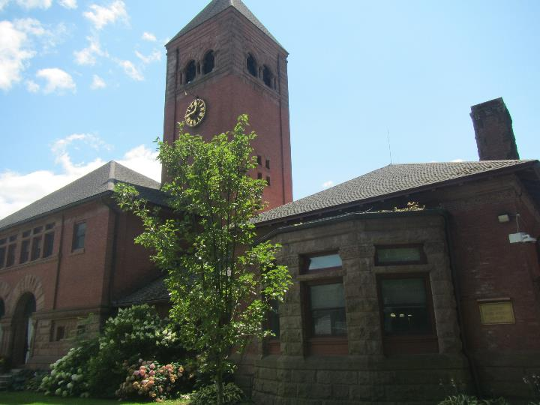

Prepared by:

Massachusetts Department of Public Health

Bureau of Climate and Environmental Health

Indoor Air Quality Program

October 2024

# BACKGROUND

|  |  |
| --- | --- |
| Building: | Dalton Free Public Library (DFPL) |
| Address: | 462 Main Street Dalton, MA |
| Assessment coordinated via: | Town of Dalton administration |
| Reason for Request: | General indoor air quality (IAQ) |
| Date of Assessment: | July 19, 2024 |
| Massachusetts Department of Public Health/Bureau of Climate and Environmental Health (MDPH/BCEH) Staff Conducting Assessment: | Michael Feeney, Director and Thomas Murphy, Environmental Analyst, IAQ Program |
| Building Description: | The Dalton Town Hall/Public Library was constructed in 1892. The basement is occupied by the Dalton Police Department. |
| Windows: | Openable in most areas |

# INTRODUCTION

# Following an evaluation of the Dalton Police Department (DPD) which occupies a section of the basement below the Dalton Town Hall (DTH), the MDPH IAQ Program was asked to conduct an IAQ assessment of the spaces occupied by the DFPL as well as the DTH. This assessment details the IAQ air sampling and observations made in the DFPL section of the building, and a separate report for the DTH has been provided.

# METHODS

Please refer to the IAQ Manual for methods, sampling procedures, and interpretation of results (MDPH, 2015).

# RESULTS AND DISCUSSION

The following is a summary of indoor air testing results (Table 1).

* ***Carbon dioxide levels*** were below 800 parts per million (ppm) in all areas assessed. It is important to note that the DFPL was barely occupied during this assessment. Carbon dioxide levels would be expected to be higher when more individuals are in the DPFL. For interpretation of data, please refer to the IAQ Manual section on carbon dioxide.
* ***Temperature*** was within the recommended range of 70°F to 78°F in areas assessed.
* ***Relative humidity*** was within the recommended range of 40% to 60% in the areas assessed. However, relative humidity indoors was 2% to 4% higher than outdoor relative humidity. These measurements indicate that no ducted mechanical means to vent water vapor outdoors from the DFPL exists or a source of moisture exists in the building elevating indoor relative humidity
* ***Carbon monoxide*** levels were non-detectable in all areas assessed.
* ***Fine particulate matter (PM2.5)*** concentrations measured were below the National Ambient Air Quality Standard (NAAQS) level of 35 μg/m3 in all areas assessed.

## Ventilation and Heating Systems

A heating, ventilating, and air conditioning (HVAC) system has several functions. First it provides heating and, if equipped, cooling. Second, it is a source of fresh air. Finally, an HVAC system will dilute and remove normally occurring indoor environmental pollutants by not only introducing fresh air, but by filtering the airstream and ejecting stale air to the outdoors via exhaust ventilation. Even if an HVAC system is operating as designed, point sources of respiratory irritation may exist and cause symptoms in sensitive individuals. The following analysis examines and identifies components of the HVAC system and likely sources of respiratory irritant/allergen exposure due to water damage, aerosolized dust, and/or chemicals found in the indoor environment.

The DFPL has no general mechanical ventilations system. Heat is provided by radiators. The DFPL space is configured in a manner to use cross-ventilation to provide comfort for building occupants. The building is equipped with windows on opposing exterior walls (Figures 1 and 2).

The DFPL has wall-mounted units (Picture 1) that provide heating and cooling [ductless mini-split (DMS)]. A DMS has a fan to draw air into its coils to either heat or cool air, which is expelled though a vent at the top of each unit. A DMS has no means to draw and condition fresh outdoor air. It is designed to recirculate air only.

With no fresh air supply, exhaust ventilation or openable windows, normally occurring indoor pollutants can build up. In addition, if a pollutant source is introduced into the building (such as water vapor during hot humid weather from open windows), there is no means to physically vent them, and in the case of hot, humid air, cause condensation to moisten cold surfaces.

As noted in the DPD and DTH reports, an examination of the furnace room interior found no source of outdoor combustion air. A set of louvered vents were found in the hallway interior wall (Picture 2), which appear to open and close when the furnace is activated, indicating that combustion air is drawn from the basement indoor air. To properly combust fuel, an outdoor source of oxygen is needed. Without an adequate fresh air supply, combustion of fuel may not proceed completely, leading to excess products of combustion being formed, including carbon monoxide. The louvered vents and the door may also allow products of combustion and fuel odors into the basement and occupied spaces in the DFPL.

IAQ staff conducted measurements for carbon monoxide. Carbon monoxide (CO) should not be present in a typical, indoor environment. If it is present, indoor carbon monoxide levels should be less than or equal to outdoor levels. No measurable levels of CO were detected inside the DFPL during this assessment which occurred when the furnace was deactivated. Such air sampling should be conducted when the furnace is on during the heating season.

Restrooms do not have exhaust fans or openable windows. In this configuration, odors, water vapor, and other pollutant tend to remain in restrooms after use.

## Microbial/Moisture Concerns

### Sources of moisture

An examination of the DFPL did not find visible mold in any locations. Of note is a peaked, tiled roof that has moss (Picture 1). Moss prevents the drying of the materials underlaying the roof tiles, which can lead to roof leaks. No visible water damage was noted in the main library or the ceiling of the upper stacks.

Plants and bushes were observed in contact with and near the exterior foundation (Picture 4). Plants near the building can cause water damage to brickwork and mortar. In addition, plants shading exterior walls can slow drying. Water can eventually penetrate the brick, subsequently freezing and thawing during the winter. This freezing/thawing action can weaken and damage bricks and mortar

Plants were also noted inside the library. Plants, soil, and drip pans can serve as sources of mold/bacterial growth. Plants should be properly maintained, over-watering of plants should be avoided, and drip pans should be inspected periodically for mold growth.

Ductless mini-splits are equipped with tubing and sometimes a pump to drain the condensation generated through operation. Leakage of water can occur when the condensate line is blocked or damaged, or the pump malfunctions. Ductless mini-split tubing and pumps should be checked regularly to ensure proper drainage and repaired/cleaned when necessary.

The US Environmental Protection Agency (US EPA) and the American Conference of Governmental Industrial Hygienists (ACGIH) recommend that porous materials (e.g., ceiling tiles, carpet) be dried with fans and heating within 24 to 48 hours of becoming wet (US EPA, 2008; ACGIH, 1989). If not dried within this time frame, mold growth may occur. Once mold has colonized porous materials such as cardboard, books or ceiling tiles, they are difficult to clean and should be discarded. Frequently solid/non-porous items can be cleaned to remove water stains and microbial growth.

### High relative humidity during hot, humid weather

One significant source of excess indoor humidity in this building is from high outdoor relative humidity. During past summers, several periods of extended hot, humid weather have occurred, in conjunction with extended periods of heavy rain. If a building such as the DFPL does not have adequate exhaust ventilation and air chilling capacity to remove/reduce relative humidity, then hot/moist air can linger to increase discomfort as well as possibly wet materials that may lead to mold growth.

The key to managing condensation in hot, humid weather indoors is understanding dew point. When warm, moist air passes over a cooler surface, condensation can form. Condensation is the collection of moisture on a surface at or below the dew point. The dew point is the temperature that air must reach for saturation to occur. If a building material/component has a temperature below the dew point, condensation will accumulate on that material. If this material is porous, such as carpeting, it may become colonized by mold.

Hot humid summers are becoming more frequent due to climate change. Massachusetts has experienced hot, humid, and rainy summers in 2018, 2021, 2023, and 2024. July of 2021 was the wettest ever recorded in Massachusetts, and the three-month period from June through August, known as the meteorological summer, was the fourth wettest on record, according to the National Oceanic and Atmospheric Administration’s (NOAA) Centers for Environmental Information (NOAA, 2021). The summer of 2023 was also hot, and wet, being measured as the second rainiest on record (WBUR, 2023). And the summer of 2024 has also had significant stretches of hot, humid weather. These conditions are challenging for buildings, particularly those without central air conditioning like the DFPL.

This weather resulted in condensation issues in many publicly owned or operated buildings with below-grade space with walls or floors in direct contact with soil or cement slab floors. In these instances, the floors in direct contact with soil may have temperatures that would result in condensation wetting floors in high relative humidity conditions.

In general, if the DFPL space had mechanical ventilation, humid air would be drawn into the HVAC system where the functioning of the air conditioning would reduce humidity levels. The DFPL has no such system. In addition, DMS do not have sufficient capacity to provide any meaningful reduction of relative humidity. When outdoor humidity is high for a significant period of time, like it has been over the summer of 2024, indoor humidity can rise to uncomfortable levels and remain elevated.

## Other IAQ Evaluations

### Carpeting

The DFPL has wall to wall carpeting throughout most of its space. The service life of carpeting in schools is approximately 10-11 years (IICRC, 2002), and will be similar to an environment such as a town library. Aging carpet can produce fibers that can be irritating to the respiratory system. In addition, lifting carpet can create tripping hazards. Carpets should be cleaned annually (or semi-annually in soiled/high traffic areas) in accordance with Institute of Inspection, Cleaning and Restoration Certification (IICRC) recommendations, (IICRC, 2012). Regular cleaning with a high efficiency particulate air (HEPA) filtered vacuum in combination with an annual cleaning will help to reduce accumulation and potential aerosolization of materials from carpeting.

### Other conditions

A fireplace was observed in the main area of the DFPL (Picture 5). If not properly sealed, the chimney connected to the fireplace can be a source of entry for respiratory irritants (dust and debris), water infiltration, hot/humid air, and pests. The fireplace and chimney should be sealed if they are no longer being used or maintained in fully usable condition.

Air purifiers were observed in areas of the DFPL (Picture 6). These should be maintained, including filter changes, in accordance with manufacturer’s instructions. Air purifiers that may produce ozone should not be used in any occupied areas (EPA, 2003).

# CONCLUSIONS AND RECOMMENDATIONS

It is important to note that the DFPL was constructed at a time when radiators and windows provided ventilation and has no mechanical ventilation system to provide fresh air or exhaust air. It is difficult to maintain occupant comfort with open windows during the heating season.

In addition, due to the age of construction of the building; lack of mechanical ventilation equipment to provide adequate heated or chilled fresh air; lack of exhaust ventilation in restrooms, the DFPL space has limited ability to reduce relative humidity indoors. If extreme relative humidity and rain occur during summer months, management of the building in such weather can be challenging. The following documents can provide guidance that can be used to reduce the impact of hot, humid weather in buildings.

* Mold growth Prevention during Hot, Humid Weather <https://www.mass.gov/service-details/preventing-mold-growth-in-massachusetts-schools-during-hot-humid-weather>
* Remediation and Prevention of Mold Growth and Water Damage in Public Schools <https://www.mass.gov/service-details/remediation-and-prevention-of-mold-growth-and-water-damage-in-public-schools-and>
* Methods for Increasing Comfort in Non-air-conditioned Schools <https://www.mass.gov/doc/methods-for-increasing-comfort-in-non-air-conditioned-schools/download>

To address the building’s problems, two sets of recommendations are made: **short-term** measures that may be implemented as soon as practicable and **long-term** measures that will require planning and resources to address overall IAQ concerns. In view of the findings at the time of the visit, the following recommendations are made:

## Short Term Recommendations

### Ventilation and Heating System Recommendations

1. Install a combustion air vent for the furnace that draws outdoor air. Once installed, permanently seal all interior wall vents in the hallway walls.
2. Install a wall–mounted carbon monoxide detector with digital readout capabilities in the DFPL as well as one near the furnace.

### Water Damage Recommendations

1. Remove moss from the peaked roof to ensure drying.
2. Trim plants and bushes at least 5 feet away from the building.
3. Keep plants in good condition, avoid overwatering, and keep them away from the airstream of ventilation equipment.
4. Ensure that condensation from mini-split equipment is draining properly. Check collector pans, piping and any associated pumps for clogs and leaks and clean periodically to prevent stagnant water build-up and remove debris that may provide a medium for microbial growth.
5. Use dehumidifiers in the building until outdoor conditions are cooler and drier and building heating is being used. Maintain all dehumidifiers and regularly remove water and clean receptacles to avoid stagnant water, odors, and the potential for leaks.
6. Do not store any equipment made of cloth, porous plastic/foam, leather, paper, or other materials capable of supporting mold growth on floors. Consider acquiring installing shelving that is made of a material that does not support mold growth (e.g., hard plastic). If metal shelve used, avoid storing materials on the lowest shelf.

### Other Recommendations

1. Consideration should be given to replacing carpeting with a different type of floor covering that can be readily cleaned. Until that time, clean high traffic areas frequently in accordance with IICRC recommendations (IICRC, 2012).
2. Seal the chimney and fireplace if no longer in use.
3. Maintain air purifiers in accordance with manufacturer's instructions. Avoid using any air purifiers that may produce ozone (e.g., ionizers). Consider locating air purifiers so the outlet of the units is in the breathing zone of occupants.
4. Refer to resource manual and other related IAQ documents located on the MDPH’s website for further building-wide evaluations and advice on maintaining public buildings. These documents are available at: <http://mass.gov/dph/iaq>.

## Long Term Recommendations

1. Consideration should be given to installing a mechanical, ducted exhaust system that vents air from all DFPL locations that have sinks, including restrooms, custodial closets, and kitchen. Such systems should only be added if the furnace is equipped with an outdoor combustion air supply vent as described above and furnace hallway vents are sealed.
2. Consideration should be given to installing a mechanical ventilation system that services all occupied areas of the DFPL with both a fresh air supply and return system.

# REFERENCES

ACGIH.1989. Guidelines for the Assessment of Bioaerosols in the Indoor Environment. American Conference of Governmental Industrial Hygienists, Cincinnati, OH.

IICRC. 2002. Institute of Inspection, Cleaning and Restoration Certification. A Life-Cycle Cost Analysis for Floor Coverings in School Facilities.

IICRC. 2012. Institute of Inspection, Cleaning and Restoration Certification. Carpet Cleaning: FAQ. Retrieved from <https://iicrc.org/>.

MDPH. 2015. Massachusetts Department of Public Health. Indoor Air Quality Manual: Chapters I-III. Available at: <https://www.mass.gov/lists/indoor-air-quality-manual-and-appendices#indoor-air-quality-manual->.

NOAA. 2021. Summer 2021 neck and neck with Dust Bowl summer for hottest on record. National Oceanic and Atmospheric Administration, 1401 Constitution Avenue NW, Room 5128, Washington, DC 20230 <https://www.noaa.gov/news/summer-2021-neck-and-neck-with-dust-bowl-summer-for-hottest-on-record>.

US EPA. 2003. “Ozone Generators that are Sold as Air Cleaners: An Assessment of Effectiveness and Health Consequences”. United States Environmental Protection Agency, Office of Air and Radiation, Indoor Environments Division, Washington, DC. Last updated September, 2018. <https://www.epa.gov/indoor-air-quality-iaq/ozone-generators-are-sold-air-cleaners>.

US EPA. 2008. “Mold Remediation in Schools and Commercial Buildings”. Office of Air and Radiation, Indoor Environments Division, Washington, DC. EPA 402-K-01-001. September 2008. Available at: <http://www.epa.gov/mold/mold-remediation-schools-and-commercial-buildings-guide>.

WBUR. 2023. “It's been a summer of rain and flooding misery in Mass.” WBUR local news. September 12, 2023. <https://www.wbur.org/news/2023/09/12/summer-flooding-rain-massachusetts>.

**Figure 1**

**Cross Ventilation in a Building Using Open Windows and Doors**

Leeward Windward

Side of Side of

Building Building

Wind Direction

**Key**

Open Hallway Door

Open Transoms

Interior Path of Cross Ventilation

Drawing Not to Scale

**Figure 2**

**Inhibition of Cross Ventilation in a Building with Several Windows and Transoms Closed**

Leeward Windward

Side of Side of

Building Building

**Key** (Drawing Not to Scale) Wind Direction

Open Window

Open Transom

Closed Window

Closed Transom

Interior Path of Cross Ventilation

**Picture 1**

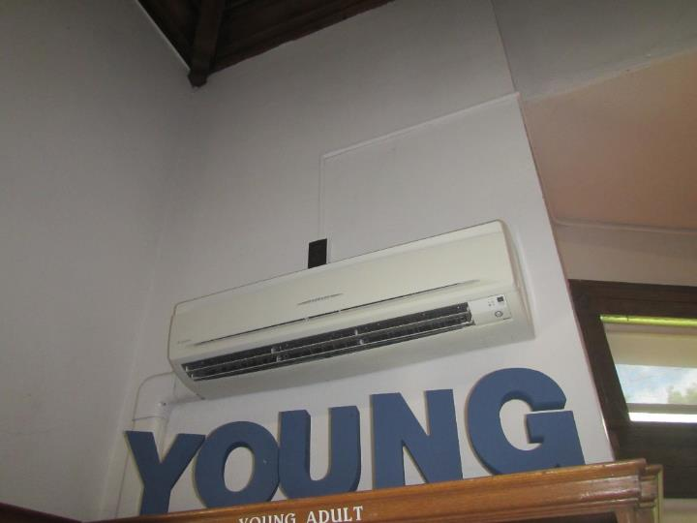

**Ductless mini-split**

**Picture 2**

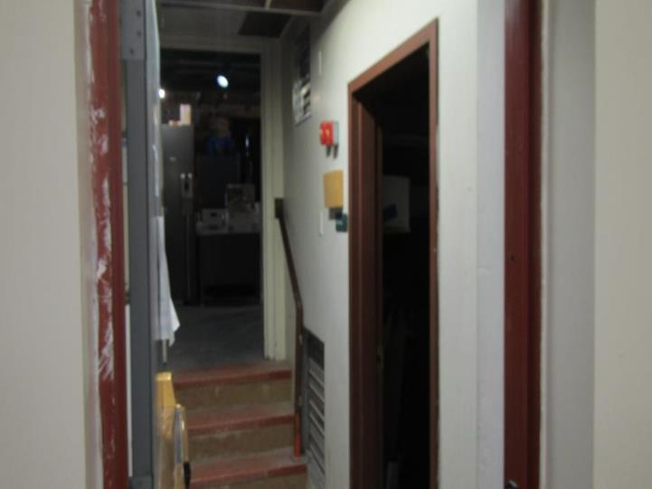

**Louvers in furnace room hallway**

**Picture 3**

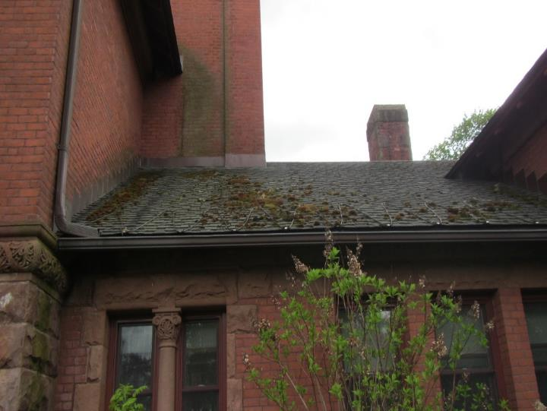

**Moss on DFPL peaked roof**

**Picture 4**

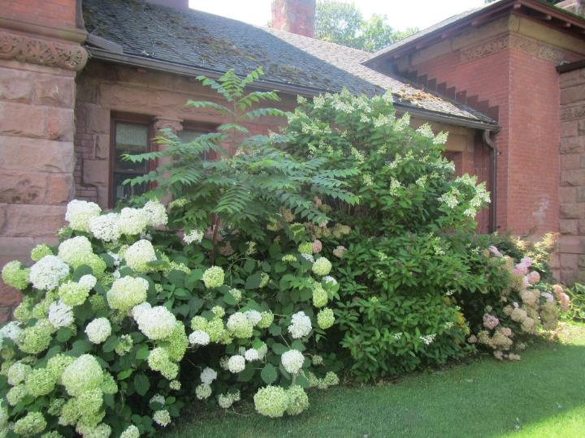

**Plants and bushes next to the exterior of the building**

**Picture 5**

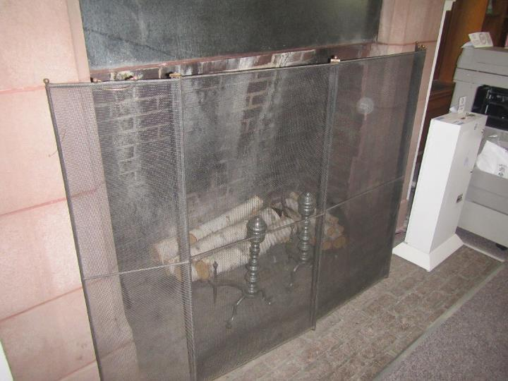

**Fireplace in the main area of the library**

**Picture 6**

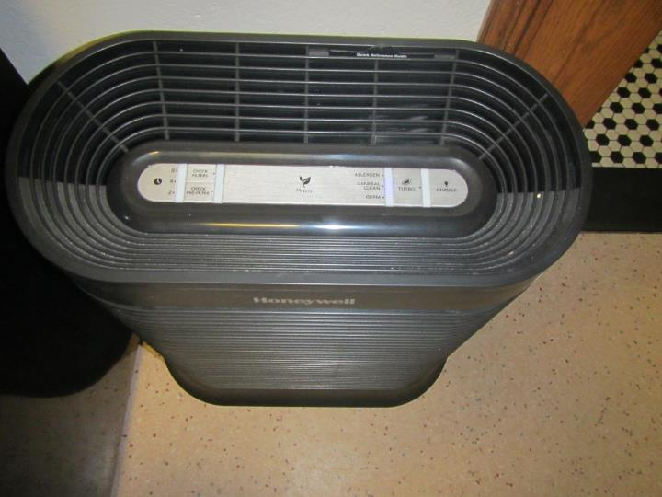

**Air Purifier**

| **Location/ Room** | **Carbon**  **Dioxide**  **(ppm)** | **Carbon Monoxide**  **(ppm)** | **Temp**  **(°F)** | **Relative**  **Humidity**  **(%)** | **PM2.5**  **(****µg/m3)** | **Occupants**  **in Room** | **Windows**  **Openable** | **Ventilation** | | **Remarks** |
| --- | --- | --- | --- | --- | --- | --- | --- | --- | --- | --- |
| **Supply** | **Exhaust** |
| Background | 431 | 1 | 82 | 47 | 3 |  |  |  |  | Sunny |
| Director’s Office | 503 | ND | 74 | 50 | ND | 0 | Y | N | N | Plant, carpeted |
| Mystery Section | 507 | ND | 75 | 49 | ND | 0 | N | N | N | Ductless mini-split, carpeted |
| Director’s Office Storage | 498 | ND | 75 | 49 | ND | 0 | N | N | N | Carpeted |
| Cookbooks Section | 514 | ND | 74 | 51 | ND | 1 | Y | N | N | Air purifier, carpeted |
| Staff Office | 503 | ND | 73 | 51 | 1 | 0 | Y | N | N | Plants, personal fan, carpeted |
| Kitchen/Break Room | 521 | ND | 74 | 51 | 1 | 0 | N | N | N | Air purifier, not carpeted, toaster oven, microwave, refrigerator, not carpeted |
| Children’s Section | 534 | ND | 74 | 51 | ND | 0 | N | N | N | Carpeted |
| Computer Area | 540 | ND | 74 | 51 | ND | 4 | Y | N | N | Air purifier, carpeted, ductless mini-split, fireplace |