**INDOOR AIR QUALITY ASSESSMENT**

**Dalton Police Department**

**462 Main St., Ste 7**

**Dalton, MA**

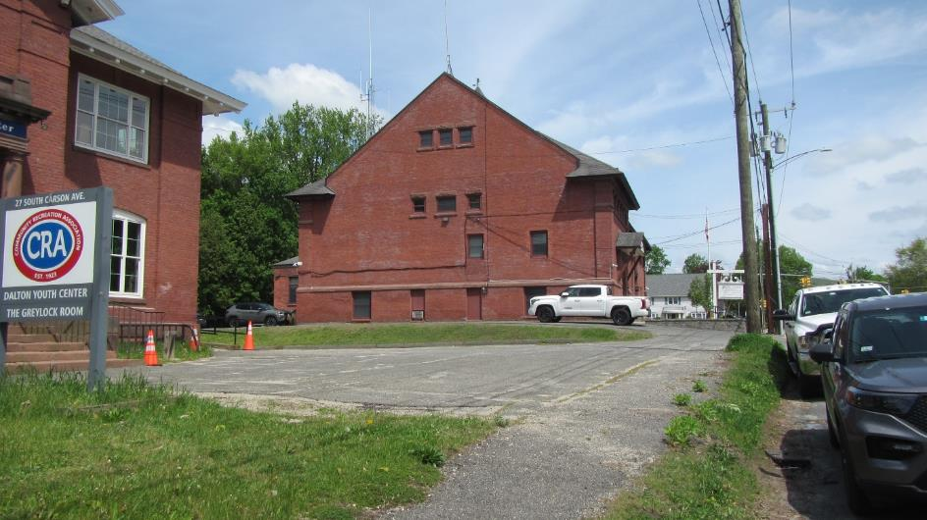

Prepared by:

Massachusetts Department of Public Health

Bureau of Climate and Environmental Health

Indoor Air Quality Program

June 2024

# BACKGROUND

|  |  |
| --- | --- |
| Building: | Dalton Police Department (DPD) |
| Address: | 462 Main St Suite 7, Dalton, MA |
| Reason for Request: | General indoor air quality (IAQ) |
| Date of Assessment: | May 17, 2024 |
| Massachusetts Department of Public Health/Bureau of Climate and Environmental Health (MDPH/BCEH) Staff Conducting Assessment: | Michael Feeney, Director, Indoor Air  Quality (IAQ) Program, and Thomas  Murphy, Env. Analyst, IAQ Program |
| Building Description: | Dalton Town Hall/Public Library was constructed in 1892. The basement was renovated in the 1970’s for occupation by the DPD. |
| Windows: | Not openable |

# INTRODUCTION

# On April 26, 2024, the BCEH IAQ Program was contacted by Dalton Police Chief Deanna Strout concerning a sewer backup that occurred in a restroom of the DPD. A previous report was sent detailing findings and recommendations regarding the flood. This report provides a general IAQ assessment of the non-flooded areas of the DPD.

# METHODS

Please refer to the IAQ Manual for methods, sampling procedures, and interpretation of results (MDPH, 2015).

# RESULTS AND DISCUSSION

The following is a summary of indoor air testing results (Table 1).

* ***Carbon dioxide levels*** were above 800 parts per million (ppm) in 9 out of 12 areas assessed, indicating inadequate fresh air in the space for the occupancy. For further interpretation of data, please refer to the IAQ Manual section on carbon dioxide.
* ***Temperature*** was within the recommended range of 70°F to 78°F in the areas assessed.
* ***Relative humidity*** was within the recommended range of 40% to 60% in the areas assessed. However, it is important to note that relative humidity indoors was 4% to 13% higher than outdoors. These measurements are a result of a lack of ducted mechanical means to vent water vapor outdoors from the DPD and may indicate a source or sources of moisture in the basement. See **Microbial/Moisture Concerns** below.
* ***Carbon monoxide*** levels were non-detectable in all areas assessed.
* ***Fine particulate matter (PM2.5)*** concentrations measured were below the National Ambient Air Quality Standard (NAAQS) level of 35 μg/m3 in all areas assessed.

## Ventilation and Heating Systems

A heating, ventilating, and air conditioning (HVAC) system has several functions. First, it provides heating and, if equipped, cooling. Second, it is a source of fresh air. Finally, an HVAC system will dilute and remove normally occurring indoor environmental pollutants by not only introducing fresh air, but by filtering the airstream and ejecting stale air to the outdoors via exhaust ventilation. Even if an HVAC system is operating as designed, point sources of respiratory irritation may exist and cause symptoms in sensitive individuals. The following analysis examines and identifies components of the HVAC system and likely sources of respiratory irritant/allergen exposure due to water damage, aerosolized dust, and/or chemicals found in the indoor environment.

The DPD has no general mechanical ventilation system. Heat is provided by radiators. The DPD space was originally configured in a manner to use cross-ventilation to provide comfort for building occupants. The building is equipped with windows on opposing exterior walls. However, due to security concerns, windows in the DPD must remain closed, which eliminates cross ventilation.

To provide cooling, some areas have window mounted air-conditioners (WACs) in ground level windows (Pictures 1 and 2). WACs recirculate air in a room, but do not provide significant fresh air. One portable WAC was found on a filing cabinet (Picture 3). As WACs operate, condensation accumulates on the cooling coils which should be drained. In this instance, overflow has corroded the file cabinet (Picture 4), possibly wetting important files.

The DPD is immediately adjacent to the furnace room of the building. An examination of the furnace room interior found no source of outdoor combustion air. A set of louvered vents were found in the hallway interior wall (Picture 5), which appear to open and close when the furnace is activated, indicating that combustion air is drawn from the basement indoor air. To properly combust fuel, an outdoor source of oxygen is needed. Without an adequate fresh air supply, combustion of fuel may not proceed completely, leading to excess products of combustion being formed, including carbon monoxide. The louvered vents and the door may also allow products of combustion and fuel odors into the basement and DPD occupied space.

MDPH staff conducted measurements for carbon monoxide. Carbon monoxide (CO) should not be present in a typical, indoor environment. If it is present, indoor carbon monoxide levels should be less than or equal to outdoor levels. No measurable levels of CO were detected during this assessment which occurred when the furnace was deactivated. Additional testing for carbon monoxide should be conducted when the furnace is on during the heating season.

The DPD contains holding areas that have exhaust fans installed in the ceiling of cells (Picture 6). These exhaust fans are not directly ducted to the outdoors and only eject air from the holding cells, which is then drawn back into the cells from the room. Exhaust ventilation fans should be connected to ductwork with a terminus outdoors to eject water vapor and odors from the building.

Restrooms do not have exhaust fans. In this configuration, restroom odors, water vapor and other pollutants will remain in restrooms after use.

## Microbial/Moisture Concerns

Several signs of water damage exist in the DPD space independent of the reported sewer backup experience in the DPD restroom. Some unfinished areas appear to have foundation walls made of brick and mortar (Pictures 8 and 9). Brick and mortar are water-permeable materials that can allow rainwater to migrate into the basement. Several DPD rooms have wooden wainscoting installed along the base of basement offices. The wainscoting appears to be made of individual strips of tongue-in-groove wood. Seams of the wainscoting also appear to be warped and cracked (Picture 9), which may occur when togue-in-groove wood is exposed to excess moisture such as water infiltrating brick and mortar. Repeated exposure to moisture can cause wood to become mold-colonized. Sources of water damage likely include:

* Water penetration through foundation walls,
* Unvented water vapor from restrooms, and
* High relative humidity during hot, humid weather causing condensation on basement walls and floors.

### Water penetration through basement foundation walls

Several conditions found during the assessment can lead to water accumulation against the exterior foundation, which in turn can migrate into the interior of the building along the foundation walls of the DPD:

* Gap between the foundation and cement sidewalk (Picture 10)
* Gap between the foundation and tarmac (Picture 11)
* Gap between cement apron and basement windowsills (Picture 12)
* Missing mortar between exterior wall bricks (Picture 13)
* Open seams in cement apron exposing soil to become moist from rain (Picture 14)
* Spaces around WAC installation (Picture 15)

Of note is the remnants of a downspout system (Picture 16). These downspouts likely emptied onto the cement apron at the base of the foundation, which in turn drained at the location in the corner of the building (Picture 16). Drained rainwater directly impacting the apron can damage the cement, cause the cement blocks to settle which disrupts water flow to the drain and opens spaces for water to penetrate beneath the apron to expose the foundation to moisture. Once water accumulates against the foundation, moisture can then migrate through seams in the foundation wall to moisten building components, including the wainscotting. To prevent moisture penetration through foundation walls, it is important to limit the ability of rainwater to penetrate below the foundation between the junction of the sidewalk and the exterior wall of the building.

If building materials become moistened and drying does not begin within 24 to 48 hours, then materials that are porous may become colonized by mold (USEPA, 2008).

### Sources of moisture in the building

In modern buildings, restrooms or janitor’s closets have motorized exhaust vents to eject odors and water vapor from these rooms directly outside. Restrooms, and rooms with sinks such as the janitor’s utility closet, all evaporate water, which would be captured and ejected from the building via a mechanical exhaust ventilation system. Since DPD does not have mechanical exhaust vents in restrooms or janitor’s closets, water vapor from these sources remains in the building, contributing to relative humidity which decreases comfort during hot, humid weather and increases the likelihood of condensation on floors and walls in contact with the ground as described in the section below.

### Condensation in basement during hot, humid weather

One significant source of excess indoor humidity in this building is from high outdoor relative humidity. Below-grade spaces constructed in buildings without insulation in foundation walls and floors may become wet from condensation during hot, humid weather. During past summers, several periods of extended hot, humid weather have occurred, in conjunction with extended periods of heavy rain. If a building does not have adequate exhaust ventilation and air chilling capacity to remove/reduce relative humidity, then hot/moist air can linger to increase discomfort as well as possibly wet materials that may lead to mold growth.

The key to managing condensation in hot, humid weather is understanding dew point. When warm, moist air passes over a cooler surface, condensation can form. Condensation is the collection of moisture on a surface at or below the dew point. The dew point is the temperature that air must reach for saturation to occur. If a building material/component has a temperature below the dew point, condensation will accumulate on that material. If this material is porous, such as carpeting, it may become colonized by mold.

The DPD floor is cement with stone/brick exterior walls. No insulation or vapor control layers appear to have been installed in wall cavities during the renovations for DPD space. Due to the age of the building, it is highly unlikely that the DPD floor has insulation. As shown by the surface temperature measurements conducted on the day of assessment (Table 2), the temperature of the floor of the first floor is lower than that of the indoor air. On a day with higher outdoor humidity or rain, the humidity indoors would be higher. For example, with a temperature of 78°F and a relative humidity of 75%, the dew point would be 69°F, which would mean floor temperatures at or below that temperature would be prone to collect moisture.

Floor surface temperatures were found to be in a range of 4°F to 10°F below measured indoor air temperatures (Table 2), which indicates that it is unlikely that insulation exists in floor materials. It also indicates that condensation likely wets floors during hot, humid weather under certain temperature and relative humidity conditions.

Another sign that the DPD has been exposed to significant periods of high relative humidity is the presence of bowed ceiling tiles. If a building experiences high relative humidity over an extended period, moisture exposure may cause ceiling tiles to sag/bow in the ceiling tile grid. This condition is not mold growth however, it indicates that care should be taken with other porous materials in the space. In addition, according to the American Society of Heating, Refrigerating and Air-Conditioning Engineers (ASHRAE), if relative humidity exceeds 70%, mold growth may occur due to wetting of building materials (ASHRAE, 2022).

If the DPD space had mechanical ventilation, the humid outside air would be drawn into the HVAC system where the functioning of the air conditioning can reduce humidity levels. DPD has no such system. In addition, WACs do not have sufficient capacity to provide any meaningful reduction of relative humidity. When outdoor humidity is high for a significant length of time, like it was during the summers of 2021 and 2023, indoor humidity can rise to uncomfortable levels and remain elevated.

## Other IAQ Evaluations

### Carpeting

The DPD has carpeting in many areas. In general, it is not recommended for police departments and other emergency response agencies to have carpeted floors due to the possible cross-contamination that may occur from footwear contact with automotive products, chemicals, or biological contamination. In addition, the Institute of Inspection, Cleaning and Restoration Certification (IICRC) discuss floor covering in its guideline, “Standard for Professional Cleaning of Textile Floor Coverings” (IICRC, 2015). Based on this standard, the IICRC recommends twice-daily vacuuming and/or pile-lifting cleaning for commercial carpeting in heavy traffic areas. This frequency of cleaning of the building as well as the use of vacuum cleaners equipped with high-efficiency particulate arrestance (HEPA) filters would remove respirable dust from the indoor air. Office areas were also mostly carpeted. Carpets in these areas should be cleaned annually (or semi-annually in soiled/high traffic areas) in accordance with Institute of Inspection, Cleaning and Restoration Certification (IICRC) recommendations, (IICRC, 2012).

### Rodents

Rodent droppings were noted in the main hallway (Picture 17). DPD staff reported rodent sightings after the flood of the restroom detailed in the water damage report (Appendix 1). Rodent infestation can result in IAQ related symptoms due to materials in their wastes (USEPA, 2024). Mouse urine contains a protein that is a known sensitizer (USEPA, 1992). A sensitizer is a material that can produce symptoms (e.g., running nose or skin rashes) in sensitive individuals after repeated exposure. A three-step approach is necessary to eliminate rodent infestation:

* Removal of the rodents.
* Cleaning of waste products from the interior of the building; and
* Reduction/elimination of pathways/food sources that are attracting rodents.

To eliminate exposure to allergens, rodents must be removed from the building. Please note that removal, even after cleaning, may not provide immediate relief since allergens can exist in the interior for several months after rodents are eliminated (Burge, 1995). Once the infestation is eliminated, a combination of cleaning and increased ventilation and filtration should serve to reduce allergens associated with rodents.

### Holding cells IAQ-related conditions

Lockup cells (Picture 18) were examined for signs of mold growth or related odors. No visible mold growth or odors were observed however, the following conditions were found in the holding cells:

* Holding cells had walls/ceilings susceptible to mold growth. The walls and ceilings are constructed of gypsum wallboard which can grow mold if moistened and not dried soon enough.
* As previously noted, holding cells do not have ducted exhaust ventilation.
* Holding cells have no sink or toilet facilities.
* As reported by DPD staff, the holding cells have repeatedly failed compliance inspections. As required by Massachusetts regulations, the cells were inspected by DPH Community Sanitation Program staff on November 3, 2023. Attached is the report of that inspection included as Appendix 2.

### Radon

Due to the location of the DPD in the basement of the Dalton Town Hall, concerns about radon inside the DPD were raised. Radon is a naturally occurring radioactive gas that seeps into buildings from the surrounding soil and at elevated levels can increase the risk of lung cancer. IAQ staff does not have the capacity to conduct radon testing. If radon testing were to be done, it should be conducted during the heating season while the building is operating in a normal manner consistent with USEPA radon testing guidelines. Radon measurement specialists and other information can be found at www.nrsb.org and http://aarst-nrpp.com/wp, with additional information at: <https://www.mass.gov/radon>.

# CONCLUSIONS AND RECOMMENDATIONS

The DPD has a number of issues related to moisture in the building. It is important to note that the DPD has no mechanical ventilation system to provide fresh air or exhaust air from its space. In addition, exterior windows cannot be opened due to security. In this configuration, the only source of fresh air is opening the main DPD hallway door.

Due to the age of construction of the building; lack of mechanical ventilation equipment to provide adequate heated or chilled fresh air; lack of exhaust ventilation in restrooms and custodial closets, repeated sewer backup into DPD space; and water penetration through the foundation, the DPD space has limited ability to reduce relative humidity indoors. It is important to note that if extreme relative humidity and rain occur this summer, management of the building in such weather can be challenging. The following documents can provide guidance that can be used to reduce the impact of hot, humid weather in buildings:

* Mold growth Prevention during Hot, Humid Weather <https://www.mass.gov/service-details/preventing-mold-growth-in-massachusetts-schools-during-hot-humid-weather>
* Remediation and Prevention of Mold Growth and Water Damage in Public Schools <https://www.mass.gov/service-details/remediation-and-prevention-of-mold-growth-and-water-damage-in-public-schools-and>
* Methods for Increasing Comfort in Non-air-conditioned Schools <https://www.mass.gov/doc/methods-for-increasing-comfort-in-non-air-conditioned-schools/download>

To address the building’s problems, two sets of recommendations are made: **short-term** measures that may be implemented as soon as practicable and **long-term** measures that will require planning and resources to address overall IAQ concerns. In view of the findings at the time of the visit, the following recommendations are provided:

## Short Term Recommendations

### Ventilation and Heating System Recommendations

1. Install a combustion air vent in the furnace room to allow for the furnace to properly combust fuel and to properly vent combustion products from the furnace room. The air vent should draw outdoor air. Once installed, permanently seal the hallway wall vent in Picture 5.
2. When operating, areas that have window-mounted air conditioners should have hallway doors closed.
3. Install a wall–mounted carbon monoxide detector with digital readout capabilities in the DPD.

### Water Damage Recommendations

1. Repoint brickwork with missing/damaged mortar in exterior walls.
2. Remove plants and reseal junction sidewalk and building foundation.
3. Reset the apron to minimize space between cement blocks and to ensure continuous drainage from roof.
4. Replace missing downspouts from roof gutter system.
5. Eliminate space between window-mounted air conditioner on outside of building.
6. Use dehumidifiers in the building until outdoor conditions are cooler and drier and building heating is being used. Maintain all dehumidifiers and regularly remove water and clean receptacles to avoid stagnant water, odors, and the potential for leaks.
7. Avoid storing porous materials on the floor, particularly on the lower level, to avoid moistening through condensation.
8. Do not store any equipment made of cloth, porous plastic/foam, leather, paper, or other materials capable of supporting mold growth on basement floors. Consider installing shelving that is made of a material that does not support mold growth (e.g., plastic). If metal shelving used, avoid storing materials on the lowest shelf.
9. Consider replacing bowed ceiling tiles.

### Other Recommendations

1. Due to the likelihood of mouse urine contamination as well as condensation in the basement that has repeated moistened floors, removal of all basement carpeting is recommended. Before any carpet removal, determine if floor covering is installed over asbestos-containing tile/flooring. If flooring contains asbestos, remove and dispose of materials in a manner consistent with Massachusetts and federal asbestos mitigation and disposal laws and regulations. In addition, if carpeting is removed in the basement, remediate in accordance with the EPA guideline “Mold Remediation in Schools and Commercial Buildings” (US EPA, 2008).
2. Use Integrated Pest Management (IPM) to remove pests from the building. A copy of the IPM recommendations can be downloaded from: <https://massnrc.org/ipm/docs/ipmkitforbuildingmanagers.pdf>. Activities that can be used to eliminate pest infestation may include the following:
   * + 1. Consult a licensed pesticide applicator on the most appropriate method to end infestation.
       2. Reduce/eliminate pathways (e.g., spaces under doors)/food sources that are attracting pests.
       3. Reduce harborages (plants/cardboard boxes) where pests may reside.
3. Consideration should be given to replacing carpeting with a different type of floor covering that can be readily cleaned. Until that time, clean high traffic areas frequently in accordance with IICRC recommendations (IICRC, 2012).
4. Refer to resource manual and other related IAQ documents located on the MDPH’s website for further building-wide evaluations and advice on maintaining public buildings. These documents are available at: <http://mass.gov/dph/iaq>.

## Long Term Recommendations

1. Consideration should be given to installing a mechanical ventilation system that services all occupied areas of the DPD with both a fresh air supply and return system.
2. Consideration should be given to installing a mechanical, ducted exhaust system that vents air from all DPD locations that have sinks, including restrooms, custodial closets, and kitchen. Such systems should only be added if the furnace is equipped with a combustion air supply vent as described above and furnace hallway vents are sealed.
3. Consideration should be given to removing water-damaged wainscoting in a manner consistent with the US EPA guidelines, Mold Remediation in Schools and Commercial Buildings.
4. Consideration should be given to constructing lockup facilities that are in compliance with 105 CMR 470.00: Maintenance and Construction of Lockup Facilities. Inspection reports for the DPD are included as Appendix 2.

# REFERENCES

ASHRAE, 2022. American Society of Heating, Refrigeration and Air Conditioning Engineers (ASHRAE) Ventilation for Acceptable Indoor Air Quality. ANSI/ASHRAE Standard 62.1-2022. Atlanta, GA.

Burge, H.A. 1995. Bioaerosols. Lewis Publishing Company, Boca Raton, FL.

IICRC. 2012. Institute of Inspection, Cleaning and Restoration Certification. Carpet Cleaning: FAQ. Retrieved from

IICRC. 2015. Institute of Inspection, Cleaning and Restoration Certification. Commercial Carpet Cleaning: FAQ.

MDFA. 1996. Integrated Pest Management Kit for Building Managers. Massachusetts Department of Food and Agriculture, Pesticide Bureau, Boston, MA.

MDPH. 2015. Massachusetts Department of Public Health. Indoor Air Quality Manual: Chapters I-III. Available at: <http://www.mass.gov/eohhs/gov/departments/dph/programs/environmental-health/exposure-topics/iaq/iaq-manual/>.

US EPA. 1992. Indoor Biological Pollutants. US Environmental Protection Agency, Environmental Criteria and Assessment Office, Office of Health and Environmental Assessment, research Triangle Park, NC. EPA 600/8-91/202. January 1992.

US EPA. 2008. “Mold Remediation in Schools and Commercial Buildings”. EPA 402-K-01-001. United States Environmental Protection Agency, Office of Air and Radiation, Indoor Environments Division, Washington, DC. September 2008. <http://www.epa.gov/mold/mold-remediation-schools-and-commercial-buildings-guide>.

US EPA 2024. Biological Pollutants' Impact on Indoor Air Quality. United States Environmental Protection Agency, Office of Radiation and Indoor Air, Indoor Environments Division. Washington, DC. <https://www.epa.gov/indoor-air-quality-iaq/biological-pollutants-impact-indoor-air-quality>

**Picture 1**

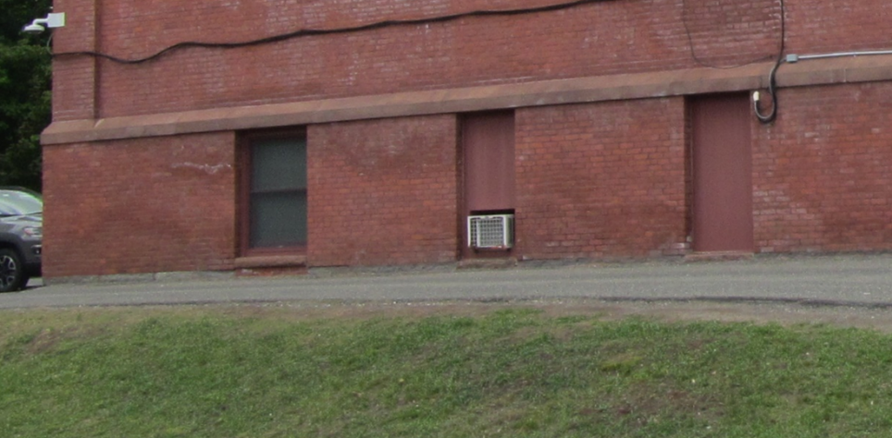

**Permanently installed window air conditioner**

**Picture 2**

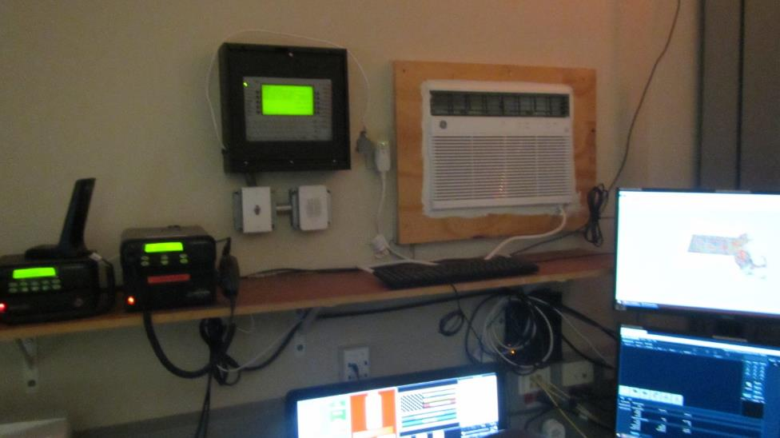

**Window air conditioner - interior side of Picture 1**

**Picture 3**

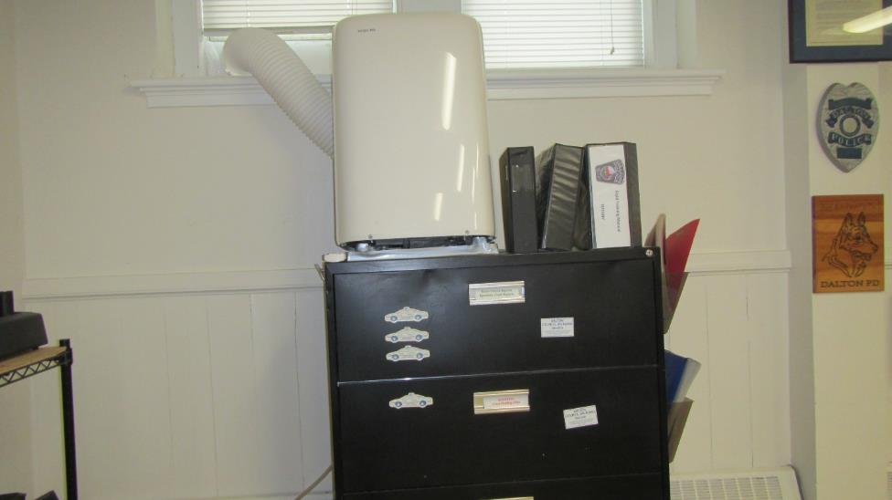

**Portable air-conditioner balanced on top of file cabinet**

**Picture 4**

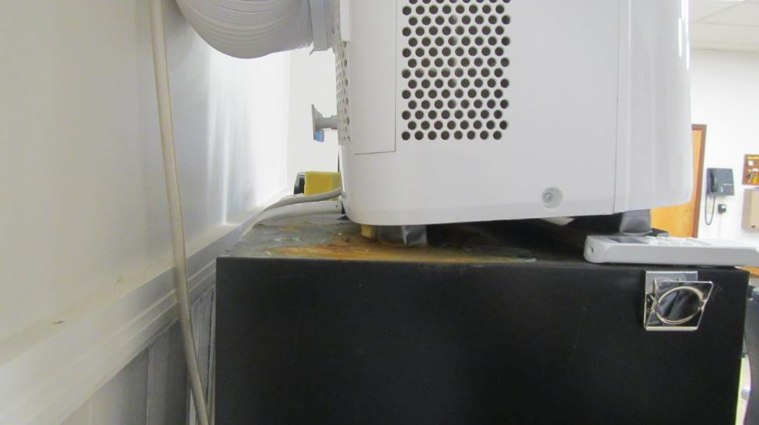

**Cabinet corrosion from condensation overflow of portable air-conditioner in Picture 3**

**Picture 5**

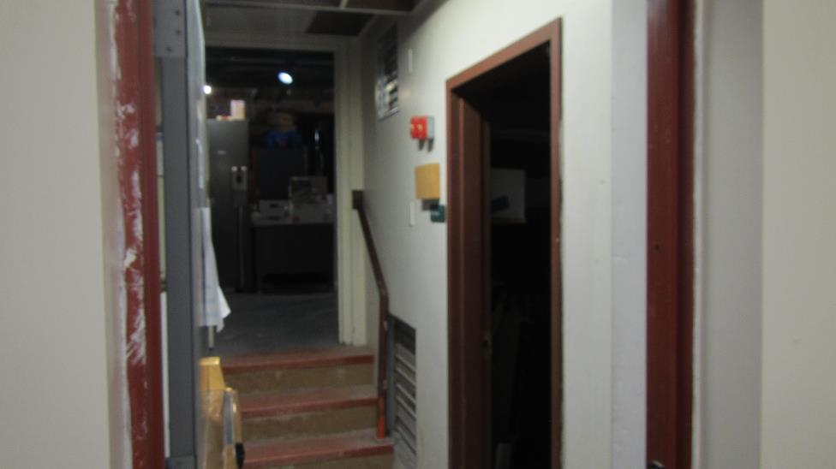

**Louvers in furnace room hallways**

**Picture 6**

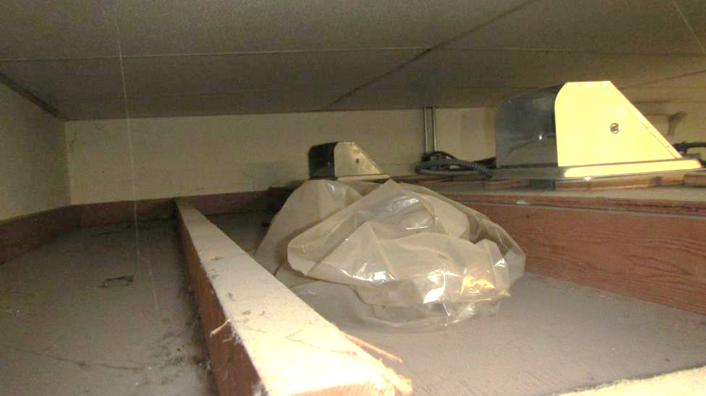

**Exhaust vent for cells, note no ductwork connected to outdoor vent**

**Picture 7**

**Furnace room with brick-and-mortar interior wall shared by DPD office with damaged wainscoting**

**Picture 8**

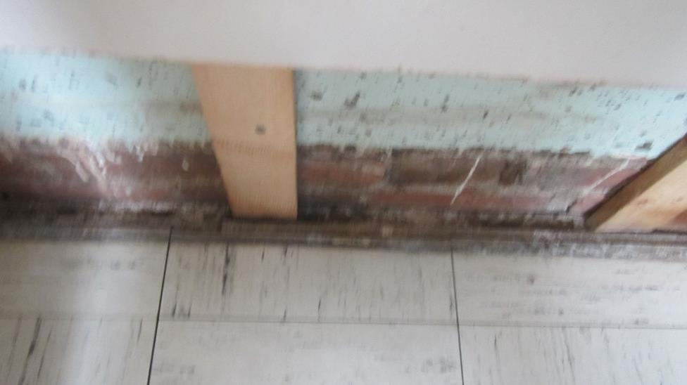

**Base of foundation wall in flooded restroom consists of brick and mortar to the floor**

**Picture 9**

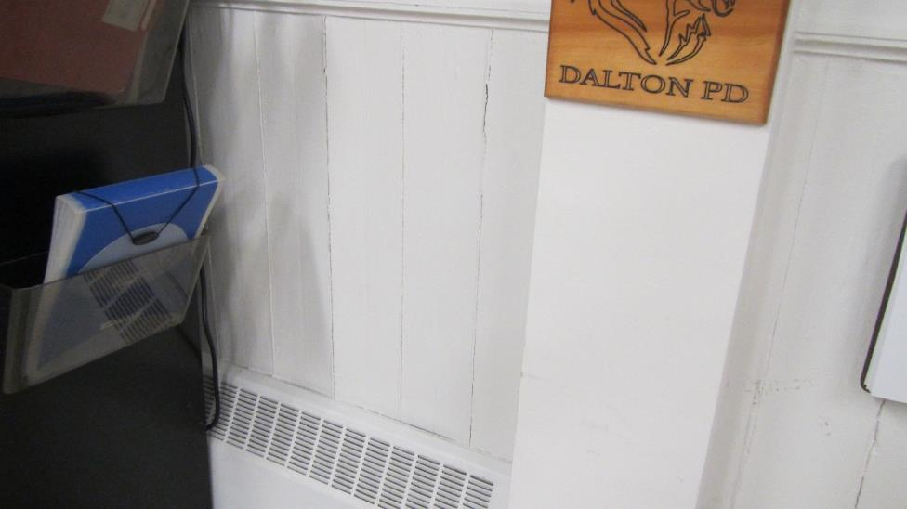

**Warped wainscoting, indicating possible water penetration through foundation wall**

**Picture 10**

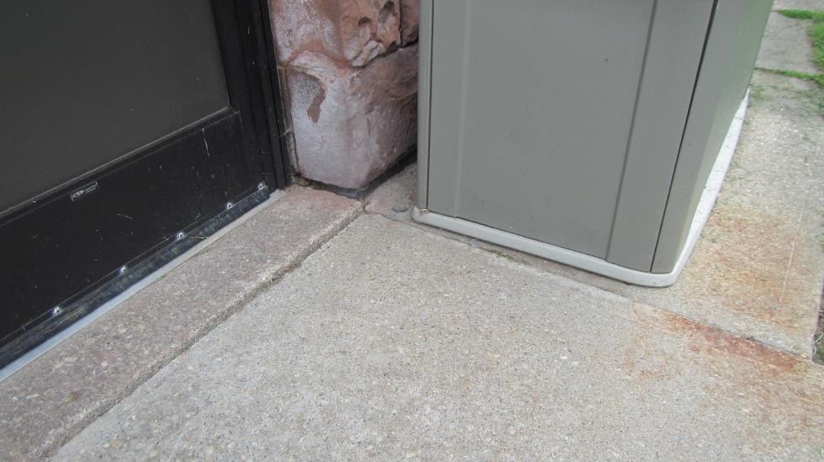

**Gap between sidewalk and foundation wall where water can accumulate**

**Picture 11**

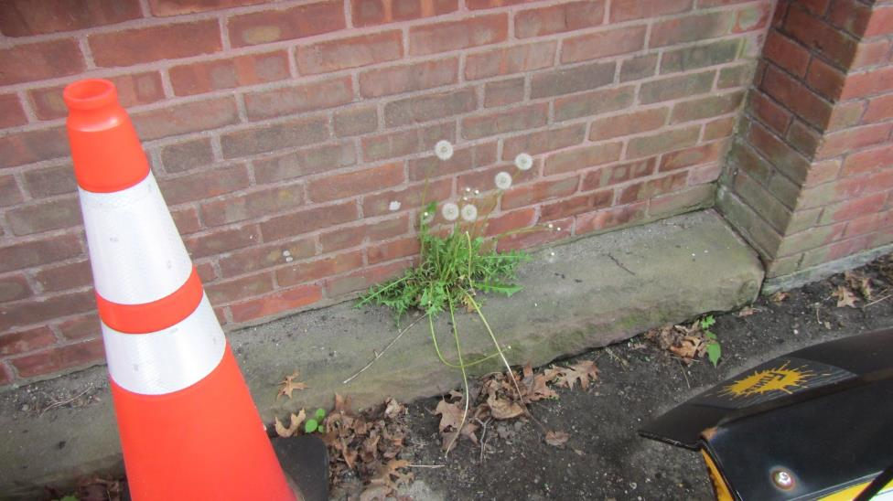

**Gap between the foundation and tarmac, also space in sill and brick joint**

**Picture 12**

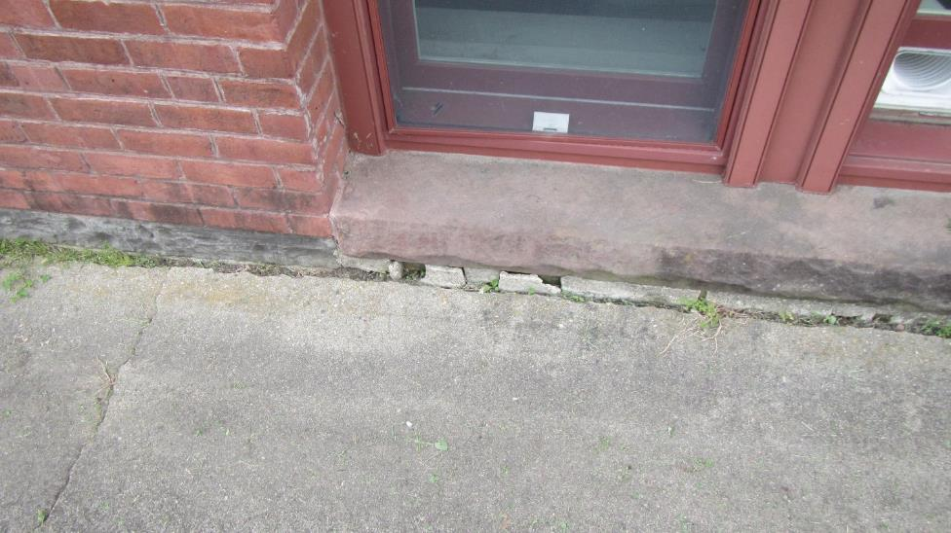

**Gap between cement apron and basement windowsill**

**Picture 13**

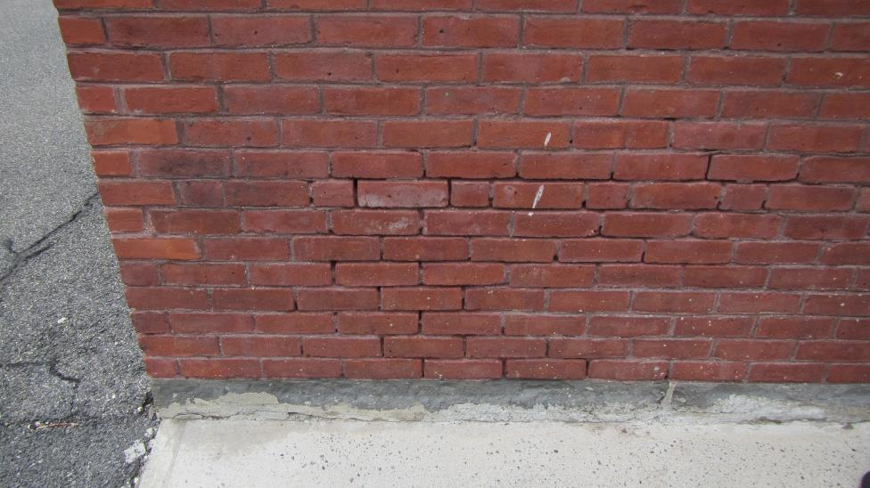

**Missing mortar between exterior wall bricks**

**Picture 14**

**Seams in cement apron exposing soil to become moist from rain
Note plant growth between cement slabs of apron as well as the windowsill and apron
**

**Seams in cement apron exposing soil to become moist from rain**

**Note plant growth between cement slabs of apron as well as the windowsill and apron**

**Picture 15**

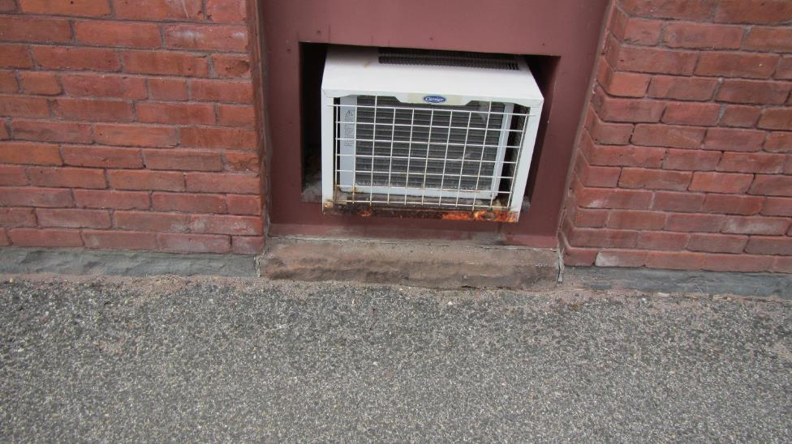

**Spaces around WAC installation, note opening larger than size of installed**

**window-mounted air-conditioner, which can allow for rainwater to moisten wood**

**Picture 16**

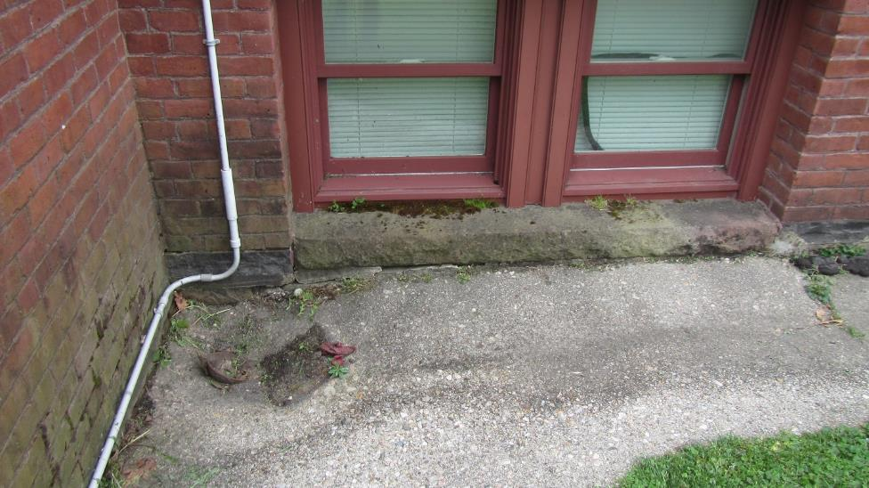

**Possible remnants of a downspout system in cement apron**

**Picture 17**

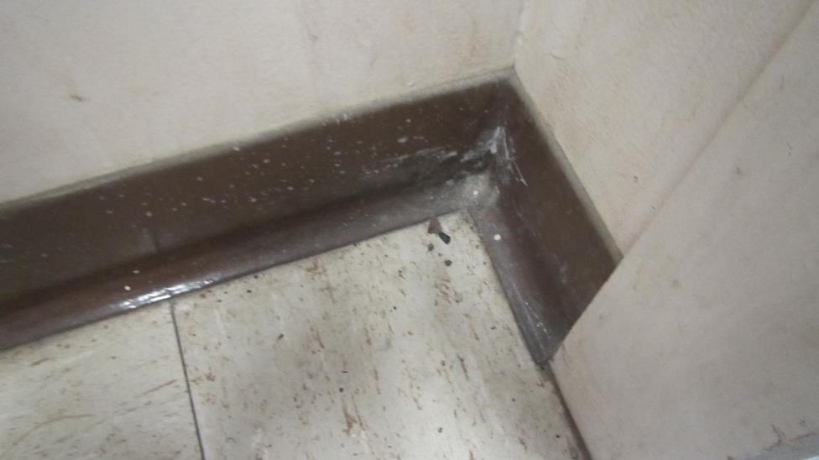

**Rodent droppings in main hallway**

**Picture 18**

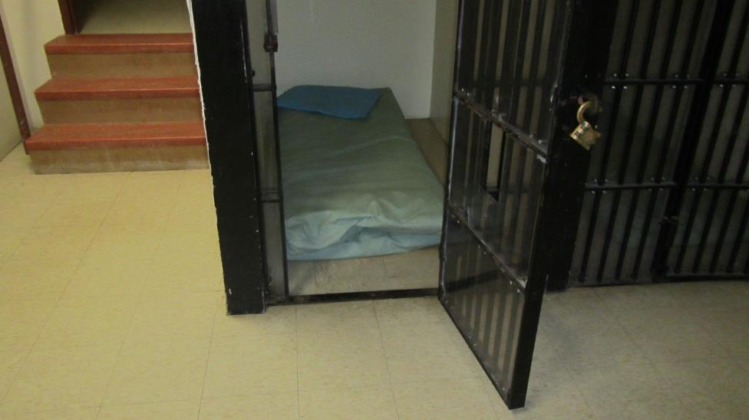

**Holding cells with gypsum wallboard walls**

| **Location/ Room** | **Carbon**  **Dioxide**  **(ppm)** | **Carbon Monoxide**  **(ppm)** | **Air Temp**  **(°F)** | **Floor Temp**  **(°F)** | **Relative**  **Humidity**  **(%)** | **PM2.5**  **(****µg/m3)** | **Occupants**  **in Room** | **Windows**  **Openable** | **Ventilation** | | **Remarks** |
| --- | --- | --- | --- | --- | --- | --- | --- | --- | --- | --- | --- |
| **Supply** | **Exhaust** |
| Background | 408 | ND | 77 |  | 47 | 5 |  |  |  |  | Sunny |
| 1 | 970 | ND | 71 | 65 | 51 | ND | 1 | N | N | N | Air purifier, dehumidifier, fans, cracked & bowing floor tiles, WAC, BCT, area carpeting |
| 2 | 1006 | ND | 72 | 65 | 55 | ND | 1 | N | N | N | Air purifier, carpeting, BCT, plant |
| 3 | 834 | ND | 71 | 61 | 54 | 1 | 0 | N | N | N | Air purifier, carpeting |
| 4 | 833 | ND | 71 | 61 | 51 | 1 | 0 | N | N | N | Water-damaged floor tiles, drywall & wood, BCT |
| 5 | 752 | ND | 71 | 66 | 56 | 3 | 0 | N | N | Y | Damaged floor tiles, holes in ceiling tiles, BCT |
| 6 | 809 | ND | 72 | 68 | 54 | 1 | 0 | N | N | N | Damaged ceiling tiles, BCT |
| Kitchen | 855 | ND | 72 | 62 | 54 | 1 | 0 | N | N | Y | BCT, holes in ceiling tile |
| 7 | 735 | ND | 72 | 65 | 56 | 2 | 0 | N | N | N | Gypsum wall board lockup cells, box fan, BCT, holes in ceiling tiles, lifting floor tiles |
| 8 | 804 | ND | 72 | 67 | 54 | ND | 1 | N | N | N | Box fan, air purifier, WAC, lifting floor tiles, holes in ceiling tiles, BCT, water-damaged wainscoting, water-damaged filing cabinet |
| 9 | 843 | ND | 73 | 65 | 54 | 4 | 0 | N | N | Y | Damaged ceiling tiles, BCT, water-damaged wainscoting, WAC, cardboard boxes on floor, carpeting, water-damaged ceiling tiles, |
| 10 | 808 | ND | 72 | 63 | 55 | 1 | 1 | N | N | N | Water-damaged wainscoting, carpeting, BCT, water-damaged ceiling tiles, cardboard boxes on floor, missing ceiling tiles |
| Lobby | 780 | ND | 71 | 65 | 55 | 2 | 0 | N | N | N | Mouse droppings on floor, water-damaged stairs & drywall, area carpeting, missing ceiling tiles, entry door not weathertight |

| **Location/ Room** | **Air Temp**  **(°F)** | **Floor Temp**  **(°F)** | **Relative**  **Humidity**  **(%)** | **Difference between air and floor surface temperatures (°F)** |
| --- | --- | --- | --- | --- |
|
| Background | 77 | - | 47 |  |
| 1 | 71 | 65 | 51 | -6 |
| 2 | 72 | 65 | 55 | -7 |
| 3 | 71 | 61 | 54 | -10 |
| 4 | 71 | 61 | 51 | -10 |
| 5 | 71 | 66 | 56 | -5 |
| 6 | 72 | 68 | 54 | -4 |
| Kitchen | 72 | 62 | 54 | -10 |
| 7 | 72 | 65 | 56 | -7 |
| 8 | 72 | 67 | 54 | -5 |
| 9 | 73 | 65 | 54 | -8 |
| 10 | 72 | 63 | 55 | -9 |
| Lobby | 71 | 65 | 55 | -6 |

**INDOOR AIR QUALITY ASSESSMENT**

**Sewage Backup Investigation**

**Dalton Police Department**

**462 Main Street Ste 7**

**Dalton, MA**

Prepared by:

Massachusetts Department of Public Health

Bureau of Climate and Environmental Health

Indoor Air Quality Program

June 2024

**BACKGROUND**

|  |  |
| --- | --- |
| **Building:** | Dalton Police Department (DPD) |
| **Address:** | Dalton Town Hall (DTH) Basement  462 Main Street Ste 7  Dalton, MA |
| **Assessment Contact:** | Chief Deanna Strout, DPD |
| **Reason for Request:** | Sewage backup and general IAQ |
| **Date of Assessment:** | May 17, 2024 |
| **Massachusetts Department of Public Health/Bureau of Environmental Health (MDPH/BEH) Staff Conducting Assessment:** | Michael Feeney, Director,  Indoor Air Quality (IAQ) Program  Thomas Murphy, Env. Analyst, IAQ  Program |
| **Date of Building Construction:** | DTH/Public Library was constructed in 1892. The basement was renovated in the 1970’s for occupation by the DPD. |
| **Building Description:** | The water damage occurred in a restroom in the front foyer of the DPD reception. The DPD is in the basement of the DTH/Public Library building. |
| **Windows:** | Not openable |

**INTRODUCTION**

On May 6, 2024 the IAQ Program was contacted by Dalton Police Chief Deanna Strout concerning a flood that occurred in the foyer DPD restroom. This report details findings and recommendations regarding the restroom flooding. A second report detailing the general indoor air quality findings and recommendations will be drafted in a separate report.

**METHODS**

Please refer to the IAQ Manual and appendices for methods, sampling procedures, and interpretation of results (MDPH, 2015).

**IAQ TESTING RESULTS**

The following is a summary of indoor air testing results. Only a limited area of the building near where the flooding/water damage occurred was tested.

* ***Temperature*** was within the recommended range of 70°F to 78°F in all areas on the day of assessment.
* ***Relative humidity*** was within the recommended range of 40 to 60% in the areas.

**DISCUSSION**

IAQ staff visited the DPD to assess the conditions and extent of a sewage (black water) flooding that was reported to have occurred prior to the initial call from DPD Chief Deanna Strout on May 6, 2024.

As reported by DTH staff, the restroom in the DPD reception foyer has repeatedly experienced black water flooding which has wet the floor and walls on several occasions. As reported by DTH staff, the pipe connecting the drain systems to the town sewage lines is of unusual length and configuration. The sewer line reportedly forms a 90-degree angle underground, which causes the system to become clogged. As reported by DTH facilities staff, the bend in the pipe is at a distance that is beyond available for plumbing equipment in the greater Dalton area.

The walls and the floor of the foyer restroom were examined. Prior to this visit, gypsum wallboard (GW) and plastic coving were removed from the restroom (Picture 1). Wall cavity wood studs and the edge of the flooring system were exposed and examined (Picture 2).

In order to contain a possible sewerage backup, public buildings will have a floor drain and a floor/wall junction that will be water resistant (tile and grout), if not waterproof. The DPD restroom does not have a floor drain or waterproof edge at the wall/floor junction. The restroom wall/floor junction appears to be gypsum wallboard (GW). It is likely covered with plastic coving as are the other walls in the DPD (Picture 3). This configuration allowed for black water to enter the wall cavity to wet GW and enter the open side of the floor tile structure when the drain system backed up. Once in the floor seam (Picture 2), black water could move by capillary action under the floor.

In order to identify possible black water wetting of the underlying floor structure, IAQ staff conducted moisture measurements. Moisture measurements were taken of the following floors: the flooded restroom, adjacent hallway and dispatch office. The moisture measurements showed that the underflooring beneath the tile was saturated (Picture 1) with black water in the restroom, hallway and part of the dispatch flooring. The moisture measurements also indicated the underlying flooring was wet for more than 11 days (240+ hours) since the last flooding incident. It is likely that the black water remains in the space between the flooring and the cement floor of the basement.

The timeframe when drying occurs is important to prevent mold growth. In general, drying of plywood should begin within 48 hours of wetting as recommended in the US EPA guidelines “Mold Remediation in Schools and Commercial Buildings” Mold Remediation in Schools and Commercial Buildings Guide: Chapter 1 | US EPA. Given the moisture measurements, the underlying floor was not dried within the US EPA guideline (~48 hours) and is likely mold contaminated.

It is important to note the following conditions regarding the materials used for flooring. The underflooring is likely not natural wood, but it is made of plywood, particle board or chip board, all of which are called engineered (manufactured) wood products. All engineered wood products are considered porous materials and can grow mold if they are wet for greater than 48 hours. If contaminated by black water, porous materials such as engineered wood cannot be appropriately cleaned and would be recommended for removal.

As initially reported, this area of the DPD has an unidentified odor. The odor experienced is likely due to the repeated accumulation of black water in the space between the wood flooring and the basement cement floor, which in turn has caused mold growth on the flooring material. Given that the floors remain water-damaged, and likely mold contaminated, removing the water- damaged flooring in a manner consistent with US EPA Mold Remediation guidelines is recommended.

Please note that the renovation of the Dalton Town Hall was reported to have occurred in 1976. If this is the case, then the floor tile may likely contain asbestos. If so, then remediation would require compliance with all federal and state asbestos laws and regulations. Prior to any remediation, the floor tile should be inspected by a MA licensed asbestos inspector.

**CONCLUSIONS/RECOMMENDATIONS**

In view of the findings at the time of the visit, the following recommendations are made regarding the DPD foyer restroom:

1. Follow EPA and industry guidelines concerning methods used to remediate buildings that are impacted by sewage (i.e., blackwater). Some of these guideline links include:
   1. USEPA’s Flood Cleanup: Protecting Indoor Air Quality <https://www.epa.gov/sites/production/files/2015-09/documents/floods.pdf> and
   2. ANSI/IICRC S500 - Standard and Reference Guide for Professional Water Damage Restoration.
2. Ensure that all porous items and building materials (e.g., engineered wood, GW) that were damaged by the backup of blackwater are removed and discarded. This would include wall studs in restroom wall cavity if deemed porous and not able to be properly sanitized.
3. Consult with a MA licensed asbestos inspector regarding the floor tile to determine if it contains asbestos. If the floor tile contains asbestos, comply with all relevant federal and state laws and regulations concerning asbestos remediation and disposal.
4. Ensure that all nonporous building materials, items, and surfaces impacted are properly disinfected prior to replacing building materials/furnishings.
5. In order to gain access to the pipe bend, accessing the pipe from the street manhole is suggested (Picture 4).
6. Consideration should be given to reconfiguring the pipe bend causing black water back up.
7. Refer to resource manual and other related indoor air quality documents located on the MDPH’s website for further building-wide evaluations and advice on maintaining public buildings. These documents are available at <http://mass.gov/dph/iaq>.

**REFERENCES**

MDPH. 2015. Massachusetts Department of Public Health. Massachusetts Department of Public Health Indoor Air Quality Manual: Chapters I-III. Available at: <http://www.mass.gov/eohhs/gov/departments/dph/programs/environmental-health/exposure-topics/iaq/iaq-manual/>.

US EPA. 2005. Mold remediation in Schools and Commercial Buildings. [Mold in Schools and Commercial Buildings | US EPA](https://www.epa.gov/mold/mold-schools-and-commercial-buildings)

**Picture 1**

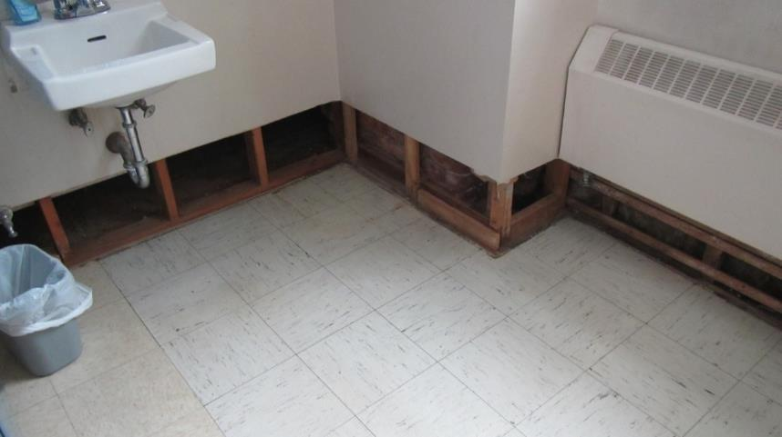

**Removed GW wetted by flooding**

**Picture 2**

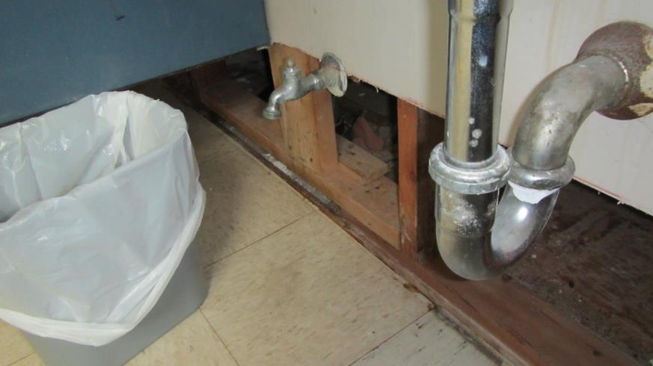

**Open seam on floor edge, note lifting tile likely from water exposure**

**Picture 3**

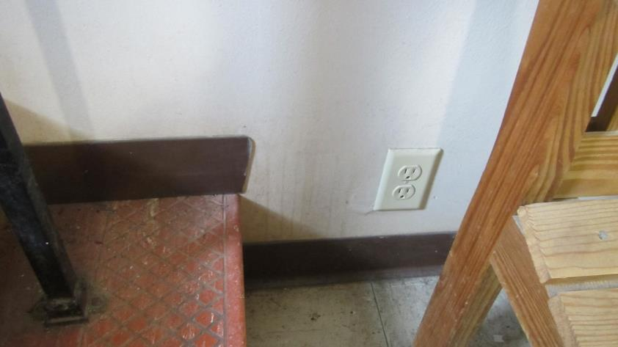

**Wall outside restroom made of GW with plastic coving**

**Picture 4**

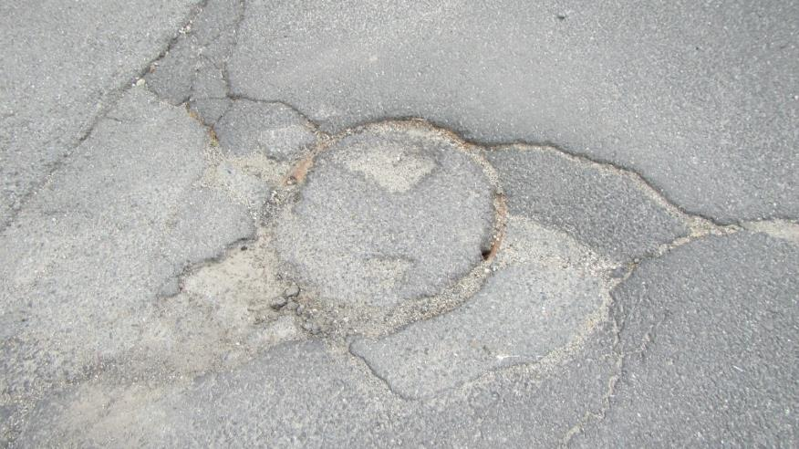

**Possible sewer manhole cover, likely not accessed since covered with tarmac**

