**INDOOR AIR QUALITY ASSESSMENT**

**Sewage Backup Investigation**

**Dalton Police Department**

**462 Main Street Ste 7**

**Dalton, MA**

Prepared by:

Massachusetts Department of Public Health

Bureau of Climate and Environmental Health

Indoor Air Quality Program

June 2024

# BACKGROUND

|  |  |
| --- | --- |
| Building: | Dalton Police Department (DPD) |
| Address: | Dalton Town Hall (DTH) Basement  462 Main Street Ste 7  Dalton, MA |
| Assessment Contact: | Chief Deanna Strout, DPD |
| Reason for Request: | Sewage backup and general IAQ |
| Date of Assessment: | May 17, 2024 |
| Massachusetts Department of Public Health/Bureau of Environmental Health (MDPH/BEH) Staff Conducting Assessment: | Michael Feeney, Director,  Indoor Air Quality (IAQ) Program  Thomas Murphy, Env. Analyst, IAQ  Program |
| Date of Building Construction: | DTH/Public Library was constructed in 1892. The basement was renovated in the 1970’s for occupation by the DPD. |
| Building Description: | The water damage occurred in a restroom in the front foyer of the DPD reception. The DPD is in the basement of the DTH/Public Library building. |
| Windows: | Not openable |

# INTRODUCTION

On May 6, 2024 the IAQ Program was contacted by Dalton Police Chief Deanna Strout concerning a flood that occurred in the foyer DPD restroom. This report details findings and recommendations regarding the restroom flooding. A second report detailing the general indoor air quality findings and recommendations will be drafted in a separate report.

# METHODS

Please refer to the IAQ Manual and appendices for methods, sampling procedures, and interpretation of results (MDPH, 2015).

# IAQ TESTING RESULTS

The following is a summary of indoor air testing results. Only a limited area of the building near where the flooding/water damage occurred was tested.

* ***Temperature*** was within the recommended range of 70°F to 78°F in all areas on the day of assessment.
* ***Relative humidity*** was within the recommended range of 40 to 60% in the areas.

# DISCUSSION

IAQ staff visited the DPD to assess the conditions and extent of a sewage (black water) flooding that was reported to have occurred prior to the initial call from DPD Chief Deanna Strout on May 6, 2024.

As reported by DTH staff, the restroom in the DPD reception foyer has repeatedly experienced black water flooding which has wet the floor and walls on several occasions. As reported by DTH staff, the pipe connecting the drain systems to the town sewage lines is of unusual length and configuration. The sewer line reportedly forms a 90-degree angle underground, which causes the system to become clogged. As reported by DTH facilities staff, the bend in the pipe is at a distance that is beyond available for plumbing equipment in the greater Dalton area.

The walls and the floor of the foyer restroom were examined. Prior to this visit, gypsum wallboard (GW) and plastic coving were removed from the restroom (Picture 1). Wall cavity wood studs and the edge of the flooring system were exposed and examined (Picture 2).

In order to contain a possible sewerage backup, public buildings will have a floor drain and a floor/wall junction that will be water resistant (tile and grout), if not waterproof. The DPD restroom does not have a floor drain or waterproof edge at the wall/floor junction. The restroom wall/floor junction appears to be gypsum wallboard (GW). It is likely covered with plastic coving as are the other walls in the DPD (Picture 3). This configuration allowed for black water to enter the wall cavity to wet GW and enter the open side of the floor tile structure when the drain system backed up. Once in the floor seam (Picture 2), black water could move by capillary action under the floor.

In order to identify possible black water wetting of the underlying floor structure, IAQ staff conducted moisture measurements. Moisture measurements were taken of the following floors: the flooded restroom, adjacent hallway and dispatch office. The moisture measurements showed that the underflooring beneath the tile was saturated (Picture 1) with black water in the restroom, hallway and part of the dispatch flooring. The moisture measurements also indicated the underlying flooring was wet for more than 11 days (240+ hours) since the last flooding incident. It is likely that the black water remains in the space between the flooring and the cement floor of the basement.

The timeframe when drying occurs is important to prevent mold growth. In general, drying of plywood should begin within 48 hours of wetting as recommended in the US EPA guidelines “Mold Remediation in Schools and Commercial Buildings” Mold Remediation in Schools and Commercial Buildings Guide: Chapter 1 | US EPA. Given the moisture measurements, the underlying floor was not dried within the US EPA guideline (~48 hours) and is likely mold contaminated.

It is important to note the following conditions regarding the materials used for flooring. The underflooring is likely not natural wood, but it is made of plywood, particle board or chip board, all of which are called engineered (manufactured) wood products. All engineered wood products are considered porous materials and can grow mold if they are wet for greater than 48 hours. If contaminated by black water, porous materials such as engineered wood cannot be appropriately cleaned and would be recommended for removal.

As initially reported, this area of the DPD has an unidentified odor. The odor experienced is likely due to the repeated accumulation of black water in the space between the wood flooring and the basement cement floor, which in turn has caused mold growth on the flooring material. Given that the floors remain water-damaged, and likely mold contaminated, removing the water- damaged flooring in a manner consistent with US EPA Mold Remediation guidelines is recommended.

Please note that the renovation of the Dalton Town Hall was reported to have occurred in 1976. If this is the case, then the floor tile may likely contain asbestos. If so, then remediation would require compliance with all federal and state asbestos laws and regulations. Prior to any remediation, the floor tile should be inspected by a MA licensed asbestos inspector.

# CONCLUSIONS/RECOMMENDATIONS

In view of the findings at the time of the visit, the following recommendations are made regarding the DPD foyer restroom:

1. Follow EPA and industry guidelines concerning methods used to remediate buildings that are impacted by sewage (i.e., blackwater). Some of these guideline links include:
   1. USEPA’s Flood Cleanup: Protecting Indoor Air Quality <https://www.epa.gov/sites/production/files/2015-09/documents/floods.pdf> and
   2. ANSI/IICRC S500 - Standard and Reference Guide for Professional Water Damage Restoration.
2. Ensure that all porous items and building materials (e.g., engineered wood, GW) that were damaged by the backup of blackwater are removed and discarded. This would include wall studs in restroom wall cavity if deemed porous and not able to be properly sanitized.
3. Consult with a MA licensed asbestos inspector regarding the floor tile to determine if it contains asbestos. If the floor tile contains asbestos, comply with all relevant federal and state laws and regulations concerning asbestos remediation and disposal.
4. Ensure that all nonporous building materials, items, and surfaces impacted are properly disinfected prior to replacing building materials/furnishings.
5. In order to gain access to the pipe bend, accessing the pipe from the street manhole is suggested (Picture 4).
6. Consideration should be given to reconfiguring the pipe bend causing black water back up.
7. Refer to resource manual and other related indoor air quality documents located on the MDPH’s website for further building-wide evaluations and advice on maintaining public buildings. These documents are available at <http://mass.gov/dph/iaq>.

# REFERENCES

MDPH. 2015. Massachusetts Department of Public Health. Massachusetts Department of Public Health Indoor Air Quality Manual: Chapters I-III. Available at: <http://www.mass.gov/eohhs/gov/departments/dph/programs/environmental-health/exposure-topics/iaq/iaq-manual/>.

US EPA. 2005. Mold remediation in Schools and Commercial Buildings. [Mold in Schools and Commercial Buildings | US EPA](https://www.epa.gov/mold/mold-schools-and-commercial-buildings)

**Picture 1**

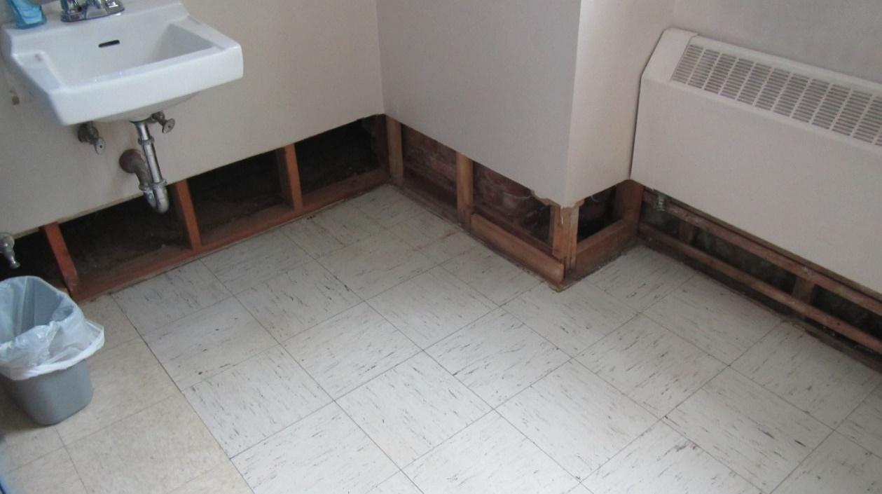

**Removed GW wetted by flooding**

**Picture 2**

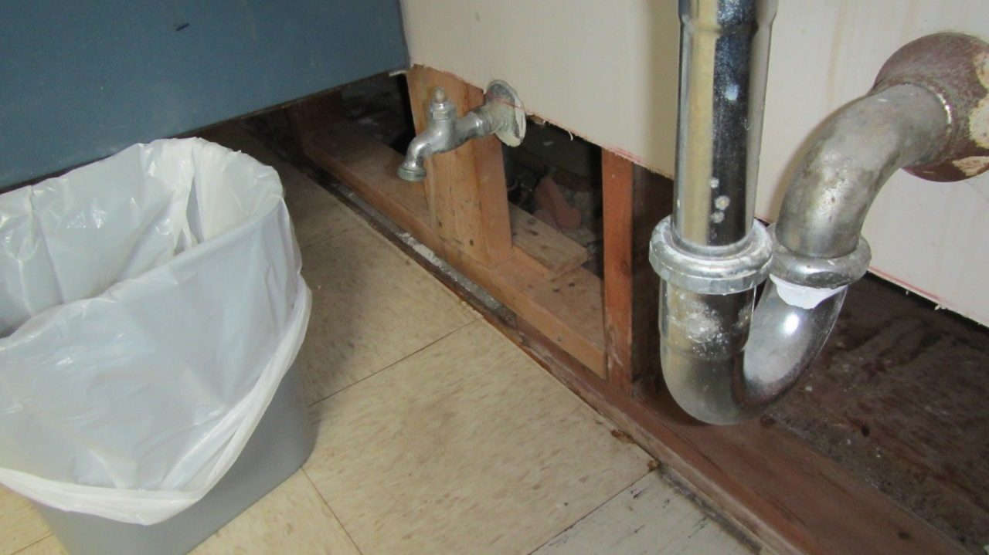

**Open seam on floor edge, note lifting tile likely from water exposure**

**Picture 3**

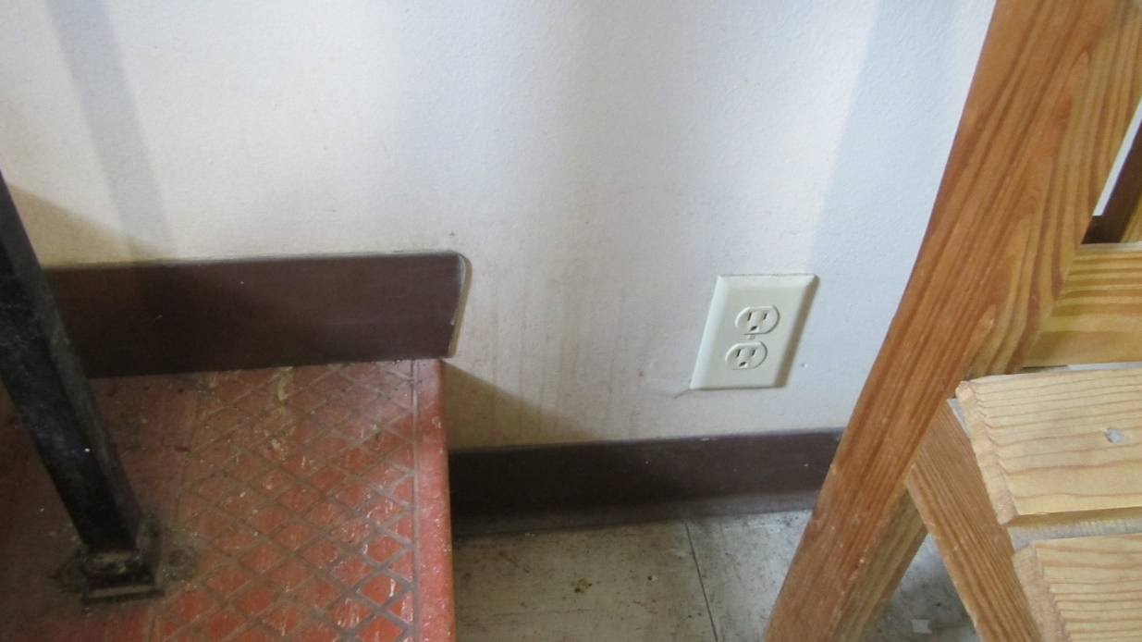

**Wall outside restroom made of GW with plastic coving**

**Picture 4**

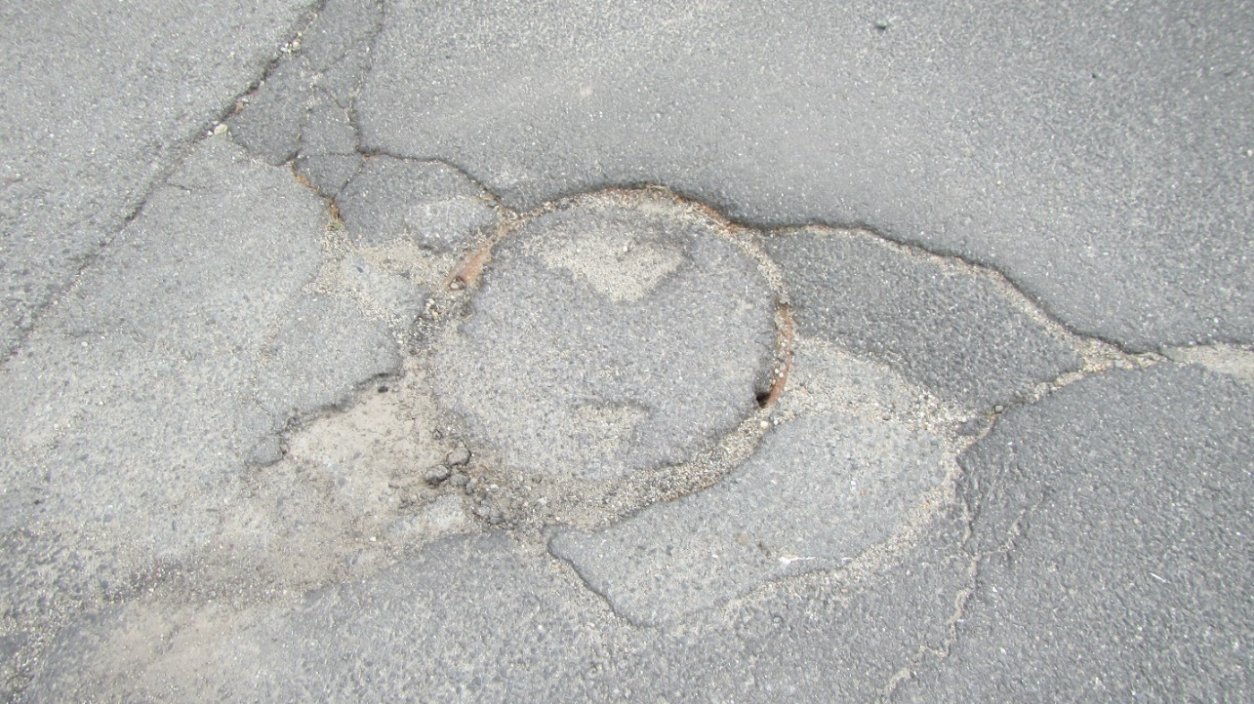

**Possible sewer manhole cover, likely not accessed since covered with tarmac**