October 19, 2018

Via E-Mail: Reg.Testimony@state.ma.us

William Anderson
Office of the General Counsel
Department of Public Health
250 Washington Street
Boston, MA 02108

Re: DoN Regulations

Mr. Anderson:

On behalf of Dana-Farber Cancer Institute (“Dana-Farber”), please accept the following comments to the Department of Public Health’s (“Department”) proposed amendments to the Determination of Need (“DoN”) regulations at 105 CMR 100.000. We appreciate the opportunity to provide comments on the significant changes that will become effective through these amendments, if they are approved as currently drafted. We believe the language as proposed will have considerable unanticipated impacts on providers’ ability to meet the public health needs of the Commonwealth in a timely manner and will add unnecessary costs to the healthcare system. We present the following concerns.

Through the proposed amendments to the DoN regulations, the Department will require a consolidated DoN application for all projects anticipated to occur in a federal fiscal year (“FFY”) if such projects, when aggregated together, meet the minimum capital expenditure. The Department’s long-standing policy has been to view expenditures at each geographically distinct facility independently. The new consolidated approach requires that the capital expenditures for proposed projects at all of a hospital’s facilities be combined for purposes of determining whether the aggregate costs exceed a statutory threshold for a DoN filing. We appreciate the Department’s desire to review a provider organization’s planning as it impacts the entire patient panel. However, this consolidation of capital expenditures across sites is unprecedented, unauthorized, and the Department has afforded the public and provider organizations just over one month to review and comment on these significant proposed changes.

Most concerning, the proposed regulations also include language that retroactively applies consolidation to projects already planned for the current FFY despite the fact that the regulations are not yet effective. The newly added 105 CMR 100.715(C) prescribes that certain projects currently underway during FFY2019 will be subject to DoN review, even though such projects historically have not been reviewed by the DoN Program. The practical effect is that the proposed regulations apply this requirement to projects that have been planned well before the proposed amendments were released. By attempting to bring these projects under DoN review, projects that commenced prior to the effective date of the regulations will be halted, delayed and potentially not approved. If projects already underway cannot move forward as planned, this will lead to poor public health outcomes, adversely impact quality of life for patients, provide uncertainty to the construction and labor industries, negatively impact healthcare job hiring, and increase costs to the healthcare system.

If the proposed language at 105 CMR 100.715(C) is adopted, we believe that the requirements of this section do not apply to any new or existing satellite project for which architectural plan review was filed with the Department prior to the start of FFY2019 (10/1/18), even if the construction occurs in FFY2019. Thus, these projects would be exempt or “grandfathered” from the consolidated filing for capital expenditures and the filing requirements under the so-called transition period of the amended regulations. We request that the Department acknowledge that this application of the proposed regulations is accurate.

Without such confirmation regarding the exemption for projects that have been filed for plan review prior to FFY2019, it is our belief that the regulation, if adopted as proposed, will unduly impact Dana-Farber and its ability to pursue its core mission: to prevent, treat and cure cancer. The Federal Government has recognized the importance of cancer hospitals, such as Dana-Farber, and has effectively encouraged their continued implementation of new community-based satellite locations. In 2015, federal legislation eliminated hospital-based Medicare reimbursement for all new hospital satellite facilities. However, Congress recognized the need to promote access to cancer services and through the subsequent 21st Century Cures Act, it exempted cancer hospitals from this treatment by allowing new cancer hospital satellites to continue to receive hospital-based reimbursement from Medicare. Consistent with the Federal Government’s support for and promotion of new cancer hospital satellites, Dana-Farber thoughtfully developed a plan for extending care to its patient panel closer to home through the addition or expansion of satellite locations.

Under current DoN regulations, Dana-Farber’s new satellite locations would not require DoN approval as the expenditure involved at each location is under the applicable DoN threshold. Dana-Farber has taken significant steps consistent with existing DoN regulations to implement these satellite facilities, including entering into long-term leases, making expenditures to design and plan the services to be offered at each location, and filing with the Department for architectural plan review. These activities are fully permitted under existing law and regulation. Although we believe the consequences would be unintended, the consolidation provisions would challenge the very feasibility of our current and planned activities in certain areas of the state, which would not otherwise be subject to a DoN, and would ultimately have a very negative impact on access to cancer care in these areas.

The retroactive application of consolidation will significantly impact Dana-Farber’s ability to move forward with providing care to its patient panel in a timely manner, ultimately delaying treatment and cures for some of the sickest patients in the Commonwealth. In addition, the ability to improve our patients’ quality of life will be impacted as those patients who are able will have to travel to Boston for treatment at Dana-Farber, exacerbating the mental, physical and emotional toll of cancer for patients who choose Dana-Farber for care. With the anticipated delays, some patients may forego travel to Boston and instead seek care locally and thus would not have access to the subspecialized care, novel therapies, genomic testing, clinical trials, pain and palliative care, nutritional and psychosocial support that we provide to patients and is not typically available in community settings. In addition to the aforementioned costs to our patients, significant costs will be imposed on Dana-Farber as it will have to undergo a costly and time-consuming DoN review process, and incur the costs associated with a delay in construction. Finally, Dana-Farber is in the midst of efforts to comply with costly and extensive federal pharmacy standards being implemented within the next year and, in reliance on current DoN regulations, has established appropriate timelines to ensure our compliance. In anticipation of these new pharmacy requirements, Dana-Farber made the decision to move forward now with building/renovation of its pharmacies to comply in time with the December 1, 2019 effective date of the new USP standards. This decision to comply with these standards was based on the facts that the proposed Board of Pharmacy regulations, once finalized, will require all hospital pharmacies to meet these standards regardless of when they were built (no grandfathering), and the Joint Commission surveys the hospital’s pharmacies according to USP standards thereby making compliance with the standards essentially required for continued Medicare participation. The proposed consolidation requirement will jeopardize Dana-Farber’s ability to meet its timeline for completion of these important pharmacy projects that will improve patient and staff safety. Such outcomes are inconsistent with the Department’s mandate to improve public health outcomes in a cost-effective manner.

Moreover, as a matter of law, the retroactive application of administrative regulations is generally not permitted unless expressly authorized by statute. The Supreme Court has ruled that “an administrative agency’s power to promulgate regulations is limited to the authority delegated by Congress… [S]tatutory grants of rulemaking authority will not, as a general matter, be understood to encompass the power to promulgate retroactive rules unless that power is conveyed by express terms.” In other words, regulations shall not be retroactive unless clearly authorized by statute. The Massachusetts Legislature has not enacted any law that grants the Department the authority to enact DoN regulations that have a retroactive effect, as proposed in 105 CMR 100.715(C). This legal principle was reinforced in a subsequent Supreme Court decision in which the Court stated that “[e]lementary considerations of fairness dictate that individuals should have an opportunity to know what the law is and to conform their conduct accordingly; settled expectations should not be lightly disrupted.” The Massachusetts Supreme Judicial Court also has applied this principle under the Massachusetts Constitution to determine if a retroactive law is equitable. Accordingly, both the U.S. Supreme Court and the highest court in Massachusetts have concluded that retroactive rulemaking is not appropriate because it does not provide notice to allow individuals to conform their behavior to comply with the law. It is settled law that the Department should not attempt to apply the consolidation requirement in a retroactive manner without a legislative mandate. The language at 105 CMR 100.715(C) should not be adopted as a matter of law.

Finally, as proposed, if capital expenditures for conservation work (e.g., replacement of facility systems, cosmetic upgrades, refurbishment) are counted toward meeting a DoN threshold, the regulations are not within the authority granted by the legislature to the Department to implement regulations that carry out the intent of the statute. Consolidation of expenditures for new projects with conservation work for all facilities will effectively override the legislature’s intent to only require DoN review for large projects by including a minimum expenditure that must be met in order to trigger the Department’s review of a project. When multiple geographically distinct projects are combined with annual capital expenditures at a main campus, including expenses to maintain existing infrastructure (i.e., conservation work), it is likely that the capital expenditure threshold will be met on an annual basis for all academic medical centers in the Commonwealth. We do not believe that the legislature intended for the Department to review the need of providers to maintain existing facilities. Accordingly, we recommend that the Department eliminate DoN review of conservation projects from the regulations.

The Department’s proposed consolidated filing requirement undermines the legislative intent behind the DoN capital expenditure thresholds and the retroactive application of this concept is inconsistent with longstanding legal principles. Ultimately, if enacted, the retrospective nature of the regulations will have, perhaps unintended, the consequence of disrupting settled expectations of providers without prior notice to allow them to plan appropriately to comply with the Department’s new rules. A more reasonable approach, that will allow providers to plan accordingly to comply with the Department’s expectations, is to revise the proposed amendments to begin in FFY2020 and eliminate 105 CMR 100.715(C).

Consistent with our above detailed comments, we ask the Department to consider the following changes to the regulations:

- Confirm that plan review projects filed with the Department prior to FFY2019 (10/1/18) are exempt from the proposed amendments to the DoN regulations in their totality.
- Remove Section 105 CMR 715(C) as it will retroactively apply the consolidation requirement to projects that have already begun.
- Eliminate the requirement to consolidate projects that will occur at different geographical locations.
- Change the effective date for the consolidated filing requirement to begin no earlier than FFY2020.
- Eliminate DoN review of conservation projects.
- Eliminate DoN review of any project that is necessary to meet state and federal regulatory requirements.

With the enactment of the 2017 DoN regulations, although there clearly has been an enhanced focus on cost control, access, and social determinants of health and public health value, the DoN process has become more extensive, time-consuming and costly, which has had the unintended effect of adversely impacting a provider’s ability to meet the needs of its patient panel in a timely manner and ultimately adds costs to the healthcare system. The proposed amendments to the regulations continue to increase administrative and cost burdens with the need to potentially develop and submit annual DoN filings and be subject to an amendment process that will cause further delays and increase costs. We believe our proposed changes should be incorporated into the proposed regulations, so that the regulations are more consistent with the Administration’s mandate for regulatory simplification.
We appreciate the opportunity to provide these important comments and express our concerns with the proposed amendments to the Department’s DoN regulations.

Sincerely,
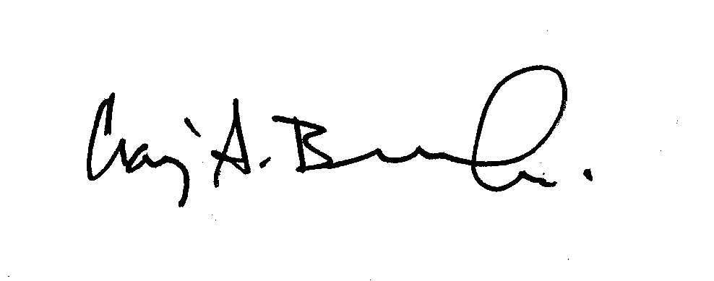
Craig A. Bunnell, MD, MPH, MBA
Chief Medical Officer
Dana-Farber Cancer Institute
450 Brookline Avenue
Boston, MA 02215

Bowen v. Georgetown Univ. Hosp., 488 U.S. 204, 208-9 (1988).
Landgraf v. USI Film Products, 511 U.S. 244, 265 (1994).
“Each individual of the society has the right to be protected by it in the enjoyment of his life, liberty and property, according to standing laws.” Mass. Const. Pt. I, art X.
Bird Anderson v. BNY Mellon, N.A., 463 Mass. 299, 314-15 (Aug. 2012).

