INDOOR AIR QUALITY ASSESSMENT

Danforth Building
123 Union Avenue
Framingham, MA

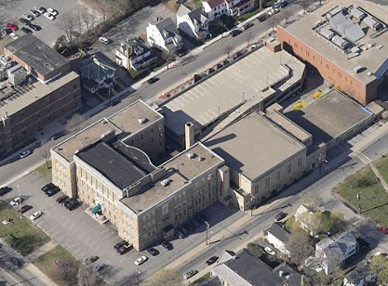

Prepared by:
Massachusetts Department of Public Health
Bureau of Environmental Health
Indoor Air Quality Program
June 2016

Background
Building: | Danforth Building (DB)
Address: | 123 Union Avenue, Framingham, MA
Assessment Requested by: | Michael Blanchard, MS, REHS/RS  Director of Public Health,  Framingham Health Department (FHD)
Reason for Request: | General indoor air quality (IAQ) and mold concerns
Date of Assessment: | May 31, 2016
Massachusetts Department of Public Health/Bureau of Environmental Health (MDPH/BEH) Staff Conducting Assessment: | Ruth Alfasso, Environmental Engineer/Inspector, Cory Holmes, and  Jason Dustin, Environmental Analysts/Inspectors
Building Description: | Large brick building complex, originally built 1930s with 1940s addition
Building Population: | The building is occupied by a number of private entities including the Danforth Art Museum, the Boys and Girls Club and the Framingham Performance Art Center and is visited by the public to take classes, work on art projects and attend events.
Windows: | Some openable

METHODS
Please refer to the IAQ Manual for methods, sampling procedures, and interpretation of results (MDPH, 2015).

IAQ Testing Results
The following is a summary of indoor air testing results (Table 1).
- Carbon dioxide levels were below 800 parts per million (ppm) in all areas tested.
- Temperature was slightly above the recommended range of 70°F to 78°F in about twenty percent of areas tested, all on the second floor.
- Relative humidity was mostly within the recommended range of 40 to 60% with some measurements above and some below.
- Carbon monoxide levels were non-detectable (ND) in all areas tested.
- Fine particulate matter (PM2.5) concentrations measured were below the National Ambient Air Quality Standard (NAAQS) level of 35 μg/m³ in all areas tested, with the exception of the Ceramics Room, which was 35 μg/m³.

Although most IAQ parameters measured were in the preferred range, most areas of the building had very low occupancy, which greatly reduces carbon dioxide levels. Note that due to issues with the heating system in this building, and the difficulty of maintaining/repairing the building systems, the Framingham Facilities Department and state Department of Public Safety has determined that it is no longer going to be occupied after September 1, 2016.

Ventilation
A heating, ventilating and air conditioning (HVAC) system has several functions. First it provides heating and, if equipped, cooling. Second, it is a source of fresh air. Finally, an HVAC system will dilute and remove normally occurring indoor environmental pollutants by not only introducing fresh air, but by filtering the airstream and ejecting stale air to the outdoors via exhaust ventilation. Even if an HVAC system is operating as designed, point sources of respiratory irritants may exist and cause symptoms in sensitive individuals. The following analysis examines and identifies components of the HVAC system and likely sources of respiratory irritant/allergen exposure due to water damage, aerosolized dust and/or chemicals found in the indoor environment.
The Danforth Building has no functioning mechanical ventilation in most areas. The Gym area on the second floor of the annex has an exhaust system. The Boys and Girls Club area is connected to an HVAC system which provides heat and cooling but reportedly does not introduce fresh air (Picture 1). There is an abandoned ventilation system for the original part of the building that has reportedly not been functional in 20 years. Without fresh air supply and exhaust ventilation, commonly found indoor air pollutants may be allowed to concentrate in occupied space. It was also reported that individual tenants are responsible for preventative maintenance of their HVAC units; it was not clear if any cleaning or filter changes were being performed in the existing units.
Heating in most areas is supplied by steam radiators. At the end of the 2015/2016 heating season, the boilers, which are nearly 100 years old, became too corroded to function safely. The steam distribution systems are so old that leaks from radiators and condensation traps occur often.
In a few areas, window air conditioners provide cooling. A ductless AC system was observed in the art room inside the Boys and Girls club area.
Outdoor conditions on the day of the visit were very warm and humid, and these conditions are reflected inside the building. With greater occupancy in the Boys and Girls club section in particular, uncomfortably warm and humid temperatures would be expected.

Microbial/Moisture Concerns
There are several sources of moisture and water damage in the building. Water-damaged walls and ceilings were observed in many areas (Pictures 2 through 7), indicating leaks from the building envelope (roof and walls). Some of the water-damaged materials appeared to be mold-colonized (Pictures 5 through 7). Efflorescence was also observed in brickwork and plaster in some areas (Pictures 8 and 9). Efflorescence is a characteristic sign of water damage to building materials such as brick or plaster, but it is not mold growth. As moisture penetrates and works its way through mortar around brick, water-soluble compounds dissolve, creating a solution. As the solution moves to the surface of the brick or mortar, water evaporates, leaving behind white, powdery mineral deposits. This condition indicates that chronic moisture has penetrated into the building. Plaster and brick do not generally grow mold because they do not contain a source of carbon, however paint, dust/debris or items near the walls that are also moistened may become mold-colonized.
Water-damaged porous building materials such as gypsum wallboard (GW) and ceiling tiles can become mold-colonized and should be removed after water leaks are repaired. The roof membranes, brick siding, flashing and some windows all appear to be in need of inspection and repair/replacement if the building is to continue to be occupied. Without stopping the source of moisture infiltration, chronic water damage and microbial colonization will continue.
The steam condensation traps for the boilers (e.g., Picture 10) reportedly leak on a regular basis. Facilities staff reported that the pipes are disintegrating and are wrapped with a deteriorating asbestos insulation. These lines are below grade and have contact with soil, which together with chronic moisture can act as a medium for microbial growth. Radiators in many areas also showed signs of chronic water damage due to leaking.
The Danforth building may also be subject to chronic condensation issues especially in areas below grade. As relatively humid air comes in contact with surfaces that are cooled below the dew point such as might occur on a below-grade wall or floor, condensation forms and may moisten porous items. Musty odors were noted in the Boys and Girls Club areas. These odors may be the result of chronic moisture on porous items such as carpeting, boxes, and clothing as well as from steam traps located in the floor. Carpeting and GW should generally not be used in below-grade spaces. Building occupants should refrain from storing papers, boxes, clothing, etc. on the floors, especially below grade.
Plants were observed growing along exterior walls/against the building (Pictures 11 and 12). Plants/shrubbery can hold moisture against exterior masonry, causing damage to brick/mortar.
The restrooms were examined and those having local exhaust ventilation were wired to the light switch. Other restrooms were found to have no exhaust ventilation. MDPH typically recommends having continuous local exhaust function in these areas during occupied hours.

Other IAQ Evaluations

Volatile Organic Compounds (VOCs)
Exposure to low levels of VOCs may produce eye, nose, throat, and/or respiratory irritation in some sensitive individuals. To determine if VOCs were present, BEH/IAQ staff examined rooms for products containing VOCs. BEH/IAQ staff noted air fresheners, hand sanitizers, cleaners, and dry erase materials in use within the building (Table 1). Art supplies, paintings, operating kilns and related materials are also present in the building, all of which can off-gas VOCs. VOCs have the potential to be irritants to the eyes, nose, throat, and respiratory system of sensitive individuals. This is particularly true in a building with no functioning mechanical ventilation.
Several 50-gallon metal drums containing an unknown material were observed in the basement (Picture 13). The bottoms of these containers were corroding, which could result in a release of material. At the time of the assessment MDPH staff recommended that the material be removed from the building as soon as possible. Mr. Jim Paolini, Director of Capital Projects and Facilities Management, reported that the material had been tested and removal will commence upon receiving the testing results.

Other conditions

Asbestos Concerns
BEH/IAQ staff noted numerous areas of what appeared to be severely damaged and friable insulation material throughout the building. Facilities staff reported that samples were send to a third party consultant to be tested for asbestos content. Lab results were not available to BEH/IAQ staff at the time of the assessment. The damaged/friable materials observed were ductwork insulation, pipe wrap insulation, floor tiles, and interlocking ceiling tiles (Pictures 14 through 18).
Most of the severely damaged materials were observed in areas that were not currently occupied. However, numerous pathways to occupied areas were noted that may allow the dusts to travel to these areas if disturbed or if pressure differentials exist. Areas of damaged materials above the ceiling tiles of unoccupied areas (e.g., former Civil Defense area in the basement adjacent to the Boys & Girls Club) directly communicate with the space above the ceiling tiles in occupied areas. Missing ceiling tiles were noted throughout the building and may serve as entry points for dust and other pollutants to occupied areas.
The abandoned ventilation ductwork may also serve as a pathway for pollutants. BEH/IAQ staff observed the rooftop mechanical room to have severely damaged duct insulation (Picture 18). The ductwork was noted to have breaches (Picture 19), which may allow the migration of these pollutants to occupied areas through the stack effect and other pressure/temperature differentials. Abandoned vents were noted in some occupied areas and appeared to be connected to this system. Some of these vents were found to be sealed (Picture 20) and some were open (Picture 21).
Doors separating occupied areas from unoccupied areas had large gaps beneath them (Picture 22). These gaps may serve as additional pathways for pollutants to travel into occupied areas. In general, doors to unconditioned areas or areas of point source pollutants should be sealed with tight-fitting door sweeps to mitigate this effect.
It should be noted that following this inspection, BEH/IAQ inspectors expressed their concerns regarding the conditions in the building to the FHD. BEH staff contacted the Department of Labor Standards (DLS) which regulates asbestos-related issues. DLS visited the building on June 2, 2016 and will be issuing a report on their findings, and in the interim recommended to town officials that they limit access and take precautions to prevent exposure opportunities in the building.

Structural Concerns
Potential structural issues were noted in the basement in the form of corroded metal support beams (Picture 23) and damaged/spalling concrete beams (Pictures 24 and 25), which in some cases are reported to support the weight of the parking lot. These issues should be examined by a building engineer for structural integrity/safety reasons.

Other Conditions
Accumulated items were found stored on floors and other flat surfaces. Boxes and other items were often found stored directly in contact with floors (Pictures 26 and 27), which may be subject to condensation and lead to additional water damage. In addition, large quantities of paper can provide harborage for pests and may represent a fire hazard. A systematic review of stored paperwork and other items should be conducted with a goal of reducing the overall amount of items and reorganizing the remaining items to be stored in a manner (contained and away from floors) that will prevent further damage, deterioration and odors.
Finally, birds/nesting materials were observed inside vents of unknown origin along the exterior of the building (Picture 28). Birds can be a source of disease, and bird wastes and feathers can contain mold, bacteria and pests (e.g., bird mites), which can be irritating to the skin and respiratory system. Birds/nests should be removed and the vents sealed on both the interior and exterior if not needed/abandoned.

Conclusions/Recommendations
Based on observations at the time of assessment the following recommendations are made. Should it be decided that the building will be unoccupied/demolished, some of these recommendations will be unnecessary.
- Follow DLS and FHD guidance regarding the safety of building occupants in regards to the likely presence of asbestos-containing materials in the Danforth building. Lab results and the feasibility of creating temporary barriers and/or the use of depressurization techniques may dictate whether the building can continue to be occupied should the presence of friable asbestos-containing materials be confirmed and found to exceed acceptable levels in occupied areas.
- Continue with plans to identify and remove 50-gallon drum containers in basement, in accordance with all state and local hazardous waste laws/regulations.
- A comprehensive review of building system repair costs should be performed. Repair of the building envelope (roof membranes, brickwork, flashing, windows, gutters/downspouts, drainage, etc.), replacing the boilers, adding air handling units to supply fresh air and exhaust ventilation, addressing structural issues and abating necessary hazardous materials, etc. should be included.
- If the building will continue to be occupied, make necessary repairs to the building envelope to prevent chronic moisture and microbial colonization.
- Use openable windows where possible to provide fresh air during temperate periods. Ensure that all windows are closed tightly at the end of the day. Do not open windows while air conditioning/cooling is occurring to prevent condensation.
- Seal all vents for the abandoned HVAC system in occupied areas.
- Remove all water-damaged porous items and building materials with recommendations found in “Mold Remediation in Schools and Commercial Buildings” published by the US Environmental Protection Agency (US EPA, 2008). Available at: http://www.epa.gov/mold/mold-remediation-schools-and-commercial-buildings-guide.
- Change HVAC filters a minimum of 2 times a year, with units vacuumed thoroughly inside and drip pans cleaned. Consider using filters of a minimum efficiency reporting value (MERV) of 8 or better filters.
- Remove any areas of carpeting that had been wet during leaks and not properly dried. Refrain from using carpeting in areas below grade that are subject to condensation.
- Repair/repaint areas of peeling plaster on walls and the ceiling. If lead paint may be an issue, ensure that lead-safe procedures are used in accordance with state and federal laws/regulations.
- Consider installing exhaust ventilation in restrooms lacking it or reconfigure existing exhaust to operate continuously during occupied hours.
- Keep stored porous items off the floor and contained in an organized manner (e.g., shelves, cabinets or totes) to make them easier to clean. Non-porous stored items should be cleaned periodically using a high efficiency particulate arrestance (HEPA) filter-equipped vacuum cleaner followed by wet wiping to prevent the buildup of dusts that can become reaerosolized or dampened and mold-colonized.
- Ensure birds/nesting materials are removed from vents/louvers on exterior of building. Clean and disinfect with an appropriate antimicrobial. If vents not needed, ensure they are properly sealed to prevent further roosting.
- Trim back plants/shrubbery to at least five feet from the building to avoid impingement of moisture on exterior walls/foundation.
- Reduce the use of VOC-containing cleaners, sanitizers and scented products, especially given the lack of ventilation in this building. Consider using HEPA-equipped vacuuming, wet wiping, and soap and water for regular cleaning tasks to prevent the introduction of VOCs and other potentially irritating chemicals into the indoor air.
- Clean vents, personal fans and heaters regularly to prevent aerosolization of debris.
- Ensure that kilns in the ceramics area are inspected on a regular basis and that local exhaust ventilation operates every time the kilns are used.
- Reduce the amount of stored materials to allow for more thorough cleaning. Clean items regularly with a wet cloth or sponge to prevent excessive dust build-up.
- Refer to resource manual and other related IAQ documents located on the MDPH’s website for further building-wide evaluations and advice on maintaining public buildings. These documents are available at: http://mass.gov/dph/iaq.

References
MDPH. 2015. Massachusetts Department of Public Health. Indoor Air Quality Manual: Chapters I-III. Available at: http://www.mass.gov/eohhs/gov/departments/dph/programs/environmental-health/exposure-topics/iaq/iaq-manual/.
US EPA. 2008. “Mold Remediation in Schools and Commercial Buildings”. Office of Air and Radiation, Indoor Environments Division, Washington, DC. EPA 402-K-01-001. September 2008. Available at: http://www.epa.gov/mold/mold-remediation-schools-and-commercial-buildings-guide.

Picture 1
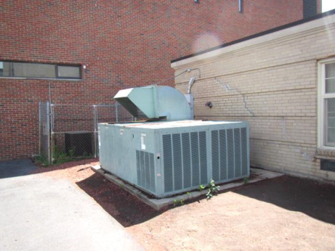
Air handling unit for the Boys and Girls Club
Picture 2
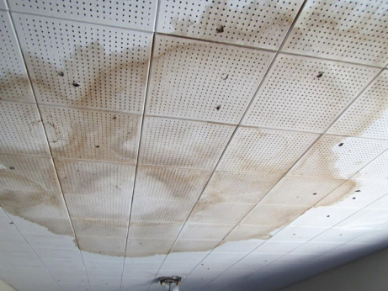
Water-damaged ceiling tiles
Picture 3
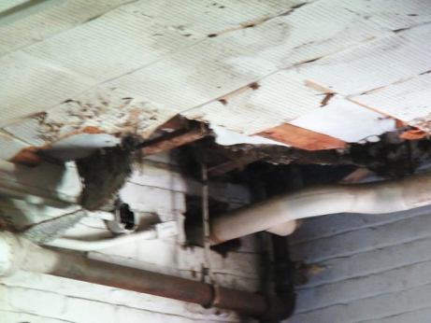
Severely water-damaged ceiling and ceiling tiles
Picture 4
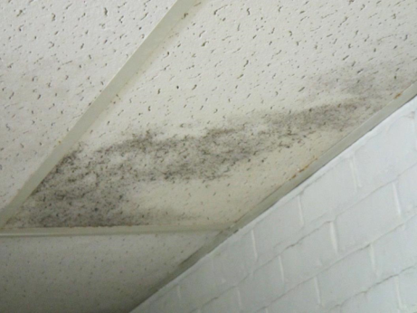
Water-damaged ceiling tiles, likely colonized by mold
Picture 5
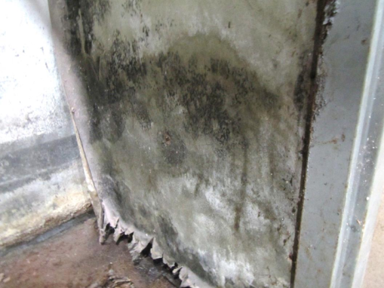
Mold-colonized wall
Picture 6
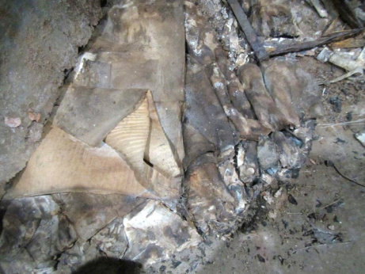
Water-damaged/mold-colonized cardboard
Picture 7
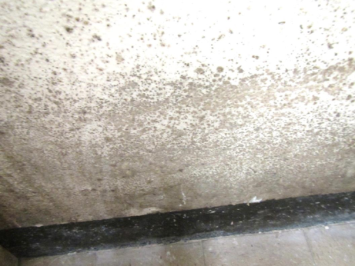
Mold-colonized wall
Picture 8
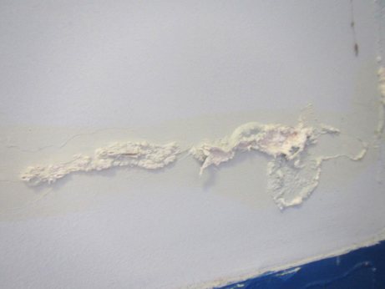
Efflorescence on interior wall
Picture 9
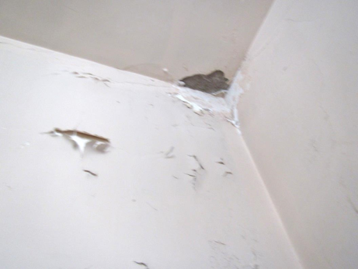
Peeling paint and efflorescence
Picture 10
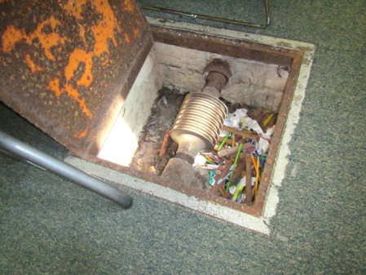
Steam trap for boilers
Picture 11
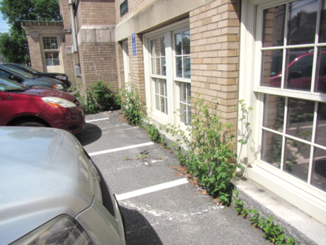
Plants growing against exterior masonry
Picture 12
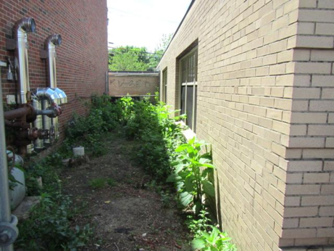
Plants growing against exterior masonry
Picture 13
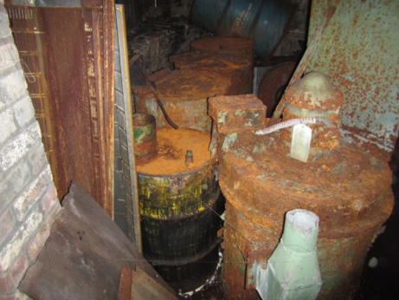
Severely corroded drums of unknown material in the basement
Picture 14
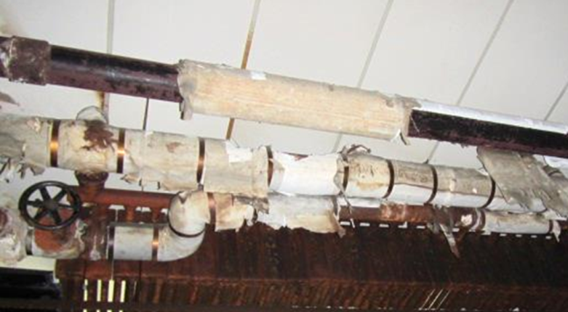
Damaged pipe insulation
Picture 15
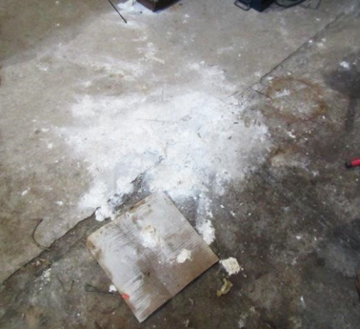
Damaged insulation material on floor of basement
Picture 16
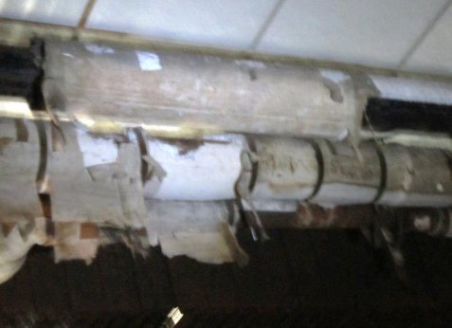
Damaged pipe insulation
Picture 17
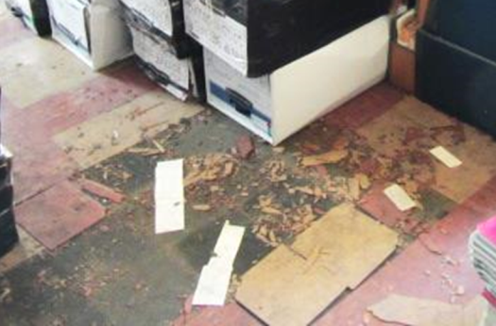
Pulverized floor tiles
Picture 18
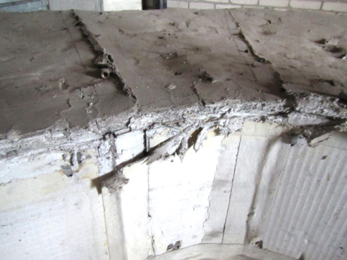
Damaged insulation material around ductwork in rooftop mechanical room
Picture 19
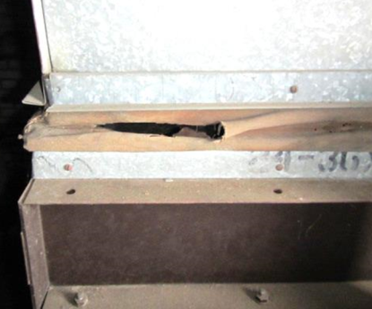
Rip/breach in ductwork in rooftop mechanical room
Picture 20
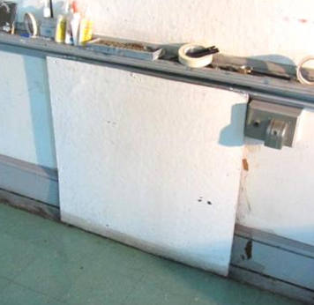
Sealed vent
Picture 21
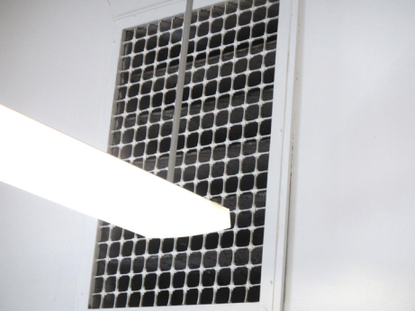
Open vent
Picture 22
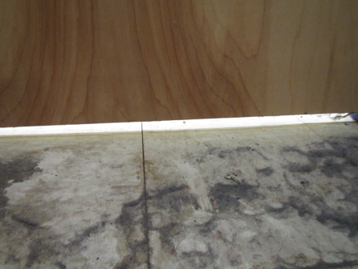
Spaces under door separating occupied areas and areas where damaged insulation material was seen
Picture 23
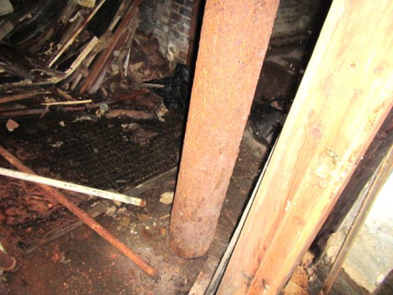
Corroded metal support beam
Picture 24
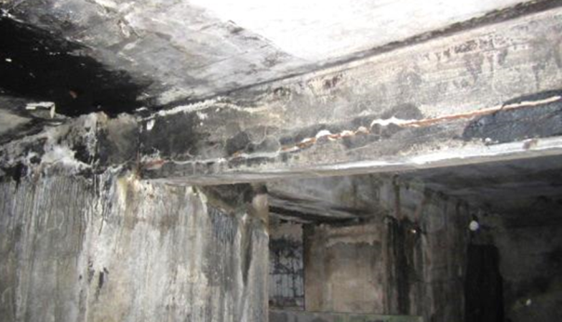
Damaged concrete support beams, note metal showing through
Picture 25
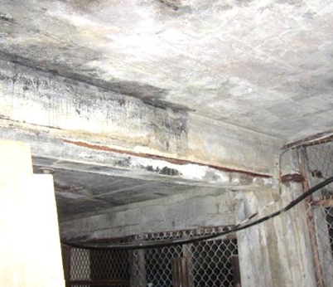
Damaged concrete support beams, note metal showing through
Picture 26
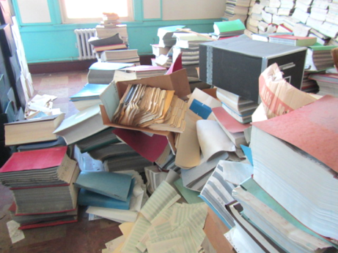
Cardboard boxes/paper materials directly on floor in unconditioned space
Picture 27
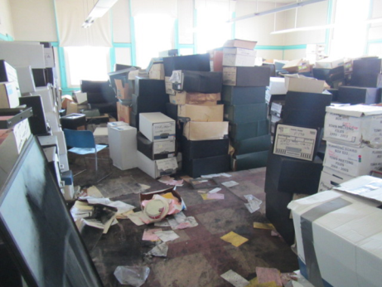
Cardboard boxes/paper materials directly on floor in unconditioned space
Picture 28
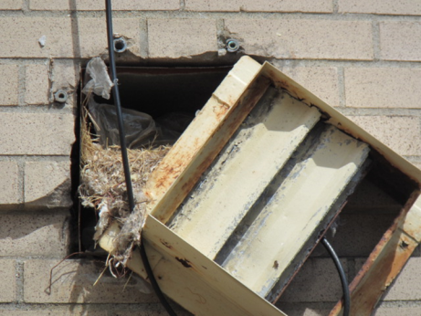
Birds/nesting materials in exterior vent
Location | Carbon  Dioxide  (ppm) | Carbon Monoxide  (ppm) | Temp  (°F) | Relative  Humidity  (%) | PM2.5  (µg/m³) | Occupants  in Room | Windows  Openable | Ventilation |  | Remarks
 |  |  |  |  |  |  |  | Intake | Exhaust
Background (outdoors) | 389 | ND | 80 | 49 | 9 |  |  |  |  | Sunny, light wind
Third Floor
Performing Arts -Wardrobe | 560 | ND | 77 | 54 | 11 | 1 | N | N | N | WD CTs, musty odor, costumes, AI
Props | 518 | ND | 78 | 53 | 9 | 2 | N | N | N | WD CTs, numerous MTs and severely WD plaster ceiling and exposed lathe, AI
Artist Guild | 454 | ND | 78 | 51 | 8 | 3 | N | N | Y | WD CT, MTs
Stage Area | 408 | ND | 79 | 49 | 7 | 0 | Y | N | N | NC – wood, paint and upholstered items
Restroom (unisex) |  |  |  |  |  |  | N | N | N | No exhaust, AF
Kitchen | 417 | ND | 78 | 49 | 6 | 0 | N | N | N | NC, microwave, water coolers
Studio A | 397 | ND | 78 | 50 | 6 | 0 | N | N | N | WD Carpet, wall has water stains
Studio B | 406 | ND | 77 | 51 | 5 | 0 | N | N | N | Carpet, HS
Studio C | 398 | ND | 77 | 51 | 5 | 0 | Y | N | N | WD carpet
Studio D | 379 | ND | 77 | 51 | 6 | 0 | N | N | N | WD carpet, HS
Studio E | 406 | ND | 76 | 51 | 5 | 0 | N | N | N | Carpet, HS
Second Floor
Museum Room #6 | 643 | ND | 79 | 50 | 12 | 5 | N | N | Y | WD CT, holes in CTs, WAC, original exhaust vent unsealed
Museum Room #7 | 602 | ND | 77 | 49 | 12 | 0 | N | N | Y | WD CTs, MT, paint odors, WAC
Museum- Pigors Gallery | 473 | ND | 77 | 44 | 11 | 0 | N | N | N | Carpet
Museum-Landman Gallery | 446 | ND | 76 | 45 | 11 | 0 | N | N | N | Older ceiling vents appear not to be functioning, carpet
Kiln Store Room | 532 | ND | 73 | 60 | 17 | 2 | N | N | N | Pathways, holes in ceilings and walls
Art Area | 650 | ND | 79 | 50 | 13 | 0 | Y | N | N
Room 4 | 517 | ND | 79 | 44 | 11 | 0 | Y | N | N | CP, NC
Pat Walker | 479 | ND | 79 | 54 | 10 | 1 | Y | N | N | WD CT, NC
Office | 575 | ND | 80 | 58 | 12 | 3 | Y | N | N | Hole in CTs, hanging items, NC, plants
Museum Room | 603 | ND | 80 | 47 | 12 | 2 | Y | N | N | CFs on, art, NC
Room 5 | 625 | ND | 79 | 42 | 12 | 4 | Y | N | N | WAC - on, holes in ceiling, NC, WD and missing CT, chalk
Room 8 | 655 | ND | 76 | 44 | 13 | 5 | Y | N | N | AC
Women’s Restroom |  |  |  |  |  |  | Y | N | N | Several fixtures out of order, WD and MT
Museum Administrative Hallway | 641 | ND | 78 | 44 | 10 | 0 | N | N | N
Collection | 663 | ND | 78 | 45 | 12 | 1 | N | N | N
Curatorial Office | 520 | ND | 77 | 45 | 9 | 3 | N | N | N | Carpet, art
Executive Office | 740 | ND | 75 | 38 | 8 | 3 | Y | N | N | AC
Danforth Main Gallery | 494 | ND | 71 | 61 | 9 | 0 | N | Y | Y
Prep Room | 486 | ND | 77 | 52 | 6 | 0 | N | N | N | Items, NC, no CT – concrete ceiling
Painting Storage | 531 | ND | 76 | 50 | 8 | 0 | N | N | N | NC, paintings
Staff lounge | 553 | ND | 77 | 48 | 10 | 0 | Y | N | N | HS, fridge, coffee
Beautiful Decay Exhibit | 445 | ND | 76 | 49 | 11 | 0 | N | N | N | Art
Museum Entry | 461 | ND | 76 | 45 | 11 | 0 | N | N | N | Marble floors
Ceramics | 802 | ND | 74 | 59 | 35 | 11 | Y  Open | N | N | Broken floor tiles
Boys and Girls Club
Main Area | 452 | ND | 78 | 43 | 10 | 8 | Y | N | N | DO to outside, NC, WD CT
Front Entrance | 469 | ND | 77 | 52 | 11 | 0 | N | N | N | Carpeted, hanging items
Director | 541 | ND | 76 | 53 | 11 | 0 | N | N | N | AI, carpet (new)
Program Director | 574 | ND | 77 | 54 | 11 | 2 | Y | N | N | Carpet
Karla | 563 | ND | 76 | 54 | 11 | 0 | N | N | N | Carpet
Plant Room | 588 | ND | 76 | 53 | 13 | 0 | N | N | N | Carpet
Staff Only | 580 | ND | 76 | 54 | 11 | 0 | N | N | N | Water cooler and fridge on carpet, HS, CP, food
Learning Center | 576 | ND | 76 | 58 | 13 | 3 | Y | N | N | WD CT, carpet, upholstered furniture
Computer Clubhouse | 518 | ND | 77 | 54 | 11 | 2 | Y | N | N | Carpet – worn, computers
Art Center | 521 | ND | 76 | 55 | 11 | 0 | N | N | N | NC, MT, ductless AC, 3 WD CT, art supplies
Art Storage 1 |  |  |  |  |  |  | N | N | N | Capped drain, WD CT, art supplies
Art Storage 2 |  |  |  |  |  |  | N | N | N | Art supplies
Janitor’s Closet |  |  |  |  |  |  | N | N | N | Strong cleaner odor
Media Center | 463 | ND | 75 | 61 | 11 | 0 | N | N | N | Carpet, musty smell, upholstered items, electronics
Teen Center | 636 | ND | 74 | 57 | 11 | 7 | N | N | N | WD CT
Women’s RR |  |  |  |  |  |  | N | N | N | Strong cleaner/AF odor
Teen Lunch | 563 | ND | 74 | 49 | 11 | 0 | N | N | N | NC, unfinished storeroom next door
Teen Lounge | 471 | ND | 74 | 47 | 7 | 0 | N | N | N | Carpet, upholstered furniture
Teen Game Area | 469 | ND | 73 | 48 | 6 | 0 | N | N | N | NC
Amateur Radio Entry | 564 | ND | 72 | 58 | 11 | 0 | N | N | N | NC, DEM, WD CT
Amateur Radio Foyer |  |  |  |  |  |  | N | N | N | Old leak/flood
Hallway |  |  |  |  |  |  | N | N | N
Gym Area
Gym Lobby | 516 | ND | 76 | 56 | 13 | 0 | Y | N | N | NC
Gym Game Area | 456 | ND | 76 | 56 | 13 | 0 | Y | N | N | Many WD CT
PAL Boxing Foyer | 471 | ND | 79 | 56 | 10 | 0 | Y | N | N | Carpeted with artificial turf/outdoor carpet
PAL Office | 549 | ND | 79 | 55 | 12 | 0 | Y | N | N | NC, boxing equipment
PAL Boxing Ring | 447 | ND | 79 | 54 | 12 | 0 | Y | N | N | Dirty floor, site of a steam leak from frozen pipes when the window was left open over the winter not used since

