INDOOR AIR QUALITY ASSESSMENT

Daniel Webster Elementary School
1456 Ocean Street
Marshfield, Massachusetts

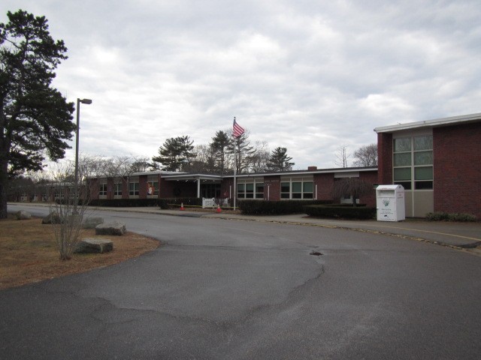

Prepared by:
Massachusetts Department of Public Health
Bureau of Environmental Health
Indoor Air Quality Program
March 2019

Background
Building: | Daniel Webster Elementary School (DWES)
Address: | 1456 Ocean Street, Marshfield, Massachusetts
Assessment Coordinated Through: | Fred Russell, Facilities Manager, Town of Marshfield
Reason for Request: | Complaints of odors described as sewer gas or propane like in Nurse’s suite and in restroom near kitchen.
Date of Assessment: | February 5, 2019
Massachusetts Department of Public Health/Bureau of Environmental Health (MDPH/BEH) Staff Conducting Assessment: | Cory Holmes, Environmental Analyst/Inspector, IAQ Program
Building Description: | The DWES is a one story brick school building; the Nurse’s suite is located off the main office and contains an examination room, office and restroom.
Windows: | Windows are openable in the space.

Methods
Please refer to the IAQ Manual and appendices for methods, sampling procedures, and interpretation of results (MDPH, 2015).

Results and Discussion
The following is a summary of indoor air testing results (Table 1).
- Carbon dioxide measurements were below the MDPH recommended level of 800 parts per million (ppm) in all areas surveyed, indicating adequate air exchange at the time of assessment.
- Temperature was within or slightly below the MDPH recommended range of 70°F to 78°F in all areas with the exception of the cafeteria (64°F).
- Relative humidity was within or close to the MDPH recommended range of 40 to 60% in all areas tested.
- Carbon monoxide levels were non-detectable (ND) in all areas tested.
- Particulate matter (PM2.5) concentrations measured were below the National Ambient Air Quality (NAAQS) level of 35 μg/m³ in all areas tested.
- Total Volatile Organic Compounds (TVOCs) although odors were present during the assessment, no measurable levels of TVOCs were detected.

Ventilation
A heating, ventilating and air-conditioning (HVAC) system has several functions. First it provides heating and, if equipped, cooling. Second, it is a source of fresh air. Finally, an HVAC system will dilute and remove normally-occurring indoor environmental pollutants by not only introducing fresh air, but also filtering the airstream and ejecting stale air to the outdoors via exhaust ventilation. Even if an HVAC system is operating as designed, point sources of respiratory irritants may be present and produce symptoms in sensitive individuals. The following analysis examines and identifies components of the HVAC system and likely sources of respiratory irritants found in the indoor environment.
The Nurse’s suite has no means of mechanical supply ventilation but relies on windows for the introduction of fresh air. The restroom contains an exhaust vent, which was strongly drawing air at the time of assessment. The restroom off the kitchen also contains an operable local exhaust vent.

Odors/TVOCs
Exposure to low levels of total volatile organic compounds (TVOCs) may produce eye, nose, throat, and/or respiratory irritation in some sensitive individuals. To determine if VOCs were present, BEH/IAQ staff took measurements with a photo-ionization detector (PID) and examined rooms for products containing VOCs. As mentioned, the assessment was prompted by odor complaints, described by occupants as a “sewer gas, propane-type odor” Slight odors were noted in the Nurse’s suite, however they were strongest in the Nurse’s restroom (Picture 1), and became more concentrated once the door was shut. An access panel was noted in the wall beneath the sink (Picture 2). It is likely that odors are being drawn from the wall cavity around this access panel, as well as any other holes/breaches in the wall (e.g., mounted accessories) by the exhaust vent (Picture 3). The source of the odor, based on the nature/description is likely sewer gasses from a corroded/cracked/damaged vent pipe in the wall cavity. Open holes/breaches were also observed above the ceiling tile system in the hallway adjacent to the Nurse’s Suite (Pictures 4 through 6).
Odors reported in the kitchen restroom seemed to be related to the operation of a water ejection pump located in that section of the building. Marshfield facilities staff manually triggered the system during the assessment in order to discern if operation of the pump was a source. Shortly during operation odors were present.

Conclusions and Recommendations
In view of the findings, the following recommendations were made at the time of the visit and are reiterated below:
- Seal all open utility holes in Nurse’s restroom and keep door shut.
- Seal all holes/breaches above ceiling tiles in hallway adjacent to Nurse’s Suite.
- Ensure local exhaust vents are operable in restrooms.
- Work with licensed plumber/building engineer to investigate plumbing system (and pump system) for corroded/damaged pipes/odor pathways (fiber optics, smoke tubes, etc.), make repairs as necessary.
- Use openable windows to supplement fresh air during temperate weather. Ensure all windows are tightly closed at the end of the day.
- Refer to resource manual and other related IAQ documents located on the MDPH’s website for further building-wide evaluations and advice on maintaining public buildings. These documents are available at http://mass.gov/dph/iaq.

References
MDPH. 2015. Massachusetts Department of Public Health. Massachusetts Department of Public Health Indoor Air Quality Manual: Chapters I-III. Available at: http://www.mass.gov/eohhs/gov/departments/dph/programs/environmental-health/exposure-topics/iaq/iaq-manual/.
Picture 1
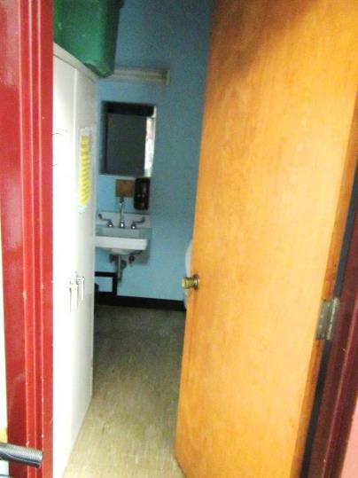
Nurse’s Restroom where odors were strongest
Picture 2
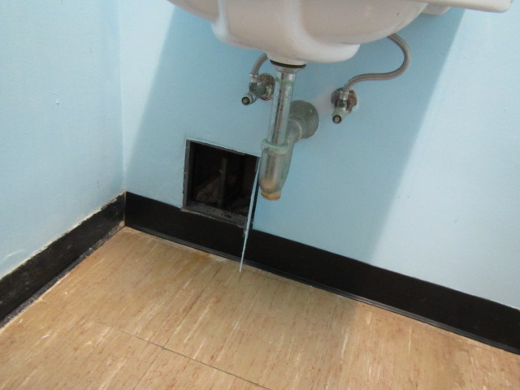
Access panel in Nurse’s restroom
Picture 3
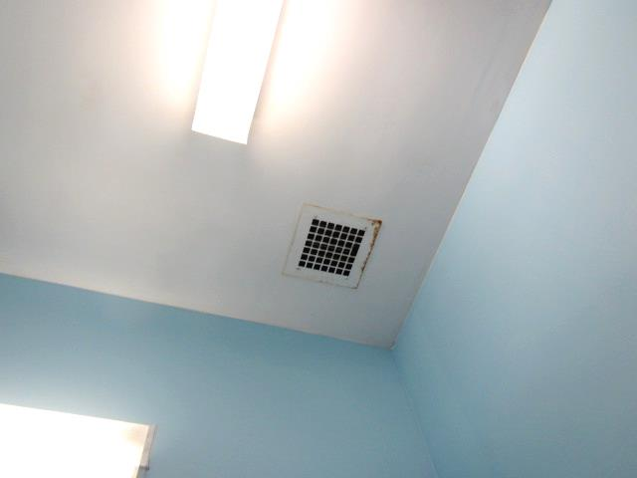
Ceiling-mounted exhaust vent in Nurse’s restroom
Picture 4
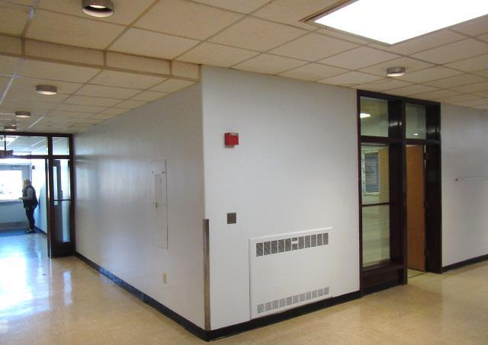
Hallway outside Nurse’s Suite, arrow indicates area of breaches/pathways for odors above ceiling tiles
Picture 5
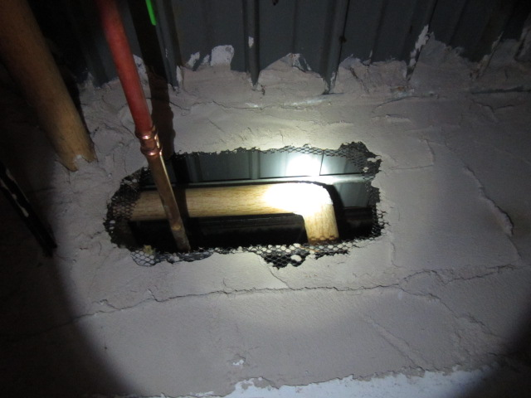
Breach in wall/pathway for odors above ceiling tiles in hallway adjacent to Nurse’s Suite
Picture 6
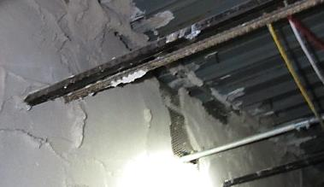
Breaches in wall/pathways for odors above ceiling tiles in hallway adjacent to Nurse’s Suite
Location | Carbon  Dioxide  (ppm) | Carbon Monoxide  (ppm) | Temp  (°F) | Relative  Humidity  (%) | PM2.5  (µg/m³) | TVOCs  (ppm) | Occupants  in Room | Windows  Openable | Ventilation |  | Remarks
 |  |  |  |  |  |  |  |  | Supply | Exhaust
Background | 391 | ND | 60 | 47 | 8 | ND |  |  |  |  | Cloudy/overcast, unseasonably warm
Cafeteria | 480 | ND | 64 | 46 | 7 | ND | 4 | Y | Y | Y
Specialist Office | 512 | ND | 71 | 38 | 7 | ND | 0 | N | Y | N | Door open
Nurse’s Suite | 506 | ND | 70 | 37 | 7 | ND | 1 | Y | N | N | Slight odors detected
Nurse’s Restroom |  | ND |  |  |  | ND |  | N | N | Y | Strong odors w/door shut, exhaust fan on, access panel into wall cavity-vent pipes
Main Office | 511 | ND | 72 | 35 | 7 | ND | 4 | Y | Y | N | Door open
Kitchen Restroom |  | ND |  |  |  | ND |  | N | N | Y | No odors/pump off (reported odors with pump on)
Kitchen | 564 | ND | 70 | 40 | 19 | ND | 15 | Y | N | Y

