.
COMMONWEALTH OF MASSACHUSETTS

SUFFOLK COUNTY BOARD OF REGISTRATION IN PHARMACY

IN THE MATTER OF DANIELLE MCCONNELL PT3961

PHA-2015-0061

CONSENT AGREEMENT FOR VOLUNTARY SURRENDER

The Massachusetts Board of Registration in Pharmacy ("Board") and Danielle McConnell ("Licensee"), a pharmacy technician licensed by the Board, PT3961, do hereby stipulate and agree that the following information shall be entered into and become a permanent part of the Licensee's record maintained by the Board :

- The Licensee acknowledges that the Board opened a complaint against her Massachusetts Pharmacy Technician license related to the conduct set forth in Paragraph 2, identified as Docket No. PHA-2015-0061 ("Complaint")

- The Board and Licensee acknowledge and agree to the following facts:

  - In November 2014 and at all relevant times Licensee worked as a pharmacy technician at Brigham and Women's Healthcare Center ("Pharmacy") located in Fox borough, Massachusetts.

  - In November 2014, Licensee diverted controlled substances from the Pharmacy, including clopidogrel, lamotrigine, montelukast, fluticasone, buproprion ER, albuterol HFA, spironolactone, Humalog insulin, metformin, and tiotropium handihaler. Licensee did not have a prescription for said controlled substances.

- The Board and Licensee acknowledge and ag1ee that Licensee's conduct described in Paragraph 2 constitutes a violation M.G.L. c. 94C, § 34 and is grounds for discipline by the Board pursuant to M.G.L. c. 112, §§ 42A and 61 and 247 CMR 10.03(x).

4. The Licensee agrees to SURRENDER her license for an indefinite period of time and refrain from practicing as a Pharmacy Technician and from working in any pharmacy-related setting in Massachusetts, commencing with the date on which the Board signs this Agreement ("Effective Date"). The Licensee further agrees to immediately return her original Massachusetts pharmacy technician registration to the Board.

1. The term "license" applies to both a current license and the right to renew an expired license.

- The Board agrees that in return for the Licensee's execution and successful compliance with all the requirements of this Agreement, the Board will not prosecute the Complaint.

- The Licensee understands that she has a right to formal adjudicatory hearing concerning the Complaint and that during said adjudication she would possess the right to confront and cross-examine witnesses, to call witnesses, to present evidence, to· testify on her own behalf, to contest the allegations, to present oral argument, to appeal to the courts, and all other rights as set forth in the Massachusetts Administrative Procedures Act, M.G.L. c. 30A, and the Standard Adjudicatory Rules of Practice and Procedure, 801 CMR
1.01 et seq. The Licensee f .1rther understands that by executing this Agreement she is knowingly and voluntarily waiving her right to a formal
adjudication of the Complaint.

- The Licensee acknowledges that she has been at all times free to seek and use legal counsel in connection with the Complaint and this Agreement.

- The Licensee acknowledges that after the Effective Date, the Agreement constitutes a public record of disciplinary action by the Board subject to the Commonwealth of Massachusetts' Public Records Law, M.G.L. c. 4, § 7. The Board may forward a copy of this Agreement to other licensing boards, law enforcement entities, and other individuals or entities as required or permitted by law.

- The Licensee certifies that she has read this Agreement. The licensee understands and agrees that entering into this Agreement is a voluntary and final act and not subject to reconsideration, appeal or judicial review.
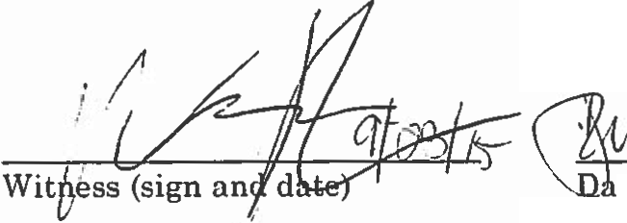

Danielle McConnell 9/23/15
(Sign and Date)

McConnell, Danielle PT396l
PHA-2015·0061

Page 2 of 3
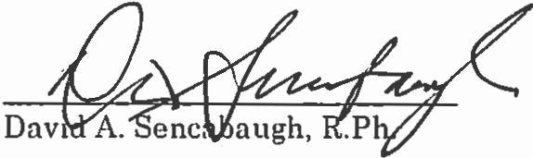

10-9-2015

Effective Date of Agreement
Executive Director
Board of Registration in Pharmacy

Fully Signed Agreement Sent to Registrant on 10/14/2015 by

Certified Mail No. 7015 1520 0002 8254 8785

McConnell, Danielle PT3961
PHA·2015·0061

Page 3 of 3

