INDOOR AIR QUALITY ASSESSMENT

Danvers Fire Department
64 High Street
Danvers

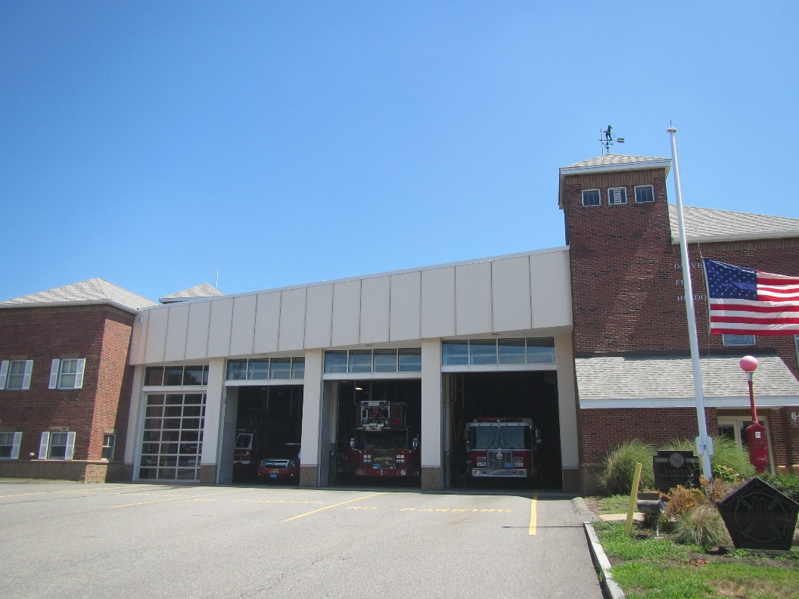

Prepared by:
Massachusetts Department of Public Health
Bureau of Climate and Environmental Health
Division of Environmental Health Regulations and Standards
July 2026

BACKGROUND
Building: | Danvers Fire Department (DFD)
Address: | 64 High Street, Danvers
Assessment Requested by: | Jamie Shafner, Deputy Fire Chief
Reason for Request: | General indoor air quality (IAQ)
Date of Assessment: | July 16, 2026
Massachusetts Department of Public Health/Bureau of Climate and Environmental Health (MDPH/BCEH) Staff Conducting Assessment: | Ruth Alfasso, Bharathi Patimalla-Dipali, and Thomas Murphy, Division of Environmental Health Regulations and Standards (EHRS).
Building Description: | The Danvers Fire Department was originally a car dealership. Significant renovations including additions on the north and south side of the station and removal of parts of the building took place in 1995. Part of the additions include areas where firefighter bedrooms are located. Original parts of the building have metal cladding, while the newer portions have brick exterior. Some of the roof is peaked with shingles, and there is a large flat roof section of ballasted rubber. The rubber portion of the roof was replaced within the last 10 years to stop leaks.
Windows: | Most windows are openable.

An indoor air assessment was done for this building by a private firm in 2012. Recommendations for this building included: removing ridge vents from the top of the roof to reduce draw of air through the building; removing insulation from the top of the garage and replacing with closed-cell polyurethane foam; sealing all joints and penetrations between garage and bunkhouse with silicone caulk; installing an air filtration system to the rear of the garage; and reworking the attic space and repairing the roof (Saybrooke Environmental, 2012).
While replacement of the rubber portion of the roof has since been conducted, it is not clear if other adjustments to the roof/attic spaces were done at that time. During this assessment, missing insulation, and other gaps were still noted between the garage area and the indoor areas.

METHODS
Please refer to the IAQ Manual for methods, sampling procedures, and interpretation of results (MDPH, 2015).

RESULTS AND DISCUSSION
The following is a summary of indoor air testing results (Table 1).
- Carbon dioxide levels were below the MDPH guideline of 800 parts per million (ppm) in all but one of the areas assessed indicating adequate ventilation for occupancy. Note that the building was not heavily occupied, and the engine bay doors and other doors were open to the outside. Carbon dioxide may be higher with higher occupancy and doors closed as may occur during cold weather.
- Temperature was within the recommended range of 70°F to 78°F in the indoor areas assessed, and higher in areas open to the outdoors.
- Relative humidity was slightly above the MDPH recommended range of 40 to 60% in many areas assessed.
- Carbon monoxide was not detected (ND) in all areas. Carbon monoxide should not be present in a typical, indoor environment. If it is present, indoor carbon monoxide levels should be less than or equal to outdoor levels. Note that no vehicles were operating in the engine bays during the assessment.
- Fine particulate matter (PM2.5) concentrations measured were below the National Ambient Air Quality Standard (NAAQS) level of 35 μg/m³ in all areas assessed. Note that outdoor air concentrations of particulate matter were elevated on the day of the assessment due to wildfire impacts. Most indoor levels were below outdoor levels.

Ventilation
A heating, ventilating, and air conditioning (HVAC) system has several functions. First, it provides heating and, if equipped, cooling. Second, it is a source of fresh air. Finally, an HVAC system will dilute and remove normally occurring indoor environmental pollutants by not only introducing fresh air but also filtering the airstream and ejecting stale air to the outdoors via exhaust ventilation. Even if an HVAC system is operating as designed, point sources of respiratory irritation may exist and lead to symptoms in sensitive individuals.
In bedroom and office areas, fresh air is provided by air-handling units (AHUs) located on the roof. Air from the AHUs is filtered, heated/cooled, and delivered to rooms via ducted supply vents (Picture 1). Air is returned/exhausted through return vents (Picture 2). All occupied spaces should have access to both supply and return ventilation. It is recommended that HVAC systems be re-balanced every five years to ensure adequate air systems function (SMACNA, 1994). It is unknown when or if this system may have last been balanced.
Note that many of the supply and return vents were found to not be working (Table 1). Not all vents were tested during the assessment, but many that were had no flow. While carbon dioxide levels in the building were almost all below the MDPH guidance level of 800 ppm, a lack of fresh air and return flow can allow pollutants such as dust and soot to build up, as well as allowing moisture to accumulate. It could not be determined during the visit if the lack of flow to some vents is due to the system cycling off when temperatures are within the setpoints, or if the system is not working.
In particular, bedrooms all had supply vents, but it appears they were designed to use the hallway return vent via an undercut under the doors. This hallway vent, which looked like it was meant to use the ceiling plenum as a return, had no apparent airflow and was visibly blocked by fiberglass insulation (Picture 3). This means that bedrooms had no effective exhaust ventilation. Fiberglass can also be a source of irritating fibers and should not be exposed in occupied areas.
Restrooms, including the shower rooms on the second floor, are equipped with direct-vented exhaust vents. Many of these were found to be working properly. However, the male shower room exhaust vent had no airflow, and building staff reported that when recently examined, it was found that the fan for this vent had been removed. The male shower room showed signs of water damage due to condensation and excess moisture accumulation, including peeling paint and potential mold. This is discussed further under “water damage issues” below. Adequate exhaust ventilation is necessary in restrooms and shower rooms to remove odors and moisture; replacing this fan should be a priority.
The ventilation system should be on and operational to supply fresh air continuously during occupied periods, which is 24/7 for a fire station. Without adequate fresh air supply and removal of stale air, common indoor air pollutants can build up and cause irritation.
Several forms of specific ventilation are present in this fire station due to specific hazards associated with fire-fighting equipment and other tasks necessary in the station:
- The engine bay is equipped with a tailpipe exhaust collection system (Plymovent™) for each engine; these were observed to be in use at the time of the visit (Picture 4). It is important to use these consistently every time a vehicle is running in the engine bays. They also need to be maintained and tested periodically to ensure adequate function.
- Direct vented exhaust is also present in the engine bay (Picture 5). This is operated manually using a switch.
- The turnout gear room is equipped with a separate ventilation system designed to remove pollutants from gear that has been at a fire. At the time of the visit, supply and return/exhaust vents in this space did not appear to be working.
- The fire station has a large capacity washing machine and dryer (Picture 6). The dryer appears to be vented to the outside, which is important to ensure moisture is not recirculated into the building. If there are concerns that this vent does not properly terminate outside, this should be checked. Venting a dryer into the wall or attic of a building can lead to moisture accumulation and mold. It also reduces the effectiveness of the dryer. Dryer vents should be cleaned at least once or twice a year to remove lint and other build-up.
- The kitchen contains a commercial-style gas stove and a commercial kitchen exhaust hood (Picture 7). Kitchen exhaust vents should be used every time the stove is used. Cooking creates odors and particulates, and the use of gas stoves can create a variety of products of combustion. An operational, properly sized, exhaust hood that is used consistently can remove these before they enter occupied areas. Note that commercial kitchen exhaust hoods work best if they are tested and calibrated periodically to ensure they are supplying the correct amount of airflow.
- The room where fire alarms are maintained has supply and return vents that appear to be part of the general occupied building ventilation system. Various maintenance/repair equipment and items like lubricants and glues were in this room. Areas where fumes may be produced from activities like small equipment repair should have direct-vented exhaust ventilation to remove those fumes and odors from the area during use and prevent them from entering occupied spaces.
- Doors to the outside of the equipment bays can be left open during weather that is not extremely hot, cold, or wet to allow for increased ventilation in these areas.
Heating in garage and utility areas is supplied by gas-fired suspended heaters (Picture 8). These heaters may produce fumes from the combustion of natural gas and need to be well maintained and used in well-ventilated areas.
Hot water radiators are also found in occupied areas of the building. A gas-fired hot water boiler for these is present in a room next to the garage (Picture 9). This unit appears to be an older model which is less efficient, and the age of the equipment makes it more difficult to maintain. This unit should be inspected and tested every year before the heating season to ensure combustion is as efficient as possible and that there are no holes or leaks in the exhaust system inside the building.
Windows in the building are mostly openable, however, according to DFD staff the interior windows looking into the engine bay cannot be opened. Open windows can be a source of additional fresh air when outside conditions are comfortable. On days like the day of the assessment where particulate levels are elevated outdoors, windows should be closed. Windows should also remain closed when the HVAC systems are working in cooling mode as excess humidity can lead to condensation.

Water damage issues
Water-damaged ceiling tiles, ceiling plaster, and wall plaster were noted in areas around the building (Picture 10; Table 1). Much of the ceiling water damage is from leaks before the roof was replaced. However, some of the damage appears to be more recent. As mentioned above, the exhaust ventilation in the men’s shower room was not functional. This is likely why there is water damage to ceiling and wall plaster, and signs of mold in a few areas of the ceiling (Pictures 11 and 12).
Water-damaged boxes were found in storage areas (Picture 13). Porous items that are water-damaged or mold-colonized should be discarded. Base coving was pulling away from the wall in the dining area (Picture 14). This is a potential sign that water damage has occurred to this wall or the adjoining floor in the past, weakening the glues. Sometimes mold will grow underneath the coving if the area is wet for long enough. This should be inspected and repaired.
There were refrigerators in the kitchen and other areas. Note that while refrigerators in this building are not covered by the food code, it is good practice to have a thermometer in each refrigerator that is visible to ensure refrigerated food temperatures are kept at 5ºC (41ºF) or less (US FDA, 2022). The large refrigerators were full, and one had a spill inside. Refrigerators need to be cleaned out regularly to prevent odors. In addition, one refrigerator gasket had signs of mold (Picture 15). If the gasket is not readily cleanable, or if mold reoccurs, the gasket should be replaced.
A room had been repurposed as a storage area that has a concrete floor and floor drain (Picture 16). Drains that are not wetted periodically can have the traps dry out and allow sewer gases and excess moisture into the building. Water should be poured down this drain at least once a week to keep the trap seal intact. Regular water flow helps prevent stagnant water, odors, and potential drain fly activity. If this room no longer needs a floor drain, it can be temporarily or permanently sealed.
Plants were noted in a few areas (Picture 17). Plants can be a source of pollen or mold. They should be well cared for, not overwatered, and placed on non-porous drip pans that are cleaned periodically. Plants should be kept away from the airstream of ventilation equipment.
Many doors to the outside of the building had gaps underneath or around them where light can be seen (Picture 18). Gaps around doors can allow unconditioned air, moisture, and pests into the building.

Other IAQ issues

Vehicle Exhaust/Sources
Under normal conditions, a firehouse can have several sources of environmental pollutants present from the operation of fire vehicles. These sources of pollutants can include:
- Vehicle exhaust containing carbon monoxide and soot;
- Vapors from diesel fuel, motor oil and other vehicle liquids which contain volatile organic compounds;
- Water vapor from drying hose equipment;
- Rubber odors from vehicle tires; and
- Residues from fires on vehicles, hoses, and fire-turnout gear.
Of particular importance is vehicle exhaust, which involves the process of combustion. As described above, the engine bays are equipped with a mechanical exhaust system to remove exhaust from vehicles. This equipment should be used every time, and maintained in accordance with manufacturer’s instructions.
Pathways between the engine bays and occupied areas should be sealed to the greatest extent possible. Several pathways were noted for vehicle exhaust and other pollutants from the engine bays to enter the areas with offices and bedrooms:
- There are two firepoles from the bunkroom hallways down to the engine bays. Each pole is in a “closet” with an open hatchway through to the lower level (Picture 19). The doors to these areas have gaps underneath them (Picture 20). This represents a wide-open pathway for any pollutants from the engine bays to enter occupied spaces. The pole hatch could be covered with a gasketed cover that can snap back closed when the pole is not in use. Alternatively, the hallway door to the hatch can be rendered airtight using door sweeps/gaskets.
- As noted in the 2012 report, the sprayed-on insulation along the ceiling of the engine bays has gaps at the edge with the walls (Picture 21). Repair or replacement of this material, using the method suggested in the 2012 report or another method, will reduce infiltration of engine bay pollutants into the rest of the building.
- There are windows into the engine bays from other parts of the building (Picture 20). Over time, gaps around these windows can occur due to settling and aging of materials. They should be checked and any gaps sealed with an appropriate sealant as also recommended in the 2012 report.
- Openable windows in the building can also allow pollutants from the engine bays and driveways into the building. Occupants should consider the direction of wind and amount of activity in the engine bays before opening windows.
- Stairwells may also be a pathway for migration of pollutants. Doors to stairwells should generally be left closed.

General IAQ Issues
Another item mentioned in the 2012 report was soot striping or “ghosting” on walls in the building (Picture 22). This occurs because there are fine particles in the air, which are deposited on walls. The striping pattern occurs because the metal studs in the walls provide a thermal bridge and will be colder during the heating season. This allows moisture to begin to condense, which provides a way for the particulates to stick to the walls. Ghosting is a sign of both excess particulates in the air and inadequate insulation/construction of the walls. Reducing the amount of particulate pollution that enters the occupied portions of the building as discussed above should reduce the occurrence of ghosting. Existing material on the walls can be removed with water and a mild cleaner. Before using a particular cleaning method, check on an inconspicuous area for paint damage.
Dust and potentially mold was noted on supply and return vents in the building (Pictures 23 and 24). Movement of air and static electricity, can lead to accumulations of dust on vents and nearby ceiling tiles. If this material is moistened due to condensation on a cold vent, mold can grow on the dust. Because the vents are non-porous, they can be cleaned to remove dust and mold. If neighboring ceiling tiles are affected, and cleaning of ceiling tiles is not effective, they should be replaced. Vents in the kitchen appeared to be stained with grease, which should also be cleaned. Grease accumulation on vents may indicate the exhaust hood is not working as well as it should or that it is not used consistently during cooking. Dust was also found on radiators and in other areas, which should be cleaned periodically.
The DFD has carpeting in a few areas. In general, it is not recommended for fire departments and other emergency response agencies to have carpeted floors due to the possible cross-contamination that may occur from footwear contact with automotive products, chemicals, or biological contamination. Building staff reported that much of the carpeting had already been removed and replaced with non-porous flooring. Any remaining carpeting should be cleaned regularly using a HEPA-equipped vacuum and deep cleaned once or twice a year. (IICRC, 2012).
Products were in use in the office that can increase VOCs in the air. Items including hand sanitizers, cleaners, and dry erase materials were noted (Table 1). Products with strong scents, including scent sprays and essential oils should not be used in a shared space as many people are sensitive to fragrance compounds. Materials that may produce fumes (e.g. paint cans, oil collection buckets, cleaning supplies; Picture 25) should be kept tightly covered/closed when not in use.
A few air purifiers are in use in the building, particularly in bunkrooms (Picture 26; Table 1). Air purifiers with HEPA filters can remove large and small particles from the air to improve air quality. Units that also have a carbon filter can remove odors as well. Air purifiers that may produce ozone should not be used; keywords such as “ionizer” can indicate units with the capacity to produce ozone. These units need to be cleaned and have the filters changed as recommended by the manufacturer. Air purifiers work best when the output air is near the breathing zone of occupants.
Storage of items and clutter were noted in various areas around the station (Picture 27). Excess items can make cleaning difficult, prevent detection of leaks, and may provide harborage for pests. Items should be sorted through periodically for things that are not needed, and the remaining items stored neatly. Displayed items should be dusted periodically.

Radon
Radon is a naturally occurring radioactive gas that seeps into buildings from the surrounding soil and can increase the risk of lung cancer at elevated levels.
The Environmental Protection Agency (EPA) conducted a National School Radon Survey “in which it discovered nearly one in five schools has at least one schoolroom with a short-term radon level above the action level of 4pCi/L (picocuries per liter) – the level at which the EPA recommends that schools take action to reduce the level” (US EPA, 1993). Homes and other occupied buildings can also be affected by radon.
Testing of buildings for radon should be conducted in a manner consistent with US EPA radon testing guidelines. Radon measurement specialists and other information can be found at www.nrsb.org and http://aarst-nrpp.com/wp, with additional information at: https://www.mass.gov/radon.

CONCLUSIONS/RECOMMENDATIONS
To remedy building problems, two sets of recommendations are made: short-term measures that may be implemented as soon as practicable and long-term measures that will require planning and resources to address overall IAQ concerns:

Short-term Recommendations

Ventilation recommendations
- Ensure all supply and return portions of the general ventilation systems are operating to supply fresh air circulation.
- Replace the exhaust vent fan in the men’s bathroom/shower room and ensure it operates at all times, not activated with a switch.
- Ensure the hallway vent(s) in the bunkroom areas are functional. Remove any fiberglass insulation from the vent. If the ceiling plenum is used to return air to the HVAC system, all ceiling tiles need to be in place and snug in the ceiling tile grid.
- Activate or repair the ventilation system in the turnout gear room.
- If possible, have the HVAC system balanced every 5 years in accordance with SMACNA recommendations (SMACNA, 1994).
- Continue to change filters for HVAC units at least two to four times a year or as per the manufacturers’ recommendations using filters with a Minimum Efficiency Rating Value (MERV) of 8 or better.
- Periodically clean dust, debris, and grease from supply and return vents and adjacent ceiling tiles.
- Ensure the PlymoventTM system is maintained and tested as recommended by the manufacturer, and that it is used every time and vehicle is operating inside the engine bays.
- Use the switch-operated exhaust vents whenever needed in the engine bays.
- Ensure the dryer vent terminates outside the building; clean periodically to remove lint.
- Use the exhaust hood over the kitchen stove while cooking. Consider having it calibrated annually to ensure adequate flow.
- Maintain the gas-fired heaters regularly and use with good ventilation.
- Maintain the hot water boiler every year, and ensure all exhaust vent pipes are intact and do not leak.
- Use openable windows for fresh air during temperate weather. Keep them closed during poor air quality days and when air conditioning is operating in the room. For windows near/overlooking the engine bays, consider what activities are taking place before opening the windows.

Water damage recommendations
- Replace water-damaged ceiling tiles.
- Once exhaust ventilation is restored to the men’s bathroom/shower room, scrape, clean, and repair water-damaged ceiling plaster and other signs of water damage or mold.
- Discard water-damaged boxes and other water-damaged porous items.
- Pull base coving in kitchen off the wall and examine behind it for mold. Remove and replace wallboard if necessary and re-glue coving.
- Routinely clean food/liquid stains from the refrigerator and food residues from refrigerators and other appliances used to prepare or heat food.
- Clean or replace dirty/stained refrigerator gaskets.
- Ensure any drains in rarely used areas are run with water several times per month to keep drain traps from drying out and to help prevent odors and pests.
- Ensure plants are well maintained, not overwatered, and placed on waterproof drip pans that are cleaned periodically.
- Replace door sweeps/weatherstripping on exterior doors to exclude pests.

Vehicle exhaust recommendations
- Find a way to seal the firepoles from creating pathways between the engine bays and the bunk room areas. This could be a gasketed cover, or weather-stripping the door, or some other method acceptable to the firefighters in this station.
- Replace or repair the insulation along the walls at the ceiling of the engine bays. Use materials that are not porous. If a spray-on product is used, ensure that manufacturers’ best practices are followed for mixing and application to achieve lasting results and avoid excess exposure to chemical components.
- Check and seal around the interior windows into the engine bays.
- If not already present, install carbon monoxide detectors in the room with the hot water boiler, in the engine bays, and at least one on each floor in the occupied side of the building. Note that units meant for general use do not trigger until carbon monoxide levels are above warning levels. Units with a readout and a lower detection limit are available for additional cost and may be helpful.

Other recommendations
- Reduction of particulate pollution in office/bunk areas should reduce “ghosting”. Existing soot on walls can be cleaned using a mild cleaner.
- Clean carpeting regularly using HEPA vacuuming, and deep clean them once or twice a year.
- Avoid using products with strong scents. Products containing VOCs should be used with good ventilation and in accordance with package instructions. Containers that may contain oils, or other potentially-hazardous materials should be kept closed or outside of occupied spaces.
- Clean and maintain air purifiers in accordance with manufacturers’ instructions including filter changes. Avoid using any units that may produce ozone. Consider equipping each bunk room with a small air purifier.
- Reduce clutter in storage areas.
- Dust display items periodically.
- Generally keep stairwell doors closed.
- Refer to resource manual and other related IAQ documents located on the MDPH’s website for further building-wide evaluations and advice on maintaining public buildings. These documents are available at: http://mass.gov/dph/iaq.

Long-term recommendations
- Remove carpeting from the remaining areas where it is present and replace with non-porous flooring
- Consider replacing the hot water boiler with a newer, more efficient unit. Ensure it properly vents outside the building.
- Consider contracting with a ventilation engineering contractor for a full examination of the existing HVAC systems and designs for feasible upgrades.
- Consider contracting with a building envelope specialist to test and control for additional pathways for pollutants from the engine bays.
- Consider actions to better insulate walls to prevent thermal bridging that is contributing to ghosting.
- Consider having the building tested for radon by a certified radon testing contractor with experience in larger, more complex buildings.

REFERENCES
ASHRAE. 2012. American Society of Heating, Refrigeration and Air Conditioning Engineers (ASHRAE) Standard 52.2-2012 -- Method of Testing General Ventilation Air-Cleaning Devices for Removal Efficiency by Particle Size (ANSI Approved).
MDPH. 2015. Massachusetts Department of Public Health. Indoor Air Quality Manual: Chapters I-III. Available at: https://www.mass.gov/lists/indoor-air-quality-manual-and-appendices.
Saybrook Environmental and Chemical Management & Envirotest Labs. Environmental Measurements Prepared for: Town of Danvers/Fire Department. Stoughton, MA. January 23, 2012.
SMACNA. 1994. HVAC Systems Commissioning Manual. 1st ed. Sheet Metal and Air Conditioning Contractors’ National Association, Inc., Chantilly, VA.
US FDA. 2022. 2022 Food Code. U.S. Department of Health and Human Services. U.S. Food and Drug Administration. College Park, MD January 18, 2023 Version. https://www.fda.gov/media/164194/download

Picture 1
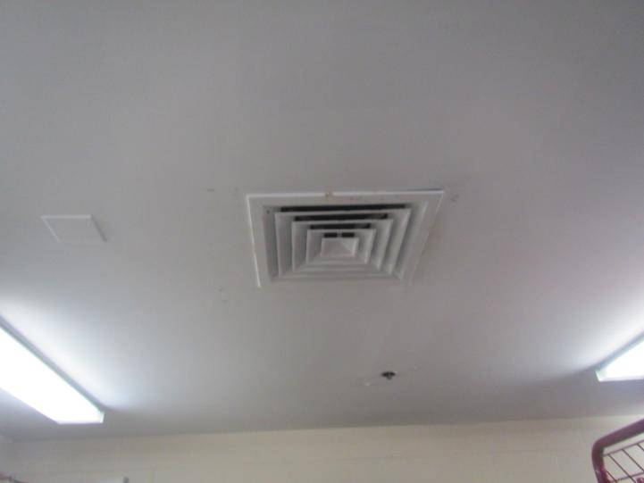
Supply vent
Picture 2
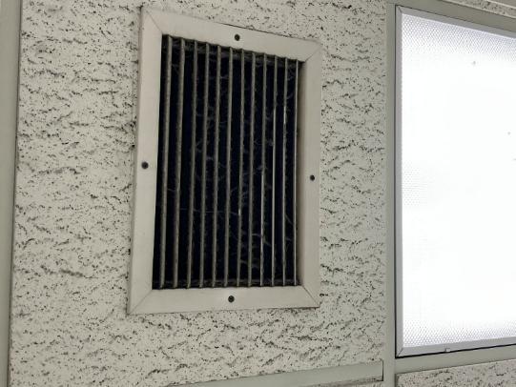
Return vent

Picture 3
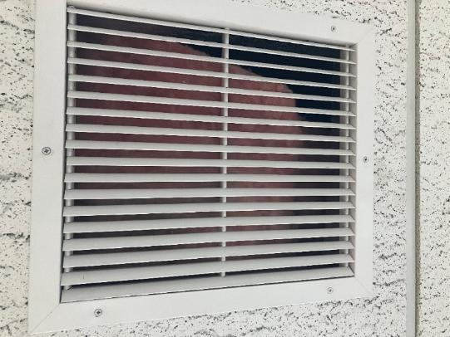
Hallway return vent, note pink fiberglass insulation inside
Picture 4
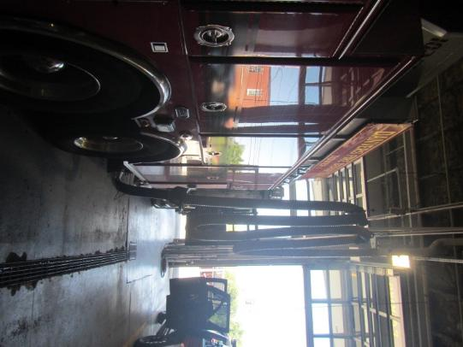
Plymovent attached to the exhaust of a vehicle

Picture 5
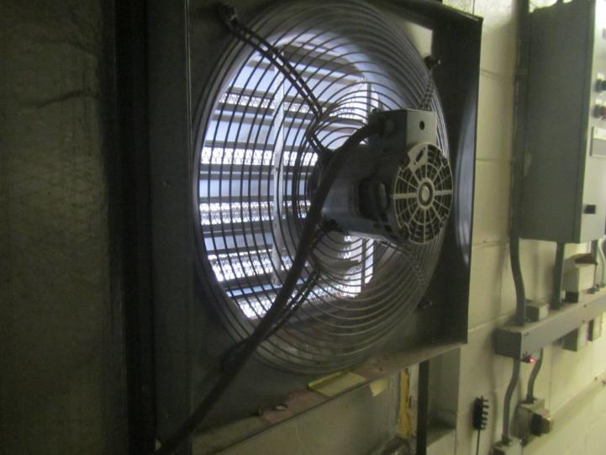
Manual switch-operated garage exhaust
Picture 6
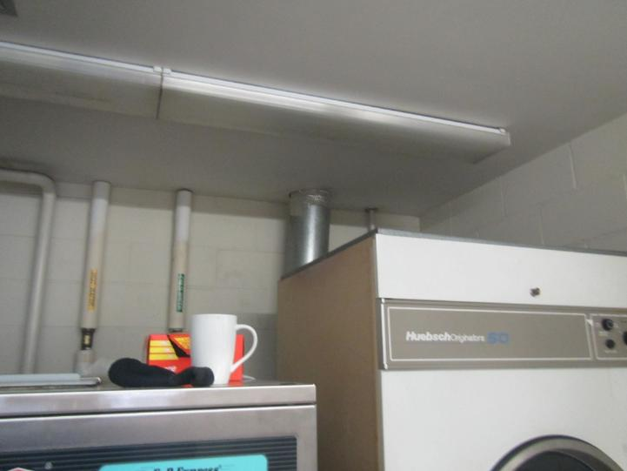
Top of large dryer with vent (silver pipe) behind it

Picture 7
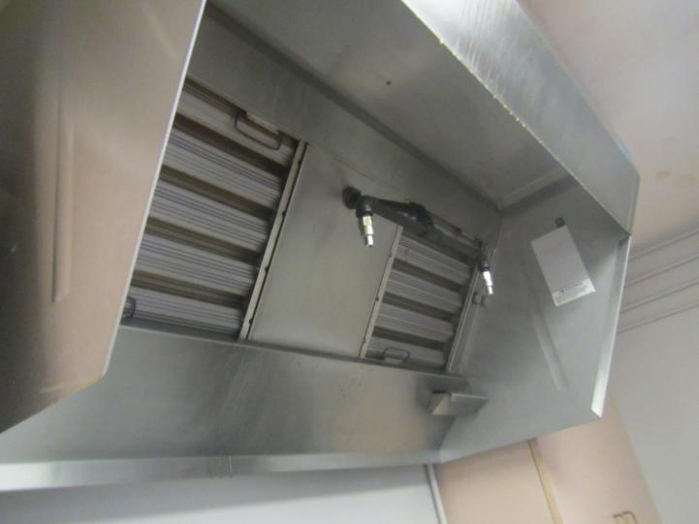
Commercial kitchen exhaust hood
Picture 8
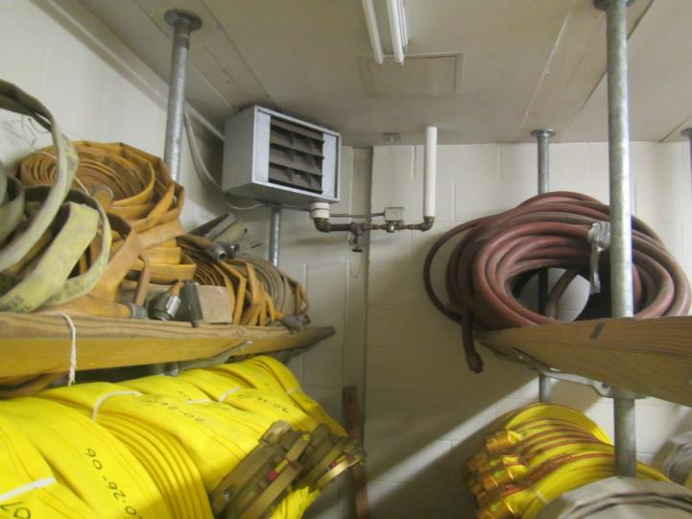
Gas-fired heater for hose storage room

Picture 9
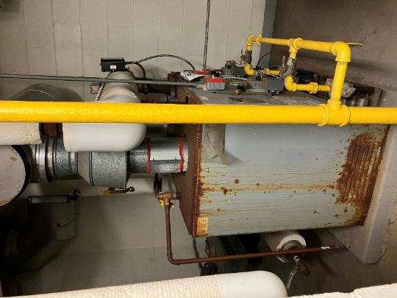
Old hot water boiler for radiators
Picture 10
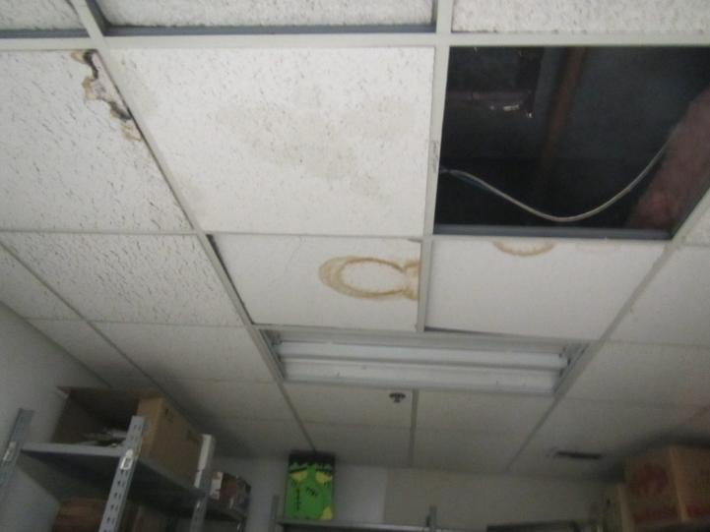
Water-damaged and missing ceiling tiles in a storage room

Picture 11
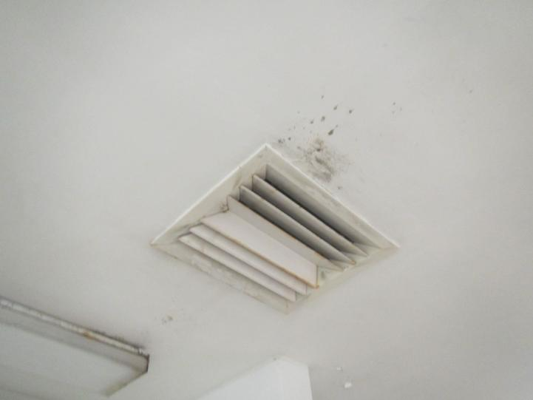
Water damage to ceiling plaster and what appears to be mold in the men’s shower room
Picture 12
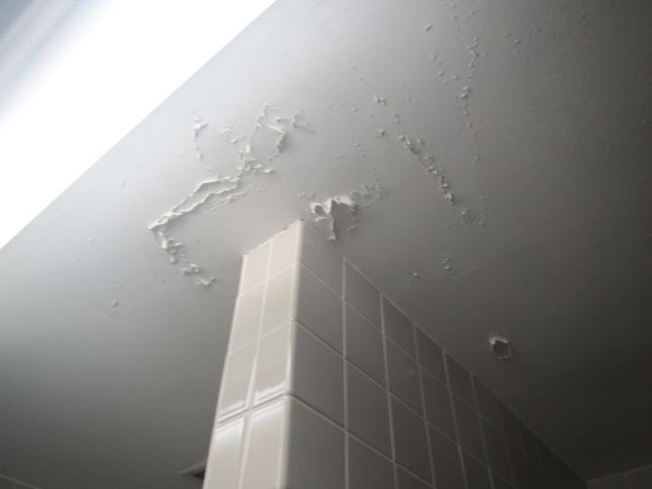
Peeling ceiling plaster in the men’s shower room

Picture 13
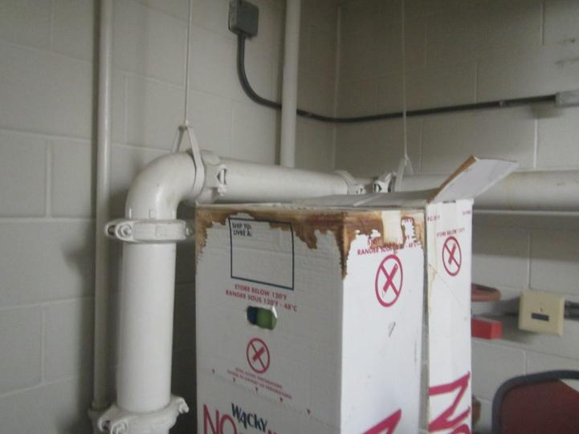
Water-damaged boxes in a storage area
Picture 14
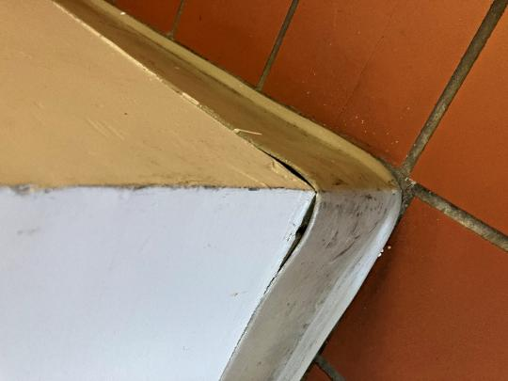
Poorly-adhered base coving in the dining area

Picture 15
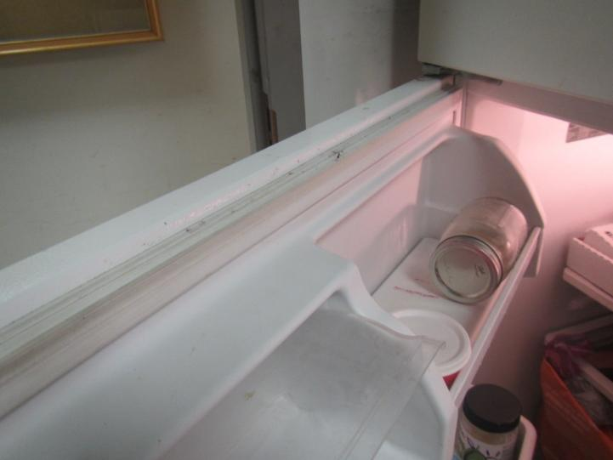
Debris and signs of mold on refrigerator gasket
Picture 16
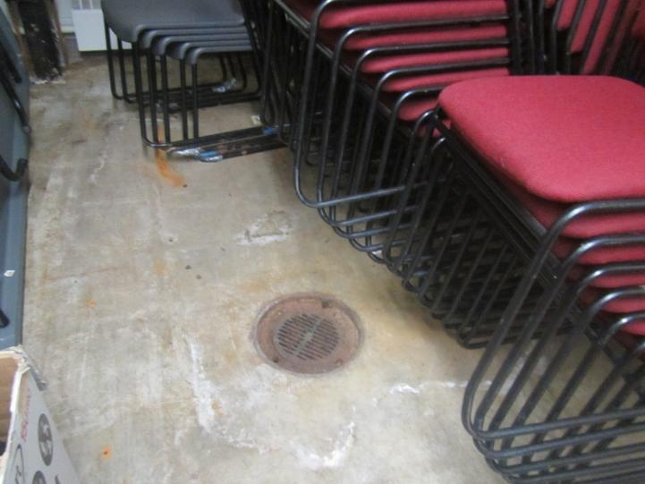
Storage room with floor drain

Picture 17
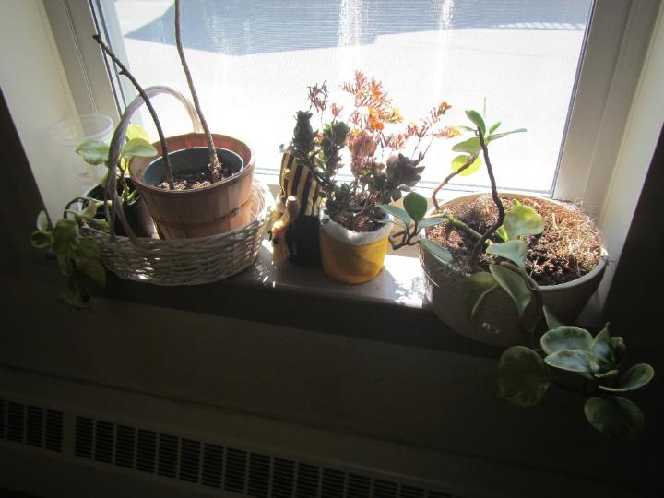
Plants on a windowsill
Picture 18
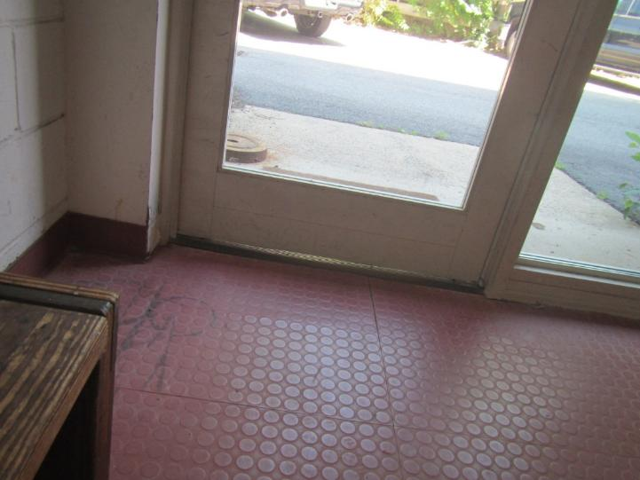
Gap below door to outside

Picture 19
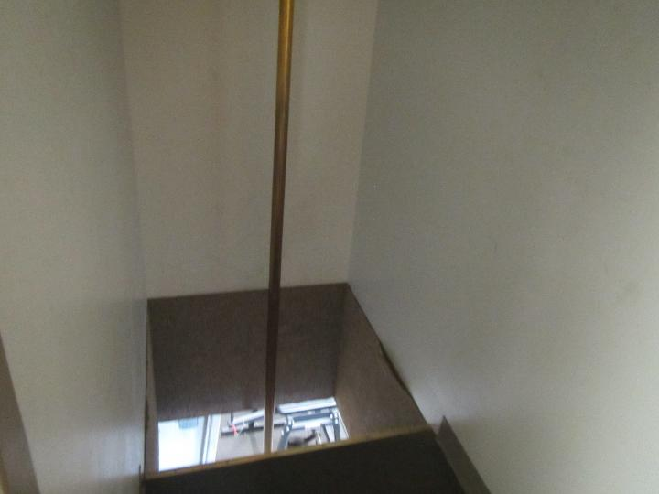
Fire pole and hatch
Picture 20
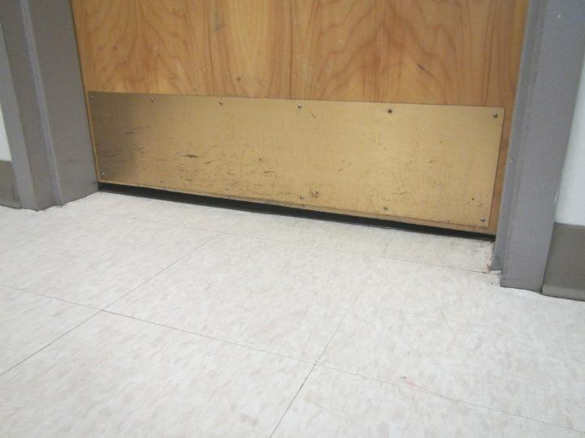
Gap underneath door to fire pole

Picture 21
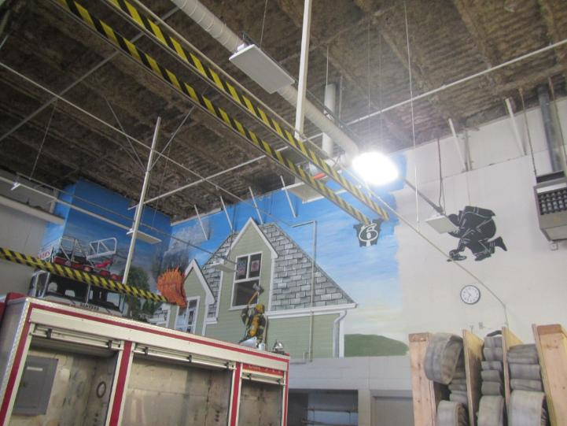
Missing insulation along corner of wall and ceiling, and window in engine bay to inside

Picture 22
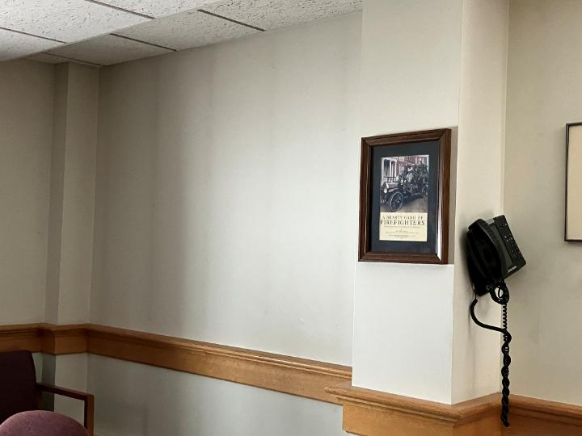
Soot stripes on the wall of the conference room
Picture 23
t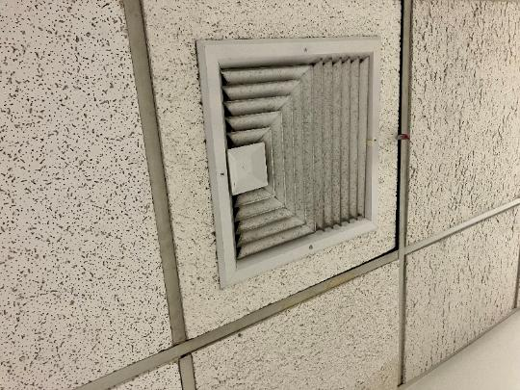
Dusty supply vent

Picture 24
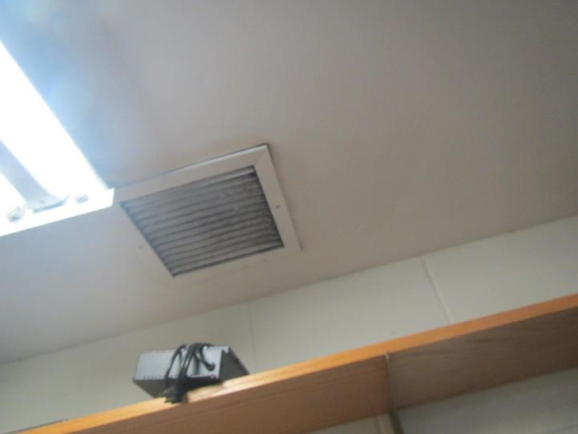
Dusty return vent
Picture 25
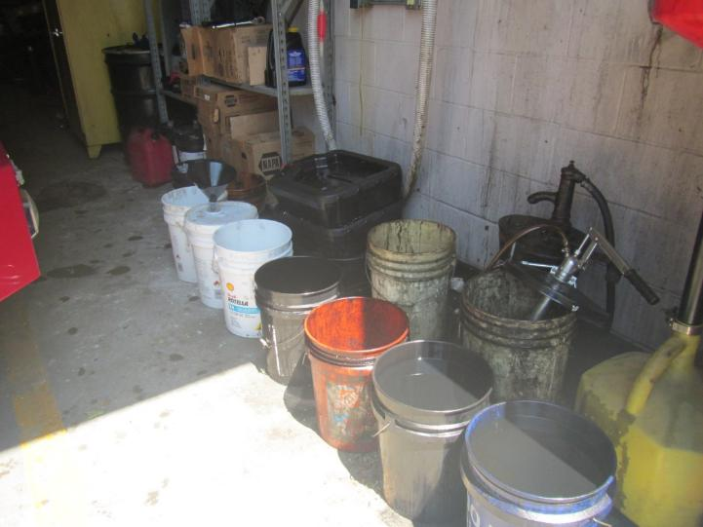
Open containers of dirty water and/or oils
Picture 26
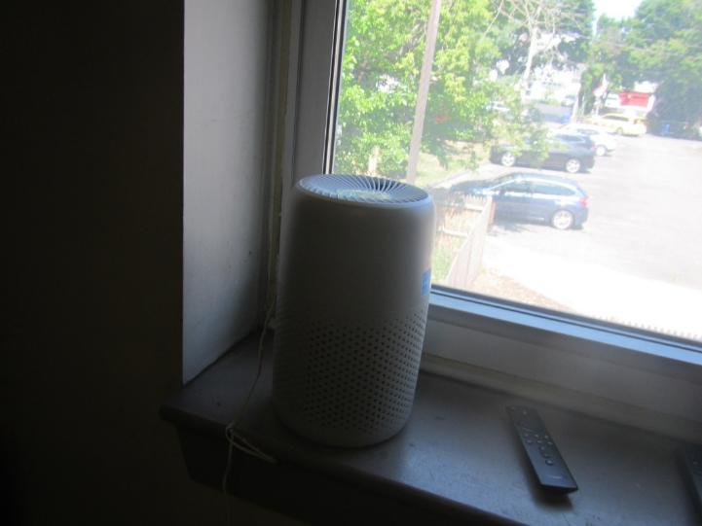
Small air purifier in a bunkroom

Picture 27
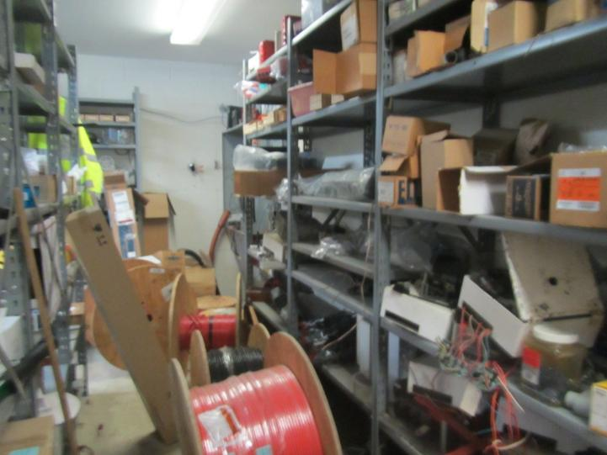
Cluttered area

Location | Carbon  Dioxide  (ppm) | Carbon Monoxide  (ppm) | Temp  (°F) | Relative  Humidity  (%) | PM2.5  (µg/m³) | Occupants  in Room | Windows  Openable | Ventilation |  | Remarks
 |  |  |  |  |  |  |  | Supply | Exhaust | Remarks
Background | 399 | ND | 84 | 41 | 18 |  |  |  |  | Mild wildfire smoke impacts
Engine Bay | 461 | ND | 83 | 47 | 24 | 4 | Doors open |  | Y | Plymovents, exhaust vent on a switch, several engines, noted the insulation is incomplete around the edge of the ceiling
Turnout Equipment Room | 459 | ND | 79 | 49 | 22 | 0 | N | Y | Y | Reported to have a separate ventilation system but it was not operating
Alarm Maintenance | 456 | ND | 78 | 47 | 20 |  | N | Y dirty or moldy | Y dusty
Conference room | 565 | ND | 76 | 45 | 12 | 0 | Y | Y |  | Carpet, upholstery
Chief’s Office | 542 | ND | 72 | 49 | 13 | 0 | Y | Y
Hallway |  |  |  |  |  |  | N | N | Y | The hallway exhaust seems to be a plenum based vent, but there’s a piece of fiberglass insulation inside and no airflow
Deputy Chief’s Office | 560 | ND | 71 | 49 | 11 | 0 | Y | Y |  | Dry erase materials
Fire Prevention | 627 | ND | 72 | 49 | 11 | 2 | Y | Y
Admin Office | 606 | ND | 72 | 48 | 11 | 1 | Y | Y |  | Plants, spill in fridge, nmot carpeted
Hose Room |  |  |  |  |  |  |  |  |  | No HVAC
Downstairs Restroom |  |  |  |  |  |  |  |  | Y dusty
Hose Drying |  |  |  |  |  |  |  |  |  | Gap under exterior door
Watch Room | 531 | ND | 78 | 47 | 15 | 0 | Y | Y | Y
Day Room | 463 | ND | 74 | 52 | 15 | 0 | Y | Y | Y | Upholstered and leather furniture
Bedroom 9 | 499 | ND | 73 | 53 | 14 | 0 | Y | Y | N
Bedroom 8 | 505 | ND | 72 | 53 | 15 | 0 | Y | Y | N
Bedroom 7 | 452 | ND | 73 | 56 | 18 | 0 | Y | Y | N | Fan on
Bedroom 6 | 531 | ND | 72 | 54 | 19 | 0 | Y | Y | N | Air purifier
Fire pole |  |  |  |  |  |  |  |  |  | No gasket, door to pole has gaps
Bedroom 5 | 509 | ND | 73 | 53 | 17 | 0 | Y | Y | N | Air purifier, fan
Bedroom 4 | 497 | ND | 73 | 52 | 17 | 0 | Y | Y | N
Study | 810 | ND | 73 | 55 | 13 | 0 | Y | Y | N | Not carpeted
Storage |  |  |  |  |  |  | N | Y | N | Water-damaged and missing ceiling tiles, fridge is dirty
Kitchen | 563 | ND | 73 | 56 | 14 | 2 | Y | Y | Y | Hood over gas stove is commercial vent to outside, no calibration, vent over table has dust, grease, or mold on it, floor is tiled
Men’s Shower room |  |  |  |  |  |  | N |  | Y | Reports that the exhaust vent had the fan removed some time back and not replaced. Signs of condensation and water damage
Women’s Shower room |  |  |  |  |  |  | N |  | Y | Less water damage than the men’s shower room
Logbook room |  |  |  |  |  |  | N |  |  | This room has old logbooks on shelving
Exercise room | 403 | ND | 72 | 60 | 10 | 0 | Y | Y | Y on | Water-damaged ceiling tiles, rubber mats
Fire pole 2 |  |  |  |  |  |  |  |  |  | No gasket, door is not airtight
Captain’s Bedroom | 466 | ND | 72 | 62 | 10 | 0 | Y | Y | N
Engine Lieutenant Bedroom | 575 | ND | 71 | 61 | 10 | 0 | Y | Y dusty
Tower Lieutenant Bedroom | 500 | ND | 71 | 62 | 8 | 0 | Y | Y |  | Fan
Bedroom 2 | 416 | ND | 70 | 61 | 10 | 0 | Y | Y on |  | Fan, air purifier
Bedroom 1 | 492 | ND | 70 | 59 | 7 | 0 | Y | Y |  | Blankets and old curtains
Shift Supervisor | 482 | ND | 71 | 58 | 8 | 0 | Y |  |  | Old curtains
Public/Training Room | 468 | ND | 71 | 58 | 9 | 0 | Y | Y on | Y not on | Not carpeted, dry erase materials
Museum area | 482 | ND | 71 | 57 | 8 | 0 | Y | Y |  | Items, door to stairs is open
Waiting room | 538 | ND | 73 | 50 | 13 | 0 | Y | Y

