**INDOOR AIR QUALITY**

**WATER DAMAGE ASSESSMENT**

**Dartmouth Middle School**

**366 Slocum Road**

**Dartmouth, Massachusetts**

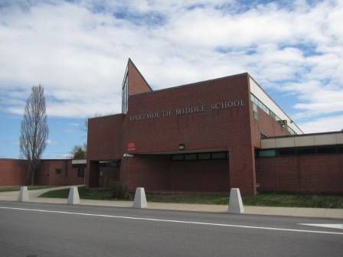

Prepared by:

Massachusetts Department of Public Health

Bureau of Environmental Health

Indoor Air Quality Program

June 2015

# Background/Introduction

At the request of the Dartmouth Public Schools (DPS) and the Dartmouth Board of Health (DBOH), the Massachusetts Department of Public Health (MDPH), Bureau of Environmental Health (BEH) provided assistance and consultation regarding indoor air quality (IAQ) concerns at the Dartmouth Middle School (DMS) located at 366 Slocum Road, Dartmouth, Massachusetts. On April 24, 2015, the school was visited by Cory Holmes, Environmental Analyst/Regional Inspector in BEH’s IAQ Program. The assessment was requested in response to concerns expressed by parents concerning mold growth related to water-damaged building materials as well as the presence of asbestos-containing materials (ACM), primarily floor tiles, in the building.

As a result of concerns, the DPS contracted an environmental consultant, Vortex Inc., to conduct a mold inspection on April 10, 2015. The Vortex report made several recommendations, including the following:

* Correct water infiltration including repair to the roof in areas where stained ceiling tiles are located in classrooms or replace existing roof.
* Replace existing water-stained ceiling tiles.
* Ensure unit ventilator filters are inspected and replaced semi-annually (Vortex, 2015).

It was reported by DPS School Business Administrator, Mr. James Kiely and Facilities Director, Mr. Richard Ferreira that several building envelope/water-proofing projects were scheduled for the summer of 2015 and that roof replacement was on a capital improvement plan.

# Methods

MDPH staff performed a visual inspection of building materials for water damage and/or microbial growth.

# Discussion

## Microbial/Moisture Concerns

As reported by DPS officials, the DMS, similar to many buildings in the New England area, experienced several issues with water penetration through the building envelope over the winter of 2014-2015 due to higher than normal snowfall. At the time of the assessment, several areas had water-damaged ceiling tiles (Picture 1; Table 1). Water-damaged ceiling tiles can provide a source of mold and should be replaced after a water leak is discovered and repaired. In order to determine if any visible mold was present on building materials, BEH/IAQ staff inspected above these water-damaged ceiling tiles. No water-damaged/mold-colonized building materials were observed above these areas in the ceiling plenum. In fact, the ceiling plenum consisted of a large open space with metal decking/ceilings and support beams (Picture 2) that are non-porous materials and not conducive to mold growth.

## Asbestos Containing Materials (ACM)

In 1986 the Environmental Protection Agency (EPA) enacted the Asbestos Hazard Emergency Response Act (AHERA). Under the requirements of AHERA, school districts are required to perform an initial inspection to determine whether ACM are present and then re-inspect asbestos-containing material in each school every three years and to develop, maintain and update an asbestos management plan and keep a copy at the school (US EPA, 1986). It was reported by DPS officials that the last AHERA inspection at the DMS occurred in October of 2013 and the report (Vortex, 2013) is available for interested parties in the main office. This report was forwarded to BEH/IAQ staff for confirmation.

Concerns regarding damaged floor tiles in classroom 110 were expressed. Although the tiles were worn, they did not appear friable and were sealed by a layer of floor wax (Pictures 3 and 4). However, it was noted that classroom furniture, including the teacher’s desk was located in this area on top of these tiles (Picture 3). It was recommended that the furniture be relocated to an area where the tiles were intact to prevent further damage to worn tiles. In addition, DPS officials discussed performing an abatement project over the summer, which would remove the tiles from the room.

Intact asbestos-containing material (ACM) does not pose a health hazard. If damaged, ACM can be rendered friable and become aerosolized. Friable asbestos is a chronic (long-term) health hazard, but will not produce acute (short-term) health effects (e.g., headaches) typically associated with buildings believed to have indoor air quality problems. Where asbestos-containing materials are found damaged, these materials should be removed or remediated in a manner consistent with Massachusetts asbestos remediation laws (MDLI, 1993).

# Recommendations

In view of the findings at the time of the visit, the following recommendations are made. These recommendations were communicated at the time of the assessment and are reiterated below.

1. Make temporary repairs to roof and replace any remaining water-damaged ceiling tiles.
2. Continue with capital improvement plans for major roof repairs/replacement.
3. For more information on water damage/mold-remediation consult “Mold Remediation in Schools and Commercial Buildings” published by the US Environmental Protection Agency (US EPA, 2001) (<http://www.epa.gov/mold/mold_remediation.html>).
4. Continue to follow AHERA regulations including 3-year inspections and updates/availability of the school’s asbestos management plan.
5. Relocate desk/furniture in the front of classroom 110 away from damaged/worn floor tiles.
6. Continue with plans for ACM abatement project in classroom 110, if funds are available.
7. Consider adopting the US EPA (2000) document, “Tools for Schools”, as an instrument for maintaining a good indoor air quality environment in the building. This document is available at: <http://www.epa.gov/iaq/schools/actionkit.html>.
8. Refer to resource manual and other related indoor air quality documents located on the MDPH’s website for further building-wide evaluations and advice on maintaining public buildings. These documents are available at: <http://mass.gov/dph/iaq>.
9. For more information on ACM/AHERA consult the US EPA website at <http://www2.epa.gov/asbestos/school-buildings> or the Massachusetts Department of Labor Standards, Asbestos Program at <http://www.mass.gov/lwd/labor-standards/asbestos-program/>.

# References

MDLI. 1993. Regulation of the Removal, Containment or Encapsulation of Asbestos, Appendix 2. 453 CMR 6,92(I)(i).

US EPA. 1986. Asbestos Hazard Emergency Response Act. Hazard Emergency Response Act of 1986 (AHERA) Public Law 99-519, Oct 22, 1986. 15 USC Section 2651.

US EPA. 2000. Tools for Schools. Office of Air and Radiation, Office of Radiation and Indoor Air, Indoor Environments Division (6609J). EPA 402-K-95-001, Second Edition. <http://www.epa.gov/iaq/schools/tools4s2.html>.

US EPA. 2001. “Mold Remediation in Schools and Commercial Buildings”. Office of Air and Radiation, Indoor Environments Division, Washington, DC. EPA 402-K-01-001. March 2001. Available at: <http://www.epa.gov/iaq/molds/mold_remediation.html>.

Vortex. 2013. Vortex, Inc., AHERA, Asbestos Re-Inspection & Management Plan, Dartmouth Middle School. Dated October 2013.

Vortex. 2015. Vortex, Inc., Mold Inspection & Report, Dartmouth Middle School – Various Classrooms. Dated April, 17, 2015.

**Picture 1**

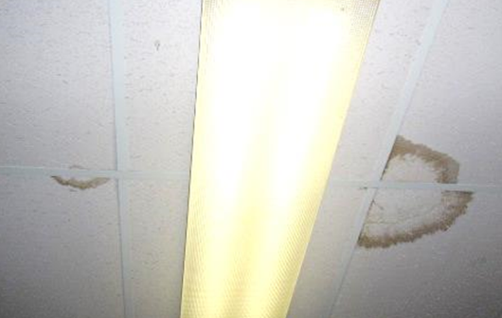

**Water-damaged ceiling tiles**

**Picture 2**

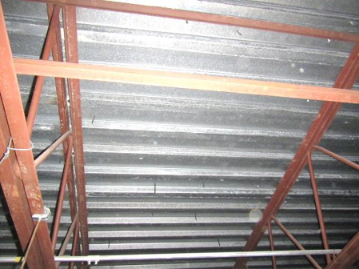

**Metal decking and support beams above ceiling tiles**

**Picture 3**

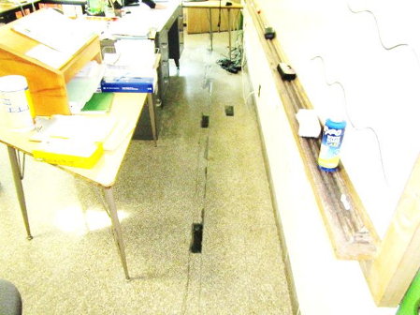

**Worn floor tiles in classroom 110, note location of desk**

**Picture 4**

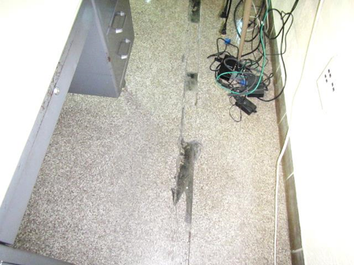

**Close-up of worn floor tiles in classroom 110**

| **Location** | | **Remarks** |
| --- | --- | --- |
| 110 | Worn floor tiles –sealed w/wax, front of classroom near office furniture |
| 207 | Water-damaged ceiling tile-corner/historic water damage, no visible mold growth/water damage above ceiling tiles |
| 300 | 3 water-damaged ceiling tiles, no visible mold growth/porous items above ceiling tiles, metal decking and supports |
| 307 | Water-damaged ceiling tile-painted/sealed, no visible mold growth/porous items above ceiling tiles, metal decking and supports |
| Hallway outside of 307 | Water-damaged ceiling tile, no visible mold growth/porous items above ceiling tiles, metal decking and supports |