INDOOR AIR QUALITY ASSESSMENT

Dartmouth Town Hall
400 Slocum Road
Dartmouth, Massachusetts

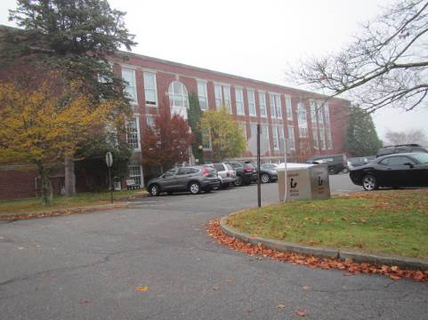

Prepared by:
Massachusetts Department of Public Health
Bureau of Environmental Health
Indoor Air Quality Program
December 2015

Executive Summary
The building had odors associated with wet mop heads used to absorb rainwater penetrating through windows during driving rainstorms. It is recommended to remove the mop heads. Windows and brickwork will require repointing to prevent ongoing infiltration.

Background
Building: | Dartmouth Town Hall (DTH)
Address: | 400 Slocum Road, Dartmouth, MA
Assessment Requested by: | Christopher Michaud, Director of Public Health
Date of Assessment: | November 6, 2015
Bureau of Environmental Health/Indoor Air Quality (BEH/IAQ) Program Staff Conducting Assessment: | Michael Feeney, Director, IAQ Program
Date of Building Construction: | 1927
Reason for Request: | Odors in certain areas of the DTH and general IAQ concerns
Building Description
The DTH is a two-story, brown brick building originally constructed in 1927 as a school. The building was renovated to become DTH in 1987. The building contains town offices and meeting rooms. Windows are openable throughout the building. This space is occupied by approximately 30 employees and can be visited by 20 to 50 individuals daily.

Results and Discussion
Test results are presented in Table 1. Please refer to the IAQ Manual for methods, sampling procedures, and interpretation of results (MDPH, 2015).

Ventilation
It can be seen from Table 1 that carbon dioxide levels were below 800 parts per million (ppm) in all areas, indicating adequate air exchange at the time of assessment. In addition, a number of areas were empty/sparsely populated at the time of the assessment, which can greatly reduce carbon dioxide levels. Carbon dioxide levels would be expected to increase with higher occupancy and windows closed. The building is equipped with and air handling unit (AHU) located in a mechanical room that contains gas-fired furnaces and a water heater.

Temperature and Relative Humidity
Temperature measurements ranged from 74ºF to 79ºF; all but one measurement were within the MDPH recommended range (Table 1). The MDPH recommends that indoor air temperatures be maintained in a range of 70°F to 78°F in order to provide for the comfort of building occupants. In many cases concerning indoor air quality, fluctuations of temperature in occupied spaces are typically experienced, even in a building with an adequate fresh air supply.
The relative humidity measurements ranged from 56-64 percent. These readings were within the MDPH recommended comfort range (Table 1) with the exception of several below-grade spaces where the relative humidity was slightly above. The MDPH recommends a comfort range of 40 to 60 percent for indoor air relative humidity. Relative humidity levels in the building would be expected to drop during the winter months due to heating. The sensation of dryness and irritation is common in a low relative humidity environment. Low relative humidity is a very common problem during the heating season in the northeast part of the United States.

Microbial/Moisture Concerns
Offices along the south exterior walls had peeling paint and efflorescence on interior plaster walls (Pictures 1 and 2). This water damage is likely the result of water infiltration through exterior brickwork and windows, which indicates the need for recaulking/repairing window frame and repointing of exterior brickwork. DTH staff report that rainwater readily enters into some offices during wind-driven rainstorms. In an effort to absorb water, used mop heads were place on top of radiators in two offices (Picture 3). The source of the odor reported in Room 215 appears to be the mop head on top of the radiator. Also of note is the installation of wall-to-wall carpeting beneath the windows, which can easily become wet during these wind-driven rain events.
The United States Environmental Protection Agency (US EPA) and the American Conference of Governmental Industrial Hygienists (ACGIH) recommend that porous materials be dried with fans and heating within 24 to 48 hours of becoming wet (US EPA, 2001; ACGIH, 1989). If porous materials (e.g., carpeting and mop heads) are not dried within this time frame, mold growth may occur. Once mold has colonized porous materials, they are difficult to clean and should be removed and discarded.
Indoor plants were noted in some areas. Plants can be a source of pollen and mold, which can be respiratory irritants to some individuals. Plants should be equipped with non-porous drip pans. Plants should also be located away from ventilation sources to prevent the entrainment and/or aerosolization of dirt, pollen, or mold.

Other IAQ Evaluations
Indoor air quality can be negatively influenced by the presence of respiratory irritants, such as products of combustion. The process of combustion produces a number of pollutants. Common combustion emissions include carbon monoxide, carbon dioxide, water vapor, and smoke (fine airborne particle material). Of these materials, exposure to carbon monoxide and particulate matter with a diameter of 2.5 micrometers (μm) or less (PM2.5) can produce immediate, acute health effects upon exposure. To determine whether combustion products were present in the indoor environment, BEH/IAQ staff obtained measurements for carbon monoxide and PM2.5.

Carbon Monoxide
Carbon monoxide should not be present in a typical, indoor environment. If it is present, indoor carbon monoxide levels should be less than or equal to outdoor levels. On the day of assessment, outdoor carbon monoxide concentrations were non-detectable (ND) (Table 1). Carbon monoxide was ND indoors (Table 1).
Of note is the configuration of the mechanical room. As mentioned previously, the AHU for the building is located in the same room as the gas-fired furnaces and water heater (Picture 4). BEH staff found that the condensation drain pipe for the AHU is drawing air and therefore depressurized when the AHU is in heating mode (Picture 5). In this condition, products of combustion from the water heater and furnaces as well as odors and pollutants from the floor drain may be drawn into the AHU via the condensation drain during the heating season.

Particulate Matter
Outdoor PM2.5 concentrations were measured at 12 μg/m³ (Table 1). Indoor PM2.5 levels ranged from 1 to 13 μg/m³ (Table 1), which were below the NAAQS PM2.5 level of 35 μg/m³. Frequently, indoor air levels of particulates (including PM2.5) can be at higher levels than those measured outdoors. A number of activities that occur indoors and/or mechanical devices can generate particulate during normal operations. Sources of indoor airborne particulates may include but are not limited to particles generated during the operation of fan belts in the HVAC system, use of stoves and/or microwave ovens in kitchen areas; use of photocopiers, fax machines and computer printing devices; operation of an ordinary vacuum cleaner and heavy foot traffic indoors.

Other Conditions
Other conditions that can affect indoor air quality were observed during the assessment. Upholstered furniture was seen in several rooms. Upholstered furniture, pillows and cushions are covered with fabric that comes in contact with human skin. This type of contact can leave oils, perspiration, hair and skin cells. Dust mites feed upon human skin cells and excrete waste products that contain allergens. In addition, if relative humidity levels increase above 60 percent, dust mites tend to proliferate (US EPA, 1992). In order to remove dust mites and other pollutants, frequent vacuuming of upholstered furniture is recommended (Berry, M.A., 1994). It is also recommended that upholstered furniture be professionally cleaned on an annual basis. If outdoor conditions or indoor activities (e.g., renovations) create an excessively dusty environment, cleaning frequency should be increased (every six months) (IICRC, 2000).

Conclusions/Recommendations
Based on observations at the time of assessment, a two-phase approach is required for remediation. The first consists of short-term measures to improve air quality and the second consists of long-term measures that will require planning and resources to adequately address overall concerns.

Short-term Recommendations
- Remove mop heads from offices.
- Re-caulk/seal window frames along the south exterior wall as needed.
- Remove carpeting beneath leaking windows along the south exterior wall.
- Scrape bubbled paint and repair plaster as needed.
- Seal the condensation drains for AHU during the heating season. Please note that this drain must be unsealed during the air-conditioning season in order to drain condensation. Failure to remove condensation drain seals can result in water back up into AHUs and produce mold growth.
- Clean upholstered furniture on a regular schedule. If not possible/practical, consider removing.
- For buildings in New England, periods of low relative humidity during the winter are often unavoidable. Therefore, scrupulous cleaning practices should be adopted to minimize common indoor air contaminants whose irritant effects can be enhanced when the relative humidity is low. To control for dusts, a high efficiency particulate arrestance (HEPA) filter equipped vacuum cleaner in conjunction with wet wiping of all surfaces is recommended. Drinking water during the day can help ease some symptoms associated with a dry environment (throat and sinus irritations).
- Refer to resource manuals and other related indoor air quality documents for further building-wide evaluations and advice on maintaining public buildings. These materials are located on the MDPH’s website: http://mass.gov/dph/iaq.

Long-term Recommendations
- Consider repointing the brick of the south exterior wall.
- Consider replacing window system along the south exterior wall.

References
ACGIH. 1989. Guidelines for the Assessment of Bioaerosols in the Indoor Environment. American Conference of Governmental Industrial Hygienists, Cincinnati, OH.
Berry, M.A. 1994. Protecting the Built Environment: Cleaning for Health. Michael A. Berry, Chapel Hill, NC.
IICRC. 2000. IICRC S001 Reference Guideline for Professional On-Location Cleaning of Textile Floor Covering Materials Institute of Inspection, Cleaning and Restoration Certification. Institute of Inspection Cleaning and Restoration, Vancouver, WA.
Massachusetts Department of Public Health. (MDPH). 2015. “Indoor Air Quality Manual: Chapters I-III”. Available from http://www.mass.gov/eohhs/gov/departments/dph/programs/environmental-health/exposure-topics/iaq/iaq-manual/
US EPA. 1992. Indoor Biological Pollutants. US Environmental Protection Agency, Environmental Criteria and Assessment Office, Office of Health and Environmental Assessment, research Triangle Park, NC. EPA 600/8-91/202. January 1992.
US EPA. 2001. “Mold Remediation in Schools and Commercial Buildings”. Office of Air and Radiation, Indoor Environments Division, Washington, DC. EPA 402-K-01-001. March 2001. Available at: http://www.epa.gov/mold/mold-remediation-schools-and-commercial-buildings-guide.
Picture 1
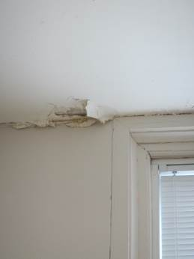
Water-damaged paint and efflorescence
Picture 2
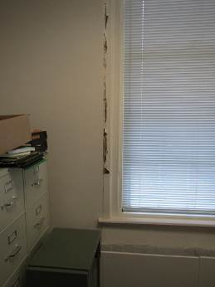
Water-damaged paint and efflorescence
Picture 3
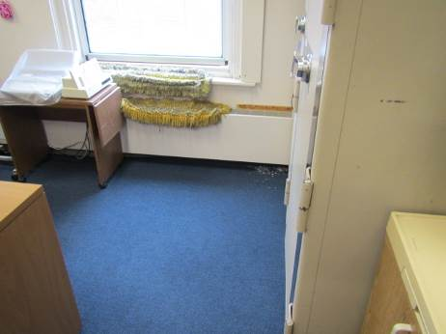
Mop heads on radiator; Note carpeting and paint chips below window
Picture 4
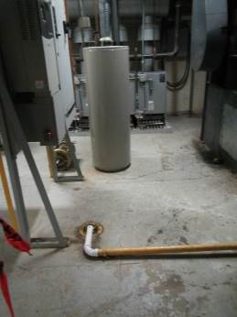
Furnaces and water heater in mechanical room
Picture 5
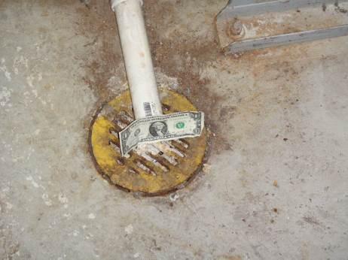
Condensation drain drawing air from room
Location | Carbon  Dioxide  (ppm) | Carbon Monoxide  (ppm) | Temp  (°F) | Relative  Humidity  (%) | PM2.5  (µg/m³) | Occupants  in Room | Windows  Openable | Ventilation |  | Remarks
 |  |  |  |  |  |  |  | Supply | Exhaust | Remarks
Background (outdoors) | 422 | ND | 64 | 78 | 12
103 | 583 | ND | 76 | 57 | 6 | 0 | N | Y | Y | Stained carpet, door open
106 | 660 | ND | 74 | 57 | 13 | 1 | N | Y | Y
108 | 603 | ND | 74 | 63 | 5 | 2 | Y | Y | Y | Photocopier
115 | 552 | ND | 75 | 62 | 4 | 1 | Y | Y | Y | Plants, efflorescence
116 | 589 | ND | 74 | 64 | 7 | 2 | Y | Y | Y | Water-damaged paint
118 | 575 | ND | 74 | 62 | 4 | 0 | Y | Y | Y | Upholstered furniture, bubbled paint
119 | 523 | ND | 74 | 62 | 5 | 0 | N | N | N | Refrigerator
202 | 572 | ND | 79 | 56 | 5 | 2 | N | Y | Y | Photocopier
206 | 540 | ND | 78 | 57 | 4 | 0 | N | Y | Y | Photocopier
206 IT | 573 | ND | 78 | 58 | 4 | 1 | N | Y | N | Door open
210 back | 539 | ND | 77 | 58 | 10 | 0 | N | Y | Y
210 front | 570 | ND | 77 | 58 | 4 | 1 | N | Y | Y | Photocopier
213 | 524 | ND | 77 | 57 | 4 | 1 | Y | Y | Y | Water-damaged plaster/windows
215 | 571 | ND | 77 | 58 | 8 | 2 | Y | Y | Y | Odor, water-damaged plaster/windows
215 inner office | 671 | ND | 77 | 59 | 4 | 2 | Y | Y | Y | Odor, water-damaged plaster/windows
217 | 664 | ND | 77 | 58 | 4 | 2 | Y | Y | Y | Water-damaged plaster/windows
303 | 559 | ND | 75 | 60 | 2 | 0 | Y | Y | Y
305 | 559 | ND | 74 | 64 | 1 | 0 | N | Y | Y | Door open
313 | 515 | ND | 76 | 58 | 2 | 0 | Y | Y | Y
314 | 524 | ND | 76 | 57 | 2 | 0 | Y | Y | Y
315 | 515 | ND | 76 | 58 | 3 | 0 | Y | Y | Y
316 | 514 | ND | 76 | 58 | 2 | 1 | Y | Y | Y | Door open
317 | 579 | ND | 76 | 60 | 2 | 2 | Y | Y | Y | Plants, photocopier, 1 water-damaged ceiling tile
318 | 526 | ND | 76 | 59 | 3 | 0 | Y | Y | Y
3rd floor hallway | 530 | ND | 76 | 59 | 2 | 0 | N | Y | Y | 6+ water-damaged ceiling tiles
Lounge | 546 | ND | 76 | 59 | 2 | 1 | Y | Y | Y | Plants, upholstered furniture
Selectman board room | 591 | ND | 76 | 60 | 2 | 2 | Y | Y | Y
Town counsel | 540 | ND | 76 | 59 | 2 | 1 | Y | Y | Y | Plants

