WATER DAMAGE ASSESSMENT

Dartmouth Town Hall
400 Slocum Road
Dartmouth, Massachusetts

Prepared by:
Massachusetts Department of Public Health
Bureau of Environmental Health
Indoor Air Quality Program
December 2019

Background
Building: | Dartmouth Town Hall (DTH)
Address: | 400 Slocum Road, Dartmouth, MA
Assessment Requested by: | Dartmouth Board of Health
Reason for Request: | Water damage and general indoor air quality (IAQ) concerns
Date of Assessment: | October 10, 2019
Massachusetts Department of Public Health/Bureau of Environmental Health (MDPH/BEH) Staff Conducting Assessment: | Mike Feeney, Director, IAQ Program
Building Description: | The DTH is a two-story brown brick building originally constructed in 1927 as a school. The building was renovated to become DTH in 1987. The building contains town offices and meeting rooms.
Building Population: | This space is occupied by approximately 30 employees and can be visited by 20 to 50 individuals daily.
Windows: | Openable

Methods
Please refer to the IAQ Manual and appendices for methods, sampling procedures, and interpretation of results (MDPH, 2015). Note that this building has been visited by the MDPH IAQ Program in November 2015. The report from that visit can be found at: https://www.mass.gov/info-details/indoor-air-quality-reports-cities-and-towns-d

IAQ Testing Results
The following is a summary of indoor air testing results (Table 1).
- Temperature was within or close to the recommended range of 70°F to 78°F in areas assessed.
- Relative humidity was within the recommended range of 40 to 60% in areas assessed.

Microbial/Moisture Concerns
The DTH experienced a water backup which wet extensive areas of the basement hallways and some adjacent rooms. At the time of this visit, carpet had been removed from the hallway (Picture 1). BEH/IAQ staff were asked to examine the DTH regarding health concerns related to water damage and installation of wall-to-wall carpeting on the basement floor.
As noted in a previous IAQ assessment, carpeting in the building was installed during the 1987 renovation. Carpeting, if well maintained, is expected to have a service life of 7 to 11 years (Bishop, 2002). Carpeting beyond its service life can become a source of fibers and debris that can be aerosolized when disturbed. Since the fan coil units do not have filters, the fans can widely distribute airborne debris. Carpets should be cleaned regularly in accordance with Institute of Inspection, Cleaning, and Restoration Certification (IICRC) recommendations (IICRC, 2012).
In addition, the basement carpeting may have been water-damaged by condensation due to lack of insulation. Of note were the weather conditions over the summer of 2018:
The New England area experienced an unprecedented period of extended hot, humid weather. According to the Washington Post, “[d]ata…show[s]…cities in the Northeast have witnessed such humidity levels for record-challenging duration...[i]ncluding Albany, Boston, Burlington Portland and Providence” during the summer of 2018 (WP, 2018). “Boston and nearby locations… [saw]…historic numbers of those warm nights with low temperatures at or above 70 degrees…Providence and Blue Hill Observatory have already broken their annual records” (WP, 2018).
Since the building was originally constructed in 1927, it is highly unlikely that the floor has either insulation or a vapor barrier. In this condition, the floor likely has a temperature similar the material beneath the floor (e.g, soil, sand, rock ledge, rock fill). If the temperature of the floor is below or equal to the dew point, the floor will begin to accumulate condensation.
The key to managing condensation is understanding dew point. Condensation is the collection of moisture on a surface at or below the dew point. The dew point is the temperature that air must reach for saturation to occur. If a building material/component has a temperature below the dew point, condensation will accumulate on that material. Over time, condensation can collect and form water droplets. With a floor chilled through contact with soil/rock, and the infiltration of unconditioned hot, humid air during the warmer months, condensation on the floor is likely.
In addition, the presence of high relative humidity (>70%) for a significantly long period, can also cause water damage to susceptible materials even in the absence of condensation or other liquid water. If these materials are porous, carbon-containing items (e.g., gypsum wallboard, carpeting, cloth, paper, and cardboard), mold can grow (ASHRAE, 1989).
It is recommended that porous material be dried with fans and heating within 24 to 48 hours of becoming wet (US EPA, 2008, ACGIH, 1989). If porous materials are not dried within this time frame, mold growth may occur. Water-damaged porous materials cannot be adequately cleaned to remove mold growth.
A method to identify areas in a building prone to condensation would be to measure air and building material temperatures. If a wide temperature range exists between measurements, the building materials at the colder end of the range may be prone to becoming moistened with condensation in hot, humid weather.
Using a laser thermometer, the surface temperature of basement interior walls and floors were measured (Table 1). Air temperature and relative humidity were also measured. A moisture meter was used to measure if carpet and/or exposed cement had measureable levels of moisture. The following conditions were noted:
- Floor temperatures were measured in a range from 59 to 64°F, while the indoor temperature was in a range of 66 to 70°F. These results indicate that the basement floor is likely not insulated and can serve as thermal bridge, leading to potential condensation on the floor which can moisten carpeting and items placed on the floor.
- Floors had moisture measurements in a range from 19 to 100 percent (Table 1). In general, wall-to-wall carpeting should not be routinely exposed to moisture routinely, since jute or latex-backed carpet can be prone to mold growth.
In each of these instances, the lower temperature of the floors and walls combined with the moisture content of the subfloor makes wall-to-wall carpet vulnerable to subsequent moistening and mold growth, especially if weather conditions are like those experienced in Massachusetts in the summer of 2018.

CONCLUSION AND RECOMMENDATIONS
Based on observations at the time of assessment, the following is recommended:
- Implement any remaining recommendations made in the previous IAQ assessment, which can be downloaded at https://www.mass.gov/info-details/indoor-air-quality-reports-cities-and-towns-d.
- Consider removing any remaining carpeting in the basement that has been wet and not properly dried.
- Replace basement flooring with materials that will either not be a mold growth medium (e.g., floor tile) or a covering that can serve as insulation and a vapor barrier (e.g., various types of carpet tile).
- Refer to resource manual and other related IAQ documents located on the MDPH’s website for further building-wide evaluations and advice on maintaining public buildings. These documents are available at: http://mass.gov/dph/iaq.

References
ACGIH. 1989. Guidelines for the Assessment of Bioaerosols in the Indoor Environment. American Conference of Governmental Industrial Hygienists, Cincinnati, OH.
ASHRAE. 1989. ASHRAE Standard: Ventilation for Acceptable Indoor Air Quality. Sections 5.11, 5.12. American Society of Heating, Refrigerating and Air-Conditioning Engineers, Inc. Atlanta, GA.
Bishop. 2002. Bishop, J. & Institute of Inspection, Cleaning and Restoration Certification. A Life Cycle Cost Analysis for Floor Coverings in School Facilities.
IICRC. 2012. Institute of Inspection, Cleaning and Restoration Certification. Carpet Cleaning: FAQ.
MDPH. 2015. Massachusetts Department of Public Health. Indoor Air Quality Manual: Chapters I-III. Available at: http://www.mass.gov/eohhs/gov/departments/dph/programs/environmental-health/exposure-topics/iaq/iaq-manual/.
US EPA. 2008. Mold Remediation in Schools and Commercial Buildings. US Environmental Protection Agency, Office of Air and Radiation, Indoor Environments Division, Washington, D.C. EPA 402-K-01-001. http://www.epa.gov/mold/mold-remediation-schools-and-commercial-buildings-guide.
WP. 2018. ‘It’s been relentless’: Smothering summer humidity in the Northeast has crushed records. Washington Post, Washington, DC. https://www.washingtonpost.com/news/capital-weather-gang/wp/2018/08/30/its-been-relentless-smothering-summer-humidity-in-the-northeast-has-crushed-records/
Picture 1
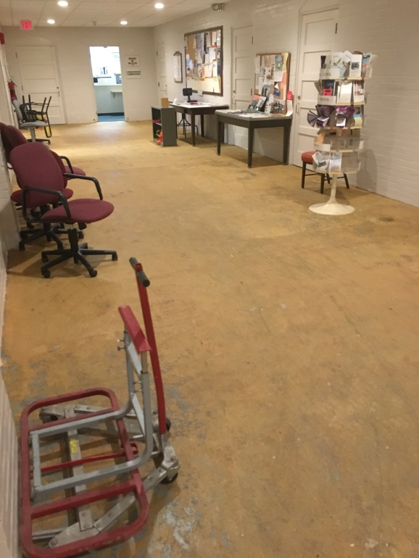
Bare floor of DTH basement hallway

Location | Air Temperature  (ºF) | Relative Humidity  (%) | Temperature Floor  (ºF) | Temperature Wall  (ºF) | Moisture Content floor  (%) | Dew Point  (ºF) | Difference in Temperature of Air v. Floor/Wall  (ºF)
119D | 70 | 58 | 64 | 64 |  | 54 | -6
119A | 69 | 57 | 60 | 60 |  | 54 | -9
119 | 69 | 57 | 63 | 61 | 21-51 | 54 | -8
119B | 70 | 56 | 59 | 59 | 36 | 54 | -11
119C | 70 | 56 | 62 | 61 | 90 | 54 | -9
116 | 70 | 56 | 63 | 61 | 19 | 54 | -9
118 | 69 | 57 | 61 | 60 | 100 | 54 | -6
103 | 68 | 57 | 62 | 62 | 88-96 | 53 | -6
108C | 68 | 58 | 63 | 62 | 86-93 | 55 | -6
108B | 68 | 55 | 63 | 63 | 79-93 | 53 | -5
103A | 66 | 57 | 62 | 62 | 86-97 | 52 | -4
104 | 67 | 56 | 62 | 63 | 23-92 | 53 | -4
Hallway North | 69 | 57 | 63 | 63 | 81-98 | 53 | -6
Hallway at elevator | 69 | 57 | 63 | 63 | 71-91 | 53 | -6
Hallway south | 69 | 57 | 63 | 63 | 82-100 | 53 | -6
Stairwell landing | 69 | 57 | 63 | 64 | 53 | 53 | -6
CO9E | 69 | 58 | 64 | 63 | 53 | 54 | -6
CO9 coal bin | 69 | 60 | 63 | 63 | 86 | 55 | -6

Condensation is the collection of moisture on a surface with a temperature below the dew point. The dew point is a temperature determined by air temperature and relative humidity. For example, at a temperature of 73°F and relative humidity of 57 percent indoors, the dew point for water to collect on a surface is approximately 57°F.
A thermal bridge is an object (usually metallic) in a wall space through which heat is transferred at a greater rate than materials surrounding it. During the heating season, the window comes in contact with heated air from the interior and chilled air from the outdoors, resulting in condensation formation if the window frame temperatures are below the dew point.

