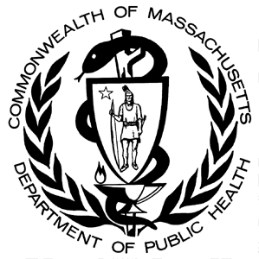

**Data Brief: An Assessment of Opioid-Related Deaths in Massachusetts**

**2013-2014**

Massachusetts Department of Public Health Posted: September 2016

**INTRODUCTION**

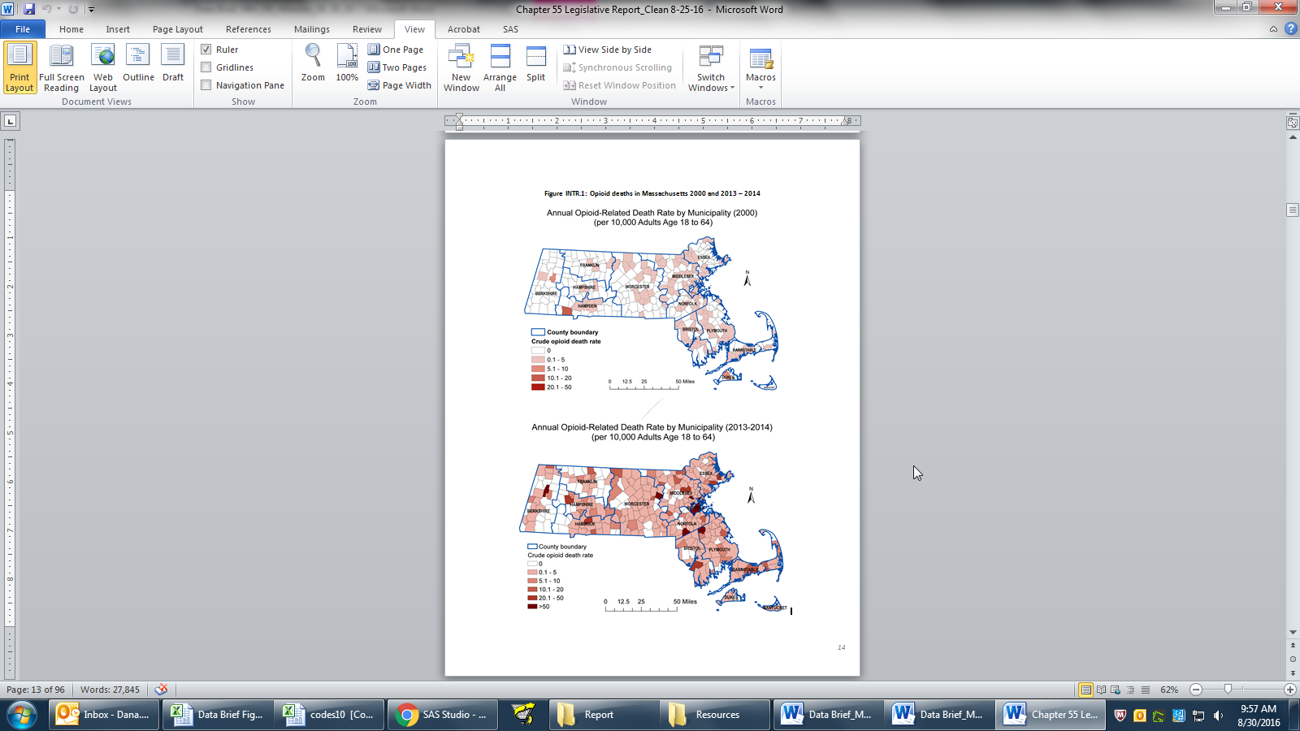  
Since 2000, opioid-related deaths have increased in Massachusetts by 350%.  The recent rate of increase is several times faster than anything seen before with every community in Massachusetts impacted by the current opioid epidemic. In 2013-2014 alone, opioid-related deaths were recorded in two-thirds of the cities and towns in Massachusetts.

Understanding the causes and deadly impacts of this issue can be a challenge. In the face of this public-health crisis, the Commonwealth of Massachusetts has taken an unprecedented look at the available data on opioid-related deaths.

CHAPTER 55

Chapter 55 of the Acts of 2015 (Chapter 55) was passed by the Massachusetts Legislature and signed into law by Governor Charles D. Baker in August 2015. This new law permits the linkage and analysis of different government data sets to better understand the opioid epidemic; guide policy development; and help make programmatic decisions.  Importantly, in addition to providing insight into the current opioid epidemic, this effort also marks the beginning of how government, academia, and private industry can and should collaborate to answer complex health questions.  This new model of cooperative data analysis has the potential to become the standard in Massachusetts and across the United States. The Chapter 55 project represents a process that should be continued, adapted, and refined as new public health challenges and new collaborates emerge.

Key Findings: In-Depth Linked Analyses

**Prescription Drugs Fuel Epidemic, but Illegally-Obtained Substances More Closely Linked to Overdose Deaths.**

Review of this data shows that illegally-obtained substances are much more frequently present in post-mortem toxicology than prescription drugs (i.e., a Schedule II-III opioids, or benzodiazepines). While prescription drug use can result in addiction and may increase the long-term risk of death, illegal drugs appear more likely to be the direct cause of death. Based on observed data, 8.3% of opioid-related overdose decedents had an opioid prescription in the same months as their death, while an estimated 85% had fentanyl and/or heroin.

1. Opioid-related overdose deaths in mutually exclusive categories were categorized based on decreasing order of deadliness of the specific drugs (*Fentanyl and/or Heroin* 🡪 *Methadone* 🡪 *other Rx* 🡪 *buprenorphine*) present in the results. A person was put into a category based on the deadliest drug present in the results, regardless of the presence of other drugs. For example, if someone had Fentanyl and Methadone present, they would be in the “Fentanyl” group.
2. Fentanyl and/or Heroin includes: Fentanyl, Heroin, and Morphine (likely Heroin).
3. Prescription opioids include Hydrocodone, Hydromorphone, Oxycodone, Oxymorphone, Codeine, and Tramadol.

While relatively few people who died of an opioid-related overdose had filled an opioid prescription within one month of their death, the majority had filled a prescription within the four year study period. This was true regardless of the substances present in the person’s system at the time of death.

|  |  |  |  |  |  |  |  |  |  |
| --- | --- | --- | --- | --- | --- | --- | --- | --- | --- |
| **Table 1: Proportion of Decedents with any Prescription1 Opioid History by Category of Opioid Present in Toxicology Screen** | | | | | | | | | |
|  | **Overall** | **Within 1 Month of Death** | | **Within 3 Months of Death** | | **Within 6 Months of Death** | | **Within Study Period** | |
| **Toxicology Result** | **n** | **n** | **%** | **n** | **%** | **n** | **%** | **n** | **%** |
| Fentanyl and Definite Heroin Present | 166 | 16 | 9.6% | 22 | 13.35 | 38 | 22.9% | 104 | 62.7% |
| Fentanyl and Likely Heroin Present | 83 | 7 | 8.4% | 16 | 19.3% | 21 | 25.3% | 54 | 65.1% |
| Fentanyl Present | 288 | 50 | 17.4% | 64 | 22.2% | 87 | 30.2% | 195 | 67.7% |
| Definite Heroin Present | 547 | 71 | 13.0% | 104 | 19.0% | 150 | 27.4% | 353 | 64.5% |
| Likely Heroin Present | 320 | 39 | 12.2& | 68 | 21.3% | 92 | 28.8% | 207 | 64.7% |
| Methadone Present | 84 | 23 | 27.4% | 34 | 40.5% | 39 | 46.4% | 64 | 76.2% |
| Prescription Opioid Present | 154 | 57 | 37.0% | 77 | 50.0% | 88 | 57.1% | 127 | 82.5% |
| Buprenorphine | 15 | <5 | N/A | <5 | N/A | <5 | N/A | 9 | 60.0% |
| Total | 1657 | --2 | --2 | --2 | --2 | --2 | --2 | 1113 | 67.2% |

1. Includes any prescription for Fentanyl, Methadone, Hydrocodone, Hydromorphone, Oxycodone, Oxymorphone, Morphine, or Codeine

2. Number not displayed because of complimentary suppression rules.

Also of importance is the finding that benzodiazepines and cocaine are commonly found in opioid deaths. The combination of opioids and benzodiazepines depresses the central nervous system at a higher rate than just using one of the medications alone. Benzodiazepines are commonly taken with opioids for non-medical purposes and were present consistently in toxicology screens, regardless of the opioid present, in over half of overdoses. Overall, 30% of opioid decedents with a toxicology screen also had cocaine present in their system.

|  |  |  |  |  |  |  |  |  |  |
| --- | --- | --- | --- | --- | --- | --- | --- | --- | --- |
| **Table 2: Proportion of Decedents with a Prescription Benzodiazepine History by Category of Opioid Present in Toxicology Screen** | | | | | | | | | |
|  | **Overall** | **Within 1 Month of Death** | | **Within 3 Months of Death** | | **Within 6 Months of Death** | | **Within Study Period** | |
| **Toxicology Result** | **n** | **n** | **%** | **n** | **%** | **n** | **%** | **n** | **%** |
| **Fentanyl and Definite Heroin Present** | 166 | 14 | 14.7% | 21 | 22.1% | 21 | 22.1% | 47 | 49.5% |
| **Fentanyl and Likely Heroin Present** | 83 | 6 | 13.6% | 6 | 13.6% | 7 | 15.9% | 14 | 31.8% |
| **Fentanyl Present** | 288 | 31 | 18.0% | 38 | 22.1 | 44 | 25.6% | 78 | 45.4% |
| **Definite Heroin Present** | 547 | 54 | 17.9% | 75 | 24.9 | 93 | 30.9% | 146 | 48.5% |
| **Likely Heroin Present** | 320 | 40 | 22.0% | 54 | 29.7 | 63 | 34.6% | 94 | 51.7% |
| **Methadone Present** | 84 | 14 | 24.1% | 19 | 32.8% | 25 | 43.1% | 40 | 69.0% |
| **Prescription Opioid Present** | 154 | 24 | 25.3% | 34 | 35.8% | 39 | 41.1% | 60 | 63.2% |
| **Buprenorphine** | 15 | <5 | N/A | <5 | N/A | <5 | N/A | 8 | 57.1% |
| **Total** | 1657 | --1 | --1 | --1 | --1 | --1 | --1 | --1 | 50.4% |

1. Number not displayed because of complimentary suppression rules.

As a result of these findings, increasing the availability of harm reduction strategies and interventions that target Heroin, Fentanyl, and polysubstance use (especially benzodiazepine and cocaine use) could significantly reduce the opioid-related death rate. In addition, these data were used to determine that the risk of death is 7 times higher for individuals who filled opioid prescriptions at 3 or more pharmacies.

**Medication Assisted Treatment Reduces the Risk of Fatal Opioid Overdose.**

Over the study period, 6.8% of total opioid-related overdose deaths in Massachusetts were preceded by a nonfatal opioid-related overdose as detected in EMS data. Of note, this estimate represents a substantial underestimate of the number of nonfatal opioid-related overdoses in Massachusetts. Not all nonfatal opioid-related overdose events result in an ambulance encounter, and not all ambulance encounters are captured in the EMS (MATRIS) data. To build on this analysis, nonfatal opioid-related overdoses identified in the emergency department and inpatient settings from the Case Mix will be included once these datasets are available.

The cumulative incidence of fatal opioid-related overdose was 1.1% for those engaged in opioid agonist treatment (OAT) (i.e., medications like methadone & buprenorphine that block the effect of opioids) versus 2.3% for those not engaged in OAT. Among people who have a nonfatal opioid-related overdose, those who are engaged in OAT had half the risk of subsequent fatal opioid-related overdose than those who are not engaged in OAT.

This suggests that overdose survivors have a short window of opportunity after a nonfatal overdose to reduce their risk of death by undergoing an evidence-based medication-assisted treatment (MAT). A comprehensive plan for delivering evidence-based MAT, such as buprenorphine or methadone treatment, to treat opioid use disorder for those with high overdose risk could significantly lower the death rate. This report only includes data for state-funded opioid agonist treatment (i.e. Buprenorphine or Methadone). Work is ongoing to examine risk reductions associated with additional MATs including naltrexone. Naltrexone, also known as Vivitrol, is a Schedule VI drug and it is not captured in the PDMP. In future work, All Payer Claims Database (APCD) data will be used to assess the potential risk reduction associated with Vivitrol use.

**Women are More Likely than Men to Experience a Fatal Overdose Due to Prescription Opioid Use.**

While men were found to be significantly more likely to die from any opioid-related overdose,women are more likely than men to die of a prescription opioid-related overdose. Women are more likely than men to both obtain Schedule II-III opioids and to have Schedule II-III opioids present in post-mortem toxicology following an opioid-related overdose death.

Additionally, females were more likely than males to have opioid prescriptions filled by multiple providers and/or at multiple pharmacies. These finding highlight that prescribers and pharmacists should be educated about personal biases.



While legally- and illegally-obtained opioids pose a risk for men and women alike, prescribers and pharmacists should be educated to utilize the Prescription Drug Monitoring Database (PDMP) through the Massachusetts Prescription Awareness Tool (MassPAT) in order to identify any active or past prescriptions for their patients, and to provide coordinated care and overdose risk reduction.

**Age-related Differences**

The percentage of opioid deaths for different age groups shows that young people of Massachusetts are especially at risk. In 2013-2014, opioids accounted for more than a quarter of **all** fatalities in the 18-24 age group. For individuals from 25-34, opioids were responsible for more than a third of all deaths, rising to more than 40% for men in this group. In 2015, roughly 2 out of every 3 people who died from opioids were younger than 44.  
  
The percentage of opioid deaths for different age groups shows that the young people of Massachusetts are at risk.



**Individuals Who Have Recently Been Released from Massachusetts Prisons are 56 Times as Likely to Die from an Opioid Related Overdose.**

Those who have recently been released from Massachusetts prisons have a short-term risk of death from opioid overdose that is greater than 50 times the risk for the general public. Twenty-five percent of Massachusetts prison inmates received treatment during their incarceration, and there was not a notable reduction in risk of fatal overdose in those that received treatment. The first month after release proved to be a critical time period for former inmates, having rates that were between 2 to 6 times higher than for later times for both all-cause mortality and for opioid-related overdoses.

To further reduce the opioid-related death rate, additional focus should be paid to those being released from Massachusetts prisons, and treatment opportunities should be standardized regardless of setting.