JULY 2023
DATA BRIEF
Verbal Screenings for Alcohol and Substance Use in Massachusetts Public Schools: 2017-2018 School Year

Introduction
As part of its response to the opioid epidemic, the Massachusetts Legislature enacted a law in 2016 requiring public schools to conduct annual screenings of students for substance use disorder (An Act Relative To Substance Use, Treatment, Education And Prevention). The law requires that schools use a verbal screening tool and administer the screening to students in two grade levels, with the choice of grades based on recommendations made by the Department of Public Health (DPH) and the Department of Elementary and Secondary Education (DESE). DPH recommends that each school district select the grades to be screened by reviewing district-level data to determine age of substance use initiation in the local school-age population. Schools usually select one middle school grade and one high school grade for screening. The law was enacted in 2016, and the first statewide screening took place during the 2017-2018 school year. This report summarizes the findings from that screening.
DPH and DESE selected the CRAFFT-II Screening Interview as the verbal screening tool that Massachusetts schools would use with their students. This tool was selected because it could be administered quickly and efficiently to a large number of students, has been validated against traditional diagnostic procedures in hospital-based adolescent clinics (Knight JR et al., 2002), was recognized by MassHealth for use in school screenings, has been validated for use with youth from ages 12 – 21 (Center for Adolescent Behavioral Health Research (CABHRe), 2021), and was identified by the American Academy of Pediatrics as a useful screening tool (Hagan, J.F., Shaw, J.S., and Duncan, P.M., 2017). In addition, DPH and DESE received permission from the tool authors at Boston Children’s Hospital to revise the tool and add questions specific to substance use by youth in Massachusetts.
School staff were required to register for a 6-hour introductory Screening, Brief Intervention, and Referral for Treatment (SBIRT) in Schools training at the School Health Institute for Education and Leadership Development. Training was provided by DPH at no cost to the schools or their staff. The training included instructions in using the CRAFFT-II screening tool as part of SBIRT, an approach that emphasizes screening and early intervention for those who are at risk of developing a substance use disorder. The SBIRT procedure includes a structured conversation between a trained school professional and a student in order to build a trusting relationship around behavior related to substance use. This is the first time this approach has been utilized across all Massachusetts public schools.
In addition, there was an optional 3-hour training for staff who wanted to enhance their skills in conducting Brief Negotiated Interviews (BNI), reinforcing healthy behaviors, and making referrals. Both of these trainings provided guidance in developing SBIRT plans and procedures, administering the screenings, scoring the results, providing brief interventions, and referring students who were at risk for a substance use disorder for further assessment and counseling. Responses to the screening questions were recorded using a spreadsheet-based data collection tool that was designed for recording the results of SBIRT administrations in schools. Responses were recorded for each individual but de-identified to preserve confidentiality. The data files were then submitted to DPH for analysis.

Results

School district and student participation
Over 80% of Massachusetts public school districts with students enrolled in grades 7-12 participated in the screening and submitted their screening results to DPH. In the participating districts, many districts screened all or nearly all of the students in the grades selected for screening. Screenings were administered to 93,983 students (Table 1).
Some students in participating districts were not screened because they were out sick on the day of screening. Other students were not screened because they were hospitalized, non-verbal, or because they had other special needs that made screening impractical.
Either an individual student or their parent/guardian could request to opt out of the screening. In the districts that participated in the screening, 6.6% of students opted out. This includes 3.7% due to parents opting out, and 2.9% due to students opting out (Table 1).

Table 1: Participation in SBIRT screening (Massachusetts, 2017-2018 school year)
School district participation | Number (n) | Percent of districts (%)
School districts with any enrollment in grades 7 -12  12 | 275 | 100.0
School district response rate | 230 | 83.6
Opt-outs | Number (n) | Percent of sample (%)
Student opt-outs | 2,883 | 2.9
Parent opt-outs | 3,742 | 3.7
Total opt-outs | 6,625 | 6.6
Student participation | Number (n) | Percent of sample (%)
Student sample | 100,608 | 100.0
Total opt-outs | 6,625 | 6.6
Number screened | 93,983 | 93.4

Notes:
1. School district: In Massachusetts, school districts are structured in a wide variety of ways, with many not fitting the traditional K-12 model. The grades taught in elementary, middle, and high schools are not uniform across the state. Some elementary schools include grades 7 and 8, which are grades that are eligible for SBIRT screening, and as a result those elementary schools are included in the analysis. In these cases, the feeder school districts are usually elementary school districts that are managed separately from the regional high school district. The entire group of schools is treated as if it were a single consolidated school district. Collaboratives, charter schools, and virtual schools are not counted as districts because they function in ways that differ from school districts, but if they submitted SBIRT data using the DPH-provided data tool, their data was included in this report.
2. School district response rate: Most participating school districts submitted data using the SBIRT data reporting tool that DPH developed and distributed to schools. A small number of school districts (16) reported that they performed SBIRT screenings but were unable to use the data tool provided. Those districts are counted as participating districts, but since they did not use the DPH-provided data tool, their data was not available for analysis and could not be included in the remainder of this report.
3. Student sample: The sample includes students who completed the screening as well as those who opted out. It does not include students who were enrolled in a grade that was screened but were not screened due to absence, illness, non-verbal learning disability, or a physical or mental condition which would have precluded screening. It also excludes students not screened due to limited school resources. We do not have a numerical breakdown of those excluded students, but we can estimate the total number excluded by using enrollment totals and subtracting out the number of students that were screened or that opted out. If those students had been included in the sample, then the estimated total number of students would be 113,761.
4. Screening using the DPH-provided data tool took place in 537 schools in 253 school districts, charter schools, and collaboratives. Some schools are spread across multiple buildings, while some school buildings house more than one school, so the number of school buildings may be slightly greater or less than the number of schools.

Student Demographics
The grades that school districts selected most often for screening were grades 7 and 9 (Table 2 and Figure 1). Those two grades accounted for 81% of the total number screened. This resulted in a relatively equal age distribution between age 12 and 15, with a smaller number of students aged 16 and older (Figure 2).

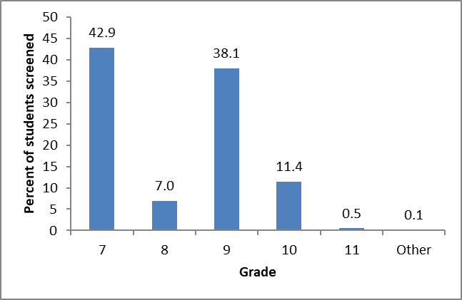
Figure 1: Grade distribution of students screened using SBIRT, Massachusetts, 2017-2018 school year (n =93,983)

Table 2: Number screened using SBIRT, by grade, Massachusetts, 2017-2018

Grade | Number screened
7 | 40,323
8 | 6,556
9 | 35,781
10 | 10,732
11 | 474
Other | 117
Total | 93,983

Notes:
“Other” grade includes ungraded schools, schools that did not report the grade of the students screened, and schools that reported the grade in a non-standard fashion (combining data from students in grades 7 and 8, for example).

Figure 2: Age distribution (percent of students screened using SBIRT),
Massachusetts, 2017-2018 school year (n =92,931)
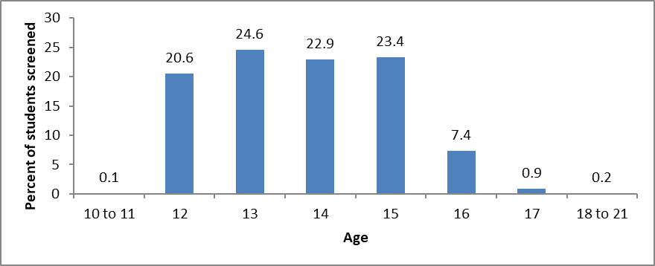
Note: Age was not reported for 1,052 (1.1%) of the 93,983 students screened.

School nurses and counselors administered 87% of the screenings (Figure 3), with the remaining screenings performed by social workers, psychologists, teachers, and other staff roles.
Figure 3: Position of staff administering in-school SBIRT,
Massachusetts, 2017-2018 school year (n = 91,242 screenings)
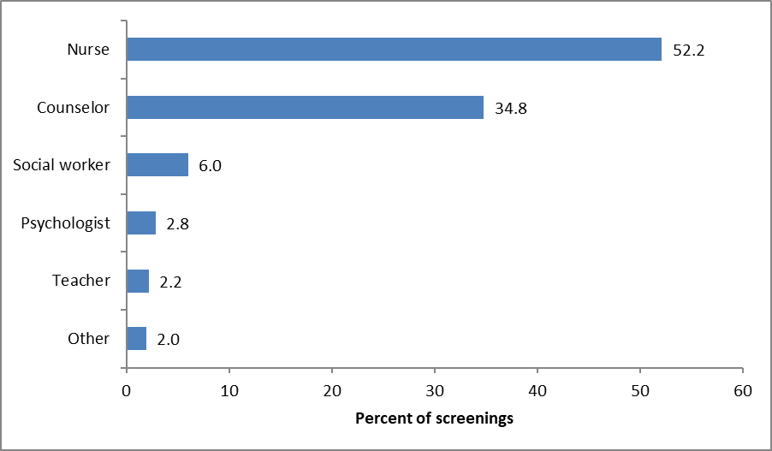
Note: “Counselor” includes guidance counselor and adjustment counselor. “Staff role” was not reported for 2,741 (2.9%) of the 93,983 students screened.

Alcohol and Substance Use Rates
Prior 12-month substance use (including alcohol, marijuana, and other substances) increased with grade and age (Figure 4). Alcohol use is more common than marijuana use at every age level (Figure 5), while the use of prescription drugs and other substances occur at far lower levels (less than 1%).
Figure 4: Prior 12-month alcohol or substance use by a) grade and b) age,
Massachusetts, 2017-2018 school year
a) Grade
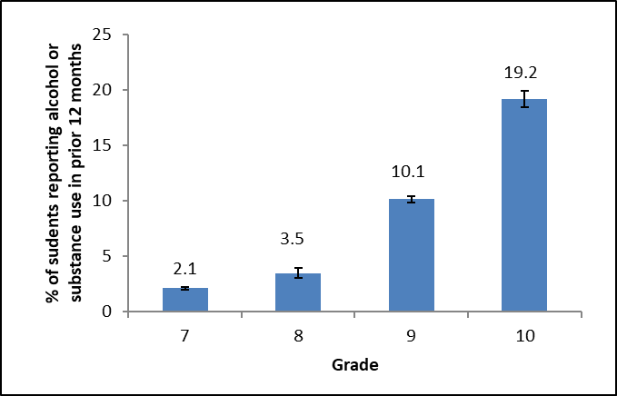

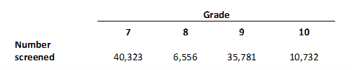

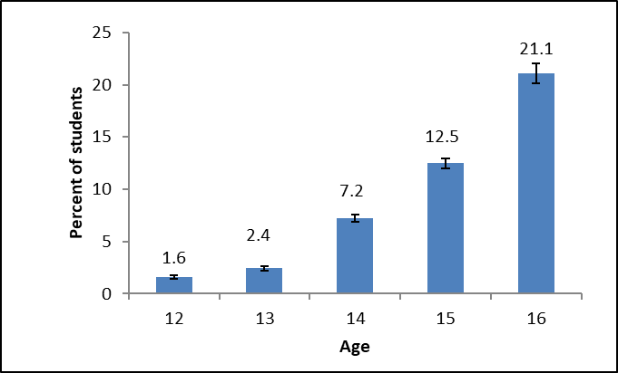
b) Age
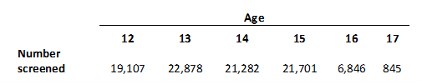

Error bars indicate the 95% confidence interval.

Figure 5: Prior 12-month alcohol and marijuana/synthetic marijuana use by grade,
Massachusetts, 2017-2018 school year
a) Alcohol
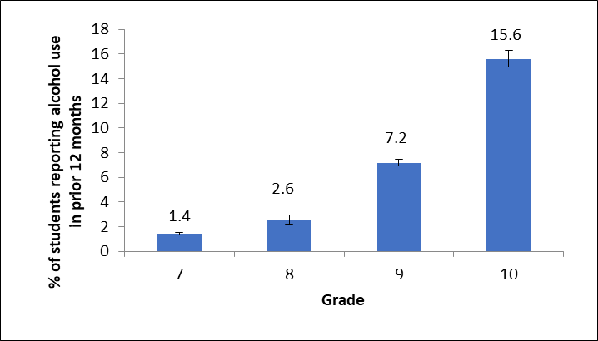

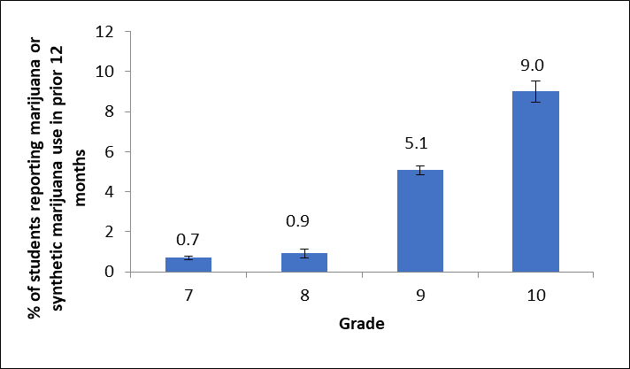
b) Marijuana or synthetic marijuana

Error bars indicate the 95% confidence interval.

Risk Assessment Scores

A score of 2 or greater on the CRAFFT screening tool is considered a positive screening result and indicates that the student is at high risk for an alcohol or substance use disorder and requires further assessment (Massachusetts Department of Public Health, 2009). Students with a positive screen are often referred for counseling or treatment. Students who report using alcohol or drugs in the prior 12 months and have a score of 0 or 1 on the CRAFFT tool do not have a positive result, but are considered to be at medium risk and usually given brief advice about the health effects of using alcohol or substances.
Although the percentage of students at medium risk increased moderately between grades 7 and 8, the percentage of students at high risk for an alcohol or substance use disorder remained very low (0.4%) for those 2 grades (Figure 6). The percentage of students at high risk increased noticeably in grades 9 and 10. There were far more students at medium risk than at high risk at every grade level.

Figure 6: Distribution of CRAFFT risk scores by grade,
Massachusetts, 2017-2018 school year
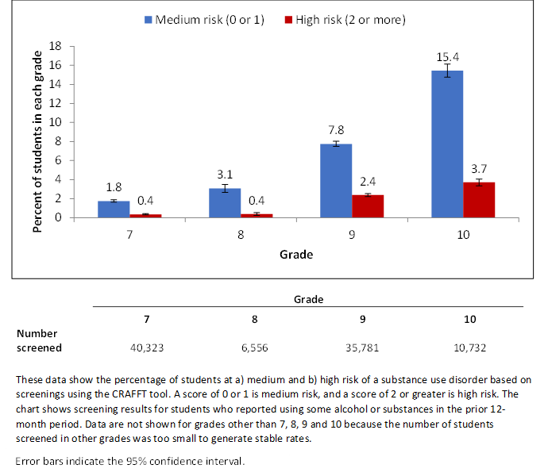

Interventions and Referrals
Over ninety percent of students (93.6%) were given praise (positive reinforcements) for making healthy decisions (Figure 7). Brief Interventions were administered to 7.9% of students. These interventions are structured conversations used with students who are using substances. It is a non-confrontational approach that uses reflective listening and motivational interviewing to strengthen the student’s own motivation to reduce risky alcohol and/or substance use. Referrals for counseling, treatment, or further assessment were given to 1,187 students, or 1.3% of students screened. Most referrals (87.2%) were for in-school counseling while 7.3% of referrals were to private providers (Figure 8).
Figure 7: Interventions Used During SBIRT Screening,
Massachusetts, 2017-2018 school year, n = 93,983 administrations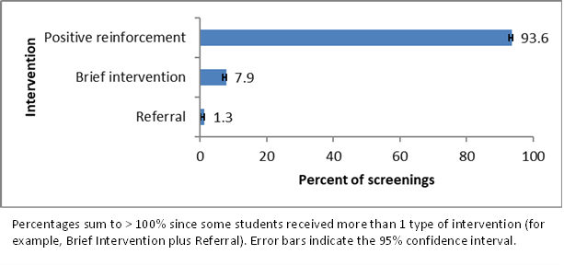
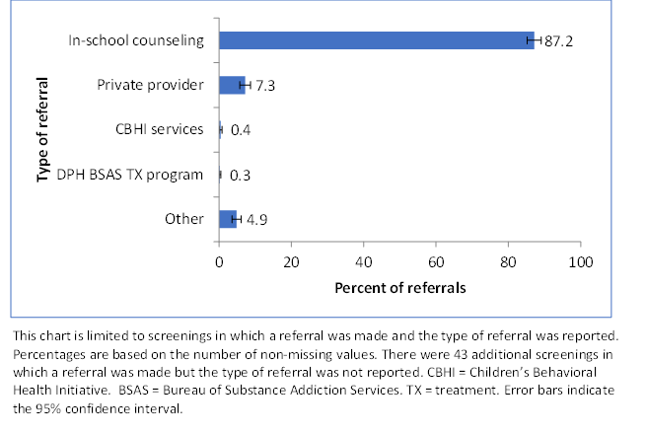
Figure 8: Type of Referrals Made During SBIRT Screenings, Massachusetts, 2017-2018 school year, n = 1,144 referrals

Summary
SBIRT can be successfully administered on a large scale in the school setting by using trained school staff, including school nurses, counselors, social workers, and psychologists. Although these staff worked in a large number of schools (537) spread across Massachusetts, they all attended required trainings, administered SBIRT to students, recorded data, conducted interventions, and made referrals. Of the 275 school districts in Massachusetts with students enrolled in a grade that was eligible for SBIRT, 230 (83.6%) participated in the screening. Some students and parents opted out of the screening, but with the overall opt-out rate only 6.6%, the screenings still reached a large number of students.
The results of SBIRT screening show that 1.3% of students screened were referred for further assessment or counseling. Schools were informed that if students were already in treatment for substance use, screenings should still be administered but that referrals would not be necessary or appropriate. As a result, referrals made through SBIRT screenings should provide one indication of the success of the screening initiative, since they provide a measure of the number of high-risk students who were not getting counseling prior to the screening, but who were identified and encouraged to receive counseling as a result of SBIRT administration. By that measure, SBIRT administration resulted in 1,188 students (1.3%) who were at high risk of a substance use disorder getting counseling or a referral for counseling. Of those students who scored 2 or higher on the CRAFFT and were at high risk, 60.2% were referred for further assessment and counseling. Comments entered by screeners indicated that some high-risk students may not have received a referral because the student was already in counseling, while in other cases the student was offered a referral, but the student refused it. Even if the student refused the referral, brief counseling was provided in almost every case, as 96.7% of high-risk students who did not receive a referral did receive a brief intervention.
Students who were not at high risk were given a brief intervention (7.9%) or positive reinforcement (93.6%), depending on whether substance use was reported by the student. Students at medium risk received a brief intervention 78.4% of the time and received positive reinforcement affirming the good decisions they had made 98.0% of the time. These interventions are important, as one of the benefits of SBIRT screening is that it may allow students to build a relationship with school health staff and provides students with an easily accessible in-school resource they can utilize if they have concerns about substance use in the future.
Since some students will opt out of the screening and other students will not disclose drug or alcohol use during the screening, SBIRT screenings will not reach every student with an alcohol or substance use disorder. Efforts that do not require a verbal screening may be needed to reach students who cannot be reached through SBIRT. Despite these limitations, SBIRT administered in school appears to be a useful way to identify students at risk for alcohol and substance use and provide them with needed resources and referrals.

References
An Act Relative To Substance Use, Treatment, Education And Prevention, 2016 Mass. Acts Chapter 52. (2016).
Center for Adolescent Behavioral Health Research (CABHRe). (2021, November). About the CRAFFT. https://crafft.org/about-the-crafft/
Hagan, J.F., Shaw, J.S., and Duncan, P.M. (2017). Bright Futures Guidelines and Pocket Guide. https://brightfutures.aap.org/materials-and-tools/guidelines-and-pocket-guide/Pages/default.aspx
Knight JR, Sherritt L, Shrier LA, Harris S, & Chang G. (2002). Validity of the CRAFFT substance abuse screening test among adolescent clinic patients. Archives of Pediatrics & Adolescent Medicine, 156(6), 607–614. https://doi.org/10.1001/archpedi.156.6.607
Massachusetts Department of Public Health. (2009). Using the CRAFFT Screening Tool: Provider Guide. https://www.masspartnership.com/provider/HealthEducation.html

Center for Adolescent Behavioral Health Research (CABHRe), Boston Children’s Hospital.
The first training was called simply “Introductory Training.”
Information about SBIRT in Schools can be found at http://www.masbirt.org/schools.
“SBIRT in Schools: Implementation Essentials.” See http://bucme.org/node/1045. Archived at web.archive.org.

