DATA BRIEF: Sports-Related Concussion among Massachusetts Youth, 2009 - 2017

Health Survey Program, Office of Data Management and Outcomes Assessment |  |  | February 2019
Massachusetts Department of Public Health | www.mass.gov/dph/hsp

Massachusetts Youth Health Survey Findings
A concussion is a type of traumatic brain injury that can be caused by a blow to the head or a jolt that causes brain to move rapidly back and forth. This can damage brain cells and create chemical changes in the brain. Concussions can be serious, particularly for young developing brains. They may cause long-term memory, learning, motor control, and/or speech problems. The symptoms can sometimes last weeks or months. Youth concussion safety laws have now been passed by all 50 states.¹
The Massachusetts Department of Public Health (MDPH)’s Youth Health Survey asked middle and high school students if they experienced concussion symptoms² while playing school sports in the last year, and if so, what actions were taken. This fact sheet describes data on youth sports concussions and policies in Massachusetts to prevent concussions among youth and ensure that appropriate management is followed.
Figure 1. Percent of MA student athletes who reported symptoms of a concussion² while playing sports in past 12 months

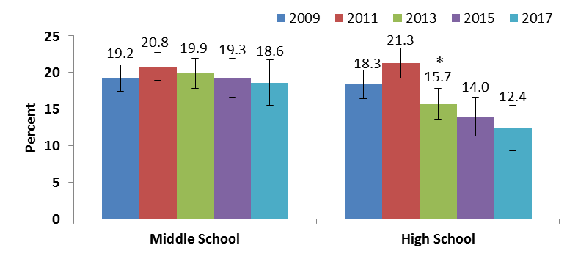
*Significantly lower than in 2011 at p < .05
Source: Massachusetts Youth Health Survey 2009-2017

Many sports pose a risk for concussion, including soccer, particularly when players head the ball.

Massachusetts Sports Concussion Regulation (105 CMR 201.000)

Passed in 2011, the Head Injuries and Concussions in Extracurricular Activities regulations apply to all public middle and high schools with grades 6-12 that provide extracurricular sports activities. They also apply to other schools subject to rules of the Massachusetts Interscholastic Athletic Association. The regulations mandate:

- Schools and school districts must have policies governing the prevention and management of concussions;
- School staff, students, and parents must take an annual training on sports-related concussions;
- Student athletes, prior to every sports season, must submit the Pre-participation Form;
- Any student showing signs and symptoms of a concussion must be removed from play immediately, may not return to practice that day, and must be medically evaluated before returning to play;
- Every student who is diagnosed with a concussion must have a graduated “Return to Play” plan and must not return to practice until he/she is medically cleared.
- Specifically identified clinicians who have verified MDPH-approved training on post-traumatic head injury management are authorized to provide medical clearance.
For more information, go to: www.mass.gov/sportsconcussion
- Centers for Disease Control and Prevention (2018.) Heads Up. Accessed at www.cdc.gov/headsup/youthsports/index.html
- Symptoms include being “knocked out”, memory problems, double or blurry vision, headaches, “pressure” in the head, nausea or vomiting.
1
1

Massachusetts Youth Health Survey Findings

Figure 2. Actions taken following reported symptoms† of a sports-related concussion among MA student athletes

- In 2017, 19% of middle school and 12% of high school student athletes reported symptoms of a sports-related concussion (Fig. 1).

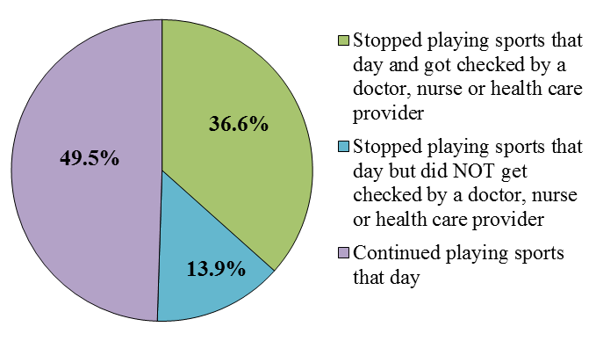
Stopped playing sports that day and got checked by a doctor, nurse or health care provider

Stopped playing sports that day but did NOT get checked by a doctor, nurse or health care provider

Continued playing sports that day

- The percentage of high school student athletes reporting symptoms of a sports concussion decreased 42% between 2011 and 2017. The percentage of middle school students reporting such symptoms did not change significantly, however (Fig. 1).

• Half (50%) of both middle and high
school students who reported
symptoms of a sports-related
concussion continued to play sports
that day. (Fig. 2).

Source: Massachusetts Youth Health Survey 2017, combined middle and high school data †Symptoms included being “knocked out”, memory problems, double or blurry vision, headaches, “pressure” in the head, nausea or vomiting.

Conclusions and Next Steps

- In 2017, 19% of middle school and 12% of high school student athletes reported symptoms of a sports concussion in the past year. This difference may be due to improved awareness and changes in policies and practices at the high school level.

- Almost half of all students are continuing to play despite experiencing concussion symptoms. Young athletes need to be encouraged to report their symptoms and be allowed to take the necessary steps to recover.

- Massachusetts regulations require collaboration among and education for school staff, parents, students, and medical providers to improve the identification and management of concussions.

- MDPH provides medical providers with information on concussion identification and management trainings, and tools for clearing a student to return to play after a head injury.

- MDPH provides school staff with technical assistance on sports concussion policies, and guidelines to help students return to the classroom after a concussion. These guidelines, Returning to School After Concussion, are available free of charge at: http://massclearinghouse.ehs.state.ma.us/category/inj.html

Resources

MDPH’s Injury Prevention and Control Program: www.mass.gov/sportsconcussion

MA Interscholastic Athletic Association: www.miaa.net

Brain Injury Association of MA:

www.biama.org

CDC Heads Up:

www.cdc.gov/headsup/index.html
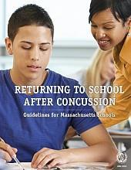

Technical notes: Percentages do not include missing responses. Youth Health Survey data are self-reported, voluntary, cross-sectional, and from a sample of public school students. Students in private schools, state custody, or other educational settings are not represented. Students who have severe limitations or disabilities, or who are often absent from school may be under-represented. Statistical significance was calculated at p < .05 using logistic regression in SAS. 2

