WIC NEEDS ASSESSMENT

2024

The annual WIC Needs Assessment estimates the percentage of WIC need met across the state and within WIC participant categories (pregnant and postpartum adults, infants, and children).

Using participant records, we calculate the number of active participants each month. Then, we divide the number of active participants by the number of WIC-eligible individuals to determine the percentage of need met.

In 2023-2024, WIC served: 45% of all 2023 births in MA 70% of eligible individuals 69% of eligible adults

67% of eligible children

83% of eligible infants

Based on 2019-2023 births, in the last year there were:

179,195 WIC-eligible individuals

125,988 active WIC participants

Estimated Need Met

by service area

≤55%

>55%–65%

>65%–70%

>70%–75%

>75%–80%

>80%–85%

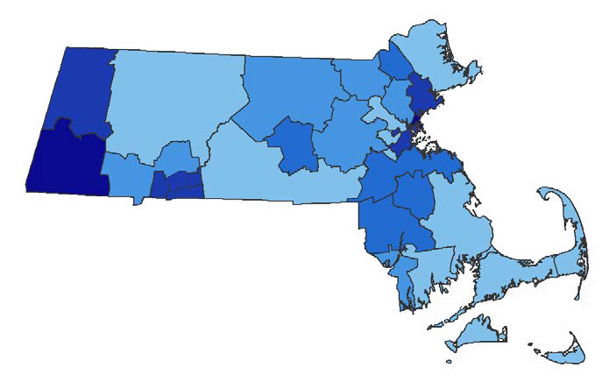

[www.mass.gov/wic](http://www.mass.gov/wic)

@MassWIC

For more information, contact [Flora.Berklein2@mass.gov.](mailto:Flora.Berklein2@mass.gov) Additional WIC data is available at [Women, Infant, and](https://www.mass.gov/info-details/women-infant-and-children-wic-program-data)  [Children (WIC) Program Data at Mass.gov.](https://www.mass.gov/info-details/women-infant-and-children-wic-program-data)