
Work-related Injuries and Illnesses
among Local Government Workers
(i.e. Municipal, County, and Regional)
in Massachusetts, 2009 - 2011

Massachusetts Department of Public Health

Summer 2016

Charles D. Baker, Governor
Karyn E. Polito, Lieutenant Governor
Marylou Sudders, Secretary of Health and Human Services
Monica Bharel, Commissioner of Public Health

Carlene Pavlos, Director, Bureau of Community Health and Prevention
Letitia K. Davis, Director, Occupational Health Surveillance Program

ww.mass.gov/dph/ohsp
Acknowledgements

This report was prepared by MyDzung Chu, MSPH, and Letitia Davis, ScD, MS, of the Occupational Health Surveillance Program (OHSP). Kathleen Grattan, James Laing, and Sangwoo Tak (formerly) of OHSP contributed to the analysis and preparation of this report. Special thanks to William Taupier and staff at the Massachusetts Department of Industrial Accidents for collecting and maintaining the data on which this report is based; Heather Rowe (formerly), Michael Flanagan, Mary Dozois, and Imani Bishop at the Massachusetts Department of Labor Standards for their consultation and assistance in coding cause of work-related injuries and illnesses. This work was funded in part through a cooperative agreement with the National Institute for Occupational Safety and Health (U60/OH008490).

For correspondence:

Contact Letitia Davis at Letitia.Davis@state.ma.us

To obtain additional copies of this report, contact:

Massachusetts Department of Public Health Bureau of Community Health and Prevention
Occupational Health Surveillance Program
250 Washington Street, 4th floor
Boston, MA 02108
617-624-5632

Local government workers in this report include those working in municipalities, counties, school districts, special districts, and regional authorities in accordance with the U.S. Census Bureau definitions of local government workers.

This report also does not include information about work-related injuries and illnesses among municipal firefighters and police officers (except as noted) as they generally do not submit claims to the Massachusetts Department of Industrial Accidents which provided the data for this analysis.

2
EXECUTIVE SUMMARY

Nationwide, local government workers, including municipal, county and regional workers, have higher rates of nonfatal work-related injuries and illnesses (WRIIs) than workers in the private sector. However, data on WRIIs among workers employed by local government agencies in Massachusetts are limited. Better information about the extent, nature, and cause of WRII among these workers is needed to inform prevention efforts and reduce associated human and economic costs. To address this information gap, the Occupational Health Surveillance Program at the Massachusetts Department of Public Health analyzed data on serious WRIIs among local government workers using workers' compensation (WC) claim records submitted to the Massachusetts Department of Industrial Accidents (DIA). DIA does not receive claims for firefighters and police officers, with rare exceptions*, as they are covered by separate systems for compensating work-related health problems. This report presents findings on nonfatal WRIIs among local government workers in Massachusetts during 2009-2011, excluding firefighters and police officers (except where noted).

Key Findings

- 8,338 WC claims for WRIIs resulting in five or more days away from work were filed for
Massachusetts local government workers during 2009-2011 - for an average of 2,779 claims per year.

- The average annual rate of claims for local public sector was 14.7 claims per 1,000 full-time equivalent (FTE) workers. A comparable rate of claims for private sector workers in Massachusetts was not available. A previous analysis of MA claims for state public sector workers in 2005 found a rate of 16.9 claims per 1,000 FTEs.¹⁶

- 64% of claimants were men, who accounted for about 40% of the local government
workforce.

- A claim can involve more than one injury or illness. A total of 10,406 WRIIs were identified: 82.1% were injuries, 3.4% were illnesses, and 14.5% could not be classified.

- Most commonly reported WRIIs were:
- Sprains, strains (49.7%), of which 32.2% involved the back;
- Contusion, crushing, and bruise injuries (13.1%), of which 27.0% were to the lower
extremities;
- Fractures (6.1%).

- The majority of claims were filed for workers in three major occupation groups:
  - Construction; Installation, Maintenance, and Repair; Production; Transportation
and Material Moving (29.6%);
  - Building and Grounds Cleaning and Maintenance (17.2%);
  - Education, Training, and Library (15.6%).

*Claims for certain police forces are covered by DIA, including some college campus police and the transit police of the MBTA. The 2009-2011 DIA database contained 34 claims for
such police officer occupations, which were included in this analysis when reporting counts and percentages but not when calculating rates. There were no claims for firefighters. 3
Key Findings (cont'd)

- A closer look at Educational Services and Public Works government functions:
• Among workers in Educational Services, the leading causes of WRIIs were falls
(29.4%), mostly on the same level; bodily reaction and exertion (29.5%), a large percentage of which were overexertion in lifting (22.1%); and slips, trips, loss of
balance-without fall (21.5%). Almost nine percent of claims were for assaults and violent acts.
• Among workers in Public Works, the leading cause of WRIIs was bodily reaction
and exertion (44.4%), a large percentage of which were due to overexertion in lifting
(32.2%). Other major causes were falls (18.5%), including falls to lower levels, and being struck by or against object or equipment (9.0%).

- WC claim rates by sub-state areas of employment:
• WC claim rates were calculated for the 48 U.S. Census place of work Public Use
Microdata Areas (PUMAs) in Massachusetts. Rates by PUMAs ranged from 5.9 to
28.6 WC claims per 1,000 FTEs. Five PUMAs had significantly higher rates than
the statewide average. These local areas should be considered as priorities for prevention outreach.

Conclusion

This analysis provides previously unavailable descriptive information about WRIIs among local government workers in Massachusetts, excluding firefighters and police. Findings underscore the need for increased efforts to prevent these injuries, particularly among those employed in Public Works and Educational Services.

Periodic review of information about where and how workers are injured or made ill on the job can provide critical information to target and design effective prevention efforts. Tracking WRII trends over time will also enable agencies to monitor their progress in meeting prevention goals. Lack of detailed information about government function and cause of WRII in the workers' compensation claim records was a significant limitation in this analysis. Local government agencies are encouraged to provide more detailed information in the workers' compensation claim records filed with DIA and also to review their own claims data to set local prevention priorities. Notably, Massachusetts recently became one of two states funded by the Centers for Disease Control and Prevention to implement improvements in the workers' compensation data system so that these claim data can be better used to inform prevention efforts. Continued collaboration among the Massachusetts Department of Public Health, the Department of Industrial Accidents, and the Department of Labor Standards, the agency that provides technical assistance to and enforces health and safety standards in local government agencies, will be important in helping local agencies create safer and healthier work environments for their employees who serve our communities.

A list of workplace health and safety resources for local government agencies is included at the end of this report (page 21).

4
Introduction
Local government workers, including municipal, county and regional workers, make up 6.9% of the Massachusetts (MA) workforce, providing services to approximately 6.7 million residents. They are the familiar faces who keep our families safe and neighborhoods operating, including, for example, crossing guards, teachers, construction workers, custodians, and utilities repairmen. According to national data from the U.S. Bureau of Labor Statistics (BLS), local government workers, like those employed by state governments, have higher rates of nonfatal work-related injuries and illnesses (WRIIs) than private sector workers.¹ This remains true even after excluding firefighters and police officers who are well known to have high risk jobs. As shown in Figure 1, national data indicate that local government workers in a number of industry groups have higher WRII rates compared to their private sector counterparts. This is in part explained by differences between the private sector and local public sector in the mix of jobs and markedly different working environments within industry groups. Additionally, in some states, local government agencies are not covered by standards set by the federal Occupational Health and Safety Administration (OSHA). Differences in access to health and safety resources may also play a role. The national findings highlight the need to look at the WRII experience of local government workers in MA. However, data on WRIIs among local government workers in MA are limited (see Box 1). Better information about the extent, nature, and causes of nonfatal WRIIs among these workers is needed to target prevention efforts and reduce associated human and economic costs.

To address this gap, the Occupational Health Surveillance Program at the MA Department of Public Health analyzed data on serious nonfatal WRIIs using workers' compensation claim records submitted to the MA Department of Industrial Accidents (DIA). DIA does not receive claims for firefighters and police officers, with rare exceptions*, as they are covered by separate systems for compensating work-related health problems. This report presents findings on nonfatal WRIIs among local government workers in MA during 2009-2011, excluding firefighters and police officers (except where noted).

Box 1. In MA, the Department of Labor Standards oversees health and safety conditions in public sectors. However, MA is one of 24 states in which public sector workers are not covered by federally-approved State OSHA Plans.2 As a result, local government agencies are not required to provide data on nonfatal WRIIs to BLS when requested for inclusion in the Survey of Occupational Injuries and Illnesses (SOII).3 Although some local agencies in MA voluntarily provide data to BLS-SOII, the numbers are too small to generate reliable statewide estimates.

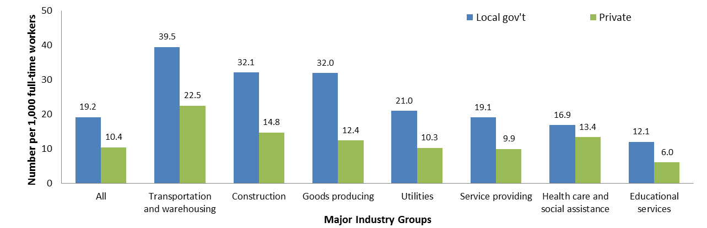
Figure 1. Incidence Rates of Nonfatal WRIIs resulting in ≥ 1 Days Away From Work, Overall and by Major Industry Groups among Local Government and Private Sectors, United States 2011

Source: U.S. Annual Bureau of Labor Statistics Survey of Occupational Injuries and Illnesses (SOII), 2011
*Claims for certain police forces are covered by DIA, including some college campus police and the transit police of the MBTA. Na=not applicable. 5

Background: Local Government Workforce in Massachusetts

According to Massachusetts data from the 2009-2011 American Community Survey, local government workers were predominantly:

Figure 2. Distribution of MA Local Government Workers by Age
Group, 2009-2011

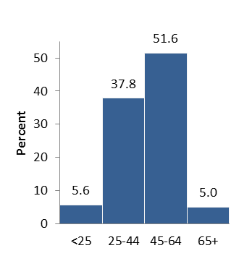
❖ Female (61.3%) (data not shown);
❖ At least 45 years old (56.6%) (Fig. 2);
❖ White non-Hispanic (86.9%) (Fig. 3);
❖ Had at least some college education (80.1%) (Fig. 4);
❖ In two major industry groups: Educational Services (60.1%);
and Public Administration (24.1%) (data not shown);
❖ In three major occupation groups: Education, Training, and
Library (44.1%), Protective Service (12.9%), and Office and Administrative Support (9.1%) (Fig. 5).

Figure 3. Distribution of MA Local Government
Workers by Race/Ethnicity, 2009-2011^
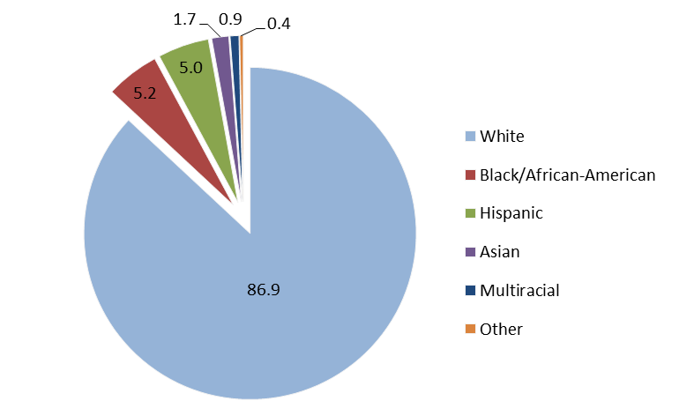

Figure 4. Distribution of MA Local Government
Workers by Education Level, 2009-2011^

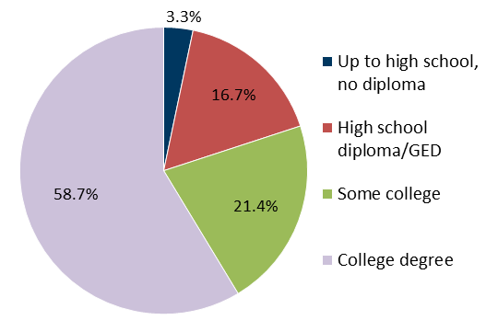

Figure 5. Distribution of MA Local Government Workers by Major Occupation, 2009-2011
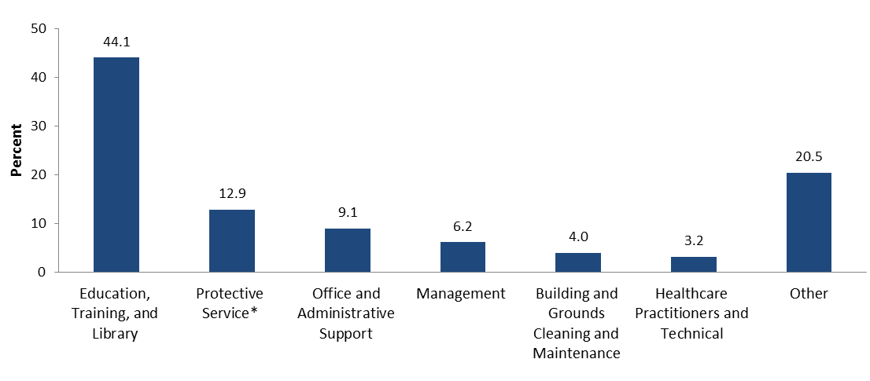
Source: American Community Survey (ACS) 3-year Public Use Microdata Sample, 2009-2011

*The ACS data contains workforce information for police officers and firefighters. They are included here under major category of Protective Service as background. ^Percentages may not add up to 100% due to rounding errors. 6

Methods 7

Data source: Records of lost-wage workers’ compensation (WC) claims submitted to the MA Department of Industrial Accidents (DIA) via employers’ First Reports of Injury (FROI), insurance company notifications, or employee claims. A "claim" refers to a report that has been filed, but not necessarily accepted. In MA, workers are eligible for lost work-time benefits when an injury or illness results in five or more days away from work; thus findings presented in this report reflect serious WRIIs. DIA does not receive claims for firefighters and police officers, with rare exceptions*, as they are covered by separate systems for compensating work-related health problems. Thus, the current analysis does not include information for these workers (except where noted).
Case ascertainment: WC claims for local government workers were identified using reported employer
and insurance carrier names in the DIA database. In accordance with the U.S. Census Bureau definition, local government workers in MA include those employed by cities and towns, counties^, school districts, including regional, vocational-technical, and charter schools, and special districts or authorities that are
considered separate governments in Census Bureau statistics.4
Surveillance period: Calendar year 2009-2011 (most current data available at study's initiation).
Information of Injury and Illness: The DIA database contained coded information on the nature of
WRII and body part affected, as well as a field for a narrative description of how the WRII occurred. Multiple natures of WRIIs and body parts affected could be reported per claim. Nature of WRII and body part affected were coded according to the American National Standards Institute Classification.5 The narrative field was used to code cause of WRII according to the 2007 Occupational Injury and Illness
Classification System.6 The date of death field was also used to identify total claims with fatal WRIIs.
Information of Occupation and Government Function: Occupation narratives in the DIA database
were used to code major occupation groups according to the 2010 Standard Occupational Classification System.7 Employer name and, in some cases, occupation or injury narratives, were used to code major
government functions according to the U.S. Census Bureau classification.4,8
Analysis: Total claims and the distribution of claims by age, gender, government function, occupation,
nature of WRII, body part affected, and, for select groups, cause of WRII were tabulated. Analyses were at the claim-level, with the exception of analyses involving nature of WRII which were at the injury-level to account for claims with multiple injuries reported. Counts and percentages were not presented where the cell size had less than six claims.
The three-year average annual claim rate, i.e. the number of WC claims per 1,000 full-time equivalent
(FTE) employees, and its 95% confidence interval (CI) were computed statewide and by geographic areas of employment. FTE estimates were obtained from the American Community Survey single-year Public Use Microdata Sample (ACS PUMS) from 2009 to 2011 using previously developed methods.9 Rates were restricted to claims for workers age 16 and over and from all occupations except police and firefighter. The variance of numerator (i.e. WC claim data) and denominator (i.e. FTE estimates) were accounted for in calculating the variance of the rate and its 95% CI.10 Statistical significance was determined by a conservative approach of non-overlapping 95% CIs.
Sub-state geography: The U.S. Census-defined place of work Public Use Microdata Area (PUMA) was
used as the geographic area of employment. This field characterizes the primary workplace location and, for this analysis, was based on the Census 2000 geographic boundaries (Appendix 1). WC claims and FTE estimates were obtained for each of the 48 place of work PUMAs in MA.
More detailed methodology available upon request.

*Claims for certain police forces are covered by DIA, including some college campus police and the transit police of the MBTA. The 2009-2011 DIA database contained 34 claims for
such police officer occupations, which were included in this analysis when reporting counts and percentages but not when calculating rates. There were no claims for firefighters.
^Starting 2010, workers from Barnstable, Bristol, Dukes, Nantucket, Norfolk, Plymouth, and Suffolk County Sheriff's Offices became state employees (MA Session Law, Acts 2009,
Ch. 61). Thus, any claims filed for these workers after 2009 were excluded from this analysis. 7
Findings

❖ From 2009 to 2011, a total of 8,338 WC claims* for WRIIs resulting in five or more days away from
work were filed for MA local government workers - for an average of 2,779 claims per year.
❖ Statewide, the average annual rate was 14.7 WC claims per 1,000 FTEs (14.2-15.3).^
❖ The majority of WC claims were filed for workers who were:
• Male (63.7%) (Fig. 6);
• At least 45 years old (65.2%) (Fig. 7);
• Residents from cities of Boston (15.5%), Springfield (2.9%), and Worcester (2.9%)
(data not shown).
❖ There were 23 WC claims for WRIIs that resulted in a fatality between 2009 and 2011. Known
causes included exposure to asbestos, falls, transportation incidents, bodily reaction and
exertions, and bodily conditions. Cause of WRII was missing or nonclassifiable for seven claims.
Several case examples are highlighted in Boxes 2-4.

Figure 6. Distribution of WC Claims among MA Figure 7. Distribution of WC Claims among MA Local Government Workers by Gender, 2009 - 2011 Local Government Workers by Age Group,
(N=8,338) 2009 - 2011 (N=8,338)†
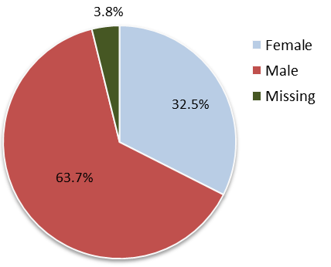
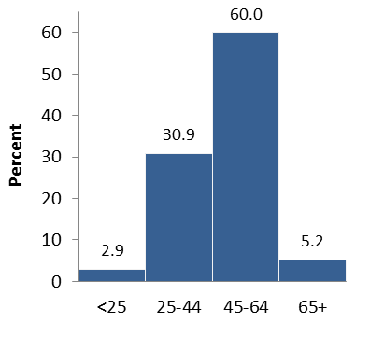

Source: Massachusetts DIA Workers' Compensation data, 2009-2011

Box 2. Fatal Occupational Injury Case
City traffic maintenance technician/electrician - October 18, 2011: A 58-year-old male traffic maintenance
technician/electrician was fatally injured when he fell from a vehicle-mounted aerial lift's raised bucket. The victim and two co-workers were repairing a faulty cantilevered traffic signal at a four-way intersection with insufficient temporary traffic control devices being used. The victim was not wearing fall protection while inside the raised bucket accessing the traffic light when a tractor-trailer driving through the intersection struck the raised bucket. The victim was ejected out of the bucket and fell approximately 17 feet
to the roadway below (MA FACE Project).¹¹

More info and steps for prevention: www.mass.gov/eohhs/docs/dph/occupational-health/bucket-struck.pdf

*Total claims included the 34 claims for police officer occupations. There were no claims for firefighters.
^Rate excluded the 34 claims from police officers.
†Percentages may not add up to 100% due to rounding errors.
8
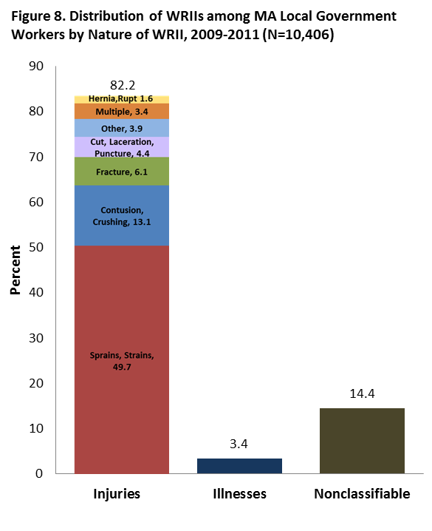
Nature of WRII
A total of 10,406 WRIIs were identified: 82.1%
were injuries, 3.4% were illnesses, and 14.5% were nonclassifiable (Fig. 8).
❖ Overall, sprains, strains were most
commonly reported (49.7%), followed by contusion, crushing, and bruise injuries (13.1%) and fractures (6.1%) (Table 1).
❖ Among illnesses, inflammation of the
joints, etc. was most commonly reported (data not shown).
Body Parts Affected
WRIIs predominantly affected the lower extremities (23.1%), the back (20.0%), and trunk regions (18.0%)
(Table 1). Specifically:

❖

❖

❖
Sprains, strains most often involved the
back (32%) and lower extremities (26%);
Contusion, crushing, bruise injuries most
often involved lower extremities (27%);
Fractures most often involved upper
(39%) and lower (38%) extremities.

Source: Massachusetts DIA Workers' Compensation data, 2009-2011

Table 1. Distribution of WRIIs among MA Local Government Workers by Nature of WRII and Major Body Part Affected,
2009-2011 (N=10,406)
Nature of WRII |  |  | Major Body Part
Nature of WRII |  |  | Head and Neck | Trunk | Back | Upper extremities | Lower extremities | Non-classifiable
 | No. | % | Row %
All | 10,406 | 100.0 | 9.9 | 18.0 | 20.0 | 17.3 | 23.1 | 6.7
Injuries | 8,546 | 82.1 | 10 | 19 | 22 | 18 | 25 | 2
Sprains, Strains | 5,172 | 49.7 | 6 | 20 | 32 | 13 | 26 | 1
Contusion, Crushing, Bruise | 1,358 | 13.1 | 15 | 21 | 9 | 21 | 27 | 1
Fracture | 637 | 6.1 | 4 | 10 | 2 | 39 | 38 | 6
Cut, Laceration, Puncture | 458 | 4.4 | 26 | 3 | -- | 54 | 14 | 2
Multiple Injuries* | 350 | 3.4 | 10 | 8 | 5 | 10 | 9 | --
Hernia, Rupture | 166 | 1.6 | 3 | 67 | 8 | 5 | 10 | 6
Other Injury | 104 | 1.0 | 13 | 26 | 26 | 12 | 17 | 5
Concussion | 89 | 0.9 | 94 | -- | -- | -- | -- | --
Dislocation | 72 | 0.7 | -- | 39 | 8 | 26 | 22 | --
Scratches, Abrasions | 59 | 0.6 | 31 | -- | -- | 29 | 22 | --
Burns | 53 | 0.5 | 25 | -- | -- | 45 | 17 | --
Other | 28 | 0.3 | 25 | -- | -- | 64 | -- | --
Illnesses | 354 | 3.4 | 14 | 24 | -- | 17 | 10 | 28
Nonclassifiable | 1,506 | 14.5 | 9 | 14 | 14 | 12 | 17 | 29
Source: Massachusetts DIA Workers' Compensation data, 2009-2011

*Multiple Injuries is a unique ANSI category on the FROI form and specific injuries cannot be separated out. Thus, total injury count is likely an underestimate. Table cells with <6 claims are indicated by --. Percentages may not add up to 100% due to rounding error. Row percentages do not add up to 100% because the 'Multiple Parts' category is not shown. 9

Occupation
Occupation characterizes the type of work and/or tasks a person usually performs at work. The largest
percentage of claims were for workers in three major occupation groups (Fig. 9):
❖ Construction; Installation, Maintenance and Repair; Production; and Transportation (29.6%).
Specific occupations include electricians, equipment operators, mechanics, and sewer system maintenance craftsman.
❖ Building and Grounds Cleaning and Maintenance (17.2%), of which 72% were custodians. Other
occupations include grounds worker, park keeper, and cemetery maintenance.
❖ Education, Training, and Library (15.6%), of which 75% were teachers, teacher aides, and
instructors. Other occupations include principals, administrative support, and bus monitors.

Figure 9. Distribution of WC Claims among MA Local Government Workers by Major Occupation, 2009-2011 (N=8,338)
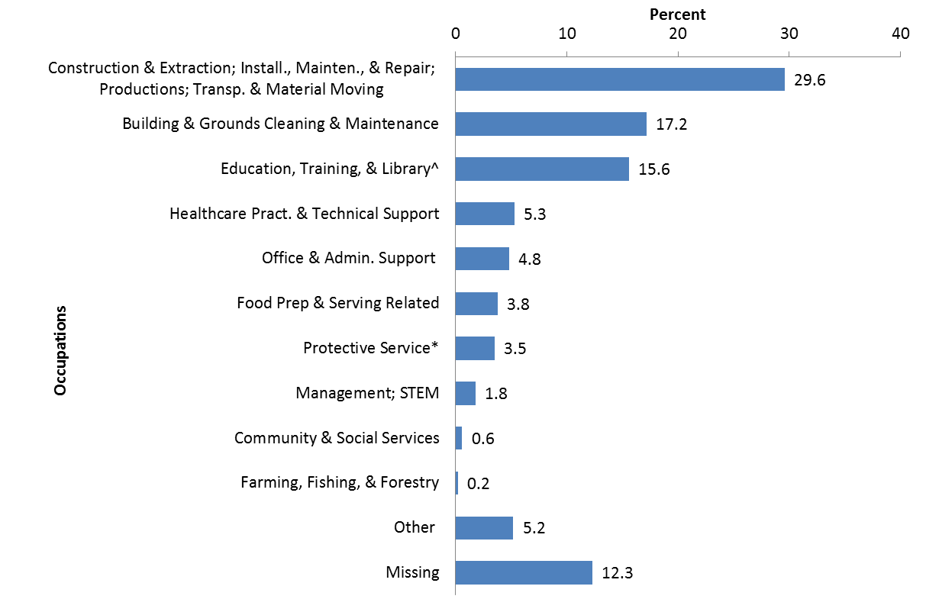

Source: Massachusetts DIA Workers' Compensation data, 2009-2011

A detailed table of WC claims by occupation can be found in Appendix 3.

*This category includes 34 claims for police officers among other occupations (e.g. crossing guards, correctional officers, and parking enforcement).
^This category includes 31 librarians.
Percentages may not add up to 100% due to rounding error.

10

Government Function

Government function characterizes the activities of a government agency into categories such as education, corrections, and transit. These categories are more specific to the working environments of local government workers than standard industry groupings under Public Administration.
❖ The majority of local government worker WC claims were from city and town governments. Among
the 51.5% of all claims with government function information available, the largest percentage of claims were for workers in Educational Services (55.5%) and Public Works (19.4%) (Fig. 10).

Figure 10. Distribution of WC Claims among MA Local Government Workers by Known Government Function*,
2009-2011 (N=4,292)
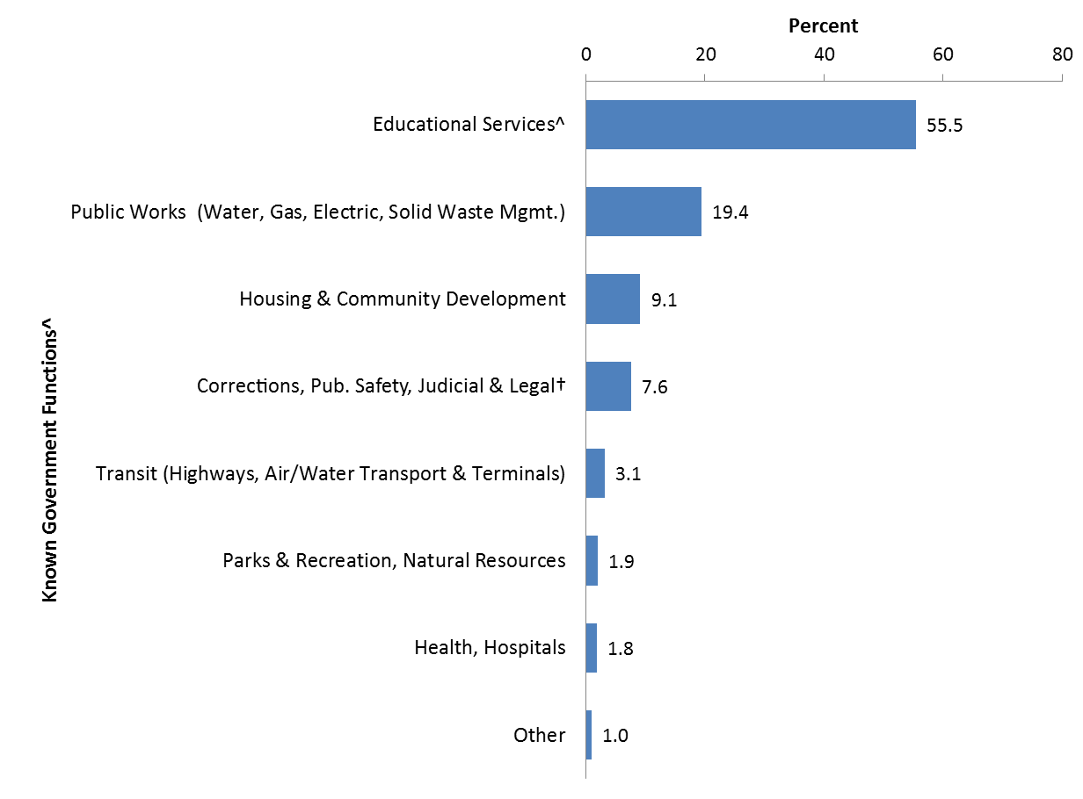
Source: Massachusetts DIA Workers' Compensation data, 2009-2011
❖ For nearly half of all claims*, only the city or town name was reported as the employer with no other
information in the occupation or injury narratives to classify them into government functions. A review of all claims did not suggest a bias in lack of government function information by city or town.

❖ Additionally, certain government functions were more likely to be identified based on the level of
detail provided for WC claim fields. For example, claims in Public Works often had employer names with the text of "DPW" or "gas and electric" while claims in Housing and Community Development often had employer names with the text of "housing" or "building". For other government functions, such as Correctional, Public Safety; Education; and Health, Hospitals, additional text clues in the occupation and/or injury narratives were helpful to identify government function since the employer name was not specific (i.e. only the city or town name was reported). For example, claims
from Educational Services often had occupation or injury narratives referencing a school setting.

❖ Overall, assignment of government function proved challenging and the lack of government function
information for the majority of claims from municipalities is a significant limitation of the WC data for local government workers. This information gap impairs a more complete assessment of the types of workplace that pose the greatest risk for workers. City and town governments are encouraged to include more detailed information about government function when reporting employer name, employee occupation, and/or description of how the injury occurred whenever possible.
A detailed table of WC claims by government function and major occupation can be found in Appendix 4.
*48.5% of WC claims had unspecified government function and were not included in Figure 10. Percentages may not add up to 100% due to rounding error.
^This category includes 8 claims for police officers and 31 for librarians among other occupations (e.g. custodians, teachers, cooks, and building maintenance).
†This category includes 26 claims for police officers among other occupations (e.g. correctional officers, life guards, foreman, custodian, EMS workers). 11
A closer look at Educational Services and Public Works

Cause of WRII was examined for claims filed for workers in Educational Services and Public Works,
the two government functions accounting for the largest percentage of claims with known information.
Educational Services: This major government function includes both educational and library
services and establishments at the local level. It does not include childcare, youth, or elder care services8, which were grouped under Other in this analysis.
Public Works: This major government function provides core and diverse services for neighborhood
quality of life.8 In this analysis, the following services were grouped into Public Works: trash and recycling collection, sewerage, utilities maintenance, and sanitation. Services related to roadways, air and ground transportation, and traffic were grouped under Transit (Highways, Air/Water Transport and Terminals). Services related to parks and recreation were grouped under Parks and Recreation, Natural Resources.

Table 2. Distribution of WC Claims among MA Local Government Workers Employed in Educational Services and Public Works by Cause of WRII, 2009-2011 (N=3,214)

Cause of WRII | Educational Services |  | Public Works
Cause of WRII | No. | % | No. | %
All | 2,380 | 100.0 | 834 | 100.0
Contact with Objects and Equipment | 225 | 9.5 | 115 | 13.8
Struck by or against object or equipment | 175 | 7.4 | 75 | 9.0
Caught in or compressed by equipment or objects,  Caught in or crushed in collapsing materials | 32 | 1.3 | 31 | 3.7
Falls | 699 | 29.4 | 154 | 18.5
Fall on same level | 513 | 21.6 | 64 | 7.7
Fall to lower level | 123 | 5.2 | 40 | 4.8
Bodily Reaction and Exertion | 701 | 29.5 | 370 | 44.4
Overexertion in lifting | 155 | 6.5 | 119 | 14.3
Slip, trip, loss of balance-without fall | 151 | 6.3 | 65 | 7.8
Bending, climbing, crawling, reaching, twisting | 55 | 2.3 | 27 | 3.2
Overexertion in pulling or pushing objects | 45 | 1.9 | 20 | 2.4
Repetitive motion | 32 | 1.3 | 13 | 1.6
Overexertion in holding, carrying, turning, or wielding objects | 24 | 1.0 | 20 | 2.4
Exposure to Harmful Substances or Environments | 86 | 3.6 | 20 | 2.4
Exposure to traumatic or stressful event, n.e.c | 53 | 2.2 | 7 | 0.8
Exposure to caustic, noxious, or allergenic substances | 22 | 0.9 | 9 | 1.1
Transportation Incident | 62 | 2.6 | 36 | 4.3
Highway incident | 29 | 1.2 | 12 | 1.4
Transportation incident, unspecified or n.e.c | 28 | 1.2 | 23 | 2.8
Assaults and Violent Acts | 213 | 8.9 | -- | --
Assaults and violent acts by person(s) | 210 | 8.8 | -- | --
Other | 40 | 1.7 | 10 | 1.2
Nonclassifiable | 213 | 8.9 | 88 | 10.6
Missing | 141 | 5.9 | 37 | 4.4
Source: Massachusetts DIA workers' compensation claims data, 2009-2011.
Not all subcategories were shown. N.e.c = nowhere else classified. Table cells with <6 claims are indicated by --. Percentages for major Cause categories may not add up to 100% due to rounding error.

12

Educational Services

Among claims in Educational Services, leading causes of WRIIs were falls (29.4%), mostly on same level, and bodily reaction and exertion (29.5%). A large percentage of these were overexertion in lifting and slip, trip, loss of balance-without fall. Close to nine percent of claims were for assaults and violent acts by person(s) (Table 2).

Cause of WRII within Occupations (Table 3):
❖ Teacher, teacher aide, and instructor occupations accounted for the highest percentage of WC claims
(40.7%). Predominant causes of their injuries were falls (35%), bodily reaction and exertion (25%), and assaults and violent acts (16%), mostly from interactions with students.
❖ Custodians had the second highest percentage of WC claims (18.4%). Predominant causes of their
injuries were bodily reaction and exertion (47%) and falls (24%).
❖ Notable were transportation incidents (39%) and falls (31%) among pupil bus transport workers.
❖ While there were only 14 claims filed for law enforcement workers, over half of their WRIIs were
caused by assaults and violent acts (57%).

Table 3. Distribution of WC Claims among MA Local Government Workers Employed in Educational Services by Leading
Occupations and Cause of WRII, 2009-2011 (N=2,374)
 |  |  | Cause of WRII
Educational Services |  |  | Contact with Objects and Equip. | Falls | Bodily Reaction and Exertion | Exposure to Harmful Substances or Env. | Transpor-tation Accidents | Assaults and Violent Acts
 | No. | % | Row %
All occupations | 2,374 | 100.0 | 9.5 | 29.4 | 29.5 | 3.6 | 2.6 | 8.9
Teacher, teacher aide, instructor | 967 | 40.7 | 9 | 35 | 25 | 3 | -- | 16
Custodian | 436 | 18.4 | 13 | 24 | 47 | 2 | -- | --
School admin, Pupil support, Librarians | 233 | 9.8 | 6 | 37 | 26 | 5 | -- | 8
Restaurant/Food service | 125 | 5.3 | 22 | 26 | 35 | 5 | -- | --
Pupil bus transport | 90 | 3.8 | -- | 31 | 13 | -- | 39 | --
Health professional | 55 | 2.3 | 11 | 29 | 33 | -- | -- | 13
Building, Grounds, Cemetery, Maintenance | 48 | 2.0 | -- | 15 | 50 | -- | -- | --
Protective Service* | 32 | 1.3 | -- | 31 | 19 | -- | -- | 28
Construction | 22 | 0.9 | 27 | 18 | 41 | -- | -- | --
Other^ | 118 | 5.0 | 8 | 24 | 35 | -- | 5 | --
Missing | 248 | 10.4 | 4 | 15 | 17 | 10 | 2 | 5
Source: Massachusetts DIA Workers' Compensation data, 2009-2011

*This category includes 8 claims for police officers among other occupations (e.g. building monitor, crossing guards).
^Examples of Other occupations: Laborer, trades worker (n=6), Mechanic, Technician, Craftsman (n=8), and Drivers, Transportation and Material Moving, Gate attendants (n=9).
Percentages may not add up to 100% due to rounding error. Table cells with <6 claims are indicated by --.
Row percentages do not add up to 100% because Cause of WRII categories of Other, Missing, and Nonclassifiable are not shown.

13

Educational Services (cont'd)

Nature by Cause of WRIIs (Table 4):
❖ Falls caused 33.7% of all WRIIs and notably, 53% of contusion, crushing, and bruise injuries, 68%
of fractures, and 52% of multiple injuries.
❖ Bodily reaction and exertion caused 26.9% of all WRIIs and notably, 44% of sprains, strains.
❖ Assaults and violent acts caused 9.4% of all WRIIs and notably, 15% of multiple injuries and 14%
of contusion, crushing, and bruise injuries.
❖ Contact with objects and equipment caused 8.7% of all WRIIs and notably, 47% of cut, laceration,
and puncture injuries.

Table 4. Distribution of WRIIs among MA Local Government Workers Employed in Educational Services by Major
Nature of WRII and Cause of WRII, 2009-2011 (N=3,084)
Educational Services |  |  | Cause of WRII
 |  |  | Contact with Objects and Equip. | Falls | Bodily Reaction and Exertion | Exposure to Harmful Substances or Env. | Transpor-tation Accidents | Assaults and Violent Acts
 | No. | % | Row %
All WRIIs | 3,084 | 100.0 | 8.7 | 33.7 | 26.9 | 3.3 | 3.5 | 9.4
Sprains, Strains | 1,315 | 42.6 | 3 | 26 | 44 | -- | 5 | 9
Contusion, Crushing, Bruise | 503 | 16.3 | 14 | 53 | 5 | -- | 2 | 14
Fracture | 280 | 9.1 | 12 | 68 | 5 | -- | -- | 4
Cut, Laceration, Puncture | 118 | 3.8 | 47 | 33 | 8 | -- | -- | 7
Multiple Injuries* | 110 | 3.6 | 5 | 52 | 22 | -- | -- | 15
Other | 298 | 9.7 | 12 | 18 | 21 | 19 | -- | 8
Nonclassifiable | 460 | 14.9 | 5 | 19 | 27 | 7 | 3 | 10

Source: Massachusetts DIA Workers' Compensation data, 2009-2011

Box 3. Fatal Occupational Injury Case
Municipal Lead Custodian - March 27, 2011: A 69-year-old male municipal custodian was fatally
injured while painting an interior section of a school lobby. The victim went to the school alone early on a Sunday morning to finish painting the lobby area that was previously started. Although the incident was un- witnessed, it appears that the victim, who was not trained on scaffolds, was working from mobile scaffolding that was not assembled to the manufacturer’s specifications when he fell from the scaffolding landing on the lobby floor. The victim was found by a co-worker later that same day when the co-worker had opened the school to let in two cooks for a fundraiser event that was going to take place that afternoon (MA FACE).¹¹

More info and steps for prevention: www.mass.gov/eohhs/docs/dph/occupational-health/mobile-scaffolding.pdf

*Multiple Injuries is a unique ANSI category on the FROI form and specific injuries cannot be separated out. Thus, total injury count is likely an underestimate.
Table cells with <6 claims are indicated by --. Percentages may not add up to 100% due to rounding error.
Row percentages do not add up to 100% because Cause of WRII categories of Other, Missing, and Nonclassifiable are not shown.

14

Public Works

Among claims in Public Works, the leading cause of WRIIs was bodily reaction and exertion (44.4%), a large percentage of which were due to overexertion in lifting (32.2%). Other major causes of WRIIs were falls (18.5%), of which 41.6% were on the same level and 26.0% to the lower levels, and struck by or against object or equipment (7.4%) (Table 2).

Cause of WRII within Occupations (Table 5):
❖ Bodily reaction and exertion consistently was the leading cause of WRIIs across all occupations.
❖ Production: Operations and Utilities workers accounted for the highest percentage of WC claims
(24.8%). Predominant causes of their WRIIs were bodily reaction and exertion (43%), falls (21%),
and contact with objects and equipment (18%). Examples of occupations in this category include
water superintendent, treatment plant operator, sewer system maintenance foreman, and craftsman.
❖ Equipment operator and maintenance workers had the second highest percentage of WC claims
(13.1%). Predominant causes of their WRIIs were similar to those of Production workers.

Table 5. Distribution of WC Claims among MA Local Government Workers Employed in Public Works by Leading
Occupations and Cause of WRII, 2009-2011 (N=834)
Public Works |  |  | Cause of WRII
 |  |  | Contact with Objects and Equipment | Falls | Bodily Reaction and Exertion | Exposure to Harmful Substances or Env. | Transpor-tation Incident | Assaults and Violent Acts
 | No. | % | Row %
All occupations | 834 | 100.0 | 13.8 | 18.5 | 44.4 | 2.4 | 4.3 | 0.5
Production: Operations, Utilities | 207 | 24.8 | 18 | 21 | 43 | 3 | 4 | --
Equipment operator/maintenance | 109 | 13.1 | 15 | 17 | 51 | -- | 5 | --
Mechanic, Technician, Craftsman | 96 | 11.5 | 19 | 17 | 48 | -- | -- | --
Construction | 69 | 8.3 | 14 | 16 | 45 | -- | -- | --
Laborer, trades worker non-specific | 66 | 7.9 | 17 | 15 | 55 | -- | -- | --
Drivers, Transp. and material moving, Parking attendant | 50 | 6.0 | -- | 20 | 64 | -- | -- | --
Foreman, non-specific | 33 | 4.0 | -- | -- | 45 | -- | -- | --
Building, Grounds, Cemetery, Maintenance, Park keeper | 30 | 3.6 | -- | -- | 47 | -- | -- | --
Other* | 101 | 12.1 | 10 | 26 | 34 | -- | -- | --
Missing | 73 | 8.8 | -- | -- | 23 | -- | -- | --

Source: Massachusetts DIA Workers' Compensation data, 2009-2011

*Examples of Other occupations: Supervisor, Management (n=17), General Operation Services (n=16), and Meter reader, Dispatcher, Mail handler (n=12).
Table cells with <6 claims are indicated by --. Percentages may not add up to 100% due to rounding error.
Row percentages do not add up to 100% because Cause of WRII categories of Other, Missing, and Nonclassifiable are not shown.

15

Public Works (cont'd)

Nature by Cause of WRIIs (Table 6):
❖ Bodily reaction and exertion caused 41.9% of all WRIIs and notably, 61% of sprains, strains.
❖ Falls caused 20.6% of all WRIIs and notably, 42% of contusion, crushing, and bruise injuries and 50% of fractures.
❖ Contact with objects and equipment caused 13.8% of all WRIIs and notably, 34% of contusion, crushing, and bruise injuries, 28% of fractures, and 51% of cut, laceration, and puncture injuries.
❖ Notably, while exposures to harmful substances or environments caused only 2.3% of all WRIIs,
they contributed to 18% of other WRIIs, such as burns, dermatitis, hearing loss, and poisonings (data not shown).

Table 6. Distribution of WRIIs among MA Local Government Workers Employed in Public Works by Major Nature of
WRII and Cause of WRII, 2009-2011 (N=1,010)
Public Works |  |  | Cause of WRII
Public Works |  |  | Contact with Objects and Equip. | Falls | Bodily Reaction and Exertion | Exposure to Harmful Substances or Env. | Transpor-tation Accidents | Assaults and Violent Acts
 | No. | % | Row %
All WRIIs | 1,010 | 100.0 | 13.8 | 20.6 | 41.9 | 2.3 | 4.8 | 0.4
Sprains, Strains | 485 | 48.0 | 5 | 16 | 61 | -- | 4 | --
Contusion, Crushing, Bruise | 135 | 13.4 | 34 | 42 | 6 | -- | 6 | --
Fracture | 50 | 5.0 | 28 | 50 | -- | -- | -- | --
Cut, Laceration, Puncture | 43 | 4.3 | 51 | -- | 21 | -- | -- | --
Multiple Injuries* | 32 | 3.2 | -- | 28 | 28 | -- | 16 | --
Other | 97 | 9.6 | 10 | 12 | 36 | 18 | -- | --
Nonclassifiable | 168 | 16.6 | 12 | 14 | 39 | -- | 6 | --

Source: Massachusetts DIA Workers' Compensation data, 2009-2011

Box 4. Fatal Occupational Injury Case
Municipal laborer/repairman - August 31, 2009: A 35-year-old male municipal laborer/repairman was
fatally injured while responding to a water main break. The victim and a co-worker, who had not been provided training on proper work zone setup, were assigned to close a water main gate valve located in a roadway approximately 900 feet away from the water main break. They positioned their work pickup truck beyond the valve facing the same direction as the flow of traffic with no other temporary traffic control devices to keep car a safe distance away from them. While the victim was using a gate valve wrench to close the valve, the co-worker was reducing water pressure in the system by releasing water at an adjacent fire hydrant. The coworker heard a crash and turned to see that the victim had been struck by a minivan that also struck the rear of the work pickup truck (MA FACE Project).¹¹

More info and steps for prevention: www.mass.gov/eohhs/docs/dph/occupational-health/fatal-reports/fatal-
report-water-valve.pdf

*Multiple Injuries is a unique ANSI category on the FROI form and specific injuries cannot be separated out. Thus, total injury count is likely an underestimate.
Table cells with <6 claims are indicated by --. Percentages may not add up to 100% due to rounding error.
Row percentages do not add up to 100% because cause of WRII categories of Other, Missing, and Nonclassifiable are not shown. 16

WC Claim Rate by Sub-state Areas of Employment

The average annual rate of WC claims was calculated for the 48 place of work Public Use Microdata
Areas (PUMAs) in MA to identify areas with high rates for targeting local-level prevention efforts.
❖ The average annual rate by PUMAs ranged from 5.9 (95% CI: 4.0-7.8) to 28.6 (20.8-36.3) WC
claims per 1,000 FTEs. Compared to the statewide rate of 14.7 WC claims per 1,000 FTEs (14.2- 15.3), 13 PUMAs had significantly lower rates (lighter blue) and five PUMAs had significantly higher rates (darker blue): 4400, 3300, 4500, 1900, and 2300 (Fig. 11).
❖ PUMA 4400, located in the southeast region of MA, had the highest rate of 28.6 WC claims per
1,000 FTE. PUMA 4400 encompasses the County of Bristol, City of Fall River, towns of Somerset and Westport, as well as several regional and vocational schools and housing authorities.

Figure 11. Average Annual Rate of WC Claims among MA Local Government Workers by
place of work Public Use Microdata Areas (PUMA), 2009-2011 (N= 8,218)*
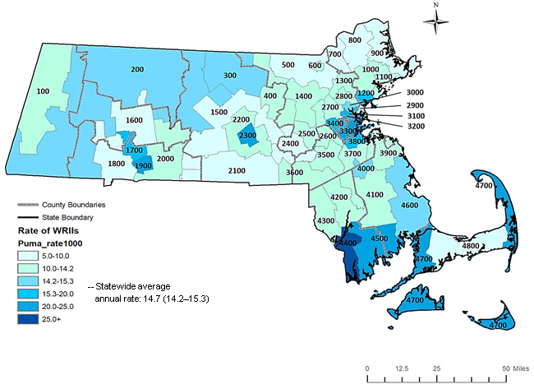
Numerator source: Massachusetts DIA Workers' Compensation data, 2009-2011
Denominator source: American Community Survey single-year Public Use Microdata Sample data, 2009-2011

*Rates are restricted to MA local government workers age 16 and over and living in MA or any of its five surrounding states (i.e. CT, RI, NY, NH, and VT).
120 claims were excluded because age was missing (n=80) or the worker was a police officer (n=34) or under 16 years old (n=6). 17
Using Data at the Local Level

To better understand the extent, nature, and cause of WRII occurring at the local level, a descriptive analysis of WC claims in high-rate PUMAs can be conducted and compared to statewide results. This information can help to establish priorities for prevention at the local level. As an illustration, WC claims for local government workers employed in PUMA 4400 were characterized.

Findings

From 2009 to 2011, there were 245 claims* for WRIIs resulting in five or more days away
from work among local government workers in PUMA 4400. Compared to statewide:

PUMA 4400 had higher percentages of WC claims filed for:
❖ Teens and young workers age 14 - 24 (7.8% vs. 3.0%) (Table 7);
❖ Workers in Educational Services (38.4% vs. 28.6%) (Table 7).
• Leading causes of their WRII were overexertion (20.2%) and fall on the same level
(18.1%), similar to statewide results. A majority of these workers were custodians (38.3%) and teachers, teacher aides, and instructors (28.7%).

PUMA 4400 had a lower percentage of WC claims filed for:
❖ Workers in Public Works (6.5% vs. 10.0%) (Table 7).
• The leading cause of their WRIIs was bodily reaction and exertion (43.8%), similar
to statewide result. Yet, the second leading cause of their WRII was contact with objects and equipment (25.0%) whereas for statewide it was falls. A majority of these workers were trades workers, laborers, and foremen.

PUMA 4400 had similar
percentages of WC claims by:
❖ Major occupations;
❖ Major natures of WRIIs

Table 7. Distribution of WC Claims among MA Local Government Workers Employed in PUMA 4400 and Statewide by Age and
Government Function, 2009-2011
 | PUMA 4400 |  | Statewide
 | No. | % | No. | %
All | 245 | 100.0 | 8,338 | 100.0
Age group
<25 | 19 | 7.8 | 242 | 3.0
25-44 | 77 | 31.4 | 2,577 | 30.9
45-64 | 132 | 53.9 | 5,006 | 60.0
65+ | 13 | 5.3 | 432 | 5.2
Missing | -- | -- | 81 | 1.0
Government function
Educational Services | 94 | 38.4 | 2,380 | 28.6
Public Works | 16 | 6.5 | 834 | 10.0
Corrections, Pub. Safety,  Judicial & Legal* | 13 | 5.3 | 327 | 3.9
Housing & Community Dev. | 8 | 3.3 | 392 | 4.7
Parks & Recreation, Natural Resources | -- | 2.0 | 83 | 1.0
Transit, Highways, Air/Water Transport  & Terminals | -- | -- | 135 | 1.6
Health, Hospitals | -- | -- | 76 | 0.9
Other | 17 | 6.9 | 65 | 0.8
Unspecified | 90 | 36.7 | 4,046 | 48.6

Source: Massachusetts DIA Workers' Compensation data, 2009-2011
*No claims for police officers. Percentages may not add up to 100% due to rounding error.

18

Discussion
Extent of the problem
This report provides previously unavailable descriptive information about WRIIs among local
government workers in Massachusetts (MA) and underscores the need for increased efforts to prevent these injuries. During 2009-2011, each year more than 2,700 employees of local government agencies experienced WRIIs serious enough to result in five or more days away from work, for a rate of 14.7 WC claims per 1,000 full-time equivalent employees. This rate should be considered a conservative assessment of the extent of the problem, as WRIIs among local firefighters and local police officers, two occupations well-known to be at high risk for on-the-job injuries1, were not available for this analysis. Also data about WC claims for less serious injuries (i.e. medical benefits-only) were not available. Nationally, medical benefits-only WC claims have been estimated to account for 80% of all WC claims filed.12 Additionally, it has been well documented in many studies that often workers eligible for WC benefits do not apply for WC13-15, although the extent to which this may be true among local government workers in MA is unknown.

Comparison with other workers
❖ How does the WRII rate for local government workers compare to the rate for private sector and state public sector workers in MA?
- Comparable findings based on WC claims for private sector workers in MA are not currently
available. Notably, MA recently became one of two states funded by the Centers for Disease Control and Prevention to implement improvements in the WC data system so that these claim data can be better used to inform prevention efforts. Thus additional information on WRIIs among private sector workers in MA should be available in the future.

- A previous analysis of MA claims for state public sector workers in 2005 found a rate of 16.9 claims per 1,000 FTEs. Healthcare related occupations were the most common occupation reported (36%) followed by protective service occupations (21%). The leading cause of injuries and illnesses identified was bodily reaction and exertion (29%), specifically overexertion, followed by assault and violence (25%). Sprains and strains (39%) were the most common type of injury followed by contusions, crushing, and bruises (23%), and fractures (5.4%).¹⁶

- It should be noted that any overall comparisons of rates between public and private sectors within state are crude and do not account for factors which may impact the occurrence, identification, and reporting of WRIIs. For example, it is important to take into account the distributions of the workforce by industry and demographic characteristics in making these comparisons.

❖ How does the WRII rate for local government workers in MA, excluding police officer and firefighting occupations, compare to the rate for local government workers in other states or nationwide?
- WC eligibility criteria and availability of data from WC programs vary by states, prohibiting state-level data from being directly compared to other states or with national estimates. The BLS Survey of Occupational Injuries and Illnesses does produce national estimates of WRIIs among local government workers, although findings based on the BLS data are not directly comparable to those based on WC claims. Additionally, BLS estimates of WRII among local government workers in MA are unavailable, as noted previously (page 5).

19

Discussion (cont'd)
Prevention priorities
Findings presented in this report highlight the need to reduce WRIIs among local government
workers, particularly among those employed in Public Works and Educational Services. Overexertion in lifting, falls on the same level and to lower levels, as well as being struck by or against an object or equipment stood out as priorities for prevention among those employed in Public Works. Falls on the same level also were predominant among those employed in Educational Services, as well as overexertion in lifting and slip, trip, loss of balance-without fall. Assaults and violent acts by person(s) also stood out as an important hazard faced by workers in Educational Services that should be addressed through prevention strategies.
The analysis of WC claim data by geographic areas of employment identified five PUMAs with
significantly higher rates than the statewide average. These local areas should be considered as priorities for prevention activities.

Some data limitations
Information about government function was not available for nearly half of the WC claims in this
analysis, in which simply the name of the city or town was reported as the employer without other informative text to classify claims into government functions. A review of all claims did not suggest a bias in lack of government function information by city or town. Though, certain government functions were more likely to be identified based on the level of detail provided for WC claim fields of employer name, occupation, and/or injury narratives. Additional limitations include a lack of detailed information about the cause of WRII on many claims. FTE estimates for local government workers that excluded firefighter and police occupations were not available at the city and town level, precluding the ability to generate rates at that level. Lastly, rates by place of work PUMAs represent the average rate of WRIIs among local government workers working in that collective area and do not reflect the individual risk of each worker nor the risk of WRIIs at other geographic levels (e.g. city, town, county, district).

Conclusions and Next Steps
Increased efforts are needed to reduce WRIIs among local government workers in Massachusetts, which includes workers from municipalities, counties, school districts, and regional authorities.
Periodic review of information about where and how workers are injured or made ill on the job can provide critical information to target and design effective prevention efforts. Tracking WRII trends over time will also enable agencies to monitor their progress in meeting prevention goals. Lack of detailed information about government function and cause of WRII in the WC claim records was a significant limitation in this analysis. Local government agencies are encouraged to provide more detailed information in the WC records filed with DIA and also to review their own claims data to set prevention priorities. Local government agencies are also encouraged to voluntarily participate in the BLS Survey of Occupational Injuries and Illness, which would then allow for comparisons with other sectors in Massachusetts and with other states. Notably, Massachusetts recently became one of two states funded by the Centers for Disease Control and Prevention to implement improvements in the WC data system so that these claim data can be better used to inform prevention efforts. Continued collaboration among the Massachusetts Department of Public Health, Department of Industrial Accidents, and the Department of Labor Standards, the agency that provides technical assistance to and enforces health and safety standards in local government agencies, will be important in helping local agencies reduce health and safety hazards faced by their employees who serve our communities.

20
Massachusetts Resources

MA Department of Labor Standards (DLS)
• DLS's Workplace Safety and Health Program (WSHP) aims to prevent injury and illness among
public sector workers through technical assistance, enforcement, and voluntary inspections.
www.mass.gov/dols/wshp
MA Department of Industrial Accidents (DIA)
• DIA provides grants for workplace health and safety training to employers and employees. Any
company covered by the MA Workers' Compensation (WC) Insurance Law is eligible to apply for
these grants. www.mass.gov/dia/safety
• For more information about WC (i.e. eligibility, filing): www.mass.gov/lwd/workers-compensation/
MA DPH Occupational Health Surveillance Program (OHSP)
• OHSP's Fatality Assessment and Control Evaluation Project (FACE) conducts research-oriented
investigations of work-related fatalities to identify factors that contribute to these deaths. This information is then used to develop and then disseminate recommendations for preventing similar
deaths in the future. www.mass.gov/dph/face
MA Coalition for Occupational Safety and Health (MassCOSH)
• MassCOSH is a nonprofit coalition that promotes workplace safety and health through training
and preventive programs. MassCOSH has developed a municipal safety and health training program geared to Departments of Public Works, as well as a Healthy Schools Program
with a focus on addressing indoor air quality and asthma prevention.www.masscosh.org

MA Municipal Association (MMA)
• MMA is a non-profit, nonpartisan association that provides advocacy, training, research, and other
services to cities and towns in MA. www.mma.org
Massachusetts Interlocal Insurance Association (MIIA)
- MIIA is a non-profit organization serving over 400 cities, towns and other public entities in MA. It provides grants, training, webinars, and health and safety resources for municipalities. www.emiia.org/risk-management-resources

Selected National Resources
Occupational Safety & Health Administration (OSHA)
• While OSHA does not have enforcement authority to inspect public sector workplaces in MA,
OSHA does provide occupational safety and health training, outreach, education, and assistance along with a free Public Sector Safety & Health Fundamentals certificate program aimed at reducing injuries, illnesses, and fatalities among workers in state and local governments.
Programs are available in construction and general industry. www.osha.gov/dte/public_sector
National Institute for Occupational Safety and Health (NIOSH)
• NIOSH conducts research, provides education resources, and develops recommendations for the
prevention of work-related injury and illness. One of its many programs is the Fire Fighter Fatality Investigation and Prevention Program that conducts independent investigations of fire fighter line- of-duty deaths to assist fire departments, fire fighters, the fire service, and others to prevent
similar fire fighter deaths in the future. www.cdc.gov/niosh/fire/
Electronic Library of Construction Occupational Safety & Health (eLCOSH)
• eLCOSH provides a wide range of user-friendly safety and health training materials and resources
for workers, employers, and researchers interested in construction health and safety.
www.elcosh.org/

21
References

1. Maloney SM. (2014). Nonfatal Injuries And Illnesses Among State And Local Government Workers.
Accessed at: http://www.bls.gov/spotlight/2014/soii-gov-workers/
2. U.S. Department of Labor, Occupational Safety and Health Administration (2015). All About OSHA.
OSHA 3302-09R 2015. Accessed at: https://www.osha.gov/Publications/all_about_OSHA.pdf
3. Wiatrowski W J. (2014). The BLS survey of occupational injuries and illnesses: A primer. American
Journal of Industrial Medicine, 57(10), 1085-1089. Accessed at: http://www.bls.gov/iif/soii_primer.pdf
4. U.S. Census Bureau, 2012 Census of Governments (2013). Individual State Descriptions: U.S.
Government Printing Office, Washington, DC. Accessed at: http://www2.census.gov/govs/cog/2012isd.pdf
5. American National Standards Institute (1995). American National Standards Institute's Method of
Recording Basic Facts Relating to the Nature and Occurrence of Work Injuries, ANSI Z16.2, revised 1995.
6. U.S. Department of Labor, Bureau of Labor Statistics (2010). Occupational Injury and Illness
Classification Manual. Accessed at: http://www.bls.gov/iif/oiics_manual_2007.pdf
7. U.S. Department of Labor, Bureau of Labor Statistics (2010). 2010 Standard Occupational Classification
(SOC) User Guide, Accessed at: http://www.bls.gov/soc/soc_2010_user_guide.pdf
8. U.S. Census Bureau (2006). Government Finance and Employment Classification Manual. U.S.
Government Printing Office, Washington, DC. Accessed at:
http://www2.census.gov/govs/pubs/classification/2006_classification_manual.pdf
9. Jones M. (2014). Methods for calculating the number of full-time equivalent employees by industry.
Presentation at the Council of State and Territorial Epidemiologists Annual Conference. Nashville, TN. June 23, 2014.
10. U.S. Census Bureau (2009). A Compass for Understanding and Using American Community Survey
Data: What PUMS Data Users Need to Know U.S. Government Printing Office, Washington, DC. Accessed
at: https://www.census.gov/content/dam/Census/library/publications/2009/acs/ACSPUMS.pdf
11. Massachusetts Department of Public Health, Occupational Health Surveillance Program (2015). Fatality
Assessment and Control Evaluation (FACE) Project. Accessed at: www.mass.gov/dph/face
12. Segupta I, Reno V, Burton JF, Baldwin M. (2012). Workers' Compensation: Benefits, coverage, and
costs, 2010. Washington, DC: National Academy of Social Insurance (NASI). Accessed at:
http://www.nasi.org/sites/default/files/research/NASI_Workers_Comp_2010.pdf
13. Biddle J, Roberts K, Rosenman KD, Welch EM. (1998). What percentage of workers with work-related
illnesses receive workers' compensation benefits? J Occup Environ Med. Apr;40(4):325-31.
14. Pransky G, Snyder T, Dembe A, Himmelstein J. (1999). Under-reporting of work-related disorders in the
workplace: a case study and review of the literature. Ergonomics. 42(1):171-82.
15. Azaroff LS, Levenstein C, Wegman DH. (2002). Occupational injury and illness surveillance: conceptual
filters explain underreporting. American Journal of Public Health, 92(9), 1421-1429. Accessed at:
http://www.ncbi.nlm.nih.gov/pmc/articles/PMC1447253/pdf/0921421.pdf
16. Massachusetts Department of Public Health, Occupational Health Surveillance Program (2009). Work-Related Injuries and Illnesses among Massachusetts State Employees, 2005: A Preliminary Report. Accessed at: www.mass.gov/eohhs/docs/dph/occupational-health/state-employees-2005.pdf

22
Appendix 1. Public Use Microdata Area and city/town boundaries in Massachusetts based on the 2000 U.S. Census geographic boundaries.

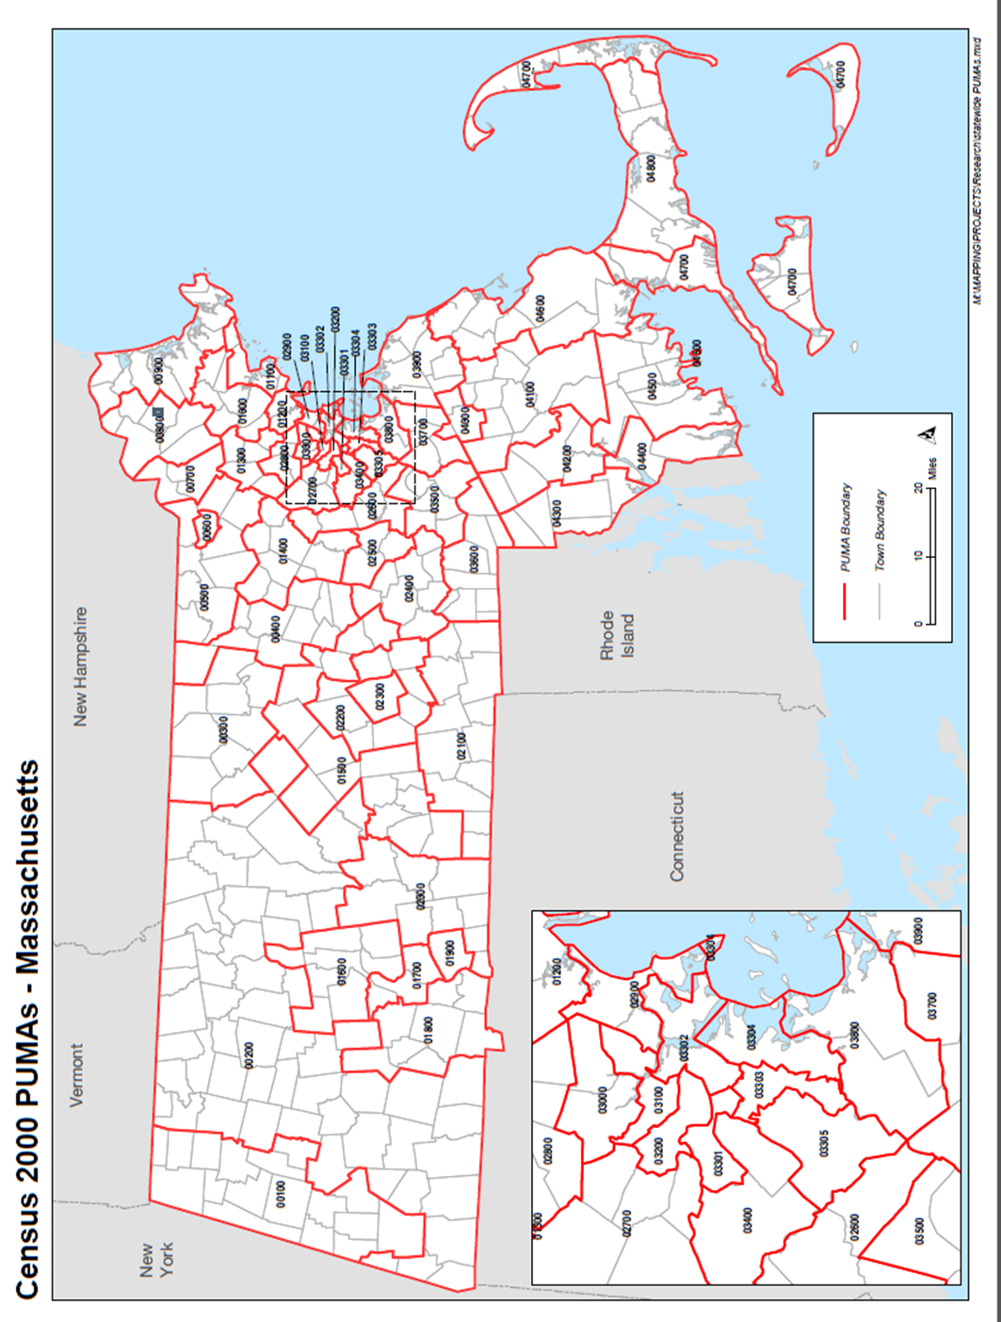

Source map: www.masslegalservices.org/system/files/library/statewide%20PUMAs%20map.pdf

23
Work-related Injuries and Illnesses among Local Government Workers in Massachusetts, 2009-2011

Appendix 2: Distribution of WC claims among MA Local Government Workers by
Claim year, Demographics, and Month of Injury, 2009-2011 (N=8,338)

 | No. | %
All | 8,338* | 100.0
Claim year
Average | 2,779 | 33.3
2009 | 2,885 | 34.6
2010 | 2,713 | 32.6
2011 | 2,740 | 32.9
Age group (years)
<18 | 21 | 0.3
18-24 | 221 | 2.7
25-34 | 907 | 10.9
35-44 | 1,670 | 20.0
45-54 | 2,863 | 34.3
55-64 | 2,143 | 25.7
65+ | 432 | 5.2
Missing | 81 | 1.0
Gender
Female | 2,706 | 32.5
Male | 5,313 | 63.7
Missing | 319 | 3.8
Month of Injury
Average | 695 | 8.3
January | 963 | 11.5
February | 698 | 8.4
March | 759 | 9.1
April | 626 | 7.5
May | 690 | 8.3
June | 661 | 7.9
July | 547 | 6.6
August | 636 | 7.6
September | 789 | 9.5
October | 701 | 8.4
November | 582 | 7.0
December | 686 | 8.2
Source: Massachusetts DIA Workers' Compensation data, 2009-2011

*Total claims included the 34 claims for police officer occupations. There were no claims for firefighters.
Percentages may not add up to 100% due to rounding error.
24

Work-related Injuries and Illnesses among Local Government Workers in Massachusetts, 2009-2011

Appendix 3: Distribution of WC claims among MA Local Government Workers by Occupation,
2009-2011 (N=8,338)
Occupation |  | No. | %
All |  | 8,338 | 100.0
Management; STEM (SOC 11-19, 23) |  | 154 | 1.8
 | Supervisor, Manager | 119 | 1.4
 | Business, Science, Technical, Communication specialists | 35 | 0.4
Community and Social Services (SOC 21) |  | 50 | 0.6
Education, Training, and Library (SOC 25) |  | 1,299 | 15.6
 | Teacher, Teacher aide, Instructor | 976 | 11.7
 | Administrative support, Pupil support, Librarian | 233 | 2.8
 | Pupil bus transport (e.g. driver, monitor) | 90 | 1.1
Healthcare Practitioners and Technical; Healthcare Support (SOC 29, 31) |  | 442 | 5.3
 | Emergency Medical Services | 333 | 4.0
 | Health professional | 109 | 1.3
Protective Service (SOC 33)* |  | 294 | 3.5
 | Law enforcement | 202 | 2.4
 | Other | 92 | 1.1
Food Preparation and Serving Related (SOC 35) |  | 317 | 3.8
Building, Grounds Cleaning and Maintenance (SOC 37) |  | 1,431 | 17.2
 | Custodian | 1,035 | 12.4
 | Building, Grounds, Maintenance, Park keeper, Cemetery | 396 | 4.8
Office and Administrative Support (SOC 43) |  | 400 | 4.8
 | Administrative, Clerical, Coordinator | 224 | 2.7
 | Meter reader, Dispatcher, Mail handler | 176 | 2.1
Farming, Fishing, and Forestry (SOC 45) |  | 16 | 0.2
Construction and Extraction; Installation, Maintenance, and Repair; Production; Transportation and Material Moving (SOC 47-53) |  | 2,468 | 29.6
 | Equipment operator/maintenance | 621 | 7.4
 | Mechanic, Technician, Craftsman | 408 | 4.9
 | Construction (e.g. electrician, plumber, carpenter, steamfitter) | 346 | 4.2
 | Drivers, Transportation and Material Moving, Gate attendant | 247 | 3.0
 | Production: Operations, Utilities (e.g. water, sewage) | 213 | 2.6
 | Other Production: Welders, Woodworkers | 7 | 0.1
 | Laborer, trades worker non-specific | 391 | 4.7
 | Foreman non-specific | 236 | 2.8
Other |  | 437 | 5.2
 | Inspector | 77 | 0.9
 | General operation services | 23 | 0.3
 | Contract, seasonal, student worker non-specific | 35 | 0.4
 | Nowhere else classified | 302 | 3.6
Missing narrative |  | 1,029 | 12.3

Source: Massachusetts DIA Workers’ Compensation data, 2009-2011
Occupation category was based on the 2010 Standard Occupational Classification System (SOC).

*This category includes 34 claims for police officers among other occupations (e.g. crossing guards, correctional officers, and parking enforcement).
Percentages may not add up to 100% due to rounding error.

25

Work-related Injuries and Illnesses among Local Government Workers in Massachusetts, 2009-2011
Appendix 4: Distribution of WC claims among MA Local Government Workers by Government
Function and Occupation, 2009-2011 (N=8,338)

Government Function by Major Occupation |  | No. | %
All |  | 8,338 | 100.0
Educational Services * |  | 2,380 | 28.5
 | Teacher, Teacher aide, Instructor | 973 | 11.7
 | Custodian | 436 | 5.2
 | Administrative support, Pupil support, Librarian | 233 | 2.8
 | Restaurant, Food service workers | 125 | 1.5
 | Pupil bus transport (e.g. driver, monitor) | 90 | 1.1
 | Health professional | 55 | 0.7
Public Works (Water, Gas, and Electric Supply, Solid Waste Management) |  | 834 | 10.0
 | Production: Operations, Utilities (e.g. water, sewage) | 207 | 2.5
 | Equipment operator/maintenance | 109 | 1.3
 | Mechanics, Technicians, Repair, Craftsman | 96 | 1.2
 | Construction (e.g. electrician, plumber, carpenter, steamfitter) | 69 | 0.8
 | Laborer, Tradesworker (non-specific) | 66 | 0.8
 | Drivers, Transportation and Material Moving, Gate attendant | 50 | 0.6
Corrections, Public Safety, Judicial & Legal^ |  | 327 | 3.9
 | Law enforcement* | 181 | 2.2
 | Other Protective Service | 71 | 0.9
Housing and Community Development |  | 392 | 4.7
 | Construction (e.g. electrician, plumber, carpenter, steamfitter) | 68 | 0.8
 | Building, Grounds, Maintenance, Park keeper, Cemetery | 65 | 0.8
 | Custodian | 49 | 0.6
 | Mechanic, Technician, Craftsman | 48 | 0.6
Transit (Highways, Air/Water Transport and Terminals) |  | 135 | 1.6
 | Construction (e.g. electrician, plumber, carpenter, steamfitter) | 48 | 0.6
 | Drivers, Transportation and Material Moving, Gate attendant | 34 | 0.4
Parks & Recreation, Natural Resources |  | 83 | 1.0
 | Building, Grounds, Maintenance, Park keeper, Cemetery | 25 | 0.3
 | Animal, Forestry, Conservation | 14 | 0.2
Health, Hospitals |  | 76 | 0.9
Other |  | 65 | 0.8
Unspecified |  | 4,046 | 48.5
 | Custodian | 531 | 6.4
 | Equipment operator/maintenance | 483 | 5.8
 | Emergency Medical Services | 312 | 3.7
 | Laborer, trades worker (non-specific) | 269 | 3.2
 | Mechanic, Technician, Craftsman | 242 | 2.9
 | Building, Grounds, Maintenance, Park keeper, Cemetery | 222 | 2.7
 | Administrative, Clerical, Coordinator | 195 | 2.3
 | Restaurant/food service workers | 186 | 2.2
 | Foreman (non-specific) | 185 | 2.2
 | Meter reader, Dispatcher, Mail handler | 147 | 1.8
 | Drivers, Transportation and Material Moving, Gate attendant | 137 | 1.6
 | Construction (e.g. electrician, plumber, carpenter, steamfitter) | 129 | 1.5
 | Other, nowhere else classified | 164 | 2.0
 | Missing occupation | 607 | 7.3
Source: Massachusetts DIA Workers' Compensation data, 2009-2011. Not all subcategories were shown. Percentages may not add up to 100% due to rounding error.
Government function was based on US Census Bureau classification. Occupation was based on the 2010 Standard Occupational Classification System.
*This category includes 8 claims for police officers and 31 librarians among other occupations (e.g. building monitor, crossing guards).
^This category includes 26 claims for police officers among other occupations (e.g. correctional officers, life guards, foreman, custodian, EMS workers). 26

Work-related Injuries and Illnesses among Local Government Workers in
Appendix 5: Distribution of WRIIs among MA Local Government Workers by Occupation and
Nature of WRII, 2009-2011 (N=10,406)

 |  |  |  | Major Nature of WRII
 | All |  |  | Sprains, Strains | Contusion, Crushing, Bruise | Frac-ture | Cut, Laceration, Puncture | Non-classi-fiable
 | No. | % |  | Row %
All occupations | 10,406 | 100.0 |  | 50 | 13 | 6 | 4 | 14
Teacher, Teacher aide, Instructor | 1,290 | 12.4 |  | 40 | 18 | 12 | 3 | 13
Custodian | 1,259 | 12.1 |  | 56 | 13 | 5 | 4 | 12
Equipment operator/maintenance | 761 | 7.3 |  | 58 | 11 | 5 | 4 | 11
Mechanics, Repair, Craftsman | 489 | 4.7 |  | 54 | 11 | 3 | 5 | 15
Building, Grounds, Maintenance, Park keeper, Cemetery | 483 | 4.6 |  | 54 | 16 | 6 | 6 | 7
Laborer, Tradesworker (non-specific) | 469 | 4.5 |  | 58 | 12 | 4 | 7 | 12
Construction (e.g. electrician, plumber, carpenter, steamfitter) | 417 | 4.0 |  | 54 | 10 | 3 | 5 | 12
Restaurant/food service workers | 385 | 3.7 |  | 41 | 17 | 5 | 8 | 14
Emergency Medical Services | 379 | 3.6 |  | 77 | 5 | 2 | 1 | 11
Drivers, Transportation and material moving, Gate attendant | 317 | 3.0 |  | 49 | 15 | 6 | 4 | 13
School administrative support, Pupil support, Librarian | 307 | 3.0 |  | 39 | 22 | 13 | 3 | 9
Administrative, Clerical, Coordinator | 301 | 2.9 |  | 41 | 21 | 10 | 2 | 10
Foreman (non-specific) | 283 | 2.7 |  | 56 | 12 | 6 | 4 | 10
Law enforcement* | 268 | 2.6 |  | 55 | 15 | 7 | 3 | 11
Productions: Operations, Utilities | 262 | 2.5 |  | 52 | 13 | 5 | 4 | 12
Meter reader, Dispatch, Mail handler | 247 | 2.4 |  | 69 | 11 | 1 | 2 | 10
Health professional | 152 | 1.5 |  | 46 | 16 | 11 | 3 | 14
Supervisor, Management | 150 | 1.4 |  | 45 | 15 | 7 | 4 | 14
Pupil bus transport | 141 | 1.4 |  | 60 | 12 | 7 | 4 | 9
Other Protective Service | 125 | 1.2 |  | 41 | 8 | 12 | 9 | 19
Inspector | 116 | 1.1 |  | 62 | 9 | 6 | 0 | 13
Community, Social, Personal Care and Services | 78 | 0.7 |  | 32 | 19 | 8 | 10 | 22
Business, STEM | 51 | 0.5 |  | 59 | 6 | 6 | 8 | 10
Other† | 447 | 4.3 |  | 50 | 13 | 5 | 6 | 13
Missing | 1,229 | 11.8 |  | 33 | 8 | 5 | 5 | 31

Source: Massachusetts DIA Workers' Compensation data, 2009-2011.
Occupation was based on the 2010 Standard Occupational Classification System. Nature of WRII was based on the American National Standards Institute Classification.

*This category includes 34 claims for police officers among other occupations (e.g. crossing guards, correctional officers, and parking enforcement).
†Examples of Other occupations: Contract, Seasonal, Student workers (n=41), Animal, Forestry, Conservation (n=20), General Operation Services (n=31).
Percentages may not add up to 100% due to rounding error. Row percentages do not add up to 100% because not all injury categories are shown.
27

