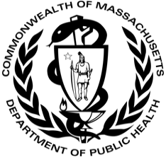
DATA REPORT November 2020
on Colorectal Cancer in Massachusetts

PURPOSE
This report presents descriptive data on colorectal cancer incidence and mortality among Massachusetts residents. Incidence refers to the number of people who have been newly diagnosed with colorectal cancer while mortality refers to the number of people who have died from the disease. This report summarizes colorectal cancer incidence and mortality in Massachusetts by race/ethnicity, age, and stage, and compares rates to the rest of the United States. Many of the analyses reported here focus on the most recently available data from the Massachusetts Cancer Registry, covering the period 2012–2016, though the report presents incidence and mortality rates over the past two decades as well.
Though colorectal cancer is one of the more common types of cancer for both men and women, it can be prevented or detected early through routine screening. Therefore, this report also presents Massachusetts colorectal cancer screening data from the Behavioral Risk Factors Surveillance System (BRFSS) and includes some lifestyle and screening recommendations.
The report begins by highlighting some of the key findings from this data review and then presents a detailed summary of colorectal cancer incidence and mortality in Massachusetts. Technical details and definitions of terms (e.g., age-adjusted rates, age-specific rates) are included at the end of the report, along with a summary of data sources.
KEY POINTS
- Colorectal cancer was the third most commonly diagnosed cancer among men and women in Massachusetts during 2012–2016 (Table 1). It was also the third leading cause of cancer death for both men and women (Table 2).
- During this time, age-adjusted incidence and mortality rates in Massachusetts were lower than in most states, as well as in the United States (Table 3 and Figure 4).
- Over the past two decades, mortality and incidence rates for men and women in Massachusetts have steadily declined (Figures 1 and 3). However, among those aged 49 years or less, incidence rates have increased (Figure 2).
- From 2012–2016, the highest incidence rates were observed among black non-Hispanics, followed by white non-Hispanics, Asian non-Hispanics, and Hispanics (Figure 5). A similar pattern was observed for mortality (Figure 6).
- During this time, incidence rates were found to increase with age, particularly after age 50 (Figure 7).
- From 2008–2016, the percentage of Massachusetts adults ages 50 to 75 who met colorectal cancer screening guidelines increased. In 2016, 76.3% of Massachusetts adults met the screening guidelines (Figure 9)
COLORECTAL CANCER COMPARED WITH OTHER CANCERS
Table 1. Total incident cases and percentage of all incident cases for the five most commonly diagnosed cancers, Massachusetts, 2012–2016
Male |  |  |  |  | Female
Cancer site |  | Cases |  | Percent | Cancer site |  |  | Cases |  | Percent
Prostate |  | 20,100 |  | 22.6 | Breast* |  |  | 29,288 |  | 30.2
Bronchus & Lung |  | 11,993 |  | 13.5 | Bronchus & Lung |  |  | 13,534 |  | 13.9
Colorectal |  | 7,256 |  | 8.2 | Colorectal |  |  | 7,243 |  | 7.5
Urinary Bladder |  | 6,945 |  | 7.8 | Corpus Uteri & Uterus, NOS |  |  | 6,523 |  | 6.7
Melanoma of Skin |  | 4,652 |  | 5.2 | Thyroid |  |  | 5,349 |  | 5.5
All Sites |  | 88,753 |  | 100 | All Sites |  |  | 97,056 |  | 100
*Breast in situ cases are excluded from 'All Sites' and breast cancer counts.
Data Source: Massachusetts Cancer Registry
Table 2. Total mortality cases and percentage of all mortality cases for the five most common causes of cancer death, Massachusetts, 2012–2016
Male |  |  |  |  |  | Female
Cancer site | Deaths |  | Percent |  |  | Cancer site | Deaths |  | Percent
Bronchus & Lung | 8,274 |  | 25.5 |  |  | Bronchus & Lung | 8,223 |  | 26.1
Prostate | 3,046 |  | 9.4 |  |  | Breast | 4,100 |  | 13.0
Colorectal | 2,471 |  | 7.6 |  |  | Colorectal | 2,597 |  | 8.2
Pancreas | 2,259 |  | 7.0 |  |  | Pancreas | 2,357 |  | 7.5
Liver & Intrahepatic Bile Ducts | 1,882 |  | 5.8 |  |  | Ovary | 1,635 |  | 5.2
All Sites | 32,384 |  | 100 |  |  | All Sites | 31,546 |  | 100
Data Source: Massachusetts Registry of Vital Records and Statistics

New cases

- In the 5-year period between 2012 and 2016, 88,753 men and 97,056 women in Massachusetts were diagnosed with cancer. Of those, 7,256 men and 7,243 women were diagnosed with colorectal cancer (an average of about 2,900 total cases of colorectal cancer per year in Massachusetts).

- Colorectal cancer was the third most common cancer diagnosis in men (after prostate cancer and bronchus and lung), and the third most common cancer diagnosis in women (after breast cancer and bronchus and lung).
- During 2012–2016, 8.2% of all diagnosed cancers in Massachusetts men and 7.5% of all diagnosed cancers in Massachusetts women were colorectal cancers.

Deaths
- Colorectal cancer was the third leading cause of cancer death for both men and women in Massachusetts between 2012 and 2016.

COLORECTAL CANCER IN MASSACHUSETTS COMPARED TO THE U.S.
Table 3. Age-adjusted colorectal cancer incidence and mortality rates, 2012–2016
Male |  |  | Female
 | Incidence | Mortality | Incidence | Mortality
Massachusetts | 40.9 | 14.0 | 32.6 | 10.6
United States | 44.5 | 17.0 | 34.0 | 12.2
Rate per 100,000
Data Sources: Massachusetts Cancer Registry, Massachusetts Registry of Vital Records and Statistics, National Center for Health Statistics, and the North American Association of Central Cancer Registries

- The age-adjusted incidence rate of colorectal cancer was about 1.3 times higher among Massachusetts men than Massachusetts women (40.9 versus 32.6 cases per 100,000, respectively).
- Similarly, the age-adjusted mortality rate of colorectal cancer was approximately 1.3 times higher among Massachusetts men than Massachusetts women (14.0 versus 10.6 per 100,000 cases, respectively).
- During 2012–2016, for both men and women, the incidence and mortality rates of colorectal cancer were lower in Massachusetts than in the United States.

COLORECTAL CANCER INCIDENCE TRENDS

- The annual incidence rates of colorectal cancer were higher among Massachusetts men than women from 1997–2016.
Over this period, the incidence rates decreased significantly, by 4.0% for men and 3.1% for women each year.

- Looking only at those aged 49 years or less, the incidence rates increased significantly, by an average of 2.2% each year from 1997–2016.
- The percentage of cases diagnosed under age 50 by race/ethnicity is as follows: white, non-Hispanic 10.4%, black, non-Hispanic 17.0% Asian, non-Hispanic 18.0%, Hispanic 24.0%.

COLORECTAL CANCER MORTALITY TRENDS

- Like incidence, the annual mortality rates of colorectal cancer were higher among Massachusetts men than women for the entire period from 1997–2016.
- During this period, the mortality rates decreased by 5.0% for men and by 4.1% for women each year; these decreases were statistically significant
Figure 4. Age-adjusted colorectal cancer incidence and mortality in the United States, 2012–2016

Incidence
Mortality

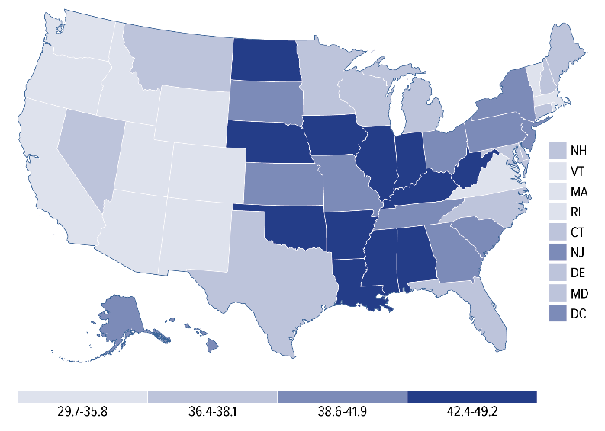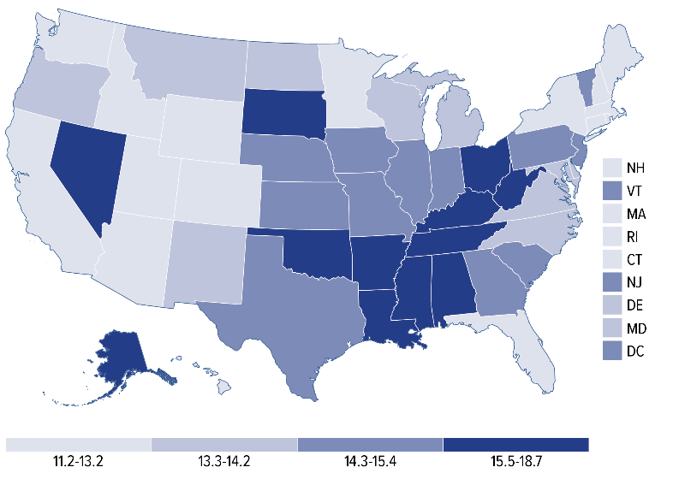
Rate per 100,000
Data Source: U.S. Cancer Statistics Working Group

- During 2012–2016, Massachusetts had the ninth lowest incidence rate for colorectal cancer in the United States.
- During 2012–2016, Massachusetts had the fourth lowest death rate for colorectal cancer in the
United States.

PATTERNS IN COLORECTAL CANCER BY RACE/ETHNICITY

- In Massachusetts, the highest overall colorectal cancer incidence rates for men and women from 2012–2016 were observed among black non-Hispanics, followed by white non-Hispanics, Asian non-Hispanics, and Hispanics.
- From 2012–2016, the age-adjusted colorectal cancer incidence rates for men and women were lower in Massachusetts than in the United States for all racial/ethnic groups (data not shown).

- The highest overall colorectal cancer mortality rates for men and women from 2012–2016 in Massachusetts were observed among black non-Hispanics, followed by white non-Hispanics, Hispanics, and then Asian non-Hispanics.
PATTERNS IN COLORECTAL CANCER INCIDENCE BY AGE

- The incidence of colorectal cancer increased with age for both Massachusetts men and women during 2012–2016.
- Due to the small number of incident cases of colorectal cancer for those less than 30 (i.e., 50 men and 65 women); those data are not shown.

- The highest age-specific incidence rates were observed among those aged 85 and older. For men, the incidence rate in this age group was 316.0 cases per 100,000, while for women in this age group, the incidence rate was lower, at 248.9 cases per 100,000.

PATTERNS OF COLORECTAL CANCER BY STAGE AT DIAGNOSIS
Table 4. Percentage of new colorectal cancer cases by stage at diagnosis, Massachusetts, 2012–2016
Stage at diagnosis | All Ages | Individuals Aged 49  Years or Less | Individuals Aged 50 Years or More
Local (confined to organ where it began) | 40.6% | 37.3% | 41.0%
Regional (spread to some nearby areas) | 33.7% | 35.6% | 33.5%
Distant (spread into other parts of the body) | 19.9% | 25.2% | 19.2%
Unknown (a stage is not assigned) | 5.8% | 1.9% | 6.3%
Data source: Massachusetts Cancer Registry

- The majority of colorectal cancer cases in Massachusetts were diagnosed at either a regional or distant stage from 2012–2016.
- According to the American Cancer Society, colorectal cancer is 90% survivable when found early (or in the local stage).
- Colorectal cancers were diagnosed more frequently at a regional or distant stage among those aged less than 50 years as compared to those aged 50 years or more. Given the increase in new cases of colorectal cancers for this younger population (Figure 2), this is especially important.

Hispanics had a higher percentage of cases (36.2%) diagnosed at regional stage compared to other race/ethnic groups.
- Black, non-Hispanics had the highest percentage of cases (26.3%) diagnosed at distant stage.

COLORECTAL CANCER SCREENING

- In 2016, 76.3% of Massachusetts adults ages 50 to 75 met colorectal cancer screening guidelines. These individuals either 1) had a colonoscopy in the past 10 years, 2) had a fecal occult blood test (FOBT) within the past year, or 3) had a sigmoidoscopy within the past 5 years and an FOBT within the past 3 years.
- A significant increase in the percentage of the population that met screening guidelines each year was observed among the white, non-Hispanic and Hispanic adults at 0.77% and 1.4%, respectively. The numbers among Asian, non-Hispanics were insufficient to calculate a percentage.
- In 2008, 68.3% of adults ages 50 to 75 reported having a colonoscopy in the prior 10 years. And in 2016, 73.1% of that same group reported having a colonoscopy in the prior 10 years. The overall rate of increase in colonoscopy screening was not statistically significant, but similar trends were seen for all reported races/ethnicities.
- In 2008, 16.2% of Massachusetts adults ages 50 to 75 reported having a FOBT in the prior year. However, in 2016, only 8.6% of that same group reported having an FOBT. The overall average rate of decrease in FOBT screening was 8.62% per year and was statistically significant.
DISCUSSION AND IMPLICATIONS FOR PREVENTION
- As detailed in this report, colorectal cancer is one of the most common cancers diagnosed in Massachusetts, and it is a leading cause of cancer-related deaths. Incidence rates have declined steadily in Massachusetts over the past 20 years, and the rates for 2012-2016 are lower in Massachusetts than in the rest of the nation.

- Colorectal cancer becomes more common as people age, with a considerable increase after age 50. However, rates are increasing in people 50 years of age or younger, and are more frequently diagnosed at regional or distant stage compared to those aged more than 50 years.

- Colorectal cancer is highly curable if it is found and treated early. Many people in Massachusetts who have colorectal cancer are not being diagnosed early enough. In fact, more than half do not have their cancer diagnosed until after it has spread beyond the colon or rectum.
- Colorectal cancer affects all racial/ethnic groups in Massachusetts, but the disease is most common among white, non-Hispanics and black non-Hispanics (as compared to Hispanics and non-Hispanic Asians).

- There are evidence-based strategies for reducing the incidence and mortality of this common and often-fatal disease. In fact, the majority of colorectal cancers are preventable through lifestyle changes and widespread screening.

- Screening, in particular, is a major element in the fight against colorectal cancer. Screening tests can detect early abnormalities, allowing for treatment before cancer has a chance to develop. If cancer is already present, screening tests can aid in early diagnosis.
LIFESTYLE RECOMMENDATIONS

- Be physically active for at least 30 minutes per day.
- Maintain a healthy weight.
- Take a multivitamin with folate every day.
- If you drink, limit alcohol to less than one drink per day (women) or less than two drinks per day (men).
- Limit red meat to no more than two servings per week.
- Eat five or more servings of fruits and vegetables a day.
- Don’t smoke.
- Eat foods containing calcium or take a calcium supplement every day.
- Start regular colorectal cancer screening at age 50.
SCREENING RECOMMENDATIONS
Widespread screening is key to increasing prevention and early detection of colorectal cancer. Recommended screening strategies and guidance include:
- Early on, colon cancer has no symptoms, so an individual could have colon cancer and not know it. The only way to know for sure is to get screened.
- When colorectal cancer is caught early, it can be cured 90% of the time.
- The U.S. Preventive Services Task Force (USPSTF) makes evidence-based recommendations about clinical preventive services. The USPSTF recommends screening for colorectal cancer starting at age 50 years and continuing until age 75 years.
- The decision to screen for colorectal cancer in adults
aged 76 to 85 years should be an individual one, considering the patient’s overall health and prior screening history.
- Additional efforts are needed to ensure that at-risk populations, including Black, non-Hispanics and those with a personal or family history of polyps or colon cancer, receive recommended screening, follow-up, and treatment.
- Two of the tests recommended by doctors are colonoscopies and FOBTs. You should talk to your doctor about the best test for you.
  - Colonoscopy: A procedure that looks for polyps.
  - FOBT: A yearly at-home test that looks for hidden blood in the stool.

TECHNICAL NOTES AND DEFINITIONS
Age-adjusted rate – a rate that accounts for the age structure of a geographic area, allowing for the comparison of areas with different age distributions. In this report, age-adjusted rates were calculated by weighting the age-specific rates for a given year by the age distribution of the U.S. standard population in the year 2000. The weighted age-specific rates were then added to produce the adjusted rate for all ages combined. Rates should only be compared if they have been adjusted to the same standard population.
Age-specific rate – a rate among people of a particular age range in a given time period. In this report, age-specific rates were calculated by dividing the number of people in an age group who were newly diagnosed with cancer (incidence) or died of cancer (mortality) by the number of people in that same age group overall.
Incidence – the number of people who are newly diagnosed with a disease, condition, or illness during a particular time period. The incidence data presented in this report were coded using the International Classification of Disease for Oncology (ICD-O) coding system.
Mortality – the number of people who died of a disease, condition, or illness during a particular time period. The mortality data presented in this report were coded using the International Classification of Diseases (ICD).
Race/ethnicity – categories presented in this report are mutually exclusive. Cases and deaths are only included in one race/ethnicity category.
Statistical significance – an estimate of the probability that the trend or difference between groups is due to chance alone. In this report, the trend or difference between groups was considered statistically significant when the p value was less than or equal to 0.05.
DATA SOURCES
Behavioral Risk Factor Surveillance System (BRFSS): The data on colorectal cancer screening were collected by the Health Survey Program as part of BRFSS. The BRFSS is a random-digit-dial telephone survey conducted among residents of Massachusetts 18 years of age and older. The data collected by the BRFSS include health characteristics, risk factors, and preventive behaviors. The Massachusetts screening data presented in this report were weighted and represent estimates for adults in Massachusetts. More information is available at: https://www.cdc.gov/brfss/index.html.
Massachusetts Cancer Registry (MCR): All Massachusetts incidence data are provided by the MCR, which is part of the Massachusetts Department of Public Health (MDPH). The MCR is a population-based cancer registry that began collecting reports of newly-diagnosed cancer cases in 1982. More information is available at: https://www.mass.gov/massachusetts-cancer-registry.
Massachusetts Registry of Vital Records and Statistics (RVRS): RVRS provides statistics on births, deaths, fetal deaths, divorces, and marriages. These data are used by local and state public health programs and medical researchers to help understand our population, promote wellness, and ensure health equity within the Commonwealth. The mortality data in this report were gathered by the RVRS. More information is available at: https://www.mass.gov/orgs/registry-of-vital-records-and-statistics.
North American Association of Central Cancer Registries (NAACCR): Established in 1987, NAACCR, Inc. is a collaborative umbrella organization for cancer registries, governmental agencies, professional associations, and private groups in North America interested in enhancing the quality and use of cancer registry data. All central cancer registries in the United States and Canada are members. U.S. Cancer Incidence data were gathered by the NAACCR. More information is available at: https://www.naaccr.org/about-naaccr/.
National Center for Health Statistics (NCHS): National mortality data were obtained from the Centers for Disease Control and Prevention’s NCHS, which collects national death data from individual state vital statistics registries. More information is available at: https://www.cdc.gov/nchs/index.htm.
U.S. Cancer Statistics Working Group. Cancer and mortality rates for each state were obtained from the U.S. Cancer Statistics Data Visualizations Tool, based on November 2018 submission data (1999–2016): U.S. Department of Health and Human Services, Centers for Disease Control and Prevention and National Cancer Institute, https://gis.cdc.gov/Cancer/USCS/DataViz.html, June 2019.

ACKNOWLEDGEMENTS

Thanks are extended to MCR staff Annie MacMillan, Susan Gershman, and Richard Knowlton for their work in preparing this report. Thanks as well to Maria McKenna for providing Behavioral Risk Factor Surveillance Survey data and to the Massachusetts Colorectal Cancer Control Program. And a final thanks to Natalie Nguyen Durham and Abbie Averbach for their report review. Also, special thanks to the Colon Cancer Coalition for funding this project. We acknowledge the Centers for Disease Control and Prevention for its support of the staff under cooperative agreement NU58DP006271-04-00 and the National Cancer Institute under contract HHSN261201800008I awarded to the Massachusetts Department of Public Health. Its contents are solely the responsibility of the authors and do not necessarily represent the official views of the Centers for Disease Control and Prevention nor the National Cancer Institute.

