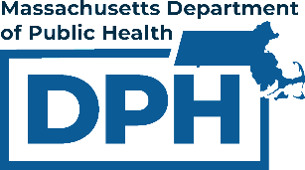

Data to Action: Leveraging the BSAS Dashboard (& Other Resources) for Community Impact

Developed with feedback and contributions from:
- Massachusetts Health Officer Association (MHOA) Education Committee
- Massachusetts Epidemiology Collaborative
- Care Massachusetts
- Heidi Lee - Redefining Community Wellness Community Advisory Board Member
- Isabella Caruso, MPH - Northborough Health and Human Services Director
- Manizeh Afridi, MPH - Public Health Consultant, CEO of Massachusetts Epidemiology Collaborative
- Pooja Shelke, MPH - Regional Epidemiologist, President of Massachusetts Epidemiology Collaborative
- Maureen O’Reilly - Community Health Educator and Epidemiologist
- Mike Rugg - Hudson Health Department YSAP Coordinator
- Massachusetts Department of Public Health (DPH)
  - Bureau of Substance Addiction Services (BSAS)
  - Office of Local and Regional Health (OLRH)
  - State Office of Rural Health (SORH)
- And the many others who helped design this tool to be as helpful as possible!

Guide Contents
Welcome to the data to action guide for the official Massachusetts Bureau of Substance Addiction Services (BSAS) data dashboard. This guide will help you to navigate the BSAS Dashboard and apply its data. This guide will also help your community and its partners ensure their actions are evidence-based.
The BSAS Dashboard currently includes three main pages: Community Profile, Data on BSAS Enrollments, and the Glossary. This guide focuses on the Community Profile page due to its direct relevance to community health. However, BSAS recommends that dashboard users access all available pages at least once.
For most readers, reading this entire guide in order would be unnecessary. Instead, you can use the tables placed around the document to access exactly what you want to know.
You can navigate to each section of the guide using the table below:
Section | Description | Page
Introduction | Important information to consider before reading the guide. | 2
Data to Action Assistance for Communities | Basic framework to gather substance-related data and form evidence-based responses. | 3
Common Data Types | An overview of common health data types (counts, rates, etc.). This section may be especially useful for those who are not familiar with statistics. | 26
Overview of the Measures on the Community Profile Page | An explanation of each data measure on the BSAS Dashboard’s Community Profile page, and what the measures can tell you about your community. | 28
Dashboard Tips & Tricks | A brief list of tips and tricks for navigating the BSAS Dashboard. | 45

Introduction
Navigation
You can scroll through the guide to find the section(s) you are looking for. However, you may find it easier to navigate the guide using the various links placed around the document. The links located in the top left corner of each page show which section you are currently viewing. You can use these links to orient yourself and backtrack to other sections, including the Contents table. Some links will redirect you to webpages or reports outside the guide.
If you notice any problems with the links in this guide, please reach out to BSASdashboard.info@mass.gov.

Common Acronyms
- BSAS: Massachusetts Bureau of Substance Addiction Services
- EMS: Emergency medical services
- ER: Emergency room
- MOUD: Medication(s) for opioid use disorder
- OTP: Opioid treatment program
- PWUD: Person/People who use drugs

Purpose
The purpose of the BSAS Dashboard is to provide an overview of data related to substance use in Massachusetts. In creating the dashboard and this guide, BSAS hopes to:
- Provide data at a community level
- Improve data accessibility and transparency
- Guide problem identification and response planning
- Aid with evaluation and resource allocation
- Simplify collaboration and learning between communities
- Get communities thinking about data and how they can use it

Data to Action Assistance for Communities
Suppose you are browsing your community’s data on the Community Profile page of the BSAS Dashboard. This may raise questions about how substance use impacts your community, and how your community can improve.
For example, suppose your community’s rate of opioid-related deaths is higher than the state average. You would likely want to know why this is happening, and how your community can work to lower its opioid-related deaths. Or suppose your community has a low rate of opioid-related deaths. You would likely want to know if there is anything your community should do to continue these positive outcomes.
This section guides these lines of thinking by providing a basic framework for generating evidence-based responses to your community’s data. This section also provides real examples of local data-to-action projects.
Before reading any content in this section, it is important to consider four things:
- “Community” is a broad term. In this guide, “community” can mean singular cities/towns or collaboratives/coalitions. It may help certain communities to act as groups when working from data to action. This section is applicable to both singular cities/towns and groups of cities/towns.
- This guide does not cover all potential information for each topic. Data sources are rarely all-inclusive, and the factors behind substance use are complex. Communities must keep this in mind when interpreting data.
- Communities may have their own datasets that are not mentioned in this guide. These community datasets may be best for answering your community’s questions. Community-collected datasets can be valuable resources for generating community-specific responses. Communities should consider all reliable sources of data when generating evidence-based responses.
- Communities and individuals will likely interpret data in different ways. It is up to your community to decide how it should interpret data and generate responses. Communities should consider multiple sources of input when making these judgements. It is best if community members directly impacted by substance use, including PWUD and their families, are involved in these dialogues.

Based on your community’s goals, you can navigate to different topics using the table below. You can follow these steps in order, or you can choose to navigate to different steps depending on your community’s needs.
Step | Contents | Page
1. Identify Relevant Data Sources and Gather Data | Data on Substance-Related Outcomes  Examples: Deaths, ER visits, etc. | 5
1. Identify Relevant Data Sources and Gather Data | Data on Treatment/Recovery Services  Examples: MOUD utilization, access to housing services, etc. | 10
1. Identify Relevant Data Sources and Gather Data | Data on Harm Reduction  Examples: Naloxone kits, fentanyl test strips, syringe programs, etc. | 13
2. Determine and Prioritize Contributing Factors | Examples of common contributing factors to substance-related trends and measures.  Examples: Inequities, social determinants of health, policies, etc. | 16
3. Determine and Prioritize Response(s) | My community wants to improve certain data measures (such as outcomes, treatment, or harm reduction). What can we do? | 20
3. Determine and Prioritize Response(s) | My community does not need to improve certain data measures (such as outcomes, treatment, or harm reduction). Should we do anything? | 21
Community Narratives | Real-world examples of local data-to-action projects.  1. From Data to Prevention: MetroWest Shared Public Health Services  2. Small Data, Big Impact: Franklin Regional Council of Governments | 23

Identify Relevant Data Sources and Gather Data
There are many sources your community can use to gather data. You can use data to gain an overall understanding of your community’s situation, or you can use data to learn more about a previously identified strength/weakness. Keep in mind that data gathering can be an iterative process. Gathering data may result in more questions, thus requiring additional data. Below are three tables of data sources your community can use to gather data on: substance-related outcomes, treatment/recovery services, and harm reduction. Note that it is best if your community collects both quantitative (numeric) and qualitative (descriptive) data when available. Also note that the sources listed here are not exhaustive.
Small communities may have limited data to work with due to data suppression. There are ways these communities can overcome this barrier. For example, small communities can use community-collected data (examples at bottom of each table). These communities can also partner with other communities to combine data during data requests, which may lessen the likelihood of suppression.

Substance-Related Outcomes

Table 1: Examples of Data Sources and Data Measures for Substance-Related Outcomes
Data Source | Data Measures
State Data Dashboards
BSAS Dashboard Community Profile Page  Provides an overview of trends related to substances and services in your community, county, and the state. | - [Substance]-related deaths*  - [Substance]-related ER visits  - Opioid-related EMS incidents  - Opioid-related overdose deaths*  - Overdose death circumstances  *Can view by subpopulation on the Deaths tab
EMS Regional Opioid Related Incident Dashboard  A subset of Massachusetts Ambulance Trip Record Information System (MATRIS) data that provides information on opioid-related EMS incidents by time, community, and other factors. | Opioid-related EMS incidents:  - Incident count  - Incident severity*  - Naloxone administration*  - Incident details such as response time, scene time, and transport time  *Can view by subpopulation
Population Health Information Tool: Prescription Monitoring Program in Massachusetts  Provides data on certain prescription drugs by county and year. | Benzodiazepines, stimulants, opioid agonists, and opioid partial agonists (MOUD):  - Prescription counts and rates  - Solid quantity rates  - Proportion of county receiving prescriptions
Population Health Information Tool: Community Health Data  Provides basic health data queries.  Use the Build a report feature or the Make a data map feature to locate certain data. The Make a data map feature includes multiple ways to subset data by location.  This source also includes various data measures related to the social determinants of health. | Build a report and Make a data map:  - Alcohol retailers  - Binge drinking  - Drug overdose  - Deaths of despair (suicide, drug poisoning, or alcohol poisoning)  Make a data map:  - Drug overdose  - Mental health and substance use among Medicare beneficiaries  - Various mental health outcomes (anxiety, depression, etc.)  - Health policies related to using prescription drugs other than as prescribed  - Medicare beneficiaries with alcohol use disorder  - Medicare beneficiaries with drug/substance use disorder  - Alcohol retailers and drinking establishments  - Excessive drinking  - Alcoholic beverage expenditures  - Alcohol-related motor vehicle crash mortality  - County health rankings for alcohol-impaired driving deaths  - Chronic liver disease and cirrhosis  - Opioid use disorder among Medicare beneficiaries  - Opioid use disorder emergency department utilization among Medicare beneficiaries  - Opioid pills, drug claims, and prescription rate  - Opioid overdose mortality  - Policies related to MOUD
Behavioral Risk Factor Surveillance System  Provides data on emerging public health issues, health conditions, and risk factors among adults. | - Binge drinking in previous 30 days*  - Heavy drinking in previous 30 days*  - Current cigarette smoking*  - Second-hand smoke exposure anywhere in previous 7 days*  - Second-hand smoke exposure while at home in previous 7 days*  - Poor mental health on 15+ of previous 30 days*  *Can view by subpopulation
Bureau of Community Health and Prevention Tobacco Dashboard  Provides an overview of data related to tobacco/nicotine products, tobacco policies, and tobacco-related outcomes by community. | Tobacco/Nicotine-related outcomes:  - Smoking rate  - Asthma ER visit rate  - Quitline intakes  - Lung cancer standard incidence ratio  Tobacco/Nicotine retail:  - Retail density and youth retail density*  - Cheapest single cigar price  - Proportion of tobacco retailers who sell cigars  - Proportion of tobacco retailers who sell vape products  Tobacco policy:  - Capping policy  - Cigar regulation  *Can view by subpopulation
Pregnancy Risk Assessment Monitoring System Data  Provides data on maternal health before, during, and after pregnancy at the state level. | - Alcohol drinking during the 3 months before pregnancy*  - Alcohol drinking during the last 3 months of pregnancy*  - Smoking during the 3 months before pregnancy*  - Smoking during the last 3 months of pregnancy*  - Smoking postpartum*  - Various outcomes related to mental health (e.g. had depression before pregnancy)*  *Can view by subpopulation
Massachusetts Violent Death Reporting System Data  Provides data on homicide and suicide deaths by county and statewide. | Homicides:  - Alcohol/substance abuse problem  - Drug related  - Positive toxicology results (multiple substance categories)  Suicides:  - Alcohol/substance abuse problem  - Drug related  - Current treatment for mental health/substance abuse problem  - History of treatment for mental health/substance abuse problem  - Various outcomes related to mental health (e.g. depressed mood)  - Positive toxicology results (multiple substance categories)
Women, Infant, and Children Program Data  Provides data on WIC participants by community or program. | - Prenatal maternal smoking
Street Check Drug Checking Dashboard  Provides community-submitted data on the presence of certain substances (e.g. fentanyl or xylazine) in the drug supply in multiple communities*, counties, and states.  *Does not include data from all Massachusetts communities | - Presence of xylazine in samples over time  - Presence of fentanyl in samples over time  - Expected substances versus detected substances  - Presence of common active cuts (e.g. caffeine, xylazine)  - Presence of common inactive cuts (e.g. cellulose, lactose)  - Presence of fentanyl analogues  - Common combinations of active cuts  - Relative ratios of xylazine to fentanyl over time
State Data Requests
Massachusetts Ambulance Trip Record Information System  Collects data on EMS incidents. | Data requests from these sources may vary by topic, substance, time frame, and subpopulation, among other characteristics.
Prescription Monitoring Program
Collects data on schedule II – IV and gabapentin prescriptions.
State Reports
Opioid Reports | Overdose Reports
Community-Collectable Qualitative Data [Example Questions]
Service providers: Substance use, mental health, harm reduction, general health, emergency response, law enforcement, etc.  These data measures are examples of questions to ask this population to gather data.  Gather this data through surveys, focus groups, interviews, content analysis, or other methods. | - How often do people contact emergency services or seek emergency health care during health emergencies related to [substance] use?  - What do you think influences the [substance]-related outcomes (such as deaths) in your community?  - How do you think [substance]-related outcomes can be improved in the community?  - How do you think your service impacts the [substance]-related outcomes in your community?
Community members with lived and living experience with substance use  These data measures are examples of questions to ask this population to gather data.  Gather this data through surveys, focus groups, interviews, content analysis, or other methods.  It may also be useful to gather data from those close to people with lived and living experience with substance use. | - What do you think influences the [substance]-related outcomes (such as deaths) in your community?  - How do you think [substance]-related outcomes can be improved in the community?  - How often do you think PWUD in your community utilize protective behaviors while using [substance]? Protective behaviors can include testing drugs before use, carrying naloxone, monitored consumption, etc.  - What influences PWUD’s decision to contact (or not contact) emergency services during a health emergency related to [substance] use?
Unique data collection methods for communities. | Measures for these sources will vary.
For information on how your community can identify potential contributing factors to its data, access the Determine and Prioritize Contributing Factors section.

Treatment/Recovery Services

Table 2: Examples of Data Sources and Data Measures for Treatment/Recovery Services
Data Source | Data Measures
State Data Dashboards
BSAS Dashboard  Provides an overview of trends related to substances and services in your community, county, and the state.  Both the Community Profile page and the Data on BSAS Enrollments page present certain relevant results by county and community. | Community Profile:  - Individuals admitted to BSAS services  - Individuals who received OTP services  - Average distance traveled to BSAS provider  - Average distance traveled to OTP provider  - Buprenorphine prescriptions filled  - Individuals who received buprenorphine prescriptions  - Number, location, and type of the BSAS providers who rendered services to your community’s residents  - Number of your community’s residents who accessed different BSAS service types  Data on BSAS Enrollments:  - Number of BSAS enrollments by timeframe, location, primary substance, and other factors*  *Can view by subpopulation
Population Health Information Tool: Health Care Facilities in Massachusetts  Provides an overview of health care facilities by facility type, purpose of licensed beds, and community. | - Facility type  - Number of licensed beds dedicated to substance use  - Service type of facility
Population Health Information Tool: Community Health Data  Provides basic health data queries.  Use the Build a report feature or the Make a data map feature to locate certain data. The Make a data map feature includes multiple ways to subset data by location.  This tool also provides various data measures related to the social determinants of health, including walkability scores. | Build a report:  - Addiction and substance use providers  - Mental health centers  Make a data map:  - Hospitals  - Pharmacies  - Addiction and substance use providers  - Substance use treatment facilities  - Mental health facilities  - Opioid use disorder emergency department utilization among Medicare beneficiaries
Population Health Information Tool: Prescription Monitoring Program in Massachusetts  Provides data on certain prescription drugs by county and year. | Benzodiazepines, stimulants, opioid agonists, and opioid partial agonists (MOUD):  - Prescription counts and rates  - Solid quantity rates  - Proportion of county receiving prescriptions
Massachusetts Trial Court Section 35 Civil Commitments  Provides data on the number of juvenile and adult Section 35 filings by county, department, and division. | - Number of MGL Chapter 123 Section 35 case filings  Click here for more information on Section 35
State Data Requests
BSAS Data Mart  Provides data requests related to services funded by BSAS and the clients who access BSAS-funded services. | Data requests from this source may vary by topic, substance, service, time frame, and subpopulation, among other characteristics.  - Substance addiction treatment admissions  - Overdose education and naloxone distribution (OEND)  - Rapid assessment of consumer knowledge (RACK)  - Post overdose support teams (POST)  - Licensing data
Prescription Monitoring Program  Collects data on schedule II – IV and gabapentin prescriptions. | Data requests from this source may vary by topic, substance, service, time frame, and subpopulation, among other characteristics.
State Reports
Licensed or certified health care facilities | Admissions
Community-Collectable Qualitative Data [Example Questions]
Service providers: Substance use, mental health, harm reduction, general health, emergency response, law enforcement, etc.  These data measures are examples of questions to ask this population to gather data.  Gather this data through surveys, focus groups, interviews, content analysis, or other methods. | - What can treatment/recovery service providers do to make services more accessible for people with substance use disorder?  - How do you work with patients with different language or cultural needs than your own?  - How knowledgeable are you of other services in or near your community?  - How connected are your services to other services in or near your community?  - What are some common barriers and facilitators to PWUD initiating services?  - What are some common barriers and facilitators to PWUD engaging with services over longer periods of time?
Community members with lived and living experience with substance use  These data measures are examples of questions to ask this population to gather data.  Gather this data through surveys, focus groups, interviews, content analysis, or other methods.  It may also be useful to gather data from those close to people with lived and living experience with substance use. | - Have you had any experiences with accessing treatment/recovery services? What were they like?  - Are services available and accessible for people with substance use disorder in your community?  - What can service providers in your community do to make services more accessible for people with substance use disorder?  - What are some common barriers and facilitators to PWUD initiating services?  - What are some common barriers and facilitators to PWUD engaging with services over longer periods of time?
Unique data collection methods for communities. | Measures for these sources will vary.
For information on how your community can identify potential contributing factors to its data, access the Determine and Prioritize Contributing Factors section.

Harm Reduction

Table 3: Examples of Data Sources and Data Measures for Harm Reduction
Data Source | Data Measures
Data Dashboards
BSAS Dashboard Community Profile Page  Provides an overview of trends related to substances and services in your community, county, and the state. | - Naloxone kits distributed in or near your community  - Fentanyl test strips received in or near your community  - Naloxone kits distributed in your community per opioid-related overdose death among your community’s residents  - Overdose death circumstances
Street Check Drug Checking Dashboard  Provides community-submitted data on the presence of certain substances (e.g. fentanyl or xylazine) in the drug supply in multiple communities*, counties, and states.  *Does not include data from all Massachusetts communities | - Presence of xylazine in samples over time  - Presence of fentanyl in samples over time  - Expected substances versus detected substances  - Presence of common active cuts (e.g. caffeine, xylazine)  - Presence of common inactive cuts (e.g. cellulose, lactose,)  - Presence of fentanyl analogues  - Common combinations of active cuts  - Relative ratios of xylazine to fentanyl over time
Syringe Services Program Locator  Provides information on syringe services programs (SSPs) in Massachusetts. | - Location/address  - Contact information  - Site availability and parking
Harm Reduction Program Locator  Provides information on programs that provide services related to basic needs, harm reduction, education/support, and testing/treatment. | - Location/address  - Contact information  - Hours of operation
EMS Regional Opioid Related Incident Dashboard  A subset of Massachusetts Ambulance Trip Record Information System (MATRIS) data that provides information on opioid-related EMS incidents by time, community, and other factors. | Opioid-related EMS incidents:  - Incident count  - Incident severity*  - Naloxone administration*  - Incident details such as response time, scene time, and transport time  *Can view by subpopulation
State Data Requests
BSAS Data Mart  Provides data requests related to services funded by BSAS and the clients who access BSAS-funded services. | Data requests from this source may vary by topic, substance, service, time frame, and subpopulation, among other characteristics.  - Substance addiction treatment admissions  - Overdose education and naloxone distribution (OEND)  - Rapid assessment of consumer knowledge (RACK)  - Post overdose support teams (POST)  - Licensing data
Massachusetts Ambulance Trip Record Information System  Collects data on EMS incidents. | Data requests from this source may vary by topic, substance, time frame, and subpopulation, among other characteristics.
State Reports and Webpages
Naloxone FAQs | Non-Fatal Opioid-Related Overdoses
Community-Collectable Qualitative Data [Example Questions]
Service providers: Substance use, mental health, harm reduction, general health, emergency response, law enforcement, etc.  These data measures are examples of questions to ask this population to gather data.  Gather this data through surveys, focus groups, interviews, content analysis, or other methods. | - What is your opinion of harm reduction?  - How knowledgeable are you of harm reduction resources in or near your community?  - [If not a harm reduction service provider] Are your services connected to any harm reduction services?  - [If a harm reduction service provider] Are your services connected to other services, such as treatment/recovery services?  - What are some common barriers and facilitators to PWUD accessing harm reduction resources?
Community members with lived and living experience with substance use  These data measures are examples of questions to ask this population to gather data.  Gather this data through surveys, focus groups, interviews, content analysis, or other methods.  It may also be useful to gather data from those close to people with lived and living experience with substance use. | - How do you think harm reduction affects PWUD in your community?  - Describe your experiences with harm reduction service providers.  - How often do/did you utilize harm reduction resources? What kinds of resources do/did you utilize?  - How accessible are harm reduction resources in your community for PWUD?  - What can providers do to make harm reduction resources more accessible for PWUD?  - What are some common barriers and facilitators to PWUD accessing harm reduction resources?
Unique data collection methods for communities. | Measures for these sources will vary.
For information on how your community can identify potential contributing factors to its data, scroll down to the next page to access the Determine and Prioritize Contributing Factors section.
Determine and Prioritize Contributing Factors
Ideally, your data gathering will provide you with a good understanding of your community, or a specific strength or weakness in your community. You can use this understanding to determine why your community is experiencing its data trends. What factors are contributing to these findings? Are these factors unique to your community? Which factors are contributing the most?
It would be best if those with lived and living experience with substance use are included in these dialogues. For more information on how to involve these populations in your community’s decision-making, refer to chapters three and four of the Substance Abuse and Mental Health Services Administration’s Community Engagement guide. Though said guide focuses on substance use prevention, its principles can apply to other domains related to substance use. You can also access Greer and colleagues’ 2019 paper on common barriers and enablers to engaging PWUD in decision-making.
Keep in mind that both positive and negative factors can influence your community. Additionally, both positive and negative factors can be inequitably distributed in your community. Below are some examples of common contributing factors to substance use, service access, and other things relevant to substances. Note that the examples listed here are not exhaustive.
Inequities
Definition: Measurable and avoidable differences between demographic subpopulations. Inequities can exist in substance-related outcomes, access to services or resources, or other important data measures. There are often many factors involved in creating inequities. Underserved populations, including Black, Indigenous, and People of Color (BIPOC) and Lesbian, Gay, Bisexual, Transgender, Queer, Intersex, and Asexual (LGBTQIA+) populations, are often affected by inequities.
Hypothetical Examples:
- In my community, residents of Neighborhood A are twice as likely to die from an opioid overdose compared to residents of Neighborhood B. Residents of Neighborhood A are also more likely to drop out of school and have a low-paying job. These differences are indicative of a health inequity between these neighborhoods.
- In my community, residents of Neighborhood A are less likely to carry naloxone compared to residents of Neighborhood B. This becomes an inequity once I consider that pharmacies are the sole distributors of naloxone in my community, and residents of Neighborhood A are less likely to be able to afford the pharmacies’ price of naloxone compared to residents of Neighborhood B.
Resources: Several data sources in the above tables allow you to view data by subpopulation. You can combine this data with data on the social determinants of health (more information below) to investigate potential health inequities in your community.
Social Determinants of Health
Definition: Non-medical factors that affect health such as economic status, education access, and neighborhood violence, among others.
Effect:
- The social determinants of health interact with substance-related measures in complex ways.
- Generally, social determinants and substance-related measures have a direct relationship. As social determinants worsen, substance-related measures typically worsen as well. As social determinants improve, substance-related measures typically improve as well.
- Differences in the social determinants of health across subpopulations often contribute to health inequities.
Resources:
- You can find social determinant data from the Census Bureau Data page and the Population Health Information Tool: Community Health Data page.
- For more information on the social determinants of health, visit the Office of Disease Prevention and Health Promotion’s Healthy People 2030 website.
Local Policies
Definition: Laws and regulations unique to your community or surrounding communities.
Effect:
- Policies shape what residents and service providers can do.
- Policies determine how a community responds to the needs of PWUD.
It is important to examine your community’s policies surrounding substance use and mental health to determine if the policies algin with your community’s goals.
Drug Supply and Service Types
Definition: The availability and consistency of substances in your community, and the availability of appropriate service types in your community. Service types not only refer to the substance of focus for the service, but also to the type of intervention (e.g. medication, support, peer, legal, etc.).
Effect:
- Established drug trafficking systems can contribute to the supply and demand for certain substances.
- Health providers' prescription practices and the location/accessibility of legal substance vendors can also influence how people use substances.
- The presence of certain substances (e.g. fentanyl or xylazine) in the drug supply can influence accidental overdoses or poisonings.
- Differences between the substances being used in your community and the available services in your community can influence whether people access services.
Resources:
- You can find direct data on the presence of substances from the Street Check Drug Checking Dashboard and community-collected data.
- You can find inferred data on the presence of substances via data on substance-related outcomes and service enrollments from the BSAS Dashboard and the BSAS Data Mart.
- You can find data on prescriptions from the Prescription Monitoring Program or the Population Health Information Tool: Prescription Monitoring Program in Massachusetts page.
- You can find data on legal substance vendors from the Bureau of Community Health and Prevention Tobacco Dashboard and the Population Health Information Tool: Community Health Data page.
Perceptions and Stigma
Definition: How your community, service providers, PWUD, and other groups view substance use. Stigma occurs when substance use is seen as wrong or shameful, or when PWUD are viewed negatively due to their use of substances.
Effect:
- Judgement or discrimination can negatively affect peoples' relationship with substances and services.
- If met with stigma or shame, then PWUD may be less likely to access services or trust providers. If met with respect, then PWUD may be more likely to access life-saving resources or form connections with providers.
- PWUD may fear involuntary institutionalization, incarceration, or custody loss of their children if they have a negative perception of providers and the community.
- The effects of stigma can extend to co-occurring mental health conditions that PWUD may be experiencing as well.
Resources:
- Understanding the role of this factor in your community will likely require community-collected data.
- For more information on these interactions, visit the National Institute on Drug Abuse’s page on Stigma and Discrimination or the National Harm Reduction Coalition page.
Service/Resources Accessibility
Definition: The accessibility of health services, substance use services, and harm reduction resources for PWUD in your community.
Effect: Accessibility can directly affect how PWUD interact with services and resources. Many things can affect access to services and resources in your community:
- Barriers to services for PWUD. This can include location, availability, cost, insurance, language, culture, perception, and other life burdens (e.g. childcare), among others.
- Capacity of services to meet the needs of PWUD. This includes staffing, training, language and cultural knowledge, and other resources.
- Coordination of service providers. This can affect referrals and the continuum of care.
- Ability of service providers to initiate services among PWUD, and then engage PWUD in services over longer periods of time.
- The awareness of PWUD of available services and resources in or near your community, and the benefits of said services or resources.
Resources: Understanding the role of this factor in your community will likely require community-collected data.
Common Behaviors
Definition: How well PWUD can identify protective substance use behaviors, and how often PWUD utilize protective behaviors. Some protective behaviors include: carrying naloxone, monitoring consumption, testing drugs before using, and using one substance at a time.
Effect: Understanding and using protective behaviors can reduce the risk of PWUD experiencing a substance-related health emergency.
Resources: Understanding the role of this factor in your community will likely require community-collected data.
Prioritizing Your Community’s Identified Factors
Your community will ultimately decide how to prioritize any identified factors. Some examples of things that may indicate a high-priority factor include:
- If the factor disproportionally affects certain subpopulations, especially disadvantaged subpopulations.
- If the factor is identified by those with lived and living experience with substance use, service providers, or other affected groups in your community.
- If the factor has a notable history within your community.
For information on how your community can form its response(s) to its data, scroll down to the next page to access the Determine and Prioritize Response(s) section.

Determine and Prioritize Response(s)

My community wants to improve certain data measures (such as outcomes, treatment, or harm reduction). What can we do?
Your community’s response(s) will depend on:
- Factor prioritization, ideally including the perspectives of PWUD
- Response feasibility
- Buy-in from those involved in planning, implementation, and evaluation
- Other such considerations that may be unique to your community
Your community’s response(s) will be unique to your community’s needs. It would likely benefit your community to take a public health approach to all responses. This means considering how factors intersect, such as how policies and the social determinants of health influence almost all other factors. It also means taking disparities and inequities into account by prioritizing subpopulations that have worse outcomes, service access, or other negative data trends. Prioritizing at-risk groups may also assist with your response formation. This allows for responses to reach entire groups rather than individuals. It also opens the door for responses to focus on building community or strengthening culture. Such responses can be important in the empowerment of people with substance use disorder.
Keep in mind that public health responses work best when they can improve both current outcomes and future outcomes. Ideally, this means your community’s responses should focus on a lower level of the health impact pyramid:

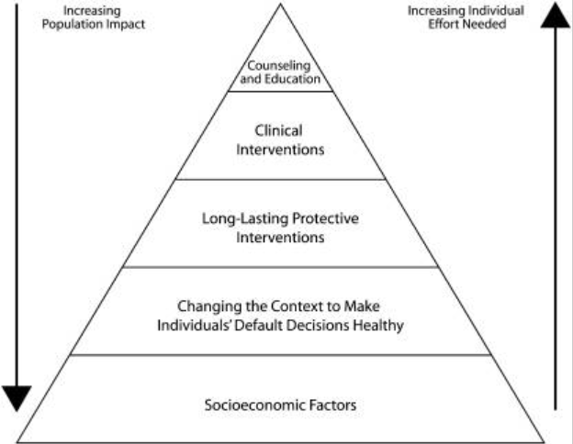

Image source:
Frieden, T. R. (2010). A framework for public health action: The health impact pyramid. American Journal of Public Health, 100(4), 590-595. https://doi.org/10.2105/AJPH.2009.185652
In may be difficult for individual communities, especially smaller communities, to implement responses with large population impacts (lower on the pyramid). However, it is important for communities to at least keep this continuum in mind. Individual-oriented responses such as counseling, educating, and providing resources are powerful responses that communities can take to assist PWUD. With this, communities can collaborate through joint policies, advocacy, or other means to make more sweeping changes for their residents.
It would also be best if your community’s response(s) include an evaluation aspect. This will help to guide your community’s future decisions and adjust as needed.
For more direct guidance on developing and implementing appropriate responses, visit the Healthy People 2030 Evidence-Based Resources for Addiction page. There you can find best practices for specific substance-related goals. Note that the strategies described in these resources may or may not be appropriate for your community’s potential response(s).
For real-world examples of local data-to-action projects, scroll down (or click the following link) to access the Community Narratives section.

My community does not need to improve certain data measures (such as outcomes, treatment, or harm reduction). Should we do anything?
Your community may be experiencing good trends in some (or all) of its data measures. However, these trends may hide inequities between subpopulations in your community. You can use certain data sources to investigate this possibility. Refer to the tables in the Identify Relevant Data Sources and Gather Data section to identify some of these sources that allow you to view data by subpopulation. You can pair this data with social determinant data from the Census Bureau Data page and the Population Health Information Tool: Community Health Data page to identify health inequities in your community.
If you uncover evidence of inequities, then it would be best if your community prioritizes this issue among its other substance-related initiatives. Your community can then gather relevant data to determine the contributing factors to any identified inequities. Community-collected data may be most appropriate for identifying said potential contributing factors.
If you do not uncover evidence of inequities, then it would be best for your community to ensure it is prepared for potential substance crises by:
- Ensuring services (e.g. health, treatment, harm reduction, etc.) and surrounding communities are coordinated
- Establishing a community drug-checking surveillance system (to check for contaminants in the drug supply)
- Strengthening prevention programs
- Creating accessible locations for harm reduction resources
Additionally, it may benefit your community to investigate why it is experiencing positive data trends. This may involve further community-specific data collection. It is likely that these trends are due to multiple contributing factors. Understanding why your community is experiencing positive trends can inform best practices for both your community and surrounding communities.
Actions such as these, among other potential responses, can help to prepare your community. Communities may find it beneficial to collaborate in developing best practices for their work in this area.
For real-world examples of local data-to-action projects, scroll down (or click the following link) to access the Community Narratives section.

Community Narratives

1. From Data to Prevention: MetroWest Shared Public Health Services
Overview: MetroWest Shared Public Health Services (MWSPHS) used multi-level data to guide a community's overdose prevention efforts.
Context:
- MetroWest is a region of the state located between the cities of Worcester and Boston.
- MWSPHS is a shared service arrangement that collaborates public health efforts across 9 municipalities in the MetroWest area.
Narrative: The occurrence of overdoses has accelerated due to the opioid epidemic. Yet, it is difficult to determine how overdoses affect specific communities. This underlines the need for evidence-based practices in overdose prevention. With this in mind, one town’s health director tasked the MWSPHS's Regional Epidemiologists with gathering data on overdoses in their community. The data would inform the town’s Post Over Dose Support Team’s prevention efforts on two fronts:
- What was the town’s overdose situation?
- Where were overdoses happening in the town?
The MWSPHS's Regional Epidemiologists worked to answer these questions with two main projects:
- Comparing Data. This aimed to contextualize the town’s overdose situation. The epidemiologists gathered overdose data on the national, state, and community level. The latter included data from the Critical Incident Management System (CIMS). They used the data to compare the town’s overdose rates to the national/state averages.
- Original Overdose Heat Map. This aimed to identify where overdoses were most/least likely to occur in the community. The MWSPHS epidemiologists used CIMS data to map (reported) overdose hotspots in the community.
These projects guided the efforts of the town’s Post Over Dose Support Team. The team now knew what was happening in their community, and they began prioritizing high-risk areas and establishments with prevention efforts (naloxone distribution, overdose prevention education, death prevention education, etc.). In the future, this data could inform further investigation on potential contributing factors to high-risk areas. This would help drive more upstream and equity-focused projects.
Through this work, MWSPHS demonstrated the simple utility of evidence-based efforts.

2. Small Data, Big Impact: Franklin Regional Council of Governments
Overview: The Franklin Regional Council of Governments (FRCOG) used data to create original, opioid-related communication materials. These communication materials helped decision makers to see OUD as a local issue, answer questions about OUD prevalence, and guide a cohesive approach to opioid response.
Context:
- Franklin County is a rural county located in the northwestern region of the state.
- The FRCOG is a regional service organization and regional planning agency that serves Franklin County’s 26 cities/towns. Among its services is a robust Community Health Department.
Narrative: While efforts to address the opioid crisis in Franklin County had been on-going for many years in county population centers, recent years have brought smaller, more rural towns into the fold. Rural towns have renewed bandwidth (the COVID-19 pandemic is largely over), and the Opioid Remediation and Recovery Fund (ORRF) has begun to distribute money. FRCOG saw a need to further support rural towns around opioid response. The evidence for this was both anecdotal and analytical. First, stories of opioid use were becoming commonplace — many people now knew someone who was impacted by OUD. Second, statewide data on the most rural towns highlighted an increase in rates of opioid-related incidents from 2013-2022; an upward trend that spanned close to a decade.
The low population of many Franklin County towns added further complications:
- Small towns’ substance-related data is often suppressed. This limited the available data for many of Franklin County’s local decision-makers.
- Small and rural towns often face limited access to resources. This lowered residents’ access to life-saving materials such as naloxone, and medication like methadone.
- Small towns generally receive less funding through ORRF because their participation in regional school districts negatively impacted their eligibility per the ORRF funding formula. This limited decision-makers’ ability to drive action in their community.
The FRCOG decided to take action to overcome these barriers and support local boards of health and select boards in addressing the crisis and spending the new national settlement funds in a way responsive to local needs. They pursued this goal through two projects:
- Local Opioid Data Fact Sheets. These aimed to communicate impact of opioids in each municipality and frame decision-making. The FRCOG worked with the Academic Public Health Corps to gather data from the state's Department of Public Health. This included data from published reports, dashboards, and data requests. The FRCOG compiled this data into fact sheets that grouped municipalities' data based on the public health collaboratives groups in Franklin County. Grouping by public health collaborative helped to overcome ‘small data’ barriers and encourage local boards of health to collaborate in their response.
- The Rural Communities Naloxone Cabinet Initiative: FRCOG worked with many towns to put up outdoor naloxone cabinets for 24/7, anonymous, no-cost access to naloxone. This Initiative works to address large gaps in naloxone access, and act as a community touch point for trainings, education and municipal engagement. FRCOG made a map with naloxone cabinet locations, using self-reported data to mark the locations of naloxone cabinets (a.k.a. ‘naloxboxes’ or ‘naloxone cases’) in Franklin County.
These materials helped generate discussion at more than 50 board of health and select board meetings across Franklin County. These discussions aided local decision-makers with framing their opioid responses. Some discussions also resulted in the placement of new naloxone cabinets throughout the county. Additionally, this work motivated one group of 15 municipalities (all in the same public health collaborative) to pool both their ORRF spending on regional projects and efforts moving forward.
Through this work, the FRCOG has demonstrated the power of data, even for small communities.
Click here and here to learn more about the FRCOG and these projects.

Common Data Types
Here is a background on the common data types you will find on the Community Profile page of the BSAS Dashboard. This information may also provide context for the data types you will find on other data sources.
Data Type | Explanation | Example [Hypothetical] | Used For
Counts | Shows how many times a measure occurred in your community. | There were 200 substance-related deaths in your community in 2023. | Assessing individual communities.
Crude Rates | Shows how many times a measure occurred in your community per 100,000* people. This accounts for differences in population size between communities.  *The BSAS Dashboard displays rates per 100,000 people, but other data sources may use different values (e.g. per 10,000) | Out of every 100,000 residents in your community, 500 residents were admitted to a BSAS service in 2023. | Assessing individual communities.  Comparison between communities, but only for measures that are not affected by other factors like age.
Age-Adjusted Rates | Shows how many times a measure occurred in your community per 100,000* people using a standardized age distribution. This accounts for differences in population size and age distribution between communities.  *The BSAS Dashboard displays rates per 100,000 people, but other data sources may use different values (e.g. per 10,000) | Out of every age-standardized 100,000 residents of your community, 500 residents visited an ER for reasons related to opioids in 2023. | Comparison between communities, especially for measures that are affected by age such as ER visit rates or death rates.
Averages | Shows the ‘typical’ value of a measure. | In 2023, the average distance residents of your community traveled to access a BSAS service was 10 miles. | Assessing individual communities.  Comparison between communities.
Ratios | Compares the size of two measures.  Typically written as: $\frac{Measure 1}{Measure 2}$  This can be simplified using division and written as: “There are ___ of Measure 1 for every one of Measure 2.” | In 2023, 50 naloxone kits were distributed in your community for every opioid-related overdose death that occurred among residents of your community. | Assessing individual communities.  Comparison between communities.
Percentiles | Shows how one value compares to other values in a group. The number of the percentile shows the proportion of values in the group that are smaller than your selected value. | Your community is in the 65th percentile for number of opioid-related overdose deaths. In other words, your community experienced more opioid-related overdose deaths than 65% of all other communities. This also means that your community experienced less opioid-related overdose deaths than the remaining 35% of all other communities. | Comparison between communities.
Refer to the Centers for Disease Control and Prevention’s Principles of Epidemiology in Public Health Practice (Third Edition): An Introduction to Applied Epidemiology and Biostatistics for more information on commonly used health statistics and graphs.

Overview of the Measures on the Community Profile Page
This section is a summary of the data measures you can access on the Community Profile page of the BSAS Dashboard. This section also explains what these measures can tell you about your community. You can display most data measures by community, county, or the entire state.
Each entry includes examples of questions that the measure can help to answer. Note that most of the questions require you to consider multiple data measures. The questions may help you think about where your community can investigate further.
For further information on Community Profile data measures, visit the Glossary page on the BSAS Dashboard.
You can navigate to the tab that includes your measure(s) of interest using this table:
Community Profile Tab | Data Measure | Page
Deaths | [Substance]-Related Deaths | 29
Deaths | Opioid-Related Overdose Deaths | 30
Deaths | Overdose Death Circumstances | 31
ER Visits | [Substance]-Related ER Visits | 33
ER Visits | Opioid-Related EMS Incidents | 34
Services | Community-Based Individuals Admitted to Intervention & Engagement Services | 35
Services | Legal-Involved Individuals Admitted to Intervention & Diversion Services | 35
Services | Individuals Admitted to Treatment Services, Except MAT | 36
Services | Legal-Involved Individuals Admitted to Treatment Services, Except MAT | 37
Services | Individuals Who Received Methadone | 37
Services | Legal-Involved Individuals Admitted to MAT Treatment Services | 38
Services | Individuals Who Received Buprenorphine Rx’s | 39
Services | Individuals Admitted to Community Support Services | 40
Services | Legal-Involved Individuals Admitted to Community Support Services | 40
Services | Naloxone Kits Distributed | 41
Services | Fentanyl Test Strips Received | 42
Services | Naloxone Kits Distributed per Opioid Overdose Death | 43
Services | Locations of BSAS Providers that Rendered Services | 44
Services | Service Categories | 45
Services | Percentile of Opioid-Related Overdose Deaths | 45
Services | Accessibility to BSAS Licensed Providers | 47
Data to Action | Reduce Opioid-Related Overdose Deaths by Increasing Naloxone Kits Distributed | 48
Data to Action | Reduce Opioid-Related Overdose Deaths by Received Buprenorphine or Methadone | 49

Deaths

[Substance]-Related Deaths
Definition:
A substance-related death occurs when someone's death involves at least one substance. Substance-related deaths include more than overdoses or poisonings. Substances can be the main or contributing cause of death. Note that multiple substances can contribute to one substance-related death. You can choose which substance you want this measure to display.
This only measures deaths among residents of your community. A resident of your community is someone with a usual place of residence or a permanent address in your community. This measure includes residents of your community who died either inside or outside your community. It does not include residents of other communities who died inside your community. Unhoused individuals with no known place of residence are also not included.
Using the Dashboard:
On the Substance-Related Deaths tab, you can alter two visualizations using multiple filters.

Chart: Deaths Trend | Map: Compare Communities
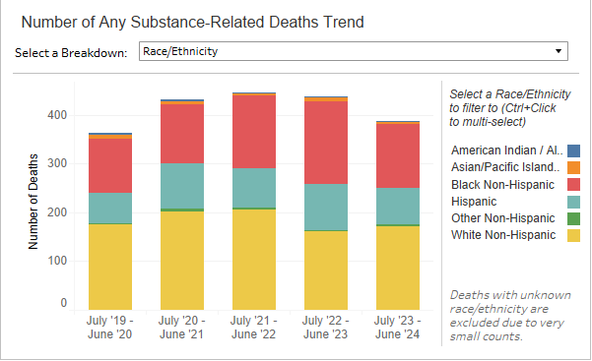 | 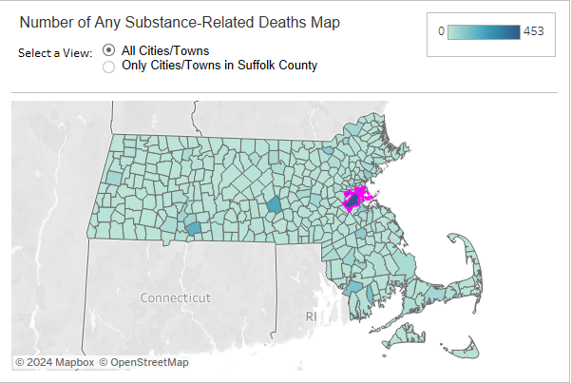
Use These Filters to Edit Both Visualizations
- ‘Select a Substance’: Display data based on a substance category (11 total).
- ‘Show by’: Display data based on a data type.
  - Death rate per 100k residents (crude rate)
  - Note that the map will switch to Age-Adjusted Rate when selecting this option
  - Number of death (count)
  - Percent of any deaths.
For more information on data types, visit the Common Data Types section.
Unique Filters for Each Visualization
- ‘Select a Breakdown’: Display chart based on another variable (7 total).  - Variables cover demographics, geography, urban/rural status, etc. | - ‘Select a View’: Display map based on geography.  - City/Town or County.
How Can this Help?
This measure can help to answer questions about your community's general substance use situation. Are certain subpopulations affected more than others? Which substances are involved in substance-related deaths among your community’s residents? How are trends changing over time?

Opioid-Related Overdose Deaths
Definition:
An opioid-related overdose death occurs when someone dies of an overdose that involves at least one opioid.
This only measures opioid-related overdose deaths among residents of your community. A resident of your community is someone with a usual place of residence or a permanent address in your community. This measure includes residents of your community who died either inside or outside your community. It does not include residents of other communities who died inside your community. Unhoused individuals with no known place of residence are also not included.
Using the Dashboard:
On the Opioid-Related Overdose Deaths tab, you can alter two charts using multiple filters.
Chart 1 (Left): Opioid Overdose Death Trend | Chart 2 (Right): Substances Present During Opioid Overdose Death Trend
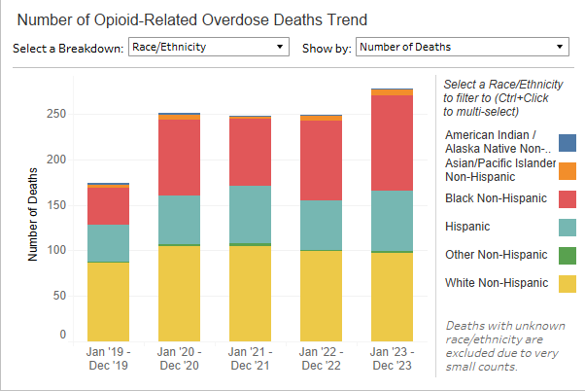 | 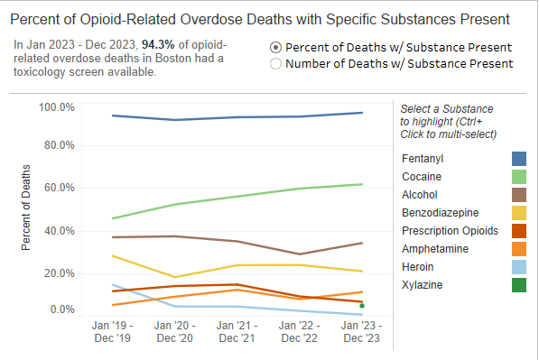
Unique Filters for Each Chart
- ‘Select a Breakdown’: Display chart based on another variable (7 total).  - Variables cover demographics, geography, urban/rural status, etc.  - ‘Show by’: Display chart based on a data type.  - Death rate per 100k residents (crude rate), Number of deaths (count), Percent of any deaths.  For more information on data types, visit the Common Data Types section. | - ‘Percent of deaths with Substance Present’: Percent.  - ‘Number of deaths with Substance Present’: Count.  Note that a toxicology screen is required to determine this information, but some opioid-related overdose deaths do not include a toxicology screen. The data on the right chart likely does not represent all opioid-related overdose deaths that occurred among your community’s residents.
How Can this Help?
This measure can help to answer questions about your community's situation with opioid use. Are certain subpopulations affected more than others? How many opioid-related deaths are due to overdose? Which substances are people using when they die due to an opioid-related overdose? How are trends changing over time?

Overdose Death Circumstances
Definition:
Records the potential for intervention during overdose deaths. This measure only includes county-level and state-level data.
Using the Dashboard:
On the Overdose Death Circumstances tab, you can view two charts.
Chart 1 (Left): County Overdose Death Circumstances | Chart 2 (Right): Overdose Death Circumstances Comparison
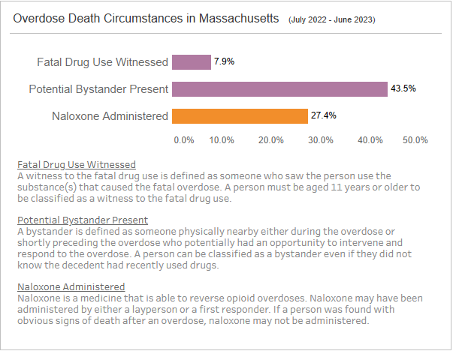 | 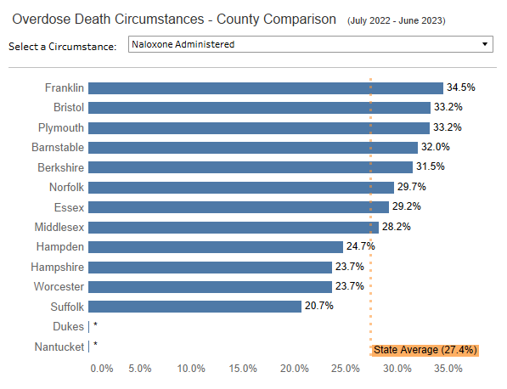
Unique Filters for Each Chart
None.  Included circumstances:  - Fatal drug use witnessed  - Potential bystander present  - Naloxone administered | - ‘Select a Circumstance’: Choose which overdose death circumstance you want to compare across counties.
Explanations for each circumstance are on the Overdose Death Circumstances page.
How Can this Help?
This measure can answer questions about the opportunity for intervention during overdoses. Do PWUD often use drugs in an isolated environment? How often do people witness an overdose? How often is naloxone administered during an overdose? Can bystanders recognize an overdose, and can they respond accordingly?
Scroll down or click the following link to access data measures on the ER Visits tab

ER Visits

[Substance]-Related ER Visits
Definition:
A substance-related ER visit occurs when at least one substance is involved in someone visiting an emergency room. Note that multiple substances can contribute to one ER visit. You can choose which substance category you want this measure to display.
This only measures ER visits among residents of your community. A resident of your community is someone with a usual place of residence or a permanent address in your community. This measure includes residents of your community who visited an ER either inside or outside your community. It does not include residents of other communities who visited an ER inside your community. Unhoused individuals with no known place of residence are also not included.
Using the Dashboard:
On the ER Visits tab, you can alter two visualizations using multiple filters.
Chart: ER Visits Trend | Map: Compare Communities
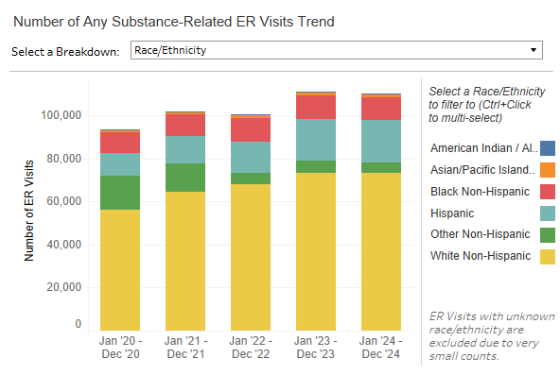 | 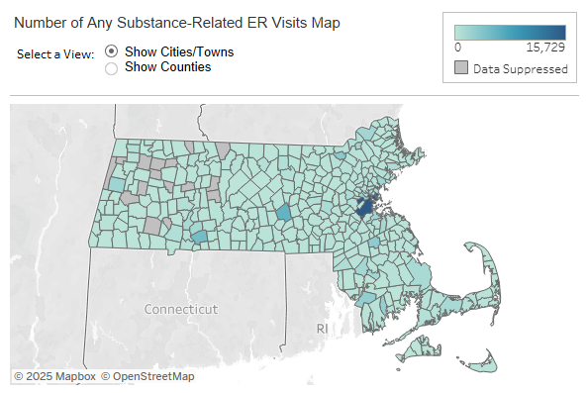
Use These Filters to Edit Both Visualizations
- ‘Select a Substance’: Display data based on a substance category (5 total).
- ‘Show by’: Display data based on a data type.
  - ER Visits rate per 100k residents (crude rate)
  - Note that the map will switch to Age-Adjusted Rate when selecting this option
  - Number of ER Visits (count).
For more information on data types, visit the Common Data Types section.
Unique Filters for Each Visualization
- ‘Select a Breakdown’: Display chart based on another variable (7 total).  - Variables cover demographics, geography, urban/rural status, etc. | - ‘Select a View’: Display map based on geography.  - City/Town or County.

How Can this Help?
This measure can help to answer questions about your community's general substance use situation. Are certain subpopulations affected more than others? How often do people visit an ER for substance-related reasons? Is ER care accessible? Which substances are involved in substance-related ER visits among your community’s residents? What demographic groups are involved in substance-related ER visits among your community’s residents? How are trends changing over time?

Opioid-Related EMS Incidents
Definition:
An opioid-related EMS incident occurs when opioids are involved in an emergency medical services call.
This measures all opioid-related EMS incidents that took place in your community. It includes incidents involving both residents of your community and residents of other communities.
Using the Dashboard:
This measure is only available on the Overview tab. To view the trend in this data, hover your mouse over its entry on the Dashboard.
How Can this Help?
This measure can help to answer questions about your community's situation with opioid use. Do PWUD choose to contact emergency services during health emergencies? Are opioids putting strain on your community's emergency health system? Are opioids prevalent in the drug supply? How are trends changing over time?
Scroll down or click the following link to access data measures on the Services tab.

Services

Individuals Admitted to Intervention & Engagement Services
Definition:
Records the number of people who were admitted to intervention & engagement services that are community-based, which refers to programs that are accessible to the public and provided outside institutional settings. These services are aimed at engaging individuals in the community, the providers of which do not need specific licensure (i.e. non-clinical). Examples include referrals to opioid urgent care centers and school outreach programs.
This measure only applies to residents of your community. A resident of your community is someone with a usual place of residence or a permanent address in your community. This measure includes residents of your community who enrolled in services at a BSAS-funded service provider located inside or outside your community. It does not include residents of other communities who enrolled in services at a BSAS-funded service provider inside your community. Unhoused individuals with no known place of residence are also not included
Using the Dashboard:
This measure is only available on the Overview tab. To view the trend in this data, hover your mouse over its entry on the Dashboard. You can also navigate to the Services tab under the ‘Service Accessibility’ subtab and use the ‘Select a View’ filter to select ‘Locations Where BSAS-Reported Clients Received Services’.
How Can this Help?
This measure can help to answer questions about your community's intervention & engagement services. Are PWUD accessing intervention & engagement services? Are intervention & engagement services accessible and appropriate for PWUD? Are PWUD aware of their service options? Are service providers coordinated with each other? Are service providers coordinated with ERs? How are trends changing over time?

Legal-Involved Individuals Admitted to Intervention & Diversion Services
Definition:
Records the number of people who were admitted involved intervention & diversion services that are legal-system Involved, which refers to services for individuals and families impacted by both Substance Use Disorder (SUD) and the legal-system. These services are aimed at engaging individuals and/or reducing recidivism. Service providers do not need specific licensure (i.e. non-clinical). Examples include drunk driver diversion services and drug court programs.
Using the Dashboard:
This measure is only available on the Overview tab. To view the trend in this data, hover your mouse over its entry on the Dashboard. You can also navigate to the Services tab under the ‘Service Accessibility’ subtab and use the ‘Select a View’ filter to select ‘Locations Where BSAS-Reported Clients Received Services’.
How Can this Help?
This measure can help to answer questions about your legal-involved intervention & diversion services. Are PWUD accessing legal-involved intervention & diversion services? Are legal-involved intervention & diversion services accessible and appropriate for PWUD? How to prepare PWUD in legal-system involved to community-based? Are service providers coordinated with each other? Are service providers coordinated with ERs? How are trends changing over time

Individuals Admitted to Treatment Services, Except MAT
Definition:
Records the number of people who were admitted to non-MAT treatment services that are community-based, which refers to programs that are accessible to the public and provided outside institutional settings. These are clinical services provided by licensed healthcare professionals. Examples include acute treatment services and outpatient services.
This measure only applies to residents of your community. A resident of your community is someone with a usual place of residence or a permanent address in your community. This measure includes residents of your community who enrolled in services at a BSAS-funded service provider located inside or outside your community. It does not include residents of other communities who enrolled in services at a BSAS-funded service provider inside your community. Unhoused individuals with no known place of residence are also not included
Using the Dashboard:
This measure is only available on the Overview tab. To view the trend in this data, hover your mouse over its entry on the Dashboard. You can also navigate to the Services tab under the ‘Service Accessibility’ subtab and use the ‘Select a View’ filter to select ‘Locations Where BSAS-Reported Clients Received Services’.
How Can this Help?
This measure can help to answer questions about your treatment services. Are PWUD accessing treatment services? Are treatment services accessible and appropriate for PWUD? Are PWUD aware of their service options? Are service providers coordinated with each other? Are service providers coordinated with ERs? How are trends changing over time?

Legal-Involved Individuals Admitted to Treatment Services, Except MAT
Definition:
Records the number of people who were admitted to non-MAT treatment services that are legal-system involved, which refers to services for individuals and families impacted by both Substance Use Disorder (SUD) and the legal-system. These are clinical services provided by licensed healthcare professionals, excluding medication-assisted treatment (MAT). Examples include County Corrections and State Parole Board.
Using the Dashboard:
This measure is only available on the Overview tab. To view the trend in this data, hover your mouse over its entry on the Dashboard. You can also navigate to the Services tab under the ‘Service Accessibility’ subtab and use the ‘Select a View’ filter to select ‘Locations Where BSAS-Reported Clients Received Services’.
How Can this Help?
This measure can help to answer questions about your legal-involved treatment services. Are PWUD accessing legal-involved treatment services? Are legal-involved treatment services accessible and appropriate for PWUD? How to prepare PWUD in legal-system involved to community-based? Are service providers coordinated with each other? Are service providers coordinated with ERs? How are trends changing over time?

Individuals Who Received Methadone
Definition:
Records the number of people who enrolled in services at an OTP in Massachusetts. OTPs provide services related to opioid use disorder. These programs typically utilize medications for addiction, including MOUD. Note that one visit to a provider may count for the BSAS service measure, the OTP service measure, and/or the prescription measures on the Dashboard. These measures can overlap.
This measure only applies to residents of your community. A resident of your community is someone with a usual place of residence or a permanent address in your community. This measure includes residents of your community who enrolled in services at a BSAS-funded service provider located inside or outside your community. It does not include residents of other communities who enrolled in services at a BSAS-funded service provider inside your community. Unhoused individuals with no known place of residence are also not included
Using the Dashboard:
This measure is only available on the Overview tab. To view the trend in this data, hover your mouse over its entry on the Dashboard. You can also navigate to the Services tab under the ‘Service Accessibility’ subtab and use the ‘Select a View’ filter to select ‘Locations Where BSAS-Reported Clients Received Services’.
How Can this Help?
This measure can help to answer questions about your community's opioid use situation. Is opioid treatment accessible and appropriate for people with opioid use disorder? Are people with opioid use disorder aware of their service options? Are service providers coordinated with each other? Are MOUD integrated into your community’s health system? How are trends changing over time?

Legal-Involved Individuals Admitted to MAT Treatment Services
Definition:
Records the number of people who were admitted to medication-assisted treatment (MAT) treatment services that are legal-system involved, which refers to services for individuals and families impacted by both Substance Use Disorder (SUD) and the legal-system. These are correctional MAT services provided by licensed healthcare professionals.
Using the Dashboard:
This measure is only available on the Overview tab. To view the trend in this data, hover your mouse over its entry on the Dashboard. You can also navigate to the Services tab under the ‘Service Accessibility’ subtab and use the ‘Select a View’ filter to select ‘Locations Where BSAS-Reported Clients Received Services’.
How Can this Help?
This measure can help to answer questions about your legal-system medication-assisted treatment (MAT) treatment services. Are PWUD accessing legal-system medication-assisted treatment (MAT) treatment services? Are legal-system medication-assisted treatment (MAT) treatment services accessible and appropriate for PWUD? How to prepare PWUD in legal-system involved to community-based? Are service providers coordinated with each other? Are service providers coordinated with ERs? How are trends changing over time?

Individuals Who Received Buprenorphine Rx’s
Definition:
Measures how many people received a buprenorphine prescription in your community. Buprenorphine is a widely used MOUD. Note that buprenorphine is one of multiple available MOUD. This measure does not cover all potential individuals who received prescriptions for MOUD.
This measure includes all individuals who received a buprenorphine prescription in your community. It includes both residents of your community and residents of other communities.
Using the Dashboard:
You can view this measure on the Overview tab. You can also view it on the Services tab when you select the ‘Treatment Service’ subtab.

Overview Tab: Count, Rate, Trend
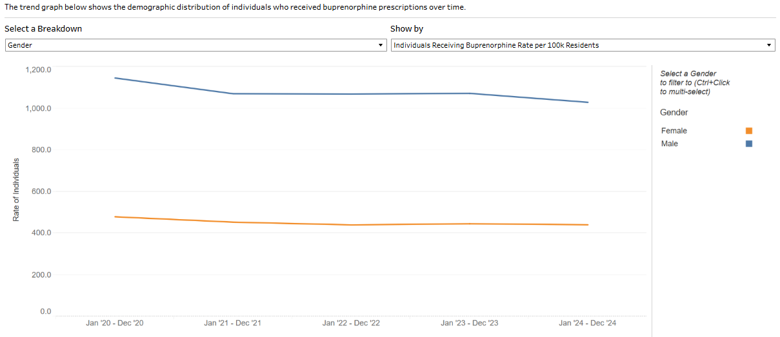
Use These Filters to Edit Both Visualizations
- ‘Select a Breakdown’: Display data based on gender or age
- ‘Show by’: Display data based on a data type.
  - Individuals Receiving Buprenorphine Rate per 100k residents (crude rate), Number of Individuals Receiving Buprenorphine (count).
For more information on data types, visit the Common Data Types section.

How Can this Help?
This can help to answer questions about MOUD and medications for addiction in your community. Is there a demand for MOUD? Are MOUD accessible? How often do providers utilize MOUD? Are these medications integrated into your community's health system? Are there regulations on MOUD and other medications for addiction? How are trends changing over time?

Individuals Admitted to Community Support Services
Definition:
Records the number of people who were admitted to community support services that are community-based, which refers to programs that are accessible to the public and provided outside institutional settings. These are services that provide ongoing support, the providers of which do not need specific licensure (i.e. non-clinical). Examples include re-entry services.
This measure only applies to residents of your community. A resident of your community is someone with a usual place of residence or a permanent address in your community. This measure includes residents of your community who enrolled in services at a BSAS-funded service provider located inside or outside your community. It does not include residents of other communities who enrolled in services at a BSAS-funded service provider inside your community. Unhoused individuals with no known place of residence are also not included
Using the Dashboard:
This measure is only available on the Overview tab. To view the trend in this data, hover your mouse over its entry on the Dashboard. You can also navigate to the Services tab under the ‘Service Accessibility’ subtab and use the ‘Select a View’ filter to select ‘Locations Where BSAS-Reported Clients Received Services’.
How Can this Help?
This measure can help to answer questions about your community-based community support services. Are PWUD accessing community-based community support services? Are community-based community support services accessible and appropriate for PWUD? Are PWUD aware of their service options? Are service providers coordinated with each other? Are service providers coordinated with ERs? How are trends changing over time?

Legal-Involved Individuals Admitted to Community Support Services
Definition:
Records the number of people who were admitted to community support services that are legal-system involved, which refers to services for individuals and families impacted by both Substance Use Disorder (SUD) and the legal-system. These are services that provide ongoing support, the providers of which do not need specific licensure (i.e. non-clinical). Examples include re-entry services.
Using the Dashboard:
This measure is only available on the Overview tab. To view the trend in this data, hover your mouse over its entry on the Dashboard. You can also navigate to the Services tab under the ‘Service Accessibility’ subtab and use the ‘Select a View’ filter to select ‘Locations Where BSAS-Reported Clients Received Services’.
How Can this Help?
This measure can help to answer questions about your community-based community support services. Are PWUD accessing community-based community support services? Are community-based community support services accessible and appropriate for PWUD? How to prepare PWUD in legal-system involved to community-based? Are service providers coordinated with each other? Are service providers coordinated with ERs? How are trends changing over time?

Naloxone Kits Distributed
Definition:
Measures the number of naloxone kits distributed in your community. This measure counts DPH-funded naloxone kits that were either distributed through a state-funded naloxone distribution program such as the Overdose Education and Naloxone Distribution (OEND) program or the Community Naloxone Program (CNP), ordered by first responders for emergency response, or filled as a prescription at a pharmacy (including Standing Order naloxone). Over-the-counter purchases of naloxone at a pharmacy are not included. Each kit contains two doses of naloxone. Naloxone is a medication that temporarily reverses an opioid overdose. It is a powerful harm reduction resource. Note that this does not measure the number of naloxone kits used. Some kits may remain unused after receipt or purchase.
Using the Dashboard:
You can view this measure on the Overview tab. You can also view it on the Services tab under the ‘Community Support Services’ subtab when you use the ‘Select a Breakdown’ filter to select ‘Naloxone Kits Distributed.

Overview Tab: Count, Rate, Trend | Services Tab: Locations of Naloxone Kits Distributed
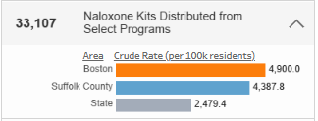 | 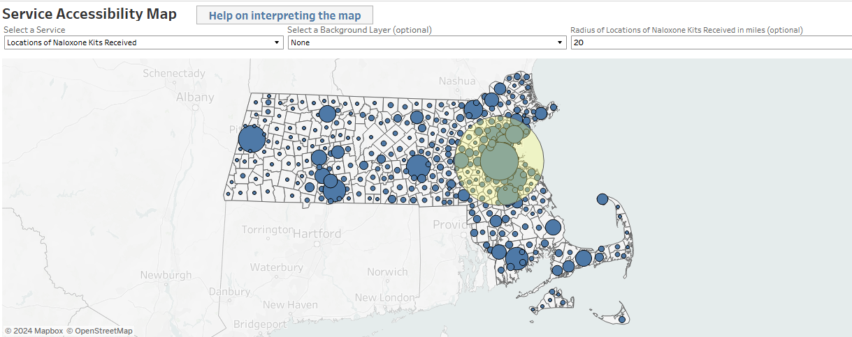
Unique Aspects
- Click the dropdown arrow to access this measure’s crude rate and comparisons.  - Hover your mouse over this measure to access its trend. | - Hover your mouse over a point to view how many kits were distributed within the selected “radius”.  - ‘Select a Background Layer’: View data based on city/town percentiles of opioid-related overdose deaths.  - Count or Age-Adjusted Rate.  - ‘Radius of Locations’: View how many kits were distributed within a specific distance from your selected community.  - Naloxone kits may be moved to or used in surrounding communities after receipt or purchase. Some communities will redistribute naloxone kits to nearby communities. The radius feature allows you to estimate how many naloxone kits were received by the general community surrounding the selected city/town/county.
How Can this Help?
This can help to answer questions about harm reduction resource availability. Is naloxone available in your community and surrounding communities? Is naloxone accessible for PWUD? How are trends changing over time?

Fentanyl Test Strips Received
Definition:
Measures the number of fentanyl test strips received in your community. This counts test strips that were delivered through either a BSAS-funded shipment or the Department of Public Health’s Health Promotion Clearinghouse. Other methods of obtaining test strips are not included. Fentanyl test strips are used to test drugs for the presence of fentanyl. They are a powerful harm reduction resource. Note that this does not measure the number of test strips used. Some test strips remain unused after delivery or purchase.
Using the Dashboard:
You can view this measure on the Overview tab. You can also view it on the Services tab under the ‘Community Support Services’ subtab when you use the ‘Select a Breakdown’ filter to select ‘Fentanyl Test Strips Received’.
Overview Tab: Count, Rate, Trend | Services Tab: Locations of Fentanyl Test Strips Received
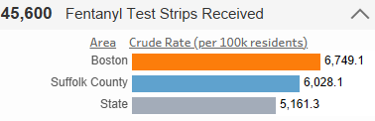 | 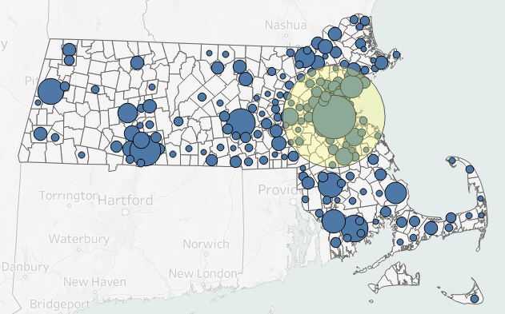
Unique Aspects
- Click the dropdown arrow to access this measure’s crude rate and comparisons.  - Hover your mouse over this measure to access its trend. | - Hover your mouse over a point to view how many test strips that location received.  - ‘Select a Background Layer’: View data based on city/town percentiles of opioid-related overdose deaths.  - Count or Age-Adjusted Rate.  - ‘Radius of Locations’: View how many test strips were received within a specific distance from your selected community.  - Fentanyl test strips kits may be moved to surrounding communities after delivery or purchase. Some communities will redistribute fentanyl test strips to nearby communities.
How Can this Help?
This can help to answer questions about harm reduction resource availability. Are fentanyl test strips available in your community and surrounding communities? Are test strips accessible for PWUD? How are trends changing over time?

Naloxone Kits Distributed per Opioid Overdose Death
Definition:
Compares the number of naloxone kits distributed in your community to the number of opioid-related overdose deaths among your community’s residents. This is a ratio, and it can be written as:
$$\frac{Number of Naloxone Kits Distributed in Your Community}{Number of Overdose Deaths Related to Opioids Among Your Community^{'}s Residents}$$
For more information on the measures used in this ratio, refer to the Naloxone Kits Distributed and Opioid-Related Overdose Deaths entries in this section.
Using the Dashboard:
This measure is only available on the Data to Action tab by selecting the “Reduce Opioid-Related Overdose Deaths by Increasing Naloxone Kits Distributed” strategy.
How Can this Help?
For further context on what this measure means for your community, read the Reduce Opioid-Related Overdose Deaths by Increasing Naloxone Kits Distributed entry.

Locations Where BSAS-Reported Clients Received Services
Definition:
Shows where your community's residents accessed BSAS-funded service providers. This also provides the number of residents from your community who accessed services, and the number of providers they accessed in each location. Please note that BSAS funds only a portion of all the substance use service providers in the state. This does not represent all people who accessed services, nor all substance use service providers in the state.
Using the Dashboard:
To view this measure, navigate to the Services tab under the ‘Service Accessibility’ subtab and use the ‘Select a View’ filter to select ‘Locations Where BSAS-Reported Clients Received Services’. The page displays this information using a map on the left side of the page. Hover your mouse over each location to access the data.
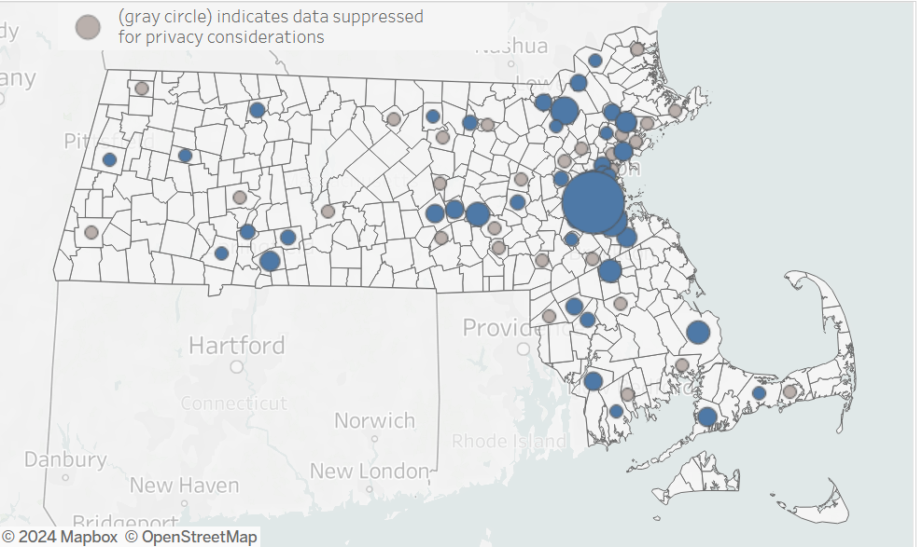
How Can this Help?
This measure can help to answer questions about your community's treatment system. Are services accessible and appropriate for PWUD? What is the burden of travel for people seeking services? Do people often leave your community to seek services? Does travel burden impact peoples' willingness to access services?

Service Categories
Definition:
This measure shows how many BSAS-Reported providers are present in your community for each service category. It also shows how many residents of your community accessed BSAS-funded providers from each service category. Note that BSAS funds only a portion of all the substance use service providers in the state. This does not represent all people who accessed services, nor all substance use service providers in the state.
The two service categories are: community-based services (intervention & engagement Services, treatment services and community support services.) and legal-involved services (intervention & diversion services, treatment services, MAT services, community support). For more information on these categories, visit the Glossary page on the dashboard.
Using the Dashboard:
To view this measure, navigate to the Services tab under the ‘Service Accessibility’ subtab and use the ‘Select a View’ filter to select ‘Locations Where BSAS-Reported Client Received Services’. The page displays this information in a chart on the right side of the page. Hover your mouse over each bar to access the exact data.
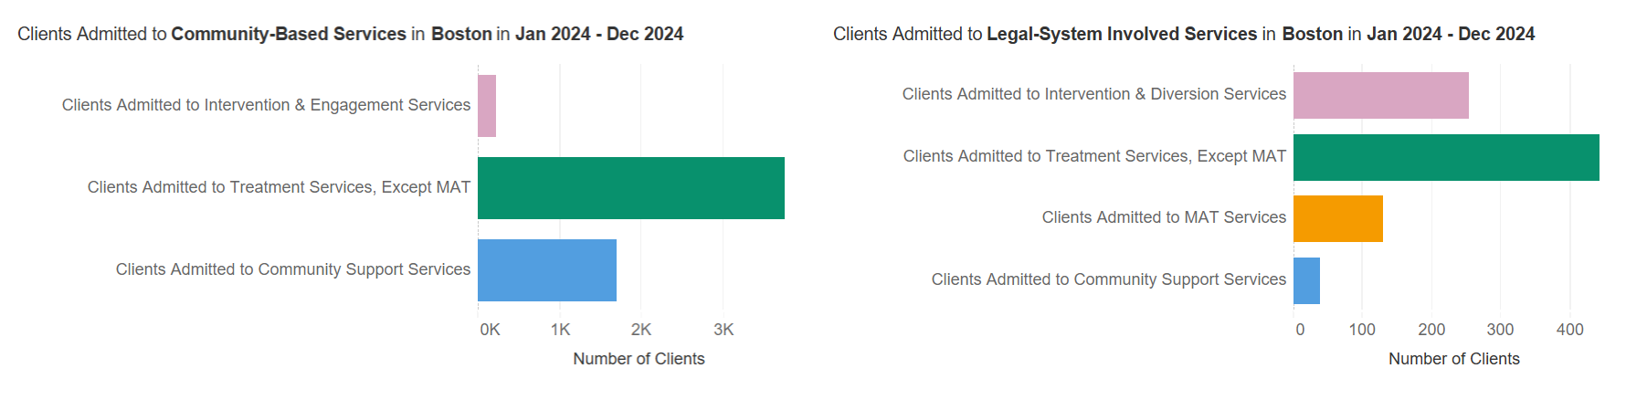
How Can this Help?
This measure can help to answer questions about your community's substance use treatment system. Is treatment accessible and appropriate for PWUD? Do the service types available meet the needs of PWUD? Are certain services underutilized?

Percentile of Opioid-Related Overdose Deaths
Definition:
Orders communities by opioid-related overdose death percentiles. The percentile categories on the dashboard are bottom 25%, middle 50%, and top 25%. These categories can be broadly defined as “low,” “moderate,” and “high” for opioid-related overdose deaths relative to other communities.
Using the Dashboard:
To view this measure, navigate to the Services tab under the ‘Community Support Service’ subtab. Use the ‘Select a Breakdown’ filter to select either ‘Naloxone Kits Distributed’ or ‘Fentanyl Test Strips Received’. Then, use the ‘Select a Background Layer’ filter to select either ‘Number of opioid-related overdose deaths’ or ‘Age-adjusted rate of opioid-related overdose deaths’. This will allow you to view communities’ percentile group for the count or age-adjusted rate of opioid-related overdose deaths, respectively. The percentile category may change depending on which option you choose.
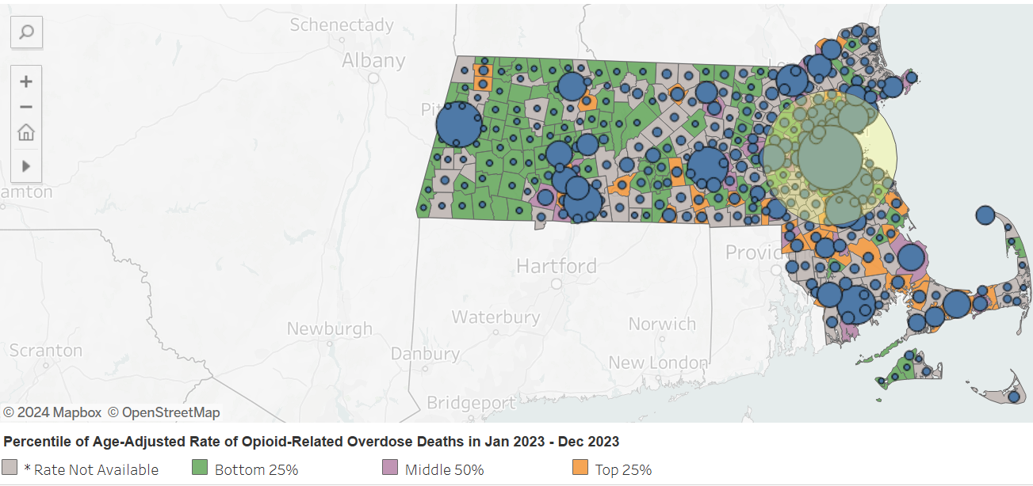
How Can this Help?
This measure can help to answer questions about your community's situation with opioid use. Are opioid-related overdose deaths prevalent? Are there any trends for the area surrounding your community? What can this tell you about the need for cross-community collaboration?
Scroll down or click the following link to access data measures on the Data to Action tab.

Accessibility to Providers
Definition:
Shows the service areas covered by each BSAS-licensed or Enterprise Invoice/Service Management (EIM/ESM) provider, incorporating different modes of transportation and estimated travel times. Note that provider information can change frequently.

Using the Dashboard:
To view this measure, navigate to the Services tab and select the ‘Service Accessibility’ subtab. Use the ‘Select a View’ filter to choose ‘Accessibility to Providers.’ To identify areas with potential for new providers, open the ‘Overlay Population Estimates’ dropdown. You can analyze accessibility using different transport modes by selecting the ‘Transport Option’—choose from drive-time, walk-time, or public-transit time. For drive-time, you can view time ranges of 0–15 minutes or 0–30 minutes; for walk-time and public transit, select either 0–30 minutes or 0–60 minutes. Additionally, use the ‘Service Category’ filter to focus on providers offering either ‘Treatment’ or ‘Wraparound’ services. Then, filter the specific service type you want to focus on by using the ‘[Treatment/Wraparound] Service Type’ filter.
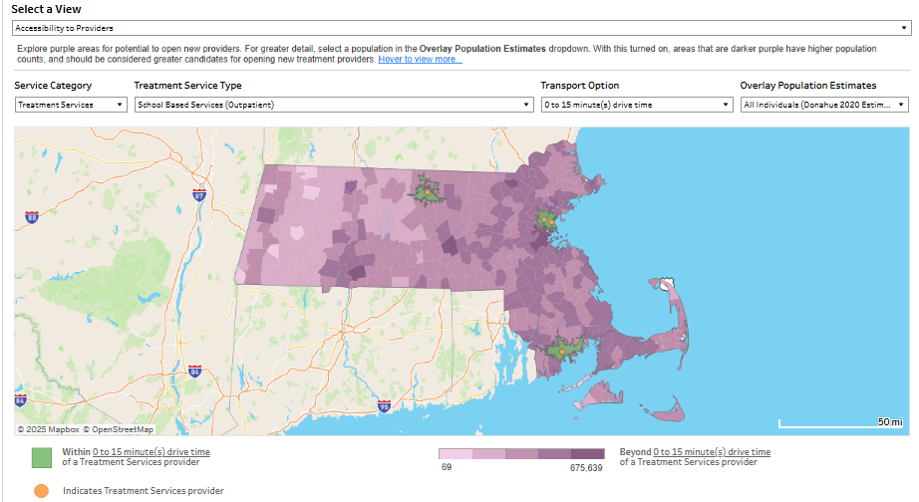
In addition to the service accessibility map, the bar chart below is a sample of what you would see based on your selections that provides a summary of the number of providers in each service category for the selected community.
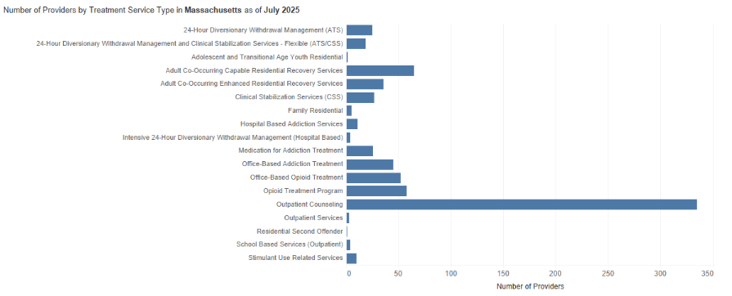

How Can this Help?
This measure can help to answer questions about your community's treatment system. Are services accessible and appropriate for PWUD? What is the service coverage for different travel modes for people seeking services? Is there any potential area to open new providers?

Data to Action

Reduce Opioid-Related Overdose Deaths by Increasing Naloxone Kits Distributed
Definition:
Compares the number of naloxone kits distributed in your community to the number of opioid-related overdose deaths among your community’s residents. This is a ratio, and it can be written as:
$$\frac{Number of Naloxone Kits Distributed in Your Community}{Number of Overdose Deaths Related to Opioids Among Your Community^{'}s Residents}$$
For more information on the measures used in this ratio, refer to the Naloxone Kits Distributed and Opioid-Related Overdose Deaths entries.
This measure uses one benchmark called ‘Minimum Recommended Threshold (80)’ to judge the relationship between naloxone kits and opioid-related overdose deaths. At least 80 kits per opioid-related overdose deaths are recommended.
This measure also shows the state and county ratios for comparison.
Using the Dashboard:
To view these measures, navigate to the Data to Action tab. Use the ‘Select a Strategy’ filter to select ‘Reduce Opioid-Related Overdose Deaths by Increasing Naloxone Kits Distributed’.
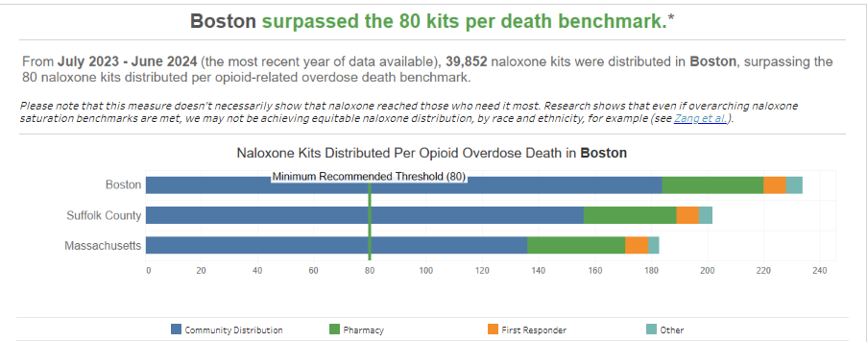
The first visual will show you the relationship between naloxone kits distributed and opioid-related overdose deaths, broken down by distribution sources (as indicated by the different colored bars).
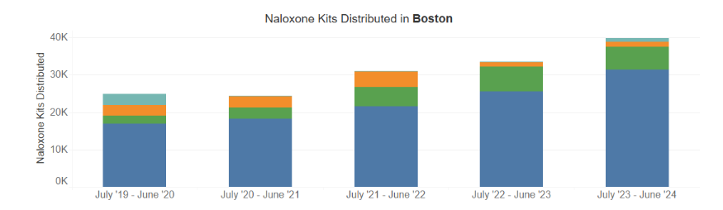
The second visual will show you the trend of total naloxone kits distributed over the past five years (not as a ratio), also broken down by distribution sources.
How Can this Help?
This can help to answer questions about naloxone availability compared to the extent of the overdose crisis in the selected community. Is naloxone relatively available in your community compared to the number of people fatally overdosing each year? How prevalent are opioid-related overdose deaths among your community’s residents? How accessible are harm reduction resources like naloxone? Which entities are using the most and the least naloxone in your community (e.g., community members receiving it from a community distribution program vs. first responders)? Are people utilizing naloxone and other harm reduction resources? Are PWUD aware of the available resources? Do PWUD trust distributors of harm reduction resources?

Reduce Opioid-Related Overdose Deaths by Received Buprenorphine or Methadone
Definition:
Compares the estimated percentage of individuals with Opioid Use Disorder (OUD) who received buprenorphine or methadone to three benchmarks:
- U.S. MOUD National Average
- Baseline Benchmark
- Current Benchmark
The estimated percentage of individuals with Opioid Use Disorder (OUD) received can be calculated from:
$$\frac{Number Individuals received buprenorphine or Methadone}{Number of individuals to have Opioid Use Disorder (OUD)}$$
This measure only shows at the state level
Using the Dashboard:
To view these measures, navigate to the Data to Action tab. Use the ‘Select a Strategy’ filter to select ‘Reduce Opioid-Related Overdose Deaths by received buprenorphine or methadone’.
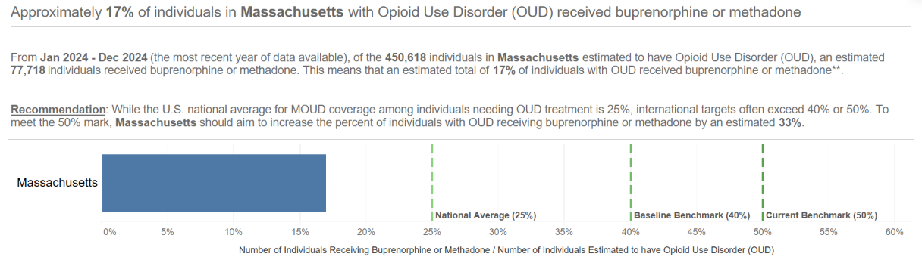
How Can this Help?
This can help to answer questions about harm reduction resource availability. It can also help to answer questions about opioid use. Is methadone or buprenorphine relatively available for the overall population in the state? How accessible are harm reduction resources like methadone or buprenorphine? How much to increase is needed to meet the MOUD benchmarks?

Dashboard Tips & Tricks
The following is a brief list of tips for successfully navigating the BSAS Dashboard. For further guidance on using the Dashboard, watch the video tutorials on both the Community Profile page and the Data on BSAS Enrollments page.
Contact BSASdashboard.info@mass.gov if you have any questions about the BSAS Dashboard, and visit this link to access BSAS’ data request form for more in-depth data requests.

Getting More Information
Hovering (not clicking) your mouse cursor over different parts of the data will pull up a window with further information.
For example, on the Overview tab of the Community Profile page, hovering your mouse cursor over most of the bolded numbers will pull up a bar graph showing the trend in that data measure over time. For some measures, such as Individuals Admitted to BSAS Services, this is the only way to view trends over time.
The windows often reword graphical data into complete sentences. This can help to clarify what the data is referring to. If you are ever confused about what a certain graphic or number means, then hover your mouse over the confusing portion. It may clear things up.

Reading Data Notices
BSAS encourages all users of the BSAS Dashboard to read the appropriate data notice(s) for the measure(s) you are investigating. This will help you better understand how the data on the Dashboard was collected and what it includes. Data notices are typically denoted by an “i” symbol or a question mark symbol:
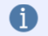

Using Filters
Most tabs include options to filter the data based on substance, time, measure, and other choices as appropriate. This can help to narrow the displayed data into exactly what you are looking for. Always check your filter settings to ensure that your desired graphic is displayed.

Data Timing
The data on the BSAS Dashboard originates from multiple sources. Because of this, certain data measures may represent different time periods. Some data measures may be more up to date than others. When interpreting a data measure, be mindful of what time period, or point in time, it covers.

Data Suppression
Some of the data on the BSAS Dashboard is represented as a range of values or is not represented at all. This is to ensure the confidentiality of sensitive health data, and it is more common with measures that include few data points.
Having suppressed data does not mean that the data is insignificant. For example, a small number of substance-related deaths may still be significant for smaller communities. Smaller communities are more likely to run into suppressed data, but there are ways these communities can overcome this barrier. For example, small communities can use community-collected data. These communities can also partner with other communities to combine data during data requests, which may lessen the likelihood of suppression.

Download and Analyze
Click the download button to download the data of the tab you are currently viewing. This will allow you to access the data as a CSV file, which you can then import into various data analysis or spreadsheet software such as Microsoft Excel. The download button, represented by a downward arrow, opens two download options for the “Selected Community” or “All Communities”:
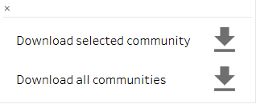

Glossary
Visit the Glossary page of the BSAS Dashboard to access the definitions of terms you may not be familiar with. You can access the Glossary using the menu located in the top left corner of the dashboard:


