Looking for data on schools and districts in Massachusetts?

The Massachusetts Department of Elementary and Secondary Education (ESE) has developed a suite of tools designed to support the use of data that is collected regularly from school districts. ESE’s tools are designed to present these data in a way that is timely, relevant, and useful to Massachusetts educators and the public. ESE’s three primary data platforms are:

**• School and District Profiles** *(*http://profiles.doe.mass.edu/*)*

**• District Analysis and Review Tools (DARTs)** *(*http://www.doe.mass.edu/apa/dart/*)*

**• Edwin Analytics** *(*https://gateway.edu.state.ma.us/*)*

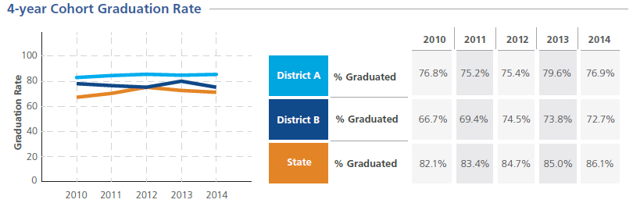

|  |  |  |  |
| --- | --- | --- | --- |
|  | **School and District Profiles** | **District Analysis and Review Tools (DARTs)** | **Edwin Analytics** |
| **Who can access it?** | Public Access | Public Access | Limited to educators granted access by their district |
| **What can I do with it?** | * Learn more about your local district or school | * Easily make comparisons between similar districts or schools, and analyze trends over time. | * Access data at the student level and dive into longitudinal data. |
| **What does it include?** | • Enrollment reports  • State assessment results  • Graduation rates  • District expenditures  • Accountability infor­mation  • And much more! | • Comparative displays of a variety of indicators, including enrollment, performance, and achievement gap data | • Annual state assessment data,  • Early Warning Indicator System (EWIS) data,  • Postsecondary outcomes of high school graduates,  • District and school financial data  • Trends over time that can be filtered by grade and student subgroup  • And much more! |
| **Where can I get it?** | http://profiles.doe.mass.edu/ | http://www.doe.mass.edu/apa/dart/ | https://gateway.edu.state.ma.us/ |
| **Where can I get help?** | data@doe.mass.edu | | |

"Learn more" icon
**Instructional Resources**

Look for the “Learn More” icon to access tutorials providing additional support on using the data