Data Update: Ewings Family of Tumors (EFOT) in Barnstable County

Massachusetts Department of Public Health June 2016

T
he Community Assessment Program (CAP) of the Massachusetts Department of Public Health, Bureau of Environmental Health (MDPH/BEH) has evaluated the incidence of the Ewings Family of Tumors (EFOT) in Barnstable County to follow up on a previous report released in December 2007. This prior report found that seven children (0 to 19 years of age) on Cape Cod were diagnosed with EFOT during the 10-year time period of 1995 to 2004 compared to approximately two that would be expected based on the statewide experience - an elevation that was statistically significant. Closer examination revealed a somewhat unusual temporal pattern with a slightly higher number of diagnoses in 2003 and 2004.
This bulletin describes changes to the classification of EFOT that have been widely accepted by the oncology field since the time of the initial evaluation and revisits the incidence of EFOT in Barnstable County during 1995 to 2004 using this updated classification scheme. It also summarizes the incidence of EFOT in Barnstable County during more recent years, the 7-year time period of 2005 to 2011.
Figure 1. Communities within Barnstable County

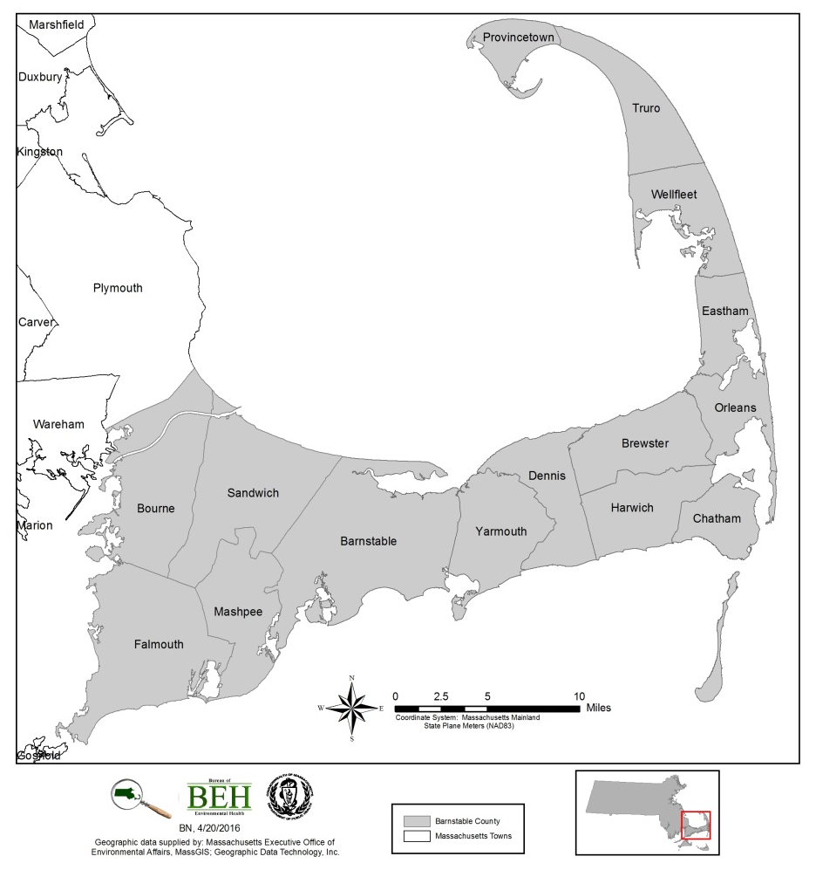
What is EFOT?
EFOT is a group of cancers that start in the bones or nearby soft tissues that share some common features. They consist of the following three types of cancers:
- Ewing sarcoma of bone
  - This type of tumor was first described by Dr. James Ewing in 1921, who found that it was different from the more common bone tumor, osteosarcoma.
- Extraosseous Ewing tumor (also known as extraskeletal Ewing sarcomas)
  - This type of tumor looks and acts very much like Ewing sarcomas in bone but starts in soft tissues around bones.
- Peripheral primitive neuroectodermal tumor (pPNET)
  - This tumor may start in bone or soft tissue and shares many features with the two tumors listed above. Peripheral PNETs that start in the chest wall are known as Askin tumors.
The cells of these three tumor types have the same abnormalities in their DNA. Nearly all EFOT cells have changes that involve the EWS gene, which is found on chromosome 22. In most cases, the change is a swapping of pieces of DNA (called a translocation) between chromosomes 22 and 11. Less often, the swap is between chromosomes 22 and 21, or rarely between 22 and another chromosome. The translocation causes the EWS gene to be turned on all the time, which leads to overgrowth of the cells and the development of this cancer. The reason that such translocations occur is not yet clear but it is important to understand that these changes involving the EWS gene are not inherited (ACS 2016).
Classification of EFOT
The definition of EFOT in this bulletin is based on the International Classification of Childhood Cancers (ICCC) utilized by the Surveillance, Epidemiology, and End Results Program (SEER) of the National Cancer Institute (NCI).
Table 1. Classification of Ewing’s Family of Tumors
Site Group | Histology | Primary Site
Ewing tumor and Askin tumor of bone | 9260 | C40.0-41.9, C76.0-76.8, C80.9
 | 9365 | C40.0-41.9
pPNET of bone | 9363-9364 | C40.0-41.9
Ewing tumor and Askin tumor of soft tissue | 9260 | C00.0-39.9, C47.0-75.9
 | 9365 | C00.0-39.9, C47.0-63.9, C65.9-76.8, C80.9
pPNET of soft tissue | 9364 | C00.0-39.9, C47.0-63.9, C65.9-69.9, C73.9-76.8, C80.9
pPNET of kidney | 9364 | C64.9
Source: Steliarova-Foucher E, Stiller C, Lacour B and Kaatsch P. International classification of childhood cancer, third edition. 2005. Cancer, 103, 1457-1467. Updated for Hematopoietic codes based on WHO Classification of Tumours of Haematopoietic and Lymphoid Tissues (2008).

It is important to note that coding changes were implemented by SEER in 2007 whereby some new diagnoses that would have been previously coded to histology 9260 would instead be coded to histology 9364 (Johnson et al., 2007). As a result, it is not possible to provide more detailed incidence data for any particular site group. Rather, the data presented here are for EFOT as a whole.
EFOT in Barnstable County during 1995 to 2004:
During the 10-year time period of 1995 to 2004, a total of nine individuals in Barnstable County were diagnosed with EFOT compared to about four that would be expected based on the statewide experience. This difference was of borderline statistical significance. The majority occurred among children with seven diagnoses observed compared to about two that would be expected - an elevation that is statistically significant.
Table 2. Incidence of Ewing’s Family of Tumors, Barnstable County, 1995-2004
Source: Massachusetts Cancer Registry, Office of Data Management and Outcomes Assessment, MDPH

According to the American Cancer Society, most diagnoses of EFOT occur in the early teenage years for unknown reasons, but they can also occur in younger children as well as in adults (ACS 2015). The ages of the nine individuals diagnosed with EFOT in Barnstable County during this 10-year time period followed this pattern with the majority of individuals diagnosed within the second decade of life (i.e., 10-19 years of age). As noted in the 2007 report, a review of the temporal distribution revealed a total of five diagnoses occurred during 2003 and 2004. In addition, no geographic clustering of addresses at the time of diagnosis was observed with one exception; two individuals lived in close proximity to one another at the time of their diagnosis but their diagnoses occurred approximately five years apart.
Note that the data provided in Table 2 differs slightly from that in the earlier 2007 report for two reasons. First, the classification used in this update is the ICCC as discussed previously. Second, the MCR is a dynamic database in which slight changes reflect late reported cases, address corrections, or other changes based on subsequent details from reporting facilities.
EFOT in Barnstable County during 2005 to 2011:
During the 7-year time period of 2005 to 2011, two individuals in Barnstable County were diagnosed with EFOT compared to about 3 that would be expected based on the statewide experience. Both individuals were children (i.e., under age 20). In order to protect patient confidentiality, no further detail about these individuals will be provided.
Table 3. Incidence of Ewing’s Family of Tumors, Barnstable County, 2005-2011
Source: Massachusetts Cancer Registry, Office of Data Management and Outcomes Assessment, MDPH

DISCUSSion
A risk factor is anything that increases a person’s chance of developing cancer and can include hereditary conditions, medical conditions or treatments, infections, lifestyle factors, or environmental exposures. Studies of children diagnosed with EFOT have not found links to radiation, chemicals, or any other environmental exposures. Although temporal clustering was noted in the years 2003 and 2004, with five individuals in Barnstable County diagnosed with EFOT during these two years, two of those individuals lived at their residences for less than one year making it less likely that residence in Barnstable County was associated with their diagnoses.
CONCLUSIONS
Although the incidence of EFOT was statistically significantly elevated among children in Barnstable County during the 10-year time period of 1995 to 2004, this elevation did not persist over time. During the 7-year time period of 2005 to 2011, two diagnoses of EFOT occurred among children compared to one that would be expected. MDPH/BEH will continue to monitor the incidence of EFOT in Barnstable County and will re-evaluate the incidence when data is available for the entire 10-year time period of 2005 to 2014.
Data SOURCES AND METHOD Notes
Data Source:
Massachusetts Cancer Registry, Office of Data Management and Outcomes Assessment, MDPH.

Method Notes:
All new diagnoses of invasive cancer, as well as certain in situ (localized) cancers, are required by law to be reported to the MCR within six months of the date of diagnosis (M.G.L. c.111. s 111b).
Individuals diagnosed with cancer were selected for inclusion based on the residential address provided to the hospital or reporting medical facility at the time of diagnosis.
The seven-year period 2005-2011 constitutes the period for which the most recent and complete cancer incidence data were available at the initiation of this analysis.
An SIR is the ratio of the observed number of cancer diagnoses in an area to the expected number of diagnoses multiplied by 100. Age-specific statewide incidence rates were applied to the population distribution of Barnstable County to calculate the number of expected cancer diagnoses.
It is standard MCR policy not to calculate rates with fewer than five observed diagnoses due to the instability of the rate.
The statistical significance of an SIR is assessed by calculating a 95% confidence interval (CI) to determine if the observed number of diagnoses is “statistically significantly different” from the expected number or if the difference may be due solely to chance. If the 95% CI range does not include the value 100, then the study population is significantly different from the comparison or “normal” population. “Statistically significantly different” means there is less than a 5% percent chance that the observed difference (either increase or decrease) in the rate is the result of random fluctuation in the number of observed cancer diagnoses.
The MDPH is bound by state and federal patient privacy and research laws not to make public the names or any other information (e.g., place of residence) that could personally identify individuals with cancer whose diagnoses have been reported to the MCR (M.G.L. c.111. s. 24A).

REFERENCES
American Cancer Society (ACS). 2016. Detailed Guide: Ewing Family of Tumors. Available at www.cancer.org.

Johnson CH, Peace S, Adamo P, Fritz A, Percy-Laurry A, Edwards BK. The 2007 Multiple Primary and Histology Coding Rules. National Cancer Institute, Surveillance, Epidemiology and End Results Program. Bethesda, MD, 2007.

Steliarova-Foucher E, Stiller C, Lacour B and Kaatsch P. International classification of childhood cancer, third edition. 2005. Cancer, 103, 1457-1467. Updated for Hematopoietic codes based on WHO Classification of Tumours of Haematopoietic and Lymphoid Tissues (2008).

RESOURCES

For additional cancer incidence data:  Massachusetts Environmental Public Health Tracking  250 Washington Street, 7th Floor  Boston MA, 02108  Tel. (800) 319-3042  www.mass.gov/dph/matracking | For more information on cancer data:  Massachusetts Cancer Registry  250 Washington Street, 6th Floor  Boston MA, 02108  Tel. (617) 624-5642  www.mass.gov/dph/mcr
For information on this bulletin or other cancer concerns:
MDPH Bureau of Environmental Health
250 Washington Street, 7th Floor
Boston MA, 02108
Tel. (617) 624-5757
www.mass.gov/dph/environmental_health

