INDOOR AIR QUALITY ASSESSMENT

David Prouty High School
302 Main Street
Spencer, Massachusetts

Prepared by:
Massachusetts Department of Public Health
Bureau of Environmental Health
Indoor Air Quality Program
December 2015

Background
Building: | David Prouty High School (DPHS)
Address: | 302 Main Street, Spencer, MA
Assessment Requested by: | N. Tracy Crowe, Ed.D., Superintendent Spencer-East Brookfield Regional School District
Date of Assessment: | October 23, 2015
Bureau of Environmental Health/Indoor Air Quality (BEH/IAQ) Program Staff Conducting Assessment: | Mike Feeney, Director, IAQ Program  Cory Holmes, Environmental Analyst/Inspector  Jason Dustin, Environmental Analyst/Inspector
Date of Building Construction: | 1966
Reason for Request: | General IAQ assessment
Building Description
The DPHS is a red brick building complex that consists of a three-story academic classroom wing connected by a bridge to a single-story wing that contains common areas such as the cafeteria, shops, music room, auditorium, and gymnasium and office space. No additions or major renovations have reportedly been made to the building. The DPHS space is occupied by approximately 395 students and 45 staff members. Windows are openable throughout the school.

Methods
Please refer to the IAQ Manual for methods, sampling procedures, and interpretation of results (MDPH, 2015).

Results
Test results are presented in Table 1.

Discussion

Ventilation
It can be seen from Table 1 that carbon dioxide levels were above 800 parts per million (ppm) in 17 of 38 areas surveyed, indicating a lack of air exchange in almost half the areas surveyed. Most environmental and occupational health scientists involved with research on IAQ and health effects have documented significant increases in indoor air quality complaints and/or health effects when carbon dioxide levels rise above 800 ppm for schools, office buildings, and other occupied spaces (Sundell et al., 2011). The Massachusetts Department of Public Health (MDPH) recommends that carbon dioxide levels be maintained below 800 ppm. It is also important to note that a number of classrooms had open windows or were empty/sparsely populated during the assessment, which can contribute to reduced carbon dioxide levels.
Fresh air is supplied to classrooms by unit ventilator (univent) systems (Picture 1). A univent draws air from the outdoors through a fresh air intake located on the exterior wall of the building (Picture 2) and returns air through an air intake located at the base of the unit (Figure 1). Fresh and return air are mixed, filtered, heated, and provided to classrooms through an air diffuser located in the top of the unit. Univents were found deactivated in many areas (Picture 3, Table 1); therefore there was no means to provide mechanical ventilation to these classrooms at the time of the assessment. Univents were also found obstructed by various items (particularly in the art room, Picture 4) or had missing/damaged diffusers/panels, exposing belts/moving parts of the units (Pictures 5 and 6), which can damage them or be a safety hazard. In order for univents to provide fresh air as designed, intakes/returns must remain free of obstructions. Importantly, these units must remain “on” and be allowed to operate while rooms are occupied.
In addition, although some motors appear to have been replaced, univents are original to the building’s construction, which makes them close to 50 years old. Efficient function of such aged equipment is difficult, since compatible replacement parts are often unavailable. According to the American Society of Heating, Refrigeration, and Air-Conditioning Engineering (ASHRAE), the service life for a unit heater (hot water or steam) is 20 years, assuming routine maintenance of the equipment (ASHRAE, 1991). Despite attempts to maintain the equipment, the operational lifespan of this equipment has been exceeded.
Mechanical exhaust ventilation in the classroom wing is provided by unit exhaust ventilators (Picture 7). A unit exhaust ventilator appears similar to a univent, but removes air from the classroom and exhausts it out of the building (Picture 2). Unit exhaust ventilators were not operating in any of the areas surveyed at the time of the assessment. Mechanical exhaust ventilation for classrooms and specialty areas in the single-story wing are provided by grated wall vents powered by rooftop motors (Picture 8).
To maximize air exchange, we recommend that both supply and exhaust ventilation operate continuously during periods of occupancy. Thermostats should be set to the fan “on” setting during occupied hours to provide a continuous source of fresh air and filtration.

Temperature and Relative Humidity
Indoor temperature measurements ranged from 67°F to 78°F (Table 1), which are within the MDPH recommended comfort range, with one exception (a room with an open window). The MDPH recommends that indoor air temperatures be maintained in a range of 70°F to 78°F to provide for the comfort of building occupants. In addition, it is difficult to control temperature and maintain comfort without operating the ventilation equipment as designed (e.g., univents/exhaust vents deactivated/obstructed).
Indoor relative humidity ranged from 19 to 38 percent (Table 1), which is below the MDPH comfort range. The MDPH recommends a comfort range of 40 to 60 percent for indoor air relative humidity. Relative humidity levels in the building would be expected to drop during winter months due to heating. The sensation of dryness and irritation is common in a low relative humidity environment. Low relative humidity is a very common problem during the heating season in the northeast part of the United States.

Microbial/Moisture Concerns
Water-damaged ceiling tiles were observed in many areas (Pictures 9 and 10; Table 1). Typically, the source of the leak above the ceiling tiles should be repaired and the water-damaged ceiling tiles should be removed and replaced. However, it was reported that the ceiling tiles at DPHS are asbestos containing materials (ACM), therefore caution must be taken when replacing tiles.
Several faculty members expressed concerns about mold growth on restroom floors. BEH/IAQ staff examined these areas and observed what appeared to be accumulated dirt/debris on floors that should be cleaned (Pictures 11 and 12).
The plumbing beneath a sink in room #201 appeared to be actively leaking (Picture 13). Chronic moistening of porous building materials has the potential to colonize mold. Although BEH/IAQ staff did not note any active mold colonization, this leak should be repaired and any water-damaged porous building materials should be discarded and replaced.

Other IAQ Evaluations
Indoor air quality can be negatively influenced by the presence of respiratory irritants, such as products of combustion. The process of combustion produces a number of pollutants. Common combustion emissions include carbon monoxide, carbon dioxide, water vapor, and smoke (fine airborne particle material). Of these materials, exposure to carbon monoxide and particulate matter with a diameter of 2.5 micrometers (μm) or less (PM2.5) can produce immediate, acute health effects upon exposure. To determine whether combustion products were present in the indoor environment, BEH/IAQ staff obtained measurements for carbon monoxide and PM2.5.

Carbon Monoxide
Carbon monoxide should not be present in a typical, indoor environment. If it is present, indoor carbon monoxide levels should be less than or equal to outdoor levels. Carbon monoxide levels outdoors were measured at 3.1 ppm, likely due to nearby traffic/vehicle exhaust. No measureable levels of carbon monoxide were detected inside the building during the assessment.

Particulate Matter
The outdoor PM2.5 concentration was measured at 8 μg/m³ (Table 1), which is below the NAAQS limit of 35 μg/m³. Indoor PM2.5 levels ranged from ND to 7 μg/m³ (Table 1), which are also below 35 μg/m³. Frequently, indoor air levels of particulate matter (including PM2.5) can be at higher levels than those measured outdoors. A number of activities that occur indoors and/or mechanical devices can generate particulate during normal operations. Sources of indoor airborne particulates may include but are not limited to particles generated during the operation of fan belts in the HVAC system, use of stoves and/or microwave ovens in kitchen areas; use of photocopiers, fax machines and computer printing devices; operation of an ordinary vacuum cleaner and heavy foot traffic indoors.

Volatile Organic Compounds (VOCs)
Exposure to low levels of total VOCs (TVOCs) may produce eye, nose, throat, and/or respiratory irritation in some sensitive individuals. To determine if VOCs were present, BEH/IAQ staff examined rooms for products containing VOCs. BEH/IAQ staff noted air fresheners, hand sanitizers, cleaners, and dry erase materials in use within the building (Table 1). All of these products have the potential to be irritants to the eyes, nose, throat, and respiratory system of sensitive individuals.
A flowery/perfume-like odor from an unknown source was detected in the main hallway and reported several days prior to the assessment. BEH/IAQ staff took TVOC measurements, however no measureable levels were detected.

Chemical storage
Several additional conditions were noted during this assessment, which can affect indoor air quality. There is a chemical storage area, which consists of two rooms (the inner and outer storerooms). The inner storeroom contains several storage containers, which include a flammable cabinet and a large wall-mounted wooden storage unit. The American Chemical Society formed the Safe Practices Subcommittee which compiled a partial list of chemicals that it believes should not be found in a secondary school chemical inventory (ACS, 2015). BEH/IAQ staff identified a number of chemicals on this list within the chemical storage area. These materials should be segregated and disposed of in a manner consistent with Massachusetts and federal hazardous waste disposal laws and regulations. The following conditions were noted in the inner storeroom:
- Gas cylinders were found stored in a drawer (Picture 14). Under both industry regulations and good chemical storage practice standards, cylinders of compressed gas must be fixed to a wall or stand to prevent damage to cylinder valves by tipping (Rose, 1984). A damaged cylinder valve can cause an immediate and uncontrolled release of the cylinder contents and result in the cylinder becoming a projectile. These cylinders must be secured as soon as possible to prevent accidental release and injury.
- Acids were stored in the wall-mounted wooden cabinet. Acid containers were heavily coated with rust, indicating significant material degradation of metal cabinet components and/or metal containers in this cabinet. Corresponding damage was noted on cabinet latches and hinges. Substantial corrosion to the latches and shelf supports indicate that acids are off-gassing from containers. In order to prevent metal corrosion, acids should be stored in acid proof cabinets.
- The storeroom has an exhaust vent, which does not appear to draw air. Exhaust vents in chemical storage areas should operate 24 hours a day to remove chemical vapors.
- Many materials appear to be of extreme age.
- Chemicals in the storeroom are stored on shelves without any barriers/guardrails to prevent bottles from falling.
- Shelves are crowded with chemical containers, so that container labels cannot be seen without moving bottles.
Similar chemical storage conditions listed were noted in other sections of the science classrooms. These storage practices can also pose conditions that can influence IAQ within these rooms and in immediately adjacent classrooms. It is highly recommended that a thorough inventory of chemicals in the science department be done to assess chemical storage and disposal in an appropriate manner consistent with Massachusetts hazardous waste laws.
In the outer room, flammable materials are stored in a flameproof cabinet (Picture 15). The National Fire Prevention Association (NFPA) does not require venting in flammable storage cabinets, however, if venting is done, it must be vented directly outdoors and in a manner that does not compromise the specific performance of the cabinet (NFPA, 1996). If air backflow from outdoors into the cabinet through the venting occurs, off-gassing chemicals can be forced from the flammable storage cabinet into the storeroom. Proper design of exhaust vents should prevent air backflow into the cabinet. A pipe was connected to the flameproof cabinet to serve as an exhaust vent (Picture 16). No air backflow device could be identified in this vent pipe. In its current condition, this pipe can provide an oxygen supply to the interior of the flameproof cabinet. It is also important to note that vents for the flameproof cabinet and the chemical hood appear to terminate through the exterior wall below openable windows (Picture 17), which can allow for infiltration of VOCs into occupied areas.

Other Concerns
Other conditions that can affect IAQ were observed during the assessment. Some personal fans, univents, and exhaust vents were observed to be dusty (Picture 18; Table 1). Dust on these items can be reaerosolized and cause irritation or odors.
In several classrooms, items were observed on the floor, windowsills, tabletops, counters, bookcases, and desks (Pictures 4 and 19). The large number of items stored in classrooms provides a source for dusts to accumulate. These items (e.g., papers, folders, boxes) make it difficult for custodial staff to clean. Items should be relocated and/or be cleaned periodically to avoid excessive dust build up. In addition, these materials can accumulate on flat surfaces (e.g., desktops, shelving and carpets) in occupied areas and subsequently be re-aerosolized causing further irritation.
An accumulation of chalk dust and pencil shavings was observed in some classrooms (Picture 20). When windows are opened or univents are operating, these materials can become airborne. Once aerosolized, they can act as irritants to eyes and the respiratory system.

Asbestos Containing Materials (ACM)
In 1986 the Environmental Protection Agency (EPA) enacted the Asbestos Hazard Emergency Response Act (AHERA). Under the requirements of AHERA, school districts are required to perform an initial inspection to determine whether ACM are present and then re-inspect asbestos-containing material in each school every three years and to develop, maintain and update an asbestos management plan and keep a copy at the school (US EPA, 1986). It was reported by school officials at the time of the assessment that the 3-year inspection was currently being conducted by a licensed environmental firm.
Concerns regarding damaged floor tiles in classroom 107 were expressed. Although the tiles were somewhat loose, they did not appear friable and were sealed by a layer of floor wax (Picture 21).
Intact ACM does not pose a health hazard. If damaged, ACM can be rendered friable and become aerosolized. Friable asbestos is a chronic (long-term) health hazard, but will not produce acute (short-term) health effects (e.g., headaches) typically associated with buildings believed to have indoor air quality problems. Where asbestos-containing materials are found damaged, these materials should be removed or remediated in a manner consistent with Massachusetts asbestos remediation laws (MDLI, 1993).

Conclusions/Recommendations
The conditions related to IAQ problems at the DPHS raise a number of issues. The general building conditions, maintenance, work hygiene practices, and the condition of HVAC equipment, if considered individually, present conditions that could degrade IAQ. When combined, these conditions can serve to further degrade IAQ. Some of these conditions can be remedied by actions of building occupants. Other remediation efforts will require alteration to the building structure and equipment.
For these reasons, a two-phase approach is required for remediation. The first consists of short-term measures to improve air quality and the second consists of long-term measures that will require planning and resources to adequately address the overall IAQ concerns.

Short-term Recommendations
- Due to the conditions noted in the chemical storage room, it is highly recommended that the Spencer-East Brookfield Regional School District contact Dwight Peavey, of the US Environmental Protection Agency, Toxics Release Inventory Program, Assistance, and Pollution Prevention Office (SPT) (phone: (617) 918-1829) to request assistance regarding classification and the prompt, proper disposal of chemicals stored in this location.
- Examine each univent for function. Survey classrooms for univent function to ascertain if an adequate air supply exists for each room. Consider consulting a heating, ventilation, and air conditioning (HVAC) engineer concerning the calibration of univent fresh air control dampers throughout the school, particulary in room 105.
- Replace missing univent cabinet panels/diffusers, have fabricated if necessary.
- Operate all ventilation systems throughout the building (e.g., gym, locker rooms, cafeteria, classrooms) continuously during periods of school occupancy and independent of thermostat control. To increase airflow in classrooms, set univent controls to “high.”
- Inspect unit exhaust motors and belts for proper function. Repair and replace as necessary.
- Remove all blockages from univents and exhaust vents to ensure adequate airflow.
- Close classroom doors to maximize air exchange.
- Use openable windows in conjunction with classroom univents and exhaust vents to increase air exchange. Care should be taken to ensure windows are properly closed at night and weekends to avoid the freezing of pipes and potential flooding.
- Investigate the source of active water leaks. Make necessary repairs and replace water-damaged ceiling tiles. Follow proper remediation requirements (MDLI, 1993) should these ceiling tiles contain asbestos.
- Disconnect the flameproof cabinet vent and seal its bunghole with an appropriately size plug.
- Repair leaking plumbing under sink in room 201.
- Consider adopting a balancing schedule of every 5 years for all mechanical ventilation systems, as recommended by ventilation industrial standards (SMACNA, 1994).
- For buildings in New England, periods of low relative humidity during the winter are unavoidable. Therefore, scrupulous cleaning practices should be adopted to minimize common indoor air contaminants whose irritant effects can be enhanced when the relative humidity is low. To control for dusts, a high efficiency particulate arrestance (HEPA) filter equipped vacuum cleaner in conjunction with wet wiping of all surfaces is recommended. Avoid the use of feather dusters. Drinking water during the day can help ease some symptoms associated with a dry environment (throat and sinus irritations).
- Change filters for air-handling equipment as per the manufacturer’s instructions or more frequently if needed. Vacuum interior of units prior to activation to prevent the aerosolization of dirt, dust, and particulates. Ensure filters fit flush in their racks with no spaces in between allowing bypass of unfiltered air into the unit.
- Relocate or consider reducing the amount of materials stored in classrooms to allow for more thorough cleaning of classrooms. Clean items regularly with a wet cloth or sponge to prevent excessive dust build-up.
- Clean personal fans, univent air diffusers, return vents, and exhaust vents periodically of accumulated dust.
- Clean chalk trays, dry erase board trays, and areas around pencil sharpeners to prevent accumulation of materials.
- Continue to follow AHERA regulations including 3-year inspections and updates/availability of the school’s asbestos management plan.
- Make repairs or remove loose floor tiles in classroom 107.
- Consider adopting the US EPA (2000) document, “Tools for Schools”, as an instrument for maintaining a good IAQ environment in the building. This document is available at: http://www.epa.gov/iaq/schools/index.html.
- Refer to resource manual and other related IAQ documents located on the MDPH’s website for further building-wide evaluations and advice on maintaining public buildings. These documents are available at: www.mass.gov/dph/iaq.

Long-term Recommendations
- Contact an HVAC engineering firm for an assessment of the ventilation system’s control system (e.g., controls, air intake louvers, thermostats). Based on the age, physical deterioration, and availability of parts for ventilation components, such an evaluation is necessary to determine the operability and feasibility of repairing/replacing the equipment.
- Examine the feasibility of initiating capital improvement plans for major roof repairs/replacement.
- Consider total removal/replacement of ceiling tile system.

References
ACS. 2015. Reducing Risks to Students and Educators from Hazardous Chemicals in a Secondary School Chemical Inventory. American Chemical Society, Washington, DC. http://www.acs.org/content/dam/acsorg/about/governance/committees/chemicalsafety/publications/reducing-risks-to-students-and-educators-from-hazardous-chemicals.pdf
ASHRAE. 1991. ASHRAE Applications Handbook, Chapter 33 “Owning and Operating Costs”. American Society of Heating, Refrigeration and Air Conditioning Engineers, Atlanta, GA.
Massachusetts Department of Public Health (MDPH). 2015. “Indoor Air Quality Manual: Chapters I-III”. Available from http://www.mass.gov/eohhs/gov/departments/dph/programs/environmental-health/exposure-topics/iaq/iaq-manual/
MDLI. 1993. Regulation of the Removal, Containment or Encapsulation of Asbestos, Appendix 2. 453 CMR 6,92(I)(i).
NFPA. 1996. Flammable and Combustible Liquids Code. 1996 ed. National Fire Prevention Association, Quincy, MA. NFPA 30.
Rose, S. 1984. Clinical Laboratory Safety. Van Nostrand Reinhold, New York, NY.
SMACNA. 1994. HVAC Systems Commissioning Manual. 1st ed. Sheet Metal and Air Conditioning Contractors’ National Association, Inc., Chantilly, VA.
Sundell. 2011. Sundell, J., H. Levin, W. W. Nazaroff, W. S. Cain, W. J. Fisk, D. T. Grimsrud, F. Gyntelberg, Y. Li, A. K. Persily, A. C. Pickering, J. M. Samet, J. D. Spengler, S. T. Taylor, and C. J. Weschler. Ventilation rates and health: multidisciplinary review of the scientific literature. Indoor Air, Volume 21: pp 191–204.
US EPA. 1986. Asbestos Hazard Emergency Response Act. Hazard Emergency Response Act of 1986 (AHERA) Public Law 99-519, Oct 22, 1986. 15 USC Section 2651.
US EPA. 2000. Tools for Schools. Office of Air and Radiation, Office of Radiation and Indoor Air, Indoor Environments Division (6609J). EPA 402-K-95-001, Second Edition. http://www.epa.gov/iaq/schools/tools4s2.html.
Picture 1
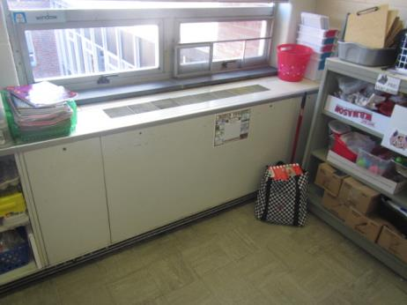
Classroom univent 1960s vintage
Picture 2
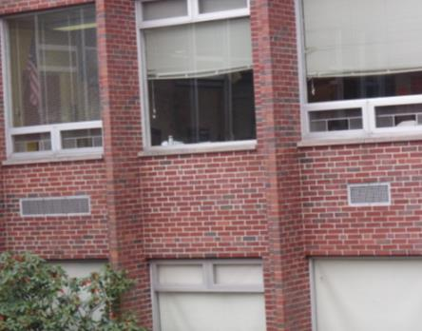
Univent air intake (left), unit exhaust vent (right)
Picture 3
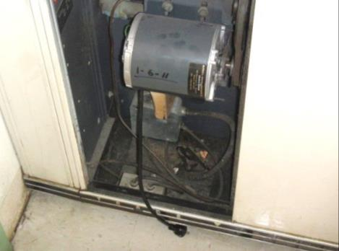
Univent motor unplugged
Picture 4
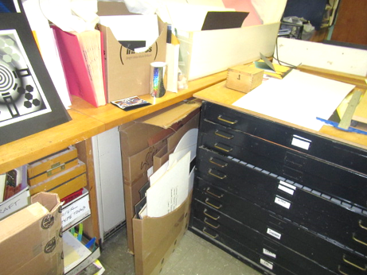
Univent (arrow) completely obstructed by items in the Art room
Picture 5
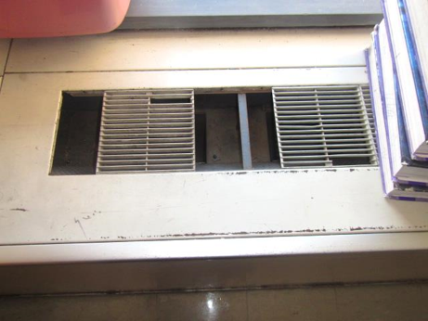
Missing/damaged univent diffuser exposing moving parts
Picture 6
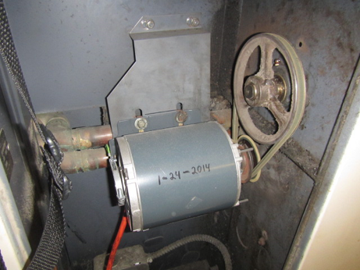
Missing univent panel exposing moving parts
Picture 7
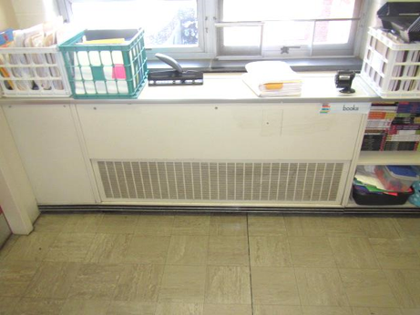
Unit exhaust ventilator
Picture 8
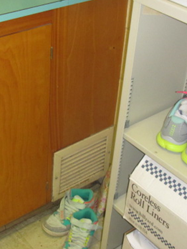
Wall-mounted exhaust vent
Picture 9
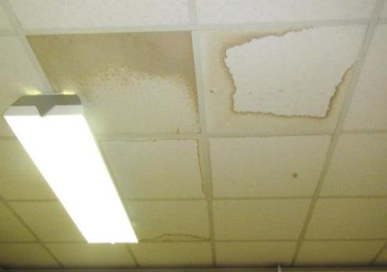
Water-damaged ceiling tiles
Picture 10
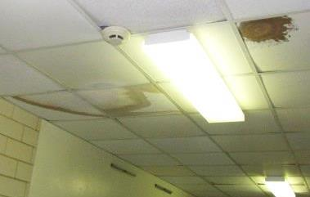
Water-damaged ceiling tiles
Picture 11
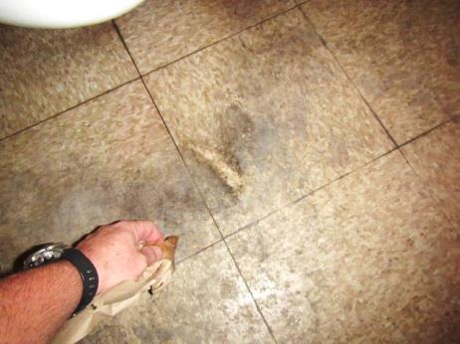
Accumulated dirt/debris on 1st floor faculty restroom (as reported to be mold by staff), note area wiped clean by BEH/IAQ staff
Picture 12
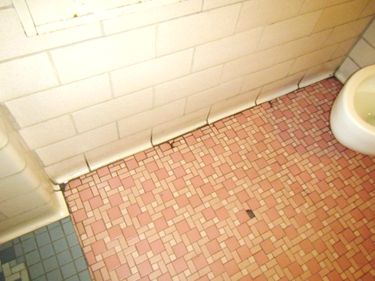
Accumulated dirt/debris around edges of 2nd floor faculty restroom (reported to be mold by staff)
Picture 13
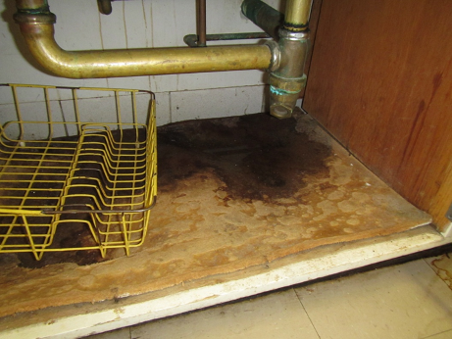
Chronic water leak under sink in room #201
Picture 14
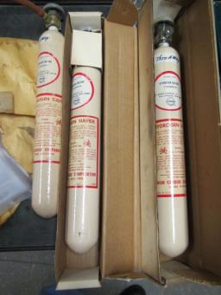
Gas cylinders in unlabeled drawer
Picture 15
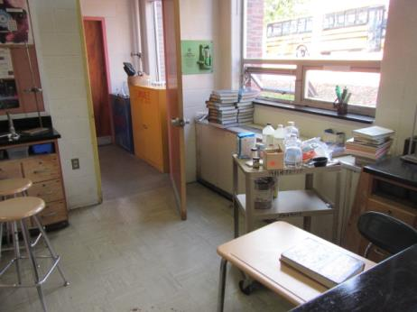
Flameproof cabinet
Picture 16
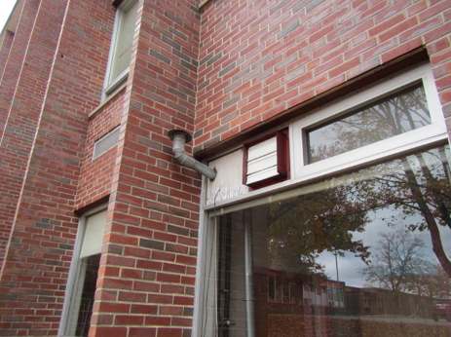
Flameproof cabinet vent next to flapper vent connected to the chemical hood
Picture 17
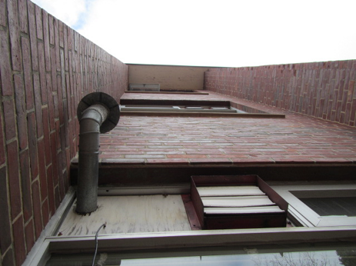
Flameproof cabinet and chemical hood vents below windows
Picture 18
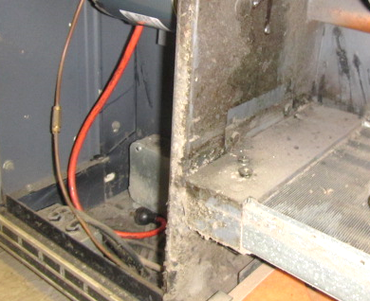
Accumulated dust/debris in univent
Picture 19
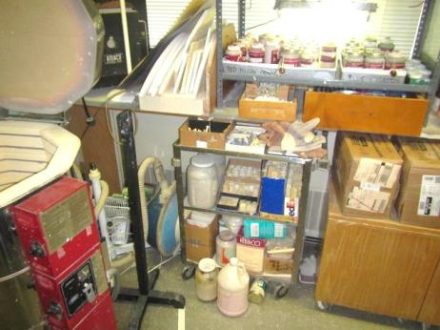
Accumulated items in Art room
Picture 20
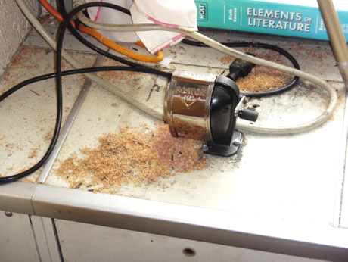
Pencil shavings on top of univent
Picture 21
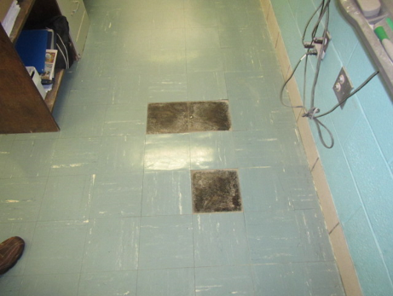
Removed/loose floor tiles in classroom 107

Location | Carbon  Dioxide  (ppm) | Carbon Monoxide  (ppm) | Temp  (°F) | Relative  Humidity  (%) | PM2.5  (µg/m³) | Occupants  in Room | Windows  Openable | Ventilation |  | Remarks
 |  |  |  |  |  |  |  | Supply | Exhaust
Background (outside) | 448 | 3.1 | 49 | 30 | 8 | - | - | - | - | Cool, clear, windy, busy street/traffic
Third Floor
301 Art | 1156 | ND | 73 | 38 | 3 | 0 | Y | Y  Blocked | Y  Blocked | WD CT
302 | 657 | ND | 73 | 24 | 4 | 1 | Y | Y | Y  Off | 14 occupants gone ~15 mins, PF-dusty, 7 WD CT, portable air conditioner
303 | 813 | ND | 70 | 30 | 2 | 19 | Y  open | Y  Off | Y  Off | UV deactivated due to noise, 2 WD CT
304 | 967 | ND | 76 | 27 | 2 | 11 | Y | Y  Off | Y  Off | 10 WD CT, DO, portable air conditioner
305 | 1080 | ND | 77 | 31 | 2 | 8 | Y | Y  Off | Y  Off | WAC, dryers-vented to outside, WD CT
306 | 798 | ND | 76 | 31 | 2 | 0 | N | N | Y | WD CT
307 | 698 | ND | 74 | 26 | 1 | 0 | Y | Y | N | WD CTs, DEM
308 | 453 | ND | 76 | 19 | 1 | 0 | Y | Y | Y  Off | Loud UV-dirty, undersized filter(gaps)
309 | 885 | ND | 77 | 24 | 2 | 18 | Y  Open | Y | Y | DEM, HS, PF
310 | 573 | ND | 75 | 22 | 2 | 0 | Y  Open | Y | Y | DEM, PF
311 | 1024 | ND | 75 | 30 | 2 | 23 | Y  Open | Y | Y  Off | Blocked unit exhaust
312 | 769 | ND | 75 | 24 | 2 | 0 | Y  Open | Y | Y | WD CTs, CT ajar, supply grates missing
313 | 780 | ND | 73 | 29 | ND | 16 | Y  Open | Y | Y | DO
314 | 694 | ND | 74 | 25 | 3 | 17 | Y  Open | Y | Y | Supply grates missing
315 | 640 | ND | 73 | 24 | 3 | 0 | Y  Open | Y | Y | PF
3rd floor hallway | - | - | - | - | - | - | - | - | - | Multiple WD CTs
2nd Floor
Faculty Lounge | 505 | ND | 73 | 22 | 2 | 4 | Y | Y | N | WAC-filter dusty, dust/cobwebs windowsill/flat surfaces
2nd floor hallway | - | - | - | - | - | - | - | - | - | WD CTs, foul odor/AF agent
Library | 928 | ND | 74 | 30 | 2 | 14 | Y  Some | Y  Off | Y | Partial carpet, PC, WD CT, dirty floors in corner with dead frog
201 | 437 | ND | 71 | 24 | 4 | 0 | Y  Open | Y  On | Y  Off | Window exhaust used only when burnt odors occur, PF, WD CTs, leaking plumbing under sink
202 | 466 | ND | 72 | 21 | 1 | 0 | Y  Open | Y  Off | Y  Off | WD CTs
203 | 561 | ND | 73 | 20 | 5 | 0 | Y | Y  On | Y  Off | Deactivated exhaust unit open with exposed wires, DEM, WD CTs, MT
204 | 728 | ND | 73 | 23 | 2 | 18 | Y  Open | Y  Off | Y | PF, HS, DEM
205 | 1110 | ND | 75 | 27 | 2 | 26 | Y | Y  Off | Y
207 | 716 | ND | 75 | 25 | 2 | 4 | Y | Y | N | UV-obstructed, WAC
210 | 892 | ND | 76 | 25 | 2 | 15 | Y | Y  Off | Y  Off | UV diffuser damaged/covered
211 | 880 | ND | 77 | 25 | 4 | 12 | Y | Y  Off | Y  Off | UV deactivated due to noise, DO
212 | 888 | ND | 75 | 29 | 3 | 1 | Y | Y  Off | Y  Off | 7 WD CT, UV-unplugged/deactivated, occupants gone over 30 mins
1st Floor
101 | 721 | ND | 67 | 26 | 7 | 13 | Y  Open | Y  On | N
103 | 957 | ND | 74 | 30 | 3 | 24 | Y | Y  On | N | WD CTs, AI
104 | 1597 | ND | 73 | 36 | 3 | 20 | Y | Y | N | MTs, WD CTs
105 | 892 | ND | 77 | 25 | 5 | 12 | Y | Y | Y | UV on/little airflow, chalk dust
107 | 996 | ND | 76 | 28 | 5 | 21 | Y | Y  Off | Y  Off | Loose floor tiles, chalk dust, PF-dusty
108 | 854 | ND | 75 | 24 | 3 | 1 | Y | Y | Y | 15 occupants gone ~ 17 mins, dislodged CT, chalk dust
109 | 628 | ND | 74 | 24 | 3 | 1 | Y | Y  Off | Y  Off | Pencil shavings near UV diffuser, 10 occupants gone ~ 15 mins
110 | 941 | ND | 74 | 27 | 4 | 17 | Y | Y | Y  Off | DEM
111 | 713 | ND | 74 | 24 | 2 | 7 | Y | Y | Y  On | DEM, previous WD from upstairs heating unit
Gym | 551 | ND | 71 | 25 | 3 | ~30 | Y | Y | Y | Exhaust partially obstructed
Girls Locker | 600 | ND | 74 | 28 | 5 | 0 | N | Y | Y  Off | Musty odor, limited exhaust
Boys Locker | 698 | ND | 75 | 37 | 6 | 0 | N | Y | Y  Off | Musty odor, limited exhaust
Auditorium | 655 | ND | 71 | 33 | 2 | 2 | N | Y | Y
12 | 1129 | ND | 76 | 29 | ND | 1 | Y | Y | Y | WAC-on, 3 missing floor tiles
13 | 1242 | ND | 76 | 30 | ND | 11 | Y | Y | Y | 5 missing floor tiles
Cafeteria | 923 | ND | 78 | 30 | ND | 5 | Y | Y | Y
Main office | 1077 | ND | 76 | 29 | ND | 2 | N | N | N
Principal | 1136 | ND | 75 | 29 | ND | 2 | Y | N | N

The service life is the median time during which a particular system or component of …[an HVAC]… system remains in its original service application and then is replaced. Replacement may occur for any reason, including, but not limited to, failure, general obsolescence, reduced reliability, excessive maintenance cost, and changed system requirements due to such influences as building characteristics or energy prices (ASHRAE, 1991).

