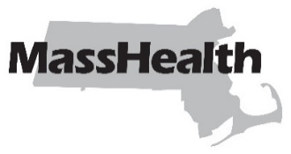
Day Habilitation Bulletin 29
Commonwealth of Massachusetts
Executive Office of Health and Human Services
Office of Medicaid
www.mass.gov/masshealth
DATE: January 2024
TO: Day Habilitation Providers Participating in MassHealth [signature of Mike Levine]
FROM: Mike Levine, Assistant Secretary for MassHealth
RE: Day Habilitation Claims Submission—Elimination of Span Date Billing

Background
MassHealth has updated its Medicaid Management Information System (MMIS) to deny claims for day habilitation (DH) services that include more than one date of service on a single claim line (referred to as “span date billing”). MassHealth is implementing this change to provide enhanced program integrity and improved tracking of the delivery of DH services.

Claims Submission and Denial of Span Date Billing
Effective for dates of service on or after March 1, 2024, DH providers must bill for DH services using one claim line for each date of service. Any claim for DH services, provided on or after this effective date, that includes more than one date of service will cause the entire claim to be denied. DH providers that have claims denied due to span date billing will need to correct and resubmit the claims using one claim line for each date of service.
Please work with your billing software provider to ensure that no claims with span date billing are submitted after this date.

MassHealth Website
This bulletin is available on the MassHealth Provider Bulletins web page.
Sign up to receive email alerts when MassHealth issues new bulletins and transmittal letters.

Questions
If you have any questions about the information in this bulletin, please contact the Long Term Services and Supports (LTSS) Provider Service Center.
Phone: | Toll free (844) 368-5184
Email: | support@masshealthltss.com
Portal: | www.MassHealthLTSS.com
Mail: | MassHealth LTSS  PO Box 159108  Boston, MA 02215
Fax: | (888) 832-3006
MassHealth on Facebook MassHealth on X (Twitter) MassHealth on YouTube

