INDOOR AIR QUALITY ASSESSMENT
Follow-up

Massachusetts Division of Capital Asset Management
and Maintenance (DCAMM)
Energy Group
One Ashburton Place, 16th floor
Boston, MA

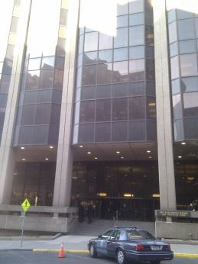

Prepared by:
Massachusetts Department of Public Health
Bureau of Environmental Health
Indoor Air Quality Program
December 2017

Background
Building: | Massachusetts Division of Capital Asset Management and Maintenance (DCAMM), Energy Group
Address: | One Ashburton Place, 16th floor
Assessment Requested by: | Parrish Rossi, Facilities Manager, DCAMM
Reason for Request: | Follow up on previous reports from visits conducted on March 6, 2017 and April 14, 2017
Date of Assessment: | December 8, 2017
Massachusetts Department of Public Health/Bureau of Environmental Health (MDPH/BEH) Staff Conducting Assessment: | Ruth Alfasso, Environmental Engineer, Indoor Air Quality (IAQ) Program
Building Description: | One Ashburton Place, also known as the McCormack Building, is a large state office building built in the 1970s.
Windows: | Not openable

Methods
Please refer to the IAQ Manual for methods, sampling procedures, and interpretation of results (MDPH, 2015).

IAQ Testing Results
The following is a summary of indoor air testing results (Table 1).
- Carbon dioxide levels were below 800 parts per million (ppm) in all areas surveyed, indicating adequate air exchange.
- Temperature was within or very close to the recommended range of 70°F to 78°F in all areas tested.
- Relative humidity was below the recommended range of 40 to 60% in all areas tested which is typical during the heating season.
- Carbon monoxide levels were non-detectable (ND) in all indoor areas tested.
- Fine particulate matter (PM2.5) concentrations measured were below the National Ambient Air Quality Standard (NAAQS) limit of 35 μg/m³ in all areas tested.

Ventilation
A heating, ventilating and air conditioning (HVAC) system has several functions. First it provides heating and, if equipped, cooling. Second, it is a source of fresh air. Finally, an HVAC system will dilute and remove normally-occurring indoor environmental pollutants by not only introducing fresh air, but by filtering the airstream and ejecting stale air to the outdoors via exhaust ventilation. Even if an HVAC system is operating as designed, point sources of respiratory irritation may exist and cause symptoms in sensitive individuals.
Fresh air is supplied by induction units located along the outer edges of the building (Picture 1). Return air is drawn around light fixtures using ducted returns.
It is important to note that relative humidity levels in the building would be expected to be low during the winter months due to atmospheric conditions and heating. Low relative humidity can lead to common symptoms such as: dry skin, lips, and scalp; dry/scratchy throats and noses (nose bleeds); exacerbation of asthma, eczema, or allergies; dry/irritated eyes; and irritation of respiratory tract.
It was reported that induction units had been cleaned recently based on recommendations in previous IAQ reports. One unit was opened and appeared to be clean (Picture 2). This unit also had a mesh screen inside; this screen would not provide any filtration of respirable particles as the mesh openings are too large, and may only function to protect the inner workings of the system from debris. It is not known if better filters that can remove particulates (e.g., MERV 8) could be installed in these units.

Microbial/Moisture Concerns
No water-damaged ceiling tiles or other materials were observed during the visit. Similarly to previous visits, plants were noted in a few areas (Table 1; Pictures 1 and 3). Plants can be a source of pollen and mold, which can be respiratory irritants to some individuals. Plants should be properly maintained and equipped with drip pans and should be located away from induction units to prevent the aerosolization of dirt, pollen and mold.
Water dispensers were located on carpet; spills can moisten carpet and lead to odors and microbial growth. The area being used as a kitchen also has carpeting, which can become moistened from refrigerator spills. It was expressed during previous visits that there were plans to replace the carpeting in the kitchen area with tile; however this has not yet been conducted.

Other Concerns
Exposure to low levels of volatile organic compounds (VOCs) may produce eye, nose, throat, and/or respiratory irritation in some sensitive individuals. BEH/IAQ staff examined spaces for products containing VOCs, noting cleaning products, and dry erase materials in a number of areas throughout the office space (Table 1). All of these products have the potential to be irritants to the eyes, nose, throat, and respiratory system of sensitive individuals. Fewer containers of VOC-containing products were observed during this visit as compared to previous ones.
A copy machine that is reportedly heavily used is located in the kitchen, which is directly adjacent to several occupied areas. Excess heat, odors, VOCs and ozone can be produced by photocopiers, particularly if the equipment is older and in frequent use. Ozone is a respiratory irritant (Schmidt Etkin, 1992). No dedicated exhaust ventilation was observed in this area.
Rodents had been reported in this office on an occasional basis during previous visits and a mousetrap was observed during this visit (Picture 3). However, it is not known if rodents have been sighted recently. Note that rodent infestation can result in IAQ related symptoms due to materials in their wastes. Mouse urine contains a protein that is a known sensitizer (US EPA, 1992). A sensitizer is a material that can produce symptoms (e.g., running nose or skin rashes) in sensitive individuals after repeated exposure. To eliminate exposure to allergens, rodents must be removed from the building. Please note that removal, even after cleaning, may not provide immediate relief since allergens can exist in the interior for several months after rodents are eliminated (Burge, 1995). Once the infestation is eliminated, a combination of cleaning and increased ventilation and filtration should serve to reduce allergens associated with rodents. It was reported that steam cleaning of the carpeting had been conducted recently.
Items were observed on a number of flat surfaces, such as windowsills, tabletops, counters, bookcases, and desks (Picture 4). The large number of items stored in offices provides a source for dusts to accumulate and make it difficult for custodial staff to clean. Items should be relocated and/or be cleaned periodically to avoid excessive dust build up.

Conclusions/Recommendations
Conditions observed during this visit indicated that some of the items, e.g., cleaning of univents and carpeting, had occurred. Based on observations at the time of assessment, the following continue to be recommended:
- Operate supply and exhaust ventilation continuously in all areas during occupied periods. Ensure all HVAC equipment is cleaned/maintained in accordance with manufacturer’s instructions. Avoid blocking HVAC equipment with boxes, furniture or other items.
- Have the HVAC system balanced every 5 years in accordance with SMACNA recommendations (SMACNA, 1994).
- For buildings in New England, periods of low relative humidity during the winter are often unavoidable. Therefore, scrupulous cleaning practices should be adopted to minimize common indoor air contaminants whose irritant effects can be enhanced when the relative humidity is low. To control for dusts, a high efficiency particulate arrestance (HEPA) filter equipped vacuum cleaner in conjunction with wet wiping of all surfaces is recommended. Avoid the use of feather dusters. Drinking water during the day can help ease some symptoms associated with a dry environment (throat and sinus irritations).
- Keep plants in good condition, avoid overwatering, and remove from the airstream of heating and ventilation equipment.
- Consider the use of waterproof mats underneath water dispensers to protect carpet.
- Consider replacing carpeting in the kitchen area with tile.
- Reduce the use of cleaning products, sanitizers, and other items that contain VOCs.
- Consider if direct exhaust ventilation is feasible for the kitchen/copy area. Ensure the copy machine is well maintained to reduce VOCs, ozone, particulates and odors.
- Use the principles of Integrated Pest Management (IPM) and the services of a licensed pest control operator to remove rodents and reduce the potential for pest infestation. Ensure that any area where rodents may have been is thoroughly cleaned to remove allergens.
- Clean blades of personal fans to prevent aerosolization of dust.
- Reduce the amount of items stored on flat surfaces to allow regular cleaning.
- If additional assistance is needed, please contact maintenance personnel for the Ashburton Place building.
- Refer to resource manual and other related IAQ documents located on the MDPH’s website for further building-wide evaluations and advice on maintaining public buildings. These documents are available at: http://mass.gov/dph/iaq.

References
Burge, H.A. 1995. Bioaerosols. Lewis Publishing Company, Boca Raton, FL.
MDPH. 2015. Massachusetts Department of Public Health. Indoor Air Quality Manual: Chapters I-III. Available at: http://www.mass.gov/eohhs/gov/departments/dph/programs/environmental-health/exposure-topics/iaq/iaq-manual/.
Schmidt Etkin, D. 1992. Office Furnishings/Equipment & IAQ Health Impacts, Prevention & Mitigation. Cutter Information Corporation, Indoor Air Quality Update, Arlington, MA.
SMACNA. 1994. HVAC Systems Commissioning Manual. 1st ed. Sheet Metal and Air Conditioning Contractors’ National Association, Inc., Chantilly, VA.
US EPA. 1992. Indoor Biological Pollutants. US Environmental Protection Agency, Environmental Criteria and Assessment Office, Office of Health and Environmental Assessment, research Triangle Park, NC. EPA 600/8-91/202. January 1992.
Picture 1
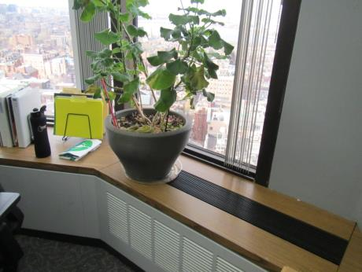
Induction unit, note plant on top
Picture 2
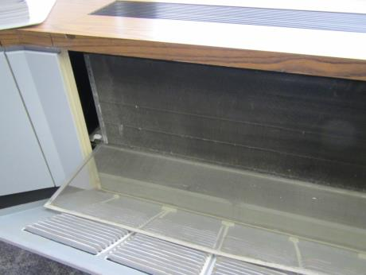
Inside induction unit, note mesh screen
Picture 3
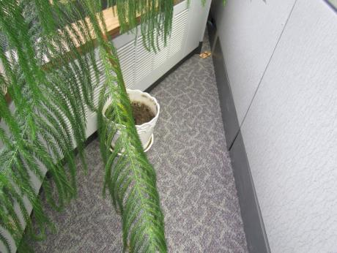
Plant overhanging induction unit, empty plant pot, and mousetrap in corner
Picture 4
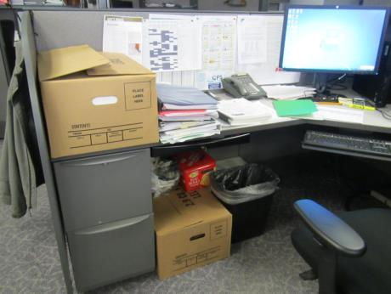
Accumulated items in a cubicle
Location | Carbon  Dioxide  (ppm) | Carbon Monoxide  (ppm) | Temp  (°F) | Relative  Humidity  (%) | PM2.5  (µg/m³) | Occupants  in Room | Windows  Openable | Ventilation |  | Remarks
 |  |  |  |  |  |  |  | Supply | Exhaust
Background | 383 | 1.3 | 41 | 23 | 11 |  |  |  |  | Sunny, windy
Conference room | 650 | ND | 69 | 20 | 3 | 0 | N | Y | Y | DEM
Cubes next to conference room | 586 | ND | 70 | 17 | 3 | 0 | N | Y | Y
Office | 573 | ND | 70 | 17 | 3 | 0 | N | Y | Y | Plant on vent, PF
Reinhardt | 578 | ND | 70 | 17 | 3 | 0 | N | Y | Y | PF
Lillis | 572 | ND | 70 | 16 | 3 | 0 | N | Y | Y
Crisley | 568 | ND | 71 | 16 | 3 | 1 | N | Y | Y | Plant, PF
Caron | 566 | ND | 71 | 16 | 3 | 0 | N | Y | Y | Plants, PF, DEM
Freeley | 567 | ND | 71 | 16 | 3 | 1 | N | Y | Y
Isenstein office | 609 | ND | 69 | 17 | 4 | 0 | N | Y | Y | PF
Rear cubes | 561 | ND | 70 | 16 | 3 | 2 | N | Y | Y | PF, plants
Kitchen | 529 | ND | 70 | 15 | 3 | 0 | N | Y | Y | Refrigerator on carpet, microwave, CP, PC
Menyo | 550 | ND | 71 | 16 | 3 | 0 | N | Y | Y | Plant
White | 571 | ND | 71 | 16 | 3 | 0 | N | Y | Y | Plants, water cooler on carpet
Soohoo | 574 | ND | 71 | 16 | 3 | 0 | N | Y | Y | AI, DEM, plants
Lewin | 592 | ND | 72 | 16 | 3 | 1 | N | Y | Y | DEM

