INDOOR AIR QUALITY REASSESSMENT

Division of Capital Asset Management and Maintenance
One Ashburton Place, 15th floor (southwest corner)
Boston, MA

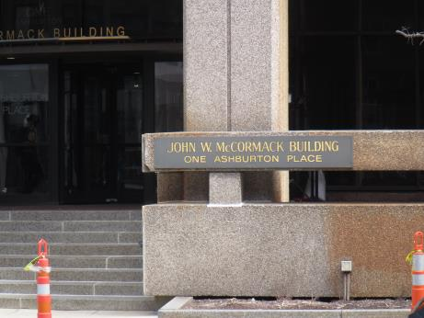

Prepared by:
Massachusetts Department of Public Health
Bureau of Environmental Health
Indoor Air Quality Program
May 2018

Background
Building: | Division of Capital Asset Management and Maintenance (DCAMM)
Address: | One Ashburton Place, 15th floor
Assessment Requested by: | Parrish Rossi, Facility Manager, One Ashburton Place
Reason for Request: | General indoor air quality (IAQ) concerns
Date of Assessment: | April 27, 2018
Massachusetts Department of Public Health/Bureau of Environmental Health (MDPH/BEH) Staff Conducting Assessment: | Ruth Alfasso, Environmental Engineer, IAQ Program
Building Description: | One Ashburton Place, also known as The McCormack Building, is a large state office building constructed in the 1970s.
Windows: | Not openable

Methods
Please refer to the IAQ Manual for methods, sampling procedures, and interpretation of results (MDPH, 2015).

IAQ Testing Results
The following is a summary of indoor air testing results (Table 1).
- Carbon dioxide levels were below 800 parts per million (ppm) in all areas surveyed, indicating adequate air exchange.
- Temperature was within the recommended range of 70°F to 78°F in all areas tested.
- Relative humidity was slightly below the recommended range of 40 to 60% in all areas tested.
- Carbon monoxide levels were non-detectable (ND) in all areas tested.
- Fine particulate matter (PM2.5) concentrations measured were below the NAAQS limit of 35 μg/m³ in all areas tested.

Other floors of this building have been assessed by this program and those reports can be found at https://www.mass.gov/service-details/indoor-air-quality-reports-cities-and-towns-b.

Ventilation
A heating, ventilating, and air conditioning (HVAC) system has several functions. First it provides heating and, if equipped, cooling. Second, it is a source of fresh air. Finally, an HVAC system will dilute and remove normally-occurring indoor environmental pollutants by not only introducing fresh air, but by filtering the airstream and ejecting stale air to the outdoors via exhaust ventilation. Even if an HVAC system is operating as designed, point sources of respiratory irritation may exist and cause symptoms in sensitive individuals.
Fresh air is supplied by induction units located along the outer edges of the building (Picture 1) and supply vents located in the ceiling (Picture 2). Return air is drawn through ceiling-mounted grates or around light fixtures using ducted returns. Some induction units had items on top of them, which can obstruct the flow of fresh air. In addition, some of the items on/near the vents of the induction units can be a source of dusts, odors and, in the case of plants, pollen, and other potential allergens. Induction unit vents should be kept free of items and kept clean.

Microbial/Moisture Concerns
A water-damaged ceiling tile was observed along the window (Picture 3). Due to the age and condition of the building, water leaks near the windows have occurred in this building during wind-driven rain events. Water-damaged ceiling tiles should be replaced when discovered. In addition, staff should avoid storing porous items (e.g., paper, boxes) in areas where leaks have occurred in the past.
Plants were noted in a few areas (Table 1; Pictures 4 and 5). Plants can be a source of pollen and mold, which can be respiratory irritants to some individuals. Plants should be properly maintained and equipped with drip pans and should be located away from induction units to prevent the aerosolization of dirt, pollen, and mold.
A miniature humidifying unit was observed in one area (Picture 6). While low relative humidity is typical during the winter months and can lead to common symptoms such as dry skin, dry eyes, and respiratory tract irritation, the use of humidification devices is not typically recommended in an office environment. Humidification units need to be kept scrupulously clean or they can become a source of microbial contamination and odors. Spills, leaks or condensation caused by these units can also be a source of moisture to porous materials. To reduce the potential for symptoms, scrupulous cleaning practices should be adopted to minimize common indoor air contaminants whose irritant effects can be enhanced when the relative humidity is low. To control for dusts, a high efficiency particulate arrestance (HEPA) filter equipped vacuum cleaner in conjunction with wet wiping of all surfaces is recommended. Drinking water during the day can help ease some symptoms associated with a dry environment.

Other Concerns
Exposure to low levels of total volatile organic compounds (TVOCs) may produce eye, nose, throat, and/or respiratory irritation in some sensitive individuals. In addition to testing, BEH/IAQ staff examined spaces for products containing VOCs. BEH/IAQ staff noted air fresheners, hand sanitizers, cleaning products, and dry erase materials in the office space (Picture 7; Table 1). All of these products have the potential to be irritants to the eyes, nose, throat, and respiratory system of sensitive individuals.
Items were observed on a number of flat surfaces, such as windowsills, tabletops, counters, bookcases, and desks (Pictures 5 and 7). Items stored in offices provide a source for dusts to accumulate. These items (e.g. papers, folders, boxes) also make it difficult for custodial staff to clean. Items should be relocated and/or be cleaned periodically to avoid excessive dust build up. Some supply vents and personal fans were observed to be dusty. Dust should be cleaned periodically to prevent aerosolization when the equipment is activated.
The offices were mostly carpeted. Carpets should be cleaned annually (or semi-annually in soiled/high traffic areas) in accordance with Institute of Inspection, Cleaning and Restoration Certification (IICRC) recommendations, (IICRC, 2012). Some carpeting was observed to be stained and worn, especially under desks (Picture 8). The use of plastic desk chair mats may help prevent damage to carpeting

Conclusions/Recommendations
Based on observations at the time of assessment, the following is recommended:
- Operate supply and exhaust ventilation continuously in all areas during occupied periods. Ensure all HVAC equipment is cleaned/maintained in accordance with manufacturer’s instructions.
- Balance the HVAC system every 5 years in accordance with Sheet Metal and Air Conditioning Contractors’ National Association (SMACNA) recommendations (SMACNA, 1994).
- Regularly clean induction unit fins and condensation pans (if any) to reduce accumulated debris.
- Remove items from the top and front of induction units to allow for air flow.
- Replace water-damaged ceiling tiles. Avoid storing porous items in areas where leaks occur.
- Keep plants in good condition, avoid overwatering, and remove from the airstream of heating and ventilation equipment. Consider reducing the number of plants in this area.
- The use of humidification devices in offices is not recommended. If they are used, ensure they are kept clean to prevent microbial colonization and odors, and that they are not placed on porous surfaces.
- For buildings in New England, periods of low relative humidity during the winter are often unavoidable. Therefore, scrupulous cleaning practices should be adopted to minimize common indoor air contaminants whose irritant effects can be enhanced when the relative humidity is low. To control for dusts, a high efficiency particulate arrestance (HEPA) filter equipped vacuum cleaner in conjunction with wet wiping of all surfaces is recommended. Avoid the use of feather dusters. Drinking water during the day can help ease some symptoms associated with a dry environment (throat and sinus irritations).
- Reduce the use of scented cleaning products, sanitizers, and other items that contain VOCs.
- Reduce the amount of items stored on flat surfaces to allow regular cleaning.
- Clean supply vents, personal fans and other equipment to prevent aerosolizing dust.
- Clean carpeting in accordance with IICRC recommendations (IICRC, 2012). Consider the use of plastic chair mats under desks to protect carpeting.
- Refer to resource manual and other related IAQ documents located on the MDPH’s website for further building-wide evaluations and advice on maintaining public buildings. These documents are available at: http://mass.gov/dph/iaq.

References
IICRC. 2012. Institute of Inspection, Cleaning and Restoration Certification. Carpet Cleaning: FAQ.
MDPH. 2015. Massachusetts Department of Public Health. Indoor Air Quality Manual: Chapters I-III. Available at: http://www.mass.gov/eohhs/gov/departments/dph/programs/environmental-health/exposure-topics/iaq/iaq-manual/.
SMACNA. 1994. HVAC Systems Commissioning Manual. 1st ed. Sheet Metal and Air Conditioning Contractors’ National Association, Inc., Chantilly, VA.
Picture 1
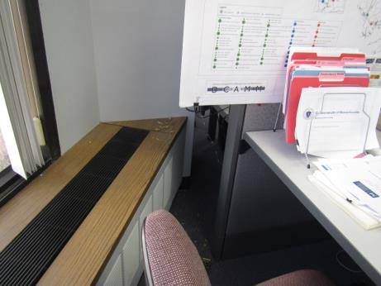
Induction unit next to window, note plant debris
Picture 2
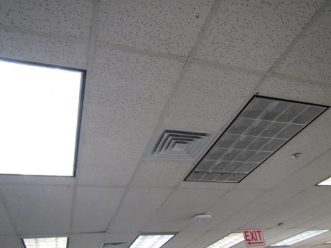
Typical supply vent and area around lights used as return
Picture 3
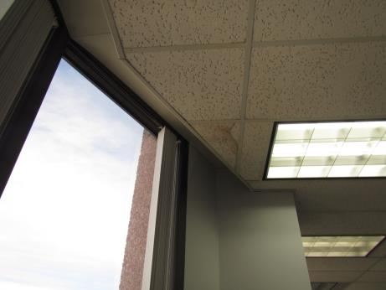
Water-damaged ceiling tile next to window
Picture 4
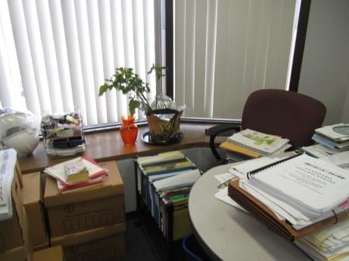
Plant in office, note items and boxes on floor
Picture 5
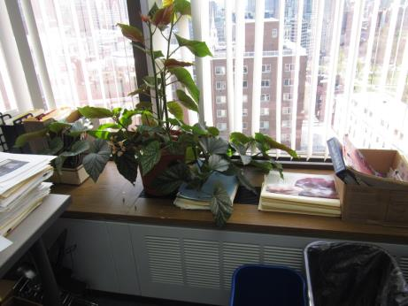
Plants on induction unit and items blocking unit airflow
Picture 6
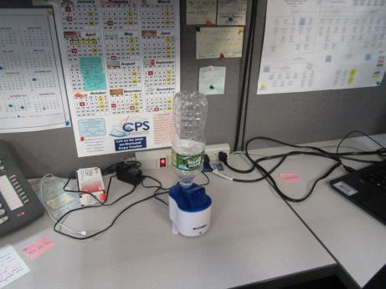
Miniature humidifier
Picture 7
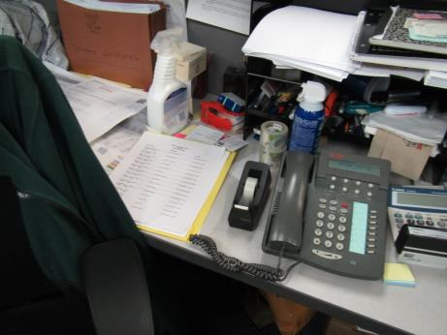
Cleaning products, markers and items on flat surfaces
Picture 8
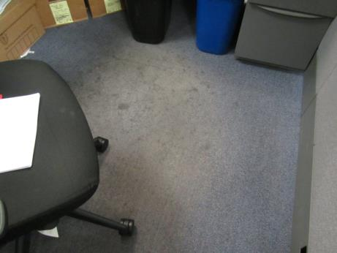
Stained, worn carpeting under desk
Location | Carbon  Dioxide  (ppm) | Carbon Monoxide  (ppm) | Temp  (°F) | Relative  Humidity  (%) | PM2.5  (µg/m³) | Occupants  in Room | Windows  Openable | Ventilation |  | Remarks
 |  |  |  |  |  |  |  | Supply | Exhaust
Background | 331 | ND | 63 | 38 | 6 |  |  |  |  | Warm and breezy
Saul | 456 | ND | 72 | 37 | 1 | 0 | N | Y | Y | Mini humidifier
Basnet | 539 | ND | 73 | 36 | 2 | 3 | N | Y | Y | Paper and boxes on desk and floor, PF
Felton | 448 | ND | 74 | 35 | 2 | 2 | N | Y | Y | Plant debris on floor and ventilator, WD-CT next to window
Freeman | 491 | ND | 75 | 34 | 1 | 0 | N | Y | Y | PF
Nicholson | 472 | ND | 75 | 34 | 2 | 0 | N | Y | Y | PF, items on desk and floor, carpet is worn and stained under desk
Assar | 562 | ND | 75 | 33 | 3 | 0 | N | Y | Y | Plant on ventilator and water stain, items on desk and floor, PF
Mitchell (office) | 430 | ND | 75 | 33 | 1 | 0 | N | Y | Y | DO, DEM, dusty PF
Welch | 487 | ND | 75 | 33 | 2 | 0 | N | Y | Y | Plants and items on ventilator

