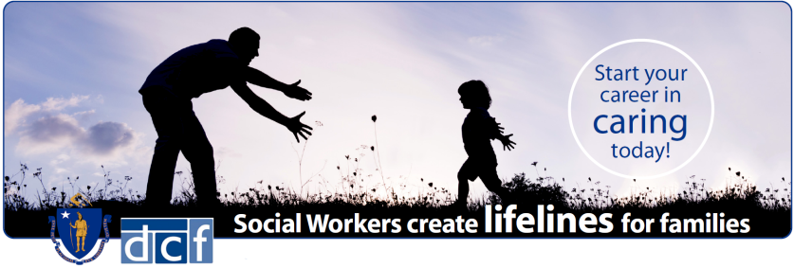
SOCIAL WORKERS VIRTUAL HIRING EVENT
YOU MUST SUBMITT ELECTRONIC COPIES OF
- Updated Resume
- College or University Transcript (Unofficial or Official)
- MA Social Work Licensure (preferred)
- 3 professional references (at least 1 must be supervisor or manager)
WE OFFER
- Starting Annual Salary at $54,281.24
- Health Insurance – 75% employer paid
- Basic Life Insurance
- Optional Life Insurance - up to 8x your annual salary
- Dental and Vision coverage plans
- Eleven Paid Holidays per year
- Tuition Benefit- for employee and their spouse
- Exceptional Retirement Savings Plan
- Vacation, Sick Time Accrual and Personal Days
- Long and Short-term Disability insurances
- Professional Development and Continuing Education
- Educational and Bilingual incentives
- Employee Assistance Program (EAP)

Become part of a hardworking, compassionate staff dedicated to the safety and protection of children. As a DCF Social Worker, you have the ability to profoundly impact lives of children and families across the Commonwealth.

Interested candidates
We are seeking dedicated and passionate individuals for these Exclusive One Day Hiring Events to be interviewed virtually.
A bachelor’s degree is required in any of the following disciplines:
Social Work | Psychology | Human Services | Sociology |
Counseling | Counseling Education | Criminal Justice
Bachelor’s degree in other closely related fields may be considered:
Social / Child Welfare | Human Development | Family / Urban Studies |
Marriage Counseling | Family Therapy | Forensic Psychology

\

COME IN WITH A PASSION…
LEAVE WITH A CAREER

Thursday 01/28/2021 – 1:00 p.m. to 7:00 p.m.
Department of Children and Families
Hiring for the Arlington and Braintree (Coastal) Area Offices ONLY
Online interviews! Pre-registration is required by Tuesday, January 26th at 12:00 noon:
https://www.mass.gov/EOHHSCAREERS
DCF is an Equal Opportunity / Affirmative Action Employer. Females, minorities, veterans, and persons with disabilities are strongly encouraged to apply.
Reasonable Accommodation: If you require an ADA accommodation, please contact Chantal St. Fleur, (617) 348-8471, TTY (617) 348-5193 or email at chantal.stfleur@mass.gov Ms. St. Fleur must receive your request for an accommodation no later than two weeks prior to the date of this event. For those who request an accommodation after this date, every effort will be made to provide a reasonable accommodation; however, we may not be able to do so given potential time constraints.

