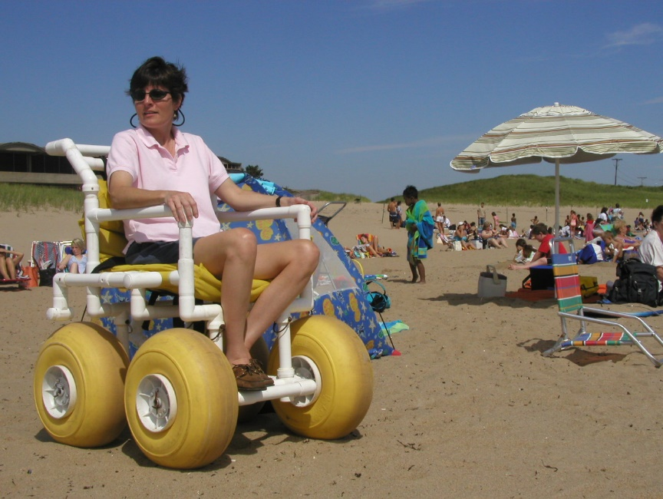
There is no cost to use beach wheelchairs. Please bring your own transfer help to get into the chair and someone to push you. The weight limit for beach wheelchairs is 275 pounds. The weight limit for floating beach wheelchairs is 300 pounds.
Beach wheelchairs are designed for use on gentle, sandy terrain. Beach wheelchairs are managed by lifeguards or other park or beach staff. You will need to get in contact with staff to use a beach wheelchair. Try calling in advance or stopping by to talk to staff before you visit the beach. You can also ask on site when you arrive to use the beach.
Floating chairs can only go into the water in good weather and water conditions. You will need to bring your own Coast Guard-certified personal flotation device and wear it while you are floating in the chair. An adult needs to be responsible for the chair at all times. You will need to bring another person with you to stay close and control the chair while it is in the water.
Conditions on the beach like steepness, debris from storms, rocks, and distance to the water may restrict the use of beach wheelchairs. If there are cobblestones or other obstacles on a beach, you may not be able to get to the edge of the water in the beach chair. Weather and water conditions may also restrict use on the beach, in the water, or both. Please respect and follow the decisions and directions of lifeguards and park staff while using the chairs.

West Region
Location | Community | Sand Chairs | Floating Chairs
Beartown State Forest, Benedict Pond Beach | Monterey | 1 | 0
Chicopee Memorial State Park Beach | Chicopee | 1 | 1
DAR State Forest Day Use Beach | Goshen | 1 | 1
Hampton Ponds State Park Beaches | Westfield | 2 | 1

Central Region
Location | Community | Sand Chairs | Floating Chairs
Ashland State Park Beach | Ashland | 1 | 0
Cochituate State Park Beach | Wayland | 1 | 1
Douglas State Forest, Wallum Lake Beach | Douglas | 1 | 0
Dunn State Park, Dunn Pond Beach | Gardner | 1 | 1
Erving State Forest, Laurel Lake Beach | Erving | 1 | 1
Hopkinton State Park Main Beach | Hopkinton | 2 | 1
Lake Dennison Recreation Area Day Use Beach | Winchendon | 1 | 1
Lake Wyola State Park Beach | Shutesbury | 1 | 1
Quinsigamond State Park, Regatta Point Beach | Worcester | 1 | 1

North Region
Location | Community | Sand Chairs | Floating Chairs
Bradley Palmer State Park Wading Pool | Topsfield | 1 | 0
Breakheart Reservation, John A. Pierce Lake | Saugus | 1 | 0
Halibut Point State Park, Trails | Rockport | 1 | 0
Harold Parker State Forest, Berry Pond Day Use Beach | N. Andover | 2 | 0
Maudslay State Park Trails | Newburyport | 2 | 0
Salisbury Beach State Reservation Beach | Salisbury | 9 | 2
Sandy Point State Reservation Beach | Ipswich | 1 | 0
Walden Pond State Reservation Beach | Concord | 2 | 2
Willard Brook State Forest & Pearl Hill State Park Trails | Ashby-Townsend | 1 | 0

South Region
Location | Community | Sand Chairs | Floating Chairs
Borderland State Park Trails | Sharon | 2 | 0
Demarest Lloyd State Park Beach | S. Dartmouth | 0 | 2
Fort Phoenix State Reservation Beach | Fairhaven | 0 | 3
Horseneck Beach State Reservation Main Beach | Westport | 5 | 3
Massasoit State Park Campers Beach | E. Taunton | 1 | 0
Myles Standish State Forest College Pond & Fearing Pond | Carver | 2 | 0
Nickerson State Park Beach | Brewster | 1 | 0
Scusset Beach State Reservation Beach | Sandwich | 3 | 2
South Cape Beach State Park Beach | Mashpee | 2 | 0
Watson Pond State Park Beach | Taunton | 1 | 0

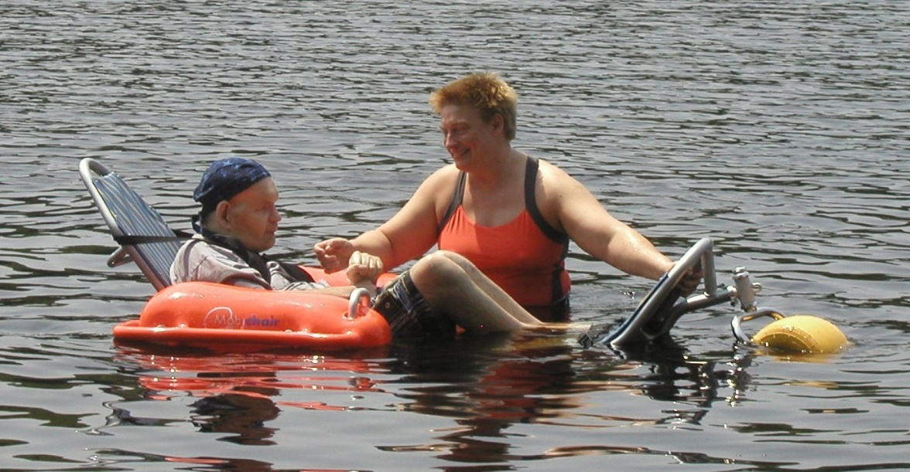

Boston Region
Location | Community | Sand Chairs | Floating Chairs
Beaver Brook Spray Deck | Belmont | 1 | 0
Carson Beach | South Boston | 3 | 1
Connell Memorial Pool | Weymouth | 1 | 0
Connors Memorial Pool | Waltham | 0 | 1
Constitution Beach Park | E. Boston | 1 | 1
Houghton’s Pond, Blue Hills Reservation | Milton | 1 | 1
Malibu Beach | Dorchester | 1 | 0
Mystic River State Reservation, Shannon Beach | Medford | 1 | 0
Nahant Beach Reservation | Lynn | 1 | 1
Nantasket Beach Reservation | Hull | 3 | 5
Pleasure Bay Beach | South Boston | 1 | 1
Quincy Shores Reservation, Wollaston Beach | Quincy | 2 | 0
Revere Beach Reservation | Revere | 1 | 1
Spectacle Island | Boston Harbor | 1 | 1
Olson Spray Deck | Hyde Park | 1 | 0
Winthrop Shore Reservation, Short Beach | Winthrop | 1 | 1

