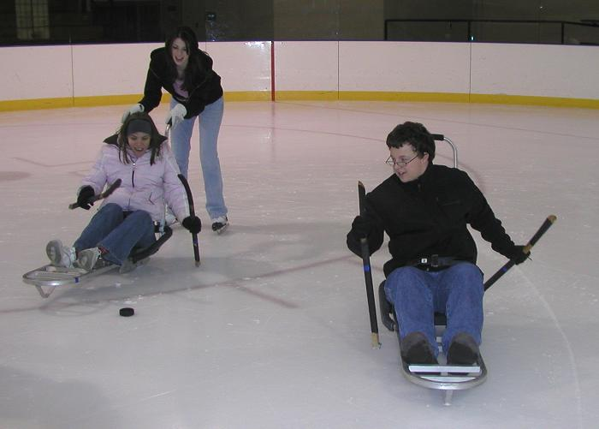
Ice sleds offer a seated option for skaters who cannot use their legs or who have balance issues too difficult for conventional skating. If you can use your upper body evenly, you can push yourself across the ice using use two short hockey sticks with a figure skating pick on the end. A stroller bar handle can be inserted into the back of the ice sled to push you if you can’t push or steer. The sleds have anti-tippers to prevent you from tipping over backwards, and adjustable leg trays that adjust for your height.
If you need help with transfers, you will need to bring your own help to transfer into the sleds. Please bring your own helmet to use with skate walkers. All equipment is best for use during uncrowded public skating times. Calling the rink in advance is recommended.
Contact DCR’s Universal Access Program at DCR.UniversalAccess@mass.gov or (413) 461-7126 for more information on adaptive skating equipment or accessible recreation opportunities.

Greater Boston Area
Town | Rink | Address | Phone | Equipment
Cambridge | Simoni | 155 Gore St. | (617) 354-9523 | 1 adult sled, 2 youth sleds, 2 handles
Charlestown | O’Neill | 150 Rutherford Ave | (617) 242-9728 | 1 adult sled, 1 youth sled, 1 handle
Dorchester | Devine | 995 Morrissey Blvd | (617) 436-4356 | 2 adult sleds, 2 handles
East Boston | Porrazzo | 199 Coleridge St. | (617) 567-9571 | 2 adult sleds, 2 handles, 3 walkers
Hyde Park | Bajko | 75 Turtle Pond Pkwy. | (617) 364-9188 | 1 adult sled, 1 youth sled, 1 handle
Jamaica Plain | Kelly | 1 Marbury Terrace | (617) 727-7000 | 1 youth sled
Medford | Flynn | Woodland Rd. | (781) 395-8492 | 5 adult sleds, 1 handle
Medford | LoConte | 97 Locust St | (781) 395-9594 | 4 adult sleds, 3 handles, 8 walkers
Newton | Daly | Nonantum Rd. | (617) 527-1741 | 2 adult sleds, 2 handles, 1 walker
North End | Steriti | 561 Commercial St. | (617) 523-9327 | 2 adult sleds, 1 handle, 1 youth walker
Revere | Cronin | 850 Revere Beach Pkwy. | (781) 284-9491 | 1 adult sled, 1 handle, 1 walker
Somerville | Somerville Veterans | 570 Somerville Ave. | (617) 623-3523 | 2 adult sleds, 1 handle
South Boston | Murphy | Day Blvd. | (617) 269-7060 | 1 adult sled, 1 handle
West Roxbury | Roche | 1275 VFW Pkwy. | (617) 323-9512 | 8 adult sleds, 4 handles
Weymouth | Connell | 220 Broad St. | (781) 335-2090 | 1 adult sled, 1 handle

Continued on back
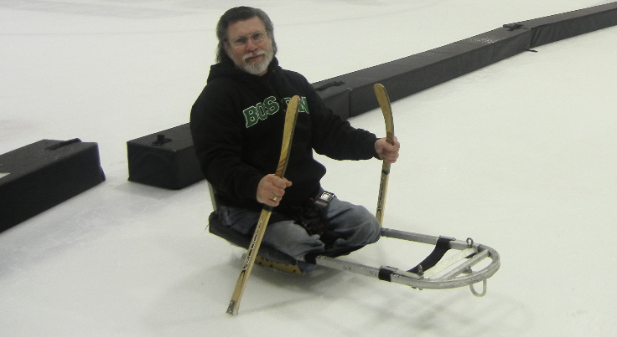
Calling the rink in advance is recommended.

North Region
Town | Rink | Address | Phone | Equipment
Newburyport | Graf | 28 Low St. | (978) 462-8112 | 1 adult sled, 1 handle

South Region
Town | Rink | Address | Phone | Equipment
Brockton | Asiaf | 702 Belmont St. | (508) 583-6804 | 4 adult sleds, 1 youth sled, 4 handles
Taunton | Aleixo | 150 Hon. Gordon Owen Riverway | (508) 824-4987 | 2 adult sleds, 1 handle
Franklin | Pirelli Veterans | 910 Panther Way | (508) 541-7024 | 2 adult sleds, 1 handle
Plymouth | Armstrong | 103 Long Pond Rd. | (508) 746-8825 | 2 adult sleds 1 handle
Fall River | Driscoll | 272 Elsbree St. | (508) 679-3274 | 6 adult sleds, 6 handles, 18 walkers

Central Region
Town | Rink | Address | Phone | Equipment
Auburn | Horgan | 403 Oxford St. | (508) 832-7201 | 2 adult sleds, 1 handle
Worcester | Buffone | 284 Lake Ave. | (508) 799-0910 | 3 adult sleds, 3 handles, 11 walkers

West Region
Town | Rink | Address | Phone | Equipment
Greenfield | Collins-Moylan | 41 Barr Ave. | (413) 772-6891 | 2 adult sleds, 2 handles
Holyoke | Fitzpatrick | 575 Maple St. | (413) 532-2929 | 8 adult sleds, 5 handles, 6 walkers
Springfield | Smead | 1780 Roosevelt Ave. | (413) 781-2599 | 2 adult sleds, 2 handles
North Adams | Foote Vietnam Veterans | 1267 Church St. | (413) 664-8185 | 2 adult sleds, 2 handles

