DCR Properties with a Connection to the American Revolution

Otis State Forest, Tolland State Forest, & Beartown State Forest, Western Massachusetts
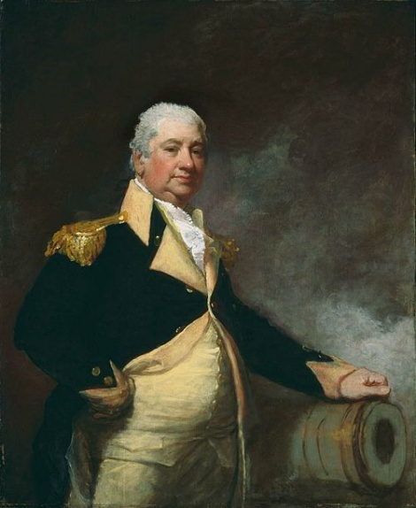
The Knox Trail traces the historic route taken in the winter of 1775-1776 by Colonel Henry Knox, acting on orders from General George Washington. Knox transported 59 heavy cannons captured at Fort Ticonderoga and Crown Point in New York across rugged terrain to the Continental Army camped outside Boston. Washington’s forces then placed these cannons on Dorchester Heights, commanding the British positions and ultimately forcing the British to evacuate Boston in March of 1776, a turning point in the war for American Independence. The Knox trail passed through what is now Otis State Forest, Tolland State Forest, and Beartown State Forest as Knox’s artillery train made its way eastward through the Berkshires towards Boston. Can you imagine the historic winter journey through this rugged landscape that Knox and his men traversed over frozen roads and trails.
Portrait of Major General Henry Knox by artist Gilbert Stuart, 1806.

Angle Tree Monument Reservation, North Attleboro
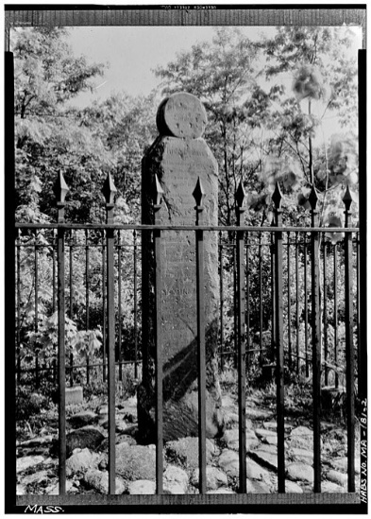
Long before the first shots of the American Revolution were fired, people gathered around a simple powerful landmark: the Angle Tree. This towering tree once marked the meeting point of three colonies: Massachusetts Bay, Plymouth, and Rhode Island. In the 1700s, borders like this mattered. They decided who collected taxes, who set the laws, and where neighbors served in the local militia. As tensions grew with British rule, these clear boundaries helped shape strong local identities and traditions of self-government. Colonists were used to making decisions close to home, and they believed those rights were worth defending. Though the original Angle Tree fell long ago, the monument that stands here today reminds us that the Revolution was not just fought on battlefields. It grew from everyday places like paths, town lines, and meeting points, where people learned what it meant to belong to a community. Imagine a time when this spot helped define responsibility, loyalty, and the idea that people should have a voice in how they are governed.
The slate marker was built in 1790 by team of gravestone makers. The stone was added to the National Historic Register in 1976.

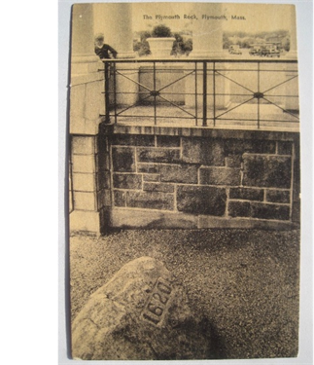
Pilgrim Memorial State Park, Plymouth
Long before Plymouth Rock became a famous symbol of the Pilgrims, it took on new meaning during the years leading up to the American Revolution. In 1774, as tensions with England grew, a local group called the Sons of Liberty decided that the Rock should no longer sit quietly by the water. They moved it ot the town square so everyone could see it as a bold symbol of liberty. As the Rock was lifted, it cracked in two. One observer said the break looked like the growing split between England and the colonies. This was a powerful image of country about to change. Plymouth Rock became more than a reminder of the past. It also became a message about freedom and self-rule. Today, Plymouth Rock rests beneath a grand portico, built with funding from the National Society of the Colonial Dames of America. Standing there, visitors can imagine how this simple stone once helped express big ideas about independence that would soon
Image of Plymouth Rock from a historic postcard.
reshape the nation.

Daughters of the American Revolution State Forest, Goshen
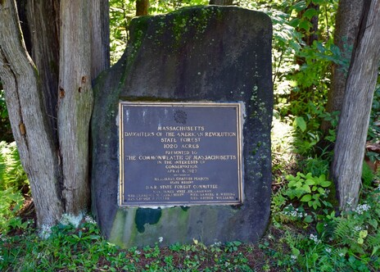
At first glance, the Daughters of the American Revolution (DAR) State Forest may seem far removed from the events of the American Revolution. No battles were fought here, and no famous patriots marched these hills. Yet this forest is deeply connected to the Revolution through the values it was created to honor. In 1929, the Massachusetts Chapter of the Daughters of the American Revolution purchased this cut-over land and gave it to the Commonwealth. Their gift reflected a growing belief that caring for the land was part of caring for the nation. This was the first DAR state forest or memorial of its kind in the United States. It is a living memorial, meant to endure, grow, and serve the public. Just as the Revolution was fought to protect shared ideals like responsibility, sacrifice, and the common good, this forest was preserved so future generations could benefit from healthy land and open space. Visiting here today, visitors are surrounded by a quiet reminder that the Revolution’s principles did not end in 19776. They continue wherever people choose stewardship over neglect and invest in a shared future.
This memorial stone and bronze plaque honors the contributions of the Daughters of the American Revolution.

Fort Phoenix State Reservation, Fairhaven
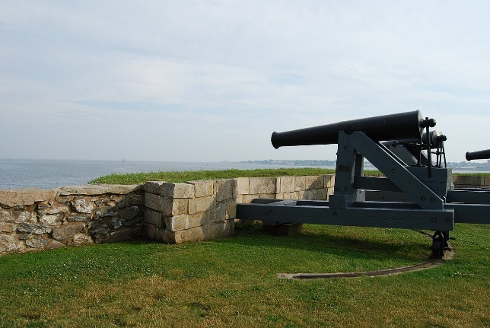
Standing at Fort Phoenix State Reservation, it is hard to imagine that the calm waters there were once the scene of sudden violence and resistance. In May 1775, just weeks after the first shots were fired at Lexington and Concord, patriots launched what is often considered the first naval battle of the American Revolution. In the harbor between Fairhaven and New Bedford, local militia and seafarers revolted against British ships, capturing supplies and signaling that the fight for independence had reached the sea. This early clash showed how important coastal communities were to the Revolution. Harbors like this one protected ships, goods, and livelihoods. And they became targets as colonists challenged British control. Fort Phoenix was later strengthened to defend the shoreline, standing guard over a working waterfront that supported the Revolutionary cause. Today, waves lap quietly against the shore, but the story remains. This place reminds us that the Revolution was not only fought on village greens and battlefields, but also on the water, where ordinary people took extraordinary risks to defend their freedom and their future.
A 24-pounder long cannon at Fort Phoenix overlooking the harbor.

Fall River Heritage State Park, Fall River
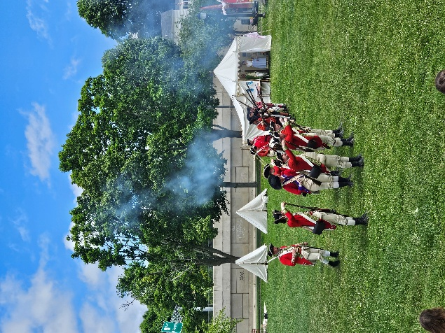
At Fall River Heritage State Park, the quiet riverfront once echoed with cannon fire and shouts of alarm. In May 1778, during the Battle of Fall River (also known as the Battle of Freetown), British forces sailed up the Taunton River to raid coastal towns and disrupt colonial shipbuilding. Local militia quickly gathered to defend their community, exchanging fire with British troops along the shoreline. Though small in scale, the battle revealed how close the war came to everyday life in Massachusetts. Rivers like the Taunton River were lifelines, carrying supplies, ships, and news, and protecting them mattered deeply to the Revolutionary cause. The engagement showed the determination of local citizens to resist British power, even when facing trained soldiers and warships. Today, the battle is regularly reenacted here, bringing history back to life where it happened. As visitors watch the river flow past, they are invited to imagine neighbors turning into defenders and a working waterfront becoming a battlefield. This place reminds us that the Revolution was fought not only by famous leaders, but also by communities willing to stand up for their homes, their livelihoods, and their independence.
In May 2025, the Battle of Fall River was reenacted at the Meadow of Fall River Heritage State Park.

National Monument to the Forefathers, Plymouth
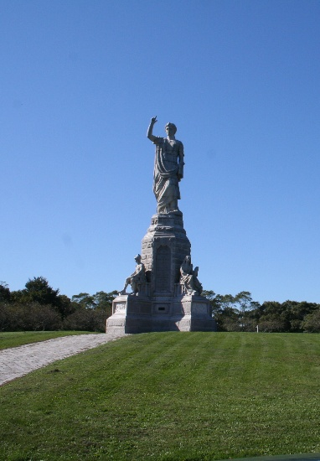
Although the National Monument to the Forefathers was build long after the American Revolution, it honors the ideals that helped make the Revolution possible. Rising above Plymouth, this powerful monument celebrates principles like liberty, law, education, and faith. These values helped shape early New England communities and later inspired colonists to challenge British rule. These ideals taught people to value self-government, personal responsibility, and the common good, long before independence was declared. By the 1700s, those beliefs were deeply rooted in daily life, helping fuel resistance to distant authority and unfair laws. While no Revolutionary battles were fought here, the ideas represented by this monument formed the foundation of the movement for independence. Today, listed on the National Register of Historic Places, the monument invites visitors to look beyond dates and battles and consider the values that united people in a time of great change. Standing there, one can reflect on how the American Revolution was not only a fight for freedom, but also a reflection of principles that had been growing for generations.
The 81-foot granite monument is topped by the figure of Faith.

Dorothy Quincy Homestead, Quincy
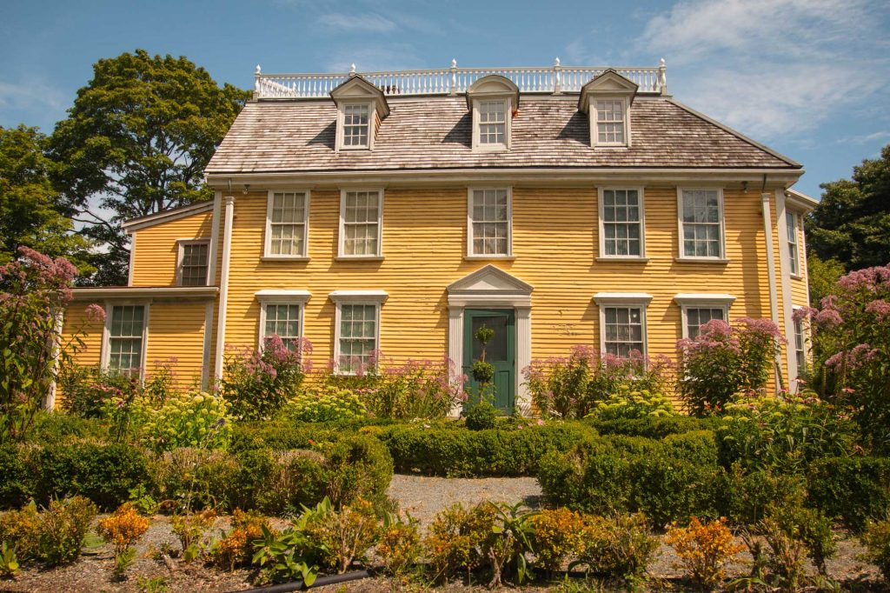
The Dorothy Quincy Homestead offers a quiet but meaningful connection to the American
Revolution through the life of a woman who lived at the center of its social and political world. Dorothy Quincy was part of a prominent Massachusetts family and later became the wife of John Hancock, a leading voice of the Revolution and the first signer of the Declaration of Independence. In the years leading up to independence, homes like this were places where news was shared, ideas were debated and relationships were formed that shaped the Revolutionary cause. Though no battles were fought here, the homestead reflects the important role of women and households in supporting the movement for independence. Today, the home is owned by DCR and managed by the National Society of Colonial Dames of America, preserving it as a place to explore the personal side of the Revolution. There, visitors are reminded that the path to independence was shaped in everyday lives and connections of the people who lived through it.
The Dorothy Quincy Homestead has roots dating back to around 1680-1686 with its original First Period Colonial structure built by Edmund Quincy II.

Lovells Island, Boston Harbor Islands, Boston
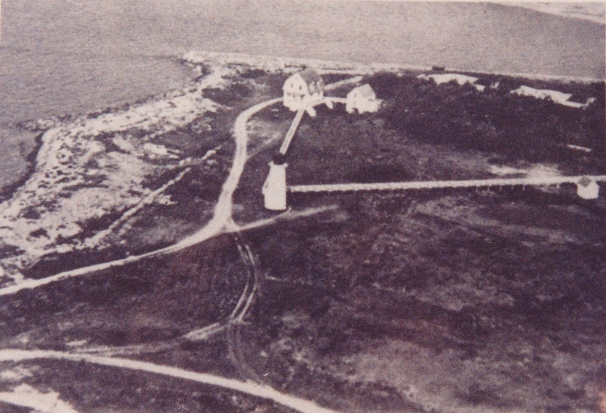
Lovells Island has a lesser-known connection to the American Revolution through the story of a
French warship and the international fight for American independence. In August 1882, the French frigate Magnifique wrecked off the shores of Lovells Island while sailing in Boston Harbor. Just a few years earlier, the Magnifique had taken part in the Battle of Ushant in 1778, a major naval clash between French and British fleets during the American Revolutionary War. France’s entry into the war marked a turning point, bringing ships, soldiers and critical support to the American cause. The loss of the Magnifique so close to shore was a reminder that even after years of fighting, the risks of war remained. Though no battle was fought on this island, the wreck links Lovells Island to the global struggle that helped secure American independence. Standing on the shoreline today, visitors can imagine Boston Harbor not just as a local waterway, but as part of a much larger Revolutionary world shaped by alliances, sacrifices, and the fight for freedom.
This historic aerial photo of Lovells Island shows the lighthouse and keeper’s house as well as other early infrastructure such as roads/paths.

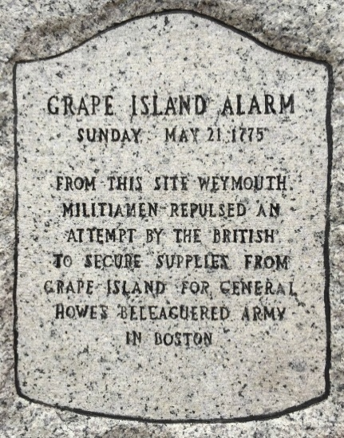
Grape Island, Boston Harbor Islands, Boston
Grape Island, a small island in Boston Harbor, played a supporting role at the very start of the American Revolution. In May 1775, British troops anchored here to gather hay for their horses in Boston. The hay was stored on land owned by Loyalists, colonists who supported the British crown. Local militia soon learned what was happening and rushed to the shoreline. From across the water, they fired on the British troops, forcing them to retreat. After driving them away, the militia crossed to the island and burned the barn where the hay had been stored. This brief but bold clash became known as the Grape Island Alarm and is considered the second armed confrontation of the American Revolution, coming just weeks after Lexington and Concord. Though small in scale, the event showed how quickly ordinary people were willing to take action. Today, Grape Island reminds us that the Revolution unfolded in quiet places, where local knowledge, swift response, and community resolve helped shape the fight for independence.
The battle is memorialized with a stone across the channel from Grape Island at modern day Webb Memorial Park in Weymouth.

Georges Island, Boston Harbor Islands, Boston
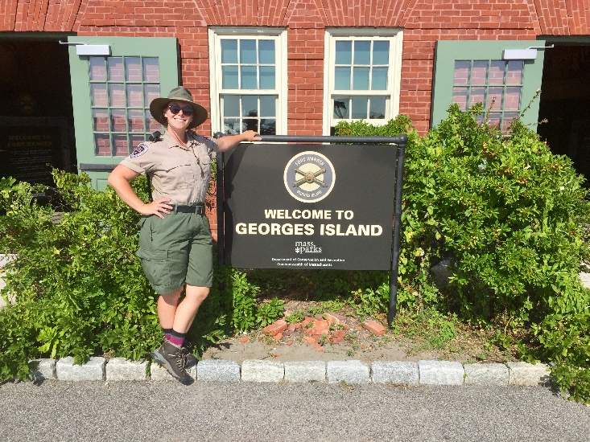
Georges Island, rising from the middle of Boston Harbor, has long been shaped by the need to
defend the city and its people. The island’s strategic location made it a natural military stronghold, guarding the harbor that was vital to trade, communication, and survival in Revolutionary Boston. While the massive granite walls of Fort Warren were completed in 1847, the fort carries the Revolution’s legacy in its very name. Fort Warren honors Dr. Joseph Warren, a Patriotic leader who sent Paul Revere on his famous midnight ride and was killed fighting at the Battle of Bunker Hill. His sacrifice became a symbol of courage and commitment to the cause of liberty. Standing on Georges Island, visitors can look out over the same waters that once needed protection and reflect on how the ideals and sacrifices of the Revolutionary era continued to shape the defense of Boston Harbor long after independence was won.
A friendly Park Interpreter greets visitors as they arrive at George’s Island in front of the Visitor Center.

Fort Revere State Reservation, Hull
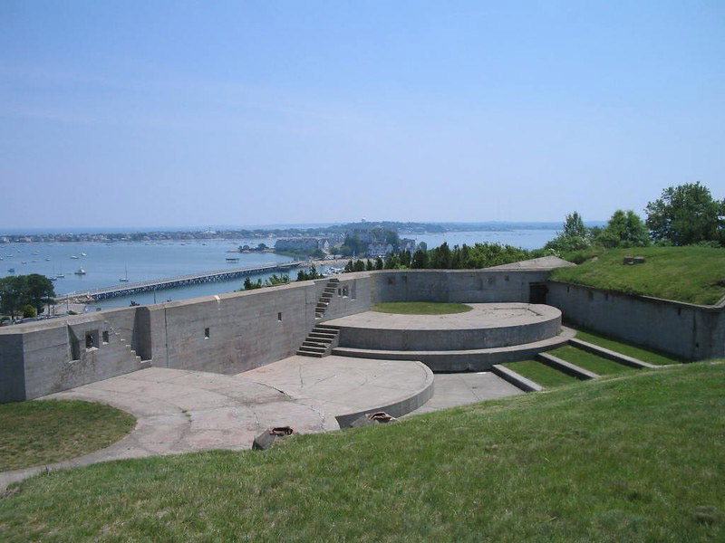
Fort Revere State Reservation in Hull stands on Telegraph Hill, a high point that played an important role during the American Revolution. In 1776, Patriot forces fortified this hill to help defend Boston Harbor as British troops prepared to leave the city. At the time, the site was known as Fort Independence, a name that reflected the colonists’ growing determination to govern themselves and protect their freedom. From this vantage point, soldiers could watch the harbor and guard against enemy ships, showing how geography shaped the fight for independence. Years later, in 1797, the name Fort Independence was transferred to the fort on Castle Island, where it remains today, and the Hull site eventually became known as Fort Revere. Though the name changed, the Revolutionary purpose of the place did not. Today, visitors can imagine Patriot soldiers scanning the horizon and recognize how this hill helped secure Boston Harbor at a moment when the future of a new nation was still uncertain.
A view of Fort Revere overlooking the harbor.

City Square Park, Charlestown
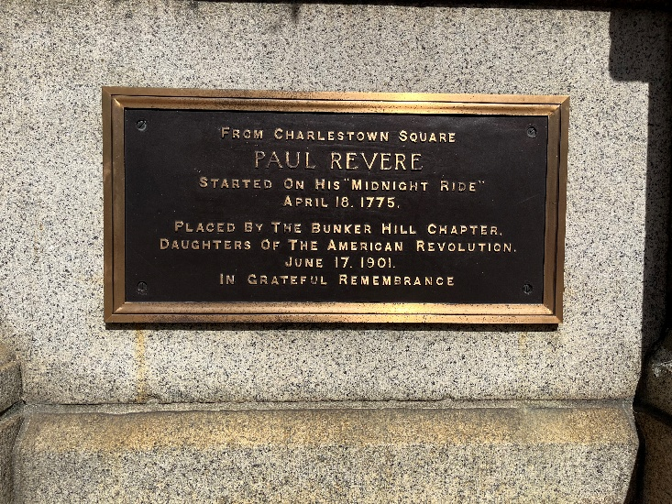
City Square Park sits in the heart of Charlestown on land that has been central to community life for more than three centuries. While the park itself was created in the 20th century, it occupies a site deeply rooted in early American history. In the 18th century, this area was part of the original Market Square and civic center of Charlestown, where colonial residents gathered for markets, meetings, and community discourse long before the Revolution. Much of the town was destroyed during the Battle of Bunker Hill in 1775, a pivotal early battle in the American Revolution fought just uphill from the square, and Charlestown’s civic heart was forever changed by the conflict. Today’s park incorporates memorials and artistic elements that reflect the neighborhood’s layered past and its enduring civic spirit, reminding visitors that the Revolution touched not just battlefields, but the everyday places where people lived, worked, and debated what freedom might mean for their future.
This marker along a beautiful granite wall within the park pays homage to Paul Revere and his famous Midnight Ride in 1775.

Paul Revere Park, Boston
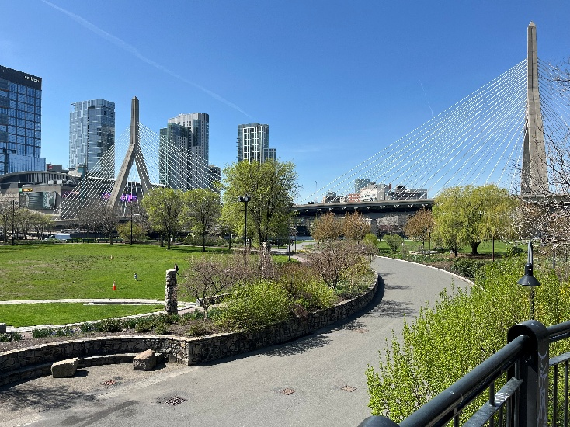
Paul Revere Park may be small, but its location places it at the heart of the American Revolution’s
story. Set along the Charles River at the base of the Zakim Bridge, this park overlooks the waterway that once served as a vital route for travel, communication, and defense in Revolutionary Boston. Nearby, Paul Revere himself crossed these waters during the tense days of April 1775 as Patriot leaders raced to warn the countryside that British troops were on the move. Rivers like the Charles were highways of the 18th century, carrying people, news, and ideas that shaped the fight for independence. Named for one of the Revolution’s most famous messengers, the park invites visitors to pause where land and water meet and imagine a city on the brink of change. Though peaceful today, this stretch of river once played a role in the urgent movement of people and information that helped spark the Revolution, reminding us that even small places can hold powerful connections to the nation’s founding.
A spring view of Paul Revere Park overlooking the city landscape of Boston.

Belle Isle Marsh Reservation, Revere
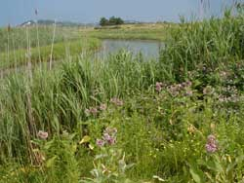
Belle Isle Marsh Reservation may feel quiet and natural today, but during the American Revolution this landscape was part of a dramatic and important moment in the fight for independence. In May 1775, the Battle of Chelsea Creek unfolded across the marshes, tidal creeks, and islands nearby. American militia pursued British troops who were trying to seize livestock and supplies from the shoreline. Knowing the marshes well, the colonist used the winding creeks and shallow waters to their advantage, surrounding the British and forcing them to retreat. During the battle, a British shop was captured and burned. This was the first naval vessel lost by the British during the Revolution. The marsh played a key role, shaping how the battle was fought and proving that local knowledge of the land could outweigh military power. Standing at Belle Isle Marsh today, you can imagine musket fire echoing across the wetland and boats moving through narrow channels. This place reminds u that the American Revolution was fought in working landscapes where nature itself helped shape the path to independence.
Belle Isle Marsh reminds us that nature itself helped share the path to independence.

Lowell Memorial Park, Charles River Reservation, Boston

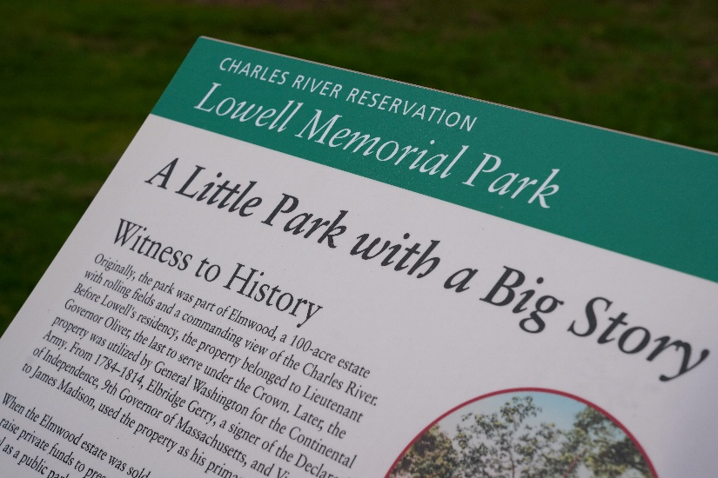
Lowell Memorial Park, part of the Charles River Reservation, is closely tied to the American Revolution through its role during the Siege of Boston in 1775-1776. This land was once part of the Elmwood estate, which served as the site of a military hospital for Patriot forces surrounding the British-held city. As thousands of colonial soldiers gathered to contain Boston after the battles of Lexington and Concord, places like this became critical support spaces, caring for the wounded and sick while the struggle for independence unfolded nearby. The Siege of Boston was a turning point in the early war, ending with the British evacuation of the city in March 1776. Designated a National Historic Landmark, the Elmwood property and the land that is now Lowell Memorial Park, reminds us that the Revolution depended on landscapes that provided care, refuge and resilience. Today, as people stroll along the river, this peaceful park invites reflection on how ordinary places played extraordinary roles in shaping the nation’s fight for independence.
A newly installed interpretive wayside sign talks more about the history of this small park with a big impact. Visit to find out more!

Rutland State Forest, Rutland
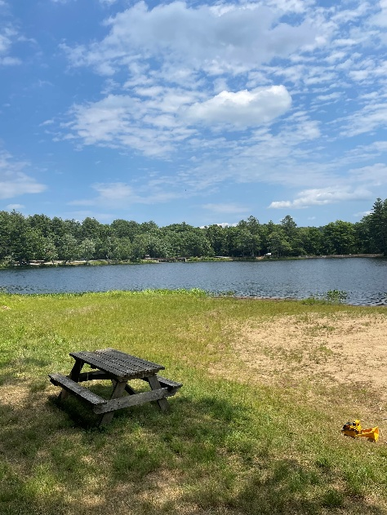
Rutland State Forest may feel peaceful today, but during the American Revolution this remote landscape played an unexpected role in a global conflict. In the late 1770s, this area was used as a prison camp for Hessian soldiers, German troops hired by the British to fight against the American colonies. After being captured, these soldiers were marched inland and held far from the coast, where escape would be difficult. The forests and hills of central Massachusetts made this an ideal location for barracks and guarded camps. Local communities helped provide food and oversight, drawing everyday people into the realities of war. Though no battles were fought here, Rutland was part of the Revolution’s hidden story. A story of imprisonment, endurance, and international struggles. Walking these quiet woods today, visitors are invited to imagine prisoners and guards sharing the same rugged landscape and to reflect on how the fight for independence reached far beyond famous battlefields into places shaped by isolation, resilience, and the lasting impacts of war.
It’s hard to imagine this place as a war prison, given its peaceful, forested landscape.

War Memorial Tower, Mount Greylock State Reservation, Lanesborough
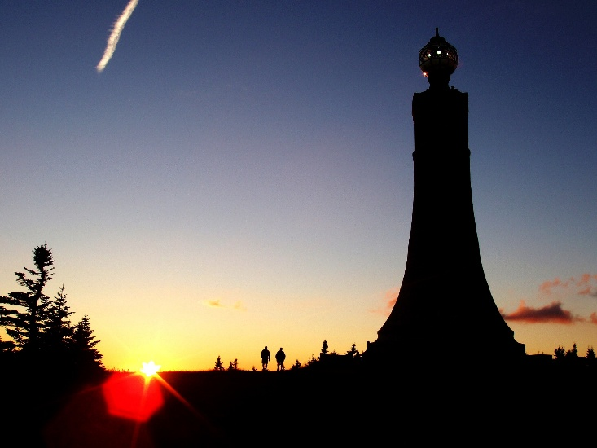
Rising above the landscape at Mount Greylock State Reservation, the War Memorial Tower invites
visitors to reflect on the service and sacrifice across generations of American history. Built in the 1930s, the tower honors Massachusetts men and women who served in the nation’s wars, including those who fought in the American Revolution. From the highest point in the state, one can imagine how hills and high ground mattered during the Revolutionary era, when lookouts and signal stations helped communities watch for danger and share news. The Revolution depended on ordinary people answering a call to defend shared ideals, often with little certainty about the outcome. Though the tower itself was built long after independence was won, it stands overlooking a landscape that connects past and present, reminding us that the freedoms first fought for in the 18th century required courage, cooperation, and sacrifice. As visitors take in the sweeping views, the tower offers a powerful place to consider how the Revolutionary spirit of service helped shape the nation and how those values continue to be honored here today.
Visitors enjoy peaceful reflection at the War Memorial Tower as the sun sets on Mount Greylock.

Quabbin Park Cemetery, Quabbin Reservoir, Ware
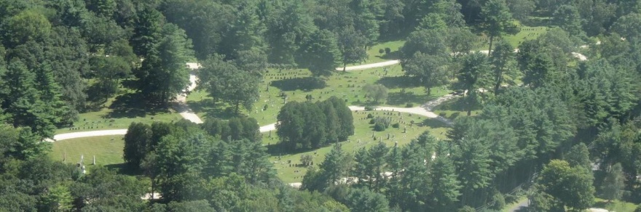
Quabbin Park Cemetery holds a quiet by powerful connection to the American Revolution and to the people whose lives helped shape the nation. This cemetery was created in the 1930s to reinter the remains of more than 7,000 individuals whose original graves were disinterred to make way for the Quabbin Reservoir. Among them are 41 veterans of the American Revolution, honored here by a bronze plaque that recognizes their service and sacrifice. These men once answered the call to defend a new idea of independence, returning after the war to live, work, and raise families in the towns of central Massachusetts. Through their original communities now lie beneath the reservoir’s waters, this cemetery preserves their memory and dignity. Here, visitors are reminded that the Revolution’s legacy lives not only in famous names and battles, but in the lives of ordinary people whose service shaped the nation and whose stories continue to be honored within this transformed landscape.
The Quabbin Park Cemetery, a quiet place to reflect on the Revolution’s legacy and the lives of people whose service helped share a nation.

Horse Caves, Holyoke Range State Park, Granby

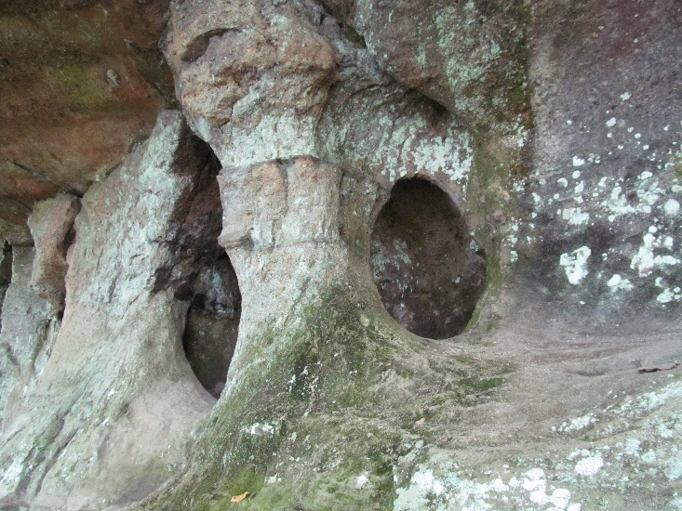
Tucked into the rugged landscape of Holyoke Range State Park, the Horse Caves are wrapped in legend that links this dramatic landscape to the uneasy years following the American Revolution. According to local stories, some of the men who fought with Daniel Shay during Shay’s Rebellion hid in these caves after their defeat by the Massachusetts militia in 1787. The rebellion was led by farmers and veterans who believed the promises of the Revolution like fairness, opportunity, and representation, were slipping out of reach. As they fled to the hills, places like the Horse Caves offered shelter, secrecy, and a last refuge. While the caves themselves were not a battlefield, they symbolize the challenges faced by the new nation as it struggled to live up to its Revolutionary ideals. Today, visitors can imagine desperate footsteps echoing off the stone ledges and reflect on how the fight for independence did not end with victory, but continued as Americans worked to define justice and freedom in a young nation.
The Horse Caves were formed when layers of hard basalt fractured and weathered over time, creating deep cracks and overhangs in the ancient volcanic rock of the Holyoke Range.

