## Universal Access Program logo of a path leading to a mountainous horizon.dcr Massachusetts logo with a laurel leaf in a circle.Herter Park/Artesani Playground Recreation Program

1255 Soldiers Field Road

Brighton, MA 02135

# Adaptive Recreation Fair!

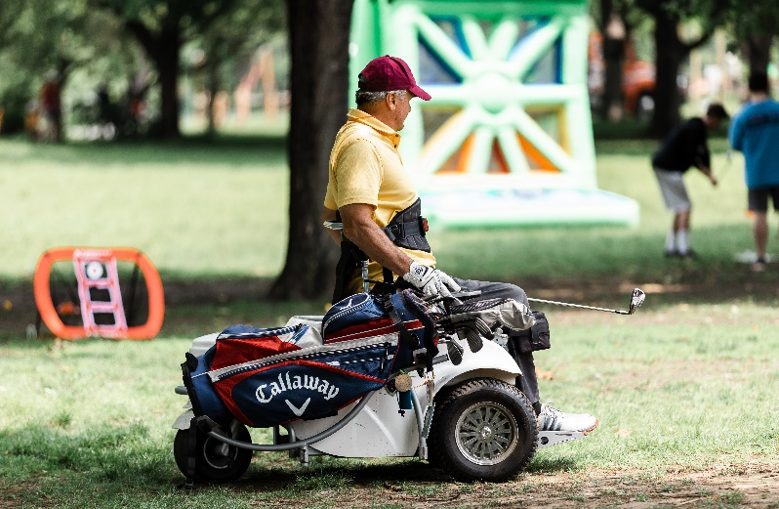**Saturday, June 7, 2025**

**10 a.m. – 3 p.m.**

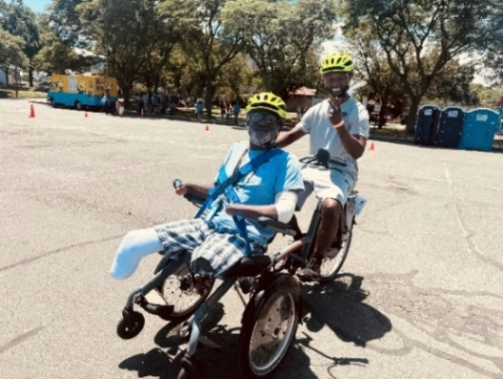**\*Cycling *Pickleball *Face Painting *Games**

**\*Equipment Demonstrations *Refreshments *Crafts *DJ Music & More!**

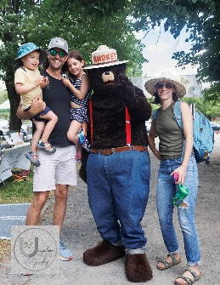Join DCR’s [**Universal Access Program**](http://www.mass.gov/dcr/universal-access) and other adaptive recreation organizations for an accessible and inclusive day of fun and networking along the Charles River! Enjoy adaptive cycling, adaptive pickleball, music, refreshments, and adaptive hiking, surfing, and fencing equipment demonstrations! There will be family-friendly activities including face painting, adaptive golf, and lawn games. Find out about adaptive recreation programs across the state!

**Pre-Registration is recommended.** Especially if you need an accommodation

*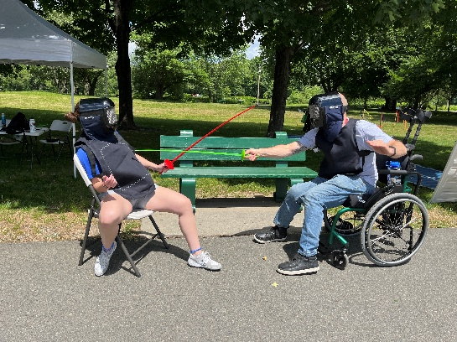***Cost: FREE!!**

**To Register:** Goonline [mass.gov/DCRAdaptiveFair](http://mass.gov/DCRAdaptiveFair), call Teri at [(413) 461-7126](tel:4134617126), or email UAP [DCR.UniversalAccess@mass.gov](mailto:DCR.UniversalAccess@mass.gov)

Photo courtesy of Unspoken Images Photography

**Volunteers Needed!** Contact Mariah at (857) 289-4175 or [Mariah.Fontaine@mass.gov](mailto:mariah.fontaine@mass.gov)

Qr code for Recreation Fair Registration form

**Scan QR Code to Register**

[Department of Conservation and Recreation](https://www.mass.gov/orgs/department-of-conservation-recreation), [Universal Access Program](https://www.mass.gov/orgs/universal-access-program)

[mass.gov/dcr/universal-access](http://www.mass.gov/dcr/universal-access)

**Exhibitors Include:**

* [ABA Centers of America](https://www.abacenters.com/)
* 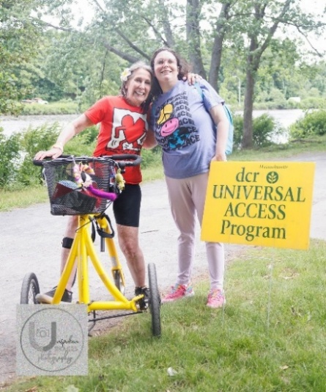[All Out Adventures](https://alloutadventures.org/)
* [Apex Social Group-Boston](https://apex-social.com/boston-childcare-agency-infants-toddlers-special-needs/)
* [Appalachian Mountain Club](https://www.outdoors.org/)
* [Boston Fencing Club](https://www.bostonfencingclub.org/)
* [Charles River Community Health](https://www.charlesriverhealth.org/)
* [Community Boating](https://www.community-boating.org/accessible/welcome/)
* [Community Rowing Inc.](https://communityrowing.org/)
* [DCR Forest Fire Control](https://www.mass.gov/forest-fire-control-programs) and [Smokey Bear](https://smokeybear.com/)
* [DCR Interpreters](https://www.mass.gov/info-details/dcr-programs-and-events)
* [Disability Resource Center](https://www.disabilityrc.org/)

Photo courtesy of Unspoken Images Photography

* [Federation for Children With Special Needs (FCSN)](https://fcsn.org/)
* [Gnome Surf](https://www.gnomesurf.com/)
* 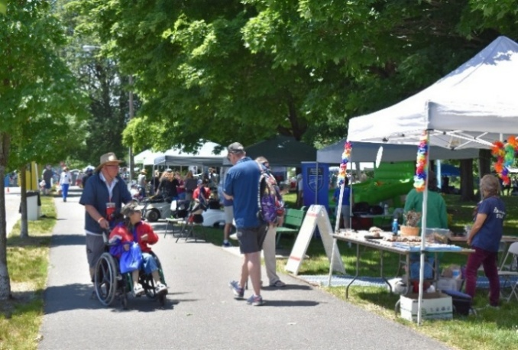[Golf for All](https://golfforall.org/)
* [Institute for Human Centered Design](https://www.humancentereddesign.org/)
* [Learners at the Center](https://learnersatthecenter.weebly.com/)
* [Massachusetts Water Resources Authority](https://www.mwra.com/) (MWRA)
* [National Park Service/Springfield Armory National Historic Site](https://www.nps.gov/spar/index.htm)
* [New England ADA Center](https://newenglandada.org/)
* [Northeast Passage](https://www.nepassage.org/)
* [Unspoken Images Photography](https://www.unspokenimagesphotography.com/)
* [Waypoint Adventure](https://www.waypointadventure.org/)

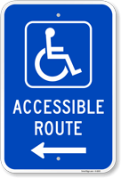**Accessible Event**

* Booths are placed along paved and stone dust paths
* 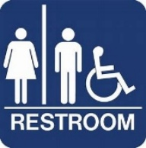Curb Ramps and Temporary Curb Ramps will be in place
* Mats will allow access to activities on grass
* Accessible portable toilets will be on site; a bathroom with accessible flush toilets and running water are a few hundred feet away
* *There are no electric hook ups available at the event*

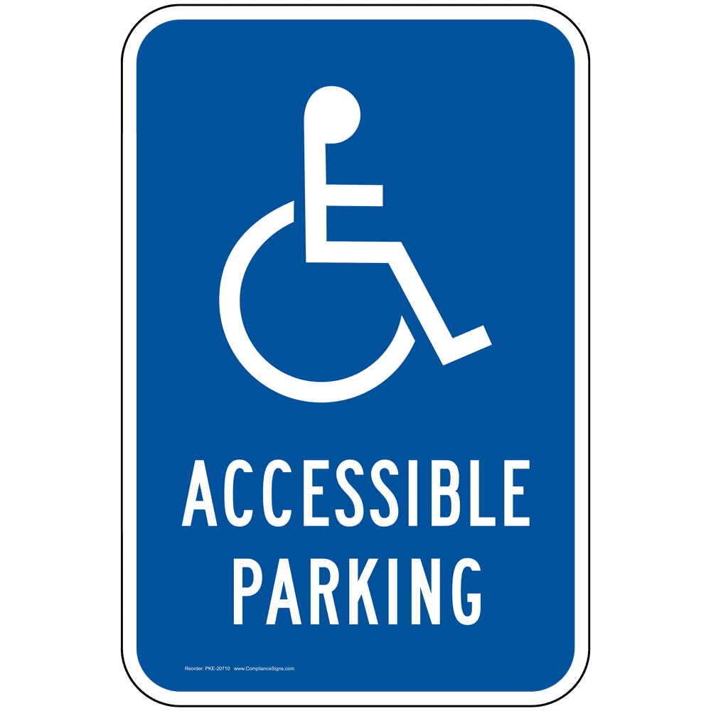**Parking is Free but Limited**

* Parking lot is shared with the public and is first-come, first served
* Drop off and pick up area at fair entrance
* Parking attendants will be available to help direct

**Special Accommodations** should be requested in advance during registration. Please allow at least two weeks (14 days) advance notice. Last minute requests will be accepted, but we may be unable to fulfill the request.

**Please bring your own water bottle:** We are no longer purchasing single-use plastic water bottles, so please bring your own reusable bottle or cup and help us promote sustainability! You can fill up at [MWRA's](https://www.mwra.com/) Quench Buggy-a mobile water fountain that provides free, cold drinking water!