# Group of people are riding recumbent trikes on a paved path next to a reservoir on a sunny fall day.Universal Access Program logo of a path leading to a mountainous horizondcr Massachusetts logo with a laurel leaf in a circle.DCR’s Universal Access Program Fall 2024 Program Schedule

## General Information

DCR’s [Universal Access Program](https://www.mass.gov/orgs/universal-access-program) is dedicated to providing outdoor recreation opportunities in Massachusetts state parks for visitors of all abilities. Accessibility is achieved through site improvements, specialized adaptive recreation equipment, and accessible recreation programs.

The Universal Access Program (UAP) offers adaptive, accessible programming seasonally at state parks, pools, and rinks. We partner throughout the year with [All Out Adventures](https://alloutadventures.org/), [Easterseals Massachusetts](https://www.easterseals.com/ma/), [Holyoke Rows](https://holyokerows.org/), and [Waypoint Adventure](http://www.waypointadventure.org/) to provide programs statewide.

Our structured programs feature adaptive equipment, professional staff, and instruction and support. Friends, family members, and companions are encouraged to take part in our programs alongside participants with disabilities.

Our Spring Program season runs from April through May, our Summer Program season runs from June through August, our Fall Program season runs from September through October, and our Winter Program season runs from November through March.

Check out [mass.gov/dcr/access](http://www.mass.gov/dcr/access) to keep up to date with our activities! If you would like to get on our mailing list to be notified of upcoming events and activities, please [contact us](mailto:DCR.UniversalAccess@mass.gov).

### Release Forms & Pre-Registration

A current release form is required for all our programs, and you must **pre-register with the organization running the program.** To pre-register, cancel, or check-in about inclement weather, please contact the providing organization listed for each program.

### Essential Eligibility Criteria & Program Attendance Guidelines

You must also meet the [essential eligibility criteria](https://www.mass.gov/service-details/essential-eligibility-criteria-for-universal-access-program-participants) and follow our [program attendance guidelines](https://www.mass.gov/info-details/essential-eligibility-criteria-for-universal-access-program-participants#program-attendance-guidelines-) (PAG) for the activity. Essential eligibility criteria (EEC) help you understand the skills you need to participate in our programs. For risk management considerations, everyone who attends our programs must complete a release form and meet these EEC, including caregivers and group staff. You can meet the EEC independently, or with the help of a caregiver (family member, friend, or PCA). Visit us at [mass.gov/uap/eec](http://www.mass.gov/uap/eec) to learn more.

If you have concerns about your ability to meet the EEC or PAG, please speak with the organization leading the activity. If you have general questions or concerns, please contact us by email [DCR.UniversalAccess@mass.gov](mailto:DCR.UniversalAccess@mass.gov) or phone at [(413) 461-7126](tel:4134617126).

## Group of people are being assisted into kayaks on the shore of a pond.Adaptive Canoeing & Kayaking

### [DAR State Forest](https://www.mass.gov/locations/daughters-of-the-american-revolution-dar-state-forest)—Canoeing & Kayaking

#### 78 Cape St, Goshen

Join UAP’s adaptive canoeing and kayaking program on Upper Highland Lake in Goshen, run by our partner [All Out Adventures](https://alloutadventures.org/). Paddlers will travel in small groups (pods) to explore the lake. Instruction, adaptive equipment, and assistance as needed is provided.

*We will paddle on the first Wednesday of September and then switch to Thursdays.*

Wednesday, 10 a.m.-2:45 p.m.

* September 4

Thursdays, 10 a.m.–2:45 p.m.

* September 12
* September 19
* September 26
* October 3

Participants may sign up for a 1 hour and 15 minute time slot: 10-11:15 a.m., 11:30 a.m.-12:45 p.m., or 1:30-2:45 p.m. You must register by 12 p.m. the day before the program.

**Cost:** $8 per participant; one guest may attend at no charge. Scholarships are available for those who need them.

**Questions & To Register:** Call [All Out Adventures](https://alloutadventures.org/) at [(413) 584-2052](tel:4135842052) or email [Programs@alloutadventures.org](mailto:Programs@alloutadventures.org)

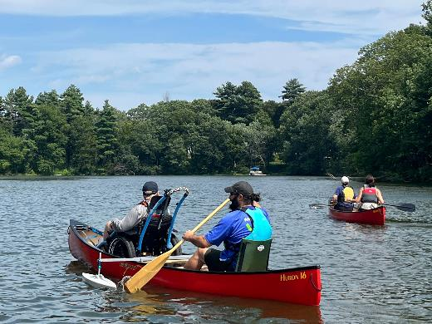

### [Whitehall State Park](https://www.mass.gov/locations/whitehall-state-park) —Canoeing

#### 300 Wood St., Hopkinton

Join UAP’s adaptive canoeing program on Whitehall Reservoir in Hopkinton, run by our partner [Waypoint Adventure](https://waypointadventure.org/). Paddlers will travel in small groups to explore the reservoir. Experience the fun and serenity of being on the water while being part of a supportive community. Benefit from a wide array of adaptive canoe equipment and instruction designed to meet your individual needs.

Wednesday, 2–4:30 p.m.

* October 9

**Cost:** $20/Participant. Cost flexible based on need.

**To Register:** Visit [waypoint-adventure.jumbula.com](https://waypoint-adventure.jumbula.com/)

**Questions:** Email [programs@waypointadventure.org](mailto:programs@waypointadventure.org)

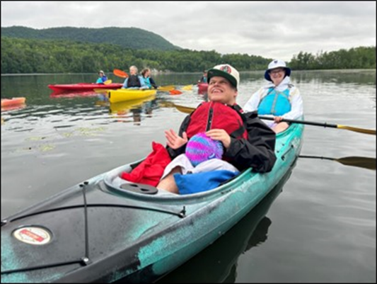

### [Beartown State Forest](https://www.mass.gov/locations/beartown-state-forest)—Kayaking

#### 214 Blue Hill Rd., Great Barrington, MA

Join UAP’s adaptive kayaking program on Benedict Pond in Great Barrington, run by our partner [All Out Adventures](https://alloutadventures.org/). Paddlers will travel in small groups (pods) to explore the pond. Instruction, adaptive equipment, and assistance as needed is provided.

Thursdays, 11 a.m.–2:30 p.m.

* October 10
* October 17
* October 24

Participants may sign up for one of two time slots: morning or afternoon. You must register by 12 p.m. the day before the program.

**Closest GPS Address:** 214 Blue Hill Rd., Great Barrington, MA. This is just east of the park entrance. Take Benedict Pond Rd. to the first parking lot on your right at the pond. **Access Blue Hill Rd. from Main Rd. (Route 23).** **Avoid accessing *Benedict Pond from the park's North Entrance due to dirt roads.***

**Cost:** $8 per participant; One guest may attend at no charge. Scholarships are available for those who need them.

**Questions & To Register:** Call [All Out Adventures](https://alloutadventures.org/) at [(413) 584-2052](tel:4135842052) or email [Programs@alloutadventures.org](mailto:Programs@alloutadventures.org)

## Two people are riding a wheelchair tandem trike on a paved path. Adaptive Cycling

### [Norwottuck Rail Trail](https://www.mass.gov/locations/norwottuck-rail-trail)—Cycling

#### 12 Railroad St., Hadley, MA

Join UAP’s adaptive cycling program in Hadley, run by our partner [All Out Adventures](https://alloutadventures.org/). We offer an array of cycles that can accommodate riders of all abilities from stable, comfortable recumbent trikes, to handcycles, to tandem recumbent trikes, to wheelchair tandems. Instruction, equipment, and assistance (as needed) are provided.

Fridays, 10 a.m.–3 p.m. in September

* September 13
* September 20
* September 27

Fridays, 11 am.–3 p.m. in October

* October 4
* October 11
* October 18

Participants may sign up for a one-hour timeslot during the program. You must register by 3 p.m. the day before the program.

**Cost**: $5-$20. Sliding scale per session.

**Questions & To Register:** Call [All Out Adventures](https://alloutadventures.org/) at [(413) 584-2052](tel:4135842052) or email [Programs@alloutadventures.org](mailto:Programs@alloutadventures.org)

### [Blackstone River Greenway](https://blackstoneheritagecorridor.org/exploring-the-blackstone-river-valley/maps-tours-guides/blackstone-river-bikeway/) at the [Blackstone River Valley Heritage Center](https://blackstoneheritagecorridor.org/happening-now/worcester-heritage-center/)—Cycling

#### 3 Paul Clancy Way, Worcester, MA

Join UAP’s adaptive cycling program in Worcester, run by our partner [All Out Adventures](https://alloutadventures.org/). We offer an array of cycles that can accommodate riders of all abilities from stable, comfortable recumbent trikes, to handcycles, to tandem recumbent trikes, to wheelchair tandems. Instruction, equipment, and assistance (as needed) are provided.

Wednesday, 11 a.m.–3 p.m.

* September 11

Participants may sign up for a one-hour timeslot during the program. You must register by 3 p.m. the day before the program.

**Cost**: $5-$20. Sliding scale per session.

**Questions & To Register:** Call [All Out Adventures](https://alloutadventures.org/) at [(413) 584-2052](tel:4135842052) or email [Programs@alloutadventures.org](mailto:Programs@alloutadventures.org)

### [Blackstone River Greenway](https://blackstoneheritagecorridor.org/exploring-the-blackstone-river-valley/maps-tours-guides/blackstone-river-bikeway/)—Cycling

#### 85 Canal St, Blackstone, MA

Join UAP’s adaptive cycling program in Blackstone, run by with our partner [All Out Adventures](https://alloutadventures.org/). We offer an array of cycles that can accommodate riders of all abilities from stable, comfortable recumbent trikes, to handcycles, to tandem recumbent trikes, to wheelchair tandems. Instruction, equipment, and assistance (as needed) are provided.

Wednesday, 11 a.m.–3 p.m.

* September 25

Participants may sign up for a one-hour timeslot during the program. You must register by 3 p.m. the day before the program.

**Cost**: $5-$20. Sliding scale per session.

**Questions & To Register:** Call [All Out Adventures](https://alloutadventures.org/) at [(413) 584-2052](tel:4135842052) or email [Programs@alloutadventures.org](mailto:Programs@alloutadventures.org)

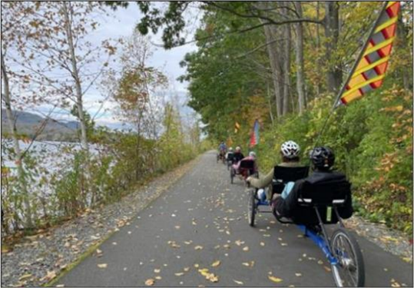

### [Ashuwillticook Rail Trail](https://www.mass.gov/locations/ashuwillticook-rail-trail), Farnams Crossing—Cycling

#### 50 Farnams Rd., Cheshire, MA

Join UAP’s adaptive cycling program in Cheshire, run by our partner [All Out Adventures](https://alloutadventures.org/). We offer an array of cycles that can accommodate riders of all abilities from stable, comfortable recumbent trikes, to handcycles, to tandem recumbent trikes, to wheelchair tandems. Instruction, equipment, and assistance (as needed) are provided.

Wednesdays, 11 a.m.–3 p.m.

* September 18
* October 2
* October 9
* October 16
* October 23

Participants may sign up for a one-hour timeslot during the program. You must register by 3 p.m. the day before the program.

**Cost**: $5-$20. Sliding scale per session.

**Questions & To Register:** Call [All Out Adventures](https://alloutadventures.org/) at [(413) 584-2052](tel:4135842052) or email [Programs@alloutadventures.org](mailto:Programs@alloutadventures.org)

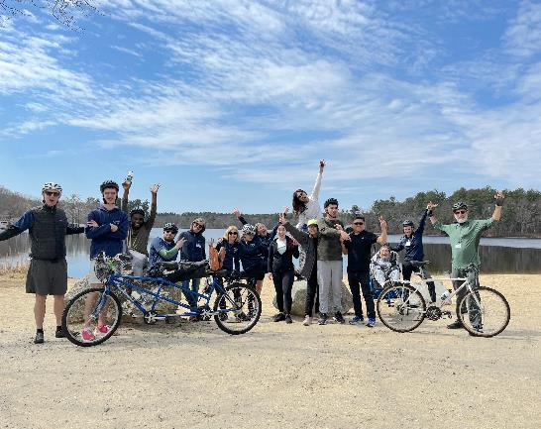

### [Cochituate State Park](https://www.mass.gov/locations/cochituate-state-park)—Tandem Cycling

#### 43 Commonwealth Road, Natick, MA

Join UAP’s adaptive tandem cycling program in Natick, run by with our partner [Waypoint Adventure](https://waypointadventure.org/). During these programs, small groups work together to cycle the back roads and bike paths of Massachusetts. Participants are encouraged to bring lunch and socialize on the trail and during breaks. We have a variety of bikes that offer different amounts of support.  We will match up two riders (a Captain and a Stoker). The Captain will be the leader and the Stoker is the other half of the team, who works with the Captain to enjoy the adventure of tandem cycling. Some of our bikes are more traditional upright bicycles that require teamwork and balance. We also have other models that are side by side or recumbent, low to the ground, tandems. Some have two wheels and require more balance while others are quite sturdy with three wheels and supportive seats.

Tuesday, 10 a.m.–1 p.m.

* October 29

**Cost:** $20/Participant. Cost flexible based on need.

**To Register:** Visit [waypoint-adventure.jumbula.com](https://waypoint-adventure.jumbula.com/)

**Questions:** Email programs@waypointadventure.org

## A person is rowing in an boat equipped with outriggers and an adaptive seat. Adaptive Rowing

### [Connecticut River Greenway State Park](https://www.mass.gov/locations/connecticut-river-greenway-state-park)—Rowing

25 Jones Ferry Rd., Holyoke, MA

Join UAP for some adaptive rowing on the Connecticut River in Holyoke! This program, run by [Holyoke Rows](https://www.holyokerows.org/), uses specialized equipment, modifications, and adaptations to meet your needs while rowing or sculling. Instruction, adaptations, and staff support are all provided. You will receive instruction and the opportunity to practice, and also have the chance to participate in competitions! Our program serves people of all capabilities, from beginners to leisure rowers, to competitive racers!

This program is free of charge and is open to people with disabilities and their families and friends. Pre-registration is required.

Thursdays, By Appointment Only

* September 5
* September 12
* September 19
* September 26
* October 3
* October 10
* October 17
* October 24
* October 31

**Cost:** Free

**Questions & to Register:** Call [Holyoke Rows](https://www.holyokerows.org/) at [(413) 320-3134](tel:4133203134) or email [office@holyokerows.org](mailto:office@holyokerows.org)

## Fall 2024 Supported Programs

Several organizations also offer adaptive programming at DCR locations on their own, sometimes with the use of DCR equipment. These are called *supported* *programs*. Each providing organization has their own requirements for programming, including release forms, EEC, and program attendance guidelines. Please contact the providing organization (by phone, email or by checking their website) for further information and to register.

### A group of golfers dressed in halloween outfits are posting for a picture. Two people are standing using para-golfers. Golfing with the Massachusetts Para-Golfers Association

The [Massachusetts ParaGolfer Association](https://www.mpga.club/) (MPGA) promotes recreational and competitive adaptive golf for players with visual impairments, amputations, loss of mobility, and spinal cord injuries. MPGA provides adaptive golf lessons, recreational programs, and competitive events. Lessons are private and always free, and we offer flexible dates and times. Please make a reservation in advance by calling or texting Steve [(508) 889-7581](tel:5088897581).

**Website:** [mpga.club](https://www.mpga.club/)

**Locations**: [DCR Golf Courses](https://www.statemadcrgolf.com/)

* [Ponkapoag Golf Course](https://www.mass.gov/locations/ponkapoag-golf-course)**,** 2167 Washington Street, Canton, MA,
* [Leo J. Martin Memorial Golf Course](https://www.mass.gov/locations/leo-j-martin-memorial-golf-course)**,** 190 Park Rd, Weston, MA

**Contact:** Steve Kuketz, [mpga.club@gmail.com](mailto:mpga.club@gmail.com), [(508) 889-7581](tel:5088897581)

### A group of golfers are posing for a photo. One person is using a wheelchair and one person is standing with a para-golfer.Golfing with Golf for All

[Golf for All](http://www.golfforall.org/)runs year-round programming for veterans, people with autism, Parkinson’s Disease, spinal cord injuries and paralysis, cerebral palsy, golfers with amputations, golfers with visual impairments, and more. Golf instruction is tailored to suit the specific needs of each participant and is taught by PGA Professionals who have successfully completed a certification process for teaching golfers with adaptive needs. Golfers of all abilities and gender are welcome, and no previous experience is necessary. During each clinic, golfers are provided with instruction, balls, adaptive equipment, and vehicles, as needed.

**Website:** [golfforall.org](http://www.golfforall.org/)

**Locations**: [DCR Golf Courses](https://www.statemadcrgolf.com/)

* [Ponkapoag Golf Course](https://www.mass.gov/locations/ponkapoag-golf-course), 2167 Washington Street, Canton, MA,

* [Leo J. Martin Memorial Golf Course](https://www.mass.gov/locations/leo-j-martin-memorial-golf-course), 190 Park Rd, Weston, MA

**Contact:** Fred Corcoran, Exec. Director, [fredcorc@golfforall.org](mailto:fredcorc@golfforall.org), [(617) 462-9899](tel:6174629899)

### A group of people in a sailboat on the river are smiling and waving at the camera. Sailing with Community Boating, Inc.

Nestled in the heart of Boston, Community Boating allows individuals to take responsibility for their learning, push themselves to overcome challenges, and experience the freedom sailing offers. With top-notch instruction and quality equipment, the program provides support and encouragement to individuals who might not otherwise be able to sail. Members include veterans, individuals with visual impairments, children with developmental disabilities, adults with chronic injury or illness, and many more.

**Website:** [community-boating.org/accessible](https://www.community-boating.org/accessible/)

**Location:** Charles River Esplanade in the [Charles River Reservation](https://www.mass.gov/locations/charles-river-reservation), 21 David G Mugar Way, Boston, MA

**Dates:** May 1–September 27

**Times:** Afternoons and weekends: see [scheduling page](https://urldefense.com/v3/__https:/community-boating.org/accessible/schedule-an-appointment/__;!!CPANwP4y!Q2u1LkgkJAT4V3lI7ecciN1Dhgn5Igla7wV8Q2gw5qfM2gpq7Gy_dt7rXgC5uQKG9hE1LQro8fs5WlZRagS9MMt5dZ0$) for appointment times

**Annual Membership:** $50 or reduced fee of $1 upon request

**Eligibility:** Any individual who needs additional assistance

**Contact:** [adoyle@community-boating.org](mailto:adoyle@community-boating.org), [(617) 523-1038](tel:6175231038)

### Adaptive Cycling & Golfing with Spaulding Adaptive Sports Centers

#### **Many styles and sizes of adaptive bicycles are parked in front of 3 accessible yurts and a Spaulding pop up canopy.** The McGraw Center

[Spaulding Adaptive Sports Centers](https://spauldingrehab.org/conditions-services/adaptive-sports) (SASC) will be offering adaptive cycling at the McGraw Center for Adaptive Sports at [Nickerson State Park](https://www.mass.gov/locations/nickerson-state-park) from May 14 through mid-October. Spaulding staff provide equipment, adaptations, and support. Pre-registration for all activities is required.

Visit SASC’s [on-line calendar](https://sasc.spauldingrehab.org/default.aspx?tab=icon) for further information about McGraw Center Programs.

**Location:** McGraw Center for Adaptive Sports, [Nickerson State Park](https://www.mass.gov/locations/nickerson-state-park), Brewster

#### A group of people are golfing on a driving range. The person in front is using a paragolfer to stand.Back on Course—Boston

SASC offers a return to golf program designed for those who are ready to play between 4–9 consecutive holes on the course. Prior participation in the Back in the Swing (BITS) series is helpful as a pre-requisite for new golfers or those returning to golf post-injury. Coaching and golf etiquette guidance provided by SASC Golf Pro.

Visit SASC’s [on-line calendar](https://sasc.spauldingrehab.org/default.aspx?tab=icon) for further information about Back on Course Programs

**Location:** [Leo J. Martin Memorial Golf Course](https://www.mass.gov/locations/leo-j-martin-memorial-golf-course), 190 Park Rd, Weston, MA

**Date:** Thursday**,** September 26

**Time:** 9:30 a.m. – 11 a.m.

**Cost:** $40 per session

**Website:** [sasc.spauldingrehab.org](https://sasc.spauldingrehab.org/)

**Contact:** [spauldingadaptivesports@partners.org](mailto:spauldingadaptivesports@partners.org), [(877) 976-7272](tel:8779767272)