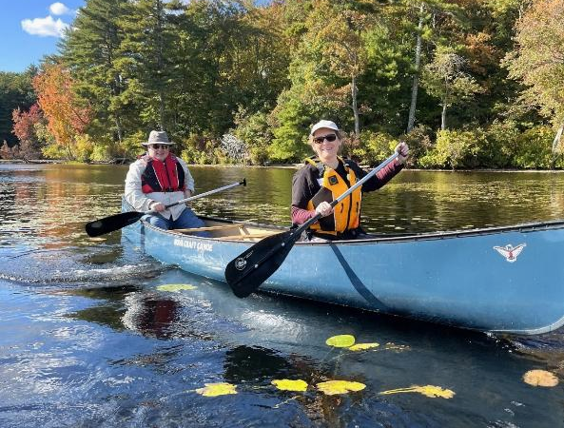


DCR’s Universal Access Program
Fall 2025 Program Schedule

 Fall 2025 Adaptive Recreation Fun!

General Information
DCR’s Universal Access Program (UAP) is dedicated to providing outdoor recreation opportunities in Massachusetts state parks for visitors of all abilities. Accessibility is achieved through site improvements, specialized adaptive recreation equipment, and accessible recreation programs.
The Universal Access Program (UAP) offers adaptive, accessible programming seasonally at state parks, pools, and rinks. We partner throughout the year with All Out Adventures, Easterseals Massachusetts, Holyoke Rows, and Waypoint Adventure to provide programs statewide.
Our structured programs feature adaptive equipment, professional staff, and instruction and support. Friends, family members, and companions are encouraged to take part in our programs alongside participants with disabilities.
UAP’s Program Seasons: Our Spring Program season runs from April through May, our Summer Program season runs from June through August, our Fall Program season runs from September through October, and our Winter Program season runs from November through March.
Website: Check out mass.gov/dcr/access to keep up to date with our activities!
Contact List: If you would like to get added to our contact list to be notified of upcoming events and activities, please email us.

Release Forms & Pre-Registration
A current release form is required for all our programs, and you must pre-register with the organization running the program. To pre-register, cancel, or check-in about inclement weather, please contact the providing organization listed for each program.

Essential Eligibility Criteria & Program Attendance Guidelines
You must also meet the Essential Eligibility Criteria (EEC) and follow our Program Attendance Guidelines (PAG) for the activity. The EEC helps you understand the skills you need to participate in our programs. For risk management considerations, everyone who attends our programs must complete a release form and meet these EEC, including caregivers and group staff. You can meet the EEC independently, or with the help of a caregiver (family member, friend, or PCA). Visit us at mass.gov/uap/eec to learn more.
If you have concerns about your ability to meet the EEC or PAG, please speak with the organization leading the activity. If you have general questions or concerns, please contact us by email DCR.UniversalAccess@mass.gov or phone at (413) 461-7126.
Accommodation Requests: If you need an accommodation at a program, like an ASL interpreter or a sighted guide, please let the program provider know when you're registering. Please allow at least two weeks (14 days) advance notice for accommodation requests. Program providers may not be able to fulfill last-minute requests.

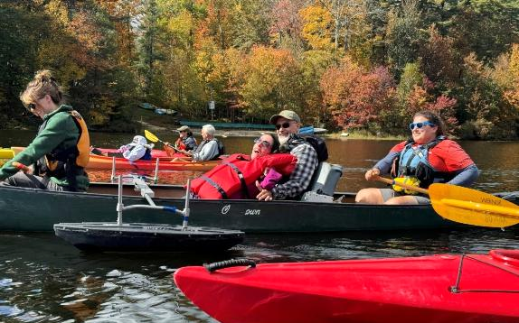
Adaptive Canoeing & Kayaking

DAR State Forest—Canoeing & Kayaking

78 Cape Street, Goshen, MA
Join the Universal Access Program for adaptive paddling on Upper Highland Lake in Goshen! During this program, run by our partner All Out Adventures, paddlers will travel in small groups (pods) to explore the lake. Instruction, adaptive equipment, and assistance (as needed) are provided.
This program is for people with disabilities, their families, support staff, and friends. Seniors are invited to register as well.
Days and Times: Thursdays, 9:45 a.m.–3 p.m.

- September 4, 2025
- September 18, 2025

Participants may sign up for one of three time slots: 9:45–11:15 a.m.; 11:30 a.m. –1 p.m.; or 1:30–3 p.m. You must register by noon the day before the program.
Cost: $8 per participant; One guest may attend at no charge. Scholarships are available for those who need them.
Questions & To Register: Register with AOA online at alloutadventures.org, call (413) 584-2052, or email programs@alloutadventures.org.

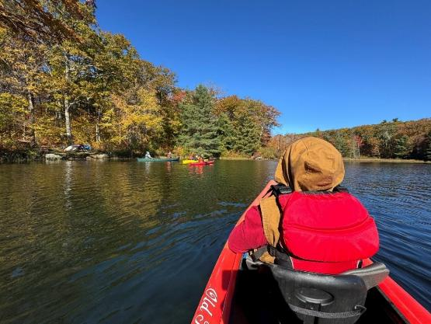
Clarksburg State Park—Kayaking

1199 Middle Road, Clarksburg, MA
Join the Universal Access Program for adaptive kayaking on Mausert’s Pond in Clarksburg! During this program, run by our partner All Out Adventures, paddlers will travel in small groups (pods) to explore the pond. Instruction, adaptive equipment, and assistance (as needed) are provided.
This program is for people with disabilities, their families, support staff, and friends. Seniors are invited to register as well.
Day and Time: Thursday, September 11, 2025; 11 a.m.–2:30 p.m.
Participants may sign up for one of two time slots: 11 a.m. –12:30 p.m. or 1–2:30 p.m. You must register by noon the day before the program.
Closest GPS Address: 1199 Middle Road, Clarksburg, MA 01247. Follow the road to the right to the boat launch. Signs to Mausert’s Pond will be posted.
Cost: $8 per participant; One guest may attend at no charge. Scholarships are available for those who need them.
Questions & To Register: Register with AOA online at alloutadventures.org, call (413) 584-2052, or email programs@alloutadventures.org.

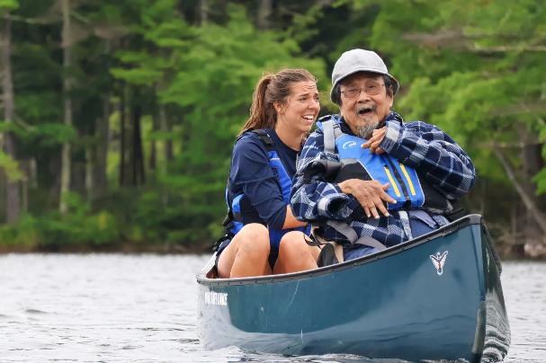
Walden Pond State Reservation—Canoeing

915 Walden Street, Concord, MA
Join the Universal Access Program for adaptive canoeing on historic Walden Pond in Concord! During this program, run by our partner Waypoint Adventure, paddlers will travel in small groups to explore the pond. Experience the fun and serenity of being on the water while being part of a supportive community. Benefit from a wide array of adaptive kayaking equipment and instruction designed to meet your individual needs.
Space is limited and pre-registration is required. Registration ends two days before the program.
Days and Times: Wednesdays, 10 a.m.–1 p.m.

- September 24, 2025
- October 1, 2025
- October 15, 2025

Meet at: Visitors Center
Cost: $20/Participant. Cost flexible based on need.
To Register: Visit waypoint-adventure.jumbula.com
Questions: Email programs@waypointadventure.org

Beartown State Forest—Canoeing & Kayaking

214 Blue Hill Road, Great Barrington, MA
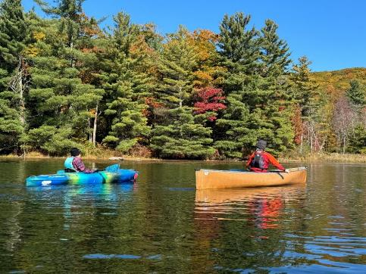
Join the Universal Access Program for adaptive paddling program on Benedict Pond in Great Barrington! During this program, run by our partner All Out Adventures, paddlers will travel in small groups (pods) to explore the pond. Instruction, adaptive equipment, and assistance (as needed) are provided.
This program is for people with disabilities, their families, support staff, and friends. Seniors are invited to register as well.
Day and Time: Thursday, September 25, 2025; 11 a.m.–2:30 p.m.
Participants may sign up for one of two time slots: 11 a.m.–12:30 p.m. or 1–2:30 p.m. You must register by noon the day before the program.
Closest GPS Address: 214 Blue Hill Road, Great Barrington, MA. This is just east of the park entrance. Take Benedict Pond Road to the first parking lot on your right at the pond. Signs to Benedict Pond will be posted.
Access Blue Hill Road from Main Road (Route 23). Avoid accessing Benedict Pond from the park's North Entrance due to dirt roads.
Cost: $8 per participant; One guest may attend at no charge. Scholarships are available for those who need them.
Questions & To Register: Register with AOA online at alloutadventures.org, call (413) 584-2052, or email programs@alloutadventures.org.

Adaptive Cycling

Ashuwillticook Rail Trail, Farnams Crossing—Cycling
50 Farnams Road, Cheshire, MA
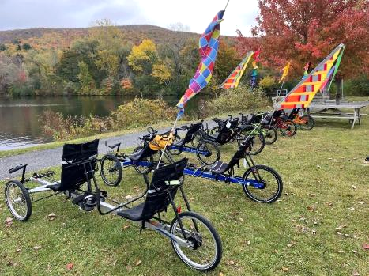
Join the Universal Access Program for adaptive cycling in Cheshire! During this program, run by our partner All Out Adventures, we offer an array of cycles that can accommodate riders of all abilities from stable, comfortable recumbent trikes, to handcycles, to tandem recumbent trikes, to wheelchair tandems. Instruction, equipment, and assistance (as needed) are provided.
This program is for people with disabilities, their families, support staff, and friends. Seniors are invited to register as well.
Days and Times: Wednesdays, 11 a.m.–3 p.m.

- September 3, 2025
- September 17, 2025
- September 24, 2025
- October 1, 2025

Participants may sign up for a one-hour timeslot during the program. You must register by noon the day before the program.
Meet At: Parking lot located at 50 Farnams Rd., Cheshire, MA 01225
Cost: $5–$20 sliding scale per session.
Questions & To Register: Register with AOA online at alloutadventures.org, call (413) 584-2052, or email programs@alloutadventures.org.

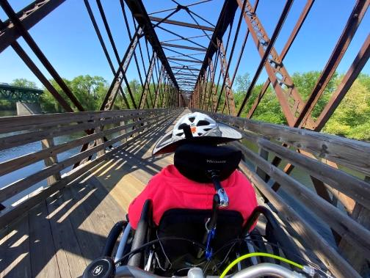
Norwottuck Rail Trail—Cycling

12 Railroad Street, Hadley, MA
Join the Universal Access Program for adaptive cycling in Hadley! During this program, run by our partner All Out Adventures, we offer an array of cycles that can accommodate riders of all abilities from stable, comfortable recumbent trikes, to handcycles, to tandem recumbent trikes, to wheelchair tandems. Instruction, equipment, and assistance (as needed) are provided.
This program is for people with disabilities, their families, support staff, and friends. Seniors are invited to register as well.
Days and Times: Fridays, 10 a.m.–3 p.m.

- September 5, 2025
- September 12, 2025
- September 19, 2025
- September 26, 2025

Participants may sign up for a one-hour timeslot during the program time. You must register by noon the day before the program.
Parking: On-street parking on Railroad St.
Cost: $5–$20 sliding scale per session.
Questions & To Register: Register with AOA online at alloutadventures.org, call (413) 584-2052, or email programs@alloutadventures.org

Pope John Paul II Park Reservation—Tandem Cycling

757 Gallivan Boulevard, Boston, MA (turn right just after Neponset Circle Shopping Center)
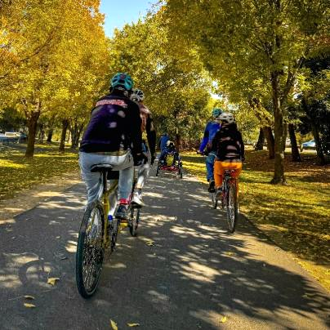
Join the Universal Access Program for accessible tandem cycling on the Lower Neponset River Trail in Boston! During this program, run by our partner Waypoint Adventure, small groups work together to cycle the back roads and bike paths of Massachusetts. Participants are encouraged to bring lunch and socialize on the trail and during breaks.
We have a variety of bikes that offer different amounts of support. We will match up two riders (a Captain and a Stoker). The Captain will be the leader, and the Stoker is the other half of the team, who works with the Captain to enjoy the adventure of tandem cycling. Some of our bikes are more traditional upright bicycles that require teamwork and balance. We also have other models that are side-by-side or recumbent, low to the ground tandems. Some have two wheels and require more balance while others are quite sturdy with three wheels and supportive seats.
Space is limited and pre-registration is required. Registration ends September 17, 2025.
Day and Time: Friday, September 19, 2025; 10 a.m.–12:30 p.m.
Meet At: Neponset River Trail Parking, Pope John Paul ll Park; Turn right just after Neponset Circle Shopping Center at 757 Gallivan Boulevard, Boston MA 02122
Cost: $20/Participant. Cost flexible based on need.
To Register: Visit waypoint-adventure.jumbula.com
Questions: Email programs@waypointadventure.org

Nashua River Rail Trail—Tandem Cycling

Route 2A, Ayer, MA
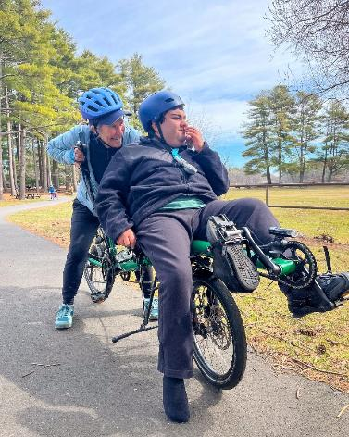
Join the Universal Access Program for accessible tandem cycling in Groton! During this program, run by our partner Waypoint Adventure, small groups work together to cycle the back roads and bike paths of Massachusetts. Participants are encouraged to bring lunch and socialize on the trail and during breaks.
We have a variety of bikes that offer different amounts of support. We will match up two riders (a Captain and a Stoker). The Captain will be the leader, and the Stoker is the other half of the team, who works with the Captain to enjoy the adventure of tandem cycling. Some of our bikes are more traditional upright bicycles that require teamwork and balance. We also have other models that are side-by-side or recumbent, low to the ground tandems. Some have two wheels and require more balance while others are quite sturdy with three wheels and supportive seats.
Space is limited and pre-registration is required. Registration ends October 15, 2025.
Day and Time: Friday, October 17, 2025; 10 a.m.–12:30 p.m.
Meet At: Broadmeadow Parking Lot—Corner of Broadmeadow Road and Court Street, Groton MA (look for the large white Waypoint bike trailer)
Cost: $20/Participant. Cost flexible based on need.
To Register: Visit waypoint-adventure.jumbula.com
Questions: Email programs@waypointadventure.org

Herter Park, Artesani Playground—Tandem Cycling

1255 Soldiers Field Road, Brighton, MA
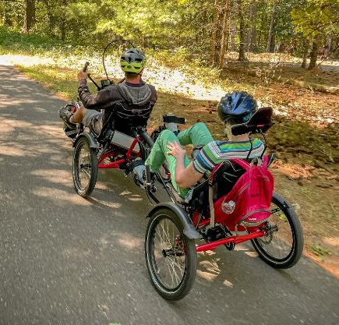
Join the Universal Access Program for accessible tandem cycling in Brighton! During this program, run by our partner Waypoint Adventure, small groups work together to cycle the back roads and bike paths of Massachusetts. Participants are encouraged to bring lunch and socialize on the trail and during breaks.
We have a variety of bikes that offer different amounts of support. We will match up two riders (a Captain and a Stoker). The Captain will be the leader, and the Stoker is the other half of the team, who works with the Captain to enjoy the adventure of tandem cycling. Some of our bikes are more traditional upright bicycles that require teamwork and balance. We also have other models that are side-by-side or recumbent, low to the ground tandems. Some have two wheels and require more balance while others are quite sturdy with three wheels and supportive seats.
Space is limited and pre-registration is required. Registration ends November 5, 2025.
Day and Time: Friday, November 7, 2025; 10 a.m.–12:30 p.m.
Cost: $20/Participant. Cost flexible based on need.
To Register: Visit waypoint-adventure.jumbula.com
Questions: Email programs@waypointadventure.org

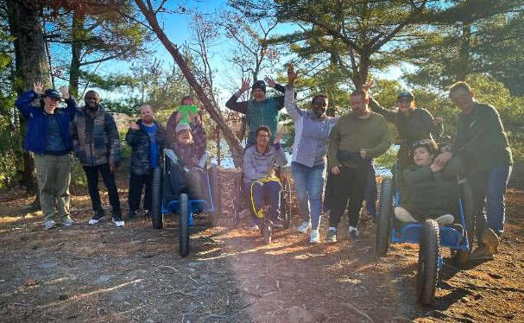
Adaptive Hiking

Halibut Point State Park—Hiking

4 Gott Avenue, Rockport, MA
Join the Universal Access Program for accessible small group hiking in Rockport! During this program, run by our partner Waypoint Adventure, you’ll see stunning forests, view ponds/waterways, eat lunch, and connect with new people.
You’ll benefit from our selection of adaptive equipment, receive instruction to meet any learning style, and be encouraged to reach your individual goals.
Space is limited and pre-registration is required. Registration ends October 20, 2025.
Day and Time: Thursday, October 23, 2025; 10 a.m.–1 p.m.
Meet at: Visitors Center
Cost: $20/Participant. Cost flexible based on need.
To Register: Visit waypoint-adventure.jumbula.com
Questions: Email programs@waypointadventure.org

Great Brook Farm State Park—Hiking

165 North Road, Carlisle, MA

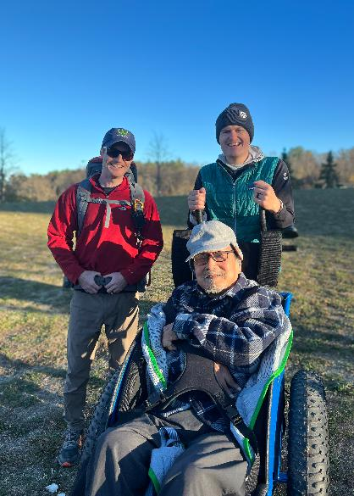
Join the Universal Access Program for accessible small group hiking in Carlisle! During this program, run by our partner Waypoint Adventure, you’ll see stunning forests and ponds/waterways, eat lunch, and connect with new people.
You’ll benefit from our selection of adaptive equipment, receive instruction to meet any learning style, and be encouraged to reach your individual goals.
Space is limited and pre-registration is required. Registration ends November 13, 2025.
Day and Time: Saturday, November 15, 2025; 10 a.m.–1 p.m.
Meet at: Main Parking Lot off North Road near the barn/ice cream (both closed seasonally)
Cost: $20/Participant. Cost flexible based on need.
To Register: Visit waypoint-adventure.jumbula.com
Questions: Email programs@waypointadventure.org

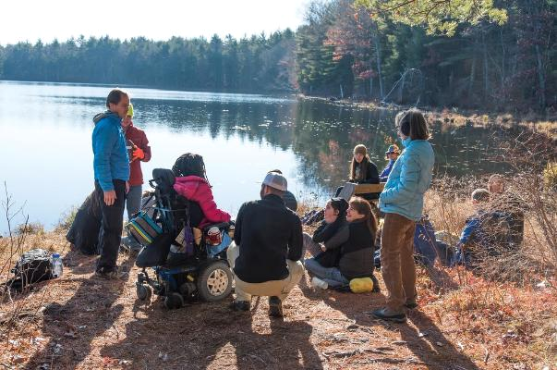
Walden Pond State Reservation—Hiking

915 Walden Street, Concord, MA
Join the Universal Access Program for accessible small group hiking at historic Walden Pond in Concord! During this program, run by our partner Waypoint Adventure, you’ll meet at the visitor’s center, hike in the woods next to the pond, and stop along the way for a picnic lunch and natural interpretation from Walden Pond park staff.
You’ll benefit from our selection of adaptive equipment, receive instruction to meet any learning style, and be encouraged to reach your individual goals.
Space is limited and pre-registration is required. Registration ends November 4, 2025.
Day and Time: Thursday, November 6, 2025; 10 a.m.–1 p.m.
Meet at: Visitors Center
Cost: $20/Participant. Cost flexible based on need.
To Register: Visit waypoint-adventure.jumbula.com
Questions: Email programs@waypointadventure.org

Adaptive Rowing

Connecticut River Greenway State Park—Rowing

25 Jones Ferry Road, Holyoke, MA
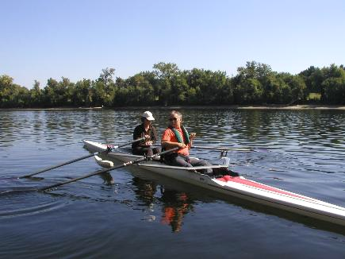
Join the Universal Access Program for adaptive rowing on the Connecticut River in Holyoke! This program, run by Holyoke Rows, uses specialized equipment, modifications, and adaptations to meet your needs while rowing or sculling. Instruction, adaptations, and staff support are all provided. You will receive instruction and the opportunity to practice and also have the chance to participate in competitions! Our program serves people of all capabilities, from beginners to leisure rowers, to competitive racers!
This program is for people with disabilities, their families, support staff, and friends. Seniors are invited to register as well. All ages and abilities are welcome!
Pre-registration is required.
Days: Thursdays, By Appointment Only

- September 4, 2025
- September 11, 2025
- September 18, 2025
- September 25, 2025
- October 2, 2025
- October 9, 2025
- October 16, 2025
- October 23, 2025
- October 30, 2025

Cost: Free
Questions & to Register: Call Holyoke Rows at (413) 320-3134 or email smoore@holyokerows.org

Fall 2025 Supported Programs
Several organizations also offer adaptive programming at DCR locations on their own, sometimes with the use of DCR equipment. These are called supported programs. Each providing organization has their own requirements for programming, including release forms, EEC, and program attendance guidelines. Please contact the providing organization (by phone, email or by checking their website) for further information and to register.

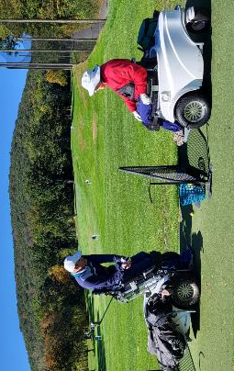
Golfing with the Massachusetts Para-Golfers Association
The Massachusetts ParaGolfer Association (MPGA) promotes recreational and competitive adaptive golf for players with visual impairments, hearing loss, amputations, loss of mobility, , and spinal cord injuries. MPGA provides adaptive golf lessons, recreational programs, and competitive events. Lessons are private and always free, and we offer flexible dates and times.
Beginners: Appointments are available weekdays to learn to play and, if needed, to get certified to rent a specialized golf cart. Players receive an introduction to MPGA adaptive golf, as well as an independent needs assessment to provide them with the right tools and equipment to help them swing with confidence.
Returning Players: We welcome anyone to play as many holes as they are capable of and enjoy (starting on the first tee time available). Most have joined a relaxed golf league style of play. A mixed players league is scheduled on Mondays, Wednesdays, and Fridays starting around 9:30–10 a.m. (based on tee time availability). Three days advance notice required, and up to 12 players may play either 9 holes, or a full 18 holes.
Please make a reservation in advance by calling or texting Steve (508) 889-7581.
Website: mpga.club
Locations: DCR Golf Courses
- Ponkapoag Golf Course, 2167 Washington Street, Canton, MA,
- Leo J. Martin Memorial Golf Course, 190 Park Road, Weston, MA
Dates: Late April through end of October 2025
Contact: Steve Kuketz, mpga.club@gmail.com, (508) 889-7581
10th Annual MPGA New England Regional Adaptive Gold Championship: October 1-October 30, 2025
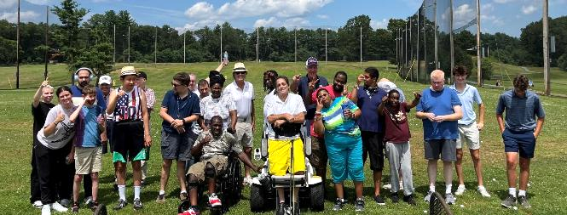

Golfing with Golf for All
Golf for All runs year-round programming for veterans, people with autism, Parkinson’s Disease, spinal cord injuries and paralysis, cerebral palsy, golfers with amputations, golfers with visual impairments, and more. Golf instruction is tailored to suit the specific needs of each participant and is taught by PGA Professionals who have successfully completed a certification process for teaching golfers with adaptive needs. Golfers of all abilities and gender are welcome, and no previous experience is necessary. During each clinic, golfers are provided with instruction, balls, adaptive equipment, and vehicles, as needed.
Website: golfforall.org
Locations: DCR Golf Courses
- Ponkapoag Golf Course, 2167 Washington Street, Canton, MA,
- Leo J. Martin Memorial Golf Course, 190 Park Rd, Weston, MA
Dates: Late April through end of October 2025
Clinics at Ponkapoag Golf Course:
- Veterans: Saturdays, 3:30–4:45 p.m.
- Golfers with Special Needs: Mondays, 6–7:15 p.m.
Clinics at Leo J. Martin Memorial Golf Course:
- Golfers with Autism: Thursdays, 12:30–1:30 p.m.
- Golfers with Parkinson’s: Thursdays, 10:30 a.m. (June & September only)
Contact: Fred Corcoran, Exec. Director, fredcorc@golfforall.org, (617) 462-9899
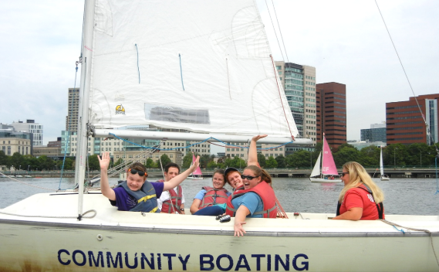

Sailing with Community Boating, Inc.
Nestled in the heart of Boston, Community Boating empowers individuals to take charge of their learning, challenge themselves, and experience the freedom that sailing brings. Through exceptional instruction and quality equipment, the program opens the doors to sailing for those who might not otherwise have the opportunity. Our diverse community includes veterans, individuals with visual impairments, children with different abilities, adults living with chronic conditions, and many others.
Website: community-boating.org/accessible
Location: Charles River Esplanade in the Charles River Reservation, 21 David G Mugar Way, Boston, MA
Dates: April 28–September 27, 2025
Times: Afternoons and weekends: see scheduling page for appointment times
Annual Membership: $50 or reduced fee of $1 upon request
Eligibility: Any individual who needs additional assistance
Contact: adoyle@community-boating.org, (617) 523-1038

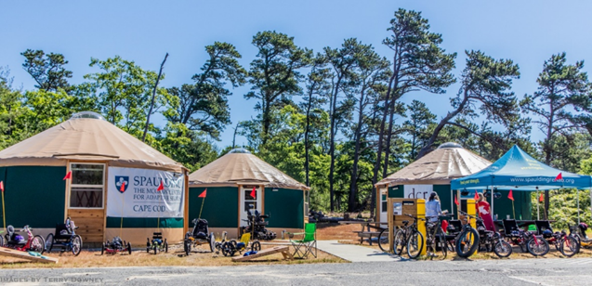
Adaptive Cycling & Golf with Spaulding Adaptive Sports Centers

The McGraw Center
Spaulding Adaptive Sports Centers (SASC) will be offering adaptive cycling at the McGraw Center for Adaptive Sports at Nickerson State Park through mid-October. Spaulding staff provide equipment, adaptations, and support. Pre-registration for all activities is required.
Visit SASC’s on-line calendar for further information about McGraw Center Programs.
Website: Spaulding Adaptive Sports Centers
Location: McGraw Center for Adaptive Sports, Nickerson State Park, Brewster
Dates: September through mid-October 2025
Contact: SpauldingAdaptiveSports@partners.org, (877) 976-7272

Back on Course-Boston
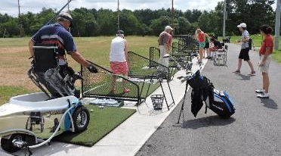
SASC offers a return to golf program designed for those who are ready to play between 4-9 consecutive holes on the course. Prior participation in the Back in the Swing (BITS) series is helpful as a pre-requisite for new golfers or those returning to golf post-injury. Coaching and golf etiquette guidance provided by SASC Golf Pro.
Visit SASC’s on-line calendar for further information about Back on Course Programs.
Website: Spaulding Adaptive Sports Centers
Location: Leo J. Martin Memorial Golf Course, 190 Park Rd., Weston, MA
Dates and Times: Fridays, 10–11:30 a.m.

- September 26, 2025
- October 3, 2025
- October 10, 2025

Cost: $40 per session
Contact: SpauldingAdaptiveSports@partners.org, (877) 976-7272

DCR Wants to Hear from You!
DCR is committed to sharing information with the public and engaging them in dialogue on issues, programs, and projects. Please help us identify the best ways to improve our state parks for visitors with disabilities and ensure our projects are meeting your needs.
You can learn about initiatives and share your thoughts by:
- Visiting DCR Public Meetings Information webpage where you can scroll through DCR projects and make public comments online.
- Receiving DCR general or project-specific announcements via email. Request to be added to the contact list by emailing Mass.Parks@mass.gov or by calling (617) 626-4973.

DCR Power-Driven Mobility Devices in Newburyport!
This Fall, borrow a Power-Driven Mobility Device, free of charge! Starting in September, DCR’s Trackchair and Mobility Scooter will both be available at Maudslay State Park in Newburyport. Amble through the decorative landscape and gardens of this former 19th century estate and enjoy the beauty of plantings, rolling meadows, and towering pines.

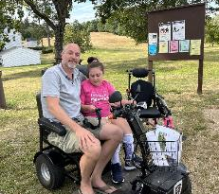
Mobility Scooter
- May 12–October 31, 2025

Trackchair
- September 5–October 31, 2025
Location: Maudslay State Park, 74 Curzon Mill Road, Newburyport
Reservations & Eligibility:
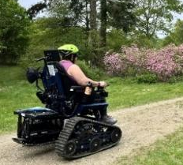
You must make a reservation at least 3 days prior to your visit.
You must review the Trackchair operating and safety instructions or the Mobility Scooter operating and safety instructions before you can make a reservation.
You’ll need to bring someone with you, 18 years of age or older, to be your companion.
You must complete a Use and Release Form at the park/forest on the day of your visit. Users under age 18 or under guardianship must have the Use and Release Form signed by their legal guardian.
Users age 16 or under will need to wear a safety helmet.
Maximum user weight: 300 pounds for the Trackchair or 500 pounds for the mobility scooter.
Visit mass.gov/dcr/PDMD for details on how to make a reservation, safety and usage guidelines, and eligibility.
Thank you to our supporting partners! DCR’s new power driven mobility devices were made possible through the generous support of Friends of Maudslay State Park and Ford Motor Company’s Bronco Wild Fund.

