# Group of hikers pose for a picture on a trail in the woods. Some are using all terrain wheelchairs.Universal Access Program logo of a path leading to a mountainous horizondcr Massachusetts logo with a laurel leaf in a circle. DCR’s Universal Access Program Spring 2025 Program Schedule

## Flower without stem with solid fillSpring 2025 Adaptive Recreation Fun!

## [General Information](https://massgov.sharepoint.com/sites/EEA-O365/DCR/Workspace/Universal_Access_Program/Shared%20Documents/Vendor%20Shared%20Files/AOA-UAP%20Shared%20Files/Session%20Reports%202024/Fall/Fall%20UAP%20Travel%20Cycling.xlsx?web=1)

DCR’s [Universal Access Program](https://www.mass.gov/orgs/universal-access-program) (UAP) is dedicated to providing outdoor recreation opportunities in Massachusetts state parks for visitors of all abilities. Accessibility is achieved through site improvements, specialized adaptive recreation equipment, and accessible recreation programs.

The Universal Access Program (UAP) offers adaptive, accessible programming seasonally at state parks, pools, and rinks. We partner throughout the year with [All Out Adventures](https://alloutadventures.org/), [Easterseals Massachusetts](https://www.easterseals.com/ma/), [Holyoke Rows](https://holyokerows.org/), and [Waypoint Adventure](http://www.waypointadventure.org/) to provide programs statewide.

Our structured programs feature adaptive equipment, professional staff, and instruction and support. Friends, family members, and companions are encouraged to take part in our programs alongside participants with disabilities.

**UAP’s Program Seasons:** Our Spring Program season runs from April through May, our Summer Program season runs from June through August, our Fall Program season runs from September through October, and our Winter Program season runs from November through March.

**Website:** Check out [mass.gov/dcr/access](http://www.mass.gov/dcr/access) to keep up to date with our activities!

**Contact List:** If you would like to get added to our contact list to be notified of upcoming events and activities, please [email us](mailto:DCR.UniversalAccess@mass.gov).

### Release Forms & Pre-Registration

A current release form is required for all our programs, and you must **pre-register with the organization running the program.** To pre-register, cancel, or check-in about inclement weather, please contact the providing organization listed for each program.

### Essential Eligibility Criteria & Program Attendance Guidelines

You must also meet the [Essential Eligibility Criteria](https://www.mass.gov/service-details/essential-eligibility-criteria-for-universal-access-program-participants) (EEC) and follow our [Program Attendance Guidelines](https://www.mass.gov/info-details/essential-eligibility-criteria-for-universal-access-program-participants#program-attendance-guidelines-) (PAG) for the activity. The EEC help you understand the skills you need to participate in our programs. For risk management considerations, everyone who attends our programs must complete a release form and meet these EEC, including caregivers and group staff. You can meet the EEC independently, or with the help of a caregiver (family member, friend, or PCA). Visit us at [mass.gov/uap/eec](http://www.mass.gov/uap/eec) to learn more.

If you have concerns about your ability to meet the EEC or PAG, please speak with the organization leading the activity. If you have general questions or concerns, please contact us by email [DCR.UniversalAccess@mass.gov](mailto:DCR.UniversalAccess@mass.gov) or phone at [(413) 461-7126](tel:4134617126).

## Two people are smiling while paddling in a tandem kayak on a tree-lined pond.Adaptive Canoeing & Kayaking

### [Beartown State Forest](https://www.mass.gov/locations/beartown-state-forest)—Kayaking

#### 214 Blue Hill Road, Great Barrington, MA

Join UAP’s adaptive kayaking program on Benedict Pond in Great Barrington, run by our partner [All Out Adventures](https://alloutadventures.org/). Paddlers will travel in small groups (pods) to explore the pond. Instruction, adaptive equipment, and assistance as needed is provided.

This program is for people with disabilities, their families, support staff, and friends. Seniors are invited to register as well. All ages and abilities are welcome!

**Day and Time:** Thursday, May 22, 11 a.m.–2:30 p.m.

Participants may sign up for one of two time slots: 11 a.m. –12:30 p.m. or 1 p.m. –2:30 p.m. You must register by 12 p.m. the day before the program.

**Closest GPS Address:** 214 Blue Hill Road, Great Barrington, MA. This is just east of the park entrance. Take Benedict Pond Road to the first parking lot on your right at the pond. Signs will be posted.

**Access Blue Hill Road from Main Road (Route 23).** ***Avoid accessing Benedict Pond from the park's North Entrance due to dirt roads.***

**Cost:** $8 per participant; One guest may attend at no charge. Scholarships are available for those who need them.

**Questions & To Register:** Call [All Out Adventures](https://alloutadventures.org/) at [(413) 584-2052](tel:4135842052) or email [Programs@alloutadventures.org](mailto:Programs@alloutadventures.org)

## Group of cyclists with a variety of tandem bikes, are making funny faces for the camera in front of a lake. Adaptive Cycling

### [Cochituate State Park](https://www.mass.gov/locations/cochituate-state-park)—Tandem Cycling

#### 43 Commonwealth Road, Natick, MA

Join the [Universal Access Program](https://www.mass.gov/orgs/universal-access-program) for accessible tandem cycling in Natick. During this program, run by our partner [Waypoint Adventure](https://waypointadventure.org/), small groups work together to cycle the back roads and bike paths of Massachusetts. Participants are encouraged to bring lunch and socialize on the trail and during breaks.

We have a variety of bikes that offer different amounts of support. We will match up two riders (a Captain and a Stoker). The Captain will be the leader, and the Stoker is the other half of the team, who works with the Captain to enjoy the adventure of tandem cycling. Some of our bikes are more traditional upright bicycles that require teamwork and balance. We also have other models that are side-by-side or recumbent, low to the ground tandems. Some have two wheels and require more balance while others are quite sturdy with three wheels and supportive seats.

**Space is limited and pre-registration is required.** Registration ends April 17, 2025.

**Day and Time:** Friday, April 18, 2025, 10 a.m.–12:30 p.m.

**Cost:** $20/Participant. Cost flexible based on need.

**To Register:** Visit [waypoint-adventure.jumbula.com](https://waypoint-adventure.jumbula.com/)

**Questions:** Email [programs@waypointadventure.org](mailto:programs@waypointadventure.org)

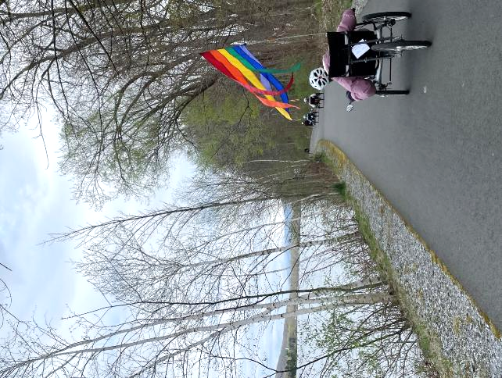

### [Ashuwillticook Rail Trail](https://www.mass.gov/locations/ashuwillticook-rail-trail), Farnams Crossing—Cycling

#### 50 Farnams Road, Cheshire, MA

Join UAP’s adaptive cycling program in Cheshire, run by our partner [All Out Adventures](https://alloutadventures.org/). We offer an array of cycles that can accommodate riders of all abilities from stable, comfortable recumbent trikes, to handcycles, to tandem recumbent trikes, to wheelchair tandems. Instruction, equipment, and assistance (as needed) are provided.

This program is for people with disabilities, their families, support staff, and friends. Seniors are invited to register as well. All ages and abilities are welcome!

**Days and Times:** Wednesdays, 11 a.m.–3 p.m.

* April 23, 2025
* May 14, 2025

Participants may sign up for a one-hour timeslot during the program. You must register by noon the day before the program.

**Meet At:** Parking lot located at 50 Farnams Rd., Cheshire, MA 01225

**Cost**: $5–$20 sliding scale per session.

**Questions & To Register:** Register with AOA online at [alloutadventures.org](https://www.alloutadventures.org/), call [(413) 584-2052](mailto:(413) 584-2052), or email [programs@alloutadventures.org](mailto:programs@alloutadventures.org).

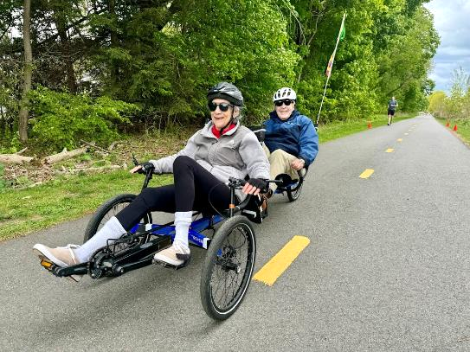

### [Blackstone River Greenway](https://blackstoneheritagecorridor.org/exploring-the-blackstone-river-valley/maps-tours-guides/blackstone-river-bikeway/)—Cycling

#### 85 Canal Street, Blackstone, MA

Join UAP’s adaptive cycling program in Blackstone, run by with our partner [All Out Adventures](https://alloutadventures.org/). We offer an array of cycles that can accommodate riders of all abilities from stable, comfortable recumbent trikes, to handcycles, to tandem recumbent trikes, to wheelchair tandems. Instruction, equipment, and assistance (as needed) are provided.

This program is for people with disabilities, their families, support staff, and friends. Seniors are invited to register as well. All ages and abilities are welcome!

**Days and Times:** Wednesday, 11 a.m.–3 p.m.

* April 30, 2025
* May 28, 2025

Participants may sign up for a one-hour timeslot during the program. You must register by noon the day before the program.

**Meet At:** Blackstone River Greenway Parking, 85 Canal St, Blackstone, MA 01504

**Cost**: $5–$20 sliding scale per session.

**Questions & To Register:** Register with AOA online at [alloutadventures.org](https://www.alloutadventures.org/), call [(413) 584-2052](mailto:(413) 584-2052), or email [programs@alloutadventures.org](mailto:programs@alloutadventures.org).

### A group of people riding a variety of recumbent trikes line up on a bike trail while UAP staff talk to them before departing. [Norwottuck Rail Trail](https://www.mass.gov/locations/norwottuck-rail-trail)—Cycling

#### 12 Railroad Street, Hadley, MA

Join UAP’s adaptive cycling program in Hadley, run by our partner [All Out Adventures](https://alloutadventures.org/). We offer an array of cycles that can accommodate riders of all abilities from stable, comfortable recumbent trikes, to handcycles, to tandem recumbent trikes, to wheelchair tandems. Instruction, equipment, and assistance (as needed) are provided.

This program is for people with disabilities, their families, support staff, and friends. Seniors are invited to register as well. All ages and abilities are welcome!

**Days and Times:** Fridays, 10 a.m.–3 p.m.

* May 2, 2025
* May 9, 2025
* May 16, 2025
* May 23, 2025
* May 30, 2025

Participants may sign up for a one-hour timeslot during the program. You must register by noon the day before the program.

**Cost**: $5–$20 sliding scale per session.

**Questions & To Register:** Register with AOA online at [alloutadventures.org](https://www.alloutadventures.org/), call [(413) 584-2052](mailto:(413) 584-2052), or email [programs@alloutadventures.org](mailto:programs@alloutadventures.org)

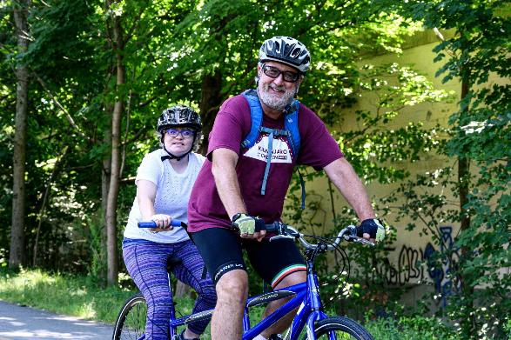

### [Nashua River Rail Trail](https://www.mass.gov/locations/nashua-river-rail-trail)—Tandem Cycling

#### Route 2A, Ayer, MA

Join the [Universal Access Program](https://www.mass.gov/orgs/universal-access-program) for accessible tandem cycling in Groton. During this program, run by our partner [Waypoint Adventure](https://waypointadventure.org/), small groups work together to cycle the back roads and bike paths of Massachusetts. Participants are encouraged to bring lunch and socialize on the trail and during breaks.

We have a variety of bikes that offer different amounts of support. We will match up two riders (a Captain and a Stoker). The Captain will be the leader, and the Stoker is the other half of the team, who works with the Captain to enjoy the adventure of tandem cycling. Some of our bikes are more traditional upright bicycles that require teamwork and balance. We also have other models that are side-by-side or recumbent, low to the ground tandems. Some have two wheels and require more balance while others are quite sturdy with three wheels and supportive seats.

**Space is limited and pre-registration is required.** Registration ends May 13, 2025.

**Day and Time:** Thursday, May 15, 2025, 10 a.m.–12:30 p.m.

**Meet At:** Broadmeadow Parking Lot—Corner of Broadmeadow Road and Court Street, Groton MA (look for the large white Waypoint bike trailer)

**Cost:** $20/Participant. Cost flexible based on need.

**To Register:** Visit [waypoint-adventure.jumbula.com](https://waypoint-adventure.jumbula.com/)

**Questions:** Email [programs@waypointadventure.org](mailto:programs@waypointadventure.org)

### Two men seated in a recumbent tandem smile before starting their ride. Women seated in a tandem recumbent trike and single recumbent trike smile while taking a break on a bike path.[Blackstone River Greenway](https://blackstoneheritagecorridor.org/exploring-the-blackstone-river-valley/maps-tours-guides/blackstone-river-bikeway/) at the [Blackstone River Valley Heritage Center](https://blackstoneheritagecorridor.org/happening-now/worcester-heritage-center/)—Cycling

#### 3 Paul Clancy Way, Worcester, MA

Join UAP’s adaptive cycling program in Worcester, run by our partner [All Out Adventures](https://alloutadventures.org/). We offer an array of cycles that can accommodate riders of all abilities from stable, comfortable recumbent trikes, to handcycles, to tandem recumbent trikes, to wheelchair tandems. Instruction, equipment, and assistance (as needed) are provided.

This program is for people with disabilities, their families, support staff, and friends. Seniors are invited to register as well. All ages and abilities are welcome!

**Day and Time:** Wednesday, May 21, 2025, 11 a.m.–3 p.m.

Participants may sign up for a one-hour timeslot during the program. You must register by noon the day before the program.

**Cost**: $5–$20. Sliding scale per session.

**Questions & To Register:** Register with AOA online at [alloutadventures.org](https://www.alloutadventures.org/), call [(413) 584-2052](mailto:(413) 584-2052), or email [programs@alloutadventures.org](mailto:programs@alloutadventures.org)

## A family poses for a picture while hiking in the woods. One person is using an all terrain wheelchair. Adaptive Hiking

### [Great Brook Farm State Park](https://www.mass.gov/locations/great-brook-farm-state-park)—Hiking

#### 165 North Road, Carlisle, MA

Join the [Universal Access Program](https://www.mass.gov/orgs/universal-access-program) for accessible small group hiking in Carlisle. During this program, run by our partner [Waypoint Adventure](https://waypointadventure.org/), you’ll see stunning forests, ponds/waterways, eat lunch, connect with new people, and end with a tour of a working barn lead by DCR staff! You’ll benefit from our selection of adaptive equipment, receive instruction to meet any learning style, and be encouraged to reach your individual goals.

**Space is limited and pre-registration is required.** Registration ends April 23, 2025.

**Day and Time:** Thursday, April 24, 2025, 11 a.m.–2 p.m.

**Cost:** $20/Participant. Cost flexible based on need. One parent/friend/PCA of program participant with a disability may attend at no charge (see Waypoint’s Registration page for details).

**To Register:** Visit [waypoint-adventure.jumbula.com](https://waypoint-adventure.jumbula.com/)

**Questions:** Email [programs@waypointadventure.org](mailto:programs@waypointadventure.org)

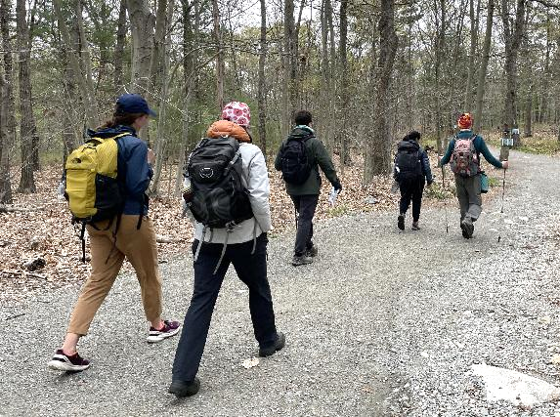

### [Breakheart Reservation](https://www.mass.gov/locations/breakheart-reservation)—Hiking

#### 177 Forest Street, Saugus, MA

Join the [Universal Access Program](https://www.mass.gov/orgs/universal-access-program) for accessible small group hiking in Saugus. During this program, run by our partner [Waypoint Adventure](https://waypointadventure.org/), we will see stunning forests, ponds/waterways, eat lunch, and connect with new people. You’ll benefit from our selection of adaptive equipment, receive instruction to meet any learning style, and be encouraged to reach your individual goals.

**Space is limited and pre-registration is required.** Registration ends May 6, 2025.

**Day and Time:** Wednesday, May 7, 2025, 11 a.m.–2 p.m.

**Cost:** $20/Participant. Cost flexible based on need. One parent/friend/PCA of program participant with a disability may attend at no charge (see Waypoint’s Registration page for details).

**To Register:** Visit [waypoint-adventure.jumbula.com](https://waypoint-adventure.jumbula.com/)

**Questions:** Email [programs@waypointadventure.org](mailto:programs@waypointadventure.org)

## Two people are rowing in a boat equipped with an adaptive seat and adaptive oars. Adaptive Rowing

### [Connecticut River Greenway State Park](https://www.mass.gov/locations/connecticut-river-greenway-state-park)—Rowing

25 Jones Ferry Road, Holyoke, MA

Join UAP for some adaptive rowing on the Connecticut River in Holyoke! This program, run by [Holyoke Rows](https://www.holyokerows.org/), uses specialized equipment, modifications, and adaptations to meet your needs while rowing or sculling. Instruction, adaptations, and staff support are all provided. You will receive instruction and the opportunity to practice and also have the chance to participate in competitions! Our program serves people of all capabilities, from beginners to leisure rowers, to competitive racers!

This program is for people with disabilities, their families, support staff, and friends. Seniors are invited to register as well. All ages and abilities are welcome!

Pre-registration is required.

**Days:** Thursdays, By Appointment Only

* April 10, 2025
* April 17, 2025
* April 24, 2025
* May 1, 2025
* May 8, 2025
* May 15, 2025
* May 22, 2025
* May 29, 2025

**Cost:** Free

**Questions & to Register:** Call [Holyoke Rows](https://www.holyokerows.org/) at [(413) 320-3134](tel:4133203134) or email [smoore@holyokerows.org](mailto:smoore@holyokerows.org)

## Spring 2025 Supported Programs

Several organizations also offer adaptive programming at DCR locations on their own, sometimes with the use of DCR equipment. These are called *supported* *programs*. Each providing organization has their own requirements for programming, including release forms, EEC, and program attendance guidelines. Please contact the providing organization (by phone, email or by checking their website) for further information and to register.

### A group of golfers are smiling under shaded trees on a golf course. One person is using a ParaGolfer and some are using golf carts. Golfing with the Massachusetts Para-Golfers Association

The [Massachusetts ParaGolfer Association](https://www.mpga.club/) (MPGA) promotes recreational and competitive adaptive golf for players with visual impairments, amputations, loss of mobility, and spinal cord injuries. MPGA provides adaptive golf lessons, recreational programs, and competitive events. Lessons are private and always free, and we offer flexible dates and times.

**Beginners:** Appointments are available weekdays to learn to play and, if needed, to get certified to rent a specialized golf cart. Players receive an introduction to MPGA adaptive golf, as well as an independent needs assessment to provide them with the right tools and equipment to help them swing with confidence.

**Returning Players:** We welcome anyone to play as many holes as they are capable of and enjoy (starting on the first tee time available). Most have joined a relaxed golf league style of play. A mixed players league is scheduled on Mondays, Wednesdays, and Fridays starting around 9:30–10 a.m. (based on tee time availability). Three days advance notice required, and up to 12 players may play either 9 holes, or a full 18 holes.

Please make a reservation in advance by calling or texting Steve [(508) 889-7581](tel:5088897581).

**Website:** [mpga.club](https://www.adaptivegolf.club/)

**Locations**: [DCR Golf Courses](https://www.statemadcrgolf.com/)

* [Ponkapoag Golf Course](https://www.mass.gov/locations/ponkapoag-golf-course)**,** 2167 Washington Street, Canton, MA,
* [Leo J. Martin Memorial Golf Course](https://www.mass.gov/locations/leo-j-martin-memorial-golf-course)**,** 190 Park Road, Weston, MA

**Dates:** Late April through end of October 2025

**Contact:** Steve Kuketz, [mpga.club@gmail.com](mailto:mpga.club@gmail.com), [(508) 889-7581](tel:5088897581)

**10th Annual MPGA New England Regional Adaptive Gold Championship**: October 1-October 30, 2025

### A group of golfers pose for a photo. One is wearing headphones, one is using a wheelchair and one is standing with a ParaGolfer. Golfing with Golf for All

[Golf for All](http://www.golfforall.org/)runs year-round programming for veterans, people with autism, Parkinson’s Disease, spinal cord injuries and paralysis, cerebral palsy, golfers with amputations, golfers with visual impairments, and more. Golf instruction is tailored to suit the specific needs of each participant and is taught by PGA Professionals who have successfully completed a certification process for teaching golfers with adaptive needs. Golfers of all abilities and gender are welcome, and no previous experience is necessary. During each clinic, golfers are provided with instruction, balls, adaptive equipment, and vehicles, as needed.

**Website:** [golfforall.org](http://www.golfforall.org/)

**Locations**: [DCR Golf Courses](https://www.statemadcrgolf.com/)

* [Ponkapoag Golf Course](https://www.mass.gov/locations/ponkapoag-golf-course), 2167 Washington Street, Canton, MA,

* [Leo J. Martin Memorial Golf Course](https://www.mass.gov/locations/leo-j-martin-memorial-golf-course), 190 Park Rd, Weston, MA

**Dates:** Late April through end of October 2025

**Clinics** **at** [**Ponkapoag Golf Course**](https://www.mass.gov/locations/ponkapoag-golf-course)**:**

* Veterans: Saturdays, 3:30–4:45 p.m.
* Golfers with Special Needs:Mondays, 6–7:15 p.m.

**Clinics** **at** [**Leo J. Martin Memorial Golf Course**](https://www.mass.gov/locations/leo-j-martin-memorial-golf-course)**:**

* Golfers with Autism: Thursdays, 12:30–1:30 p.m.
* Golfers with Parkinson’s: Thursdays, 10:30 a.m. (June & September only)

**Contact:** Fred Corcoran, Exec. Director, [fredcorc@golfforall.org](mailto:fredcorc@golfforall.org), [(617) 462-9899](tel:6174629899)

### A group of people in a sailboat on the river are smiling and waving at the camera. Sailing with Community Boating, Inc.

Nestled in the heart of Boston, Community Boating allows individuals to take responsibility for their learning, push themselves to overcome challenges, and experience the freedom sailing offers. With top-notch instruction and quality equipment, the program provides support and encouragement to individuals who might not otherwise be able to sail. Members include veterans, individuals with visual impairments, children with developmental disabilities, adults with chronic injury or illness, and many more.

**Website:** [community-boating.org/accessible](https://www.community-boating.org/accessible/)

**Location:** Charles River Esplanade in the [Charles River Reservation](https://www.mass.gov/locations/charles-river-reservation), 21 David G Mugar Way, Boston, MA

**Dates:** April 28–September 27, 2025

**Times:** Afternoons and weekends: see [scheduling page](https://urldefense.com/v3/__https:/community-boating.org/accessible/schedule-an-appointment/__;!!CPANwP4y!Q2u1LkgkJAT4V3lI7ecciN1Dhgn5Igla7wV8Q2gw5qfM2gpq7Gy_dt7rXgC5uQKG9hE1LQro8fs5WlZRagS9MMt5dZ0$) for appointment times

**Annual Membership:** $50 or reduced fee of $1 upon request

**Eligibility:** Any individual who needs additional assistance

**Contact:** [adoyle@community-boating.org](mailto:adoyle@community-boating.org), [(617) 523-1038](tel:6175231038)

### Adaptive Cycling, Kayaking, Paddleboarding, Yoga, & Yard Games with Spaulding Adaptive Sports Centers

#### **Many styles and sizes of adaptive bicycles are parked in front of 3 accessible yurts and a Spaulding pop up canopy.** The McGraw Center

[Spaulding Adaptive Sports Centers](https://spauldingrehab.org/conditions-services/adaptive-sports) (SASC) will be offering a variety of adaptive sport programs at the McGraw Center for Adaptive Sports at [Nickerson State Park](https://www.mass.gov/locations/nickerson-state-park) starting mid-May through mid-October. Spaulding staff provide equipment, adaptations, and support. Pre-registration for all activities is required.

Visit SASC’s [on-line calendar](https://sasc.spauldingrehab.org/default.aspx?tab=icon) for further information about McGraw Center Programs.

**Website:** [Spaulding Adaptive Sports Centers](https://spauldingrehab.org/conditions-services/adaptive-sports)

**Location:** McGraw Center for Adaptive Sports, [Nickerson State Park](https://www.mass.gov/locations/nickerson-state-park), Brewster

**Dates:** Mid-May through mid-October 2025

**Contact:** [SpauldingAdaptiveSports@partners.org](mailto:SpauldingAdaptiveSports@partners.org), (877) 976-7272

## DCR Wants to Hear from You!

DCR is committed to sharing information with the public and engaging them in dialogue on issues, programs, and projects. Please help us identify the best ways to improve our state parks for visitors with disabilities and ensure our projects are meeting your needs.

You can learn about initiatives and share your thoughts by:

* Visiting [DCR Public Meetings Information](https://www.mass.gov/dcr-public-meetings-information) webpage where you can scroll through DCR projects and make public comments online.
* Receiving DCR general or project-specific announcements via email. Request to be added to the contact list by emailing [Mass.Parks@mass.gov](mailto:Mass.Parks@mass.gov) or calling [(617) 626-4973](tel:6176264973).

## Inside of yurt with a wooden floor, table with benches, and a bunk bed with a double mattress on the bottom and a single mattress on the top. Round yurt covered in green canvas has a sloping vinyl roof with dome skylight. L-shaped cement walkway from front door to parking area. Accessible Camping—Registration is Open!

DCR accessible campsites provide a variety of camping experiences in campgrounds across Massachusetts. The sites all have room for accessible parking, and a flat, firm, and stable surface for camping. Yurts and cabins provide shelter, access to electricity, and furniture. RV-only sites have a paved parking area, and some of them also have an area for a tent. Accessible pop-up and tent sites have hard-packed level ground, pedestal grills or accessible fire rings, and accessible picnic tables.

You'll always find accessible restrooms located in the same loop as the accessible sites. Some accessible sites are close to the restrooms for easier access, while others are further away for a more secluded camping experience. The path from most accessible campsites to the restroom is the campground road, which was not designed as an accessible pedestrian route. You can drive to the accessible restrooms and park there.

To see a list of accessible campsites, visit [Accessible Camping](https://www.mass.gov/info-details/accessible-camping).

If you have questions about a specific site, about accessible camping in general, or are having trouble making a reservation for an accessible site, please contact the Universal Access Program.

**Herter Park/Artesani Playground  
Recreation Program**

1255 Soldiers Field Road

Brighton, MA 02135

**Adaptive Recreation Fair!**

**Saturday, June 7, 2025**

**10 a.m. – 3 p.m.**

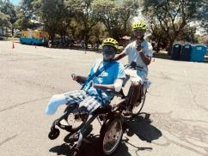**\*Cycling *Pickleball *Face Painting *Games *Equipment Demonstrations *Games *Crafts *Refreshments *DJ Music & More**

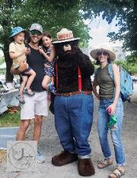Join DCR’s [**Universal Access Program**](http://www.mass.gov/dcr/universal-access) and other adaptive recreation organizations for an accessible and inclusive day of fun and networking along the Charles River! Enjoy adaptive cycling, adaptive pickleball, music, refreshments, and adaptive hiking, surfing, and fencing equipment demonstrations! There will be family-friendly activities including face painting, adaptive golf, and lawn games. Find out about adaptive recreation programs across the state!

**Pre-Registration is recommended.** Especially if you need an accommodation

*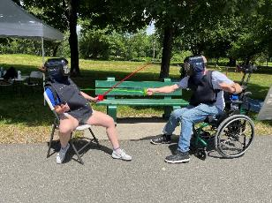***Cost: FREE!!**

**To Register:**

Photo courtesy of Unspoken Images Photography

* Goonline [mass.gov/DCRAdaptiveFair](http://mass.gov/DCRAdaptiveFair)
* call Teri at [(413) 461-7126](tel:4134617126), or
* email [DCR.UniversalAccess@mass.gov](mailto:DCR.UniversalAccess@mass.gov)

**Volunteers Needed!** Contact Mariah at (857) 289-4175 or [Mariah.Fontaine@mass.gov](mailto:Mariah.Fontaine@mass.gov)

**Exhibitors Include:**

* [ABA Centers of America](https://www.abacenters.com/)
* 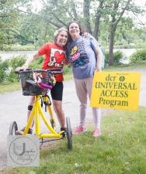[Abby Care-MA](https://www.abbycare.org/paid-family-caregiving/massachusetts)
* [All Out Adventures](https://alloutadventures.org/)
* [Apex Social Group-Boston](https://apex-social.com/boston-childcare-agency-infants-toddlers-special-needs/)
* [Appalachian Mountain Club](https://www.outdoors.org/)
* [Boston Fencing Club](https://www.bostonfencingclub.org/)
* [Charles River Community Health](https://www.charlesriverhealth.org/)
* [Community Boating](https://www.community-boating.org/accessible/welcome/)
* [Community Rowing Inc.](https://communityrowing.org/)
* [DCR Forest Fire Control](https://www.mass.gov/forest-fire-control-programs) and [Smokey Bear](https://smokeybear.com/)
* [DCR Interpreters](https://www.mass.gov/info-details/dcr-programs-and-events)
* [Disability Resource Center](https://www.disabilityrc.org/)
* [Federation for Children With Special Needs (FCSN)](https://fcsn.org/)
* [Girls Chronically Rock](https://girlschronicallyrock.com/)
* 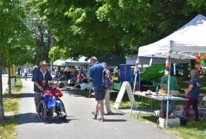[Gnome Surf](https://www.gnomesurf.com/)
* [Golf for All](https://golfforall.org/)
* [Learners at the Center](https://learnersatthecenter.weebly.com/)
* [Massachusetts Water Resources Authority](https://www.mwra.com/) (MWRA)
* [National Park Service/Springfield Armory National Historic Site](https://www.nps.gov/spar/index.htm)
* [Northeast Passage](https://www.nepassage.org/)
* [SMILE Mass](https://smilemass.org/)
* [Unspoken Images Photography](https://www.unspokenimagesphotography.com/)
* [Waypoint Adventure](https://www.waypointadventure.org/)

**Accessible Event:**

* Booths are placed along paved and stone dust paths
* ****Curb Ramps and Temporary Curb Ramps will be in place
* Mats allow access to activities on grass
* Accessible portable toilets will be on site; a bathroom with accessible flush toilets and running water are a few hundred feet away
* *There are no electric hook ups available at the event*

**Parking is Free but Limited:**

* Parking lot is shared with the public and is first-come, first served
* Drop off and pick up area at fair entrance
* Parking attendants will be available to help direct

**Special Accommodations** should be requested in advance during registration. Please allow at least two weeks (14 days) advance notice. Last minute requests will be accepted, but we may be unable to fulfill the request.

**Bring Your Own Water Bottle Event:** We are no longer purchasing single-use plastic water bottles, so please bring your own reusable bottle or cup and help us promote sustainability! You can fill up at [MWRA's](https://www.mwra.com/) Quench Buggy-a mobile water fountain that provides free, cold drinking water!

Qr code for Recreation Fair Registration form

**Scan QR Code to Register**

[Department of Conservation and Recreation](https://www.mass.gov/orgs/department-of-conservation-recreation), [Universal Access Program](https://www.mass.gov/orgs/universal-access-program)

[mass.gov/dcr/universal-access](http://www.mass.gov/dcr/universal-access)