
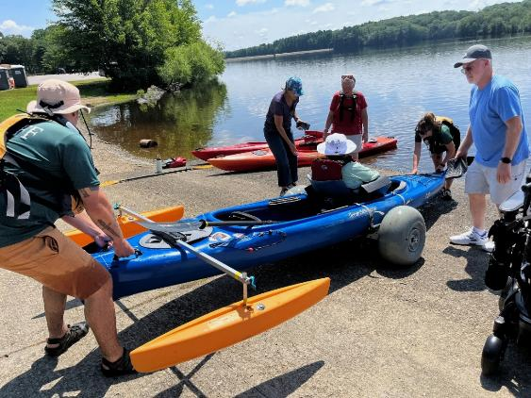

DCR’s Universal Access Program
Spring 2026 Program Schedule
Spring 2026 Adaptive Recreation Fun!

General Information
DCR’s Universal Access Program (UAP) is dedicated to providing outdoor recreation opportunities in Massachusetts state parks for visitors of all abilities. Accessibility is achieved through site improvements, specialized adaptive recreation equipment, and accessible recreation programs.
The Universal Access Program (UAP) offers adaptive, accessible programming seasonally at state parks, pools, and ice skating rinks. We partner throughout the year with All Out Adventures, Easterseals Massachusetts, Holyoke Rows, and Waypoint Adventure to provide programs statewide.
Our structured programs feature adaptive equipment, professional staff, and instruction and support. Friends, family members, and companions are encouraged to take part in our programs alongside participants with disabilities.
UAP’s program seasons: Our Spring program season runs from April through May, our Summer program season runs from June through August, our Fall program season runs from September through October, and our Winter program season runs from November through March.
Website: Check out mass.gov/dcr/access to keep up to date with our activities!
Contact List: If you would like to be added to our contact list to be notified of upcoming events and activities, please email us.

Release Forms & Pre-Registration
A current release form is required for all our programs, and you must pre-register with the organization running the program. To pre-register, cancel, or check-in about inclement weather, please contact the providing organization listed for each program.

Essential Eligibility Criteria & Program Attendance Guidelines
You must also meet the Essential Eligibility Criteria (EEC) and follow our Program Attendance Guidelines (PAG) for the activity. The EEC helps you understand the skills you need to participate in our programs. For risk management considerations, everyone who attends our programs must complete a release form and meet these EEC, including caregivers and group staff. You can meet the EEC independently, or with the help of a caregiver (family member, friend, or PCA). Visit mass.gov/uap/eec to learn more.
If you have concerns about your ability to meet the EEC or PAG, please speak with the organization leading the activity. If you have general questions or concerns, please contact us by email at DCR.UniversalAccess@mass.gov or phone at (413) 461-7126.
Accommodation requests: If you need an accommodation at a program, like an ASL interpreter or a sighted guide, please let the program provider know when you're registering. Please allow at least two weeks (14 days) advance notice for accommodation requests. Program providers may not be able to fulfill last-minute requests.

Adaptive Cycling

Pope John Paul II Park Reservation—Tandem Cycling

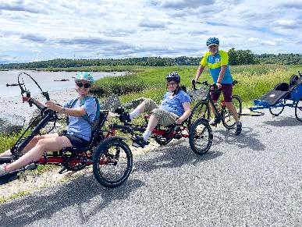
757 Gallivan Boulevard, Boston, MA (turn right just after Neponset Circle Shopping Center)
Join the Universal Access Program for accessible tandem cycling on the Lower Neponset River Trail in Boston! During this program, run by our partner Waypoint Adventure, small groups work together to cycle the back roads and bike paths of Massachusetts. Participants are encouraged to bring lunch and socialize on the trail and during breaks.
We have a variety of bikes that offer different amounts of support. We will match up two riders (a Captain and a Stoker). The Captain will be the leader, and the Stoker is the other half of the team, who works with the Captain to enjoy the adventure of tandem cycling. Some of our bikes are more traditional upright bicycles that require teamwork and balance. We also have other models that are side-by-side or recumbent, low to the ground tandems. Some have two wheels and require more balance while others are quite sturdy with three wheels and supportive seats.
Space is limited and pre-registration is required. Registration ends April 1, 2026.
Day and Time: Friday, April 3, 2026; 10 a.m.–12:30 p.m.
Meet At: Neponset River Trail Parking, Pope John Paul ll Park; Turn right just after Neponset Circle Shopping Center at 757 Gallivan Boulevard, Boston MA 02122
Cost: $20/Participant. Cost flexible based on need.
To Register: Visit waypoint-adventure.jumbula.com
Questions: Email programs@waypointadventure.org

Ashuwillticook Rail Trail, Farnams Crossing—Cycling

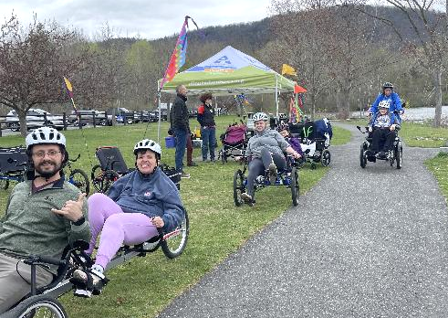
50 Farnams Road, Cheshire, MA
Join the Universal Access Program’s adaptive cycling program in Cheshire! During this program, run by our partner All Out Adventures, we offer an array of cycles that can accommodate riders of all abilities from stable, comfortable recumbent trikes, to handcycles, to tandem recumbent trikes, to wheelchair tandems. Instruction, equipment, and assistance (as needed) are provided.
This program is for people with disabilities, their families, support staff, and friends. Seniors are invited to register as well.
Pre-registration required: Registration ends at 5 p.m., two days before the program.
Days and Times: Wednesdays, 11 a.m.–3 p.m.

- April 8, 2026
- April 29, 2026
- May 6, 2026
- May 20, 2026

Participants may sign up for a one-hour timeslot during the program.
Meet At: Parking lot located at 50 Farnams Rd., Cheshire, MA 01225
Cost: $5–$20 sliding scale per session.
Questions & To Register: Register with AOA online at alloutadventures.org, call (413) 584-2052, or email programs@alloutadventures.org.

Blackstone River Greenway—Cycling

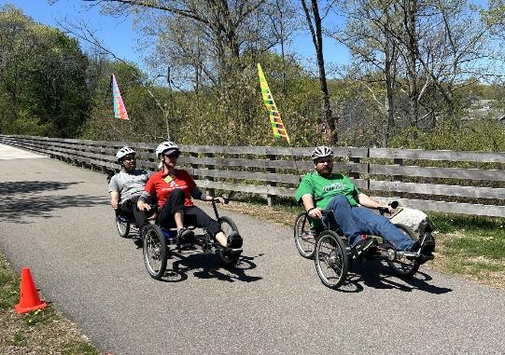
85 Canal Street, Blackstone, MA
Join the Universal Access Program’s adaptive cycling program in Blackstone! During this program, run by our partner All Out Adventures, we offer an array of cycles that can accommodate riders of all abilities from stable, comfortable recumbent trikes, to handcycles, to tandem recumbent trikes, to wheelchair tandems. Instruction, equipment, and assistance (as needed) are provided.
This program is for people with disabilities, their families, support staff, and friends. Seniors are invited to register as well.
Pre-registration required: Registration ends at 5 p.m., two days before the program.
Day and Time: Wednesday, April 15, 2026; 11 a.m.–3 p.m.
Participants may sign up for a one-hour timeslot during the program.
Meet At: Blackstone River Greenway Parking, 85 Canal St., Blackstone, MA 01504
Cost: $5–$20 sliding scale per session.
Questions & To Register: Register with AOA online at alloutadventures.org, call (413) 584-2052, or email programs@alloutadventures.org.

Norwottuck Rail Trail—Cycling

12 Railroad Street, Hadley, MA

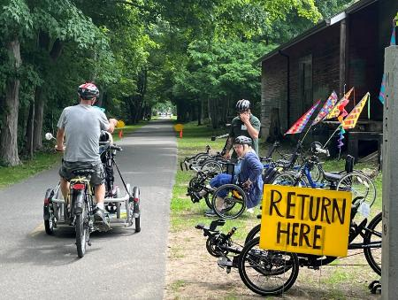
Join the Universal Access Program for adaptive cycling in Hadley! During this program, run by our partner All Out Adventures, we offer an array of cycles that can accommodate riders of all abilities from stable, comfortable recumbent trikes, to handcycles, to tandem recumbent trikes, to wheelchair tandems. Instruction, equipment, and assistance (as needed) are provided.
This program is for people with disabilities, their families, support staff, and friends. Seniors are invited to register as well.
Pre-registration required: Registration ends at 5 p.m., two days before the program.
Days and Times: Fridays, 10 a.m.–3 p.m.
- April 17, 2026
- April 24, 2026
- May 1, 2026
- May 8, 2026
- May 15, 2026
- May 22, 2026
- May 29, 2026

Participants may sign up for a one-hour timeslot during the program time.
Parking: On-street parking on Railroad St.
Cost: $5–$20 sliding scale per session.
Questions & To Register: Register with AOA online at alloutadventures.org, call (413) 584-2052, or email programs@alloutadventures.org

Blackstone River Greenway at the Blackstone River Valley Heritage Center—Cycling

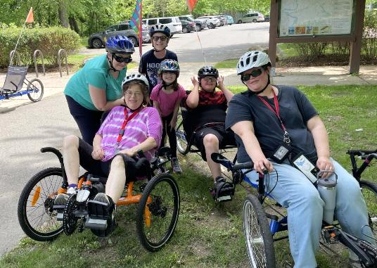
3 Paul Clancy Way, Worcester, MA
Join UAP’s adaptive cycling program in Worcester! During this program, run by our partner All Out Adventures, we offer an array of cycles that can accommodate riders of all abilities from stable, comfortable recumbent trikes, to handcycles, to tandem recumbent trikes, to wheelchair tandems. Instruction, equipment, and assistance (as needed) are provided.
This program is for people with disabilities, their families, support staff, and friends. Seniors are invited to register as well.
Pre-registration required: Registration ends at 5 p.m., two days before the program.
Day and Time: Wednesday, May 13, 2026; 11 a.m.–3 p.m.
Participants may sign up for a one-hour timeslot during the program.
Cost: $5–$20. Sliding scale per session.
Questions & To Register: Register with AOA online at alloutadventures.org, call (413) 584-2052, or email programs@alloutadventures.org

Adaptive Hiking

Harold Parker State Forest—Hiking

305 Middleton Road, North Andover, MA
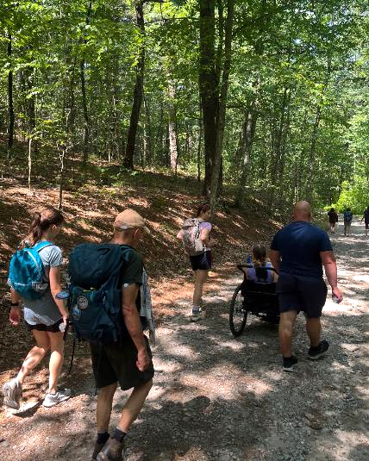
Join the Universal Access Program for accessible small group hiking in North Andover! During this program, run by our partner Waypoint Adventure, you’ll see stunning forests, view ponds/waterways, eat lunch, and connect with new people.
You’ll benefit from our selection of adaptive equipment, receive instruction to meet any learning style, and be encouraged to reach your individual goals.
Space is limited and pre-registration is required. Registration ends April 22, 2026.
Day and Time: Friday, April 24, 2026; 10 a.m.–1 p.m.
Cost: $20/Participant. Cost flexible based on need.
To Register: Visit waypoint-adventure.jumbula.com
Questions: Email programs@waypointadventure.org

Middlesex Fells Reservation—Hiking

3 Woodland Road, Stoneham, MA
Join the Universal Access Program for accessible small group hiking in in Stoneham! During this program, run by our partner Waypoint Adventure, you’ll see stunning forests, view ponds/waterways, eat lunch, and connect with new people.
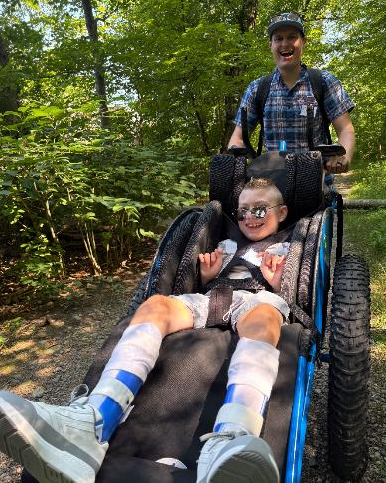
You’ll benefit from our selection of adaptive equipment, receive instruction to meet any learning style, and be encouraged to reach your individual goals.
Space is limited and pre-registration is required. Registration ends May 3, 2026.
Day and Time: Tuesday, May 5; 11 a.m.–2 p.m.
Meet At: Parking lot address is 3 Woodland Rd., Stoneham, MA. You will turn off Woodland Rd. onto New England Sanna Acc. Follow signs around the building to the parking lot in back of the complex.
This location can also be accessed by MBTA Bus 99 from Wellington Station or Malden Center.
Cost: $20/Participant. Cost flexible based on need.
To Register: Visit waypoint-adventure.jumbula.com
Questions: Email programs@waypointadventure.org

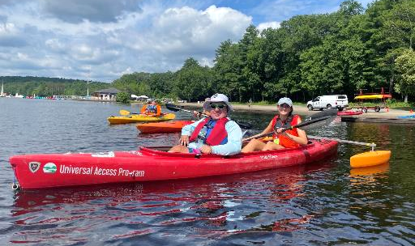
Adaptive Kayaking

Hopkinton State Park—Kayaking

164 Cedar Street, Hopkinton, MA
Join the Universal Access Program’s adaptive kayaking program on Hopkinton Reservoir in Hopkinton! During this program, run by our partner All Out Adventures, paddlers will travel in small groups (pods) to explore the reservoir. Instruction, adaptive equipment, and assistance (as needed) are provided.
This program is for people with disabilities, their families, support staff, and friends. Seniors are invited to register as well.
Pre-registration required: Registration ends at 5 p.m., two days before the program.
Day and Time: Thursday, May 28, 2026; 11 a.m.–3 p.m.
Participants may sign up for one of two time slots: 11 a.m.–12:30 p.m. or
1:15–2:45 p.m.
Meet At: Meet at the public boat launch. There will be signs pointing the way to the program base.
Cost: $8 per participant; One guest may attend at no charge. Scholarships are available for those who need them.
Questions & To Register: Register with AOA online at alloutadventures.org, call (413) 584-2052, or email programs@alloutadventures.org.

Adaptive Rowing

Connecticut River Greenway State Park—Rowing

25 Jones Ferry Road, Holyoke, MA
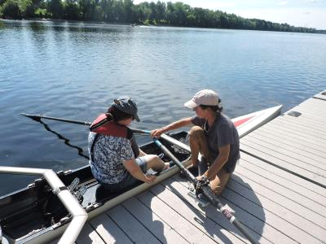
Join the Universal Access Program for adaptive rowing on the Connecticut River in Holyoke! This program, run by Holyoke Rows, uses specialized equipment, modifications, and adaptations to meet your needs while rowing or sculling. Instruction, adaptations, and staff support are all provided. You will receive instruction and the opportunity to practice and also have the chance to participate in competitions! Our program serves people of all capabilities, from beginners to leisure rowers, to competitive racers!
This program is for people with disabilities, their families, support staff, and friends. Seniors are invited to register as well.
Pre-registration is required.
Days: Thursdays, By Appointment Only

- April 9, 2026
- April 16, 2026
- April 23, 2026
- April 30, 2026
- May 7, 2026
- May 14, 2026
- May 21, 2026
- May 28, 2026

Cost: Free
Questions & to Register: Call Holyoke Rows at (413) 320-3134 or email smoore@holyokerows.org

Spring 2026 Supported Programs
Several organizations also offer adaptive programming at DCR locations on their own, sometimes with the use of DCR equipment. These are called supported programs. Each providing organization has their own requirements for programming, including release forms, EEC, and program attendance guidelines. Please contact the providing organization (by phone, email or by checking their website) for further information and to register.

Golfing with the Massachusetts Para-Golfers Association
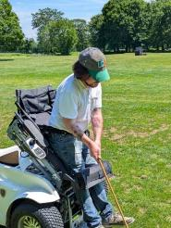
The Massachusetts ParaGolfer Association (MPGA) promotes recreational and competitive adaptive golf for players with visual impairments, hearing loss, amputations, loss of mobility, and spinal cord injuries. MPGA provides adaptive golf lessons, recreational programs, and competitive events. Lessons are private and always free, and we offer flexible dates and times.
Beginners: Appointments are available weekdays to learn to play and, if needed, to get certified to rent an adaptive golf cart. Players receive an introduction to MPGA adaptive golf, as well as an independent needs assessment to provide them with the right tools and equipment to help them swing with confidence.
Returning Players: We welcome anyone to play as many holes as they are capable of and enjoy (starting on the first tee time available). Most have joined a relaxed golf league style of play. A mixed players league is scheduled on Mondays, Wednesdays, and Fridays starting around 9:30–10 a.m. (based on tee time availability). Three days advance notice required, and up to 12 players may play either 9 holes, or a full 18 holes.
Please make a reservation in advance by calling or texting Steve (508) 889-7581.
Website: mpga.club
Locations: DCR Golf Courses
- Ponkapoag Golf Course, 2167 Washington St., Canton, MA
- Leo J. Martin Memorial Golf Course Driving Range, 190 Park Rd., Weston, MA
(Note: Leo J. Martin greens are closed this season for construction and course improvements)
Dates: Late April through end of October 2026
Contact: Steve Kuketz, mpga.club@gmail.com, (508) 889-7581
11th Annual MPGA New England Regional Adaptive Golf Championship:
October 1–October 30, 2026

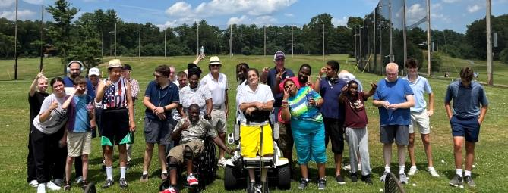
Golfing with Golf for All
Golf for All runs year-round programming for veterans, people with autism, Parkinson’s Disease, spinal cord injuries and paralysis, cerebral palsy, golfers with amputations, golfers with visual impairments, and more. Golf instruction is tailored to suit the specific needs of each participant and is taught by PGA Professionals who have successfully completed a certification process for teaching golfers with adaptive needs. Golfers of all abilities and gender are welcome, and no previous experience is necessary. During each clinic, golfers are provided with instruction, balls, adaptive equipment, and vehicles, as needed.
Website: golfforall.org
Locations: DCR Golf Courses
- Ponkapoag Golf Course, 2167 Washington St., Canton, MA,
- Leo J. Martin Memorial Golf Course Driving Range, 190 Park Rd., Weston, MA
(Note: Leo J. Martin greens are closed this season for construction and course improvements)
Dates: Late April through end of October 2026
Clinics at Ponkapoag Golf Course:
- Veterans: Saturdays, 3:30–4:45 p.m.
- Golfers with Special Needs: Mondays, 6–7:15 p.m.
Clinics at Leo J. Martin Memorial Golf Course Driving Range:
- Golfers with Autism: Thursdays, 12:30–1:30 p.m.
Contact: Fred Corcoran, Exec. Director, fredcorc@golfforall.org, (617) 462-9899

Sailing with Community Boating, Inc.
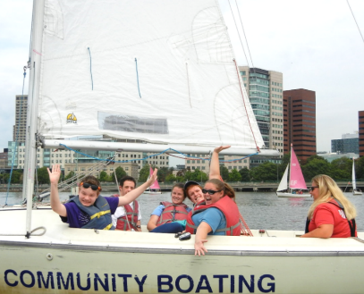
Nestled in the heart of Boston, Community Boating (CB) empowers individuals to take charge of their learning, challenge themselves, and experience the freedom that sailing brings. Through exceptional instruction and quality equipment, the program opens the doors to sailing for those who might not otherwise have the opportunity. Our diverse community includes veterans, individuals with visual impairments, children with different abilities, adults living with chronic conditions, and many others.
How the program works:
- Sign up for a 90-minute orientation sail; fill out intake questionnaire (what your individual needs are)
- Recreational sails or sailing lessons (bring guests no additional fee); Up to two 90-minute sails per week
- Schedule appointments online, or call the Boathouse
Website: community-boating.org/accessible/welcome/
Location: Charles River Esplanade in the Charles River Reservation, 21 David G Mugar Way, Boston, MA
Dates: April 27–late September/early October 2026
Spring & Fall Schedule (April through May & late August through October): Weekdays 1:30-5 p.m.; Weekends 10 a.m.–5:30 p.m.
Summer Schedule (June 15 through August 21): Weekdays 10:30 a.m.–6:00 p.m.; Weekends 10:00 a.m.–5:30 p.m.
Annual Membership: $50 or reduced fee of $1 upon request
Eligibility: Any individual who needs additional assistance
Contact: Amelia Doyle, CB Universal Access Program Manager, adoyle@community-boating.org, (617) 523-1038

Adaptive Cycling, Kayaking, Paddleboarding, Yoga, & Yard Games with Spaulding Adaptive Sports Centers

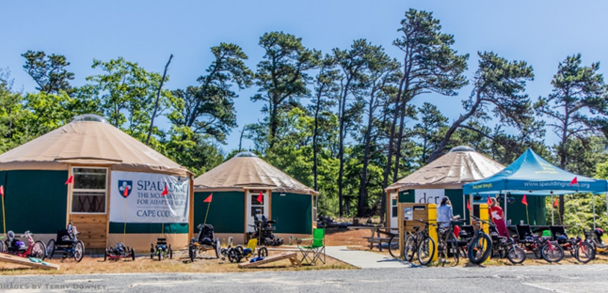
The McGraw Center for Adaptive Sports
Spaulding Adaptive Sports Centers (SASC) will be offering a variety of adaptive sport programs at the McGraw Center for Adaptive Sports at Nickerson State Park starting mid-May through mid-October. Spaulding staff provide equipment, adaptations, and support. Pre-registration for all activities is required.
Visit SASC’s on-line calendar for further information about McGraw Center Programs.
Website: Spaulding Adaptive Sports Centers
Location: McGraw Center for Adaptive Sports, Nickerson State Park, Brewster, MA
Dates: Mid-May through mid-October 2026
Contact: SpauldingAdaptiveSports@mgb.org, (877) 976-7272

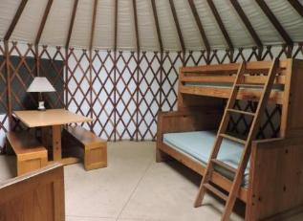
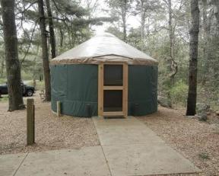
Accessible Camping—Registration is Open!
DCR accessible campsites provide a variety of camping experiences in campgrounds across Massachusetts. The sites all have room for accessible parking, and a flat, firm, and stable surface for camping. Yurts and cabins provide shelter, access to electricity, and furniture. RV-only sites have a paved parking area, and some of them also have an area for a tent. Accessible pop-up and tent sites have hard-packed level ground, pedestal grills or accessible fire rings, and accessible picnic tables.
To see a list of accessible campsites, visit mass.gov/AccessibleCamping.
If you have questions about a specific site, about accessible camping in general, or are having trouble making a reservation for an accessible site, please contact the Universal Access Program.

DCR Wants to Hear from You!
DCR is committed to sharing information with the public and engaging them in dialogue on issues, programs, and projects. Please help us identify the best ways to improve our state parks for visitors with disabilities and ensure our projects are meeting your needs.
You can learn about initiatives and share your thoughts by:
- Visiting DCR Public Meetings Information webpage where you can scroll through DCR projects and make public comments online.
- Receiving DCR general or project-specific announcements via email. Request to be added to the contact list by emailing Mass.Parks@mass.gov or by calling (617) 626-4973.

Retiring After 31 Years of Creating Opportunities
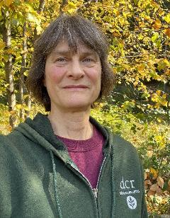
Congratulations to Marcy Marchello, our Recreation Manager of 31 years, as she wraps up her work for DCR this spring!
“It’s been an amazing journey building the UA program with our director, Tom McCarthy, from the ground up over three decades. We started with individual cross country ski sessions at the D.A.R. State Forest and a small rowing program on the Connecticut River. Over time, with ongoing support from DCR, we’ve been able to expand and sustain opportunities for people with disabilities, their caregivers and families across Massachusetts.
Our spring newsletter shows how much we’ve grown, thanks to a strong UAP team and a network of partners providing adaptive recreation statewide. It has been an honor to be part of this vital endeavor for all these years and to meet and work with so many wonderful people. Though it is time for me to retire and I will miss this job enormously, you may still see me at an occasional program. These programs are fantastic for enhancing quality of life! Keep coming and don’t miss out!”
