# Two people are riding a recumbent tandem along a dirt trail next to a tree-lined river. Universal Access Program logo of a path leading to a mountainous horizondcr Massachusetts logo with a laurel leaf in a circle.DCR’s Universal Access Program Summer 2025 Program Schedule

## Dim (Medium Sun) with solid fillSummer 2025 Adaptive Recreation Fun!

## General Information

DCR’s [Universal Access Program](https://www.mass.gov/orgs/universal-access-program) (UAP) is dedicated to providing outdoor recreation opportunities in Massachusetts state parks for visitors of all abilities. Accessibility is achieved through site improvements, specialized adaptive recreation equipment, and accessible recreation programs.

The Universal Access Program (UAP) offers adaptive, accessible programming seasonally at state parks, pools, and rinks. We partner throughout the year with [All Out Adventures](https://alloutadventures.org/), [Easterseals Massachusetts](https://www.easterseals.com/ma/), [Holyoke Rows](https://holyokerows.org/), and [Waypoint Adventure](http://www.waypointadventure.org/) to provide programs statewide.

Our structured programs feature adaptive equipment, professional staff, and instruction and support. Friends, family members, and companions are encouraged to take part in our programs alongside participants with disabilities.

**UAP’s Program Seasons:** Our Spring Program season runs from April through May, our Summer Program season runs from June through August, our Fall Program season runs from September through October, and our Winter Program season runs from November through March.

**Website:** Check out [mass.gov/dcr/access](http://www.mass.gov/dcr/access) to keep up to date with our activities!

**Contact List:** If you would like to get added to our contact list to be notified of upcoming events and activities, please [email us](mailto:DCR.UniversalAccess@mass.gov).

### Release Forms & Pre-Registration

A current release form is required for all our programs, and you must **pre-register with the organization running the program.** To pre-register, cancel, or check-in about inclement weather, please contact the providing organization listed for each program.

### Essential Eligibility Criteria & Program Attendance Guidelines

You must also meet the [Essential Eligibility Criteria](https://www.mass.gov/service-details/essential-eligibility-criteria-for-universal-access-program-participants) (EEC) and follow our [Program Attendance Guidelines](https://www.mass.gov/info-details/essential-eligibility-criteria-for-universal-access-program-participants#program-attendance-guidelines-) (PAG) for the activity. The EEC help you understand the skills you need to participate in our programs. For risk management considerations, everyone who attends our programs must complete a release form and meet these EEC, including caregivers and group staff. You can meet the EEC independently, or with the help of a caregiver (family member, friend, or PCA). Visit us at [mass.gov/uap/eec](http://www.mass.gov/uap/eec) to learn more.

If you have concerns about your ability to meet the EEC or PAG, please speak with the organization leading the activity. If you have general questions or concerns, please contact us by email [DCR.UniversalAccess@mass.gov](mailto:DCR.UniversalAccess@mass.gov) or phone at [(413) 461-7126](tel:4134617126).

## Young person paddling at the front of a canoe is smiling. A dog is seated in the middle. Adaptive Canoeing & Kayaking

### [Harold Parker State Forest](https://www.mass.gov/locations/harold-parker-state-forest)—Canoeing

#### 33 Harold Parker Road, Andover, MA

Join UAP’s adaptive canoeing program on Field Pond in Andover! During this program, run by our partner [Waypoint Adventure](https://waypointadventure.org/), paddlers will travel in small groups to explore the pond. Experience the fun and serenity of being on the water while being part of a supportive community. Benefit from a wide array of adaptive canoeing equipment and instruction designed to meet your individual needs.

**Space is limited and pre-registration is required.** Registration ends two days before the program.

**Days & Times:**

* Wednesday, June 11, 5:30–8 p.m.
* Wednesday, June 18, 10 a.m.–12:30 p.m.

**Meet At:** Collins lot,33 Harold Parker Road, Andover, MA

**Cost:** $20/Participant. Cost flexible based on need.

**To Register:** Visit [waypoint-adventure.jumbula.com](https://waypoint-adventure.jumbula.com/)

**Questions:** Email [programs@waypointadventure.org](mailto:programs@waypointadventure.org)

### Two people are paddling in a tandem kayak on a pond in the forest.[Beartown State Forest](https://www.mass.gov/locations/beartown-state-forest)—Kayaking

#### 214 Blue Hill Road, Great Barrington, MA

Join UAP’s adaptive kayaking program on Benedict Pond in Great Barrington! During this program, run by our partner [All Out Adventures](https://alloutadventures.org/), paddlers will travel in small groups (pods) to explore the pond. Instruction, adaptive equipment, and assistance (as needed) are provided.

This program is for people with disabilities, their families, support staff, and friends. Seniors are invited to register as well. All ages and abilities are welcome!

**Day and Time:** Thursday, June 12, 11 a.m.–2:30 p.m.

Participants may sign up for one of two time slots: 11 a.m. –12:30 p.m. or 1 p.m. –2:30 p.m. You must register by 12 p.m. the day before the program.

**Closest GPS Address:** 214 Blue Hill Road, Great Barrington, MA. This is just east of the park entrance. Take Benedict Pond Road to the first parking lot on your right at the pond. Signs will be posted.

**Access Blue Hill Road from Main Road (Route 23).** ***Avoid accessing Benedict Pond from the park's North Entrance due to dirt roads.***

**Cost:** $8 per participant; One guest may attend at no charge. Scholarships are available for those who need them.

**Questions & To Register:** Register with AOA online at [alloutadventures.org](https://www.alloutadventures.org/), call [(413) 584-2052](mailto:(413) 584-2052), or email [programs@alloutadventures.org](mailto:programs@alloutadventures.org).

### A group of people give the thumbs up sign while standing near the waters edge among a variety of kayaks. [Clarksburg State Park](https://www.mass.gov/locations/clarksburg-state-park)—Kayaking

#### 1199 Middle Rd. Clarksburg, MA

Join UAP’s adaptive kayaking program on Mausert’s Pond in Clarksburg! During this program, run by our partner [All Out Adventures](https://alloutadventures.org/), paddlers will travel in small groups (pods) to explore the pond. Instruction, adaptive equipment, and assistance (as needed) are provided.

This program is for people with disabilities, their families, support staff, and friends. Seniors are invited to register as well. All ages and abilities are welcome!

**Day and Time:** Thursday, June 26, 11 a.m.–2:30 p.m.

Participants may sign up for one of two time slots: 11 a.m. –12:30 p.m. or 1 p.m. –2:30 p.m. You must register by 12 p.m. the day before the program.

**Closest GPS Address:** 1199 Middle Rd., Clarksburg, MA 01247. Follow the road to the right to the boat launch. Signs to Mausert’s Pond will be posted.

**Cost:** $8 per participant; One guest may attend at no charge. Scholarships are available for those who need them.

**Questions & To Register:** Register with AOA online at [alloutadventures.org](https://www.alloutadventures.org/), call [(413) 584-2052](mailto:(413) 584-2052), or email [programs@alloutadventures.org](mailto:programs@alloutadventures.org).

### [Hopkinton State Park](https://www.mass.gov/locations/hopkinton-state-park)—Kayaking

#### 164 Cedar St., Hopkinton

Join UAP’s adaptive kayaking program on Hopkinton Reservoir in Hopkinton! During this program, run by our partner [All Out Adventures](https://alloutadventures.org/), paddlers will travel in small groups (pods) to explore the reservoir. Instruction, adaptive equipment, and assistance (as needed) are provided.

This program is for people with disabilities, their families, support staff, and friends. Seniors are invited to register as well. All ages and abilities are welcome!

**Days and Times:** Tuesdays, 10 a.m.–3 p.m.

* July 8, 2025
* July 15, 2025
* July 22, 2025
* July 29, 2025
* August 5, 2025
* August 12, 2025
* August 19, 2025

Participants may sign up for one of three time slots: 10 a.m.–11:15 a.m.; 11:30 a.m. –12:45 p.m.; or 1:30 p.m.–2:45 p.m. You must register by 12 p.m. the day before the program.

**Groups:** Schools, group homes or day programs with more than 3 individuals may register for up to four dates.

**Meet At:** Meet at the public boat launch. There will be signs pointing the way to the program base.

**Cost:** $8 per participant; One guest may attend at no charge. Scholarships are available for those who need them.

**Questions & To Register:** Register with AOA online at [alloutadventures.org](https://www.alloutadventures.org/), call [(413) 584-2052](mailto:(413) 584-2052), or email [programs@alloutadventures.org](mailto:programs@alloutadventures.org).

### [DAR State Forest](https://www.mass.gov/locations/daughters-of-the-american-revolution-dar-state-forest)—Canoeing & Kayaking

#### 78 Cape St, Goshen

This program is for people with disabilities, their families, support staff, and friends. Seniors are invited to register as well. All ages and abilities are welcome!

**Days and Times:** Wednesdays, 9:45 a.m.–3 p.m.

* July 9, 2025
* July 16, 2025
* July 23, 2025
* July 30, 2025
* August 6, 2025
* August 13, 2025
* August 20, 2025

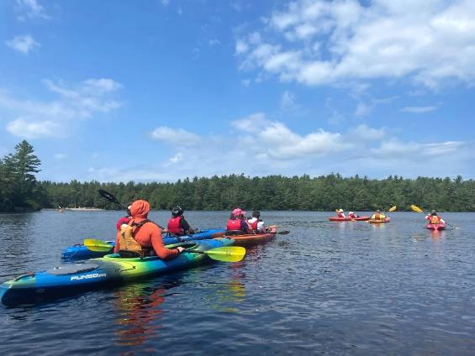Participants may sign up for one of three time slots: 9:45–11:15 a.m.; 11:30 a.m. –1:00 p.m.; or 1:30–3:00 p.m. You must register by 12 p.m. the day before the program.

**Groups:** Schools, group homes or day programs with more than 3 individuals may register for up to four dates.

**Cost:** $8 per participant; One guest may attend at no charge. Scholarships are available for those who need them.

**Questions & To Register:** Register with AOA online at [alloutadventures.org](https://www.alloutadventures.org/), call [(413) 584-2052](mailto:(413) 584-2052), or email [programs@alloutadventures.org](mailto:programs@alloutadventures.org).

### [Charles River Reservation](https://www.mass.gov/locations/charles-river-reservation)—Kayaking

#### 48 Woerd Avenue, Waltham (across the street from this address)

Join UAP’s adaptive kayaking program at Charles River Reservation in Waltham! During this program, run by our partner [Waypoint Adventure](https://waypointadventure.org/), paddlers will travel in small groups to explore the river. Experience the fun and serenity of being on the water while being part of a supportive community. Benefit from a wide array of adaptive kayaking equipment and instruction designed to meet your individual needs.

**Space is limited and pre-registration is required.** Registration ends two days before the program.

**Days and Times:**

* Thursday, July 10, 1–3 p.m.
* Thursday, July 17, 1–3 p.m.
* Saturday, August 9, 10 a.m.–12 p.m. & 1–3 p.m.

**Meet At:** Boat Launch at the end of a parking lot across the street from 48 Woerd Avenue, Waltham, MA.

**Cost:** $20/Participant. Cost flexible based on need.

**To Register:** Visit [waypoint-adventure.jumbula.com](https://waypoint-adventure.jumbula.com/)

**Questions:** Email [programs@waypointadventure.org](mailto:programs@waypointadventure.org)

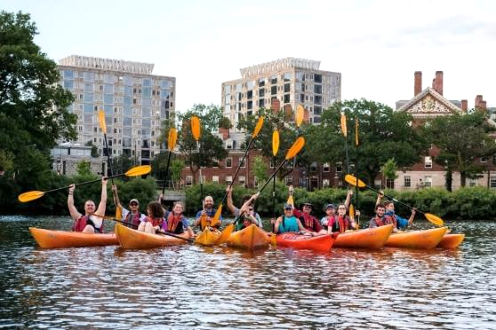

### [Charles River Reservation](https://www.mass.gov/locations/charles-river-reservation)—Kayaking

#### 668 Memorial Drive, Cambridge

Join UAP’s adaptive kayaking program at Magazine Beach in Cambridge! During this program, run by our partner [Waypoint Adventure](https://waypointadventure.org/), paddlers will travel in small groups to explore the river. Experience the fun and serenity of being on the water while being part of a supportive community. Benefit from a wide array of adaptive kayaking equipment and instruction designed to meet your individual needs.

**Space is limited and pre-registration is required.** Registration ends two days before the program.

**Days and Times:**

* Saturday, July 12, 1–3 p.m.
* Tuesday, August 12, 1–3 p.m.
* Tuesday, August 26, 1–3 p.m.

**Meet At:** Magazine Beach Cartop Boat Launch, 668 Memorial Drive, Cambridge MA

**Cost:** $20/Participant. Cost flexible based on need.

**To Register:** Visit [waypoint-adventure.jumbula.com](https://waypoint-adventure.jumbula.com/)

**Questions:** Email [programs@waypointadventure.org](mailto:programs@waypointadventure.org)

### [Belle Isle Marsh Reservation](https://www.mass.gov/locations/belle-isle-marsh-reservation)—Intermediate Kayaking

#### 1399 Bennington Street, East Boston

Join UAP for an intermediate level adaptive kayaking program in East Boston! This program, run by our partner [Waypoint Adventure](https://waypointadventure.org/), is meant for people looking for a higher level of challenge than our typical programs. This program is for people who can paddle the front or back of a tandem kayak (with breaks) for the entire program.

Paddlers will explore the ocean and salt marshes in Boston Harbor. Experience the fun and serenity of being on the water while being part of a supportive community. Benefit from a wide array of adaptive kayaking equipment and instruction designed to meet your individual needs.

**Space is limited and pre-registration is required.** Registration ends July 22.

**Day and Time:** Thursday, July 24, 10 a.m.–2 p.m.

**Meet At:** Park in main parking lot at 1399 Bennington St., East Boston. Follow signs to the boat launch near Belle Isle Observation Tower.

**Cost:** $20/Participant. Cost flexible based on need.

**To Register:** Visit [waypoint-adventure.jumbula.com](https://waypoint-adventure.jumbula.com/)

**Questions:** Email [programs@waypointadventure.org](mailto:programs@waypointadventure.org)

### A group of kayakers are paddling on a lake in front of a sailing clubhouse.[Quinsigamond State Park](https://www.mass.gov/locations/quinsigamond-state-park)—Kayaking

#### 10 N. Lake Ave., Worcester

Join UAP’s adaptive kayaking program at Regatta Point on Lake Quinsigamond in Worcester! During this program, run by our partner [All Out Adventures](https://alloutadventures.org/), paddlers will travel in small groups (pods) to explore the lake. Instruction, adaptive equipment, and assistance (as needed) are provided.

This program is for people with disabilities, their families, support staff, and friends. Seniors are invited to register as well. All ages and abilities are welcome!

**Days and Times:** Thursdays, 10 a.m.–3 p.m.

* July 31, 2025
* August 7, 2025
* August 14, 2025
* August 21, 2025

Participants may sign up for one of three time slots: 10 a.m.–11:15 a.m.; 11:30 a.m. –12:45 p.m.; or 1:30 p.m.–2:45 p.m. You must register by 12 p.m. the day before the program.

**Groups:** Schools, group homes or day programs with more than 3 individuals may register for up to four dates.

**Cost:** $8 per participant; One guest may attend at no charge. Scholarships are available for those who need them.

**Questions & To Register:** Register with AOA online at [alloutadventures.org](https://www.alloutadventures.org/), call [(413) 584-2052](mailto:(413) 584-2052), or email [programs@alloutadventures.org](mailto:programs@alloutadventures.org).

### People in two tandem kayaks on a tree-lined lake, smile for a photo. [Cochituate State Park](https://www.mass.gov/locations/cochituate-state-park)—Kayaking

#### 43 Commonwealth Road, Natick, MA

Join UAP’s adaptive kayaking program on Lake Cochituate in Natick! During this program, run by our partner [Waypoint Adventure](https://waypointadventure.org/), paddlers will travel in small groups to explore the lake. Experience the fun and serenity of being on the water while being part of a supportive community. Benefit from a wide array of adaptive kayaking equipment and instruction designed to meet your individual needs.

**Space is limited and pre-registration is required.** Registration ends July 29.

**Day and Time:** Thursday, July 31, 1–3 p.m.

**Cost:** $20/Participant. Cost flexible based on need.

**To Register:** Visit [waypoint-adventure.jumbula.com](https://waypoint-adventure.jumbula.com/)

**Questions:** Email [programs@waypointadventure.org](mailto:programs@waypointadventure.org)

### [Whitehall State Park](https://www.mass.gov/locations/whitehall-state-park)—Kayaking

#### 299 Wood Street, Hopkinton

Join UAP’s adaptive kayaking program on Whitehall Reservoir in Hopkinton! During this program, run by our partner [Waypoint Adventure](https://waypointadventure.org/), paddlers will travel in small groups to explore the reservoir. Experience the fun and serenity of being on the water while being part of a supportive community. Benefit from a wide array of adaptive kayaking equipment and instruction designed to meet your individual needs.

**Space is limited and pre-registration is required.** Registration ends two days before the program.

**Days and Times:** Tuesday, 1–3 p.m.

* August 5
* August 19

**Cost:** $20/Participant. Cost flexible based on need.

**To Register:** Visit [waypoint-adventure.jumbula.com](https://waypoint-adventure.jumbula.com/)

**Questions:** Email [programs@waypointadventure.org](mailto:programs@waypointadventure.org)

## Adaptive Cycling

### [Norwottuck Rail Trail](https://www.mass.gov/locations/norwottuck-rail-trail)—Cycling

#### 12 Railroad Street, Hadley, MA

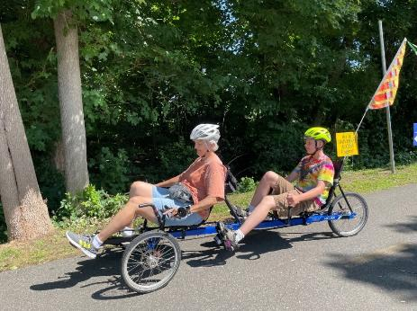Join UAP’s adaptive cycling program in Hadley! During this program, run by our partner [All Out Adventures](https://alloutadventures.org/), we offer an array of cycles that can accommodate riders of all abilities from stable, comfortable recumbent trikes, to handcycles, to tandem recumbent trikes, to wheelchair tandems. Instruction, equipment, and assistance (as needed) are provided.

This program is for people with disabilities, their families, support staff, and friends. Seniors are invited to register as well. All ages and abilities are welcome!

**Days and Times:** Fridays, 10 a.m.–3 p.m.

* June 13, 2025
* June 20, 2025
* June 27, 2025
* July 11, 2025
* July 18, 2025
* July 25, 2025
* August 8, 2025
* August 15, 2025
* August 22, 2025

Participants may sign up for a one-hour timeslot during the program time. You must register by noon the day before the program.

**Parking:** On-street parking on Railroad St.

**Cost**: $5–$20 sliding scale per session.

**Questions & To Register:** Register with AOA online at [alloutadventures.org](https://www.alloutadventures.org/), call [(413) 584-2052](mailto:(413) 584-2052), or email [programs@alloutadventures.org](mailto:programs@alloutadventures.org)

### [Cochituate State Park](https://www.mass.gov/locations/cochituate-state-park)—Tandem Cycling

#### 43 Commonwealth Road, Natick, MA

Join the [Universal Access Program](https://www.mass.gov/orgs/universal-access-program) for accessible tandem cycling in Natick! During this program, run by our partner [Waypoint Adventure](https://waypointadventure.org/), small groups work together to cycle the back roads and bike paths of Massachusetts. Participants are encouraged to bring lunch and socialize on the trail and during breaks.

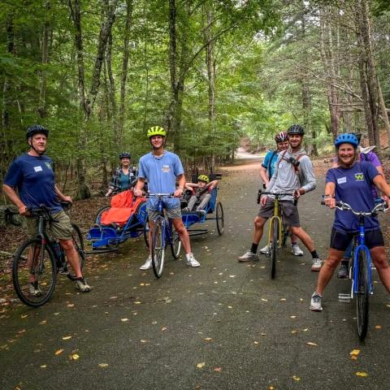We have a variety of bikes that offer different amounts of support. We will match up two riders (a Captain and a Stoker). The Captain will be the leader, and the Stoker is the other half of the team, who works with the Captain to enjoy the adventure of tandem cycling. Some of our bikes are more traditional upright bicycles that require teamwork and balance. We also have other models that are side-by-side or recumbent, low to the ground tandems. Some have two wheels and require more balance while others are quite sturdy with three wheels and supportive seats.

**Space is limited and pre-registration is required.** Registration ends June 13, 2025.

**Day and Time:** Monday, June 16, 2025, 10 a.m.-12:30 p.m.

**Cost:** $20/Participant. Cost flexible based on need.

**To Register:** Visit [waypoint-adventure.jumbula.com](https://waypoint-adventure.jumbula.com/)

**Questions:** Email [programs@waypointadventure.org](mailto:programs@waypointadventure.org)

### Two people riding a wheelchair tandem pose for a picture in front of a visitor center. [Blackstone River Greenway](https://blackstoneheritagecorridor.org/exploring-the-blackstone-river-valley/maps-tours-guides/blackstone-river-bikeway/) at the [Blackstone River Valley Heritage Center](https://blackstoneheritagecorridor.org/happening-now/worcester-heritage-center/)—Cycling

#### 3 Paul Clancy Way, Worcester, MA

Join UAP’s adaptive cycling program in Worcester! During this program, run by our partner [All Out Adventures](https://alloutadventures.org/), we offer an array of cycles that can accommodate riders of all abilities from stable, comfortable recumbent trikes, to handcycles, to tandem recumbent trikes, to wheelchair tandems. Instruction, equipment, and assistance (as needed) are provided.

This program is for people with disabilities, their families, support staff, and friends. Seniors are invited to register as well. All ages and abilities are welcome!

**Day and Time:** Wednesday, June 25, 2025, 11 a.m.–3 p.m.

Participants may sign up for a one-hour timeslot during the program. You must register by noon the day before the program.

**Cost**: $5–$20. Sliding scale per session.

**Questions & To Register:** Register with AOA online at [alloutadventures.org](https://www.alloutadventures.org/), call [(413) 584-2052](mailto:(413) 584-2052), or email [programs@alloutadventures.org](mailto:programs@alloutadventures.org)

### [Pope John Paul II Park Reservation](https://www.mass.gov/locations/pope-john-paul-ii-park-reservation)—Tandem Cycling

#### 757 Gallivan Street, Boston, MA (turn right just after Neponset Circle Shopping Center)

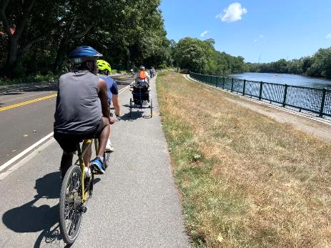Join the [Universal Access Program](https://www.mass.gov/orgs/universal-access-program) for accessible tandem cycling on the Neponset River Trail Boston! During this program, run by our partner [Waypoint Adventure](https://waypointadventure.org/), small groups work together to cycle the back roads and bike paths of Massachusetts. Participants are encouraged to bring lunch and socialize on the trail and during breaks.

We have a variety of bikes that offer different amounts of support. We will match up two riders (a Captain and a Stoker). The Captain will be the leader, and the Stoker is the other half of the team, who works with the Captain to enjoy the adventure of tandem cycling. Some of our bikes are more traditional upright bicycles that require teamwork and balance. We also have other models that are side-by-side or recumbent, low to the ground tandems. Some have two wheels and require more balance while others are quite sturdy with three wheels and supportive seats.

**Space is limited and pre-registration is required.** Registration ends July 16, 2025.

**Day and Time:** Friday, July 18, 2025, 10 a.m.–1 p.m.

**Meet At:** Neponset River Trail Parking, Pope John Paul ll Park; Turn right just after Neponset Circle Shopping Center at 757 Gallivan Boulevard, Boston MA 02122

**Cost:** $20/Participant. Cost flexible based on need.

**To Register:** Visit [waypoint-adventure.jumbula.com](https://waypoint-adventure.jumbula.com/)

**Questions:** Email [programs@waypointadventure.org](mailto:programs@waypointadventure.org)

### [Wompatuck State Park](https://www.mass.gov/locations/wompatuck-state-park)—Tandem Cycling

#### 204 Union St, Hingham

Join the [Universal Access Program](https://www.mass.gov/orgs/universal-access-program) for accessible tandem cycling in Hingham! During this program, run by our partner [Waypoint Adventure](https://waypointadventure.org/), small groups work together to cycle the back roads and bike paths of Massachusetts. Participants are encouraged to bring lunch and socialize on the trail and during breaks.

We have a variety of bikes that offer different amounts of support. We will match up two riders (a Captain and a Stoker). The Captain will be the leader, and the Stoker is the other half of the team, who works with the Captain to enjoy the adventure of tandem cycling. Some of our bikes are more traditional upright bicycles that require teamwork and balance. We also have other models that are side-by-side or recumbent, low to the ground tandems. Some have two wheels and require more balance while others are quite sturdy with three wheels and supportive seats.

**Space is limited and pre-registration is required.** Registration ends August 13, 2025.

**Day and Time:** Friday, August 15, 2025, 10 a.m.–12:30 p.m.

**Meet At:** Visitor Center parking lot located at 204 Union St., Hingham.

**Cost:** $20/Participant. Cost flexible based on need.

**To Register:** Visit [waypoint-adventure.jumbula.com](https://waypoint-adventure.jumbula.com/)

**Questions:** Email [programs@waypointadventure.org](mailto:programs@waypointadventure.org)

## A group of people are hiking on a trail in the woods. One person is being pushed in an all-terrain wheelchair. Adaptive Hiking

### [Wompatuck State Park](https://www.mass.gov/locations/wompatuck-state-park)—Hiking

#### 204 Union St, Hingham

Join the [Universal Access Program](https://www.mass.gov/orgs/universal-access-program) for accessible small group hiking in Hingham! During this program, run by our partner [Waypoint Adventure](https://waypointadventure.org/), you’ll see stunning forests, ponds/waterways, eat lunch, and connect with new people. You’ll benefit from our selection of adaptive equipment, receive instruction to meet any learning style, and be encouraged to reach your individual goals.

**Space is limited and pre-registration is required.** Registration ends July 14, 2025.

**Day and Times:** Wednesday, July 16, 10 a.m.–1 p.m.

**Cost:** $20/Participant. Cost flexible based on need. One parent/friend/PCA of program participant with a disability may attend at no charge (see Waypoint’s Registration page for details).

**To Register:** Visit [waypoint-adventure.jumbula.com](https://waypoint-adventure.jumbula.com/)

**Questions:** Email [programs@waypointadventure.org](mailto:programs@waypointadventure.org)

### [Blue Hills Reservation](https://www.mass.gov/locations/blue-hills-reservation)—Hiking

#### 840 Hillside Street, Milton, MA

Join the [Universal Access Program](https://www.mass.gov/orgs/universal-access-program) for accessible small group hiking in Milton! During this program, run by our partner [Waypoint Adventure](https://waypointadventure.org/), you’ll see ponds/waterways, eat lunch, connect with new people, and *visit the Mass Audubon’s Blue Hills Trailside Museum!* You’ll benefit from our selection of adaptive equipment, receive instruction to meet any learning style, and be encouraged to reach your individual goals.

**Space is limited and pre-registration is required.** Registration ends July 24, 2025.

**Day and Time:** Saturday, July 26, 10 a.m.–1 p.m.

**Cost:** $20/Participant. Cost flexible based on need. One parent/friend/PCA of program participant with a disability may attend at no charge (see Waypoint’s Registration page for details).

**To Register:** Visit [waypoint-adventure.jumbula.com](https://waypoint-adventure.jumbula.com/)

**Questions:** Email [programs@waypointadventure.org](mailto:programs@waypointadventure.org)

[**Middlesex Fells Reservation**](https://www.mass.gov/locations/middlesex-fells-reservation)**—Hiking**

3WoodlandRoad,Stoneham

Join the [Universal Access Program](https://www.mass.gov/orgs/universal-access-program) for accessible small group hiking in in Stoneham. During this program, run by our partner [Waypoint Adventure](https://waypointadventure.org/), you’ll see stunning forests, ponds/waterways, eat lunch, and connect with new people. You’ll benefit from our selection of adaptive equipment, receive instruction to meet any learning style, and be encouraged to reach your individual goals.

**Space is limited and pre-registration is required.** Registration ends July 31, 2025.

**Day and Time:** Saturday, August 2, 10 a.m.–1 p.m.

**Meet At:** Parking lot address is 3 Woodland Rd, Stoneham, MA. You will turn off Woodland Road onto New England Sanna Acc. Follow signs around the building to the parking lot in back of the complex.

**Cost:** $20/Participant. Cost flexible based on need. One parent/friend/PCA of program participant with a disability may attend at no charge (see Waypoint’s Registration page for details).

**To Register:** Visit [waypoint-adventure.jumbula.com](https://waypoint-adventure.jumbula.com/)

**Questions:** Email [programs@waypointadventure.org](mailto:programs@waypointadventure.org)

**Adaptive Rowing**

### [Connecticut River Greenway State Park](https://www.mass.gov/locations/connecticut-river-greenway-state-park)—Rowing

#### 25 Jones Ferry Road, Holyoke, MA

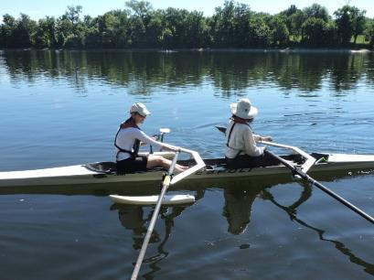Join UAP for some adaptive rowing on the Connecticut River in Holyoke! This program, run by [Holyoke Rows](https://www.holyokerows.org/), uses specialized equipment, modifications, and adaptations to meet your needs while rowing or sculling. Instruction, adaptations, and staff support are all provided. You will receive instruction and the opportunity to practice and also have the chance to participate in competitions! Our program serves people of all capabilities, from beginners to leisure rowers, to competitive racers!

This program is for people with disabilities, their families, support staff, and friends. Seniors are invited to register as well. All ages and abilities are welcome!

Pre-registration is required.

**Days:** Thursdays, By Appointment Only

* June 5, 2025
* June 12, 2025
* June 19, 2025
* June 26, 2025
* July 3, 2025
* July 10, 2025
* July 17, 2025
* July 24, 2025
* July 31, 2025
* August 7, 2025
* August 14, 2025
* August 21, 2025
* August 28, 2025

**Cost:** Free

**Questions & to Register:** Call [Holyoke Rows](https://www.holyokerows.org/) at [(413) 320-3134](tel:4133203134) or email [smoore@holyokerows.org](mailto:smoore@holyokerows.org)

## A child is jumping from the edge of the pool into the arms of staff holding a floatation noodle. Adaptive Swimming

### [Bennett Field Pool](https://www.mass.gov/locations/veterans-memorial-bennett-field-swimming-pool)-Swimming

#### 1260 Main Street, Worcester

Join UAP for an adaptive recreational swim program! This program, run by [Easterseals Massachusetts](mailto:Easterseals%20Massachusetts), is led by aquatics instructors and a lifeguard. Groups will participate in fun safety activities and water games that maximize independence in the water. This swim program is a six-week, recreational program and does not provide swim lessons.

The adaptive swim program is open to individuals with disabilities of all ages and their families. This is a special opportunity to swim with new friends before the pool opens to the public!

Pre-registration is required.

**Days and Times:** Fridays; Children ages 5–12 (9–9:45 a.m.); Children ages 13+ & Adults (10–10:45 a.m.)

* July 11, 2025
* July 18, 2025
* July 25, 2025
* August 1, 2025
* August 8, 2025
* August 15, 2025

**Cost:** Free

**Questions & to Register:** Call Patrick Remy at [(508) 751-6417](tel:508-751-6417) or email [PRemy@eastersealsma.org](mailto:PRemy@eastersealsma.org)

## Summer 2025 Supported Programs

Several organizations also offer adaptive programming at DCR locations on their own, sometimes with the use of DCR equipment. These are called *supported* *programs*. Each providing organization has their own requirements for programming, including release forms, EEC, and program attendance guidelines. Please contact the providing organization (by phone, email or by checking their website) for further information and to register.

### Golfing with the Massachusetts Para-Golfers Association

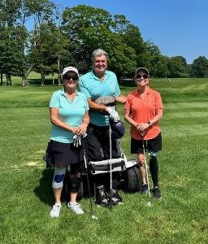The [Massachusetts ParaGolfer Association](https://www.mpga.club/) (MPGA) promotes recreational and competitive adaptive golf for players with visual impairments, hearing loss, amputations, loss of mobility, , and spinal cord injuries. MPGA provides adaptive golf lessons, recreational programs, and competitive events. Lessons are private and always free, and we offer flexible dates and times.

**Beginners:** Appointments are available weekdays to learn to play and, if needed, to get certified to rent a specialized golf cart. Players receive an introduction to MPGA adaptive golf, as well as an independent needs assessment to provide them with the right tools and equipment to help them swing with confidence.

**Returning Players:** We welcome anyone to play as many holes as they are capable of and enjoy (starting on the first tee time available). Most have joined a relaxed golf league style of play. A mixed players league is scheduled on Mondays, Wednesdays, and Fridays starting around 9:30–10 a.m. (based on tee time availability). Three days advance notice required, and up to 12 players may play either 9 holes, or a full 18 holes.

Please make a reservation in advance by calling or texting Steve [(508) 889-7581](tel:5088897581).

**Website:** [mpga.club](https://www.adaptivegolf.club/)

**Locations**: [DCR Golf Courses](https://www.statemadcrgolf.com/)

* [Ponkapoag Golf Course](https://www.mass.gov/locations/ponkapoag-golf-course)**,** 2167 Washington Street, Canton, MA,
* [Leo J. Martin Memorial Golf Course](https://www.mass.gov/locations/leo-j-martin-memorial-golf-course)**,** 190 Park Road, Weston, MA

**Dates:** Late April through end of October 2025

**Contact:** Steve Kuketz, [mpga.club@gmail.com](mailto:mpga.club@gmail.com), [(508) 889-7581](tel:5088897581)

**10th Annual MPGA New England Regional Adaptive Gold Championship**: October 1-October 30, 2025

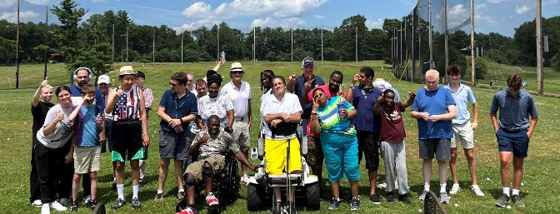

### Golfing with Golf for All

[Golf for All](http://www.golfforall.org/)runs year-round programming for veterans, people with autism, Parkinson’s Disease, spinal cord injuries and paralysis, cerebral palsy, golfers with amputations, golfers with visual impairments, and more. Golf instruction is tailored to suit the specific needs of each participant and is taught by PGA Professionals who have successfully completed a certification process for teaching golfers with adaptive needs. Golfers of all abilities and gender are welcome, and no previous experience is necessary. During each clinic, golfers are provided with instruction, balls, adaptive equipment, and vehicles, as needed.

**Website:** [golfforall.org](http://www.golfforall.org/)

**Locations**: [DCR Golf Courses](https://www.statemadcrgolf.com/)

* [Ponkapoag Golf Course](https://www.mass.gov/locations/ponkapoag-golf-course), 2167 Washington Street, Canton, MA,

* [Leo J. Martin Memorial Golf Course](https://www.mass.gov/locations/leo-j-martin-memorial-golf-course), 190 Park Rd, Weston, MA

**Dates:** Late April through end of October 2025

**Clinics** **at** [**Ponkapoag Golf Course**](https://www.mass.gov/locations/ponkapoag-golf-course)**:**

* Veterans: Saturdays, 3:30–4:45 p.m.
* Golfers with Special Needs:Mondays, 6–7:15 p.m.

**Clinics** **at** [**Leo J. Martin Memorial Golf Course**](https://www.mass.gov/locations/leo-j-martin-memorial-golf-course)**:**

* Golfers with Autism: Thursdays, 12:30–1:30 p.m.
* Golfers with Parkinson’s: Thursdays, 10:30 a.m. (June & September only)

**Contact:** Fred Corcoran, Exec. Director, [fredcorc@golfforall.org](mailto:fredcorc@golfforall.org), [(617) 462-9899](tel:6174629899)

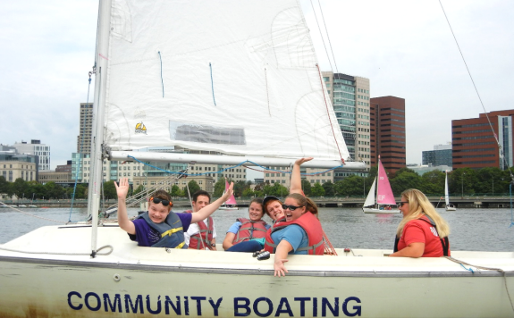

### Sailing with Community Boating, Inc.

Nestled in the heart of Boston, Community Boating empowers individuals to take charge of their learning, challenge themselves, and experience the freedom that sailing brings. Through exceptional instruction and quality equipment, the program opens the doors to sailing for those who might not otherwise have the opportunity. Our diverse community includes veterans, individuals with visual impairments, children with different abilities, adults living with chronic conditions, and many others.

**Website:** [community-boating.org/accessible](https://www.community-boating.org/accessible/)

**Location:** Charles River Esplanade in the [Charles River Reservation](https://www.mass.gov/locations/charles-river-reservation), 21 David G Mugar Way, Boston, MA

**Dates:** April 28–September 27, 2025

**Times:** Afternoons and weekends: see [scheduling page](https://urldefense.com/v3/__https:/community-boating.org/accessible/schedule-an-appointment/__;!!CPANwP4y!Q2u1LkgkJAT4V3lI7ecciN1Dhgn5Igla7wV8Q2gw5qfM2gpq7Gy_dt7rXgC5uQKG9hE1LQro8fs5WlZRagS9MMt5dZ0$) for appointment times

**Annual Membership:** $50 or reduced fee of $1 upon request

**Eligibility:** Any individual who needs additional assistance

**Contact:** [adoyle@community-boating.org](mailto:adoyle@community-boating.org), [(617) 523-1038](tel:6175231038)

### **Many styles and sizes of adaptive bicycles are parked in front of 3 accessible yurts and a Spaulding pop up canopy.** Adaptive Cycling, Kayaking, Paddleboarding, Yoga, & Yard Games & Golf with Spaulding Adaptive Sports Centers

#### The McGraw Center

[Spaulding Adaptive Sports Centers](https://spauldingrehab.org/conditions-services/adaptive-sports) (SASC) will be offering a variety of adaptive sport programs at the McGraw Center for Adaptive Sports at [Nickerson State Park](https://www.mass.gov/locations/nickerson-state-park) starting mid-May through mid-October. Spaulding staff provide equipment, adaptations, and support. Pre-registration for all activities is required.

Visit SASC’s [on-line calendar](https://sasc.spauldingrehab.org/default.aspx?tab=icon) for further information about McGraw Center Programs.

**Website:** [Spaulding Adaptive Sports Centers](https://spauldingrehab.org/conditions-services/adaptive-sports)

**Location:** McGraw Center for Adaptive Sports, [Nickerson State Park](https://www.mass.gov/locations/nickerson-state-park), Brewster

**Dates:** Mid-May through mid-October 2025

**Contact:** [SpauldingAdaptiveSports@partners.org](mailto:SpauldingAdaptiveSports@partners.org), [(877) 976-7272](tel:(877)%20976-7272)

### People are cheering while paddling in two Hawaiian outrigger canoes. Watersports with AccesSportAmerica

AccesSportAmerica is offering adaptive watersports at [Malibu Beach](https://www.mass.gov/locations/savin-hill-and-malibu-beach) on Boston Harbor in Dorchester.

**Windsurfing:** Seated and standing adaptations with a full range of tandem, catamaran, and single boards.

**Hawaiian Outrigger Canoeing:** Three, four person canoes with paddle adaptations.

**Stand Up Paddling:** Single, double and 8-person stand up boards with seats and standers.

**Kayaking:** Single and double kayaks with adaptive paddles.

Each sport is adapted to fit every individual’s unique needs. AccesSport trainers, interns, and volunteers are on site.

Athletes can sign up as an individual or programs can send groups. Individual sessions will include four athletes, and groups will be 6-10.

**Location:** [Malibu Beach](https://www.mass.gov/locations/savin-hill-and-malibu-beach), 68 Denny St., Dorchester, MA

**Website:** <https://goaccess.org/>

**Dates & Times:** July & August; Tuesday- Friday by appointment

**Cost:** Individuals $50/session; Groups $120/session

**Contact:** [Nate@goaccess.org](mailto:Nate@goaccess.org); [(978) 7906-2960](tel:8779767272)

## DCR Pilots Powered Mobility Devices!

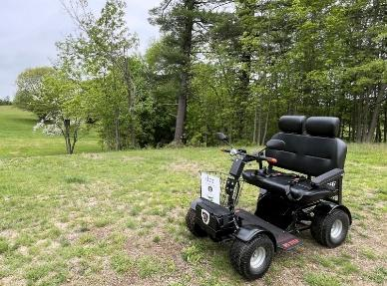Explore Massachusetts State Parks in new ways and on new trails!

Beginning this summer, visitors with mobility impairments can borrow a [Power-Driven Mobility Device](https://www.mass.gov/info-details/dcr-power-driven-mobility-devices#2025-locations-availability) at select parks, free of charge.

UAP is currently piloting a [Trackchair](https://www.mass.gov/info-details/action-trackchair-axis-operating-and-safety-instructions) and a [Mobility Scooter](https://www.mass.gov/info-details/mobility-scooter-operating-and-safety-instructions).

### [Mobility Scooter](https://www.mass.gov/info-details/mobility-scooter-operating-and-safety-instructions)

**Location:** [Maudslay State Park](https://www.mass.gov/locations/maudslay-state-park), 74 Curzon Mill Road, Newburyport

* May 12–October 31, 2025

### A person is riding a track chair on a trail in the woods.[Trackchair](https://www.mass.gov/info-details/action-trackchair-axis-operating-and-safety-instructions)

**Location:** [Windsor State Forest](https://www.mass.gov/locations/windsor-state-forest), River Rd., Windsor

* June 13–September 1, 2025

**Location:** [Maudslay State Park](https://www.mass.gov/locations/maudslay-state-park), 74 Curzon Mill Road, Newburyport

* September 5–October 31, 2025, 2025

**Reservations & Eligibility:**

You must make a reservation at least 3 days prior to your visit.

You must review the [Trackchair operating and safety instructions](https://www.mass.gov/info-details/action-trackchair-axis-operating-and-safety-instructions) or the [Mobility Scooter operating and safety instructions](https://www.mass.gov/info-details/mobility-scooter-operating-and-safety-instructions) before you can make a reservation.

You’ll need to bring someone with you, 18 years of age or older, to be your **companion**.

You must complete a **Use and Release Form** at the park/forest on the day of your visit. Users under age 18 or under guardianship must have the **Use and Release Form** signed by their legal guardian.

Users age 16 or under will need to wear a **safety helmet**.

Maximum user weight: 300 pounds for the Trackchair or 500 pounds for the mobility scooter.

Visit [mass.gov/dcr/PDMD](http://www.mass.gov/dcr/PDMD) for details on [how to make a reservation](https://www.mass.gov/info-details/dcr-power-driven-mobility-devices#how-to-make-a-reservation), [safety and usage guidelines](https://www.mass.gov/info-details/dcr-power-driven-mobility-devices#safety-and-usage-guidelines), and [eligibility](https://www.mass.gov/info-details/dcr-power-driven-mobility-devices#eligibility).

**The Massachusetts Statewide Independent Living Council**

Invites you to

# ADA Day at Dunn State Park!

**Friday, August 1, 2025**

**11 a.m. – 3 p.m.**

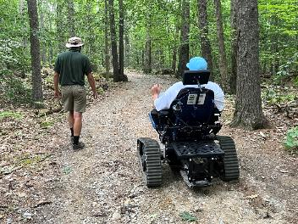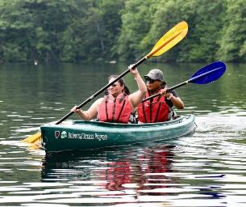**Celebrate 35 years of the Americans with Disabilities Act!!**

Photo courtesy of Sue Rorke

Hike, kayak, swim, listen to music and hang out with friends! Light lunch and drinks provided.

[DCR's Universal Access Program](https://www.mass.gov/orgs/universal-access-program) will host accessible hiking and kayaking with partners from [All Out Adventures](https://alloutadventures.org/) and [Waypoint Adventure](https://ma.waypointadventure.org/).

ASL will be provided for those needing assistance accessing accessible activities. Parking is limited so carpooling is encouraged!

**Location:** [Dunn State Park](https://www.mass.gov/locations/dunn-state-park), 289 Pearl St., Gardner, MA

**RSVP by July 17th at:** [https://masilc.formstack.com/forms/2025adaday](https://urldefense.com/v3/__https:/masilc.formstack.com/forms/2025adaday__;!!CPANwP4y!X01UpNDXhmRmlAJVZbdlfvdCOyaz8ohA7HMuC0e1y-68hoXu3qLh9OzoB_7WaZhwgDbG8YDJuXXD72mRHtiA9Q$)

**Questions?** Email MASILC: [info@masilc.org](mailto:info@masilc.org)

**Join Triangle, Inc. on Saturday, August 2nd for**

# Flyer for Beach: Ability! Content in posting. Beach:Ability!

***Celebrate summer in Boston at the beach!***

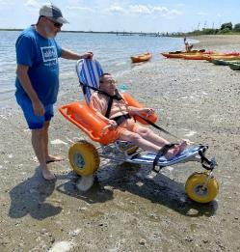This family-friendly event is accessible, free, and open to the public! Pack your towel, sunscreen, beach umbrella, and sandals and join the Triangle, Inc. community for a fun day in the sun!

**When:** Saturday, August 2, 2025

11 a.m.–3 p.m.

**Where:**[Constitution Beach](https://www.mass.gov/locations/constitution-beach-park)  
East Boston, MA 02128  
*Near the Orient Heights MBTA Stop*

**Rain Date:** To be determined

**Register online by July 25, 2025:**<https://triangle-inc.org/beachability/>

**Join Revere Commission on Disabilities &  
Revere Parks and Recreation Department for**

# All-Abilities Day at Revere Beach!

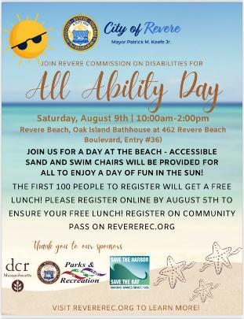You are invited for a day at the beach! Accessible sand and floating beach wheelchairs will be available for all to enjoy a day of fun in the sun!! Lunch will be provided for the first 100 people who register.

**When:** Saturday, August 9, 2025,

10 a.m.–2 p.m.

**Where:** [Revere Beach](https://www.mass.gov/locations/revere-beach-reservation) at the Oak Island Bathhouse (Access Points 36)  
462 Revere Beach Boulevard *(directly across from 461 Revere Beach Boulevard)*

**Register online by August 5th to ensure your FREE LUNCH!**

**To Register:** Register on Community Pass on [Revere Recreation.org](https://www.revererec.org/home)

**Questions:** Contact Ralph at [rdecicco@revere.org](mailto:rdecicco@revere.org)

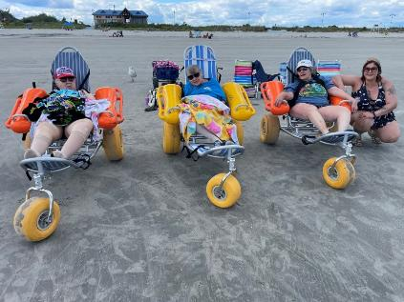

# Summer Adaptive Ice Skating & BBQ in E. Boston!

**Monday, Aug. 25, 2025**

**11 a.m. – 1:30 p.m.**

[**Porrazzo Memorial Rink**](https://www.mass.gov/locations/porrazzo-memorial-rink)

199 Coleridge St, E. Boston, MA 02128

Join [Universal Access Program](https://www.mass.gov/orgs/universal-access-program) and [Spaulding Adaptive Sports Centers](https://sasc.spauldingrehab.org/) for some cool summer skating and then enjoy a waterfront barbeque on [Constitution Beach](https://www.mass.gov/locations/constitution-beach-park) (courtesy of [FMC Ice Sports](https://fmcicesports.com/rink/east-boston-porrazzo-skating-arena/)).

Use your wheelchair, an ice sled, a skate walker, ice grippers, or conventional skates on the ice. Spin, slide and play gently competitive games! There will be pucks and colorful balls to shoot around, races, and a tower of blocks to crash down!

The rink is cold, so please dress warmly and bring your winter coat, gloves, and a hat!

This program is for people with disabilities, their families, support staff, and friends. All are encouraged to join on the ice to help support! Yaktrax (ice grippers) are available in the lobby for those that can’t skate.

**Pre-registration is required.** You must request to register by 12 p.m. two days before the program. You must sign up for a time slot and can skate for one hour.

**Groups:** Maximum group size is 15, including staff.

**Cost: FREE**

**Questions & to Register:** Email [DCR.UniversalAccess@mass.gov](mailto:DCR.UniversalAccess@mass.gov) or call [(413) 461-7126](tel:4134617126)

The international symbol of accessibility.**Coming Event**

[Department of Conservation and Recreation](https://www.mass.gov/orgs/department-of-conservation-recreation), [Universal Access Program](https://www.mass.gov/orgs/universal-access-program)

[mass.gov/dcr/universal-access](http://www.mass.gov/dcr/universal-access)