# Group of hikers are walking on a snowy trail in the forest. Two people are using hiking poles and one person is using a kicksled. Universal Access Program logo of a path leading to a mountainous horizondcr Massachusetts logo with a laurel leaf in a circle.DCR’s Universal Access Program Winter 2024–2025 Program Schedule

## White Snowflake Winter 2024–2025 Adaptive Recreation Fun!

## [General Information](https://massgov.sharepoint.com/sites/EEA-O365/DCR/Workspace/Universal_Access_Program/Shared%20Documents/Vendor%20Shared%20Files/AOA-UAP%20Shared%20Files/Fall/Fall%20UAP%20Travel%20Cycling.xlsx?web=1)

DCR’s [Universal Access Program](https://www.mass.gov/orgs/universal-access-program) is dedicated to providing outdoor recreation opportunities in Massachusetts state parks for visitors of all abilities. Accessibility is achieved through site improvements, specialized adaptive recreation equipment, and accessible recreation programs.

The Universal Access Program (UAP) offers adaptive, accessible programming seasonally at state parks, pools, and rinks. We partner throughout the year with [All Out Adventures](https://alloutadventures.org/), [Easterseals Massachusetts](https://www.easterseals.com/ma/), [Holyoke Rows](https://holyokerows.org/), and [Waypoint Adventure](http://www.waypointadventure.org/) to provide programs statewide.

Our structured programs feature adaptive equipment, professional staff, and instruction and support. Friends, family members, and companions are encouraged to take part in our programs alongside participants with disabilities.

Our Spring Program season runs from April through May, our Summer Program season runs from June through August, our Fall Program season runs from September through October, and our Winter Program season runs from November through March.

Check out [mass.gov/dcr/access](http://www.mass.gov/dcr/access) to keep up to date with our activities! If you would like to get on our mailing list to be notified of upcoming events and activities, please [contact us](mailto:DCR.UniversalAccess@mass.gov).

### Release Forms & Pre-Registration

A current release form is required for all our programs, and you must **pre-register with the organization running the program.** To pre-register, cancel, or check-in about inclement weather, please contact the providing organization listed for each program.

### Essential Eligibility Criteria & Program Attendance Guidelines

You must also meet the [essential eligibility criteria](https://www.mass.gov/service-details/essential-eligibility-criteria-for-universal-access-program-participants) and follow our [program attendance guidelines](https://www.mass.gov/info-details/essential-eligibility-criteria-for-universal-access-program-participants#program-attendance-guidelines-) (PAG) for the activity. Essential eligibility criteria (EEC) help you understand the skills you need to participate in our programs. For risk management considerations, everyone who attends our programs must complete a release form and meet these EEC, including caregivers and group staff. You can meet the EEC independently, or with the help of a caregiver (family member, friend, or PCA). Visit us at [mass.gov/uap/eec](http://www.mass.gov/uap/eec) to learn more.

If you have concerns about your ability to meet the EEC or PAG, please speak with the organization leading the activity. If you have general questions or concerns, please contact us by email [DCR.UniversalAccess@mass.gov](mailto:DCR.UniversalAccess@mass.gov) or phone at [(413) 461-7126](tel:4134617126).

## Two people are riding an upright tandem bicycle on a paved bike trail.Adaptive Cycling

### [Wompatuck State Park](https://www.mass.gov/locations/wompatuck-state-park)—Adaptive Tandem Cycling

204UnionSt,Hingham

Join the [Universal Access Program](https://www.mass.gov/orgs/universal-access-program) for accessible tandem cycling in Hingam. During this program, run by our partner [Waypoint Adventure](https://waypointadventure.org/), small groups work together to cycle the back roads and bike paths of Massachusetts. Participants are encouraged to bring lunch and socialize on the trail and during breaks.

We have a variety of bikes that offer different amounts of support. We will match up two riders (a Captain and a Stoker). The Captain will be the leader, and the Stoker is the other half of the team, who works with the Captain to enjoy the adventure of tandem cycling. Some of our bikes are more traditional upright bicycles that require teamwork and balance. We also have other models that are side-by-side or recumbent, low to the ground tandems. Some have two wheels and require more balance while others are quite sturdy with three wheels and supportive seats.

**Space is limited and pre-registration is required.** Registration ends November 14, 2024.

**Day and Time:** Friday, November 15, 2024, 10 a.m.–1:30 p.m.

**Meet At:** Visitor Center parking lot located at 204 Union St., Hingham.

**Cost:** $20/Participant. Cost flexible based on need. One parent/friend/PCA may attend for no charge (see Waypoint’s registration page for details).

**To Register:** Visit [waypoint-adventure.jumbula.com](https://waypoint-adventure.jumbula.com/)

**Questions:** Email [programs@waypointadventure.org](mailto:programs@waypointadventure.org)

## Two kids are seated in ice sleds laughing while their father stands behind them on the ice holding their sled handles. A person using a skate walker is in the background. Adaptive Ice Skating

### [Henry J. Fitzpatrick Rink](https://www.mass.gov/locations/henry-j-fitzpatrick-rink)—Adaptive Ice Skating

575MapleSt,Holyoke

Join the [Universal Access Program](https://www.mass.gov/orgs/universal-access-program) and [Holyoke Rows](https://www.holyokerows.org/) for [accessible skating, socializing, and fun](https://www.mass.gov/info-details/adaptive-ice-skating-programs-0) in Holyoke.

Use your wheelchair, an ice sled, a skate walker, ice grippers, or conventional skates on the ice. Spin, slide and play gently competitive games! There will be pucks and colorful balls to shoot around, obstacle courses, races, and a tower of blocks to crash down!

The rink is cold, so please dress warmly and bring your winter coat, gloves or mittens, and a hat!

This program is for people with disabilities, their families, support staff, and friends. All are encouraged to join on the ice to help support! Yaktrax (ice grippers) are available in the lobby for those that can’t skate.

**Space is limited and pre-registration is required**. Sign up for a timeslot to enter the ice and skate for one hour. You must request to register by 12 p.m. two days before the program.

**Groups:** Maximum group size is 15, including staff. Large school groups should register by individual classroom to minimize group size. All groups must submit a complete sign-in sheet and release forms one week in advance.

**Days and Times:** Sundays, 11:30 a.m.–2 p.m.

* November 17, 2024
* December 8, 2024
* January 19, 2025
* February 23, 2025
* March 2, 2025

**Cost: FREE** (entry & equipment are free-of-charge)

**Questions & To Register:** Email [DCR.UniversalAccess@mass.gov](mailto:DCR.UniversalAccess@mass.gov) or call [(413) 461-7126](tel:4134617126).

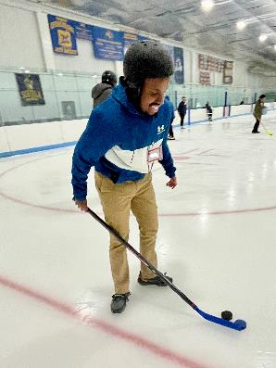

### [Porrazzo Memorial Rink](https://www.mass.gov/locations/porrazzo-memorial-rink)—Adaptive Ice Skating

199ColeridgeSt,EastBoston

Join the [Universal Access Program](https://www.mass.gov/orgs/universal-access-program) and [Spaulding Adaptive Sports Centers](https://spauldingrehab.org/conditions-services/adaptive-sports) for [accessible skating, socializing, and fun](https://www.mass.gov/info-details/adaptive-ice-skating-programs-0) in East Boston.

Use your wheelchair, an ice sled, a skate walker, ice grippers, or conventional skates on the ice. Spin, slide and play gently competitive games! There will be pucks and colorful balls to shoot around, obstacle courses, races, and a tower of blocks to crash down!

The rink is cold, so please dress warmly and bring your winter coat, gloves or mittens, and a hat!

This event is for people with disabilities, their families, support staff, and friends. All are encouraged to join on the ice to help support! Yaktrax (ice grippers) are available in the lobby for those that can’t skate.

**Space is limited and pre-registration is required**. Sign up for a timeslot to enter the ice and skate for one hour. You must request to register by 12 p.m. two days before the program.

**Groups:** Maximum group size is 15, including staff. Large school groups should register by individual classroom to minimize group size. All groups must submit a complete sign-in sheet and release forms one week in advance.

**Days and Times:** Wednesdays, 11 a.m.–1:30 p.m.

* December 11, 2024
* January 8, 2025
* February 5, 2025
* March 5, 2025

**Cost: FREE** (entry & equipment are free-of-charge)

**Questions & To Register:** Email [DCR.UniversalAccess@mass.gov](mailto:DCR.UniversalAccess@mass.gov) or call [(413) 461-7126](tel:4134617126).

### A man seated in a wheelchair is laughing while being pushed on the ice by AOA staff. [Charles J. Buffone Rink](https://www.mass.gov/locations/charles-j-buffone-rink)—Adaptive Ice Skating

284LakeAve,Worcester

Join the [Universal Access Program](https://www.mass.gov/orgs/universal-access-program) for [accessible skating, socializing, and fun](https://www.mass.gov/info-details/adaptive-ice-skating-programs-0) in Worcester. This program is run by our partner, [All Out Adventures](https://alloutadventures.org/) (AOA).

Use your wheelchair, an ice sled, a skate walker, ice grippers, or conventional skates on the ice. Spin, slide and play gently competitive games! There will be pucks and colorful balls to shoot around, obstacle courses, races, and a tower of blocks to crash down!

The rink is cold, so please dress warmly and bring your winter coat, gloves or mittens, and a hat!

This event is for people with disabilities, their families, support staff, and friends. All are encouraged to join on the ice to help support! Yaktrax (ice grippers) are available in the lobby for those that can’t skate.

**Space is limited and pre-registration is required**. Sign up for a timeslot to enter the ice and skate for one hour. You must request to register by 12 p.m. two days before the program.

**Groups:** Maximum group size is 15, including staff. Large school groups should register by individual classroom to minimize group size. All groups must submit a complete sign-in sheet and release forms one week in advance.

**Days and Times:** Mondays, 1–3 p.m.

* December 16, 2024
* January 13, 2025
* February 10, 2025
* March 10, 2025

**Cost: FREE** (entry & equipment are free-of-charge)

**Questions & To Register:** Email [DCR.UniversalAccess@mass.gov](mailto:DCR.UniversalAccess@mass.gov) or call [(413) 461-7126](tel:4134617126).



### [Peter W. Foote Vietnam Veterans Memorial Rink](https://www.mass.gov/locations/peter-w-foote-vietnam-veterans-memorial-rink)—Adaptive Ice Skating

1267SouthChurchSt,NorthAdams

Join the [Universal Access Program](https://www.mass.gov/orgs/universal-access-program) for [accessible skating, socializing, and fun](https://www.mass.gov/info-details/adaptive-ice-skating-programs-0) in North Adams. This program is run by our partner, [All Out Adventures](https://alloutadventures.org/) (AOA).

Use your wheelchair, an ice sled, a skate walker, ice grippers, or conventional skates on the ice. Spin, slide and play gently competitive games! There will be pucks and colorful balls to shoot around, obstacle courses, races, and a tower of blocks to crash down!

The rink is cold, so please dress warmly and bring your winter coat, gloves or mittens, and a hat!

This event is for people with disabilities, their families, support staff, and friends. All are encouraged to join on the ice to help support! Yaktrax (ice grippers) are available in the lobby for those that can’t skate.

**Space is limited and pre-registration is required**. Sign up for a timeslot to enter the ice. You must register by 12 p.m. the day before the program and can skate for one hour.

**Groups:** Maximum size is 15, including staff.

**Days and Times:** Thursdays, 1–3 p.m.

* December 19, 2024
* January 16, 2025
* February 13, 2025
* March 13, 2025

**Cost: FREE** (entry & equipment are free-of-charge); AOA suggested donation—$5/person

**Questions & To Register:** Register with AOA online at [alloutadventures.org](https://www.alloutadventures.org/), call [(413) 584-2052](mailto:(413) 584-2052), or email [programs@alloutadventures.org](mailto:programs@alloutadventures.org).

### A person wearing ice skates is walking outside the rink. Two people are supporting her with a waist belt. [Gardner Veterans Rink](https://www.mass.gov/locations/gardner-veterans-rink)—Adaptive Ice Skating

45VeteransDrive,Gardner

Join the [Universal Access Program](https://www.mass.gov/orgs/universal-access-program) for [accessible skating, socializing, and fun](https://www.mass.gov/info-details/adaptive-ice-skating-programs-0) in Gardner. This program is run by our partner, [All Out Adventures](https://alloutadventures.org/) (AOA).

Use your wheelchair, an ice sled, a skate walker, ice grippers, or conventional skates on the ice. Spin, slide and play gently competitive games! There will be pucks and colorful balls to shoot around, obstacle courses, races, and a tower of blocks to crash down!

The rink is cold, so please dress warmly and bring your winter coat, gloves or mittens, and a hat!

This event is for people with disabilities, their families, support staff, and friends. All are encouraged to join on the ice to help support! Yaktrax (ice grippers) are available in the lobby for those that can’t skate.

**Space is limited and pre-registration is required**. Sign up for a timeslot to enter the ice. You must register by 12 p.m. the day before the program and can skate for one hour.

**Groups:** Maximum size is 15, including staff.

**Days and Times:** Fridays, 10:30 a.m.–1 p.m.

* January 10, 2025
* January 24, 2025
* February 28, 2025

**Cost: FREE** (entry & equipment are free-of-charge); AOA suggested donation—$5/person

**Questions & To Register:** Register with AOA online at [alloutadventures.org](https://www.alloutadventures.org/), call [(413) 584-2052](mailto:(413) 584-2052), or email [programs@alloutadventures.org](mailto:programs@alloutadventures.org)

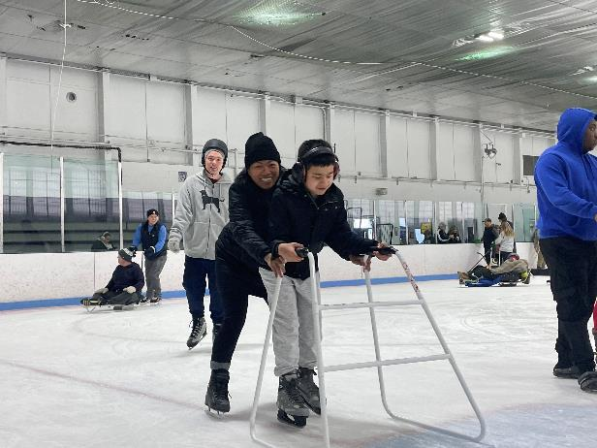

### [John G. Asiaf Memorial Rink](https://www.mass.gov/locations/john-g-asiaf-memorial-rink)—Adaptive Ice Skating

702BelmontSt,Brockton

Join the [Universal Access Program](https://www.mass.gov/orgs/universal-access-program) for [accessible skating, socializing, and fun](https://www.mass.gov/info-details/adaptive-ice-skating-programs-0) in Brockton. This program is run by our partner, [All Out Adventures](https://alloutadventures.org/) (AOA).

Use your wheelchair, an ice sled, a skate walker, ice grippers, or conventional skates on the ice. Spin, slide and play gently competitive games! There will be pucks and colorful balls to shoot around, obstacle courses, races, and a tower of blocks to crash down!

The rink is cold, so please dress warmly and bring your winter coat, gloves or mittens, and a hat!

This event is for people with disabilities, their families, support staff, and friends. All are encouraged to join on the ice to help support! Yaktrax (ice grippers) are available in the lobby for those that can’t skate.

**Space is limited and pre-registration is required**. Sign up for a timeslot to enter the ice. You must register by 12 p.m. the day before the program and can skate for one hour.

**Groups:** Maximum size is 15, including staff.

**Days and Times:** Sundays, 12:20–2:10 p.m.

* January 19, 2025
* February 2, 2025
* February 16, 2025

**Cost: FREE** (entry & equipment are free-of-charge); AOA suggested donation—$5/person

**Questions & To Register:** Register with AOA online at [alloutadventures.org](https://www.alloutadventures.org/), call [(413) 584-2052](mailto:(413) 584-2052), or email [programs@alloutadventures.org](mailto:Programs@alloutadventures.org).

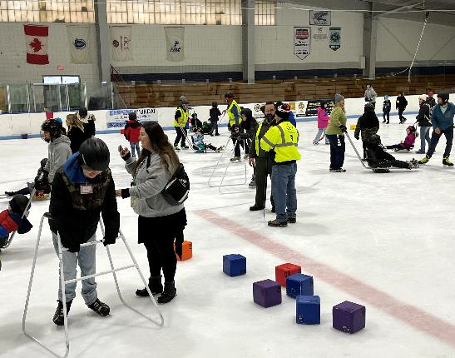

### [Arthur R. Driscoll Memorial Rink](https://www.mass.gov/locations/arthur-r-driscoll-memorial-rink)—Adaptive Ice Skating

272ElsbreeSt,FallRiver

Join the [Universal Access Program](https://www.mass.gov/orgs/universal-access-program) and [All Out Adventures](https://alloutadventures.org/) (AOA) for [accessible skating, socializing, and fun](https://www.mass.gov/info-details/adaptive-ice-skating-programs-0) in Fall River.

Use your wheelchair, an ice sled, a skate walker, ice grippers, or conventional skates on the ice. Spin, slide and play gently competitive games! There will be pucks and colorful balls to shoot around, obstacle courses, races, and a tower of blocks to crash down!

The rink is cold, so please dress warmly and bring your winter coat, gloves or mittens, and a hat!

This event is for people with disabilities, their families, support staff, and friends. All are encouraged to join on the ice to help support! Yaktrax (ice grippers) are available in the lobby for those that can’t skate.

**Space is limited and pre-registration is required**. Sign up for a timeslot to enter the ice and skate for one hour. You must request to register by 12 p.m. two days before the program.

**Groups:** Maximum size is 20 (including staff). Large school groups should register by classroom to minimize group size. All groups must complete a sign-in sheet and submit release forms one week in advance.

**Days and Times:** Wednesdays, 11 a.m.–1 p.m.

* January 29, 2025
* February 26, 2025

**Cost: FREE** (entry & equipment are free-of-charge)

**Questions & To Register:** Email [DCR.UniversalAccess@mass.gov](mailto:DCR.UniversalAccess@mass.gov) or call   
[(413) 461-7126](tel:4134617126).

## A group of hikers wearing winter gear are posing for the camera in a forest. Some are seated in all-terrain wheelchairs and some are holding hiking sticks.Adaptive Outdoor Programs: Hiking, Kicksledding, Snowshoeing, Cross-Country Skiing, Sit-Skiing, & Gentle Hockey

### [Middlesex Fells Reservation](https://www.mass.gov/locations/middlesex-fells-reservation)—Adaptive Hiking

3WoodlandRoad,Stoneham

Join the [Universal Access Program](https://www.mass.gov/orgs/universal-access-program) for accessible small group hiking in Stoneham. During this program, run by our partner [Waypoint Adventure](https://waypointadventure.org/), you’ll see stunning forests, ponds/waterways, eat lunch, and connect with new people. You’ll benefit from our selection of adaptive equipment, receive instruction to meet any learning style, and be encouraged to reach your individual goals.

**Space is limited and pre-registration is required.** Registration ends November 16, 2024.

**Day and Time:** Sunday, November 17, 2024, 11–3 p.m.

**Meet at:** Parking Lot address: 3 Woodland Rd, Stoneham MA. Turn off Woodland Road onto New England Sana Acc. From there, follow the Waypoint Adventure signs around the buildings to the parking lot in the back of the complex.

**Cost:** $20/Participant. Cost flexible based on need. One parent/friend/PCA of program participant with a disability may attend at no charge (see Waypoint’s Registration page for details).

**To Register:** Visit [waypoint-adventure.jumbula.com](https://waypoint-adventure.jumbula.com/)

**Questions:** Email [programs@waypointadventure.org](mailto:programs@waypointadventure.org)

### [Blue Hills Reservation](https://www.mass.gov/locations/blue-hills-reservation)—Adaptive Hiking

860 Hillside St., Milton

Join the [Universal Access Program](https://www.mass.gov/orgs/universal-access-program) for accessible small group hiking in Milton. During this program, run by our partner [Waypoint Adventure](https://waypointadventure.org/), we will see stunning forests, ponds/waterways, eat lunch, and connect with new people. You’ll benefit from our selection of adaptive equipment, receive instruction to meet any learning style, and be encouraged to reach your individual goals.

**Space is limited and pre-registration is required.** Registration ends December 6, 2024.

**Day and Times:** Saturday, December 7, 2024, 10 a.m.–12 p.m. or 1–3 p.m.

**Meet at:** Houghton’s Pond Parking Lot (860 Hillside St, Milton MA 02186). Look for the green and blue signs for directions.

**Cost:** $20/Participant. Cost flexible based on need. One parent/friend/PCA of program participant with a disability may attend at no charge (see Waypoint’s Registration page for details).

**To Register:** Visit [waypoint-adventure.jumbula.com](https://waypoint-adventure.jumbula.com/)

**Questions:** Email [programs@waypointadventure.org](mailto:programs@waypointadventure.org)

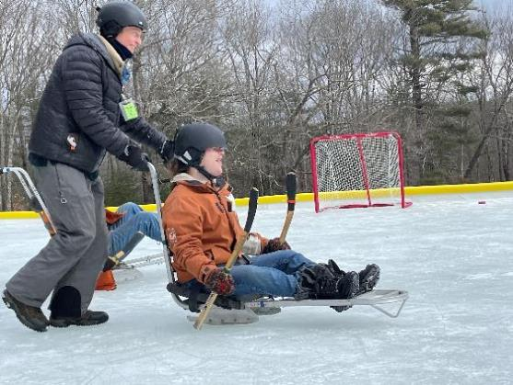

### [Wendell State Forest](https://www.mass.gov/locations/wendell-state-forest)—Adaptive Outdoor Winter Recreation

392WendellRd,MillersFalls

Join the [Universal Access Program](https://www.mass.gov/orgs/universal-access-program) for [accessible winter outdoor recreation](https://www.mass.gov/info-details/adaptive-cross-country-skiing-and-snowshoeing) in Millers Falls. This program is run by our partner [All Out Adventures](https://alloutadventures.org/) (AOA).

Enjoy the winter woods with hiking, outdoor ice skating, cross-country skiing, sit cross-country skiing, ice sled skating, kicksledding, or snowshoeing. Activities offered may vary depending upon weather conditions. Instruction, adaptive equipment, and assistance provided.

**Space is limited and pre-registration is required.** You must register for a timeslot by 12 p.m. the day before the program.

**Days and Times:** Saturdays, 11 a.m.–3 p.m.

**Timeslots:** 11 a.m.–12:30 p.m.; 12–1:30 p.m.; 1:30–3:00 p.m.

* January 11, 2025
* January 18, 2025
* January 25, 2025
* February 1, 2025
* February 8, 2025
* February 15, 2025
* February 22, 2025
* March 1, 2025

**Meet At:** Wendell State Forest Headquarters, at 392 Wendell Rd in Millers Falls.

**Cost**: **FREE**; AOA suggested donation—$5/person

**Questions & To Register:** Register with AOA online at [alloutadventures.org](https://www.alloutadventures.org/), call [(413) 584-2052](mailto:(413) 584-2052), or email [programs@alloutadventures.org](mailto:programs@alloutadventures.org)

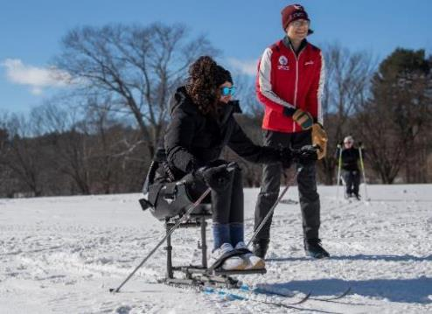

### [Leo J. Martin Ski Track](https://www.mass.gov/locations/leo-j-martin-ski-track)—Adaptive Cross-Country Skiing

190ParkRd,Weston

Join the [Universal Access Program](https://www.mass.gov/orgs/universal-access-program) for [accessible cross-country skiing](https://www.mass.gov/info-details/adaptive-cross-country-skiing-and-snowshoeing) in Weston. During this program, run by our partner [Waypoint Adventure](https://waypointadventure.org/), you will hit the trails using a kicksled, sit-ski, snowshoes, ice grippers or cross-country skis. You’ll receive instruction to meet any learning style and be encouraged to reach your individual goals.

Snow is made on site and trails are groomed daily!

**Space is limited and pre-registration is required.** Registration ends the day before the program.

**Days and Times:** 10 a.m.–2 p.m.

* Wednesday, January 15, 2025
* Wednesday, January 22, 2025
* Sunday, January 26, 2025
* Wednesday, January 29, 2025
* Wednesday, February 5, 2025
* Sunday, February 9, 2025
* Wednesday, February 12, 2025
* Wednesday, February 19, 2025
* Thursday, February 20, 2025
* Wednesday, February 26, 2025

**Cost:** $20/Participant. Cost flexible based on need.

**To Register:** Visit [waypoint-adventure.jumbula.com](https://waypoint-adventure.jumbula.com/)

**Questions:** Email [programs@waypointadventure.org](mailto:programs@waypointadventure.org)

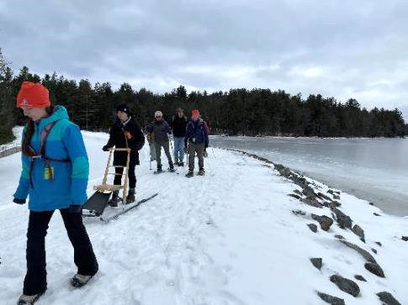

### [DAR State Forest](https://www.mass.gov/locations/daughters-of-the-american-revolution-dar-state-forest)—Adaptive Outdoor Winter Recreation

78CapeSt.,Goshen

Join the [Universal Access Program](https://www.mass.gov/orgs/universal-access-program) for [accessible winter outdoor recreation](https://www.mass.gov/info-details/adaptive-cross-country-skiing-and-snowshoeing) in Goshen. This program is run by our partner [All Out Adventures](https://alloutadventures.org/) (AOA).

Enjoy the winter woods with hiking, cross-country skiing, sit-skiing, kick sledding, or snowshoeing. Activities offered may vary depending upon weather conditions. Instruction, adaptive equipment, and assistance provided.

There is an accessible warming hut on site.

**Space is limited and pre-registration is required.** You must register by 12 p.m. the day before the program.

**Days and Times:** Thursdays, 11 a.m.–3 p.m.

* January 9, 2025
* January 23, 2025
* February 6, 2025

**Cost**: **FREE**; AOA suggested donation—$5/person

**Questions & To Register:** Register with AOA online at [alloutadventures.org](https://www.alloutadventures.org/), call [(413) 584-2052](mailto:(413)%20584-2052), or email [programs@alloutadventures.org](mailto:programs@alloutadventures.org)

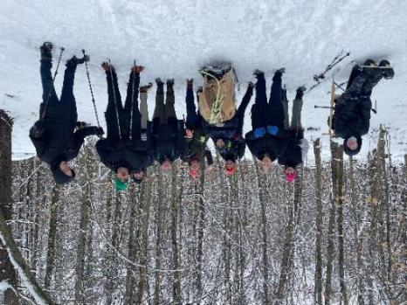

### [Dunn State Park](https://www.mass.gov/locations/dunn-state-park)—Adaptive Outdoor Winter Recreation & First Day Adaptive Hiking

289PearlSt.,Gardner,MA

Join the [Universal Access Program](https://www.mass.gov/orgs/universal-access-program) for [accessible winter outdoor recreation](https://www.mass.gov/info-details/adaptive-cross-country-skiing-and-snowshoeing) in Gardner. These programs are run by our partner [All Out Adventures](https://alloutadventures.org/) (AOA).

Enjoy the beauty of winter by exploring wooded trails! Join us for hiking, kick sledding, or snowshoeing. Activities offered may vary depending upon weather conditions. Instruction, adaptive equipment, and assistance provided.

A warm building, fireplace, and indoor restrooms available in the accessible Visitors Center!

**Space is limited and pre-registration is required.** You must register by 12 p.m. the day before the program.

**First Day Adaptive Hike:** Monday, January 1, 2025, 11 a.m.–2 p.m.

**Cost: FREE**;AOA suggested donation—$5/person

**Questions & To Register:** Register with AOA by calling [(413) 584-2052](mailto:(413)%20584-2052), or emailing [programs@alloutadventures.org](mailto:programs@alloutadventures.org)

**Accessible Winter Recreation:** Fridays, 11 a.m.–3 p.m.

* January 31, 2025
* February 7, 2025
* February 14, 2025
* February 21, 2025

**Cost**: **FREE**; AOA suggested donation—$5/person

**Questions & To Register:** Register with AOA online at [alloutadventures.org](https://www.alloutadventures.org/), call [(413) 584-2052](mailto:(413)%20584-2052), or email [programs@alloutadventures.org](mailto:programs@alloutadventures.org)

A person seated on a kicksled is being assisted along a snowy trail in the forest.
One staff member is  pushing and one is pulling the kicksled. 

### [Pittsfield State Forest](https://www.mass.gov/locations/pittsfield-state-forest)—Adaptive Outdoor Winter Recreation

1041CascadeSt.,Pittsfield

Join the [Universal Access Program](https://www.mass.gov/orgs/universal-access-program) for [accessible winter outdoor recreation](https://www.mass.gov/info-details/adaptive-cross-country-skiing-and-snowshoeing) in Pittsfield. This program is run by our partner [All Out Adventures](https://alloutadventures.org/) (AOA).

Enjoy the beauty of winter by exploring wooded trails! Join us for hiking, kick sledding, or snowshoeing. Activities offered may vary depending upon weather conditions. Instruction, adaptive equipment, and assistance provided.

There is an accessible warming hut on site.

**Space is limited and pre-registration is required.** You must register by 12 p.m. the day before the program.

**Day and Time:** Thursday, February 20, 2025, 11 a.m.–3 p.m.

**Cost**: **FREE**; AOA suggested donation—$5/person

**Questions & To Register:** Register with AOA online at [alloutadventures.org](https://www.alloutadventures.org/), call [(413) 584-2052](mailto:(413)%20584-2052), or email [programs@alloutadventures.org](mailto:programs@alloutadventures.org)