# Universal Access Program logo of a path leading to a mountainous horizondcr Massachusetts logo with a laurel leaf in a circle. DCR’s Universal Access Program Summer 2024 Program Schedule

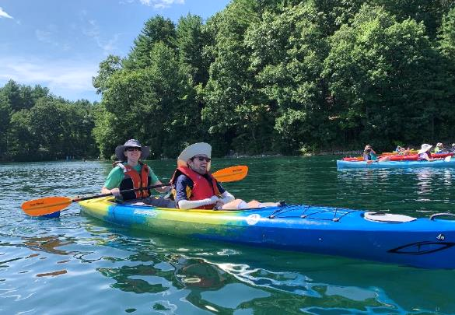

## **General Information**

DCR’s [Universal Access Program](https://www.mass.gov/orgs/universal-access-program) is dedicated to providing outdoor recreation opportunities in Massachusetts state parks for visitors of all abilities. Accessibility is achieved through site improvements, specialized adaptive recreation equipment, and accessible recreation programs.

The Universal Access Program (UAP) offers adaptive, accessible programming seasonally at state parks, pools, and rinks. We partner throughout the year with [All Out Adventures](https://alloutadventures.org/), [Easterseals Massachusetts](https://www.easterseals.com/ma/), [Holyoke Rows](https://holyokerows.org/), and [Waypoint Adventure](http://www.waypointadventure.org/) to provide programs statewide.

Our structured programs feature adaptive equipment, professional staff, and instruction and support. Friends, family members, and companions are encouraged to take part in our programs alongside participants with disabilities.

Our Spring Program season runs from April through May, our Summer Program season runs from June through August, our Fall Program season runs from September through October, and our Winter Program season runs from November through March.

Check out [mass.gov/dcr/access](http://www.mass.gov/dcr/access) to keep up to date with our activities! If you would like to get on our mailing list to be notified of upcoming events and activities, please [contact us](mailto:DCR.UniversalAccess@mass.gov).

### Release Forms & Pre-Registration

A current release form is required for all our programs, and you must **pre-register with the organization running the program.** To pre-register, cancel, or check-in about inclement weather, please contact the providing organization listed for each program.

### Essential Eligibility Criteria & Program Attendance Guidelines

You must also meet the [essential eligibility criteria](https://www.mass.gov/service-details/essential-eligibility-criteria-for-universal-access-program-participants) and follow our [program attendance guidelines](https://www.mass.gov/info-details/essential-eligibility-criteria-for-universal-access-program-participants#program-attendance-guidelines-) (PAG) for the activity. Essential eligibility criteria (EEC) help you understand the skills you need to participate in our programs. For risk management considerations, everyone who attends our programs must complete a release form and meet these EEC, including caregivers and group staff. You can meet the EEC independently, or with the help of a caregiver (family member, friend, or PCA). Visit us at [mass.gov/uap/eec](http://www.mass.gov/uap/eec) to learn more.

If you have concerns about your ability to meet the EEC or PAG, please speak with the organization leading the activity. If you have general questions or concerns, please contact us by email [DCR.UniversalAccess@mass.gov](mailto:DCR.UniversalAccess@mass.gov) or phone at [(413) 461-7126](tel:4134617126).

## **Holyoke Rows logoHOLYOKE ROWS-Rowing**

### Two people in a rowing shell. The person in back is facing the person in front.Rowing

This program, operated by [Holyoke Rows](https://www.holyokerows.org/), is free to individuals with disabilities and their families. While receiving instruction and the opportunity to practice, rowers also have the chance to participate in competitions! Our program serves people of all capabilities, from beginners to leisure rowers, to competitive racers!

#### [Connecticut River](https://www.mass.gov/locations/connecticut-river-greenway-state-park) at 25 Jones Ferry Rd., Holyoke, MA

Thursdays, By Appointment Only

* June 6
* June 13
* June 20
* June 27
* July 11
* July 18
* July 25
* August 1
* August 8
* August 15
* August 22

**Cost:** Free

**To Register:** Call [Holyoke Rows](https://www.holyokerows.org/) at [(413) 320-3134](tel:4133203134) or email [office@holyokerows.org](mailto:office@holyokerows.org)

Massachusetts Alternative Finance Program

## **EASTERSEALS-Pool Program**

### A group of people playing in a pool. Swimming

Join us for an adapted recreational swim program! Led by aquatics instructors and a lifeguard, groups will participate in fun safety activities and water games that maximize independence in the water. This swim program is a six-week, recreational program and does not provide swim lessons. The swim program is open to individuals with disabilities of all ages and their families. This is a special opportunity to swim with new friends before the pool opens to the public!

#### [Bennett Field Pool](https://www.mass.gov/locations/veterans-memorial-bennett-field-swimming-pool), 1260 Main St., Worcester

Tuesdays: Children 5–12 (9–9:45 a.m.); Children 13+ & Adults (10–10:45 a.m.)

* July 9
* July 16
* July 23
* July 30
* August 6
* August 13

Fridays: Children 5–12 (9–9:45 a.m.); Children 13+ & Adults (10–10:45 a.m.)

* July 12
* July 19
* July 26
* August 2
* August 9
* August 16

**Cost:** Free

**To Register:** Call Patrick Remy, [Easterseals Massachusetts](mailto:Easterseals%20Massachusetts), at [(508) 751-6417](tel:508-751-6417) or email [PRemy@eastersealsma.org](mailto:PRemy@eastersealsma.org)

## **Logo: Waypoint AdventureWAYPOINT ADVENTURE- Cycling, Kayaking & Canoeing**

### Two people wearing helmets are riding a tandem upright bicycle on a tree-lined path. Tandem Cycling

During [Waypoint Adventure’s](https://waypointadventure.org/) Tandem Cycling Program, small groups work together to cycle the back roads and bike paths of Massachusetts. Participants are encouraged to bring lunch and socialize on the trail and during breaks. We have a variety of bikes that offer different amounts of support.  We will match up two riders (a Captain and a Stoker). The Captain will be the leader and the Stoker is the other half of the team, who works with the Captain to enjoy the adventure of tandem cycling. Some of our bikes are more traditional upright bicycles that require teamwork and balance. We also have other models that are side by side or recumbent, low to the ground, tandems. Some have two wheels and require more balance while others are quite sturdy with three wheels and supportive seats.

#### Herter Park, [Artesani Playground](https://www.mass.gov/locations/artesani-playground-wading-pool-and-spray-deck), 1255 Soldiers Field Road, Brighton, MA

Friday, 10 a.m.-1:30 p.m.

* July 26

#### [Wompatuck State Park](https://www.mass.gov/locations/wompatuck-state-park), 204 Union St, Hingham, MA

Friday, 10 a.m.-1:30 p.m.

* August 16

**Cost:** $20/Participant. Cost flexible based on need.

**To Register:** Visit [waypoint-adventure.jumbula.com](https://waypoint-adventure.jumbula.com/)

### Two people are riding in a red, 2-person kayak with attached outriggers on a pond. Kayaking & Canoeing

Enjoy small group kayaking and canoeing with [Waypoint Adventure](https://www.waypointadventure.org/)! Join them at historic [Walden Pond State Reservation](https://www.mass.gov/locations/walden-pond-state-reservation), on Spot Pond at [Middlesex Fells Reservation](https://www.mass.gov/locations/middlesex-fells-reservation), at [Cochituate State Park](https://www.mass.gov/locations/cochituate-state-park), at [Harold Parker State Forest](https://www.mass.gov/locations/harold-parker-state-forest), and on the Charles River at Magazine Beach in the [Charles River Reservation](https://www.mass.gov/locations/charles-river-reservation). Experience the fun and serenity of being on the water while being part of a supportive community!

#### Kayaking at [Walden Pond State Reservation](https://www.mass.gov/locations/walden-pond-state-reservation), 915 Walden St, Concord, MA

Thursdays, 1–3 p.m.

* July 11
* July 18
* July 25
* August 29

Tuesdays, 1–3 p.m.

* August 6
* August 13
* August 20
* August 27

#### Canoeing at [Middlesex Fells Reservation](https://www.mass.gov/locations/middlesex-fells-reservation), 4 Woodland Rd, Stoneham, MA

Thursdays, 1–3:30 p.m.

* July 11
* July 18
* July 25

#### Canoeing at [Harold Parker State Forest](https://www.mass.gov/locations/harold-parker-state-forest), Collins Lot, 33 Harold Parker Rd. (east of Harold Parker Rd & Gould Rd. intersection), Andover, MA

Tuesdays, 1–3:30 p.m.

* August 6
* August 13
* August 20
* August 27

#### Kayaking at [Cochituate State Park](https://www.mass.gov/locations/cochituate-state-park), 43 Commonwealth Rd, Natick

Tuesday, 1–3 p.m.

* July 23

Thursday, 1-3 p.m.

* August 1

#### Kayaking at [Charles River Reservation](https://www.mass.gov/locations/charles-river-reservation), Magazine Beach, 668 Memorial Dr., Cambridge

Tuesday, 1–3 p.m.

* July 9

#### Kayaking at [Charles River Reservation](https://www.mass.gov/locations/charles-river-reservation), Waltham, Public Boat Launch, Woerd Ave

Saturday, 10 a.m.–12 p.m. & 1-3 p.m.

* August 10

**Cost:** $20/Participant. Cost flexible based on need.

**To Register:** Visit [waypoint-adventure.jumbula.com](https://waypoint-adventure.jumbula.com/)

**Logo: All Out AdventuresALL 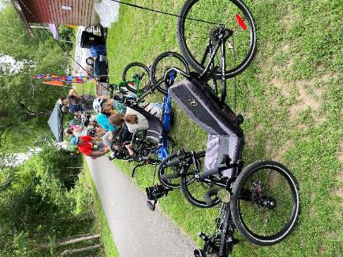OUT ADVENTURES-Cycling, Kayaking & Canoeing**

### A group of cyclists wearing helmets are riding a variety of recumbent bikes along a paved path next to a reservoir. Cycling

Join [All Out Adventures](https://alloutadventures.org/) for accessible cycling in Central and Western Mass locations including: the [Norwottuck Rail Trail](https://www.mass.gov/locations/norwottuck-rail-trail) in Hadley, and the [Blackstone River Greenway](https://blackstoneheritagecorridor.org/exploring-the-blackstone-river-valley/maps-tours-guides/blackstone-river-bikeway/) (in Blackstone and Worcester. We have an array of cycles that can accommodate riders of all abilities from stable, comfortable recumbent trikes to handcycles to tandem recumbent trikes to wheelchair tandems. This program is open to people with disabilities and their families and friends. Instruction, equipment, and assistance as needed are provided. Sign up for a 1 to1.5-hour time slot during the program time.

#### [Blackstone River Greenway](https://blackstoneheritagecorridor.org/exploring-the-blackstone-river-valley/maps-tours-guides/blackstone-river-bikeway/), 85 Canal St, Blackstone, MA

Wednesday, 11 a.m.–3 p.m.

* June 19

#### [Blackstone River Greenway](https://blackstoneheritagecorridor.org/exploring-the-blackstone-river-valley/maps-tours-guides/blackstone-river-bikeway/) at the [Blackstone River Valley Heritage Center](https://blackstoneheritagecorridor.org/happening-now/worcester-heritage-center/), 3 Paul Clancy Way, Worcester, MA

Wednesday, 11 a.m.–3 p.m.

* June 26

#### [Norwottuck Rail Trail](https://www.mass.gov/locations/norwottuck-rail-trail), 12 Railroad St., Hadley, MA

Fridays, 10 a.m.–3 p.m.

* June 14
* June 21
* June 28
* July 12
* July 19
* July 26
* August 9
* August 16
* August 23
* August 30

**Cost**: $5 per participant. Scholarships are available for those who need them.

**To Register:** Call [All Out Adventures](https://alloutadventures.org/) at [(413) 584-2052](tel:4135842052) or email [Programs@alloutadventures.org](mailto:Programs@alloutadventures.org)

### A group of people paddling on a lake. Some are in canoes and some are riding kayaks. Kayaking & Canoeing

Join [All Out Adventures](https://alloutadventures.org/) for accessible paddling at various locations across Massachusetts including Cheshire Reservoir (off the [Ashuwillticook Rail Trail](https://www.mass.gov/locations/ashuwillticook-rail-trail)), [Hopkinton State Park](https://www.mass.gov/locations/hopkinton-state-park), [DAR State Forest](https://www.mass.gov/locations/daughters-of-the-american-revolution-dar-state-forest) in Goshen, [Dunn State Park](https://www.mass.gov/locations/dunn-state-park) in Gardner, and [Quinsigamond State Park](https://www.mass.gov/locations/quinsigamond-state-park) in Worcester! Paddlers will travel together in a small pod exploring the lakes and ponds. Instruction, adaptive equipment, and assistance (as needed) provided. Sign up for a 1.25-hour time slot during the program time.

#### Kayaking on Cheshire Reservoir at Farnams Crossing, 50 Farnams Rd, Cheshire, MA

Saturday, 11:00 a.m.–3 p.m.

* June 29

#### Kayaking at [Hopkinton State Park](https://www.mass.gov/locations/hopkinton-state-park), 164 Cedar St., Hopkinton

Tuesdays, 10:00 a.m. -3 pm

* July 9
* July 16
* July 23
* July 30
* August 6
* August 13
* August 20
* August 27

#### Canoeing and Kayaking at [DAR State Forest](https://www.mass.gov/locations/daughters-of-the-american-revolution-dar-state-forest), 78 Cape St, Goshen

Wednesdays, 9:45 a.m.–3:15 p.m.

* July 10
* July 17
* July 24
* July 31
* August 7
* August 14
* August 21
* August 28

#### Canoeing at [Dunn State Park](https://www.mass.gov/locations/dunn-state-park), 289 Pearl St., Gardner

Thursdays, 10 a.m.-3 p.m.

* July 11
* July 18
* July 25

#### Kayaking at Regatta Point in [Quinsigamond State Park](https://www.mass.gov/locations/quinsigamond-state-park), 10 N. Lake Ave., Worcester

Thursdays, 10 a.m.-2:45 p.m.

* August 1
* August 8
* August 15
* August 22
* August 29

**Cost:** $8 per participant. Scholarships are available for those who need them.

**To Register:** Call [All Out Adventures](https://alloutadventures.org/) at [(413) 584-2052](tel:4135842052) or email [Programs@alloutadventures.org](mailto:Programs@alloutadventures.org)

## **Summer 2024 Supported Programs**

Several organizations also offer adaptive programming at DCR locations on their own, sometimes with the use of DCR equipment. These are called *supported* programs. These supported programs may have their own requirements and release forms. Please contact the providing organization for more information about a supported program. Each providing organization has their own requirements for programming, including EEC and program attendance guidelines. Please check their website or inquire for more details when registering for a program.

### Two people are using ParaGolfers on a green grassy putting range. Logo: MPGAMASSACHUSETTS PARA-GOLFERS ASSOCIATION-Golfing

The [Massachusetts ParaGolfer Association](https://www.mpga.club/) (MPGA) promotes recreational and competitive adaptive golf for players with visual impairments, amputations, loss of mobility, and spinal cord injuries. MPGA provides adaptive golf lessons, recreational programs, and competitive events. Lessons are private and always free and we offer flexible dates and times. Please make a reservation in advance by calling or texting Steve [(508) 889-7581](tel:5088897581).

**Website:** [mpga.club](https://www.mpga.club/)

**Locations**: [DCR Golf Courses](https://www.statemadcrgolf.com/)

* [Ponkapoag Golf Course](https://www.mass.gov/locations/ponkapoag-golf-course)**,** 2167 Washington Street, Canton, MA,
* [Leo J. Martin Memorial Golf Course](https://www.mass.gov/locations/leo-j-martin-memorial-golf-course)**,** 190 Park Rd, Weston, MA

**Contact:** Steve Kuketz, [mpga.club@gmail.com](mailto:mpga.club@gmail.com), [(508) 889-7581](tel:5088897581)

### A group of people are standing on a green grassy golf course posing for a picture. One person is standing using ParaGolfer and one person is using a white cane.Text Description automatically generatedGOLF FOR ALL-Golfing

[Golf for All](http://www.golfforall.org/)runs year-round programming for veterans, people with autism, Parkinson’s Disease, spinal cord injuries and paralysis, cerebral palsy, golfers with amputations, golfers with visual impairments, and more. Golf instruction is tailored to suit the specific needs of each participant and is taught by PGA Professionals who have successfully completed a certification process for teaching golfers with adaptive needs. Golfers of all abilities and gender are welcome, and no previous experience is necessary. During each clinic, golfers are provided with instruction, balls, adaptive equipment, and vehicles, as needed.

**Website:** [golfforall.org](http://www.golfforall.org/)

**Locations**: [DCR Golf Courses](https://www.statemadcrgolf.com/)

* [Ponkapoag Golf Course](https://www.mass.gov/locations/ponkapoag-golf-course), 2167 Washington Street, Canton, MA,

* [Leo J. Martin Memorial Golf Course](https://www.mass.gov/locations/leo-j-martin-memorial-golf-course), 190 Park Rd, Weston, MA

**Contact:** Fred Corcoran, Exec. Director, [fredcorc@golfforall.org](mailto:fredcorc@golfforall.org), [(617) 462-9899](tel:6174629899)

### A group of people in a sailboat on the river are smiling and waving at the camera. Graphical user interface Description automatically generated with low confidenceCOMMUNITY BOATING, Inc.-Sailing

Nestled in the heart of Boston, Community Boating allows individuals to take responsibility for their learning, push themselves to overcome challenges, and experience the freedom sailing offers. With top-notch instruction and quality equipment, the program provides support and encouragement to individuals who might not otherwise be able to sail. Members include veterans, individuals with visual impairments, children with developmental disabilities, adults with chronic injury or illness, and many more.

**Website:** [community-boating.org/accessible](https://www.community-boating.org/accessible/)

**Location:** Charles River Esplanade in the [Charles River Reservation](https://www.mass.gov/locations/charles-river-reservation), 21 David G Mugar Way, Boston, MA

**Dates:** May 1–October 15

**Times:** Afternoons and weekends: see [scheduling page](https://urldefense.com/v3/__https:/community-boating.org/accessible/schedule-an-appointment/__;!!CPANwP4y!Q2u1LkgkJAT4V3lI7ecciN1Dhgn5Igla7wV8Q2gw5qfM2gpq7Gy_dt7rXgC5uQKG9hE1LQro8fs5WlZRagS9MMt5dZ0$) for appointment times

**Annual Membership:** $50 or reduced fee of $1 upon request

**Eligibility:** Any individual who needs additional assistance

**Contact:** [uap@community-boating.org](mailto:uap@community-boating.org), [(617) 523-1038](tel:6175231038)

### Many styles and sizes of adaptive bicycles are parked in front of 3 accessible yurts and a Spaulding pop up canopy. SPAULDING ADAPTIVE SPORTS CENTERS-Cycling, Kayaking, Paddleboarding, Yoga, Yard Games & Golf

[Spaulding Adaptive Sports Centers](https://spauldingrehab.org/conditions-services/adaptive-sports) (SASC) will be offering a variety of adaptive sport programs at the McGraw Center for Adaptive Sports at [Nickerson State Park](https://www.mass.gov/locations/nickerson-state-park) starting May 14th. Spaulding staff provide equipment, adaptations, and support. Pre-registration for all activities is required.

**Location:** McGraw Center for Adaptive Sports, [Nickerson State Park](https://www.mass.gov/locations/nickerson-state-park), Brewster

#### Back on Course-Boston

SASC will also be offering a return to golf program designed for those who are ready to play between 4–9 consecutive holes on the course. Prior participation in the Back in the Swing (BITS) series is helpful as a pre-requisite.

**Location:** [Leo J. Martin Memorial Golf Course](https://www.mass.gov/locations/leo-j-martin-memorial-golf-course), 190 Park Rd, Weston, MA

**Dates/Time:** 9:30 a.m. – 11 a.m.

* June 27
* July 25
* August 29

**Cost:** $40 per session

Visit SASC’s [On-line Calendar](https://sasc.spauldingrehab.org/default.aspx?tab=icon) for McGraw Center and Back on Course Programs

**Website:** [sasc.spauldingrehab.org](https://sasc.spauldingrehab.org/),

**Contact:** [spauldingadaptivesports@partners.org](mailto:spauldingadaptivesports@partners.org), [(877) 976-7272](tel:8779767272)

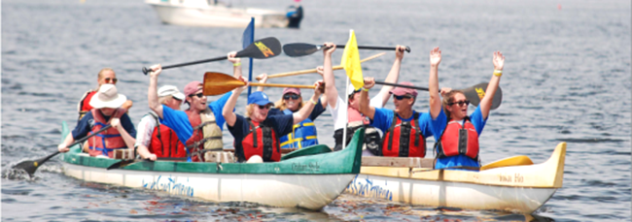**AccesSportAmerica-Watersports**

AccesSportAmerica is offering adaptive watersports at [Malibu Beach](https://www.mass.gov/locations/savin-hill-and-malibu-beach) on Boston Harbor in Dorchester.

**Windsurfing:** Seated and standing adaptations with a full range of tandem, catamaran, and single boards.

**Hawaiian Outrigger Canoeing:** Three, four person canoes with paddle adaptations.

**Stand Up Paddling:** Single, double and 8-person stand up boards with seats and standers.

**Kayaking:** Single and double kayaks with adaptive paddles.

Each sport is adapted to fit every individual’s unique needs. AccesSport trainers, interns, and volunteers are on site.

Athletes can sign up as an individual or programs can send groups. Individual sessions will include four athletes, and groups will be 6-10.

**Location:** [Malibu Beach](https://www.mass.gov/locations/savin-hill-and-malibu-beach), 68 Denny St., Dorchester, MA

**Website:** https://goaccess.org/

**Dates & Times:** July & August; Tuesday- Friday by appointment

**Cost:**  Individuals $50/session; Groups $120/session

**Contact:** [Nate@goaccess.org](mailto:Nate@goaccess.org); [(978) 7906-2960](tel:8779767272)

 **The Massachusetts Statewide Independent Living Council**

Invites you to

## **ADA Day at Dunn State Park!**

**Friday, August 2, 2024**

**11 a.m. – 3 p.m.**

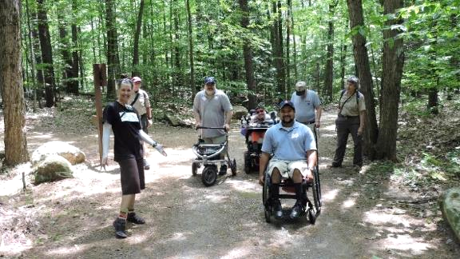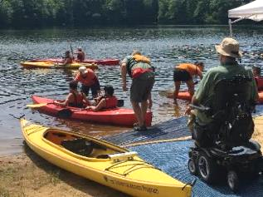**Celebrate 34 years of the Americans with Disabilities Act!!**

Hike, kayak, swim, listen to music and hang out with friends. Light lunch and drinks provided.

[DCR's Universal Access Program](https://www.mass.gov/orgs/universal-access-program) will host accessible hiking and kayaking with partners from [All Out Adventures](https://alloutadventures.org/) and [Waypoint Adventure](https://ma.waypointadventure.org/).

ASL will be provided for those needing assistance accessing accessible activities. Parking is limited so carpooling is encouraged!

**Location:** [Dunn State Park](https://www.mass.gov/locations/dunn-state-park), 289 Pearl St., Gardner, MA

**RSVP by July 18th at:** <https://masilc.formstack.com/forms/2024adaday>

**Questions?** Email MASILC: [info@masilc.com](mailto:info@masilc.com)

**Join Triangle, Inc. on Saturday, August 10th**

### Beach:Ability!

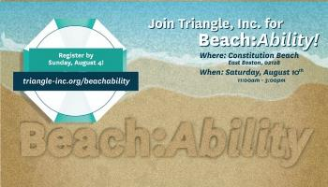This family-friendly event is accessible, free, and open to the public! Pack your towel, sunscreen, each umbrella, and sandals and join the Triangle, Inc. community for a fun day in the sun!

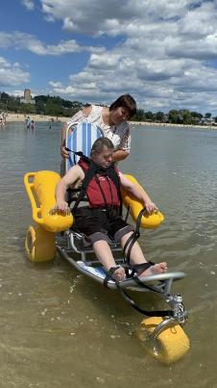**When:** Saturday, August 10, 2024  
11a.m. – 3p.m.  
*Kayaks will be available from 11am-2pm with our friends from Piers Park Sailing Center!*

**Where:**[Constitution Beach](https://www.mass.gov/locations/constitution-beach-park)  
East Boston, MA 02128  
*Near the Orient Heights MBTA Stop*

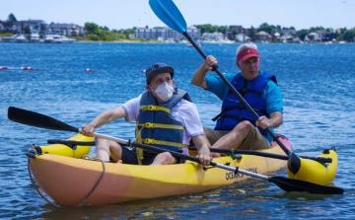**Register on-line by August 4th:**  <https://triangle-inc.org/beachability/>

**Join Revere Commission on Disabilities, Saturday August 17th**

### All-Ability Day at Revere Beach Reservation!

You are invited for an accessible day at the beach, featuring sand and floating beach wheelchairs, for all to enjoy a day of fun in the sun! Lunch will be provided for the first 100 people who register.

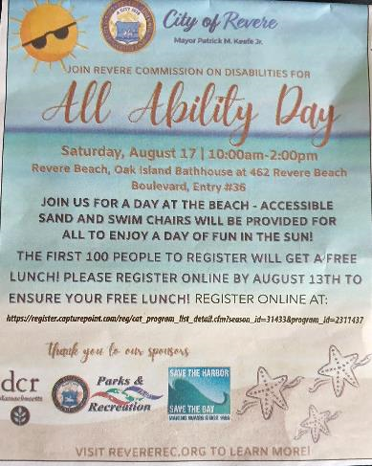**Where:**[Revere Beach Reservation](https://www.mass.gov/locations/revere-beach-reservation)  
Oak Island Bathhouse at 462 Revere Beach Boulevard   
*(Entry #36)*

**When:** Saturday, August 17, 2024  
10a.m. – 2p.m.

**Register on-line by August 13th to ensure your FREE LUNCH!**

Register on Community Pass at [All Abilities Day Out at Revere Beach Registration](https://register.capturepoint.com/reg/cat_program_list_detail.cfm?season_id=31433&program_id=2311437)

**To Learn More:** Visit Revere Parks and Recreation Department: [www.revererec.org](http://www.revererec.org/)

**Questions?** Call 781-286-8190

## **Summer Adaptive Ice Skating & BBQ in E. Boston!**

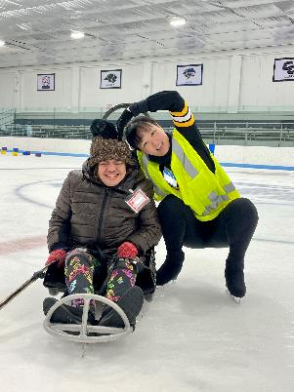**Monday, Aug. 26, 2024**

**11 a.m. – 1:30 p.m.**

[**Porrazzo Memorial Rink**](https://www.mass.gov/locations/porrazzo-memorial-rink)

199 Coleridge St, E. Boston, MA 02128

Join Universal Access for some cool summer skating and then enjoy a waterfront barbeque on [Constitution Beach](https://www.mass.gov/locations/constitution-beach-park) (courtesy of FMC Ice Sports).

On the ice you can use your wheelchair, an ice sled, a skate walker, ice grippers, or conventional skates. Spin, slide and play gently competitive games! Admission and equipment are provided free of cost.

**You will need to pre-register for this program.** Call [(413) 461-7126](tel:4134617126) or email [DCR.UniversalAccess@mass.gov](mailto:DCR.UniversalAccess@mass.gov) to reserve a time.

The rink is cold, so please dress warmly and bring your winter coat, gloves or mittens, and a hat! Face masks are welcome and appreciated.

**Coming Event**

[Department of Conservation and Recreation](https://www.mass.gov/orgs/department-of-conservation-recreation), [Universal Access Program](https://www.mass.gov/orgs/universal-access-program)

[mass.gov/dcr/universal-access](http://www.mass.gov/dcr/universal-access)