# DCR Universal Access Program Winter 2023-2024 Schedule

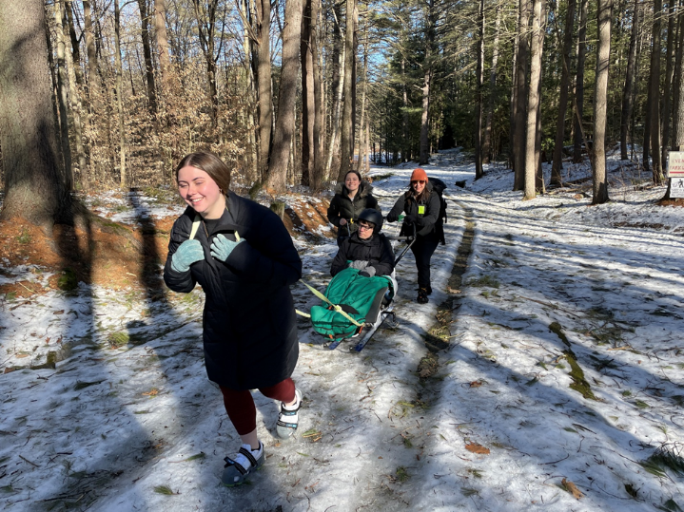

DCR’s [Universal Access Program](https://www.mass.gov/orgs/universal-access-program) is dedicated to providing outdoor recreation opportunities in Massachusetts state parks for visitors of all abilities. Accessibility is achieved through site improvements, specialized adaptive recreation equipment, and accessible recreation programs.

## General information

The Universal Access Program (UAP) offers adaptive, accessible programming seasonally at state parks, pools, and rinks. We partner throughout the year with [All Out Adventures](https://alloutadventures.org/), [Easterseals Massachusetts](https://www.easterseals.com/ma/), [Holyoke Rows](https://holyokerows.org/), and [Waypoint Adventure](http://www.waypointadventure.org/) to run our programs. Some of our programs are supported by [Spaulding Adaptive Sports Centers](https://sasc.spauldingrehab.org/).

Our structured programs feature adaptive equipment, professional staff, and instruction and support. Friends, family members, and companions are encouraged to take part in our programs alongside participants with disabilities.

Our main winter program season runs from November through March, and our main summer season runs from June through September. If you would like to get on our mailing list to be notified of upcoming events and activities, please [contact us](mailto:DCR.UniversalAccess@mass.gov).

## Release Forms and Pre-registration

A current release form is required for all of our programs, and you must pre-register with the organization running the program. To pre-register for an activity, in the event there is inclement weather, or if you need to cancel, please contact the providing organization listed for each program.

## Essential Eligibility Criteria and Program Attendance Guidelines

You must also meet the [essential eligibility criteria](https://www.mass.gov/service-details/essential-eligibility-criteria-for-universal-access-program-participants) and follow our [program attendance guidelines](https://www.mass.gov/info-details/essential-eligibility-criteria-for-universal-access-program-participants#program-attendance-guidelines-) for the activity. Essential eligibility criteria (EEC) help you understand the skills you need to participate in our programs. For risk management considerations, everyone who attends our programs must meet these EEC. You can meet the EEC independently, or with the help of a caregiver (family member, friend, or PCA). Visit us at [mass.gov/uap/eec](http://www.mass.gov/uap/eec) to learn more. If you have concerns about your ability to meet the EEC or PAG, please speak with the organization leading the activity. If you have general questions or concerns, please contact us at by email or phone at [DCR.UniversalAccess@mass.gov](mailto:DCR.UniversalAccess@mass.gov) or [(413) 461-7126](tel:4134617126).

Check out [mass.gov/dcr/access](http://www.mass.gov/dcr/access) to keep up-to-date with our activities!

## Supported Programs

Several organizations also offer adaptive programming at DCR locations on their own, sometimes with the use of DCR equipment. These are called supported programs. These supported programs may have their own requirements and release forms. Please contact the providing organization for more information about a supported program.

Each providing organization may follow their own COVID-19 protocols for in-person programming, including mask wearing and social distancing. Please check their website or inquire for more details when registering for a program.

## Outdoor Programs

### DAR State Forest, Goshen

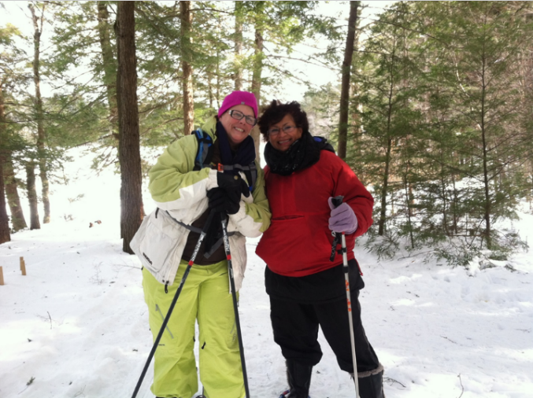

Enjoy the accessible lakeside trail on snowshoes, skis, ice grippers, or kick sleds.

**Dates and times:** Thursdays, 11 a.m.–3 p.m.

* January 11
* January 25
* February 8
* February 29

**Cost:** Suggested donation of $5.

**To register:** Call All Out Adventures at [(413) 584-2052](tel:4135842052) or email [kailean@alloutadventures.org](mailto:kailean@alloutadventures.org)

### Dunn State Park, Gardner

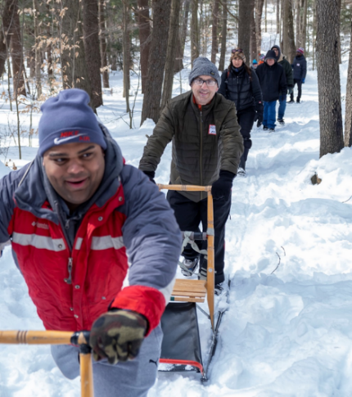

Hit the trails to snowshoe, hike, or kick sled. Warm up by the fireplace in the accessible visitor center.

**Dates and times:** Fridays, 11 a.m.–3 p.m.

* January 26
* February 2
* February 9
* February 16

**Cost:** Suggested donation of $5.

**To register:** Call All Out Adventures at [(413) 584-2052](tel:4135842052) or email [kailean@alloutadventures.org](mailto:kailean@alloutadventures.org)

### Leo J. Martin Ski Track, Weston

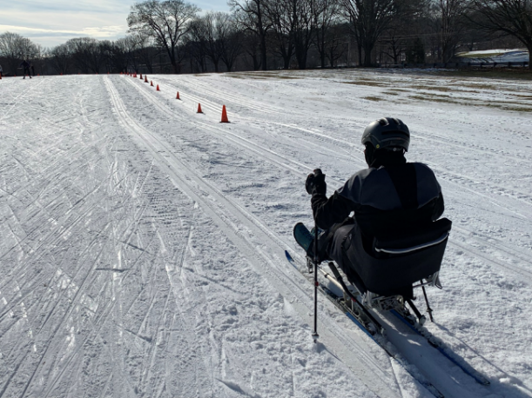

**Dates and times**:

* **January 17:** 10–11:30 a.m., 12:30–2 p.m.
* **January 20:** 11 a.m.–12 p.m., 1–2 p.m., 2–3 p.m.
* **January 25:** 1–2:30 p.m.
* **January 31:** 10–11:30 a.m., 12:30–2 p.m.
* **February 11:** 10–11 a.m., 11 a.m.–12 p.m., 1–2 p.m.
* **February 14:** 10–11:30 a.m., 12:30–2 p.m.
* **February 21:** 10–11:30 a.m., 12:30–2 p.m.
* **February 22:** 10–11:30 a.m., 12:30–2 p.m.

**Cost:** $20 per participant. [Scholarships](https://waypoint-adventure.jumbula.com/scholarships) are available.

**To register:** [Register online](https://waypoint-adventure.jumbula.com/open-enrollment) with Waypoint Adventure at [waypointadventure.org](https://www.waypointadventure.org/).

Adaptive cross-country skiing lessons are also available at [Leo J. Martin Ski Track](https://www.mass.gov/locations/leo-j-martin-ski-track) on a first-come, first-served basis. Email [Charles River Recreation](https://www.skiboston.com/) at [skiboston.com/accessibility](https://www.skiboston.com/accessibility) or call [(617) 965-5110](tel:6179655110) to schedule an outing.

### Wendell State Forest, Wendell

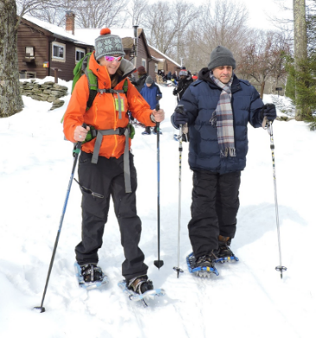

Enjoy the winter woods with outdoor ice skating, cross-country skiing, sit-skiing, gentle sled hockey, kick sledding, and snowshoeing, as conditions permit. Bring a lunch and warm up around the fire before heading out on the groomed trails for a group excursion.

**Dates and times:** Saturdays, 11 a.m.–3 p.m.

* January 13
* January 20
* January 27
* February 3
* February 10
* February 17
* February 24

**Cost:** Suggested donation of $5.

**To register:** Call All Out Adventures at [(413) 584-2052](tel:4135842052) or email [kailean@alloutadventures.org](mailto:kailean@alloutadventures.org)

## Adaptive Skating

Come join the fun at our adaptive skating programs in Brockton, East Boston, Fall River, Gardner, Holyoke, North Adams, and Worcester!

Lace up a pair of conventional skates or slide around the ice on your manual or power wheelchair. Ice sleds are also available: move yourself with small hockey sticks or be pushed around the rink by a friend.

Spin, slide, race, slalom, and play gently competitive games. Enjoy obstacle courses, a tower of blocks for building up and crashing down, races, colorful balls and pucks to pass around, and gently competitive hockey games.

You can use ice sleds, skate walkers, helmets, ice grippers, and ice skates. Admission and equipment are provided free of cost. You will need to pre-register with the providing organization and meet our essential eligibility criteria for ice skating programs.

The rinks will be cold, so please dress warmly and bring your winter coat, gloves or mittens, and a hat.

### Brockton

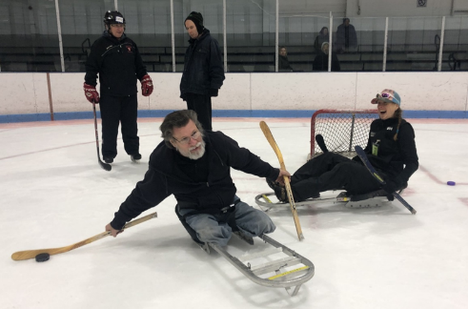

**Location:** Asiaf Memorial Rink, Brockton.

**Dates and times:** Sundays, 12:20–2:10 p.m.

* January 7
* February 4
* March 10

This program takes place during public skating on a reserved section of the ice.

**To register:** Call All Out Adventures at [(413) 584-2052](tel:4135842052) or email [kailean@alloutadventures.org](mailto:kailean@alloutadventures.org)

### East Boston

A group of standing skaters are passing a hockey puck to a skater in an orange vest. behind them, another skater is being pushed in an ice sled.


**Location:** Porrazzo Memorial Rink

**Dates and times:** Wednesdays, 11 a.m.-1:30 p.m.

* December 6
* January 10
* February 7
* March 6

**To register**: Call [(413) 461-7126](tel:4134617126) or email [DCR.UniversalAccess@mass.gov](mailto:DCR.UniversalAccess@mass.gov)

### Fall River

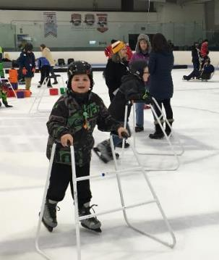

**Location:** Driscoll Memorial Rink, Fall River

**Dates and times:** Wednesdays, 11 a.m.–1 p.m.

* January 31
* February 28

**To register**: Call [(413) 461-7126](tel:4134617126) or email [DCR.UniversalAccess@mass.gov](mailto:DCR.UniversalAccess@mass.gov)

### Gardner

**Location:** Gardner Veterans Rink

**Dates and times:** Fridays, 10:30 a.m.–1 p.m.

December 15, January 19, March 1

**To register:** Call All Out Adventures at [(413) 584-2052](tel:4135842052) or email [kailean@alloutadventures.org](mailto:kailean@alloutadventures.org)

### Holyoke

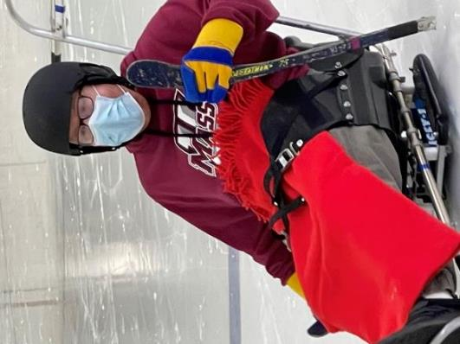

**Location:** Fitzpatrick Memorial Rink

**Dates and times:** Sundays, 11:30 a.m.–2 p.m.

* November 19
* December 3
* February 18
* February 25
* March 3

**To register**: Call [(413) 461-7126](https://www..mass.gov/%28413%29%20461-7126) or email [DCR.UniversalAccess@mass.gov](mailto:DCR.UniversalAccess@mass.gov)

### North Adams

**Location:** Peter W. Foote Vietnam Veterans Memorial Rink, North Adams.

**Dates and times:** Thursdays, 11:30 a.m.–1:30 p.m.

January 4, February 15, March 14

This program takes place during public skating on a reserved section of the ice.

**To register:** Call All Out Adventures at [(413) 584-2052](tel:4135842052) or email [kailean@alloutadventures.org](mailto:kailean@alloutadventures.org)

### Worcester

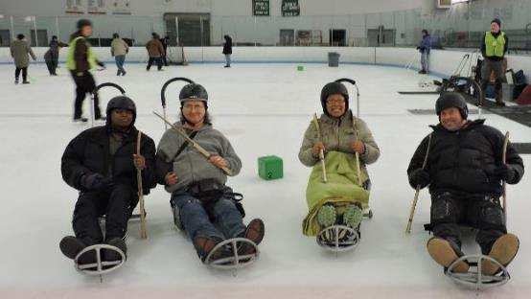

**Location:** Buffone Rink, Worcester

**Dates and times:** Mondays, 1–3 p.m.

* December 11
* January 15
* February 12
* March 11

**To register**: Call [(413) 461-7126](tel:4134617126) or email [DCR.UniversalAccess@mass.gov](mailto:DCR.UniversalAccess@mass.gov)

## Supported Programs

Several organizations also offer adaptive programming at DCR locations on their own, sometimes with the use of DCR equipment. These are called supported programs. These supported programs may have their own requirements and release forms. Please contact the providing organization for more information about a supported program.

### Spaulding Adaptive Sports Center's Community Sled Hockey

Spaulding Adaptive Sports Centers (SASC) offers sled hockey at Allied Veteran's Skating Rink in Everett as part of their [Sears Adaptive Hockey Program](https://sasc.spauldingrehab.org/hockey.aspx). Practices and clinics consist of group drills, small games, scrimmaging, and individual coaching.

For more information or to register, visit the [SASC online calendar](https://sasc.spauldingrehab.org/default.aspx?tab=icon), call   
[(877) 976-7272](tel:8779767272) or email [spauldingsledhockey@partners.org](mailto:spauldingsledhockey@partners.org)

### Spaulding Adaptive Sports Center's Ski/Ride Club

Spaulding Adaptive Sports Ski/Ride Club provides instructors and equipment for both skiers and snowboarders with disabilities at Wachusett Mountain State Reservation. Lessons are designed in collaboration with Wachusett Mountain Ski Area and provide all adaptive gear necessary for either stand-up or sit-down skiers. Certified adaptive snow sports instructors provide private lessons for skiers of all levels, regardless of ability or experience, to reach their most independent skiing or riding ability.

For more information or to register, visit the SASC online calendar, call   
[(877) 976-7272](tel:8779767272) or email [spauldingadaptivesports@partners.org](mailto:spauldingadaptivesports@partners.org).

### Wachusett Mountain Ski Area adaptive lessons

Adaptive downhill skiing lessons are also offered by Wachusett Mountain Ski Area. Wachusett Mountain staff are trained in working with skiers with physical, cognitive, hearing, visual, and developmental disabilities. You need to make a reservation to schedule an adaptive lesson. Lesson cost varies by the type of lesson, the type of area ticket needed, and the equipment required.

For more information or to schedule a lesson, visit the Wachusett Adaptive Lessons website and email [adaptive@wachusett.com](mailto:adaptive@wachusett.com) or call [(978) 464-2300](tel:9784642300), ext. 3308.

### Para Nordic Ski Clinic with Ski Boston at Leo J. Martin Ski Course

January 27, 2024, 10:30 a.m.–1:30 p.m.

[All-ages introduction to Para Nordic skiing](https://www.skiboston.com/para) as a sit, standing skier or a skier with visual impairment. No previous experience is required. Learn more about the sport and further opportunities to ski, train and even compete. On-snow training, with all equipment provided. Coaching provided by U.S. Paralympics Nordic Team Coach, BethAnn Chamberlain.

Cost is $15 per skier which includes your trail pass and gear rental. If cost is a barrier to participate, please email [grants@skiboston.com](mailto:grants@skiboston.com)