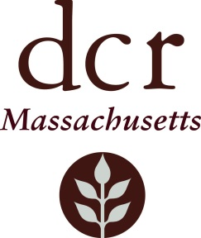
Volunteer in the Parks Information Form

Thank you for your interest in volunteering at a DCR park, beach or reservation. So that we may get to know your objectives better, please fill out this brief questionnaire and email it
to lisa.barstow@mass.gov. We can then follow up with scheduling. Thank you for your interest in DCR.

Please check off the box that most closely matches the statement: “I represent ________________________”

Non-profit organization Community Interest Group Private business/company

College Established “Friends of the Park” group Individual citizen or family

Other (explain): _____________________________________________________________________________

Your Name _________________________________________Your Phone______________________________

Your Organization ___________________________________________________________________________

What is the date(s) and duration of time you plan to offer? __________________________________________
DATE(S) HOURS OF THE DAY
How many volunteers are participating? ________

How many volunteers would be minors (minors must be accompanied by an adult)? _____________________

What is your purpose for volunteering with DCR? __________________________________________________

Do you have your own transportation or will you use public transportation: MY OWN PUBLIC

Do you still need assistance deciding on a property? YES NO

Visit this page for a list of DCR parks that accept volunteers/volunteer groups.
https://www.mass.gov/service-details/volunteers-in-the-parks
____________________________________________________________________________________________

Prior to your volunteer event, you will need to complete the applicable form below and return to lisa.barstow@mass.gov. You may call Lisa Barstow at 617 626 4954 for assistance.

  - If your group is a non-profit, please download, complete and return this form: DCR Volunteer/Stewardship Agreement Form

  - If your group is a school, scout troup, company, or any other organized or ad hoc group, please download, complete and return this form: http://www.mass.gov/eea/docs/dcr/volunteer/volunteer-release-form1.pdf

  - If your groups involves minors, please download this additional form: DCR Parent/Guardian Permission Form for Volunteer Activities Involving Minors

__________________________________________________________________________
Thank you for your interest in volunteering with your state parks and reservations.

