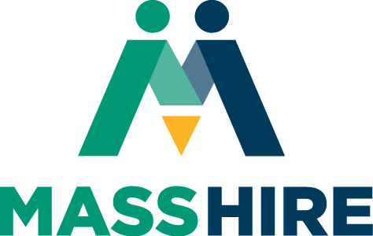


This form is optional, for staff facilitation use only (in person, by phone, survey tool or direct email). Do not post online. Please note this assessment is designed to help with on-going process improvement. No personal information is collected.

What city or town do you currently live in?
- _______________________________________
Which certification(s) were you enrolled in?

- Data analytics
- IT support
- Project/Program management
- UX (User Experience) design
- Digital Marketing and E-Commerce
- Python
- Advanced Data Analytics
- Business Intelligence
- Cybersecurity

What was your key objective in taking this certificate training?

- Earn a certificate to get a job
- To advance in my current job
- Learn skills for a new job
- Add to school coursework
- Get extra help in this area
- Learn more about an area of personal interest
- Start my own business
- None of the other
- Prefer not to say

Did you complete the certificate training?

- Yes
- No

If no, why not?

- Didn’t have time
- Lost interest
- Wasn’t what I thought it would be
- Too easy – got bored
- Too hard
- Personal reasons
- Other____________________

If yes, how long did it take you to finish?

- One week
- One month
- Two-three months
- Four-six months
- Other ____________________

Please indicate your prior experience with online learning prior to this program:

- I had never taken an online course before
- I started an online course but didn’t finish
- I completed a hybrid class with both virtual and in person learning
- I completed 1-3 courses fully online
- I completed 3 or more fully online courses

Rate your knowledge about the certificate topic prior to training?

- 1 - No knowledge
- 2 - Some knowledge
- 3 - Average knowledge
- 4 - Better than average
- 5 - High – why wasn’t I teaching this course?!

Rate your knowledge about the certificate topic following training?

- 1 - No knowledge
- 2 - Some knowledge
- 3 - Average knowledge
- 4 - Better than average
- 5 - High – I could teach the class

Do you feel you were given a good explanation of the training before you started?

- Yes
- No

If no, what was a surprise?

- How much time it took
- It was easier than I thought it would be
- It was harder than I thought it would be
- I didn’t really understand the topic as well as I thought I did
- Other______________________

Describe your employment situation prior to starting training

- Employed parttime (less than 30 hours a week
- Employed fulltime (more than 30 hours a week
- Unemployed and looking for work
- Underemployed – my job doesn’t fit my skills prior training or interests
- Self-employed
- Retired

If you are employed, is your job related to the training you signed up for/completed?

- Yes
- No

Do you think this training will help your employment situation?

- Yes – it will help me in my current job
- Yes – I will add to my resume for future job applications
- Yes – it already has – just got a new job because of this training
- Yes – I’m starting my own business
- No – I’m still looking
- No – I’m not looking for work
- Other____________________

If you are currently working, are you:

- Working from home
- Working outside of your home

Since completing training, are you considering “work from home” employment?

- Yes
- No
- I am already working from home

Would you recommend this training to friends, family, and coworkers?

- Yes
- No
If no, why not?

____________________________________________________________________________

How did you find out about the Grow with Google scholarship program?

- Website
- Email
- Friend
- MassHire Career Center staff
- News media (radio, TV, newspaper)
- Social media (Twitter, Facebook, LinkedIn)
- Other__________________
Are you interested in other Grow with Google certificates?

- Yes
- No

If yes, which one(s)?

- Data analytics
- IT support
- Project/Program management
- UX (User Experience) design
- Digital Marketing and E-Commerce
- Python
- Advanced Data Analytics
- Business Intelligence
- Cybersecurity

Would you like information about additional no-cost services available to you at your local MassHire Career Center, such as resume support, employment opportunities, training programs, job seeking skills training, and career guidance?

- Yes
- No

Thank you for your feedback as we continue to strive to make this program a valuable resource for our state!

